#### **Manufacturing and Expiry Dates Sum**

**1. Apr 21 : Goods purchased from Dairy Foods & co for the following bill no: D108 (25days)**

|  |  |  |
| --- | --- | --- |
| **Butter** | **Cheese** | **Milk** |
| **150packs @ Rs. 70** | **100packs @ Rs. 55** | **50packs @ Rs. 22** |
| **Batch No: DF3004** | **Batch No: DF4005** | **Batch No: DF7004** |
| **MFG Date: 01.04.2020** | **MFG Date: 01.01.2020** | **MFG Date: 21.01.2020** |
| **Expiry Date: 01.01.2021** | **Expiry Date: 01.02.2021** | **Expiry Date: 22.01.2020** |

**2. Apr 21 : Goods purchased from M/s. THULASI PHARMACY for the following bill no: 25 (25days)**

|  |  |
| --- | --- |
| **B-Complex** | **Metformin** |
| **500strips (1strip=10tab) @ Rs. 30** | **450strips (1strip=10tab) @ Rs. 45** |
| **Batch No: TH1001** | **Batch No: TH1005** |
| **MFG Date: 01.09.2019** | **MFG Date: 15.04.2020** |
| **Expiry Date: 01.01.2021** | **Expiry Date: 01.12.2021** |

**3. Apr 23 : Goods sold to Mr. Kumar agencies for the following bill no:101 (5days)**

* **Cheese 50packs @ Rs. 65**
* **Milk 30packs @ Rs. 25**
* 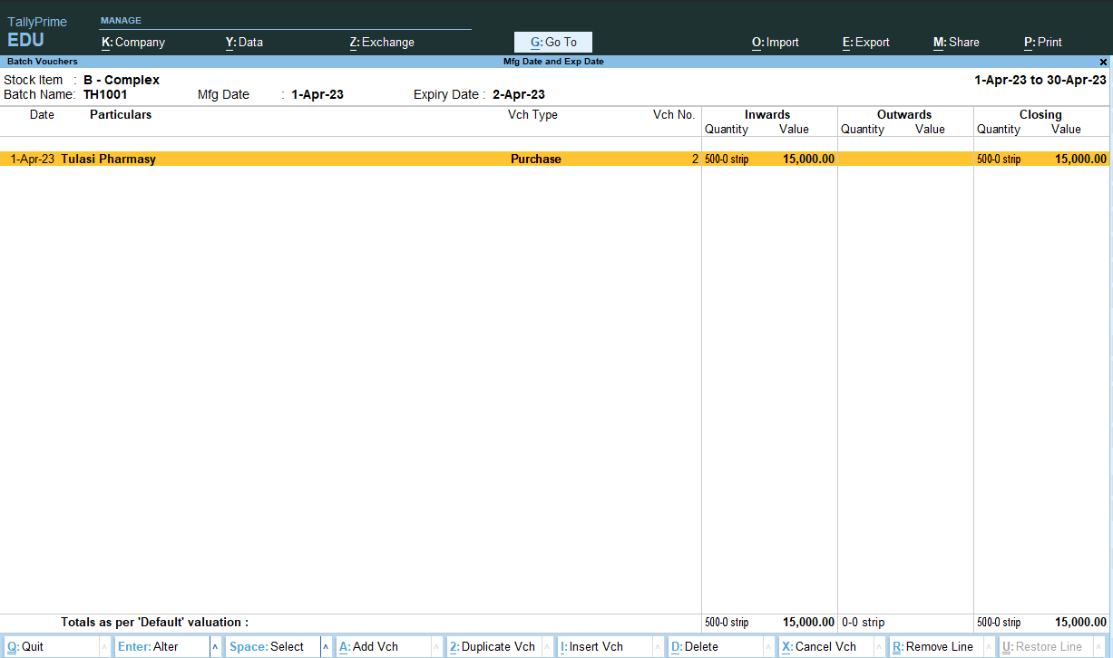
* 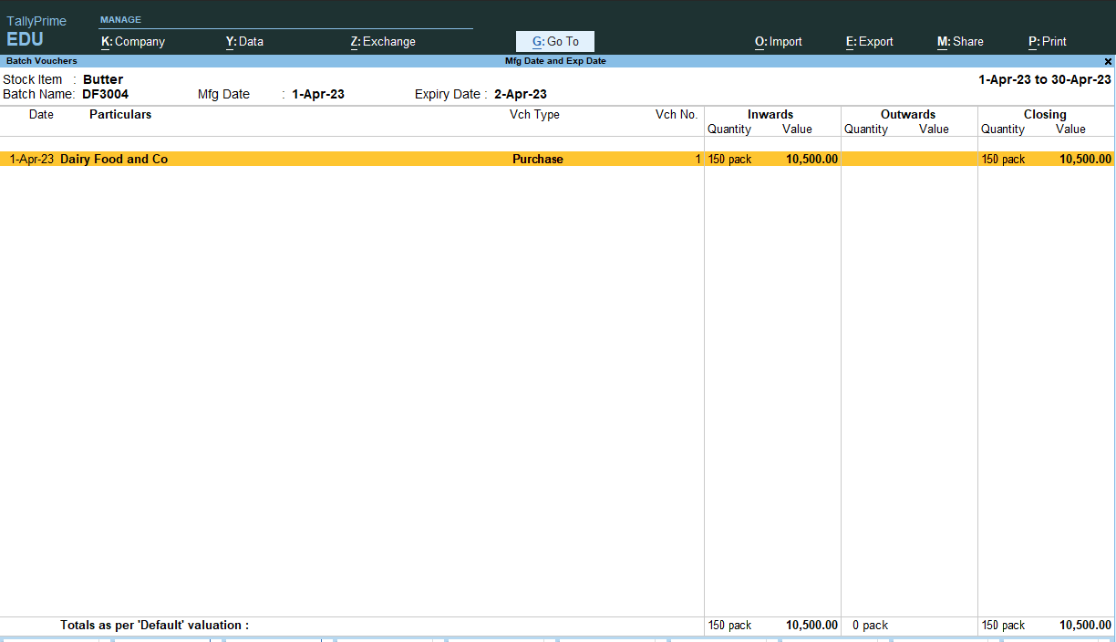
* 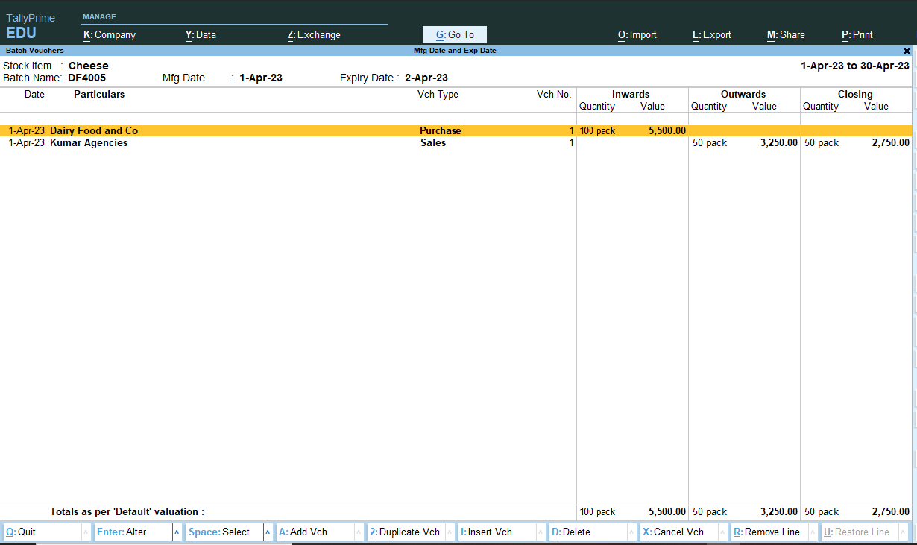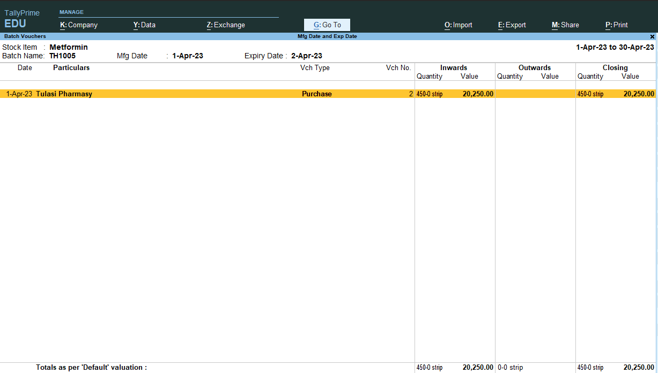

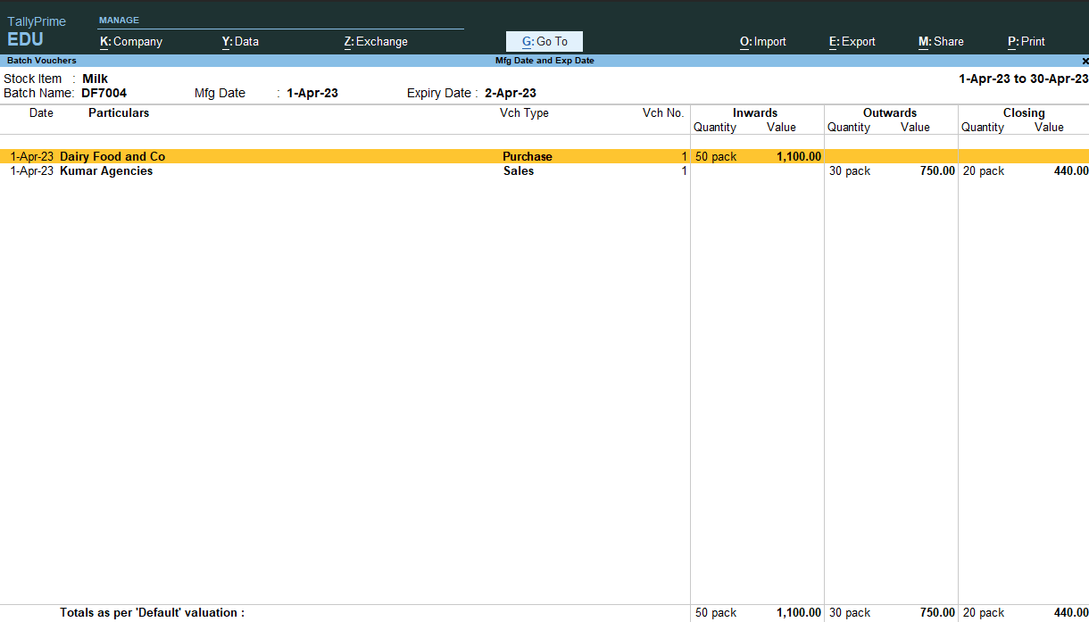

**This project complete .**