**REACT – ASSIGNMENT**

**HANDS-ON:**

1. **Create a new React application** using the create-react-app tool with the name as “blogapp”.
2. Open the application in Visual Studio Code (VS Code).
3. Create a new file named Posts.js inside the src folder.
4. Inside Posts.js, create a class-based component named Posts.
5. Initialize the component state using the constructor. The state should hold a list of posts.
6. Create a method named loadPosts() inside the component. This method should:
   * Use the Fetch API to retrieve posts from the URL:  
     https://jsonplaceholder.typicode.com/posts
   * Assign the fetched data to the component’s state.
7. Use the componentDidMount() lifecycle hook to call the loadPosts() method when the component is mounted. This ensures the posts are fetched as soon as the component loads.
8. Implement the render() method to display:
   * The title of each post in a heading (<h2>).
   * The body of each post in a paragraph (<p>).
9. Define the componentDidCatch() method to handle and display any errors that occur in the component. Errors should be shown using alert messages.
10. Import and add the Posts component to the App component (in App.js) so it gets rendered.
11. npm start

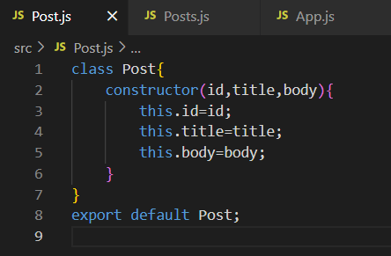

**Posts.js:**

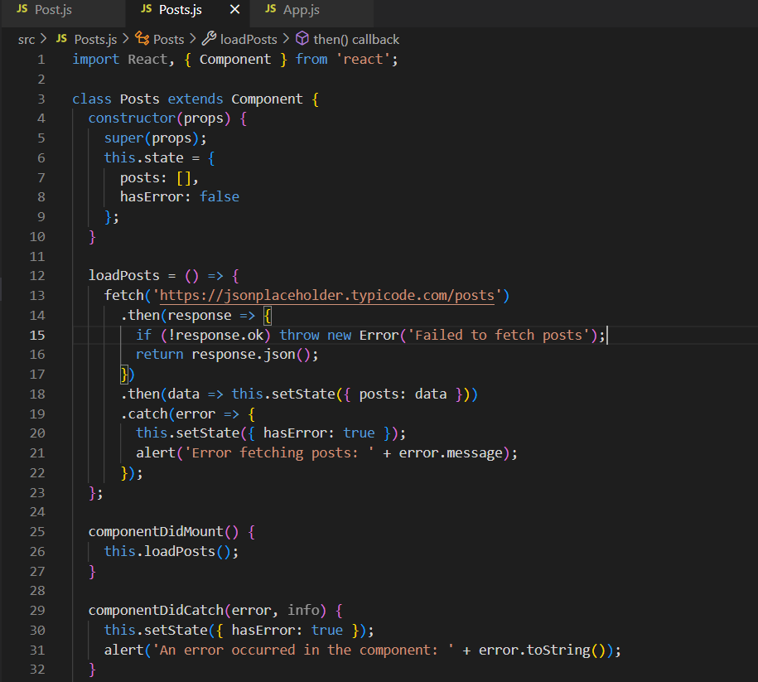

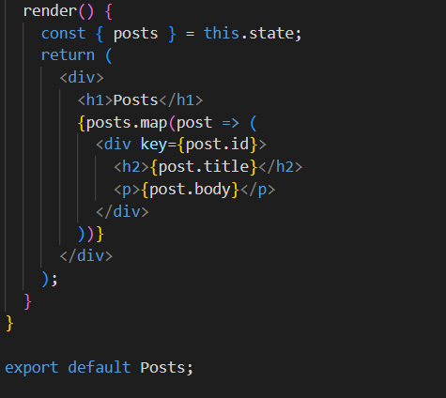

**App.js:**

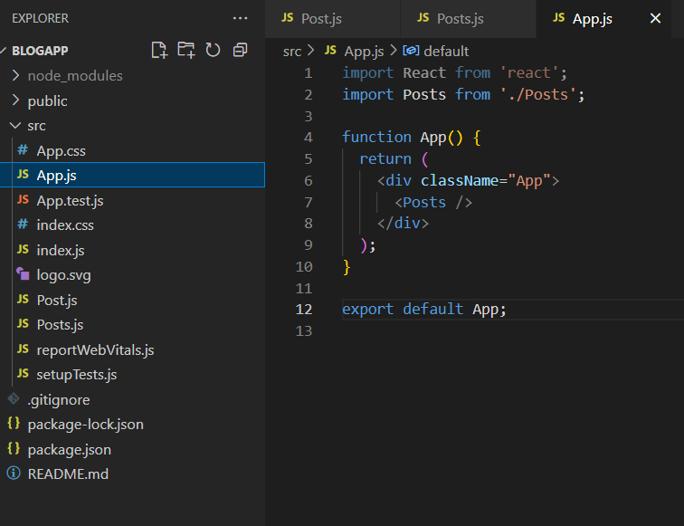

**OUTPUT:**

