CE2107 Lab2 Assignment Sheet (to be submitted to NTULearn before next lab)

Name: Unnikrishnan Malavika Lab Group: SEP4 Date: 14/09/2020

1. Section 6.2. Give a short 2-3 lines description on concept behind the reflectance reading process. Why does the black surface result in slower voltage decay?

**ANS. Each IR Sensor consists of an LED emitting Infrared light and a phototransistor to receive light being reflected, which in turn converts this to electrical energy in term of conducted current and voltage. More light received at transistor means more current conducted. The reflectance of the surface will affect the “effective resistance” of the transistor which in turn affects the decay rate of the voltage. A white reflective surface has more light on the base of the transistor, and conducts more current through the collector-emitter. This current will discharge the capacitor. So since the black surface has lower reflectance, the decay rate of the voltage is also slower than a white surface.**

1. Section 6.3. Where are the sources of the offset error between estimated and actual distance?

**ANS. Since there are only 8 sensors, the limited value of reading from the sensors contribute to the final weighted estimation, making it less accurate as only these 8 binary readings will be combined into a single position parameter.**

**So, if the midpoint of the black line is lying more to the left or to the right of a sensor, the sensor reading will still be the discrete value corresponding to the respective sensor returning a binary value 1, as declared in the array. This maybe improved if we add more sensors in between the existing sensor, making the weighted sum more accurate as the difference between the discrete values, in the array of distance values, will be smaller.**

**The other source is the height of sensors above the surface. The farther away the sensors are, the greater the offset will be.**

1. Section 7.2.  Figure 7. The robot state toggled between LEFT and CENTER state repeatedly when it is detected that the robot is off to the left of the line (input: ‘01’). Under such condition, do you expect the robot to move toward the right in the zig-zag pattern or do you expect it to move in the smooth curve. Assume we shorten the time in each state from 500msec to 5 msec.

**ANS. The robot will move in a zig-zag pattern because it is always toggled between LEFT and CENTER states. The smaller the time in each state, the smaller the zig-zag motions are going to be and hence it’ll seem as though it is beginning to move in a curved trajectory.**

1. Section 7.3. Sketch the FSM diagram of your design that overcome the issue mentioned in this section. Label the FSM according to that shown in Figure 7. Take a photo/copy of your sketch and paste it here.

**ANS.** 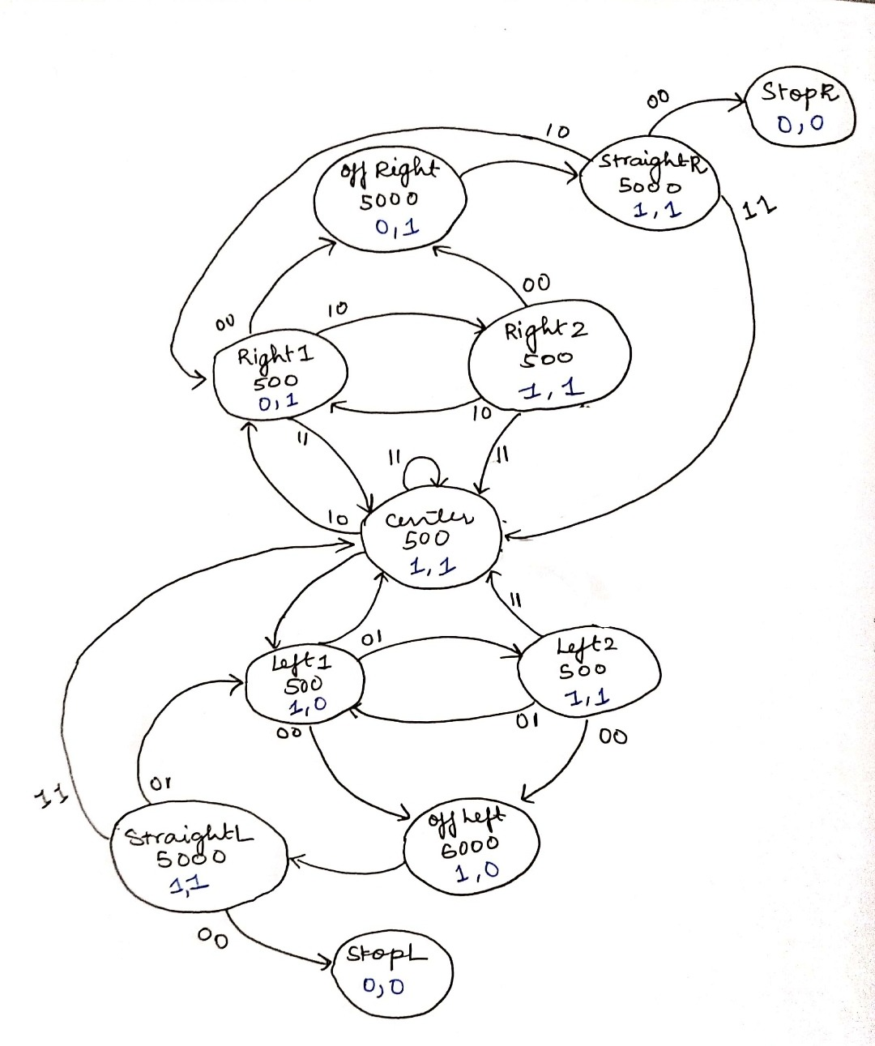



1. Section 7.3. Write down the procedure to initialise P2.4 to be an input pin with internal pull-up resistor

**ANS.** P2->SEL0 &= ~0x10;

P2->SEL1 &= ~0x10; // setup P2.4 as GPIO

P2->DIR &= ~0x10; // make P2.4 as input

P2->REN |= 0x10; //Enable Pullup/Pulldown for 2.4

P2->OUT |= 0x10; // assign Pull up (=1) for p2.4

1. Section 7.3. Other than the List within List method used in the original Lab2_FSMMain.c, which other construct is commonly used to implement a FSM?

**ANS. Another construct that is commonly used to implement FSM is switch case – where the different states in FSM are represented as the different cases to switch between.**

1. Section 7.3. What is the purpose of toggling LED within the main routine or ISR?

**ANS. The purpose of the toggling LED within main routine/ ISR is for us to know that the routines are running smoothly, i.e. , it is for debugging purposes. If the LED stops toggling then we know that there must have been some error with our code or that the loop has been exited.**

**For example, in the FSM project, we use the LEDs to simulate the motors of the robot so that we can verify If our function is running correctly.**

1. Section 7.4. Which of the three functions Reflectance_Read(), Reflectance_Center() and Reflectance_Position() will give the best accuracy for the location of the robot with respect to the line?

**ANS. Reflectance_Position() will give the best accuracy because it gives us an estimated distance closest to the actual distance – since the bits of the sensor are multiplied by their respective position from the center.**