BMB - Bahrain Middle East Bank:
Role & Responsibilities: Maintenance activities for Domain Controllers
· Patching of BMB domain controllers for both primary and secondary (AD and exchange and proxy) scheduled monthly.
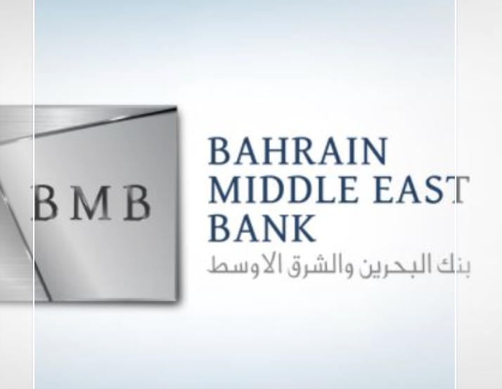
SUMMARY:
Executed the Maintenance activities of Bahrain Middle East Bank for its Domain controllers. Patching of BMB Domain controllers for both primary and secondary that is, Active directory and exchange and proxy which would be scheduled monthly. Post patch completed all the health checks of Domain controllers and troubleshooted all the failed ones. This needs to be performed one by one so that the Domain controller is up and functional.
