MOHG - Mandarin Oriental Group:
Maintenance activities/ Resolving AD issues/Installations
Roles & Responsibilities:
· Schedule patches through KACE tool for servers also manual installations for failure servers using remote desktop connection manager V2.7
· Resolving requests such as Account lockout issues, password reset, restore computers, user’s member group, VPN security groups.
· Installations of packages Visual studio, CrowdStrike, Edge, TrendMicro and MS office.
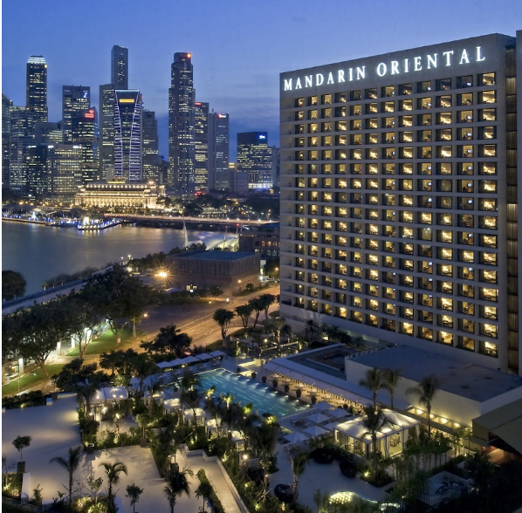
SUMMARY:
Involved in scheduled maintenance activities for Mandarin Oriental Group using the KACE tool for servers and troubleshooted failed servers through manual installations. Used remote desktop connection manager V2.7 during the process.
Resolved active directory requests such as Account Lockout issues, password resets, restore computers if deleted accidently, user’s member group and VPN security groups creations.
Handled installation requests from onsite team such as Visual Studio, CrowdStrike, Edge, TrendMicro, MS office and completed successfully including installations of their packages.
