SecureHealth
An AWS-Based Secure Patient Records Portal with Role-Based Access Control and Encrypted Data Storage

Applied Group Project — Implementation & Report
Option 1: Secure Web/Application System
Malav Mehta — N10004901
Robert Ruiz Villalta — N01346353
Zawad Hossain — N10030823
Cinderella Akash Gill — N10037055

MCSC-6002-RNA: Cybersecurity Architecture, Design, and Secure Software Development
Professor Timothy Wong
Humber Polytechnic
August 16, 2026

1. Introduction and Objectives
SecureHealth is a cloud-native patient records portal built to demonstrate that the security controls taught across this course — strong authentication, least-privilege access, encryption, integrity verification, validated input and continuous monitoring — can be combined into a single working system rather than studied in isolation. The system allows a small clinic to register, search, view and update patient records while protecting that data against the classes of attack most commonly seen in healthcare.
The project deliberately treats security as an architectural property rather than a feature added at the end. Every request passes through the same pipeline — establish identity from a validated token, authorise the action against a deny-by-default matrix, validate the input, perform the operation with encryption and integrity checks, and write an audit record — and no step in that pipeline can be bypassed by the client.

1.1 Objectives
- Design a layered AWS architecture with explicit trust boundaries between the client, application and data zones, and document the data flows that cross them.
- Implement six security controls: authentication with multi-factor authentication, role-based access control, input validation, encryption at rest and in transit, integrity verification, and logging with monitoring.
- Model realistic threats using STRIDE and demonstrate through automated testing that the implemented controls mitigate them.
- Deliver a working, deployed system rather than a prototype, and evidence its behaviour with reproducible tests and security scans.

1.2 Scope
The system is deployed on AWS in the ca-central-1 region and uses fictional patient data only. Integration with real clinical systems (EMR, HL7 or FHIR), payment processing and multi-region production deployment are outside the scope. An IoT equipment-monitoring capability was designed but deliberately excluded from implementation; it is documented as a future expansion in Section 8.

2. System Overview
SecureHealth is a serverless application. A Next.js single-page dashboard authenticates staff through Amazon Cognito and calls a REST API hosted on Amazon API Gateway, which invokes AWS Lambda functions that hold all business and security logic. Patient records are stored in Amazon DynamoDB, with clinical fields encrypted through AWS Key Management Service before they are written. A second DynamoDB table holds an append-only audit trail.

2.1 Roles
Role | Capability
Admin | Full record access, plus exclusive access to the audit log
Doctor | Full clinical record access: create, read, search and update
Receptionist | Demographic fields only; clinical notes and allergies are redacted server-side, and write operations are refused

2.2 Interface summary
Endpoint | Roles | Purpose
GET /health | All authenticated | Deployment and authentication check; returns the caller's role
POST /patients | Admin, Doctor | Create a patient record
GET /patients?q= | All | Search by name or health card
GET /patients/{id} | All | Retrieve one record
PUT /patients/{id} | Admin, Doctor | Update a record; re-encrypts and re-hashes
GET /audit | Admin only | Read the audit trail

Every endpoint sits behind the Cognito authorizer, so an unauthenticated request is rejected with HTTP 401 before any application code executes.

3. Architecture Design
The architecture is organised into three trust zones. The client zone is untrusted: it runs in the user's browser and nothing it sends is believed without verification. The application zone is semi-trusted: API Gateway and Lambda enforce authentication, authorisation and validation. The data zone is trusted and is reachable only from Lambda functions holding least-privilege IAM roles.
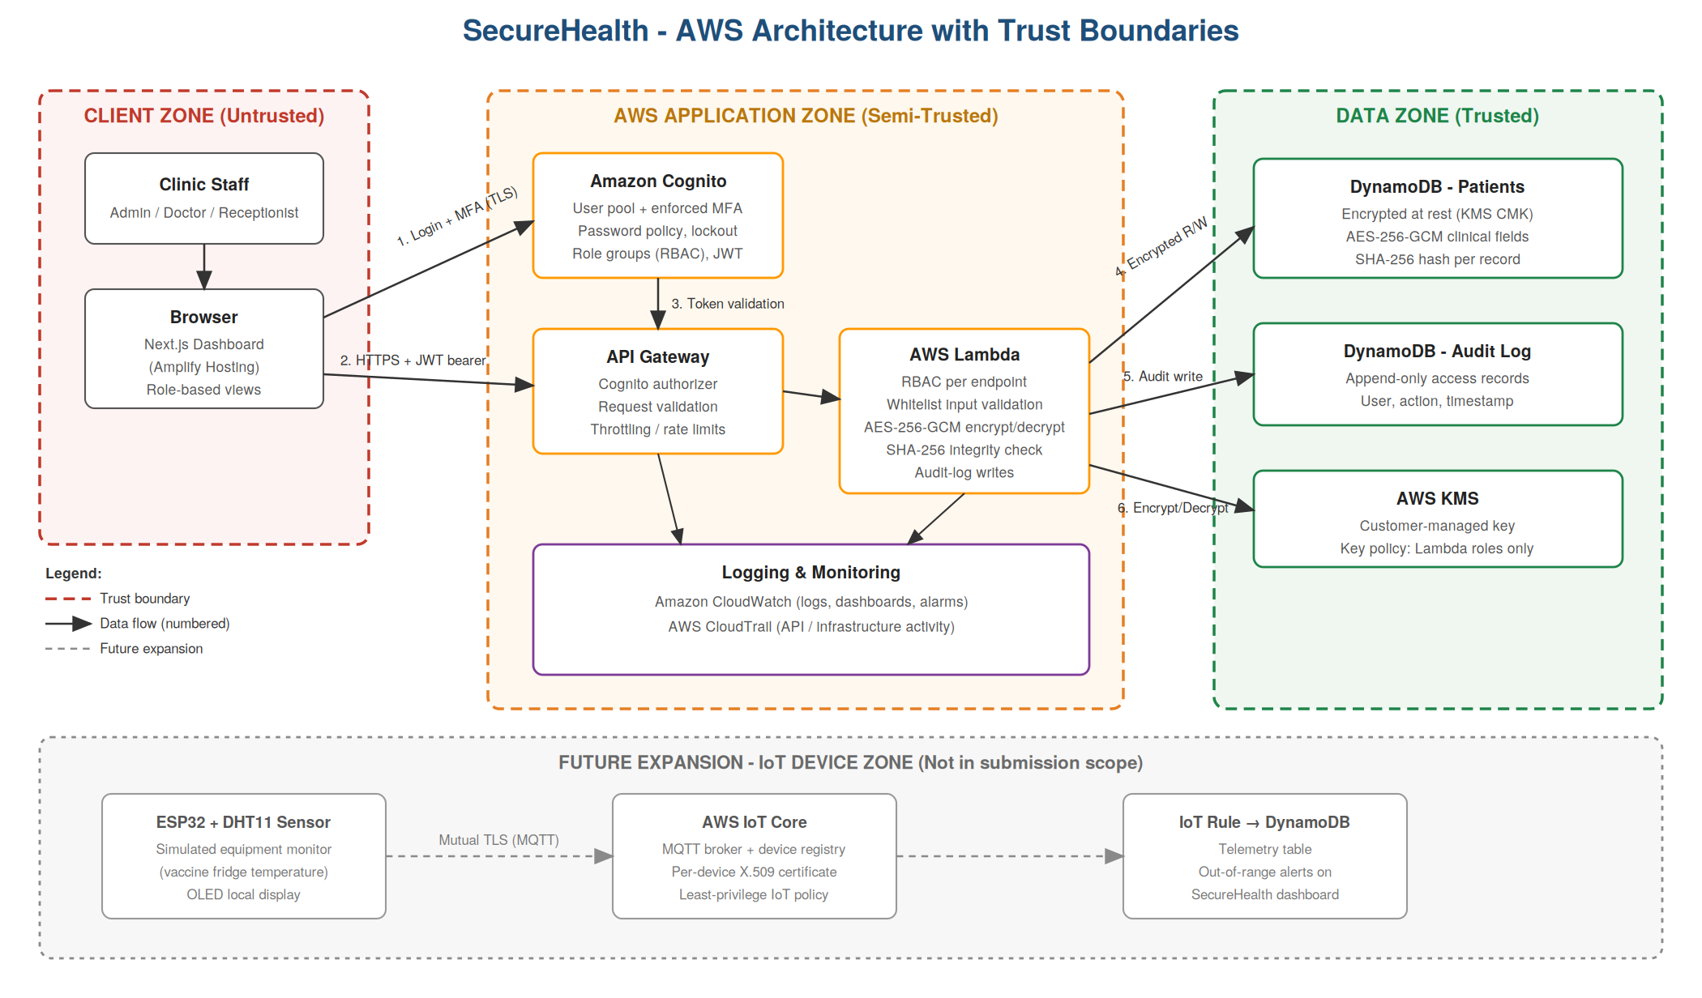
Figure 1: SecureHealth architecture showing trust boundaries, numbered data flows, and the planned IoT device zone marked as future expansion.

3.1 Trust boundaries and data flows
Three boundary crossings carry security significance, and each was analysed with STRIDE before implementation began:
- Browser to Cognito (flow 1): credentials and the one-time code cross the public internet. Protected by TLS 1.2+ and HSTS.
- Browser to API Gateway (flow 2): every request carries a bearer token that is validated at the gateway. This is where spoofing and privilege escalation are stopped.
- Lambda to DynamoDB and KMS (flows 4–7): the only path into the data zone. Access is granted through IAM roles scoped to a single table and a single key.

3.2 Design decisions

Serverless rather than server-based
A serverless design removes an entire class of vulnerability from scope: there are no operating systems to patch, no long-lived instances to compromise and no inbound network surface beyond the API Gateway endpoint. It also makes least privilege natural, because each function receives only the permissions its own task requires.

Encryption delegated to KMS
Clinical fields are encrypted with AES-256-GCM through AWS KMS rather than in application code with a locally held key. The plaintext key never enters the function's memory, key usage is recorded in CloudTrail, and the key policy restricts use to the Lambda execution roles. Each ciphertext is bound to its record through an encryption context containing the patient identifier, so a ciphertext copied onto a different record fails to decrypt. The trade-off is a 4 KB plaintext limit per call, which is why clinical notes are capped at 2,000 characters.
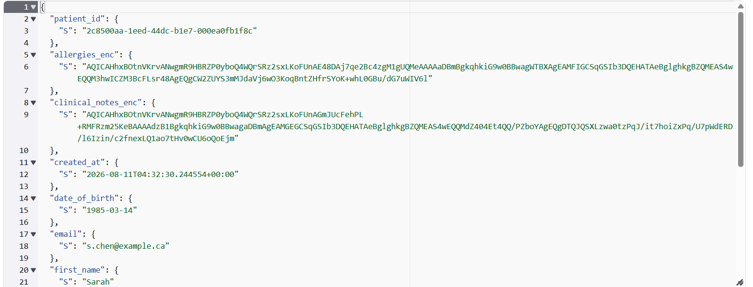
Figure 2: The stored representation of a patient record. Clinical fields appear only as KMS ciphertext alongside a SHA-256 integrity hash, while demographic fields remain in clear text so that search continues to work. No plaintext clinical note exists anywhere in the item.

Hashing plaintext rather than ciphertext
The integrity hash is computed over the decrypted, canonical record. This detects tampering in both directions: an attacker who edits a clear field such as a patient's name, and one who swaps an encrypted blob, both produce a mismatch. Hashing the stored ciphertext would have caught only the second case.

Infrastructure as code
The entire stack — Cognito, KMS, DynamoDB, API Gateway, Lambda, alarms and dashboard — is declared in a single AWS SAM template. Each team member deploys an identical copy into their own AWS account, and security configuration is reviewable in version control rather than clicked into a console.

4. Security Features Implemented
The project requirement is a minimum of four controls; SecureHealth implements all six.
Control | Implementation | Where in the code
Authentication & MFA | Amazon Cognito user pool; TOTP MFA enforced for every account; 12-character password policy requiring mixed case, digits and symbols; admin-only account provisioning (no self-registration); JWT identity tokens with one-hour expiry and refresh-token revocation | template.yaml (UserPool, UserPoolClient); frontend/lib/auth.ts
Role-Based Access Control | Three Cognito groups (Admin, Doctor, Receptionist) surfaced as the cognito:groups claim; a deny-by-default permission matrix maps each action to the roles permitted; any action absent from the matrix is refused | common.py (PERMISSIONS, is_allowed); enforced in every handler
Input validation | Server-side whitelist validation of every field before any data-store access; unknown fields rejected outright; strict patterns for names, health cards, dates, email and phone; 10 KB body cap and per-field length limits | common.py (parse_body, _check_field)
Encryption (AES-256-GCM) | Clinical fields encrypted through AWS KMS with a customer-managed key before storage; DynamoDB tables additionally encrypted at rest with the same CMK; per-record encryption context binds each ciphertext to its patient; TLS 1.2+ in transit | common.py (encrypt_field, decrypt_field, to_storage)
Hashing & integrity | SHA-256 hash computed over the canonical plaintext record, stored alongside it and re-verified on every read; mismatch returns HTTP 409, withholds the record and raises an alert | common.py (compute_integrity, from_storage)
Logging & monitoring | Append-only DynamoDB audit table recording user, role, action, outcome, record id and timestamp for every operation including denials; Admin-only audit API and UI; structured security events parsed by CloudWatch metric filters into six alarms and a nine-widget dashboard; CloudTrail records all AWS API and KMS activity | common.py (write_audit, emit_security_event); audit.py; template.yaml

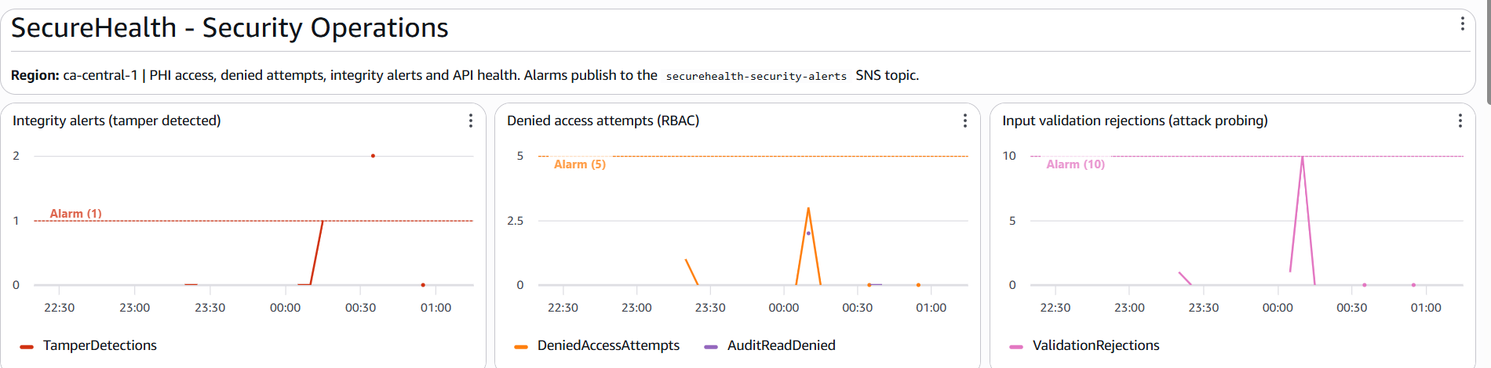
Figure 3: The security dashboard during testing. Integrity alerts, denied access attempts and validation rejections are each plotted against their alarm threshold, so an operator sees both the event and how close it sits to triggering.

4.1 The request pipeline
Every handler follows the same sequence, which makes each control testable in isolation and impossible to skip:
identity (validated claims only) -> authorise (deny-by-default)
-> validate (whitelist) -> act (encrypt / verify hash) -> audit
Identity is taken exclusively from the cognito:groups claim that API Gateway injects after validating the token. Request headers and bodies are never consulted for identity, so a client that supplies its own role field gains nothing.

4.2 Redaction as a server-side control
When a Receptionist retrieves a record, the clinical fields are replaced with [REDACTED] on the server before the response is serialised. The user interface also hides the create and audit functions for that role, but the interface is presentation, not enforcement: a Receptionist calling the API directly with a valid token still receives HTTP 403 on a write and redacted fields on a read. This distinction was verified explicitly in testing.
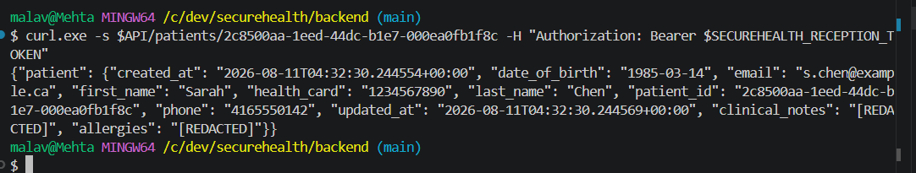
Figure 4: A Receptionist retrieving a patient record. Clinical notes and allergies are returned as [REDACTED] while demographic fields remain visible; redaction is applied on the server before the response is serialised.

4.3 Failing safely
When integrity verification fails, the API returns HTTP 409, withholds the record entirely and writes a TAMPER_DETECTED event. In list results a single failing record is skipped and counted rather than breaking the whole response, so one corrupted row cannot deny access to the rest of the register. Error responses carry a machine-readable code and a generic message; stack traces, table names and ARNs are confined to CloudWatch.

5. Threat Modelling and Risk Analysis
Threat modelling followed the STRIDE methodology (Shostack, 2014), applied to the data-flow diagram in Figure 1 before implementation began. Each trust-boundary crossing was examined for spoofing, tampering, repudiation, information disclosure, denial of service and elevation of privilege. The model was built in OWASP Threat Dragon; the resulting mitigations map directly onto the six controls in Section 4, and the test suite in Section 6 is organised around the same categories.
Category | Threat | Risk | Mitigation
Spoofing | Credential stuffing or brute-force against staff accounts | High | Enforced TOTP MFA, 12-character password policy, Cognito lockout and threat protection
Spoofing | Forged, expired or replayed JWT used to impersonate a clinician | High | API Gateway Cognito authorizer validates signature, issuer, audience and expiry before any code runs; one-hour token lifetime
Spoofing | Identity asserted through request headers or body | Medium | Identity read only from validated authorizer claims; headers and body never consulted
Spoofing | MFA fatigue or social engineering of a staff member | Low | Residual. Awareness guidance only; number-matching MFA noted as future work
Tampering | Injection payloads altering stored data | High | Whitelist validation before any data-store access; DynamoDB SDK parameterised access
Tampering | Record altered directly in the database by an insider or intruder | High | SHA-256 integrity hash verified on every read; 409 response, record withheld, alert raised
Tampering | Encrypted field copied from one patient to another | Medium | Per-record KMS encryption context causes decryption to fail on mismatch
Tampering | Audit log entries edited to conceal activity | Low | Residual. No update or delete path exists in the application; IAM grants write-only. S3 Object Lock export is future work
Repudiation | A user denies viewing or modifying a record | Medium | Append-only audit trail capturing identity, action, record and timestamp for every operation
Information Disclosure | PHI exposed from a stolen table, snapshot or backup | High | AES-256-GCM field encryption plus KMS encryption at rest; key policy limited to Lambda execution roles
Information Disclosure | Receptionist reads clinical notes or allergies | Medium | Server-side redaction by role applied on every response path, not in the UI
Information Disclosure | Internal detail leaked through error responses | Medium | Generic client errors with machine codes; stack traces confined to CloudWatch
Denial of Service | Request flooding or oversized payloads exhausting capacity | Medium | API Gateway throttling (20 req/s, burst 40); 10 KB body cap; serverless elasticity
Elevation of Privilege | Low-privilege role reaching write or audit endpoints | High | Deny-by-default RBAC enforced server-side in every handler; denials audited
Elevation of Privilege | Mass assignment of privileged fields such as is_admin | Medium | Unknown fields rejected; patient_id and integrity hash are server-generated only

5.1 Residual risk
Three threats are accepted rather than fully mitigated, and are recorded as open in the threat model. MFA fatigue remains possible because the system cannot prevent a user from approving a prompt they did not initiate. Audit log immutability rests on application design and IAM permissions rather than cryptographic enforcement. Rate limiting is applied per method rather than per identity, so a distributed attacker has more headroom than a single client. Each has a documented next step in Section 9. Recording residual risk openly is preferable to implying that a system of this size eliminates all threats.

6. Testing and Validation
Testing is organised in two layers. The unit layer stubs AWS entirely and exercises the security logic — validation, encryption, integrity, access control — in isolation, so it runs in under a second without credentials. The integration layer performs real HTTP requests against the deployed API using genuine Cognito tokens for all three roles, verifying that the same guarantees hold end to end. Every test carries a marker naming the STRIDE category it validates, and docs/TEST-MATRIX.md maps each test to its threat and control.
Suite | Tests | Scope | Result
test_validation.py | 45 | Injection, XSS, mass assignment, field rules, oversized input | All pass
test_encryption_integrity.py | 17 | No plaintext at rest, context binding, tamper detection, hash forgery | All pass
test_access_control.py | 33 | Identity spoofing, 15-case RBAC matrix, redaction, audit completeness | All pass
test_handlers.py | 20 | Full request pipeline including the 409 tamper flow | All pass
test_integration.py | 30 | The same checks against the deployed API with real Cognito tokens | All pass

All 145 tests pass. The unit layer completes in under a second without AWS credentials; the integration layer runs against the deployed stack using tokens for all three roles.

6.1 Attack scenarios
The following scenarios were executed against the deployed system and captured as evidence.
Attack scenario | Expected | Observed
Unauthenticated request to any endpoint | 401 Unauthorized | 401 from the API Gateway authorizer before any Lambda executes
Forged or alg:none JWT | 401 / 403 | Rejected by the Cognito authorizer
SQL-style injection in a name field | 400 with no reflection | 400 validation_failed; payload not echoed in the response
Stored XSS payload in a name field | 400 | 400 validation_failed
Mass assignment of is_admin | 400 | 400 with 'Unknown field(s): is_admin'
Receptionist POSTs a new patient record | 403 | 403 forbidden; event logged as DENIED_ROLE
Receptionist reads a clinical record | Clinical fields redacted | clinical_notes and allergies returned as [REDACTED]; demographics visible
Doctor requests the audit log | 403 | 403 forbidden; the attempt itself is audited
Record altered directly in DynamoDB, then read | Integrity failure | 409 integrity_failure; record withheld from search with a banner; TAMPER_DETECTED written to the audit log
Original value restored, record read again | 200 | Verification passes; record served normally

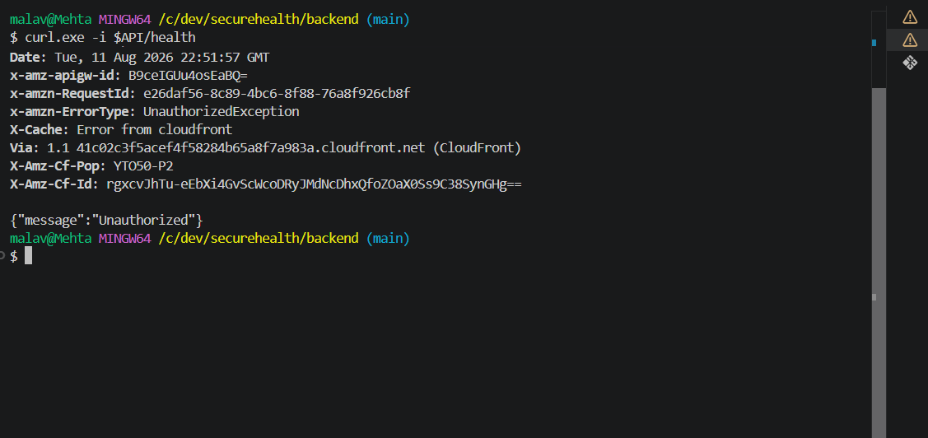
Figure 5: A request carrying no token is rejected with HTTP 401 by the API Gateway Cognito authorizer, before any application code executes.
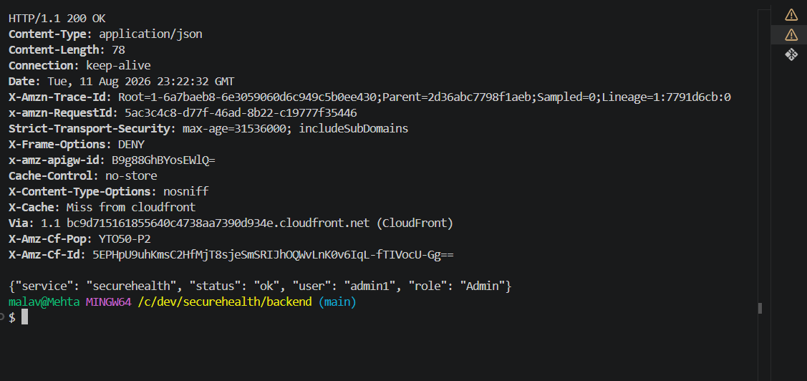
Figure 6: The same endpoint with a valid token after multi-factor sign-in. The role is resolved from the validated Cognito group claim, and the response carries the full set of security headers.
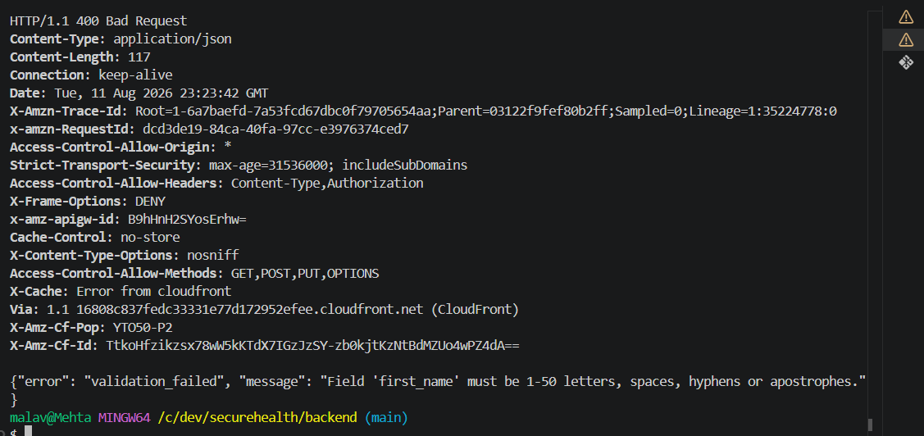
Figure 7: An injection payload submitted in a name field is rejected with HTTP 400. The error names the field but never echoes the submitted value, so the response itself cannot become a reflection vector.
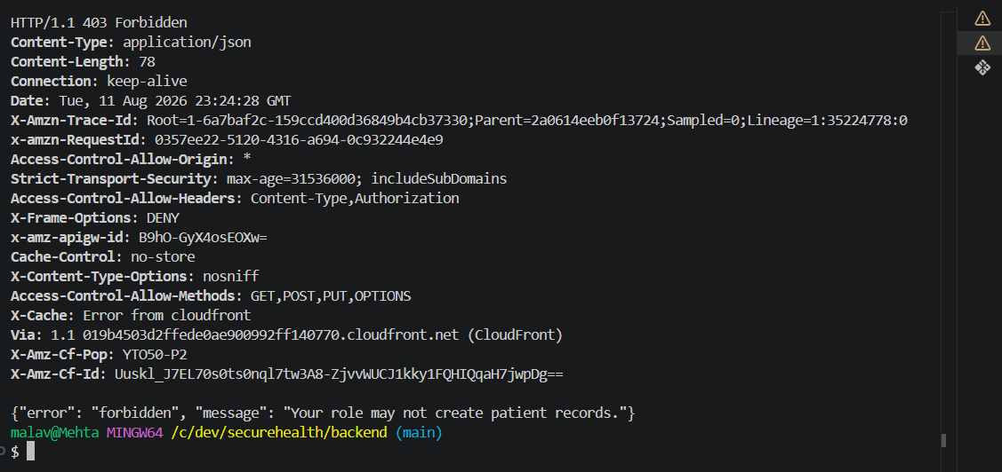
Figure 8: A Receptionist calling the create endpoint directly receives HTTP 403. The user interface hides this action for that role, but the refusal comes from the server.
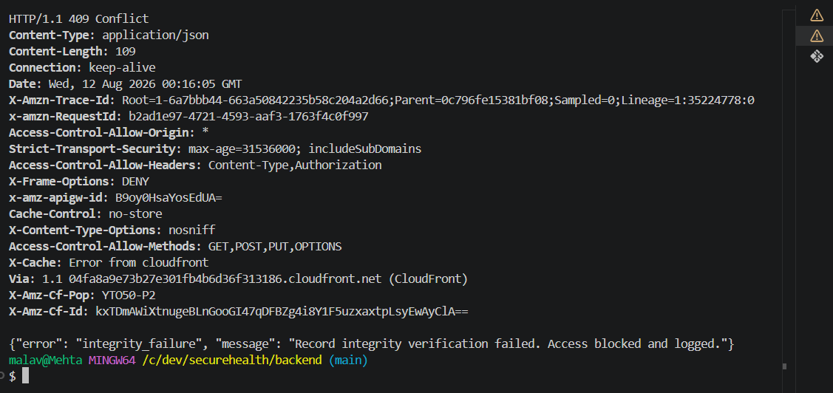
Figure 9: A patient record altered directly in DynamoDB fails SHA-256 verification on the next read. The API returns HTTP 409, withholds the record and writes a TAMPER_DETECTED event.
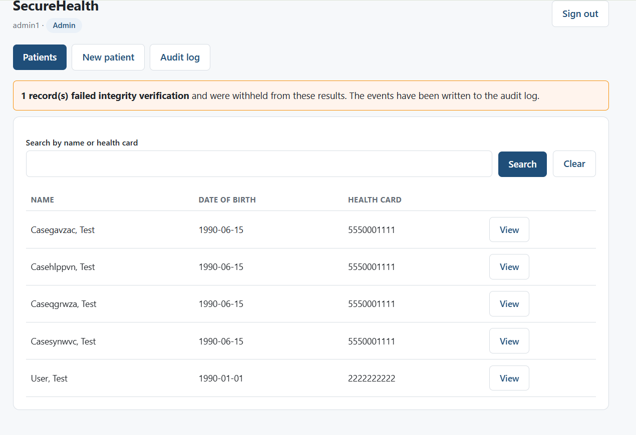
Figure 10: The dashboard after the same tampering. The affected record is withheld from search results and the user is told why, while the remaining records continue to be served.
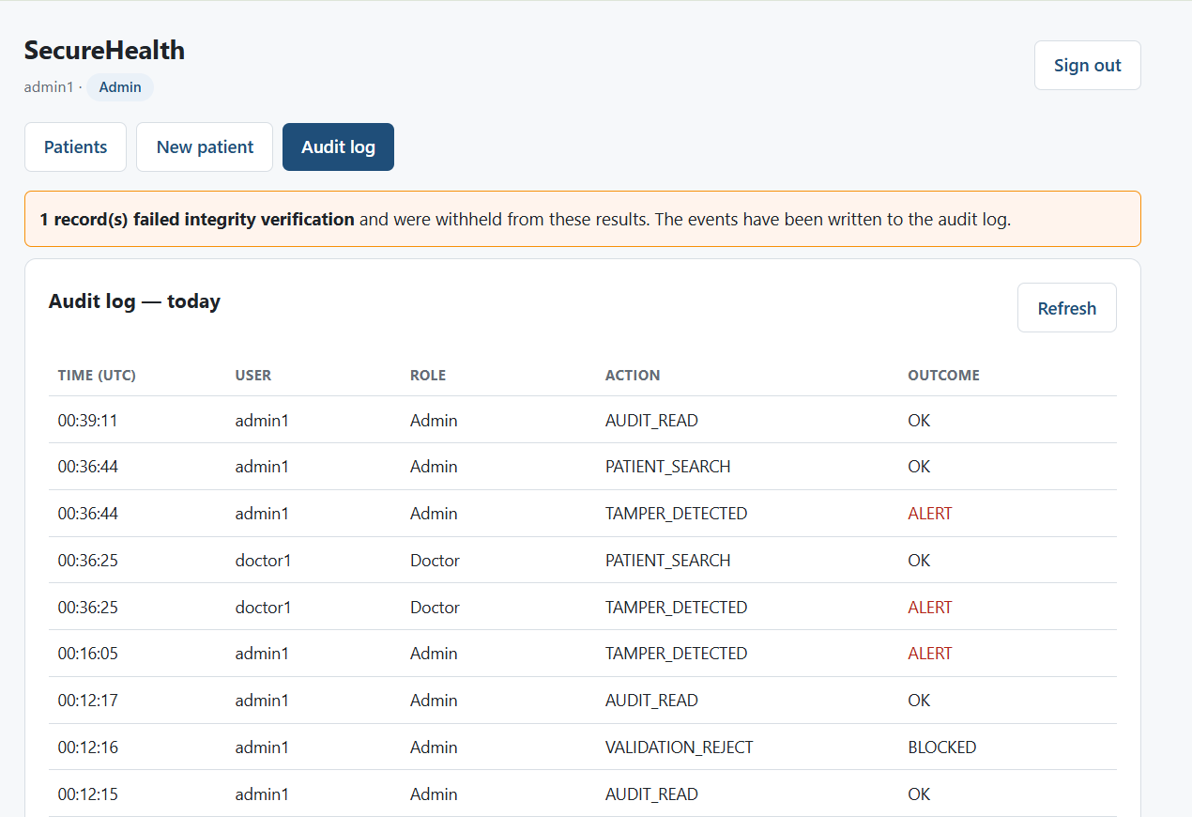
Figure 11: The Admin-only audit view, showing successful access alongside integrity alerts and blocked validation attempts. Denials are recorded as deliberately as successes.

6.2 Static analysis
Bandit was run across all handler code. It reported no issues at any severity across 428 lines. This reflects specific design choices rather than chance: no secrets appear in source, SHA-256 is used instead of MD5 or SHA-1, JSON parsing is used instead of pickle or eval, and there are no subprocess calls or string-built queries.

6.3 Dynamic analysis
An OWASP ZAP automated scan was run against the running frontend. No high-risk findings were reported. Four findings were remediated and re-verified; the remainder were accepted or dismissed with reasons.
Finding | Risk | Disposition | Justification
Content Security Policy header not set | Medium | Remediated | CSP added in next.config.js
Missing anti-clickjacking header | Medium | Remediated | X-Frame-Options: DENY added
Server leaks framework via X-Powered-By | Low | Remediated | poweredByHeader disabled
X-Content-Type-Options missing | Low | Remediated | nosniff added
CSP allows unsafe-inline and unsafe-eval | Medium | Accepted | Required by the Next.js development server for hot module replacement; a production build with nonce-based CSP removes both
Suspicious comments in a bundled chunk | Info | False positive | Matched inside a generated _next development bundle, not project source
Modern web application | Info | No action | Informational note that the target is a single-page application

It is worth noting where these findings sit. All of them concern the frontend delivery layer. The API — where personal health information actually resides — already returns the full set of security headers, verified on every integration run, and ZAP was unable to progress past the login page without credentials.
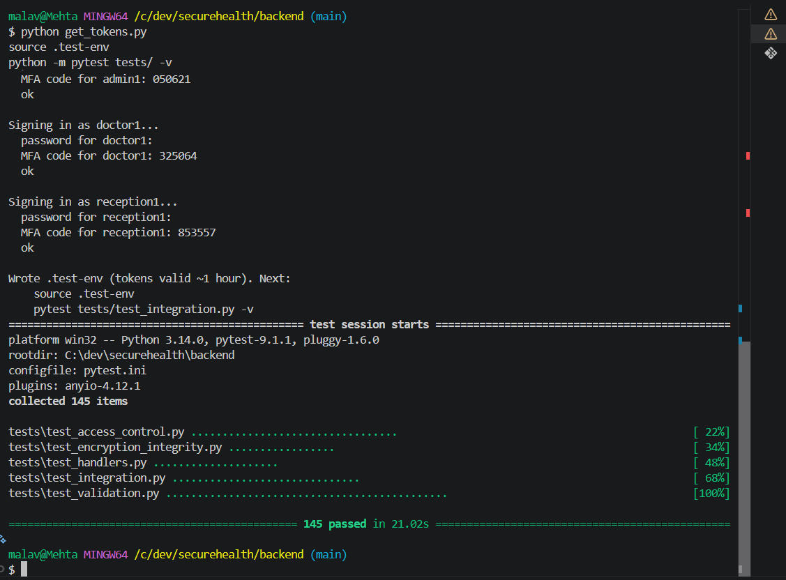
Figure 12: The full test suite: 145 tests collected across five modules, all passing. Integration tests execute against the deployed stack using real tokens for all three roles.

6.4 A defect found by testing
The automated suite identified a real inconsistency that manual testing had missed: the health endpoint, written during the first phase before response handling was centralised, omitted the X-Frame-Options header that the shared module applies everywhere else. Manual verification with curl had not caught it because the header was present on every endpoint that was checked by hand. The header was added and the test now passes. This is a small defect, but it illustrates precisely why automated tests were written rather than relying on manual verification.

7. Challenges and Lessons Learned

7.1 Least privilege enforcing itself against us
The first authenticated request to the deployed system returned HTTP 502. CloudWatch showed the cause: the Lambda execution role held permission to write to the audit table but not to use the KMS key protecting it, so DynamoDB refused the write. The encryption control was working exactly as designed — it simply had not been told that our own code was authorised. The lesson is that with envelope encryption, data permissions and key permissions are separate grants, and forgetting the second produces a failure that looks like a bug rather than a security control.

7.2 Account-level prerequisites invisible until first deployment
Stack creation failed repeatedly with an error stating that a CloudWatch Logs role must be set in account settings. API Gateway can only write access logs when an account-wide IAM role is registered, which is a one-time setting per account and region that does not exist in a fresh account. Because every team member deploys into their own account, the fix was documented as a reproducible command sequence in the repository README rather than clicked into a console once. Infrastructure as code covers the resources it declares, not the account-level state those resources assume.

7.3 Configuration drift from a bulk file copy
A CORS configuration fix, applied by hand to the local template, was silently reverted when a later archive was unpacked over the working directory. The frontend stopped receiving data and the cause was not obvious, because the code was correct and the deployment had succeeded. The lesson was procedural rather than technical: every infrastructure change belongs in the repository as a commit, and a change that exists only in a working copy will eventually be overwritten by one that does.

7.4 Cloud services with hidden state
Two deployments failed because AWS had already auto-created resources our template wanted to own — Lambda log groups appear automatically on first invocation. Rather than fight the collision, the template was restructured to reference the existing groups instead of declaring them, at the cost of an explicit retention policy. Choosing to work with a platform's defaults, and documenting what was given up, was faster than forcing the platform to match our template.

7.5 Working across four separate AWS accounts
Each member deploys their own stack, which removed the risk of one person's experiment breaking another's environment and forced the setup process to be genuinely reproducible. The cost is that a fix applied in one account is not a fix anywhere else until it is committed and redeployed, which made disciplined version control a practical necessity rather than good practice.

7.6 Credential hygiene under time pressure
Early work was carried out using root account credentials because that was the fastest path to a working deployment. Migrating to an IAM user with its own access key was a five-minute task that had been deferred for hours. Working under deadline pressure is exactly when security shortcuts feel most justified and are least defensible; recognising that tendency in ourselves was among the more useful outcomes of the project.

8. Future Expansion: IoT Equipment Monitoring
A hardware extension was designed but deliberately excluded from implementation so that effort could be concentrated on the security controls being assessed. It is documented here as a security-focused roadmap.
Connected devices are increasingly common in clinical settings and expand the attack surface when left unmanaged (Li et al., 2024; Kelly et al., 2023). Medical supplies such as vaccines and laboratory samples require controlled storage conditions that are frequently monitored manually or not at all, so a failing refrigeration unit can spoil inventory before anyone notices.

8.1 Proposed design
- An ESP32 microcontroller with a DHT11 sensor monitors the temperature of a simulated medical storage unit, displaying live readings on an OLED screen.
- The device publishes telemetry over MQTT to AWS IoT Core using mutual TLS with a per-device X.509 certificate and a least-privilege IoT policy.
- An IoT rule routes readings into DynamoDB, and the SecureHealth dashboard surfaces current values and out-of-range alerts.

8.2 Security implications
The extension introduces a fourth trust zone. A physical device is inherently less trustworthy than a browser session: it can be stolen, its firmware can be extracted and its credentials can be cloned. The design therefore treats the device as untrusted until it authenticates, using per-device certificates so that a compromised unit can be revoked individually rather than requiring a shared secret to be rotated across a fleet. Two new STRIDE threats arise directly: spoofing, where an attacker impersonates a device to inject false readings, and tampering, where genuine telemetry is altered in transit. Mutual TLS addresses both.

9. Conclusion
SecureHealth demonstrates a working secure system rather than a design exercise. Six security controls are implemented and deployed on AWS, a STRIDE threat model drove the design before code was written, and 145 automated tests — all passing — verify that the resulting controls behave as intended. Static and dynamic analysis found no high-risk issues, and the four findings that were actionable were fixed and re-verified.
The most instructive result was not that the controls worked, but how they behaved when things went wrong. Least-privilege IAM blocked our own code until it was correctly authorised. The integrity check refused to serve a record that had been altered in the database, and resumed serving it when the original value was restored. Automated tests caught a header inconsistency that manual checking had missed. Each of these was, at the time, an obstacle; collectively they are evidence that the controls are real rather than decorative.
Several limitations remain and are documented rather than concealed: patient search uses a table scan that a production system would replace with a secondary index, CORS is permissive for demonstration purposes, audit immutability rests on application design rather than cryptographic enforcement, and rate limiting is not per-identity. Knowing precisely where a system's guarantees end is itself a security property, and stating those boundaries clearly is more useful than claiming completeness.

10. Team Contributions
All members contributed to design, implementation, testing and documentation. The table indicates each member's primary area of ownership.
Team member | Contribution
Malav Mehta | AWS architecture and trust-boundary design; backend security implementation (Cognito authentication and RBAC, KMS encryption, SHA-256 integrity, audit logging); STRIDE threat model; infrastructure as code; demo lead
Robert Ruiz Villalta | Next.js frontend: authentication and MFA flow, role-aware dashboard, patient records interface, integrity-alert handling; architecture and data-flow diagrams; report contributions
Zawad Hossain | Logging and monitoring: audit table design, Admin audit viewer, CloudWatch metric filters, alarms and dashboard; IoT future-expansion design
Cinderella Akash Gill | Testing and validation lead: 145-test pytest suite, attack scenarios, Bandit and OWASP ZAP scans, test-to-threat matrix, testing documentation; report compilation

11. References
Amazon Web Services. (n.d.). Security pillar — AWS Well-Architected Framework. https://docs.aws.amazon.com/wellarchitected/latest/security-pillar/welcome.html
Canadian Centre for Cyber Security. (2026). Ransomware threat outlook 2025–2027. Government of Canada. https://www.cyber.gc.ca/en/guidance/ransomware-threat-outlook-2025-2027
Canadian Internet Registration Authority. (2025). 2025 CIRA cybersecurity survey. https://www.cira.ca/en/resources/documents/cybersecurity/2025-cybersecurity-survey/
Dolezel, D., Kruse, C., & Shanmugam, R. (2026). Cybersecurity in healthcare: A systematic review and narrative analysis. Applied Clinical Informatics, 17(2), 315–328. https://doi.org/10.1055/a-2865-4206
Elendu, C., Omeludike, E. K., Oloyede, P. O., Obidigbo, B. T., & Omeludike, J. C. (2024). Legal implications for clinicians in cybersecurity incidents: A review. Medicine, 103(39), e39887. https://doi.org/10.1097/MD.0000000000039887
IBM. (2025). Cost of a data breach report 2025. https://www.ibm.com/reports/data-breach
Kelly, B. S., Quinn, C., Belton, N., Lawlor, A., Killeen, R. P., & Burrell, J. (2023). Cybersecurity considerations for radiology departments involved with artificial intelligence. European Radiology, 33(12), 8833–8841. https://doi.org/10.1007/s00330-023-09860-1
Li, C., Wang, J., Wang, S., & Zhang, Y. (2024). A review of IoT applications in healthcare. Neurocomputing, 565, 127017. https://doi.org/10.1016/j.neucom.2023.127017
OWASP Foundation. (2021). OWASP Top 10:2021 — The ten most critical web application security risks. https://owasp.org/Top10/
Seh, A. H., Zarour, M., Alenezi, M., Sarkar, A. K., Agrawal, A., Kumar, R., & Ahmad Khan, R. (2020). Healthcare data breaches: Insights and implications. Healthcare, 8(2), 133. https://doi.org/10.3390/healthcare8020133
Shostack, A. (2014). Threat modeling: Designing for security. John Wiley & Sons.
Webster, P. (2020). Canadian digital health data breaches: Time for reform. The Lancet Digital Health, 2(3), e113–e114. https://doi.org/10.1016/S2589-7500(20)30030-3

Appendix A: Evidence Index
Screenshots and generated reports supporting this document are held in docs/evidence/ in the project repository.
Evidence | Demonstrates
401 response without a token | Authentication enforced at the gateway before application code runs
200 response with role claim | Successful MFA login and role extraction
DynamoDB item view | Clinical fields stored as ciphertext with an integrity hash; no plaintext at rest
403 on Receptionist create | Deny-by-default RBAC enforced server-side
[REDACTED] fields for Receptionist | Field-level redaction by role
409 after console tampering | SHA-256 integrity verification detecting an out-of-band change
Dashboard integrity banner | One record withheld from search results and reported to the user
Audit log API response | Complete trail including denials and validation rejections
pytest run output | All 145 tests passing, mapped to STRIDE categories
Bandit report | No issues across 428 lines of handler code
ZAP reports (before and after) | Four findings remediated and re-verified
CloudWatch alarms overview | Six security alarms deployed and in a healthy state

