**Lesson 02 Demo 01**

**Create and Navigate Between Components in Angular**

**Objective:** To create and navigate between components in Angular

**Tools required:** Visual Studio Code

**Prerequisites:** JavaScript

Steps to be followed:

1. Generate new components
2. Create a navigation bar
3. Style the navigation bar
4. Add routing specifications

**Step 1: Generate new components**

* 1. Open the previously created **estore** application in Visual Studio Code and run the following commands to run the project:

**ng serve -o**

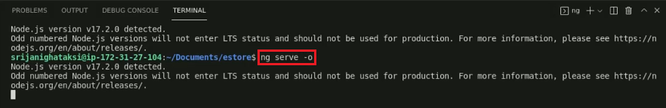

* 1. Generate some components by using the following commands:

**ng g c home**

**ng g c products**

**ng g c news**

* 1. Check the newly created components in the Angular workspace

**Step 2: Create a navigation bar**

* 1. Open the app.component.html file and delete all the template code

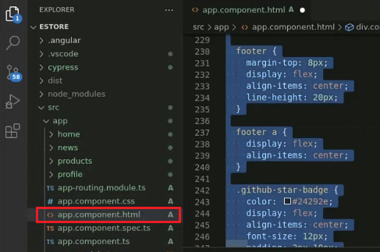

* 1. Add the router tag and an unordered list

* 1. Check the output by running the following command:

**ng serve -o**

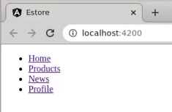

**Step 3: Style the navigation bar**

* 1. Open the **app.component.css** and add elements according to the HTML file

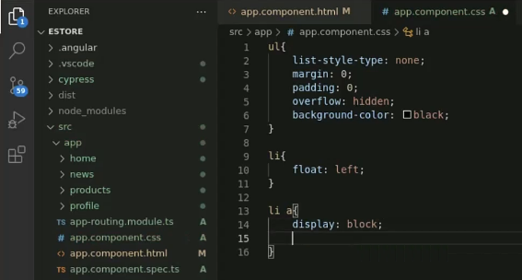

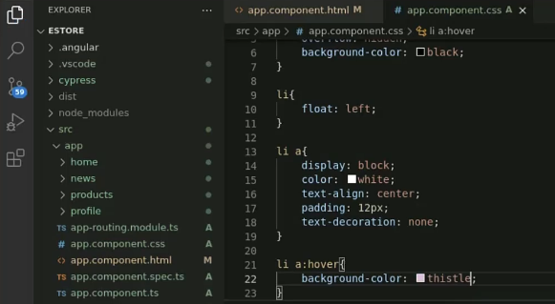

* 1. Save the **app.component.css** file and open the html file in a browser

**Step 4: Add routing specifications**

* 1. Open the **app-routing.module.ts** file

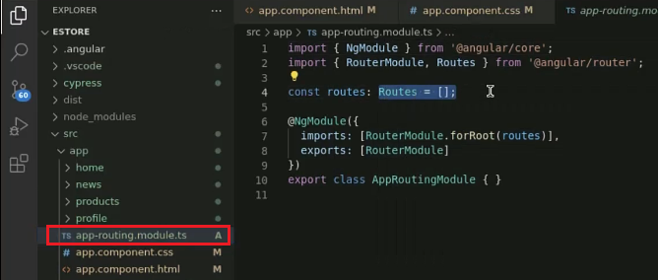

* 1. Add routes objects

* 1. Add router links in the **app.component.html** file

* 1. Save the file and go to the browser to check each component’s routing

