**Lesson 01 Demo 01**

**Creating an Angular Project and Understanding the Project Structure**

**Objective:** To create an Angular project and understand the project structure

**Tools required:** Visual Studio Code

**Prerequisites:** JavaScript

Steps to be followed:

1. Validate the installation of Angular CLI
2. Create a new Angular project
3. Run the project
4. Understand the project structure

**Step 1:** **Validate the installation of Angular CLI**

* 1. Open the terminal and run the following command to validate if Angular CLI has been installed:

**ng help**

* 1. If it is not, run the following command to install it:

**sudo npm install -g @angular/cli**

* 1. Validate if it is correctly installed using the following command:

**ng help**

**Step 2: Create a new Angular project**

* 1. Run the following commands to create a new Angular project and answer **y** for all the successive queries:

**cd Documents**

**ng new estore**

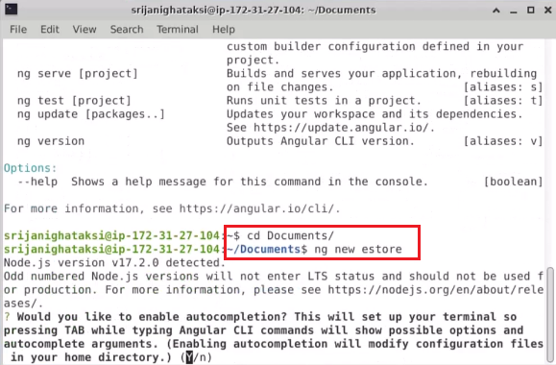

* 1. Open the project in Visual Studio Code

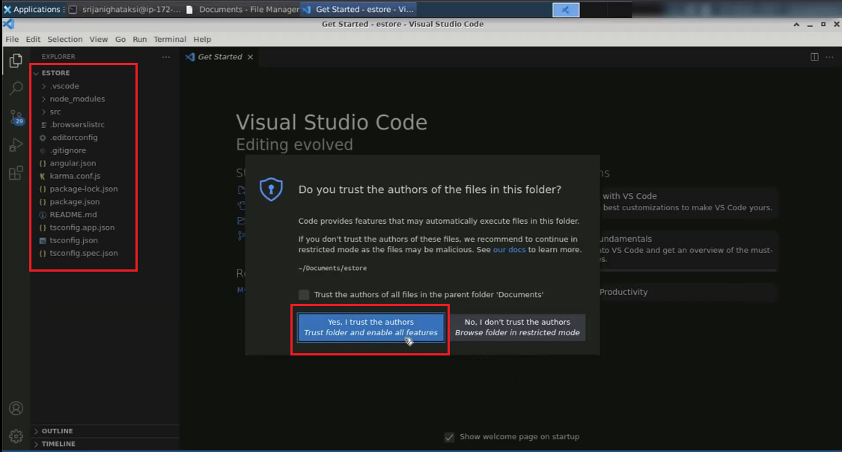

**Step 3: Run the project**

* 1. Run the following commands to run the project:

**ng serve -o**

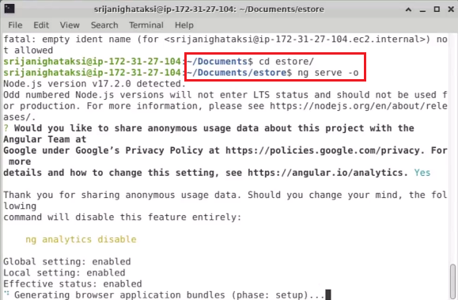

* 1. Open the browser

**Step 4: Understand the complete project structure**

* 1. Understand the complete project structure by opening all the directories and packages

