**Lesson 02 Demo 02**

**Component Interaction to Pass Data**

**Objective:** To make two components interact with each other to pass the data

**Tools required:** Visual Studio Code

**Prerequisites:** JavaScript

Steps to be followed:

1. Use @Input decorator for interaction between components

**Step 1: Use @Input decorator for interaction between components**

* 1. Open the previously created **estore** application in Visual Studio Code and run the following commands to run the project:

**ng serve -o**

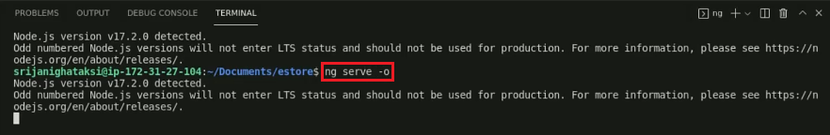

* 1. Open **home.component.ts** and add the decorator code in it

* 1. Open **app.component.ts** and add **appName**

* 1. Open **app.component.html** and add app-home tags

* 1. Change the text for **home.component.html** file

* 1. Rerun the project

