**Lesson 01 Demo 02**

**Using Angular CLI Commands**

**Objective:** To use Angular CLI commands

**Tools required:** Visual Studio Code

**Prerequisites:** JavaScript

Steps to be followed:

1. Check the version
2. Use the ng help command
3. Use the ng build command
4. Use the ng test command
5. Use the ng g c command
6. Use the ng g service command
7. Use the ng lint command

**Step 1: Check the version**

* 1. Open the terminal and run the following command to check the version of Angular CLI:

**ng version**

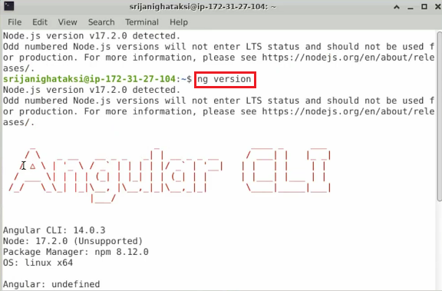

* 1. Run the same command in the Visual Studio Code terminal:

**ng version**

**Step 2: Use the ng help command**

* 1. Run the following command to see the list of available commands:

**ng help**

**Step 3: Use the ng build command**

* 1. Run the following command to create a distribution directory:

**ng build**

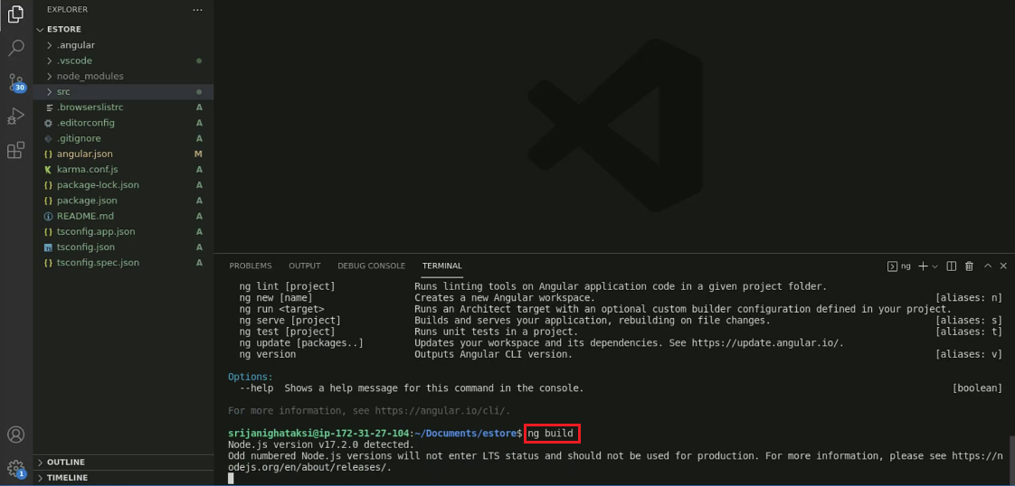

* 1. Check for the distribution directory in the project explorer

**Step 4: Use the ng test command**

* 1. Run the following command to do unit testing:

**ng test**

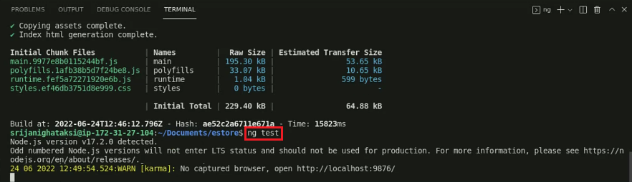

* 1. Once the browser pops up, check if the test ran successfully or not

**Step 5: Use the ng g c command**

* 1. Run the following command to generate **the profile** component:

**ng g c profile**

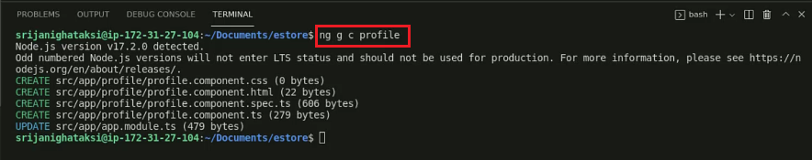

* 1. Now, check if the **profile** component is created or not

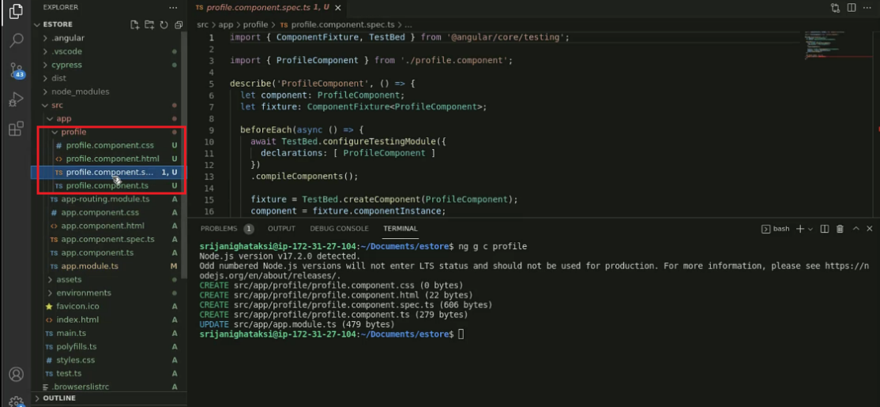

**Step 6: Use the ng g service command**

* 1. Run the following command to generate service:

**ng g service DataProvider**

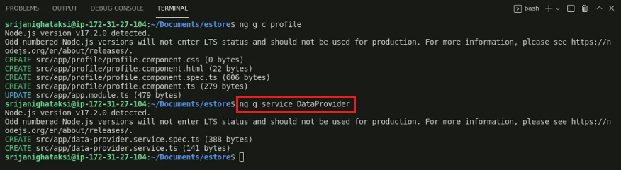

* 1. Now, check if the **DataProvider** service is created or not

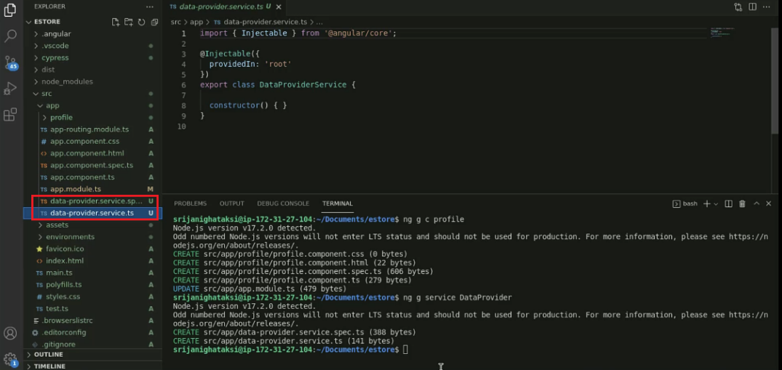

**Step 7: Use the ng lint command**

* 1. Run the following command to run linting tools on the project:

**ng lint**

* 1. If the package was not initially available, it is now installed. Run the same command to run the linting tools:

**ng lint**

* 1. Check if the problem pointed out is accurate or not. It is mentioned in the outcome, the **Lifecycle methods should not be empty.** Open the **profile.component.ts** file, and you can see that the constructor is empty. Hence, we can say that the command worked successfully.

