**Lesson 02 Demo 03**

**Using ngFor and ngIf**

**Objective:** To use ngFor and ngIf in Angular

**Tools required:** Visual Studio Code

**Prerequisites:** JavaScript

Steps to be followed:

1. Create a structure of the Product objects
2. Create a list of products in the service
3. Use ngFor to display products
4. Use ngIf in the div tag

**Step 1: Create a structure of the Product objects**

* 1. Create a new folder by the name of **modal** in the **src** folder

* 1. Create a file **product.ts** in the **modal** folder and create an **export** class in it

* 1. Generate a **products** service by using the following command:

**ng g s products**

**Step 2: Create a list of products in the service**

* 1. Create an array of **Product** objects

* 1. Inject **products** service in **products.component.ts**

* 1. Rerun the project

**Step 3: Use ngFor to display products**

* 1. Use **ngFor** in the **products.component.html** to display products on the products page

* 1. Rerun the project

**Step 4: Use ngIf in the div tag**

* 1. Create a variable **showProducts** in **products.component.ts** with a **true** value

* 1. Create a div tag in **products.component.html** with **ngIf**

* 1. Rerun the project

* 1. Change the value of the **showProducts** variable in **products.component.ts** to **false**

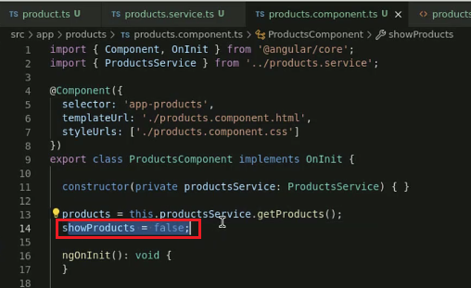

* 1. Rerun the project

