**Lesson 02 Demo 04**

**Creating Reactive Form with FormControl**

**Objective:** To create a reactive form with FormControl in Angular

**Tools required:** Visual Studio Code

**Prerequisites:** JavaScript

Steps to be followed:

1. Create a reactive form in the HTML file

**Step 1: Create a reactive form in the HTML file**

* 1. Add **ReactiveFormsModule** in the **app.module.ts** file

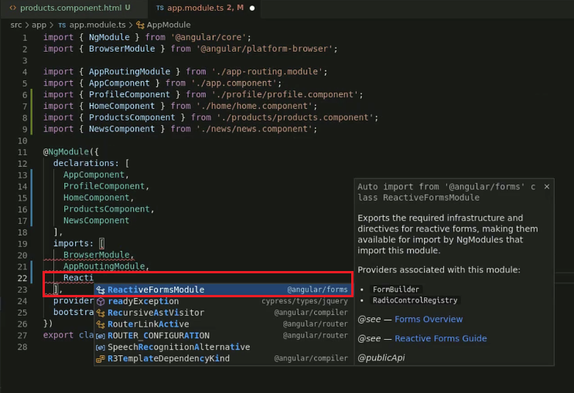

* 1. Create a new **FormGroup** in the **products.component.ts** file

* 1. Add **productForm** in a div tag in the **products.component.html** file

* 1. Run the project by using the following command:

**ng serve -o**

