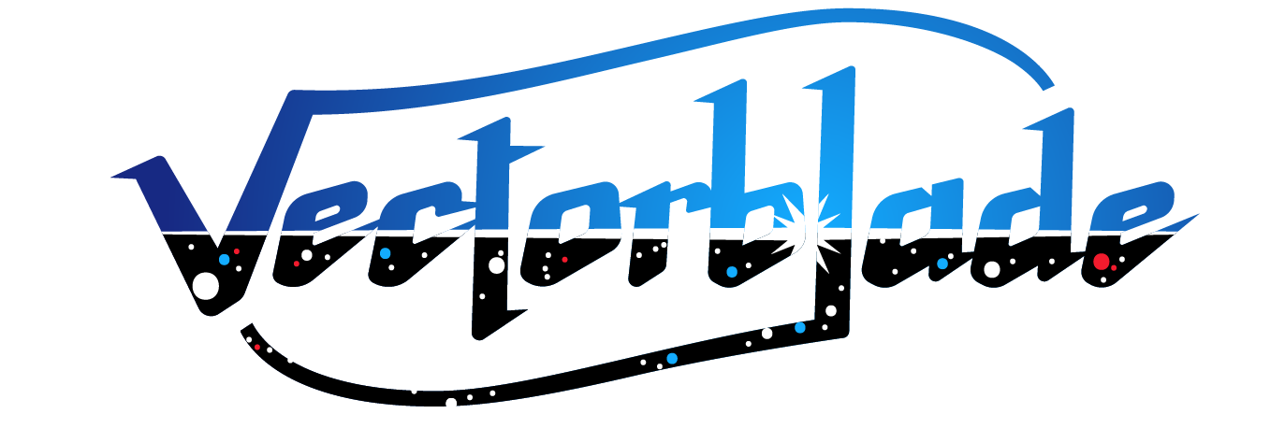

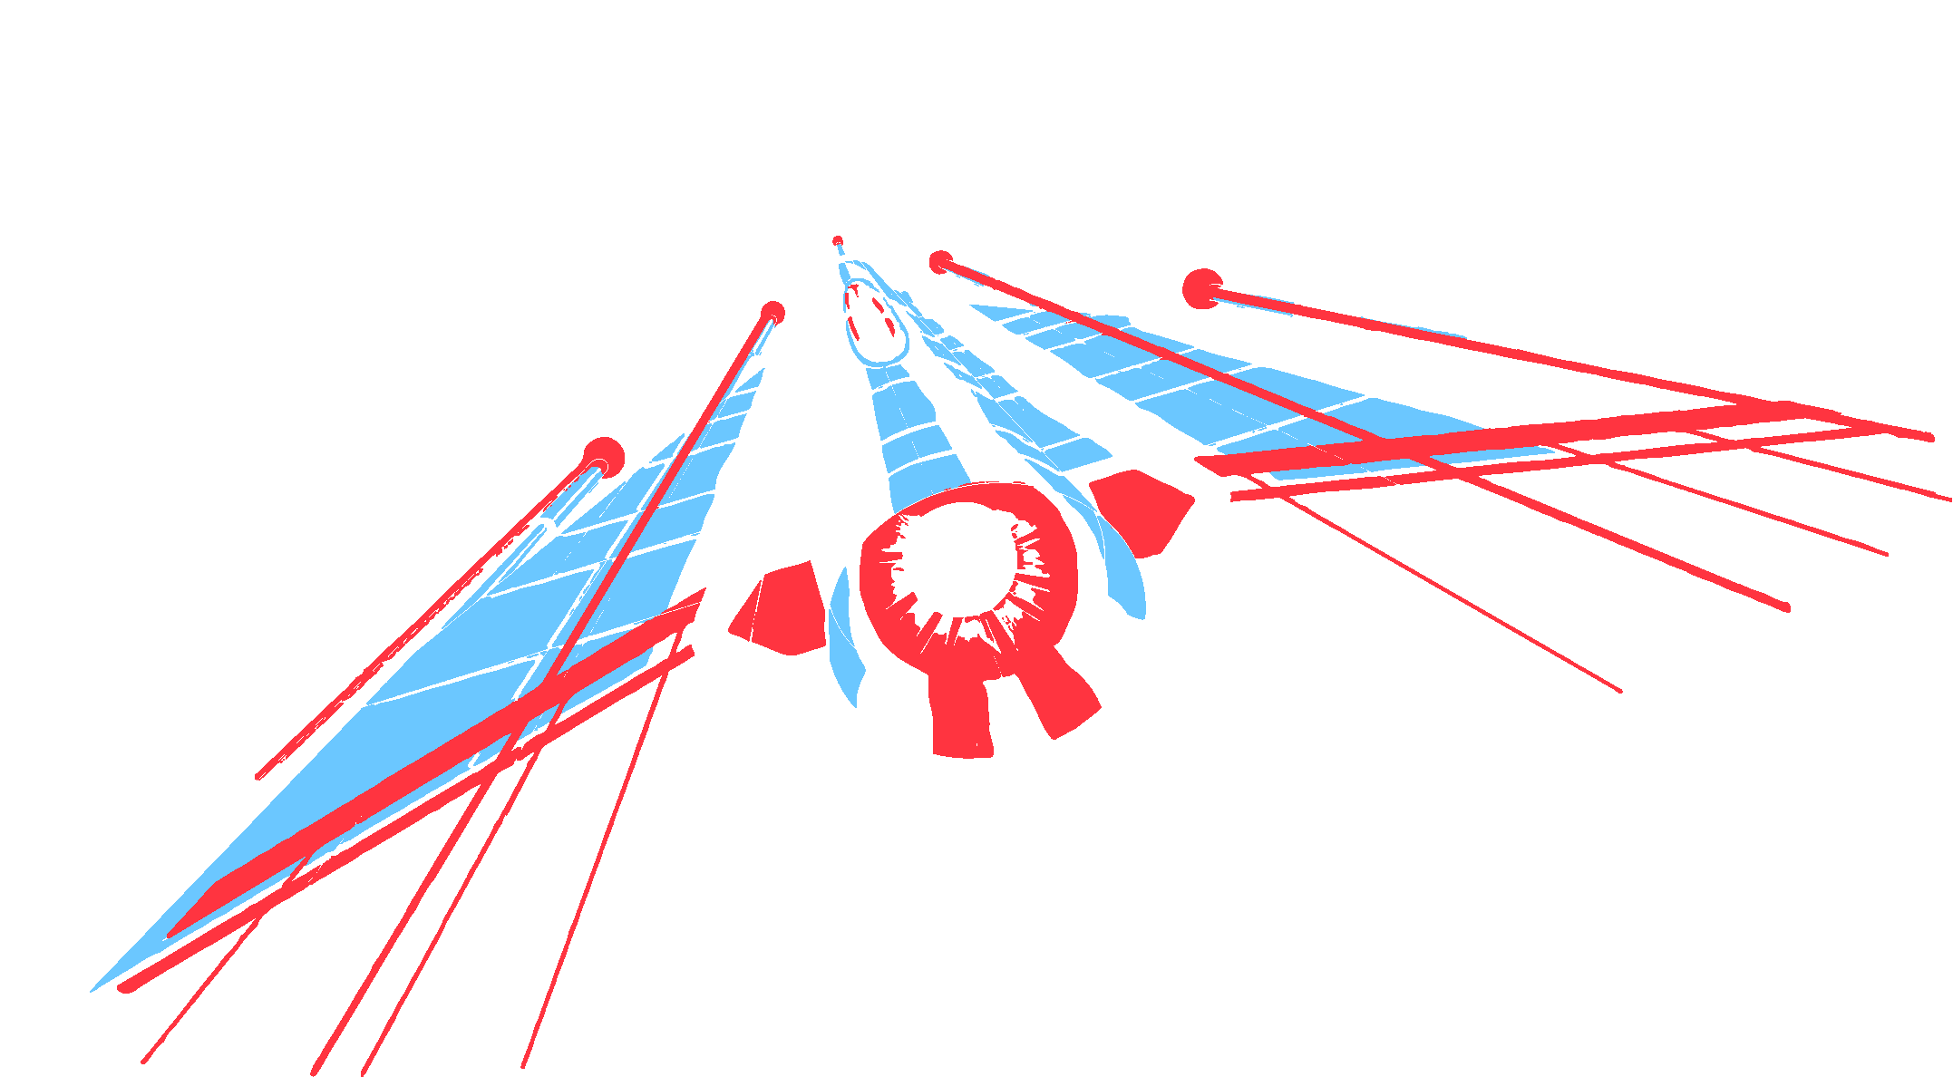
A Vectrex game by Malban



Thank you!
I would like to thank following people for all kinds of support they have provided during the development of Vectorblade:

My girlfriend for being patient enough to tolerate the ridiculous amount of time I have spent with Vectrex “stuff” over the last years.
Thomas Sontowski for the help and insights he provided, for his fantastic VecFever and also for his ever present willingness to accommodate to (sometimes stupid seeming) feature requests.
VTK for the music and sound effects, his testing and the overall enthusiasm to help out in every possible way during development time.
Jacek Selanski for all his art, which is present within Vectorblade.
VectrexMad! For his patience and support during the “overlay madness”.
Chris Parsons for his support and accepting me as a guest during my visit in Walsall.
Helmut Müller, Peer Johannsen, Jerome Vincentelli and the other active beta testers who provided much valued input. Without you guys, Vectorblade would not be as finished a product as it is now!
Last but not least I would like to thank Edgar Vigdal for having done such a wonderful job on creating Deluxe Galaga and Warblade, I know you are no longer amongst us, but a tiny little piece of your work lives on in Vectorblade.
(Thanks also go out to EMV Software for allowing the “Vectrex port”!)

First time
The first time you insert your new Vectorblade Cartridge into your Vectrex you will be asked to calibrate Vectorblade to your own Vectrex machine.
Due to the analog nature of the Vectrex’ hardware every Vectrex behaves slightly different. Using calibration you can optimize the accuracy of the visuals.
The first information needed for calibration is, whether your Vectrex is a so called “NoBuzz” Vectrex (newer hardware generation). “NoBuzz” Vectrex are vastly more sensitive to calibration, so a different calibration routine is used.
Calibration is done in several steps. Each of those steps is designed to optimize one specific vector drawing routine. You will be asked to align vector drawings using your joystick.
Joystick up/down
To align the drawing use the joystick up/down (coarse alignment).
Button 1
Provides a short help on the current proceedings.
Button 2+3
Can be used to fine tune the calibration in “single steps”.
Button 4
Advances to the next calibration step.

If you use your Vectorblade cartridge with other Vectrex, you most probably have to recalibrate. You can start the calibration process from the options menu.
Size Adjustment
During calibration, you will also be asked to adjust the screen size of the game. Some more “technical” words on that.
The configurable “size” value (printed in the middle of the screen in the center of the rectangle) represents the positioning scale of nearly all objects within Vectorblade. The size of each individual object is not changed!
Vectorblade was developed with the default scale set to 128 – thus the optimal performance can be expected if you use this value.
Why change it?
The scale is variable, because every Vectrex behaves slightly differently and it might be necessary to make adjustments to fit your personal Vectrexes needs.
Additionally to fit the overlay perfectly for your gameplay, an adjustment might be in order.
Beware of following facts, when adjusting the screen size:
- if the scale is configured too small – collision detection might be not 100% correct
- if configured too large – it may cause slowdowns during the game, and the screen might start to “wobble”
Additional information
VecVox
Vectorblade supports a device called “VecVox” (also known as AtariVox). The device is used to create artificial speech output. Best results (the output comes from the Vectrex, not some speakers far away) can be obtained if you find a device with an inbuilt speaker. More current versions of VecVox “only” have a connector to an amplifier.

The cartridge
The Vectorblade cartridge is custom made. At the moment it is a “one of its kind”. The game uses a 4 bank system, each bank having a size of 48kB – so the complete game is about 192kB.
The game is delivered on a 256kB flash chip, which is also used to store game information and high scores.
The flash chip itself is socketed and can (if need be) updated.
Information about Vectorblade (and possible updates) can be found at:

http://vide.malban.de/vectorblade

The Menu

After the title screen, above “menu” screen is displayed. Using the joystick you can select:
Up (Icon: Fighter -> start the game)
Down (Icon: Podium -> display high scores)
Left (Icon: Scroll -> display achievements)
Right (Icon: Tools -> options)

The selected icon is highlighted; pressing button 4 will activate the selection.
Within the menu (and sub menus) you can press button 1 to display a short help text.

Help
Vectorblade comes with an inbuilt help system. Nearly everywhere, button 1 switches the screen to display a short help text. Button 4 exits the help screen – or continues to the next help page.
The only place where button 1 does not function as “help” is while actually playing the game, there button 1 functions as a second choice for your fire button!

High Score

Selecting the “Podium” icon in the main menu displays the high scores of your Vectorblade cartridge. Per default the high scores of your selected game mode are displayed (normal/hardcore).
Button 2 switches the high score display to the other game mode. You can identify the hardcore mode by a skull displayed with the scores. Button 4 returns to the main menu.
High scores are stored persistently on the Vectorblade cartridge.

Achievements
Selecting the “Scroll” icon in the main menu displays all achievements you can collect while playing Vectorblade. More than thirty different achievements are known to exist - try to get ‘em all!
The list of achievements can be scrolled using the joystick up and down.
For each achievement, following information is displayed:
- Name the name of the achievement
- When what you must do to be rewarded the achievement
- Reward what effect does the achievement have on your
future games

Achievements in general are rewarded after you reach predefined goals while playing Vectorblade. The goals may be to get a defined high score, or have a certain amount of money etc.
Reaching an achievement has most of the time no immediate effect on the current game, but rather gives a better start configuration for future games, for example: to start with a higher fighter speed or start with more bullets.

Achievements that you have reached are marked with a little trophy symbol, like:
Achievements are stored persistently on the Vectorblade cartridge.

Options
Selecting the tools icon in the main menu displays a secondary menu with configuration items.
To select an item use joystick up/down, the selected item is highlighted.

Selected option: Back
To go back to the menu, press button 4

Selected option: Display Secrets
If at some stage you buy a “secret message” in the in game shop, you can redisplay the bought message(s) by pressing button 4.

Selected option: Reset
Pressing button 4 will reset all stored settings, achievements and high scores on the Vectorblade cartridge.

Selected option: Calibrate
Pressing button 4 will execute the calibration sequence.

Selected option: Mode
Pressing button 4 will change the game Mode:
NORMAL versus HARDCORE
Hardcore: The game is essentially the same as the NORMAL game mode, but you only have one life and you cannot earn more lives within the game. Also you cannot buy items in the shop.
Hardcore gameplay has an own set of high scores.

Selected option: Difficulty
EASY:
You will start with this game mode. It features 100 unique levels including various boss fights. You start with three lives and are able to buy or earn more lives during the gameplay.
Once you finish all 100 levels and beat the final boss, the game restarts at level 1 with a higher difficulty. Once you finished difficulty easy, you will also be able to select the difficulty NORMAL.
(Once you finish NORMAL, you will be able to select HARD, than ABSURD and finally MANIAC)
If a number is displayed on the left side of the difficulty setting, you can use the joystick left/right to select the level you want to start the next game with.

The game
Ship Movement
Your spaceship is displayed on the bottom of the screen. You can steer your ship by using the joystick (left and right).
In case you encounter an asteroid field, weapons will not help you. The controls are automatically switched and weapons cannot be fired anymore, instead in addition to moving left/right you can accelerate and decelerate using button 4 (speed up) and button 3 (slow down).

Weapons
To fire your basic weapon use either button 1 or button 4. Should your fighter be equipped with any kind of smart bomb, these can be activated using button 2.
If your ship is equipped with an auto fire device – holding the fire buttons will launch a steady stream of shots.

Pause
The game can be paused by pressing button 3. In pause mode, the statistics of your current game and the equipment of your ship is displayed. Use joystick up/down to scroll the information.
Button 4 exits the pause mode.


Collectables
Of enemies that are destroyed by you - only debris remains. Your ship, the Vectorblade, is equipped with a scanner device that automatically scans the debris and displays information whether a usable (or dangerous) item is hidden amongst the debris.
To make your life as a pilot as simple as possible, your screen only displays items that the scanner deems noteworthy.
Following is a list of items that your scanner is known to recognize.
Bonus items
Bonus items are discernable by their 8 sided shape. In general bonus items enhance your ship.
1 Shot

This is the most basic weapon that can be equipped to the Vectorblade. You will learn that this item is a malus in disguise, since it may happen that you collect it and downgrade a previously installed weapon. Nonetheless, starting a game you might want to collect these too, since you also get an additional bullet in the air.
2 Shot

The first weapon upgrade immediately doubles your fire power. You will fire two parallel moving shots!

Armor (fighter enhancement)

Armor protects you from one enemy shot. It lasts indefenitely – till you are hit (or you collect another fighter enhancement).
Money bomb (immediate)

Upon collection of this strange little device all visible enemies are destroyed and leave something valuable behind. The remains of the enemies are displayed as money.

Diamond bomb (immediate)

Upon collection of this strange little device all visible enemies are destroyed and leave something valuable behind. The remains of the enemies are displayed as diamonds. Rumors have it, that collecting a huge amount of diamonds might come handy some day…
Extra bullet

This very nice extra allows you to have one more shot in the air at any given time (up to a maximum of 10).

Extra speed

The Vectorblade can move slightly faster.


Extra rate
The speed of your shots increases.

Extra time

All timed effects extend for an additional 5 seconds.

Minestorm

This triggers a special event. Your ship encounters a mine field. You must navigate your ship through the field and dodge incoming mines.

Shield (fighter enhancement + timed)

The Vectorblade is shielded from (nearly) all damage – for a limitted amound of time.

Multiply 2 (timed)

All scores you receive are multiplied by two – for a limitted amound of time.

Multiply 5 (timed)

All scores you receive are multiplied by five – for a limitted amound of time.
Scoop (fighter enhancement + timed)

After collecting the scooper, Vectorblade is able to influence up to two aliens to fight alongside. The scoop effect is timed but the captured enemies will stay with the Vectorblade until the next warp.

Money items
Money items are discernable by their rectangular shape. They give the amount of money denoted…



Malus items
Items with a negative effect are discernable by their triangular shape.
Bullet -

Upon collecting, the amount of shots in the air at the same time will be reduced by 1.

Speed -

Upon collecting, the speed of your fighter will be decreased.

Rate -

Upon collecting, the speed the fired bullets will be reduced.

Letter items
Collecting a complete set of “EXTRA” enhances your weapon.
Shot 1 -> Shot 2 -> Shot 3 -> Shot 4 -> ???

Rank markers
Rank markers are easily discerned – they are larger than other collectibles and are surrounded by a circle. Collecting a complete set of rank markers enhances your military rank.


Shop
Within the game every 5 levels you are invited to enter a shop and spend your well earned money.
The shop offers a wide selection of usefull items, but it may be, that not all items are available. Some items can only be bought after you reached some internal goals (e.g. achievements).
To navigate within the shop use joystick up/down. To exit the shop select DONE and press button 4.
To buy an item, select the desired item and press button 4.
At the top of the shop your current money is displayed. Each item listed shows also the cost.
On the bottom left you can see three of your most important fighter stats:
- S -> speed (fighter speed)
- B -> bullets (amount of bullets in the air)
- R -> rate (speed of your bullets)
The higher the bar within the display – the better.

Death
Upon death your fighter gets downgraded and you have to restart the current level.



