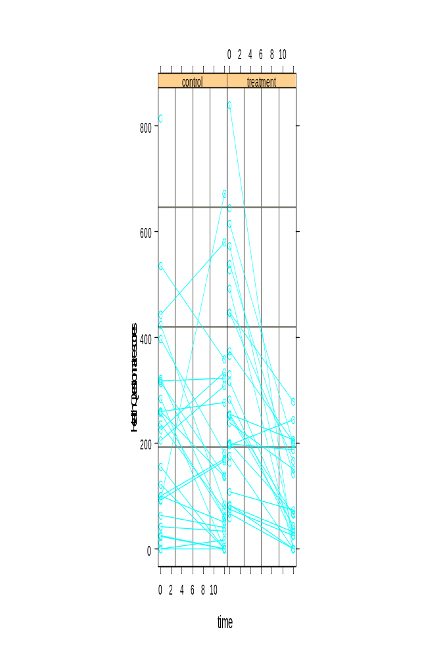Health Questionnaire Scores
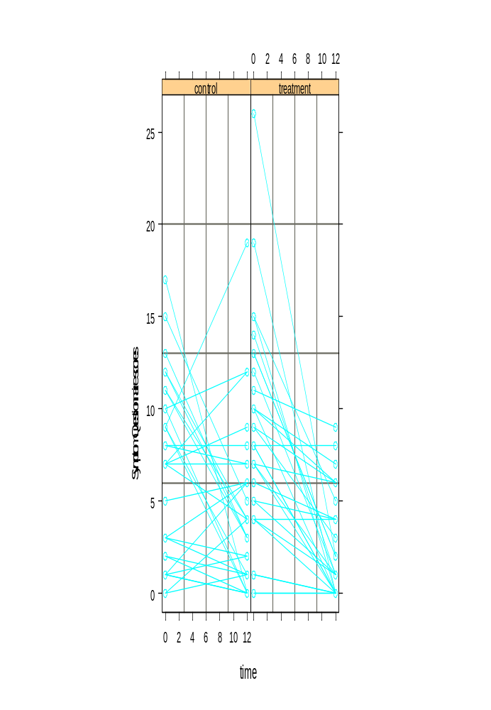Symptoms Questionnaire Scores

Paper Towel Test (area of leakage)

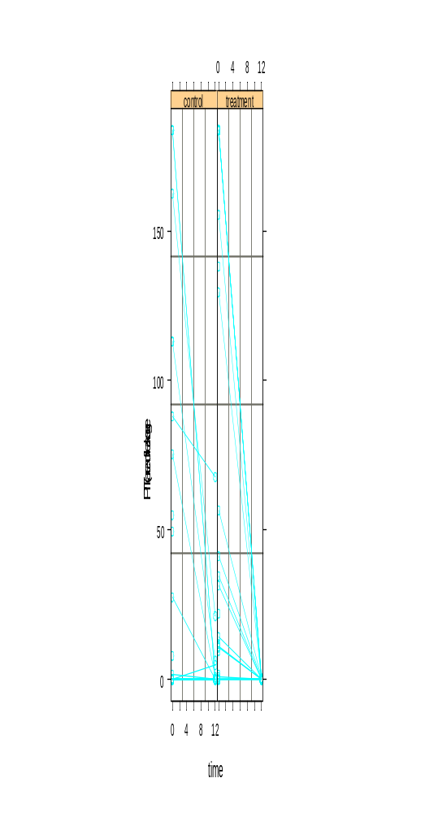
Bladder Diary (daily frequencies)

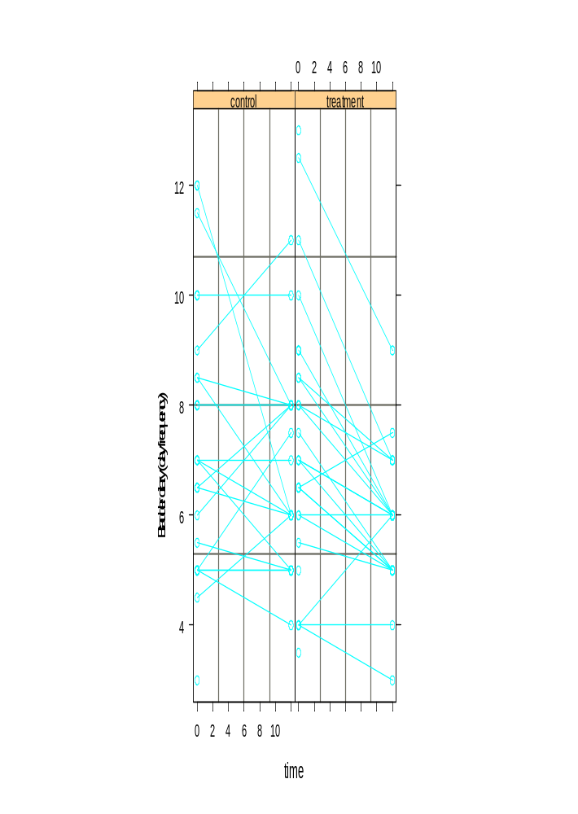
Bladder Diary (nightly frequencies)

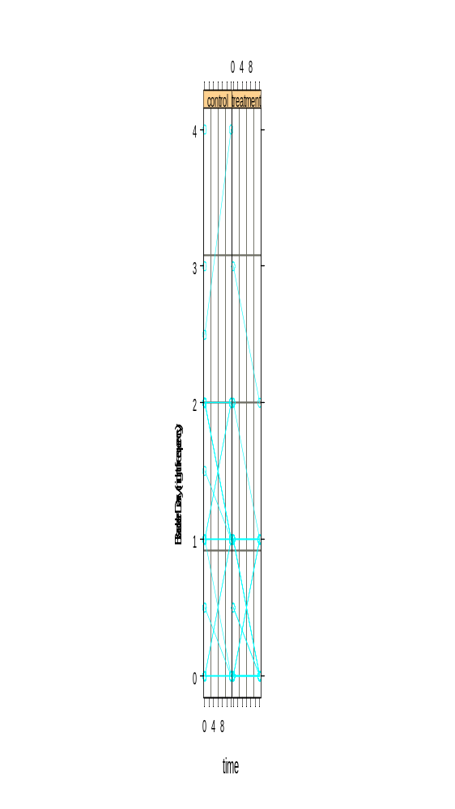
Bladder Diary (maximum nightly volumes)

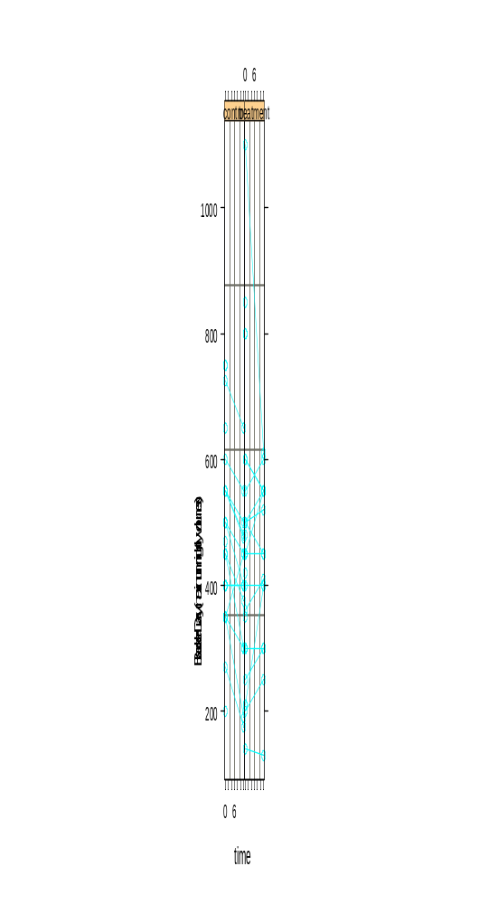
Bladder Diary (maximum daily volumes)

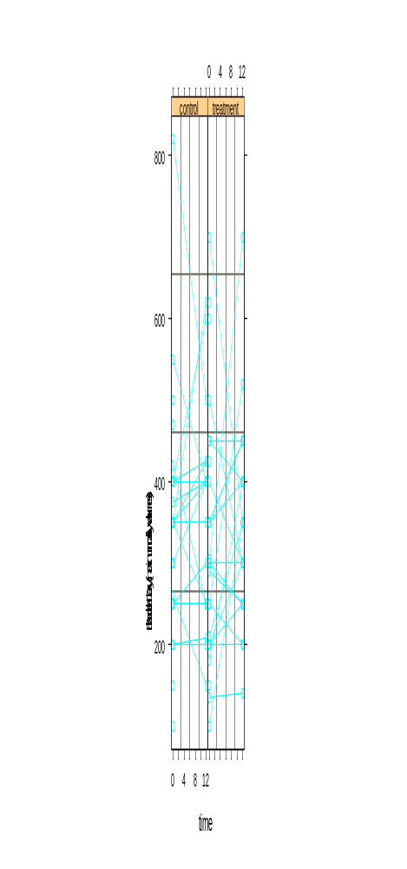
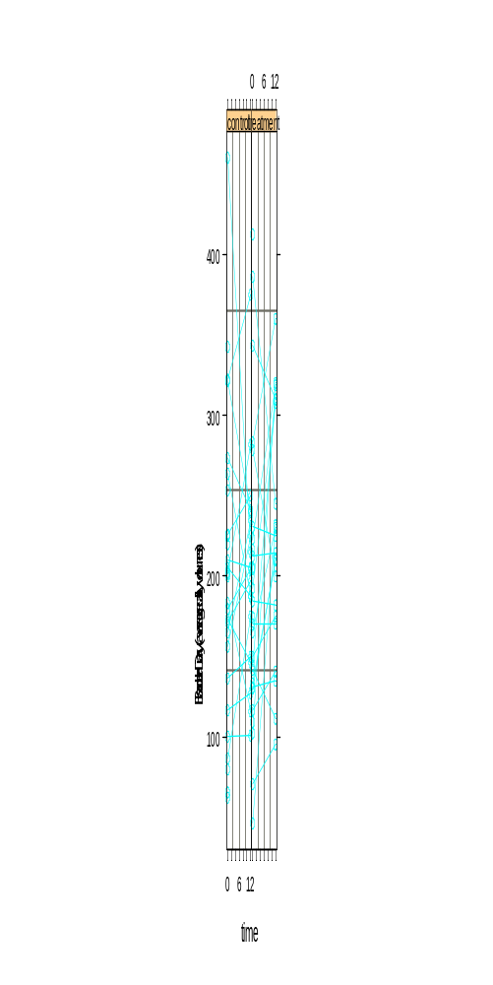Bladder Diary (average daily volumes)
HQ * type of operation
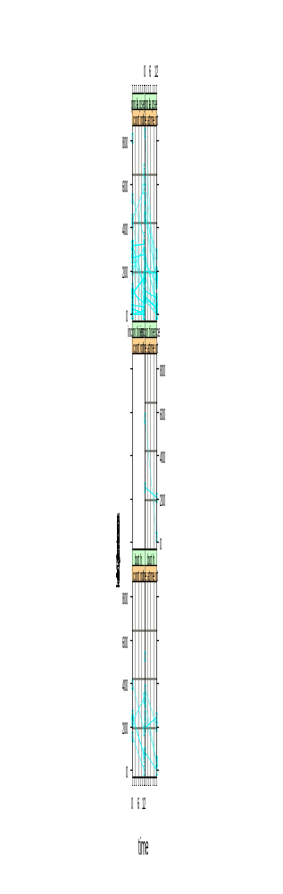
SQ * type

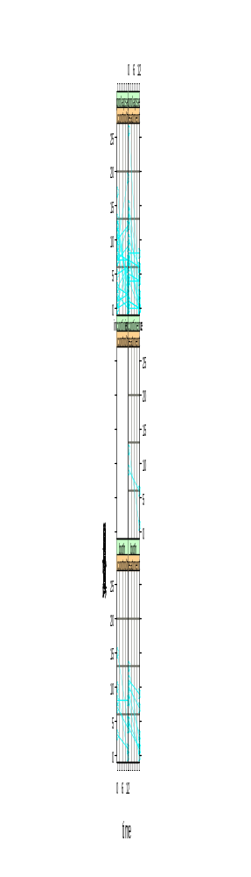

PTT (area) * type

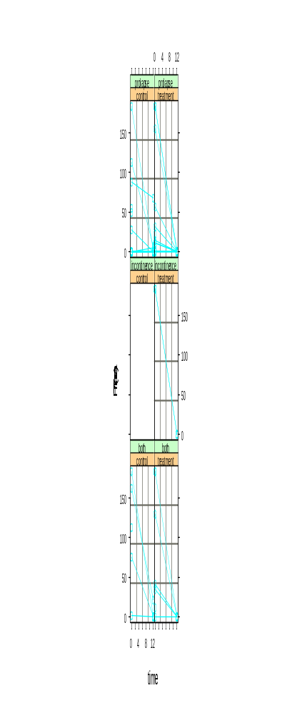
HQ by operation type
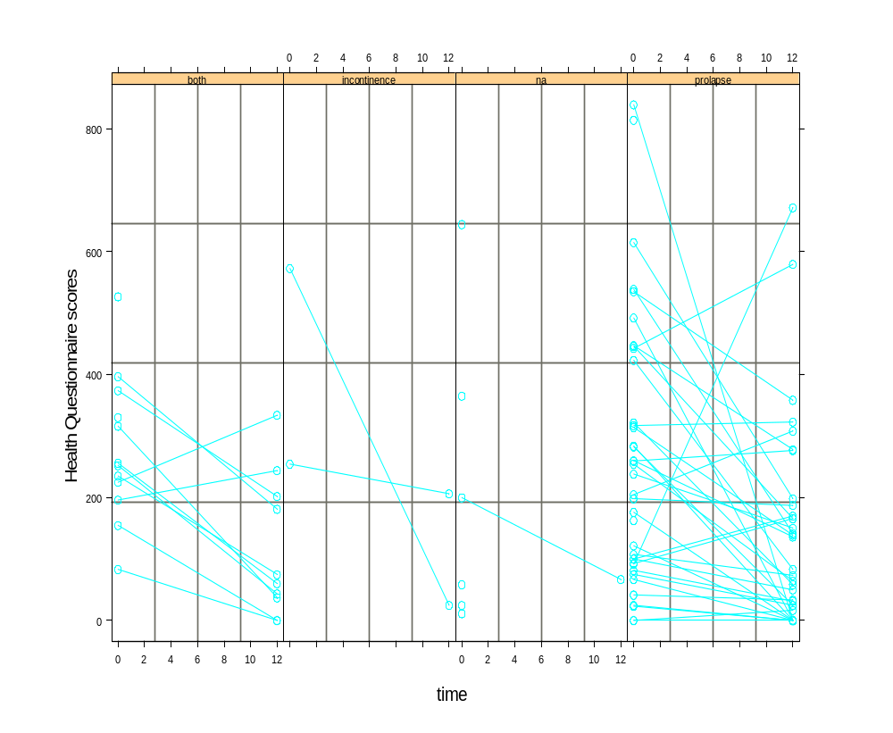

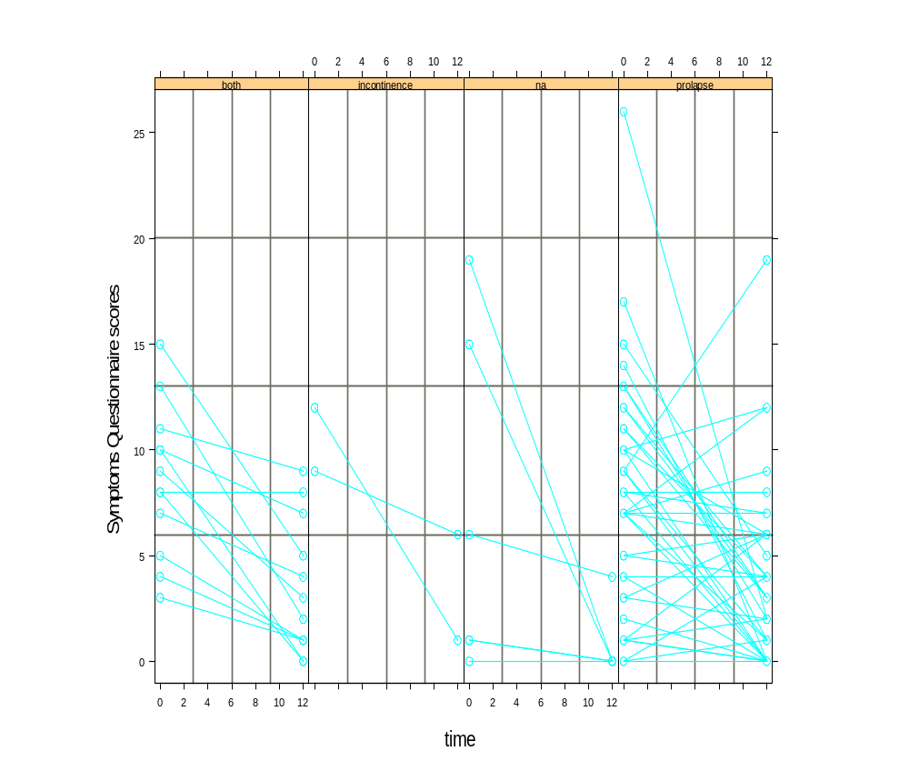SQ by operation type
PTT (area) by operation type
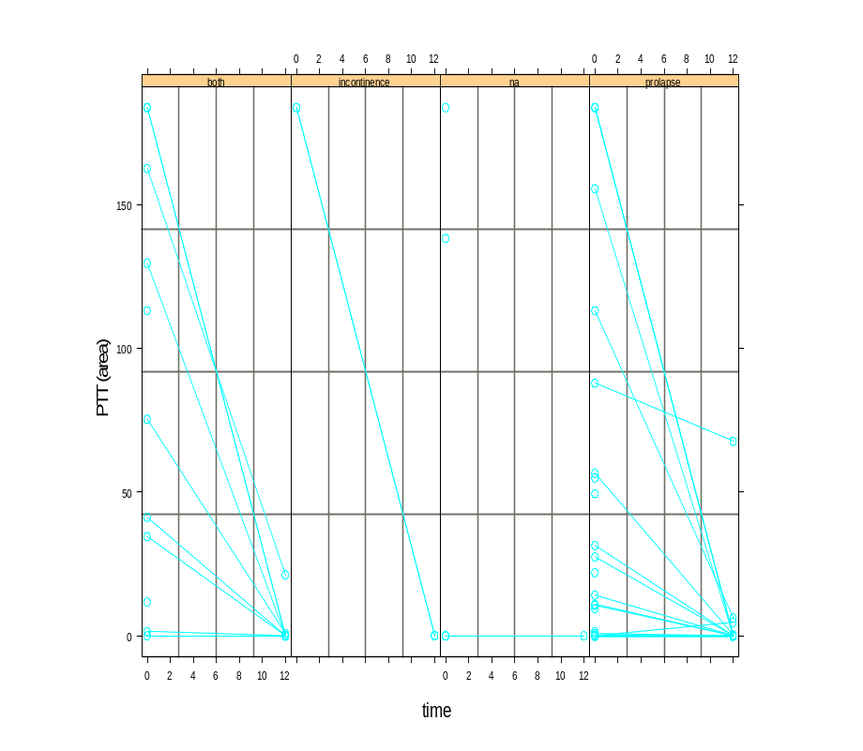
Health Questionnaire + Symptoms Questionnaire by Age groups (<50,50-59,70-69,70+)

