Volatility Effects in Alcohol Consumption

Resulting from the
Elimination of Retail Monopolies

Department of Statistics

School of Mathematics

University of New South Wales

Presenter: Mark Villar

Supervisor: William Dunsmuir

MATH5925 Project

TABLE OF CONTENTS

1. INTRODUCTION 3

2. BACKGROUND AND DATA REVIEW
Background 5
Data 9
Exploratory Data Analysis 12

Data Transformations and Other Covariates 13

3. METHODOLOGY 17
Design 18
ARIMA Intervention Models using SAS 19
ARIMA Intervention Models using S-Plus 22
GARCH Intervention Models using S-Plus 23

Diagnostic Tests 26
4. EMPIRICAL RESULTS 27
5. CONCLUSION 49
6. SUGGESTIONS FOR FURTHER WORK 52

1 Introduction

Many time series encountered in practice require the assessment of impacts from covariates including intervention variables. During the period for which a time series is observed, it is sometimes the case that a change has affected the level of the series, such as a public policy change. Modelling intervention variables is relevant as it enables meaningful estimation and interpretation of changes that interrupt the normal evolution of the observed series. This study focuses on modelling the dynamically changing variability associated with a change in public policy and its effects on inferences about the intervention. Generalised Autoregressive Conditional Heteroskedasticity (GARCH) models, commonly used in financial and econometric applications, are used to characterise the dynamic nature of the volatility. These models provide an additional dimension to standard intervention analysis by accounting for ‘volatility effects’ and thereby facilitating a means to assess their impact on inference about intervention parameters.

Recent studies examining the impact of privatisation on alcohol sales have found that the elimination of state-owned and operated retail monopolies have resulted in significant increases in alcohol consumption. The purpose of this study is to assess the validity of such claims by incorporating the time dependent behaviour in the variability of alcohol consumption associated with this change in public policy. The main objective of our analysis is to answer three key questions:

- Is there evidence of a change in the volatility structure after privatisation?
- If so, does misspecification of the volatility structure lead to incorrect inferences regarding the intervention?
- Can we model the volatility change and if so, what impact does it have on the parameter estimates?

We focus on monthly sales data of wine and spirits collected for each state that implemented privatisation. Data on the monthly sales of non-intervention states is also used as a control variable, controlling for nation-wide trends and fluctuations over time. Assessment of the volatility effects on the intervention estimates requires the application of both traditional time series methods such as seasonal Autoregressive Integrated Moving Average (ARIMA) models and transfer functions, as well as models of changing volatility, namely GARCH modelling. We begin by using the Box-Jenkins interrupted time-series design to identify a parsimonious ARIMA model for each state. Transfer functions representing hypothesised effects of the intervention are added to these ARIMA specifications and model estimation is performed using maximum likelihood methods. The two transfer functions used in our analysis include a pulse function for short-term effects and a step function for permanent changes to the level of the series. However, the change in the variability associated with the intervention is the phenomena we are most interested in and wish to characterise with GARCH models. By comparing the results of fitting standard time series models that do not account for volatility effects, with models that use GARCH modelling techniques, we are able to determine whether claims of significant long-term increases in alcohol consumption due to privatisation can be substantiated.

2 Background and Data Review

Background

In the United States the alcohol industry has traditionally been a heavily regulated industry. Wine and spirits were sold only in a limited number of state-owned and operated stores for as many as fifty years after the end of Prohibition. Over the past thirty years several states have abandoned their retail monopoly structure, with the extent and timing of the deregulation varying between state to state. Consequently, abrupt and dramatic increases in alcohol availability ensued. In Iowa for instance, retail outlets rapidly increased from 200 state stores to 800 private wine outlets and 400 spirits outlets on the 1st of July 1985. Nearly all grocery and convenience stores entered the market, Sunday sales were legalised, hours of sales were extended, advertising was allowed and alcohol could be purchased on credit.

An economist would normally expect a positive relationship between alcohol availability and consumption, the hypothesis being – unrestricted free markets increase alcohol consumption while public monopolies restrict consumption. Given the economic implications of deregulating the alcohol industry, research has been devoted to examining its effects on drinking, specifically, to determine whether privatisation delivered long-term or permanent changes to consumption levels. However, the sizeable body of evidence examining the impact of privatisation on alcohol sales has produced widely disparate results. Early formative research on privatisation analysed annual sales data using ordinary least squares (OLS) regression models for each beverage at the time of intervention. Smart (1986) concluded that the introduction of wine into grocery stores created no short- or medium-term increase in wine sales or total per capita alcohol consumption in the Canadian province of Quebec. On the other hand, Macdonald (1986) found statistically significant increases in wine consumption in three of the four U.S. states he analysed. Mulford and Fitzgerald (1988) conclude from their analysis of the Iowa experience that there was no significant increase in self-reported consumption levels and that the increase in wine sales was merely temporary. However, these studies suffered from serious methodological deficiencies, having used OLS regression techniques on time-series data, and thereby failing to control for autoregression of the dependent variable and serial correlation in the error term (Wagenaar and Holder, 1991). The interpretation of such findings is therefore problematic and can only be regarded as instructive, at the very least.

In response to these deficiencies, later studies adopted more appropriate evaluation methods. Box-Jenkins interrupted time series analyses, which combine ARIMA and transfer function models, have become prominent in the literature. These types of analytic strategies can also account for factors such as the natural effects of population growth, trends in beverage sales independent of changes to alcohol control policies and seasonal patterns in such sales. Adrian et al. (1994) re-analysed the Quebec experience with more post-intervention observations while using multiple regression and time series forecasting techniques. The authors found that there was an increase in wine consumption soon after privatisation, but concluded that this effect was only temporary and not representative of a long-term change in consumption levels. Wagenaar and Holder (1991) performed interrupted time series analyses on monthly data while controlling for an initial stocking effect, cross-beverage substitution, national alcohol sales patterns and border-state alcohol sales. They found a 92% increase in wine sales in Iowa and a corresponding increase of 48% in West Virginia associated with the intervention. Mulford et al. (1992), who were critical of Wagenaar and Holder’s (1991) findings, published a second study of the Iowa experience using Box-Jenkins analyses with an interrupted time-series design. The authors found that while privatisation modestly increased the sales of both wine and spirits, the increase dissipated to pre-intervention levels over time, rendering the effects of privatisation to be short-term. However, Wagenaar and Holder (1993) subsequently observed several methodological problems with the Mulford study, particularly its failure to control for nationwide trends in alcohol sales over the period.

Wagenaar and Holder’s (1995) paper replicated previous analyses of the effects of wine privatisation in five additional U.S. states, this time with increased post-intervention data. Results confirmed that the elimination of retail wine monopolies is followed by significantly increased wine sales, with the magnitude of effects ranging from 13% in New Hampshire to 150% in Idaho. Moreover, Holder and Wagenaar (1990) report a 9.5% increase in distilled spirits sales following the end of Iowa’s spirits monopoly. Research by Laxer et al. (1994) and Wagenaar and Langley (1995) considering the relationship between alcohol regulation and consumption in non-U.S. jurisdictions such as Alberta, Canada and New Zealand, lend further support to the hypothesis that unrestricted free markets increase alcohol consumption while public monopolies restrict consumption.
Given the disparity of findings in this area of research and the ongoing debate over methodology, there is one feature common in all these studies. To date prior research has not explicitly addressed the change in variability associated with discrete changes in alcohol control policies. While recognising the complexity of contemporary alcohol control systems in their assessment of privatisation effects, standard intervention analysis using ARIMA models and transfer functions, ignore the dynamic nature of the volatility associated with the intervention. Because previous studies failed to explicitly account for conditional heteroskedasticity, the misspecification of the volatility structure could possibly have led to erroneous conclusions. This current study aims to contribute to the growing body of methods available in evaluating the impact of privatisation, particularly the inclusion of ‘volatility effects’ in the formulation of time series models and their influence on intervention parameters.

Data

Outcome measures used are quantities of absolute ethanol sold in the form of wine or spirits measured as shipments from wholesalers to retail suppliers. While retail sales data for state monopoly stores is available before the end of wine monopolies, such data is not available from individual retail outlets after privatisation. Data on wholesale shipments, on the other hand, are consistently available throughout the thirty-year period studied. Consequently, our analysis focuses on wholesale data to provide a consistent measure of alcohol sales for the study period. The data set used for this research project was obtained from the University of Minnesota, School of Public Health, Division of Epidemiology.

Data on monthly consumption of wine was obtained from January 1968 to December 1997 (n = 360) for the seven states that had adopted privatisation policy in wine sales at some point during the period. Source of wine data is the Wine Institute, based on reports from the Bureau of Alcohol, Tobacco and Firearms, U.S. Department of the Treasury. Wine ethanol figures were also adjusted beginning in 1984 to take into account the growing market share of wine coolers, which have lower alcohol concentration than other wine. Figure 1 shows the time series plots of wine sales in ethanol litres for each state and the aggregate sales for the non-intervention states.

Additional data up to December 2000 (n = 396) on the monthly consumption of spirits were available for the three study states we analysed. Source of spirits data is the Distilled Spirits Council of the United States, based on its monthly reports of total volume of spirits sold to licensed retail establishments. Figure 2 displays the time series plots for spirits sales.
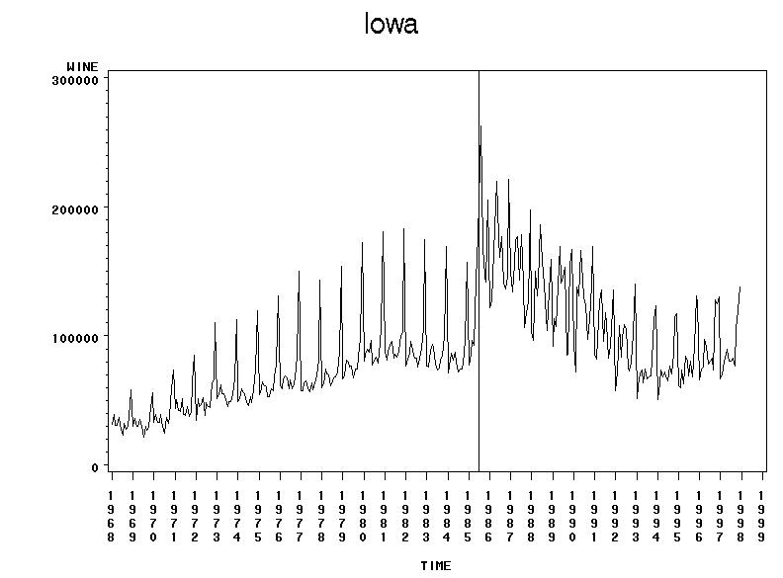
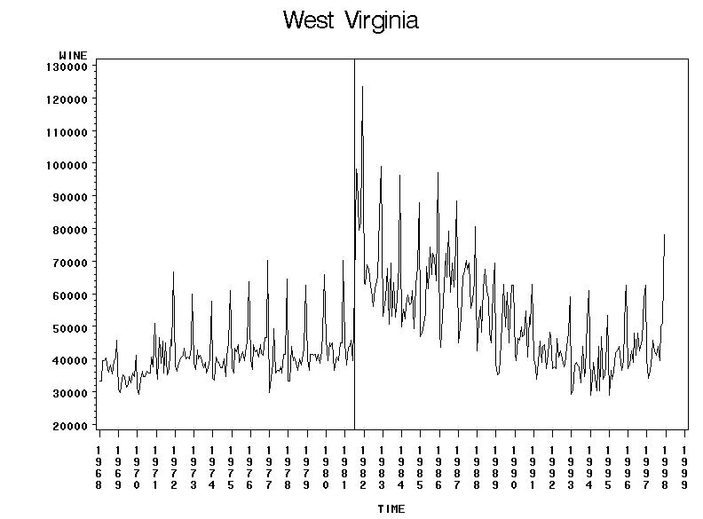

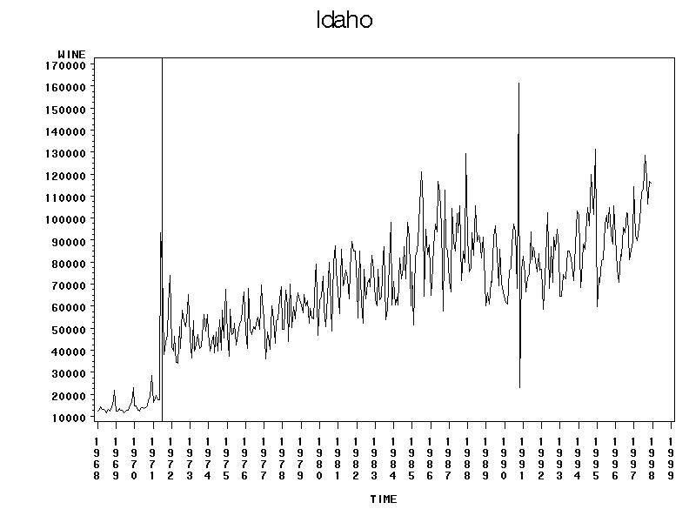
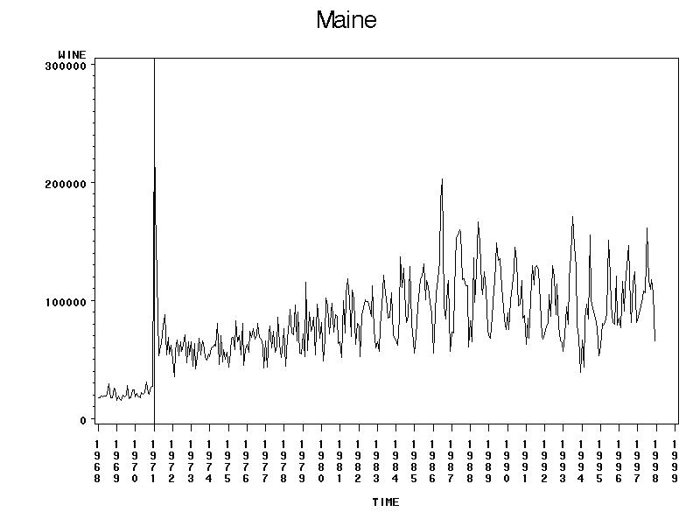

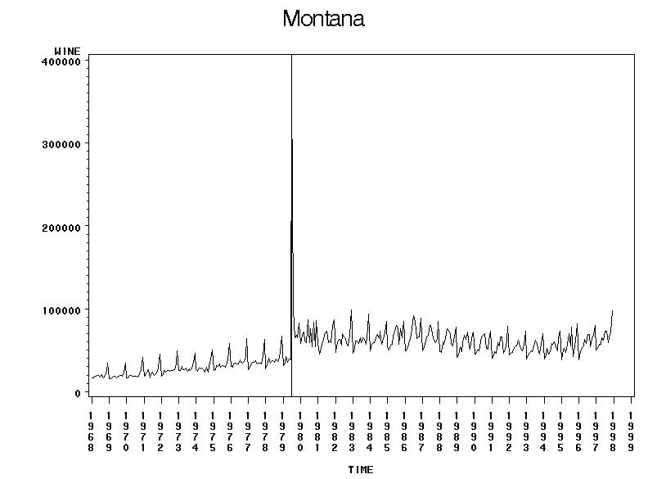
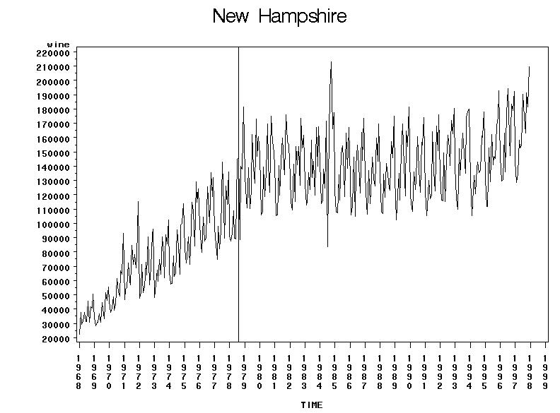

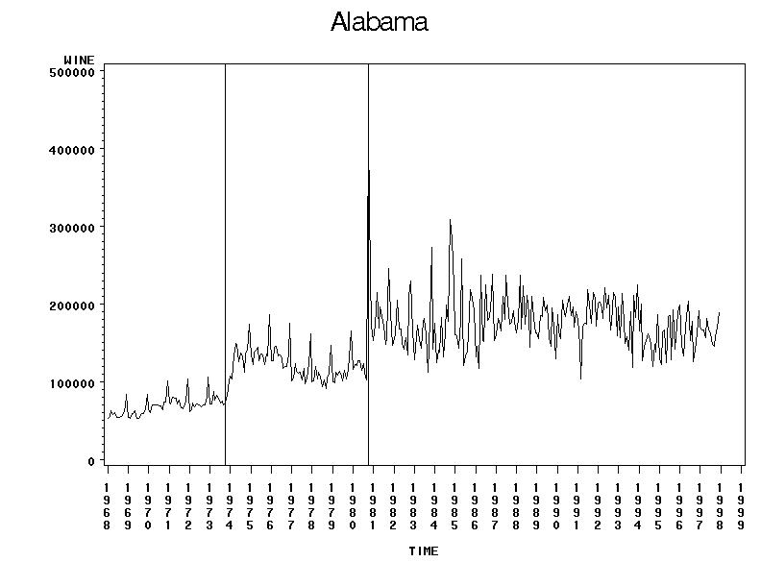
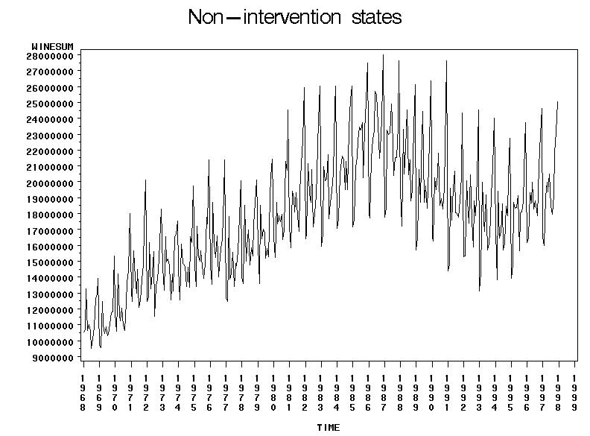

Figure 1: Monthly wine sales in litres of ethanol for the period January 1968 to December 1997.
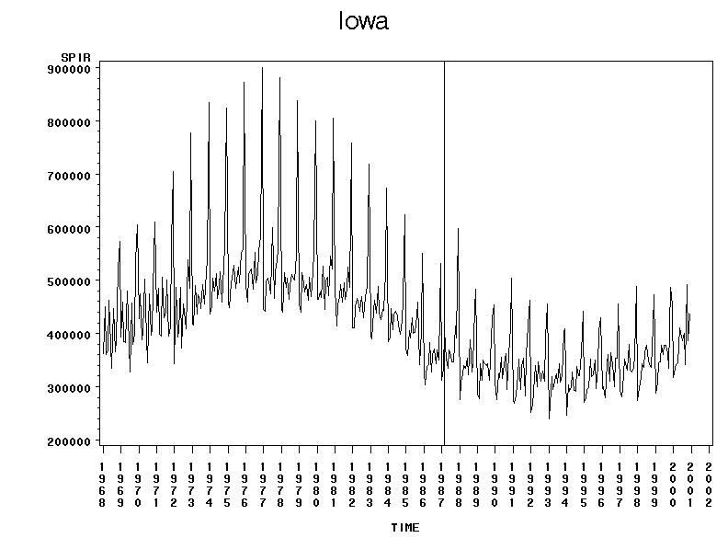
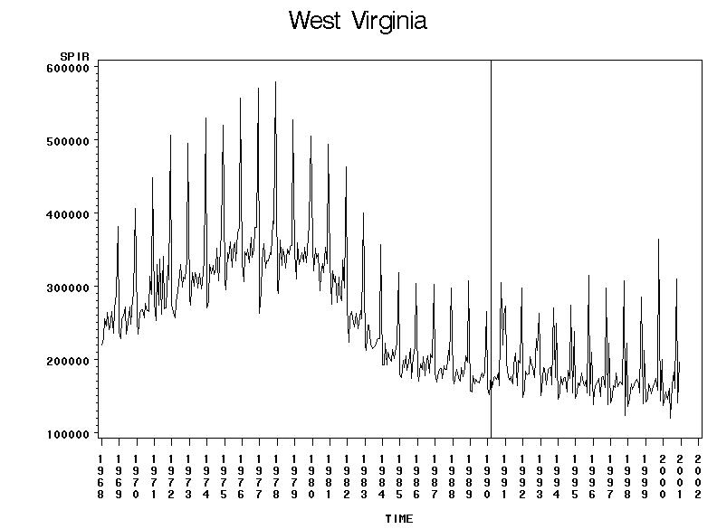

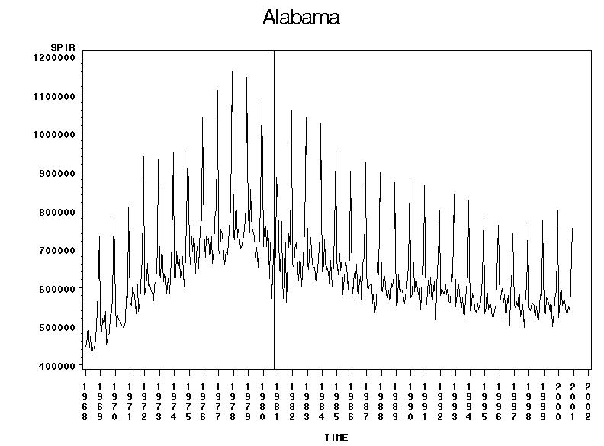
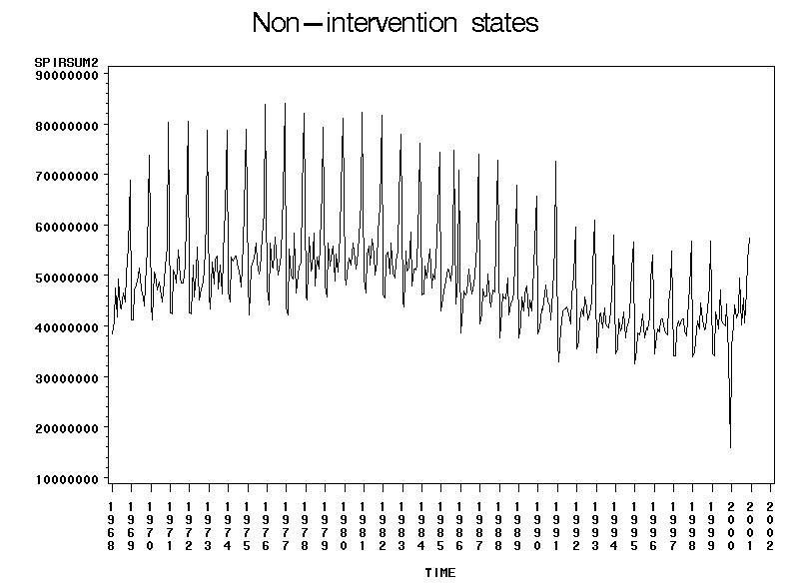

Figure 2: Monthly spirits sales in litres of ethanol for the period January 1968 to December 2000.

Exploratory Data Analysis

Figure 1 indicates that monthly sales of wine are serially correlated and exhibit a clear seasonal pattern. The sharp increases and decreases in wine sales appear to follow one another in a reasonably regular manner, reflecting its seasonality. The seasonal pattern is characterised with one major peak and several minor peaks during the year. It also appears that the amount of seasonal variation is increasing with the level of the series. However, the most prominent feature common to all time series plots in Figure 1 is the substantial break in variability that occurs at the point of intervention, represented by the vertical line. Variability in the post-intervention period appears to have increased substantially, with fluctuations becoming noticeably larger in all states except New Hampshire. While not conclusive, this provides prima facie evidence of a changing volatility structure in the time series process after the intervention.

The impact of the privatisation of spirits sales on variability is not as distinct as shown in Figure 2. While there was a clear increase in variability for the wine series, it is difficult to tell from visual impression alone whether there was indeed a change in the volatility structure of the spirits sales after privatisation. Nonetheless, appropriate modelling techniques need to be developed to determine whether the volatility observed after the intervention does indeed exhibit time-dependent behaviour. Table 1 lists each state’s privatisation policy effect date(s) with the corresponding number of observations used in our analysis.

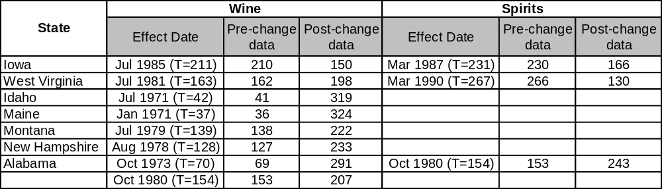
Table 1: Privatisation effect dates for wine and spirits with the corresponding number of observations.

While earlier studies such as Wagenaar and Holder (1991) were criticised for unbalanced designs, particularly the lack of post-intervention data, this current study’s analysis period provides extended long-term follow-up of privatisation effects.

Data Transformations and Other Covariates
At the outset, the question of whether the data requires an appropriate transformation needs to be addressed. Because the data exhibits increasing seasonal variation with the level of the series, a log-transformation was used to ‘equalise’ variability and reduce heteroskedasticity. Time series data on the drinking-age population for each state is also readily available and was utilised in our analysis as another control measure. Consequently, the log of the population-adjusted sales per capita becomes the dependent variable we wish to analyse in our study. Likewise, the aggregate consumption in the non-intervention states, henceforth known as the control covariate, undergoes the same transformations. This predictor is used to control for national trends and fluctuations that could influence the behaviour of the series, independent of the change in public policy.
These transformed quantities provide three distinct advantages. Firstly, a per capita measure effectively controls for differences in population across states. Secondly, the use of the drinking age population instead of total population prevents those under 21 years of age to be factored in to our analysis since they are ‘non-drinkers’ according to the law. Although this fails to account for the problem of underage drinking, the intuition behind this transformation is still theoretically sound. Finally, the logarithm metric improves the interpretability of parameter estimates because of its affinity with percentage changes. Figure 3 displays the time series plots for the transformed wine data while Figure 4 shows the transformed spirits data.

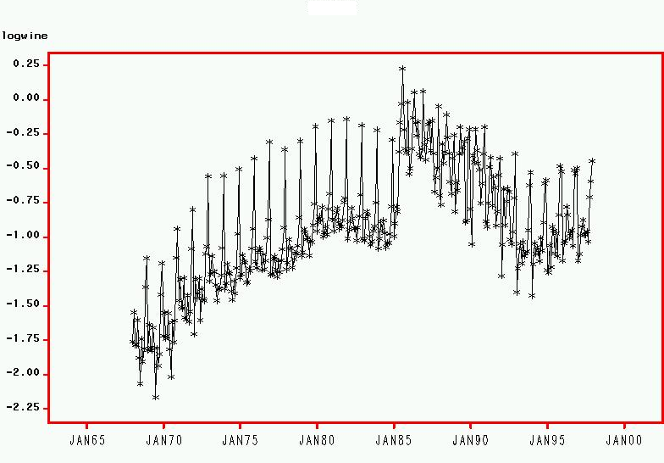
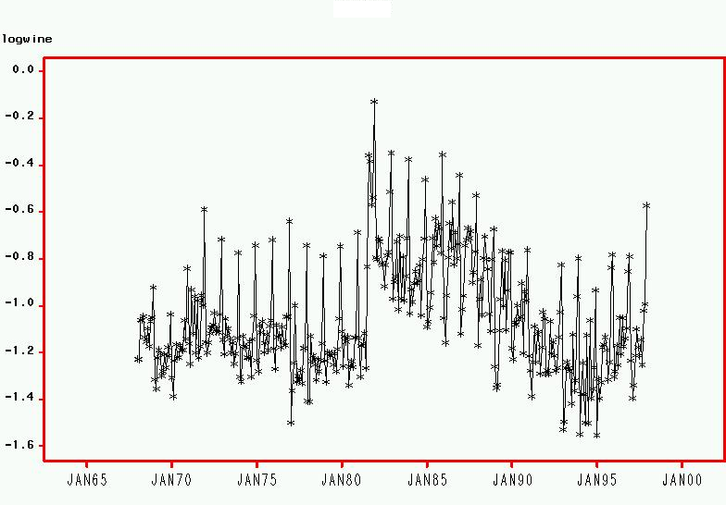
IOWA WEST VIRGINIA

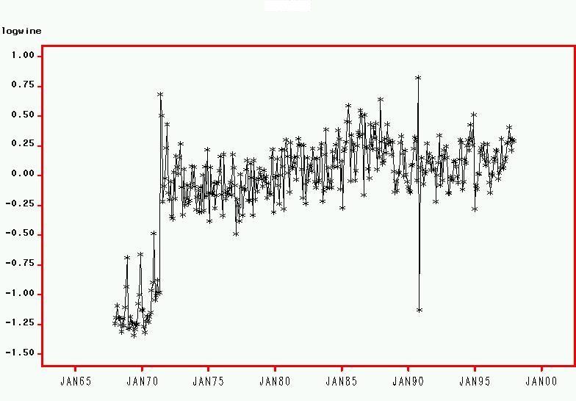
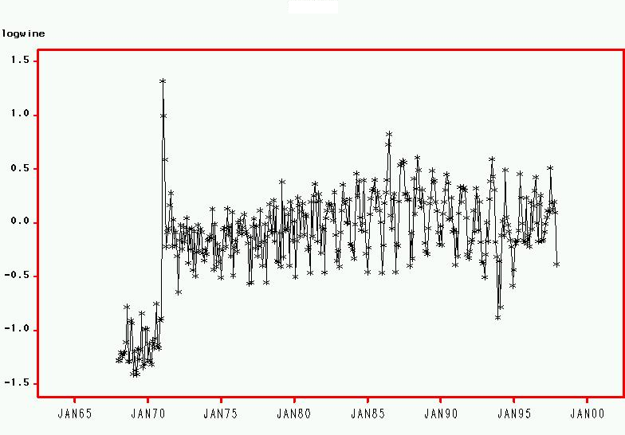
IDAHO MAINE

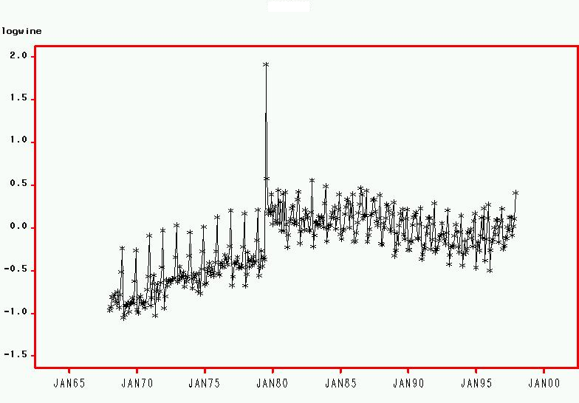
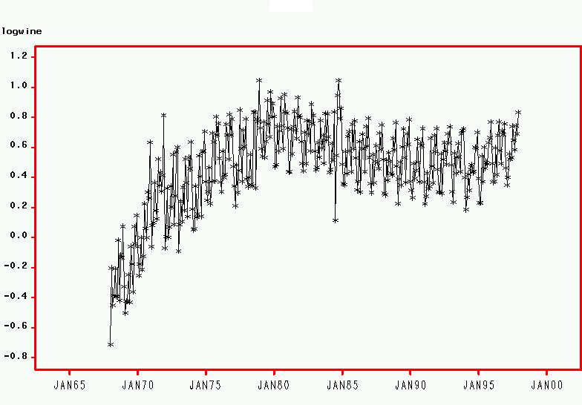
MONTANA NEW HAMPSHIRE

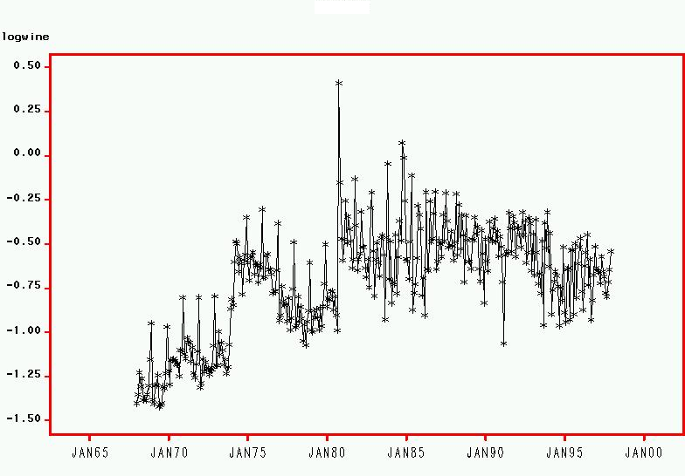
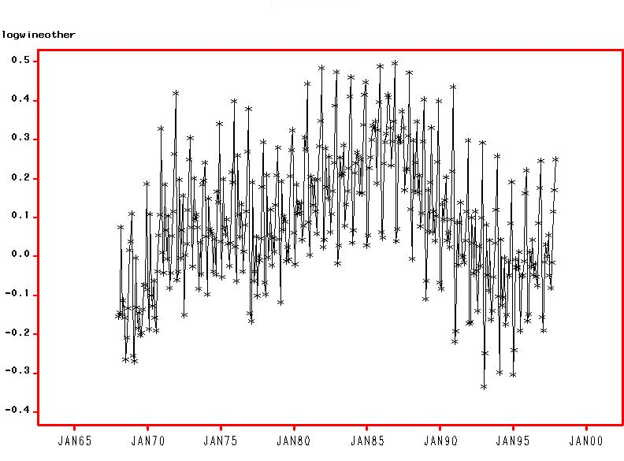
ALABAMA NON-INTERVENTION STATES

Figure 3: Log of monthly wine sales in ethanol litres per capita from January 1968 to December 1997
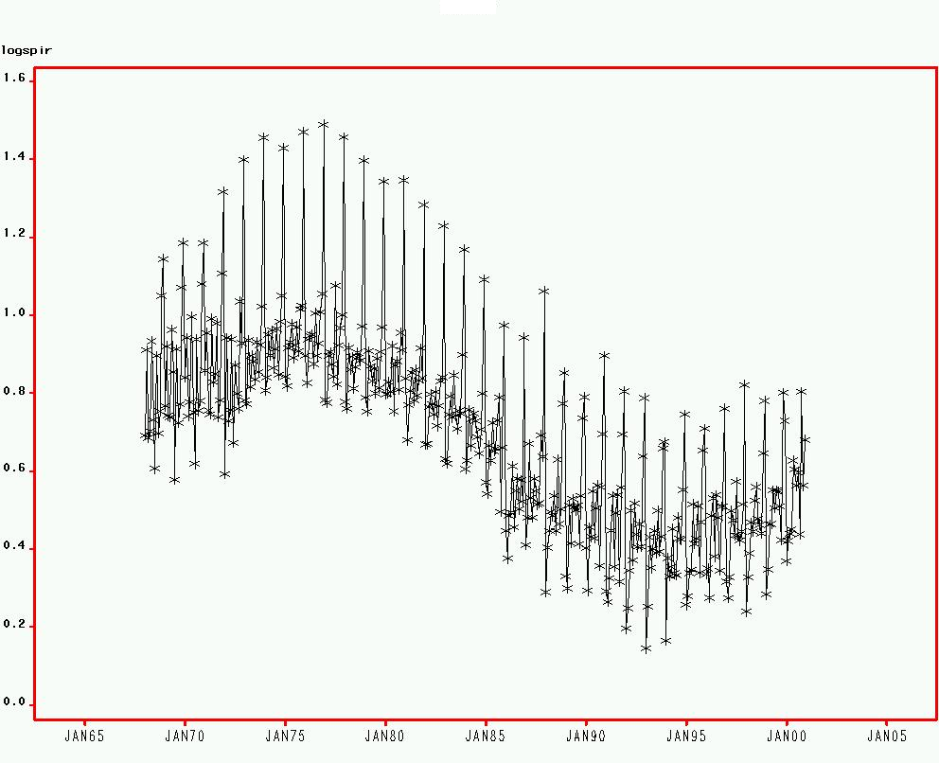
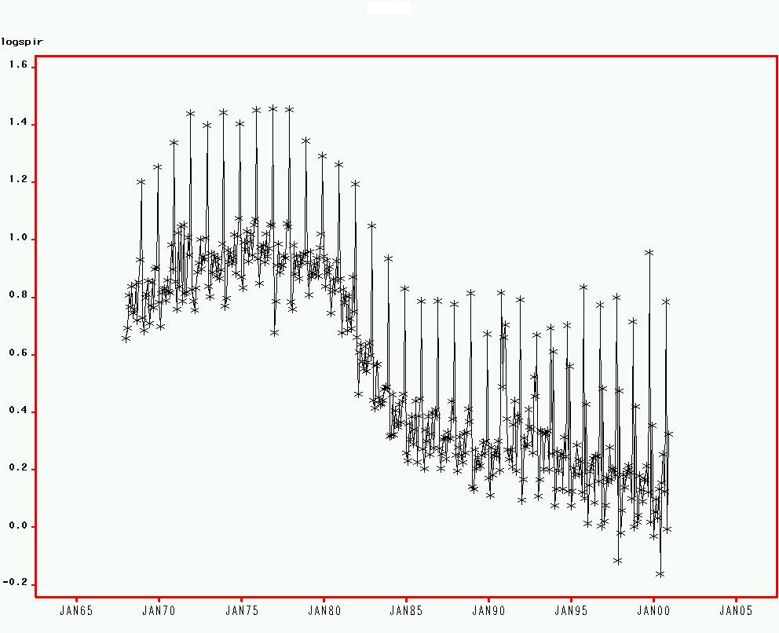
IOWA WEST VIRGINIA

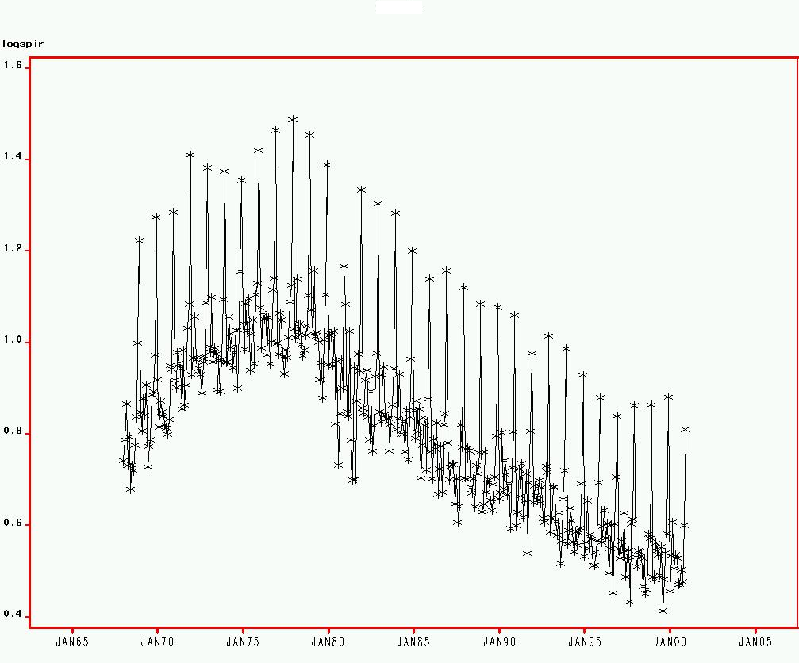
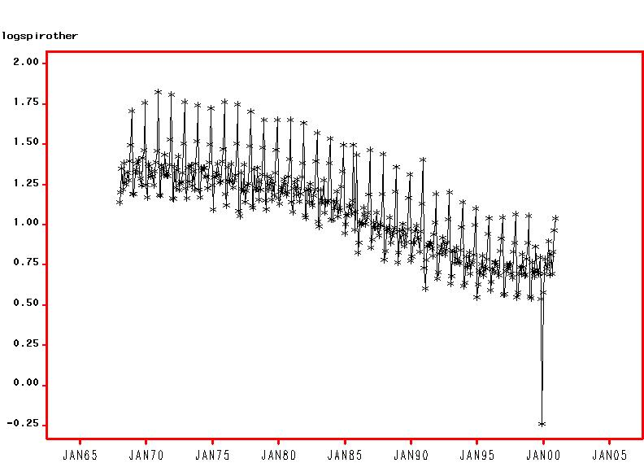
ALABAMA NON-INTERVENTION STATES

Figure 4: Log of monthly spirits sales in ethanol litres per capita from January 1968 to December 2000

3 Methodology

Although the literature has witnessed the extensive use of ARIMA models, we are not aware of any empirical work specific to the area of alcohol consumption that has combined GARCH methodology with intervention analysis. In the finance literature however, the GARCH modelling strategy has received widespread attention, particularly in ‘event-study’ approaches. Recent financial research such as Batchelor and Orakcioglu (2003), Wang et al. (2002) and Corhay and Tourani Rad (1996) have applied GARCH modelling techniques to estimate not only the effects of a particular economic event, but also to uncover the time-varying volatility in stock market returns associated with that event. By accounting for GARCH effects these studies found that estimates of parameter coefficients differed considerably in most cases, which in turn led to different interpretations of the economic significance of the event in question. Moreover, the GARCH methods employed in these papers were found to produce more efficient estimates and thus possess better statistical properties.

While these studies examined the impact of ‘events’ and not interventions per se, many parallels can be drawn from our current study, nonetheless, in particular, the adjustment for GARCH properties of the time series. This provides justification of the modelling framework chosen for this study despite its apparent lack of precedence outside the finance and econometric literature. The preferred research design for evaluating the effects of privatisation will now be reviewed, beginning with the interrupted time series design and ARIMA intervention models, followed by the main innovation introduced in this study, GARCH intervention models.

Design
Following the approach taken by Wagenaar and Holder (1991) and (1995), we treat the elimination of the state retail monopoly on wine and spirits as a natural experiment, using an interrupted time series design. The design involves an examination of observations over time, hypothesised to be affected by the intervention, and a comparison time series that was expected not to be affected. This design can be shown as:

X₁ X₂ X₃ … X_{n} I X_{n+1} X_{n+2} … X_{n+m}
X₁ X₂ X₃ … X_{n} X_{n+1} X_{n+2} … X_{n+m}

where X_{i} represents the sales of wine or spirits per month expressed as a volume of absolute ethanol, I represents the policy change ending a state monopoly, n is the number of observations before the end of the monopoly and m is the number of observations after the end of the monopoly. The second line in the design diagram above shows a comparison time series not influenced by the specific policy change being evaluated. In this study, the comparison or ‘control’ group consists of the states that did not implement any policy changes regarding the retail sales of alcohol.

ARIMA Intervention Models using SAS
Box-Jenkins intervention-analysis models consistent with the Wagenaar and Holder approach were developed for each dependent time series variable using the SAS software package. As most statistical results in time series analysis are conditional on stationarity of the fundamental processes, the properties of each series are first considered, particularly the need for differencing transformations. Since monthly sales of alcoholic beverages are characterised by dominant seasonal cycles and serial correlation, multiplicative seasonal ARIMA models were developed iteratively for each series. The procedure involves repeatedly going through cycles of specifying a model, estimating it and evaluating its adequacy in terms of accounting for all significant dimensions of the autocorrelation structure in the time series. The general seasonal ARIMA model for the outcome variable y_{t} is given by:

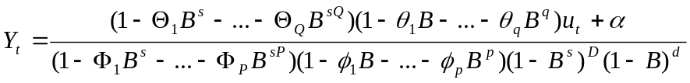 (1)

where p is the order of the autoregressive process, d is the degree of non-seasonal differencing, q is the order of the moving average process, P is the order of the seasonal autoregressive process, D is the degree of seasonal differencing, Q is the order of the seasonal moving average process, s is the seasonal span, 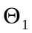 to 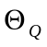 are seasonal moving average parameters, 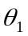 to 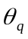 are regular moving average parameters, 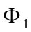 to 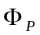 are seasonal autoregressive parameters, 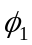 to 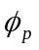are regular autoregressive parameters, u_{t} is a random white-noise error component, α is a constant and B is the backshift operator such that 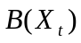equals 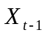.

In the present study, a preliminary ARIMA (p,d,q)(P,D,Q)_{s} model was identified for each series resulting from several iterations of the identification-estimation-diagnosis process. This model-building process ensures that all conventional criteria for ARIMA model adequacy are met, including statistically significant model parameters and the absence of serial correlation in the residuals.

Transfer functions representing hypothesised effects of the intervention were also added to the ARIMA model. The need to measure two specific effects of privatisation determined the functional form of these intervention components. While a step function is used to estimate the long-run or permanent change in the mean level associated with privatisation, a pulse function is used to control for transitory initial stocking effects. These temporary stocking effects represent the expected immediate surge in wholesale distribution as new private outlets throughout each state were stocked. The general form of the transfer function is given by:

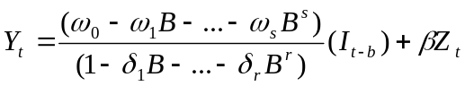 (2)

where 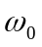 to 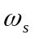 and 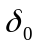 to 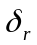 specify the manner in which the input or intervention variable, 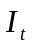, influences the output or dependent variable y_{t} . To test for effects of the intervention, is either a step function with the value zero before the intervention and one thereafter, or a pulse function with the value one for the month in which the intervention begins and zero otherwise; b is a delay parameter indicating the lag between the intervention and the initial effects of the intervention, Z_{t} is the control covariate while is its parameter coefficient. In the present case there was only one covariate, that being alcohol sales from non-intervention states, used to control for national trends and fluctuations when assessing intervention effects. The functional form of the step function, S_{t}, and the pulse function, P_{t}, are expressed as follows:

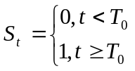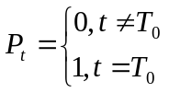

Long-term or permanent effects of privatisation, represented by S_{t}, were best modelled using the formula 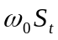, while temporary stocking effects were effectively captured by the expression 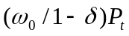. All parameters of each model, including the ARIMA components, step and pulse functions and the control variable, were then estimated simultaneously using maximum likelihood methods by combining Equations (1) and (2). However, it is important to note that the results obtained from the ARIMA models estimated in SAS are merely points of reference for future analysis to be performed in an alternative statistical package, S-Plus. Due to certain limitations of the SAS software, it was found necessary to replicate the intervention analysis described above in the S-Plus environment in order to proceed to the next stage of our investigation.

ARIMA Intervention Models using S-Plus
For each seasonal multiplicative ARIMA (p,d,q)(P,D,Q)_{s} model obtained from SAS, we determined an S-Plus equivalent, with a few notable differences. Firstly, the order of integration for the non-seasonal and seasonal components, d and D respectively, could not be specified efficiently using S-Plus, so each series was differenced accordingly, depending on the values of d. Secondly, the multiplicative nature of the ARIMA model and the insignificance of the autoregressive parameters (p=0 and P=0) in all cases allow each series to be characterised as a simplified MA(13) process. The pulse function specified in SAS also proved difficult to accommodate in S-Plus. While SAS allows for the estimation of decay parameter in the pulse function, S-Plus does not permit such specifications and runs into problems of non-identifiability. To counteract such difficulties, a transformation of the data is possible by applying an appropriate ‘filter’ to the pulse. This filtered pulse explicitly accounts for the decay parameter prior to estimation, and thereby reduces the number of parameters to be estimated. Finally, estimation in S-Plus was performed using its built-in FinMetrics module. This is established by specifying the mean equation as an MA(13) process with exogenous variables consisting of the step and filtered pulse functions and the control covariate, while setting the variance equation to its default option of GARCH(0,0). This procedure implies constant variance errors and produces estimates compatible with that of an ARIMA model. Despite these procedural modifications, we were able to obtain adequate ARIMA equivalents in S-Plus.
GARCH Intervention Models
Researchers examining intervention effects are interested in accurately determining if an intervention is associated with a deviation from the expected path of a series. Accurate estimates of the variance structure are important for inference about such deviations. These reasons underscore the value of modelling approaches that can uncover changes in volatility following an intervention. The main technical innovation in this study is the use of a GARCH model to track changes in volatility after privatisation. It is conjectured that GARCH intervention models utilise full information in comparison to standard intervention models and thus provide a more rigorous framework for evaluating the impact of privatisation on alcohol consumption.

GARCH models were originally proposed to model financial time series. It is observed in many financial time series that although the residuals obtained after modelling the mean process are uncorrelated, the squared residuals are highly correlated. This implies that the variance of the time series is dependent on past observations. To capture this phenomenon of ‘clustering volatility’ Engle (1982) developed a new class of stochastic processes called autoregressive conditional heteroskedasticity (ARCH). These are zero mean, serially uncorrelated processes with non-constant variances conditional on the past, but constant unconditional variances. For such processes the recent past offers information about the one-period ahead forecast of volatility. The ARCH model was extended to the generalised autoregressive conditional heteroskedastic (GARCH) model by Bollerslev (1986) to allow the current conditional variance to be a function of past conditional variances as well as the past error terms derived from the mean process. The development of GARCH models not only facilitated effective modelling of the mean process, but more importantly, the time-dependent nature of volatility.

A GARCH intervention model that allows for ‘volatility effects’ is simply an ARIMA intervention model with the addition of a variance equation. In other words, the intervention model retains its mean equation through the combination of Equations (1) and (2), but is augmented by a conditional variance equation characterised by a GARCH process of orders m and n, denoted GARCH(m,n). A GARCH(m,n) model can be expressed as follows:
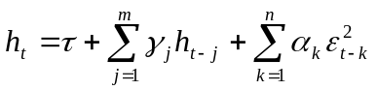 and 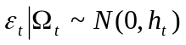 (3)
where 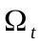 is the information set at time t on which the distribution of the errors is assumed to be conditioned, and τ, α and γ are parameters to be estimated. These parameters are also assumed to satisfy the following conditions: 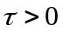, 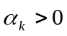 for 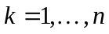 and 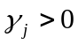 for 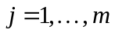. Equation 3 implies that conditional variances h_{t} at time t depend on recent squared innovations 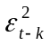 as well as on past conditional variances h_{t-j}. However, it might be expected that other exogenous variables such as the control covariate or the two transfer functions, could possibly influence the behaviour of the conditional variance. The decision to include these exogenous variables in the conditional variance equation is based on a stepwise examination of each variable’s contribution to improving model performance.
To determine the appropriate orders of ARCH and GARCH terms, m and n, respectively, we begin by estimating a simple GARCH (1,1) model. Higher order models are also estimated and compared to the GARCH (1,1) specification. Using standard model selection criteria such as the Akaike Information Criteria (AIC) and the Bayesian Information Criteria (BIC), as well as other diagnostic checks to be discussed later, the optimal GARCH (m,n) model is chosen among a variety of different specifications. These GARCH intervention models are estimated using the iterative BHHH algorithm, a non-linear optimisation technique in the S-Plus FinMetrics module used to compute maximum likelihood estimates (MLE). Convergence is reached within the specified maximum number of iterations (50) and reliable coefficient estimates and their corresponding standard errors are obtained.

Diagnostic tests
Apart from checking the autocorrelation function plots for the absence of serial correlation, further diagnostic tests based on standardised residuals need to be performed in order to test the validity of the models. By defining the standardised residuals as follows:
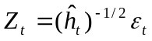 (4)
where 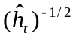 is the square root of the estimated conditional variance. If the GARCH model is correctly specified, then these standardised residuals and the corresponding squared standardised residuals should be uncorrelated. The Ljung-Box portmanteau test for serial correlation is used to assess the adequacy of these models. The Ljung-Box Q-statistic is given by:
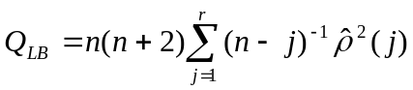 (5)
where 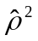 is the sample autocorrelation at lag j computed from the residuals and n is the number of observations. Under the null hypothesis that the model is correctly specified, Q_{LB} is asymptotically distributed as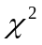 with 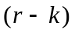 degrees of freedom, where k is the number of independent parameters.

To check the assumption of conditional normality of the residuals, an inspection of the quantile-quantile plots is carried out. The Shapiro-Wilk test however provides a more formal framework for determining the correct form for the density of 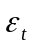. For further details of this normality test, refer to the S-Plus manual.
4 Empirical Results

The results from fitting the three intervention models outlined in Section 3 are presented for each state that implemented privatisation. Because this study is most interested in the permanent, long-term change associated with the intervention, we only report the estimated coefficients related to the step function. Therefore, inference about the impact of ‘volatility effects’ focuses on the parameter estimates for the step function in comparison to when GARCH properties are accounted for. In other words, are the estimates obtained from the standard ARIMA intervention model significantly different from those obtained from the GARCH intervention model? The coefficient estimates for the conditional variance parameters are also reported, as well as the relevant diagnostic tests generated by S-Plus. Relevant GARCH plots are also presented in order to reinforce (or refute) the validity of the chosen models.

The other parameters are not of direct interest, but still provide a appropriate method of comparison between the various models, particularly the congruence (or lack thereof) between the two ‘equivalent’ ARIMA models estimated using different software packages. Findings by Wagenaar and Holder are also reported to provide an appropriate reference point to previous research on the same data, albeit for a shorter time span. Analysis of each state is presented separately, with the wine series preceding the analysis of spirits.
IOWA – Wine
Key Findings:
Analysis of Wine
 | Model | Estimate | Standard error | t-statistic | p-value | Percent change
ARIMA SAS | ARIMA (0,1,4) (0,1,1) | 0.286 | 0.132 | 2.17 | 0.03 | 33.1%
ARIMA S+ | MA(13) | 0.356 | 0.066 | 5.40 | 0.00 | 42.7%
GARCH S+ | GARCH(1,1) | 0.322 | 0.189 | 1.70 | 0.09* | 38.0%*
Wagenaar & Holder | ARIMA (0,1,4) (0,1,1) | 0.658 | 0.067 | 9.82 | 0.00 | 93.0%
Table 2: Analysis of wine privatisation in Iowa, July 1985. * denotes insignificant at the 5% level.
The inclusion of volatility effects characterised by the GARCH(1,1) model suggests that the standard ARIMA model has overestimated the permanent increase in wine consumption by 4.7%. However our modelling strategy proved to be inadequate for the Iowa case, producing a statistically insignificant estimate for the step function parameter, with a p-value of 0.09. While the diagnostic checks in the proceeding section provide possible explanations as to our model’s failure to generate an acceptable model outcome, it is worthwhile noting here that perhaps the ARIMA model is sufficient for this case and to capture the volatility effects through GARCH techniques may not in fact yield significantly different findings.
Diagnostics:
S-Plus Maximum Likelihood Estimation
Mean process: |  |  | Iowa wine |  |  | Exogenous variables in variance eq.
Conditional variance equation: |  |  | GARCH(1,1) |  |  | step function & control variable
Estimated coefficients: | Value | Standard error | t-statistic | p-value |  | Diagnostic tests: | Statistic | p-value
A | 0.0003 | 0.0002 | 1.92 | 0.06* |  | SW normality test | 0.984 | 0.46
ARCH(1) | 0.2266 | 0.0434 | 5.22 | 0.00 |  | LB test for std. residuals | 5.36 | 0.94
GARCH(1) | 0.7756 | 0.0451 | 17.22 | 0.00 |  | LB test for squared std. residuals | 11.57 | 0.48
Table 3: Conditional variance parameter estimates and diagnostic tests for the Iowa wine series.
IOWA – Wine
Table 3 suggests that the coefficient estimates for the conditional variance equation, particularly ARCH(1) and GARCH(1) are both highly significant. The GARCH (1,1) model also passes the Ljung-Box tests of overall serial correlation in the standardised residuals and squared standardised residuals, as well as the Shapiro-Wilk test of conditional normality. However the model violates the fundamental stability condition of GARCH models: 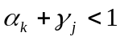. In this case, the sum of the two conditional variance terms marginally exceeds one and thus fails to generate a stationary solution. In fact, 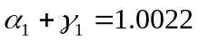, suggesting the presence of an autoregressive unit root. The diagnostic plots shown in Figure 5 also suggest model inadequacy, particularly the ACF of the squared standardised residuals, exhibiting significant serial correlation at lag 24, the second seasonal lag.
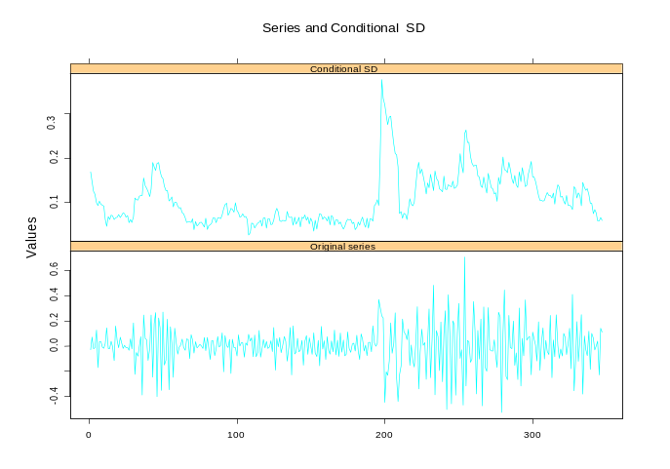
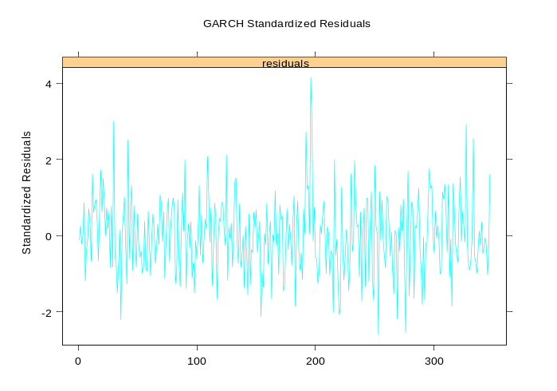
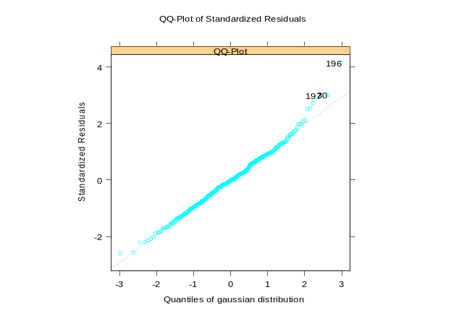
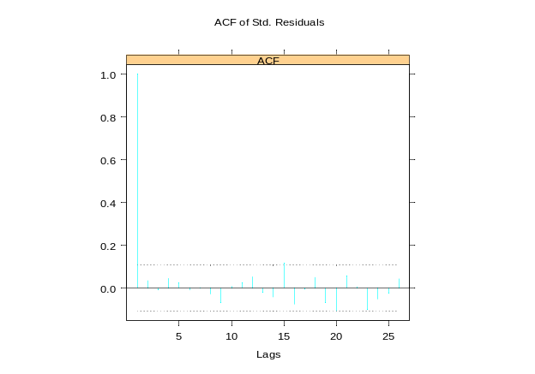
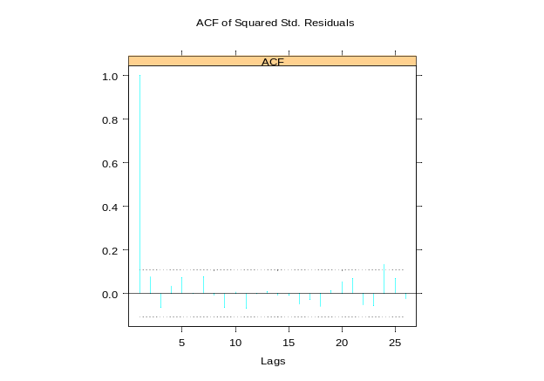

Figure 5: GARCH (1,1) diagnostic plots for the Iowa wine series.
IOWA – Spirits
Key Findings:
Analysis of Spirits
 | Model | Estimate | Standard error | t-statistic | p-value | Percent change
ARIMA SAS | ARIMA (0,1,5) (0,1,1) | 0.038 | 0.027 | 1.40 | 0.16* | 3.8%*
ARIMA S+ | MA(13) | 0.045 | 0.026 | 1.78 | 0.08* | 4.6%*
GARCH S+ | GARCH(1,1) | -0.009 | 0.027 | -0.35 | 0.73* | -0.9%*
Wagenaar & Holder | ARIMA (0,1,4) (0,1,1) | 0.091 | 0.029 | 3.14 | 0.00 | 9.5%
Table 4: Analysis of spirits privatisation in Iowa, March 1987
Table 4 indicates that both the ARIMA and GARCH model fits produced parameter estimates that were not significantly different to zero. The purported 9.5% increase in consumption levels associated with privatisation reported by Wagenaar and Holder is invalidated given additional data. However due to the insignificance of our findings, assessment of the impact of volatility effects for the Iowa wine series is inconclusive.
Diagnostics:
S-Plus Maximum Likelihood Estimation
Mean process: |  |  | Iowa spirits |  |  | Exogenous variables in variance eq.
Conditional variance equation: |  |  | GARCH(1,1) |  |  | none
Estimated coefficients: | Value | Standard error | t-statistic | p-value |  | Diagnostic tests: | Statistic | p-value
A | 0.0005 | 0.0002 | 2.81 | 0.01 |  | SW normality test | 0.977 | 0.03
ARCH(1) | 0.3471 | 0.0913 | 3.80 | 0.00 |  | LB test for std. residuals | 4.46 | 0.97
GARCH(1) | 0.5840 | 0.0829 | 7.05 | 0.00 |  | LB test for squared std. residuals | 10.43 | 0.58
Table 5: Conditional variance parameter estimates and diagnostic tests for the Iowa spirits series.
Table 5 suggests that the GARCH coefficient estimates are all highly significant and the stability condition 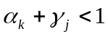 been satisfied. The insignificant Ljung-Box statistics also imply that the conditional variance equation has been correctly specified. However, modelling the volatility structure proved unnecessary given the inconclusive nature of our parameter estimates.
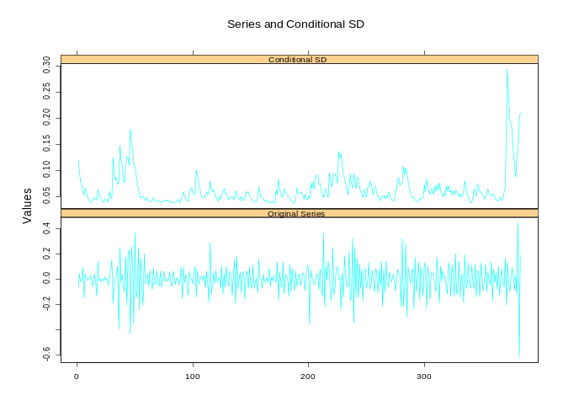
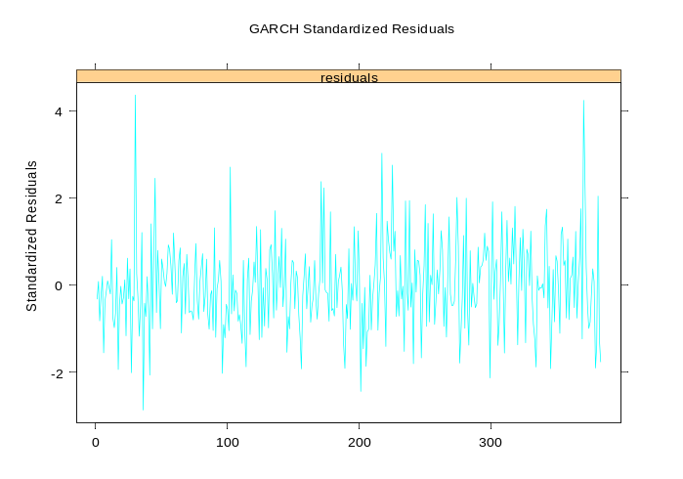
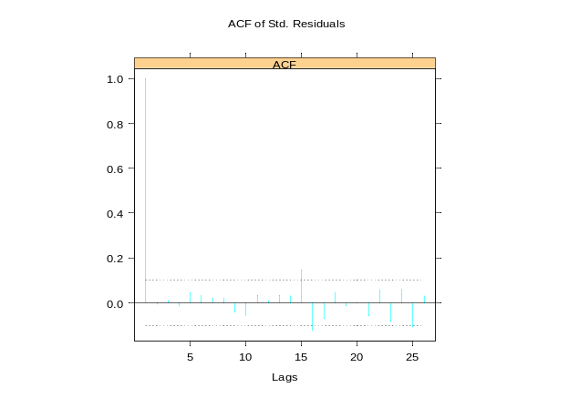
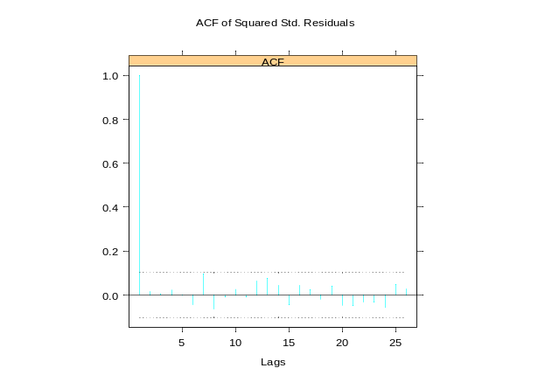
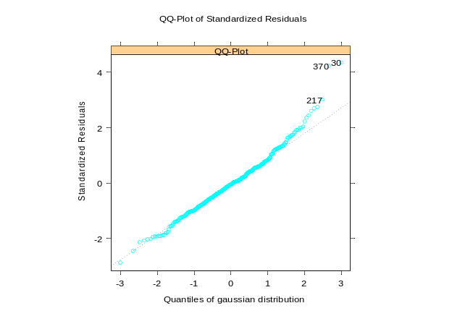
IOWA – Spirits

Figure 6: GARCH (1,1) diagnostic plots for the Iowa spirits series.

WEST VIRGINIA – Wine
Key Findings:
Analysis of Wine
 | Model | Estimate | Standard error | t-statistic | p-value | Percent change
ARIMA SAS | ARIMA (0,1,3) (0,1,1) | 0.562 | 0.053 | 10.53 | 0.00 | 75.5%
ARIMA S+ | MA(13) | 0.465 | 0.095 | 4.88 | 0.00 | 59.3%
GARCH S+ | GARCH(1,1) | 0.406 | 0.124 | 3.28 | 0.00 | 50.1%
Wagenaar & Holder | ARIMA (0,1,3) (0,1,1) | 0.393 | 0.052 | 7.56 | 0.00 | 48.2%
Table 6: Analysis of wine privatisation in West Virginia, July 1981
The ARIMA model overestimates the permanent increase in consumption by 9.2%. Since the GARCH estimate for the step function is highly significant, we can conclude that inferences about the intervention without accounting for stochastic volatility are inaccurate in this case. The ‘size effect’ of privatisation is substantially different under the two models and thus the inclusion of volatility effects makes a considerable impact on our conclusions. Specifically, it deflates the magnitude of the purported increase. It is also worth noting that the standard error estimate from the GARCH model is slightly larger here, implying decreased estimation efficiency.
Diagnostics:
S-Plus Maximum Likelihood Estimation
Mean process: |  |  | West Virginia wine |  |  | Exogenous variables in variance eq.
Conditional variance equation: |  |  | GARCH(1,1) |  |  | step function
Estimated coefficients: | Value | Standard error | t-statistic | p-value |  | Diagnostic tests: | Statistic | p-value
A | 0.0009 | 0.0004 | 1.96 | 0.05 |  | SW normality test | 0.978 | 0.07
ARCH(1) | 0.1920 | 0.0712 | 2.70 | 0.01 |  | LB test for std. residuals | 10.29 | 0.59
GARCH(1) | 0.7225 | 0.0903 | 8.01 | 0.00 |  | LB test for squared std. residuals | 7.14 | 0.85
Table 7: Conditional variance parameter estimates and diagnostic tests for the W. Virginia wine series.

WEST VIRGINIA – Wine
Table 7 indicates that the GARCH parameter estimates are significant and the stationarity condition has been satisfied. This confirms the existence of time-varying volatility and justifies the use of the GARCH modelling framework. Serial dependence in the residuals has also been accounted for and the normality assumption has been upheld, according to the diagnostic test statistics. The diagnostic plots in Figure 7 also support the validity of the GARCH (1,1), presenting no serious evidence against the model specification.
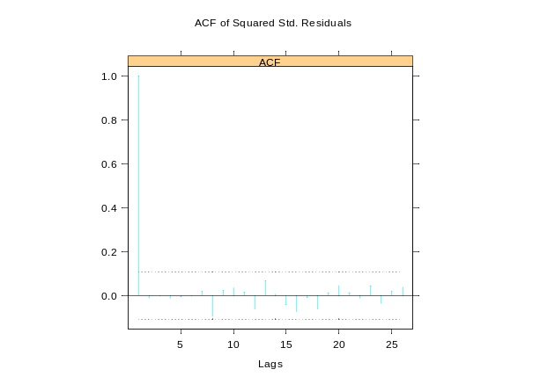
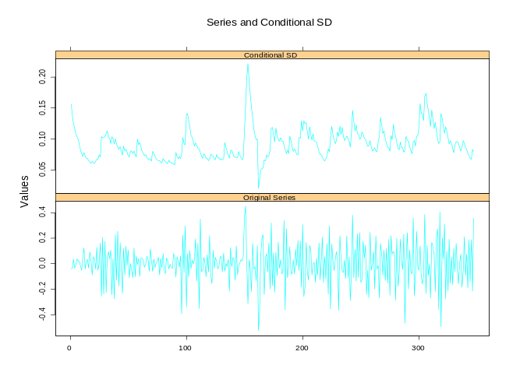
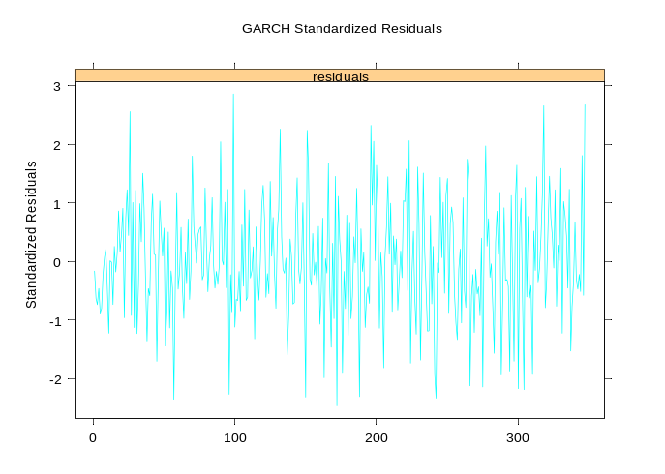
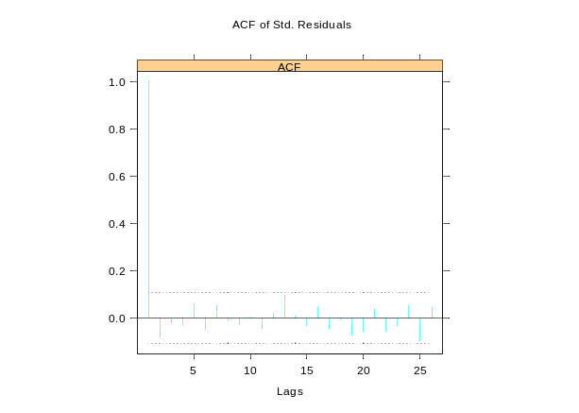
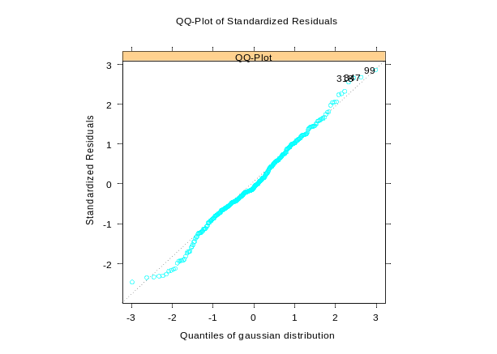

Figure 7: GARCH (1,1) diagnostic plots for the West Virginia wine series.
WEST VIRGINIA – Spirits
Key Findings:
Analysis of Spirits
 | Model | Estimate | Standard error | t-statistic | p-value | Percent change
ARIMA SAS | ARIMA (0,1,1) (0,1,1) | 0.207 | 0.064 | 3.26 | 0.00 | 23.0%
ARIMA S+ | MA(13) | 0.146 | 0.031 | 4.74 | 0.00 | 15.7%
GARCH S+ | GARCH(1,1) | -0.159 | 0.027 | -5.94 | 0.00 | -14.7%
Table 8: Analysis of spirits privatisation in West Virginia, March 1990
The ARIMA model overestimates the permanent change in consumption by 30.4%. This is a very substantial difference brought about by the inclusion of volatility effects, and in fact we witness a decrease in consumption levels, contrary to the hypothesised effect! This reversal of direction in the permanent change is a very interesting result and warrants further discussion. While it is surprising to find such conflicting results between the GARCH and ARIMA estimates, there are several plausible explanations behind such a discrepancy. These will be discussed in further detail in the ‘Conclusions’ section. Table 8 also suggests that the GARCH modelling resulted in increased estimation efficiency, evidenced by the smaller standard errors.
Diagnostics:
S-Plus Maximum Likelihood Estimation
Mean process: |  |  | West Virginia spirits |  |  | Exogenous variables in variance eq.
Conditional variance equation: |  |  | GARCH(1,1) |  |  | none
 | Step Function Coefficient Estimates |  |  |  |  | Standard Error Estimates
Estimated coefficients: | Value | Standard error | t-statistic | p-value |  | Diagnostic tests: | Statistic | p-value
A | 0.0004 | 0.0001 | 2.82 | 0.01 |  | SW normality test | 0.978 | 0.06
ARCH(1) | 0.1831 | 0.0553 | 3.31 | 0.00 |  | LB test for std. residuals | 8.11 | 0.78
GARCH(1) | 0.7684 | 0.0599 | 12.83 | 0.00 |  | LB test for squared std. residuals | 6.07 | 0.91
Table 9: Conditional variance parameter estimates and diagnostic tests for the W. Virginia spirits series.
WEST VIRGINIA – Spirits
The parameter estimates for the conditional variance equation and the corresponding diagnostic tests shown in Table 9 indicate the need for GARCH modelling while the diagnostic plots in Figure 8 present no serious evidence against the GARCH (1,1) specification. The only minor concern is the marginally significant sample autocorrelation at lag 25 (possibly the second seasonal lag) of the squared standardised residuals. However for our purposes, the model is considered adequate.
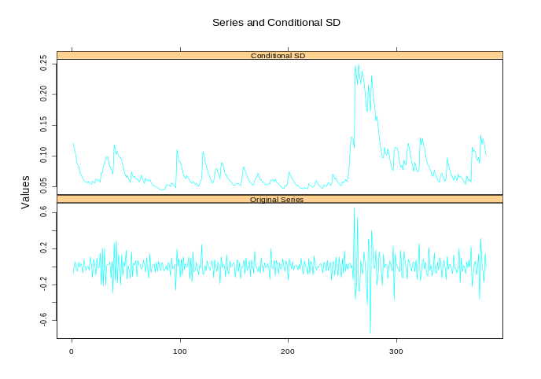
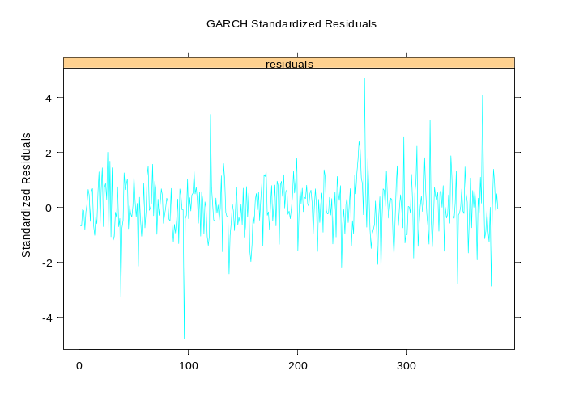
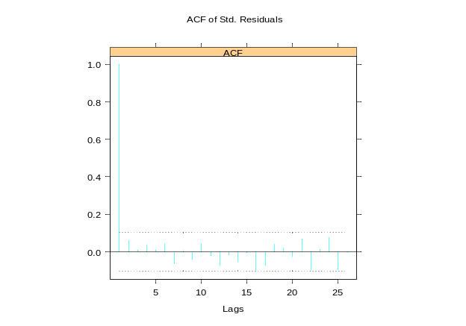
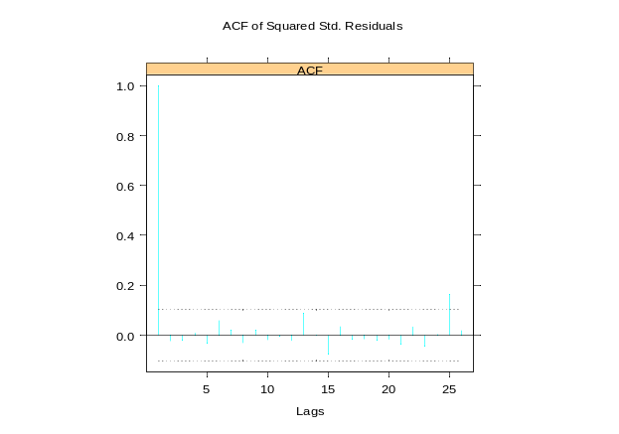
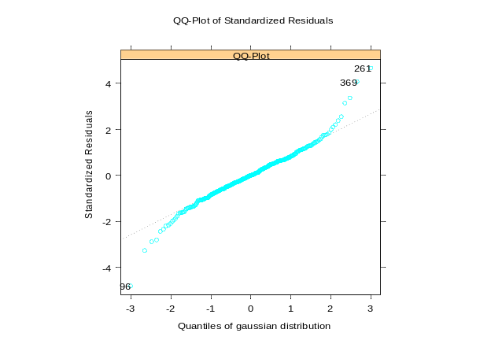

Figure 8: GARCH (1,1) diagnostic plots for the West Virginia spirits series.

IDAHO – Wine
Key Findings:
Analysis of Wine
 | Model | Estimate | Standard error | t-statistic | p-value | Percent change
ARIMA SAS | ARIMA (0,0,0) (0,1,1) | 0.930 | 0.039 | 24.03 | 0.00 | 153.3%
ARIMA S+ | MA(13) | 0.869 | 0.078 | 11.14 | 0.00 | 138.4%
GARCH S+ | GARCH(1,2) "t" | 0.833 | 0.068 | 12.19 | 0.00 | 130.0%
Wagenaar & Holder | ARIMA (0,0,1) (0,1,1) | 0.917 | - | - | - | 150.1%
Table 10: Analysis of wine privatisation in Idaho, July 1971
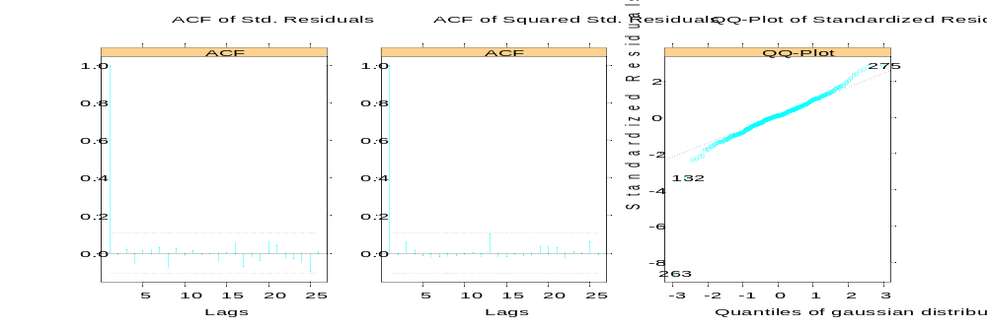
The ARIMA model overestimates the permanent increase in consumption by 8.4%. The inclusion of volatility effects also leads to increased estimation efficiency, evidenced by the smaller standard errors. However, our findings for the Idaho case bear further scrutiny. It was observed that ARIMA modelling sufficiently accounted for serial correlation in the residuals and the squared residuals, thereby rendering the need for GARCH modelling superfluous. Some diagnostic plots for the ARIMA model are provided in Figure 9 below, demonstrating the adequacy of standard intervention modelling for the Idaho wine series.
Figure 10: Some ARIMA diagnostic plots for the Idaho wine series.
IDAHO – Wine
Diagnostics:
S-Plus Maximum Likelihood Estimation
Mean process: |  |  | Idaho wine |  |  | Exogenous variables in variance eq.
Conditional variance equation: |  |  | GARCH(1,2) "t" |  |  | none
 | Step Function Coefficient Estimates |  |  |  |  | Standard Error Estimates
Estimated coefficients: | Value | Standard error | t-statistic | p-value |  | Diagnostic tests: | Statistic | p-value
A | 0.0117 | 0.0040 | 2.94 | 0.00 |  | SW normality test | 0.978 | 0.06
ARCH(1) | 0.0560 | 0.0265 | 2.11 | 0.04 |  | LB test for std. residuals | 8.11 | 0.78
GARCH(1) | 0.9038 | 0.1590 | 5.69 | 0.00 |  | LB test for squared std. residuals | 6.07 | 0.91
GARCH(2) | -0.4853 | 0.0206 | -23.62 | 0.00
TDFI | 5.0623 | 0.9229 | 5.49 | 0.00
Table 11: Conditional variance parameter estimates and diagnostic tests for the Idaho wine series.
Table 11 suggests that conventional criteria for GARCH model adequacy have been satisfied for the Idaho wine series. Interestingly, the conditional variance equation is best characterised by the GARCH (1,2) with a conditional t-distribution, as opposed to the GARCH (1,1) with a Gaussian distribution, identified for all other states examined. Whether this peculiarity can be attributed to the adequacy of the ARIMA model is certainly a question worth asking since this is the only instance that modelling the volatility effects is explicitly unnecessary. Figure 11 displays the diagnostic plots for this ‘instructive’ GARCH model.
IDAHO – Wine
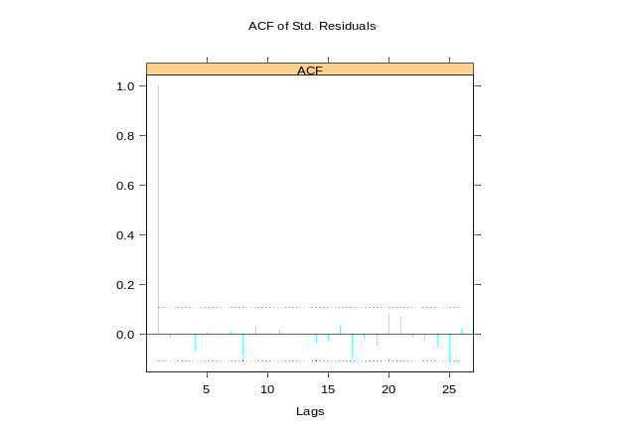
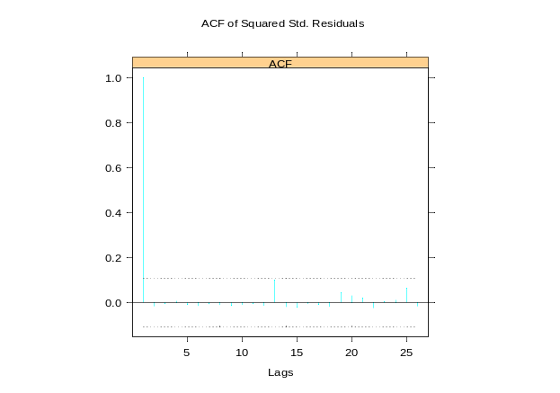
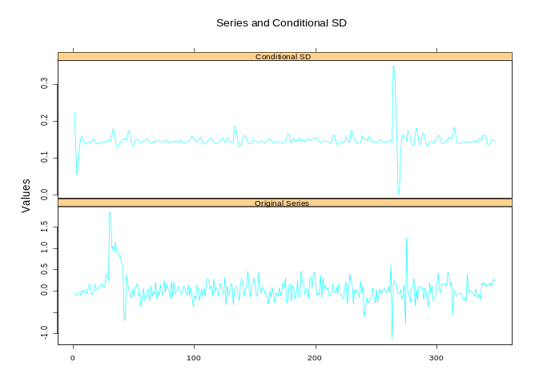
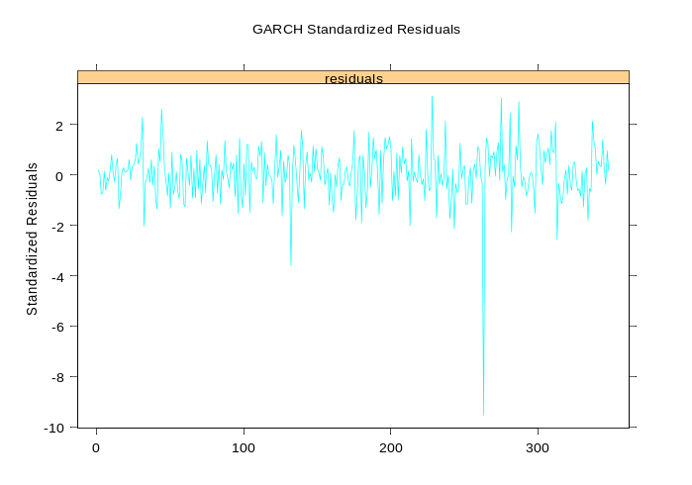
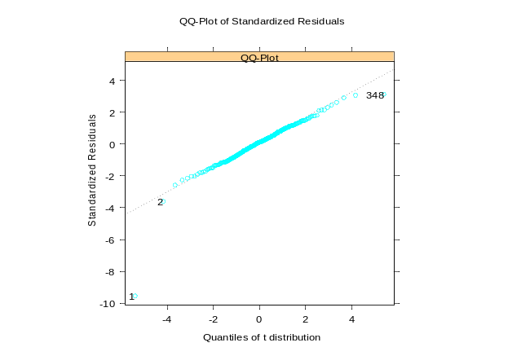

Figure 11: GARCH (1,2) ‘t’ diagnostic plots for the Idaho wine series.

MAINE – Wine
Key Findings:
Analysis of Wine
 | Model | Estimate | Standard error | t-statistic | p-value | Percent change
ARIMA SAS | ARIMA (0,0,0) (0,1,1) | 0.837 | 0.048 | 17.54 | 0.00 | 131.0%
ARIMA S+ | MA(13) | 0.841 | 0.045 | 18.51 | 0.00 | 131.9%
GARCH S+ | GARCH(1,1) | 0.836 | 0.045 | 18.62 | 0.00 | 130.6%
Wagenaar & Holder | ARIMA (0,0,1) (0,1,1) | 0.862 | - | - | - | 136.7%
Table 12: Analysis of wine privatisation in Maine, January 1971
The ARIMA model overestimates the permanent increase in consumption by 1.3%. While the GARCH parameter estimate is highly significant, the inclusion of volatility effects did not result in significantly different findings from that of an ARIMA model for the Maine wine series. There was also no observed improvement in estimation efficiency after adjusting for GARCH properties and thus the need to go beyond ARIMA intervention analysis is debatable in this case.
Diagnostics:
S-Plus Maximum Likelihood Estimation
Mean process: |  |  | Maine wine |  |  | Exogenous variables in variance eq.
Conditional variance equation: |  |  | GARCH(1,1) |  |  | none
Estimated coefficients: | Value | Standard error | t-statistic | p-value |  | Diagnostic tests: | Statistic | p-value
A | 0.0077 | 0.0021 | 3.67 | 0.00 |  | SW normality test | 0.987 | 0.74
ARCH(1) | 0.1317 | 0.0416 | 3.17 | 0.00 |  | LB test for std. residuals | 4.31 | 0.98
GARCH(1) | 0.6122 | 0.2018 | 3.03 | 0.00 |  | LB test for squared std. residuals | 7.00 | 0.86
Table 13: Conditional variance parameter estimates and diagnostic tests for the Maine wine series.
Table 13 indicates that our GARCH modelling strategy for the Maine wine series provided a stationary solution and produced white noise standardised residuals. The diagnostic plots in Figure 11 also support the adequacy of the model, presenting no serious evidence against the GARCH (1,1) specification.
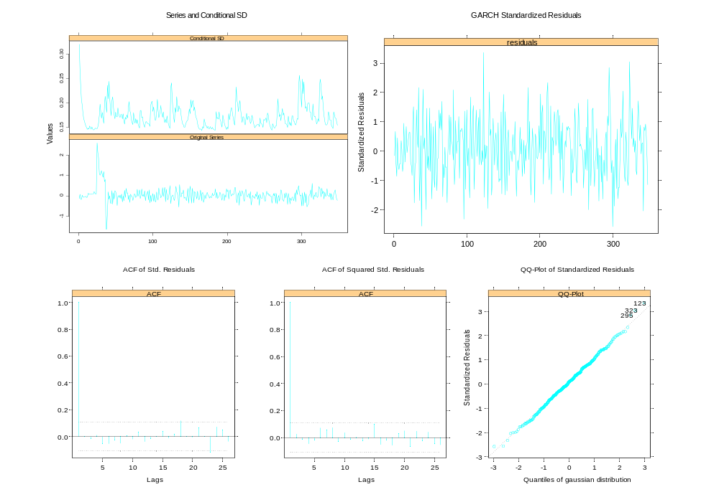
MAINE – Wine
Figure 11: GARCH (1,1) diagnostic plots for the Maine wine series.

MONTANA – Wine
Key Findings:
Analysis of Wine
 | Model | Estimate | Standard error | t-statistic | p-value | Percent change
ARIMA SAS | ARIMA (0,1,1) (0,1,1) | 0.459 | 0.045 | 10.12 | 0.00 | 58.2%
ARIMA S+ | MA(13) | 0.481 | 0.030 | 15.88 | 0.00 | 61.7%
GARCH S+ | GARCH(1,1) | 0.394 | 0.030 | 12.99 | 0.00 | 48.3%
Wagenaar & Holder | ARIMA (0,1,1) (0,1,1) | 0.561 | - | - | - | 75.3%
Table 14: Analysis of wine privatisation in Montana, July 1979
The ARIMA model overestimates the permanent increase in consumption by 13.4%. While there is no improvement in estimation efficiency for the Montana wine series, the considerable difference in parameter estimates attributable to volatility effects justifies the use of our GARCH modelling approach. The adjustment for GARCH properties therefore makes a significant impact on the magnitude of the hypothesised increase and standard intervention analysis is considered inadequate in this case.
Diagnostics:
S-Plus Maximum Likelihood Estimation
Mean process: |  |  | Montana wine |  |  | Exogenous variables in variance eq.
Conditional variance equation: |  |  | GARCH(1,1) |  |  | none
Estimated coefficients: | Value | Standard error | t-statistic | p-value |  | Diagnostic tests: | Statistic | p-value
A | 0.0011 | 0.0004 | 2.69 | 0.01 |  | SW normality test | 0.982 | 0.32
ARCH(1) | 0.2208 | 0.0694 | 3.18 | 0.00 |  | LB test for std. residuals | 11.21 | 0.51
GARCH(1) | 0.6017 | 0.1044 | 5.76 | 0.00 |  | LB test for squared std. residuals | 6.30 | 0.90
Table 15: Conditional variance parameter estimates and diagnostic tests for the Montana wine series.
Table 15 indicates that conventional criteria for GARCH model adequacy is satisfied while the diagnostic plots shown in Figure 12 present no serious evidence against the GARCH (1,1) specification for the Montana wine series.
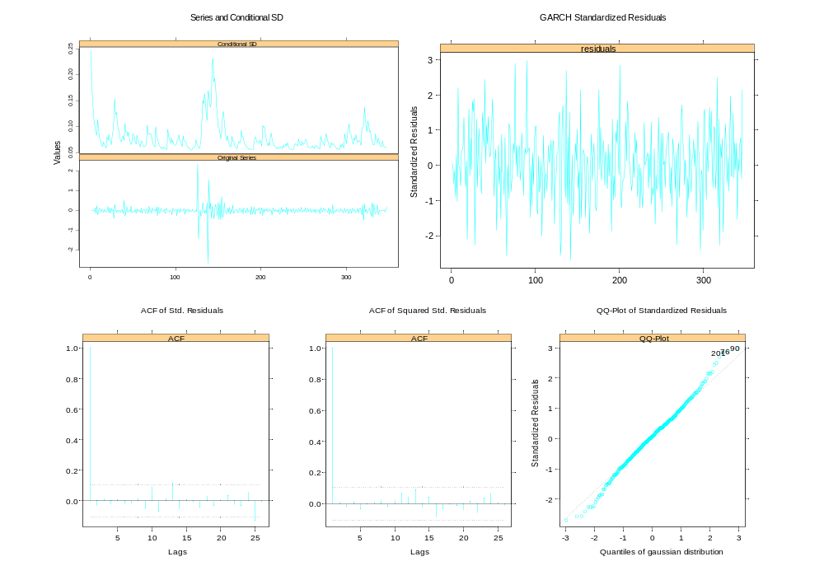
MONTANA – Wine
Figure 12: GARCH (1,1) diagnostic plots for the Montana wine series.

NEW HAMPSHIRE – Wine
Key Findings:
Analysis of Wine
 | Model | Estimate | Standard error | t-statistic | p-value | Percent change
ARIMA SAS | ARIMA (0,1,5) (0,1,1) | 0.101 | 0.053 | 1.93 | 0.05 | 10.7%
ARIMA S+ | MA(13) | 0.129 | 0.054 | 2.39 | 0.02 | 13.8%
GARCH S+ | GARCH(1,1) | 0.107 | 0.021 | 5.10 | 0.00 | 11.3%
Wagenaar & Holder | ARIMA (0,1,10) (0,1,1) | 0.122 | - | - | - | 13.0%
Table 16: Analysis of wine privatisation in New Hampshire, August 1978
The ARIMA model overestimates the permanent increase in consumption by 2.5%. Similar to the Maine experience, the GARCH model estimate does not present a significant deviation from the estimate obtained from the ARIMA model. However, we observe an improvement in estimation efficiency, with the inclusion of volatility effects generating smaller standard error estimates. Thus there is some utility to be gained from the GARCH adjustment process, namely the improved statistical properties of the modelling framework.
Diagnostics:
S-Plus Maximum Likelihood Estimation
Mean process: |  |  | New Hampshire wine |  |  | Exogenous variables in variance eq.
Conditional variance equation: |  |  | GARCH(1,1) |  |  | control variable
Estimated coefficients: | Value | Standard error | t-statistic | p-value |  | Diagnostic tests: | Statistic | p-value
A | 0.00089 | 0.00034 | 2.65 | 0.01 |  | SW normality test | 0.980 | 0.15
ARCH(1) | 0.3325 | 0.0930 | 3.58 | 0.00 |  | LB test for std. residuals | 5.68 | 0.93
GARCH(1) | 0.6219 | 0.0833 | 7.47 | 0.00 |  | LB test for squared std. residuals | 11.92 | 0.45
Table 17: Conditional variance parameter estimates & diagnostic tests for the New Hampshire wine series.
As is the case in previous states examined, the GARCH (1,1) model specification provides an adequate characterisation of the conditional variance equation, evidenced by Table 17 and the diagnostic plots displayed in Figure 13.
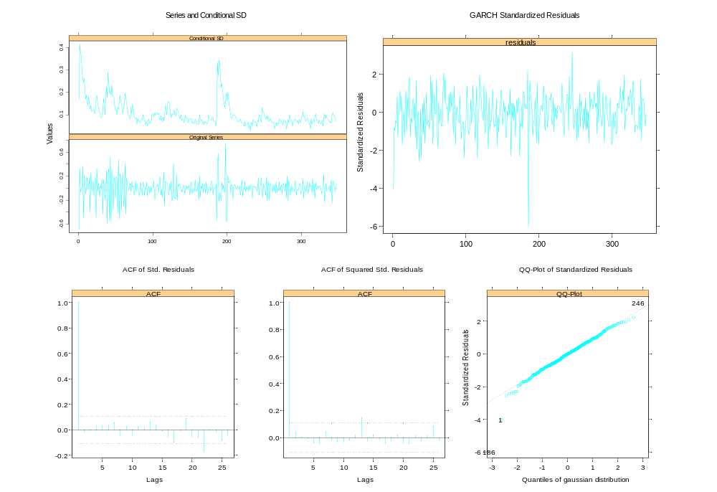
NEW HAMPSHIRE – Wine
Figure 13: GARCH (1,1) diagnostic plots for the New Hampshire wine series.

ALABAMA – Wine
Key Findings:
Analysis of Wine
 | Model | Estimate | Standard error | t-statistic | p-value | Percent change
ARIMA SAS | ARIMA (0,1,1) (0,1,1) | 0.128 | 0.100 | 1.28 | 0.20* | 13.6%*
ARIMA S+ | MA(13) | 0.167 | 0.074 | 2.25 | 0.03 | 18.1%
GARCH S+ | GARCH(1,1) | -0.340 | 0.044 | -7.67 | 0.00 | -28.9%
Wagenaar & Holder | ARIMA (0,1,8) (0,1,1) | 0.144 | - | - | - | 15.5%*
Table 18: Analysis of partial wine privatisation in Alabama, October 1973
The ARIMA model overestimates the permanent increase in consumption by 47.0% in relation to the partial privatisation policy implemented in October 1973. Like the West Virginia spirits case, not only do we witness a significant discrepancy between the ARIMA and GARCH estimates, but we also observe a reversal of direction in the purported change associated with the intervention.
Analysis of Wine
 | Model | Estimate | Standard error | t-statistic | p-value | Percent change
ARIMA SAS | ARIMA (0,1,1) (0,1,1) | 0.518 | 0.100 | 5.19 | 0.00 | 67.8%
ARIMA S+ | MA(13) | 0.547 | 0.066 | 8.33 | 0.00 | 72.8%
GARCH S+ | GARCH(1,1) | 0.856 | 0.050 | 17.16 | 0.00 | 135.3%
Wagenaar & Holder | ARIMA (0,1,8) (0,1,1) | 0.350 | - | - | - | 42.0%
Table 19: Analysis of full wine privatisation in Alabama, October 1980
The ARIMA model underestimates the permanent increase in consumption by 62.5% in relation to the full privatisation policy implemented in October 1980. This again is a substantial discrepancy that warrants further in-depth analysis to be detailed in the ‘Conclusions’ section. For the moment, it is worth noting that two step functions and a combined filtered pulse were included in the model to represent the two stages of wine privatisation that had taken place in Alabama.
ALABAMA – Wine
Diagnostics:
S-Plus Maximum Likelihood Estimation
Mean process: |  |  | Alabama wine |  |  | Exogenous variables in variance eq.
Conditional variance equation: |  |  | GARCH(1,1) |  |  | none
Estimated coefficients: | Value | Standard error | t-statistic | p-value |  | Diagnostic tests: | Statistic | p-value
A | 0.0006 | 0.0003 | 1.96 | 0.05 |  | SW normality test | 0.987 | 0.76
ARCH(1) | 0.4454 | 0.0997 | 4.47 | 0.00 |  | LB test for std. residuals | 8.34 | 0.76
GARCH(1) | 0.5261 | 0.0536 | 9.82 | 0.00 |  | LB test for squared std. residuals | 13.12 | 0.36
Table 20: Conditional variance parameter estimates and diagnostic tests for the Alabama wine series.
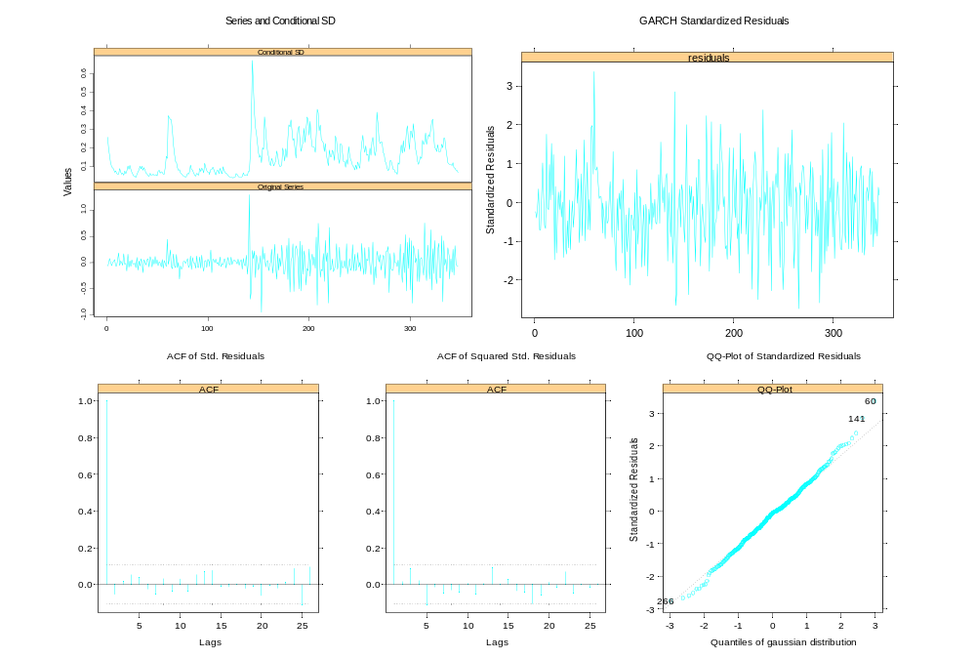
The GARCH (1,1) model specification again provides an adequate description of the conditional variance, evidenced by Table 20 and the diagnostic plots in Figure 14.
Figure 14: GARCH (1,1) diagnostic plots for the Alabama wine series.
ALABAMA – Spirits
Key Findings:
Analysis of Spirits
 | Model | Estimate | Standard error | t-statistic | p-value | Percent change
ARIMA SAS | ARIMA (0,1,4) (0,1,1) | -0.059 | 0.025 | -2.34 | 0.02 | -5.7%
ARIMA S+ | MA(13) | -0.053 | 0.017 | -3.05 | 0.00 | -5.2%
GARCH S+ | GARCH(1,1) | -0.035 | 0.024 | -1.46 | 0.15* | -3.4%*
Wagenaar & Holder | ARIMA (0,1,9) (0,1,1) | -0.051 | - | - | - | -5.0%*
Table 21: Analysis of spirits privatisation in Alabama, October 1980
Table 21 indicates that while the ARIMA model estimated a 5.2% permanent decrease associated with the intervention, the GARCH model failed to obtain an estimate significantly different from zero. Like in the Iowa spirits case, it is difficult to assess the impact of volatility effects for the Alabama spirits series given the insignificance of our GARCH model findings.
Diagnostics:
S-Plus Maximum Likelihood Estimation
Mean process: |  |  | Alabama spirits |  |  | Exogenous variables in variance eq.
Conditional variance equation: |  |  | GARCH(1,1) |  |  | none
Estimated coefficients: | Value | Standard error | t-statistic | p-value |  | Diagnostic tests: | Statistic | p-value
A | 0.0001 | 0.0001 | 1.57 | 0.12 |  | SW normality test | 0.986 | 0.71
ARCH(1) | 0.0649 | 0.0315 | 2.06 | 0.04 |  | LB test for std. residuals | 10.56 | 0.57
GARCH(1) | 0.8687 | 0.0626 | 13.89 | 0.00 |  | LB test for squared std. residuals | 20.86 | 0.05
Table 22: Conditional variance parameter estimates and diagnostic tests for the Alabama spirits series.
Table 22 certainly indicates our model’s lack of adequacy, both in terms of insignificant parameter coefficients, with the p-value of = 0.12, and the unsatisfactory Ljung-Box test statistic for the standardised squared residuals. The diagnostic plots in Figure 15 confirm our modelling strategy’s inability to capture the volatility effects successfully for the Alabama spirits series.
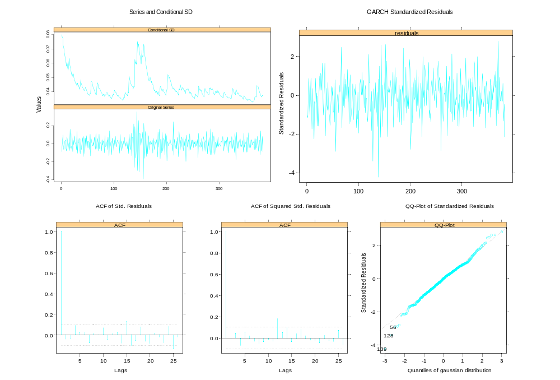
ALABAMA – Spirits
Figure 15: GARCH (1,1) diagnostic plots for the Alabama spirits series.

5 Conclusion

Comparison of GARCH and ARIMA models
Wine | Step Function Parameter Estimates |  |  |  |  | Standard Error Estimates
 | State | GARCH estimate | ARIMA estimate | Difference |  | GARCH std.error | ARIMA std. error | Difference
 | Iowa* | 38.0% | 42.7% | -4.7% |  | 0.189 | 0.066 | -0.123
 | West Virginia | 50.1% | 59.3% | -9.2% |  | 0.124 | 0.095 | -0.029
 | Idaho | 130.0% | 138.4% | -8.4% |  | 0.068 | 0.078 | 0.010
 | Maine | 130.6% | 131.9% | -1.3% |  | 0.045 | 0.045 | 0.000
 | Montana | 48.3% | 61.7% | -13.4% |  | 0.030 | 0.030 | 0.000
 | New Hampshire | 11.3% | 13.8% | -2.5% |  | 0.021 | 0.054 | 0.033
 | Alabama (partial) | -28.9% | 18.1% | -47.0% |  | 0.044 | 0.074 | 0.030
 | Alabama (full) | 135.3% | 72.8% | 62.5% |  | 0.050 | 0.066 | 0.016
Spirits | Step Function Parameter Estimates |  |  |  |  | Standard Error Estimates
 | State | GARCH estimate | ARIMA estimate | Difference |  | GARCH std.error | ARIMA std. error | Difference
 | Iowa* | -0.9% | 4.6% | 5.5% |  | 0.027 | 0.026 | -0.001
 | West Virginia | -14.7% | 15.7% | 30.4% |  | 0.027 | 0.031 | 0.004
 | Alabama* | -3.4% | -5.2% | -1.8% |  | 0.024 | 0.017 | -0.007
Table 23: Comparative analysis of GARCH and ARIMA model estimates for the permanent change in consumption. A negative (positive) difference implies that the ARIMA model has overestimated (underestimated) the permanent change by not accounting for volatility effects.
A key objective of this study is to determine whether there is a change in the volatility structure of alcohol consumption after privatisation. In general, it was found that the volatility structure does indeed change dynamically, exhibiting time-dependent behaviour following intervention. These ‘volatility effects’ are modelled using GARCH techniques for the purpose of determining the validity of standard intervention analysis. In particular, we compare the results from fitting ARIMA intervention models with the more rigorous GARCH framework that allows adjustment for volatility effects. Consequently, we empirically investigate how adjustment for GARCH properties affects the magnitude and significance of the step function parameter, which represents the hypothesised long-term or permanent change in alcohol consumption levels.
From Table 23 it is concluded that the GARCH intervention models considered here generally:
- Reduce the magnitude of the estimated permanent change in consumption.
- Increase estimation efficiency by generating lower standard error estimates.
Thus the inclusion of volatility effects significantly changes our inferences about the impact of privatisation on alcohol consumption. While standard ARIMA intervention models tend to overestimate the permanent change, this is not to say that our modelling strategy was the preferred method of analysis in all the cases examined. Recall that for the Idaho case, the adjustment for volatility effects was deemed unnecessary and the ARIMA model was considered adequate. The lack of significant differences between ARIMA and GARCH estimates for Maine and New Hampshire also suggest that volatility effects may not have an influential impact on intervention parameters. Moreover, our GARCH methodology failed to produce satisfactory model outcomes for Iowa (wine and spirits) and Alabama (spirits). The shortfalls of our analysis however are overshadowed by evidence from the other study states.

By allowing for nonlinear intertemporal dependence in the residuals series, we were able to detect not only significant discrepancies between ARIMA and GARCH model estimates, but more importantly, the reversal of direction to the hypothesised effect, observed in the West Virginia spirits and Alabama wine (partial) cases. A possible explanation for this surprising result is the impact of volatility effects on the other exogenous variables in the mean process, namely the aggregate consumption of non-intervention states and the filtered pulse function. Because these are control variables that account for nationwide sales trends and stocking effects, it is possible that the ARIMA model, with its incorrectly specified variance structure, will fail to effectively discriminate between the underlying effects of control variables and the step function parameter. An ARIMA model as such may report a positive estimate for the long-term change, when in fact a decrease in consumption levels has occurred given the stochastic nature of the volatility. Furthermore, we were able to recognise the very substantial underestimation of the permanent change associated with Alabama’s full privatisation policy. These results highlight the appropriateness of GARCH intervention models in identifying potential biases that can arise from the misspecification of the volatility structure.

While the use of GARCH models has received limited attention outside the finance and econometrics literature, this study demonstrates its potential applicability and usefulness in the public health arena where similar variance anomalies have appeared, particularly in the area of alcohol consumption. By augmenting the standard ARIMA intervention model to accommodate for volatility effects, we are able to draw conclusions from a more rigorous analytical framework. This promising approach to interrupted time series analysis and intervention modelling hopes to deliver more accurate inferences about the intervention and therefore advance our understanding of the socio-economic consequences associated with deregulating the alcohol industry.
6 Suggestions for further work

In the absence of theoretical guidance from the literature, the determination of the ‘true’ long-term effect associated with an intervention is an inherently difficult problem. While adjusting for volatility effects permitted higher quality conclusions to be drawn from the data, there is still considerable scope for improvement, particularly through the use of Markov Chain Monte Carlo (MCMC) methods. By performing controlled experiments using simulated models of similar structure identified in our study, we can effectively test the validity of our findings and obtain more general conclusions. After simulating thousands of replications, we can theoretically ascertain ‘true’ parameter values. Moreover, by refitting the ‘wrong’ model without the GARCH errors, we can quantify the biases that result from variance misspecification.

However, our initial simulation attempts using S-Plus proved unsuccessful and were abandoned for this study due to time constraints. After an initial trial run, we encountered optimisation problems, with less than 50% of replications reaching convergence. Because of the complexity of the numerical algorithms involved, convergence to an optimal solution proved quite a challenge, however this part of the analysis is certainly worth investigating in the future.
References:
R. Batchelor and I. Orakcioglu (2003) “Event-related GARCH: the impact of stock dividends in Turkey” Applied Financial Economics (13), 295-307
T. Bollerslev (1986) “Generalized Autoregressive Conditional Heteroskedasticity” Journal of Econometrics (31), 307-27
G. Box and G. Jenkins (1976) Time Series Analysis: Forecasting and Control, revised edition, San Francisco, Holden-Day
A. Corhay and A. Tourani Rad (1996) “Conditional Heteroskedasticity Adjusted Market Model and an Event Study” Quarterly Review of Economics and Finance (36)(4), 529-538
R. Engle (1982) “Autoregressive Conditional Heteroskedasticity with Estimates of the Variance of United Kingdom Inflation” Econometrica (50)(4), 987-1006
H. Holder and A. Wagenaar (1990) “Effects of the elimination of a state monopoly on distilled spirits’ retail sales: a time-series analysis of Iowa” British Journal of Addiction (85), 1615-1625
G. Laxer, D. Green, T. Harrison and D. Neu (1994) Out of Control – Paying the Price for Privatizing Alberta’s Liquor Control Board. Ottawa: Canadian Centre for Policy Alternatives
R. D. Martin, J. Wang, H.Y. Gao, Y. Zhan and Z. Ding (2000) S+ GARCH User’s Manual, Data Analysis Products Division, MathSoft, Inc. Seattle, Washington
A. Wagenaar and H. Holder (1991) “A Change from Public to Private Sale of Wine: Results from Natural Experiments in Iowa and West Virginia” Journal of Studies on Alcohol (52)(2), 162-173
A. Wagenaar and H. Holder (1995) “Changes in Alcohol Consumption Resulting from the Elimination of Retail Wine Monopolies: Results from Five U.S. States” Journal of Studies on Alcohol (56)(5), 566-572
A. Wagenaar and J. Langley (1995) “Alcohol licensing system changes and alcohol consumption: introduction of wine into New Zealand grocery stores” Addiction (90), 773-783
Z. Wang, V. Salin, N. Hooker and D. Leatham (2002) “Stock market reaction to food recalls: a GARCH application” Applied Economics Letters (9), 979-987
Appendix
Construction of the Filtered Pulse Function:
Recall from p. 21 that temporary stocking effects were best modelled using the expression . Since the decay parameter δ could not be directly specified in S-Plus estimation, an appropriate filter was applied to the original pulse function such that:
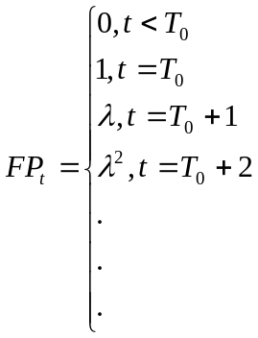
where FP_{t} represents the filtered pulse function, T₀ is the point of intervention, and λ is the coefficient that best describes the geometric decay pattern of the stocking effects. In our preliminary model runs, the δ parameter obtained from SAS is used as an initial guess for λ. Ultimately an optimal λ value is chosen using conventional information criteria and overall significance of parameter estimates. These λ values are given in Table 24 over the page.

Decay Values of Filtered Pulse Functions used in S-Plus Estimation
State | Wine |  |  | Spirits
State | SAS | S-Plus |  | SAS | S-Plus
Iowa | 0.67 | 0.37 |  | -0.03* | 0.30
West Virginia | 1.03* | 0.77 |  | 0.77 | 0.38
Idaho ** | -0.25* | 0.61
Idaho ** |  | 0.20
Maine | 0.62 | 0.62
Montana | 0.25 | 0.25
New Hampshire | -0.7* | no FP
Alabama (partial) | -0.12* | 0.40 |  | -0.79* | 0.25
Alabama (full) |  | 0.70
Table 24: Initial guesses for λ are shown in the SAS column while the optimal λ
used in the final model is listed in the S-Plus column.

* denotes either insignificant result or non-stationary solution.
** represents the two filtered pulse functions modelled for the Idaho case. The first
represents the initial stocking effects associated with the intervention, while
the second models the abrupt and inexplicable surge in consumption level that
occurs around 1990.

Note: New Hampshire was the only study state that had negligible stocking effects
and as such, did not require a pulse function.

Wagenaar and Holder’s (1991) study was criticised on three grounds: (i) the shortness of their post-intervention study period, (ii) a possible misspecification of their time-series intervention model, (iii) the inclusion of wine coolers in their sales data analysis, even though Iowa’s privatisation legislation did not change the wine cooler distribution system or wine cooler availability.
Alabama eliminated its monopoly on wine in two phases. In October 1973, the state implemented partial privatisation with three of its most populous counties (representing 31% of the total Alabama population) allowing private retail outlets to sell wine for off-premise consumption. The state effected full privatisation in October 1980, with privatised wine sales being permitted in all counties.
This quantity is measured by dividing the monthly ethanol litres sold (multiplied by 10), by the number of people over 21 years of age, and then taking its natural logarithm.
SAS allows only the specification of autoregressive components within its GARCH modelling option (AUTOREG procedure). Since moving average parameters cannot be specified, we are unable to perform the required ARIMA model fits that incorporate GARCH-type volatility structures inherent in the series.
Since the seasonal order of integration was 1 (D=1) for all ARIMA models, differencing at lag 12 was required in all cases. The need for further differencing at lag 1 rested upon whether d=1 or d=0.
Details regarding the construction of the filtered pulse can found in the Appendix.
There are two ways ARIMA models can be estimated in S-Plus, through the ‘arima.mle’ command and the method outlined above. The latter was chosen as the preferred method for ease of exposition.
In all the cases, the filtered pulse was excluded as an influential exogenous variable in the variance equation. While the inclusion of the step function and / or the control covariate appeared to improve model performance in some cases for the wine data, neither were found worthy of inclusion in the spirits data.
S-Plus User’s Guide (March 2000) pp.139-140
To improve the interpretability of the parameters, results were also converted to an estimated percentage change in alcohol sales after privatisation. Since the data was already transformed to the logarithm metric, conversion to percentage terms was a simple calculation using the expression 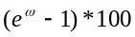, where is the parameter estimate.
Details regarding the estimation of all parameters are available upon request from the author. Note also that the intercept term was omitted from the mean process in all cases due to insignificance.
The p-values of the Ljung-Box statistics for the standardised and squared standardised residuals of the ARIMA model are: p = 0.97 and p = 0.92, respectively.
For the purposes of consistency and illustration, GARCH modelling was performed nonetheless.
The step functions were weighted according to the extent of privatisation, while the combined filtered pulse function consisted of two different decay parameter weights (see Appendix for details).

