Iowa
ARIMA (0,1,4) (0,1,1)

Parameter | Estimate | Std. Error | t-statistic | p-value
θ₁ | -0.767 | 0.054 | -14.16 | <.0001
θ₂ | -0.042 | 0.066 | -0.64 | 0.5234
θ₃ | 0.2612 | 0.066 | 3.98 | <.0001
θ₄ | -0.261 | 0.053 | -4.92 | <.0001
Θ₁ | -0.517 | 0.049 | 10.55 | <.0001
β | 0.481 | 0.106 | 4.54 | <.0001
ω₁ | 0.526 | 0.104 | 5.06 | <.0001
υ₁ | 0.422 | 0.108 | 3.92 | <.0001
δ₁ | 0.665 | 0.139 | 4.78 | <.0001
υ₋₁ | 0.621 | 0.096 | 6.49 | <.0001
υ₋₂ | 0.215 | 0.093 | 2.32 | 0.0203

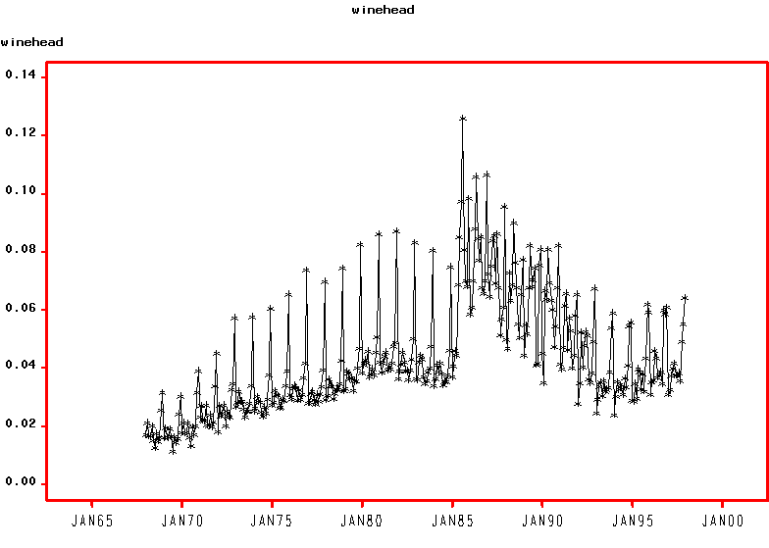

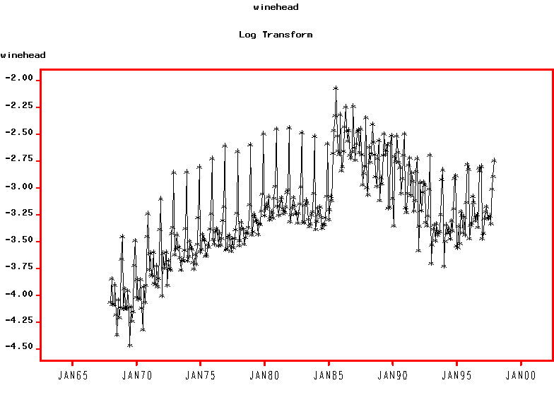
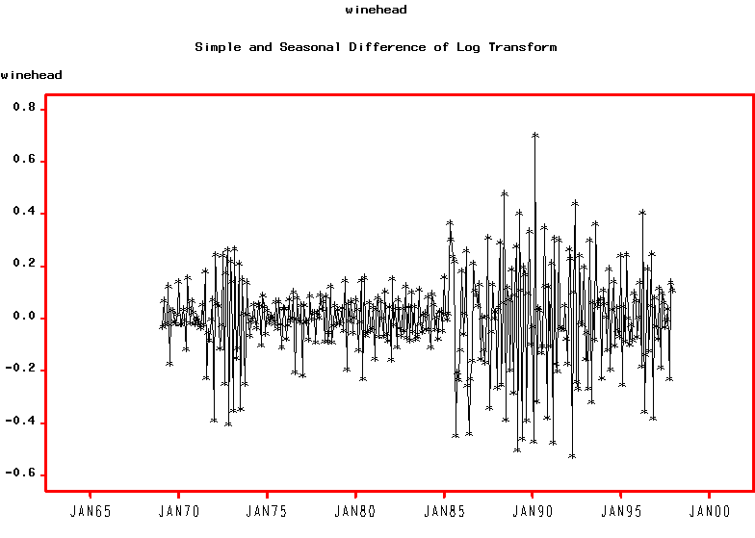
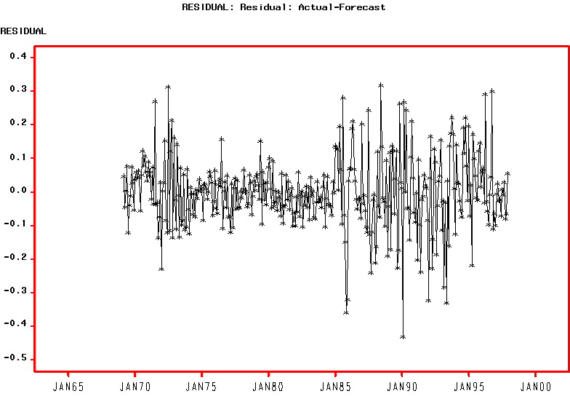
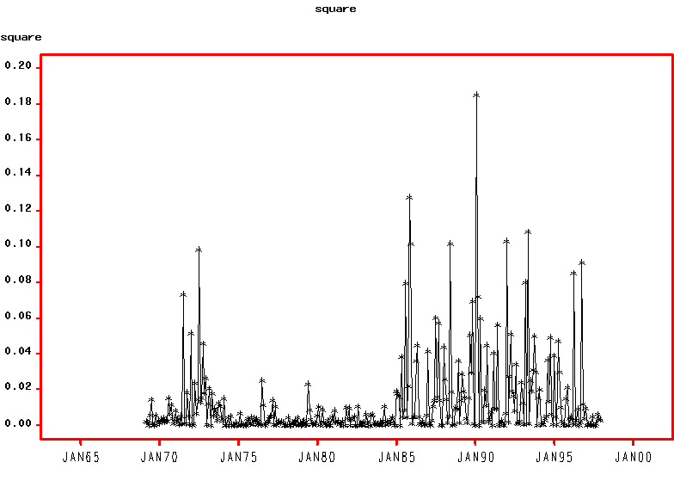

Estimated Coefficients:
--------------------------------------------------------------
Value Std.Error t value Pr(>|t|)
MA(1) -3.645e-008 1.715e-001 -2.126e-007 5.000e-001
MA(2) 0.000e+000 NA NA NA
MA(3) -2.821e-008 5.903e-001 -4.779e-008 5.000e-001
MA(4) 1.848e-009 4.025e-001 4.592e-009 5.000e-001
MA(5) 0.000e+000 NA NA NA
MA(6) 0.000e+000 NA NA NA
MA(7) 0.000e+000 NA NA NA
MA(8) 0.000e+000 NA NA NA
MA(9) 0.000e+000 NA NA NA
MA(10) 0.000e+000 NA NA NA
MA(11) 0.000e+000 NA NA NA
MA(12) -2.418e-008 1.776e-001 -1.362e-007 5.000e-001
MA(13) 1.410e-007 2.609e-001 5.405e-007 5.000e-001
MA(14) 0.000e+000 NA NA NA
MA(15) -4.400e-008 7.195e-001 -6.115e-008 5.000e-001
MA(16) -1.511e-008 3.755e-001 -4.024e-008 5.000e-001
xwine.s1 9.621e-001 3.170e-002 3.035e+001 0.000e+000
xwine.may85 -4.258e-002 1.466e-002 -2.904e+000 1.966e-003
xwine.jun85 -8.658e-002 2.307e-002 -3.753e+000 1.032e-004
xwine.fp1 -9.865e-004 9.913e+004 -9.952e-009 5.000e-001
xwine.ctrl -9.367e-002 1.798e-002 -5.211e+000 1.663e-007
A 6.956e-004 9.519e-005 7.308e+000 1.035e-012
ARCH(1) 1.000e-001 8.862e-002 1.128e+000 1.300e-001
ARCH(2) 1.000e-003 5.042e-002 1.983e-002 4.921e-001
ARCH(3) 1.000e-003 4.245e-002 2.356e-002 4.906e-001
zwine.s1 -5.582e-012 1.839e-004 -3.036e-008 5.000e-001
zwine.s2 -9.404e-012 2.564e-004 -3.668e-008 5.000e-001

--------------------------------------------------------------

AIC(27) = -1574.776
BIC(27) = -1470.845

Normality Test:
--------------------------------------------------------------
Jarque-Bera P-value Shapiro-Wilk P-value
188939 0 0.2662 0

Ljung-Box test for standardized residuals:
--------------------------------------------------------------
Statistic P-value Chi^2-d.f.
162.3 0 12

Ljung-Box test for squared standardized residuals:
--------------------------------------------------------------
Statistic P-value Chi^2-d.f.
64.98 2.752e-009 12

