Montana
ARIMA (0,1,1) (0,1,1)
Parameter | Estimate | Std. Error | t-statistic | p-value
θ₁ | 0.865 | 0.028 | 30.67 | <.001
Θ₁ | 0.710 | 0.042 | 17.10 | <.001
β | 0.704 | 0.077 | 9.11 | 0.001
ω₁ | 0.454 | 0.048 | 9.56 | <.001
υ₁ | 0.439 | 0.079 | 5.57 | <.001
υ₁₁ | 1.816 | 0.081 | 22.56 | <.001
δ₁ | 0.306 | 0.162 | 1.89 | <.001

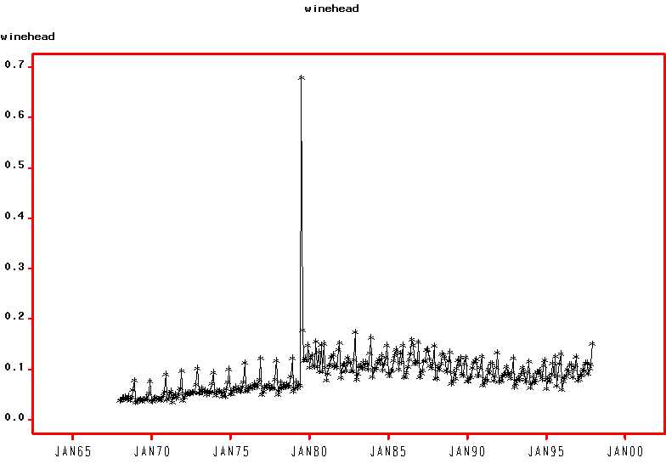

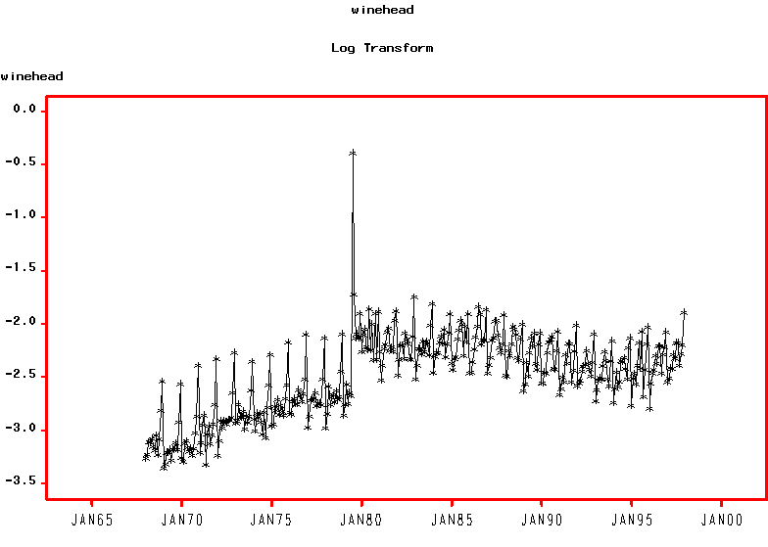
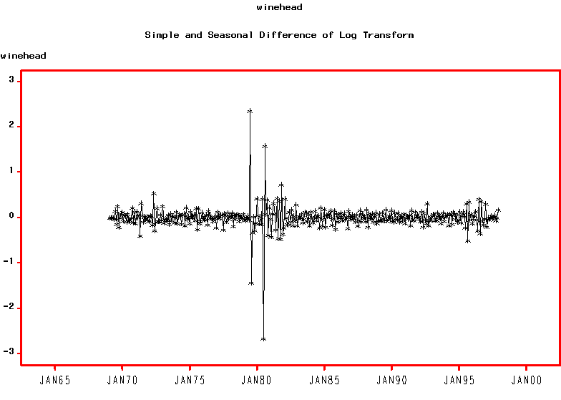
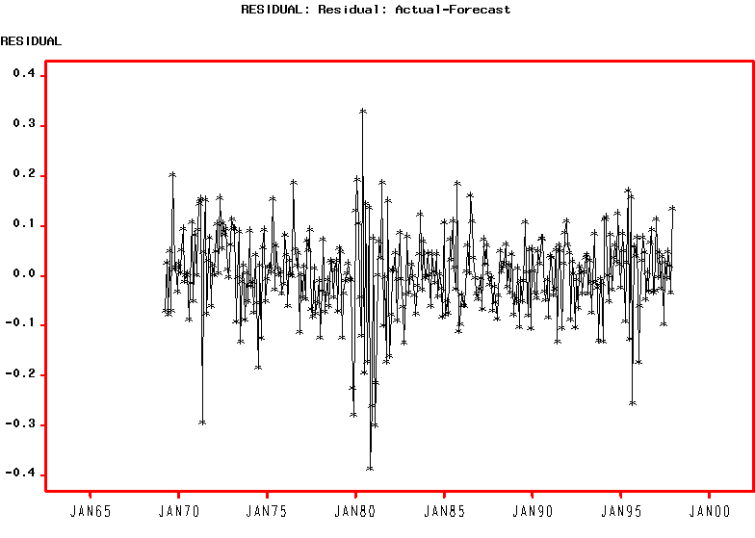
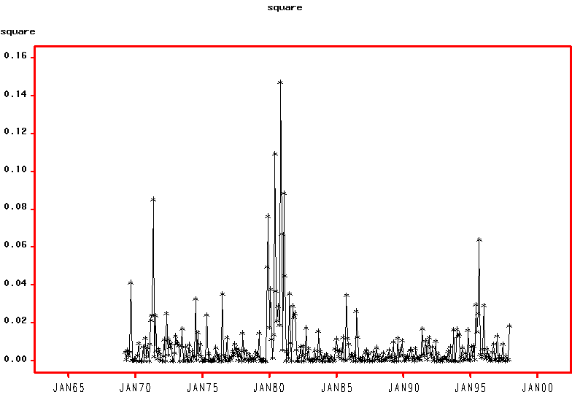

GARCH (1,1)
Parameter | Estimate | Std. Error | t-statistic | p-value
θ₁ | -0.856 | 0.028 | -30.75 | <.001
Θ₁ | -0.716 | 0.033 | -21.38 | <.001
β | 0.690 | 0.063 | 10.98 | <.001
ω₁ | 0.375 | 0.026 | 14.17 | <.001
υ₁ | 0.528 | 0.164 | 3.23 | <.001
υ₁₁ | 1.870 | 0.109 | 17.22 | <.001
δ₁ | 0.310 * | - | - | -
γ | 0.001 | 0.0003 | 2.82 | 0.005
a₁ | 0.188 | 0.058 | 3.22 | <.001
b₁ | 0.661 | 0.085 | 7.76 | <.001

Fit Statistics | Value
AIC | -749.27
BIC | -672.28
Test Statistics | Value | p-value
W test for normality | 0.986 | 0.682
Q_{LB} test for standardised residuals | 27.34 | 0.007
Q_{ML} test for squared std. residuals | 4.90 | 0.961

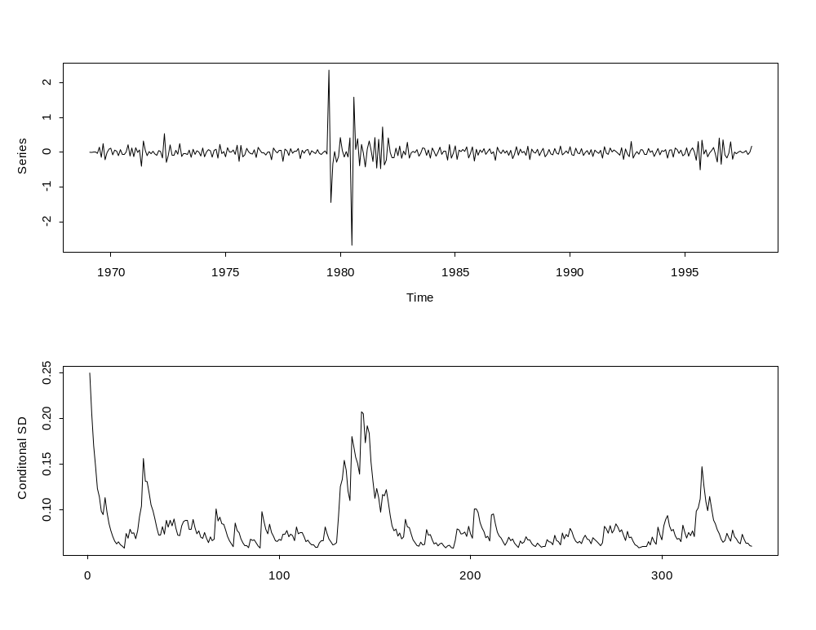

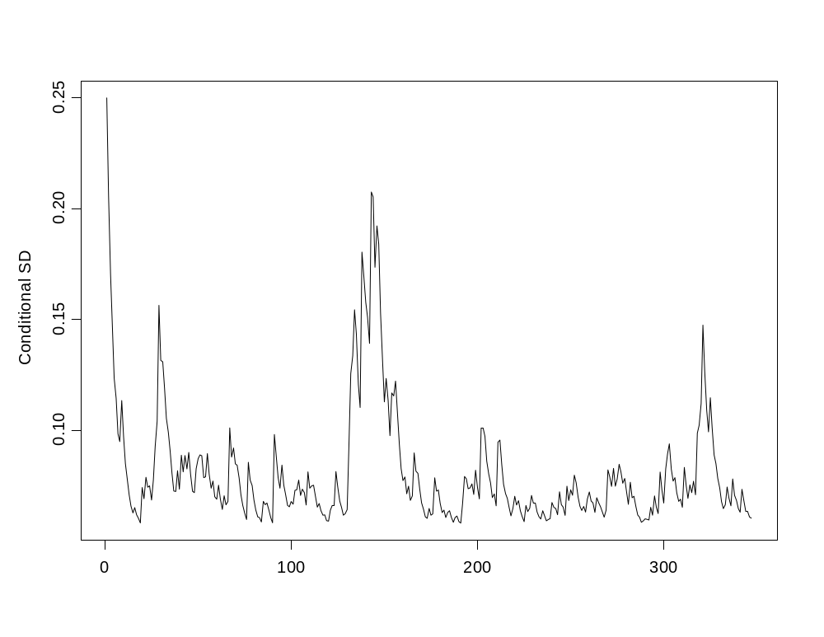

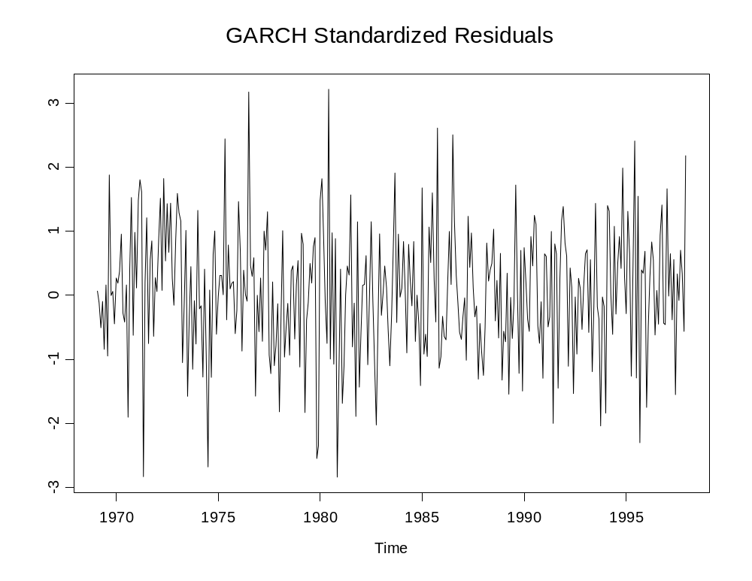

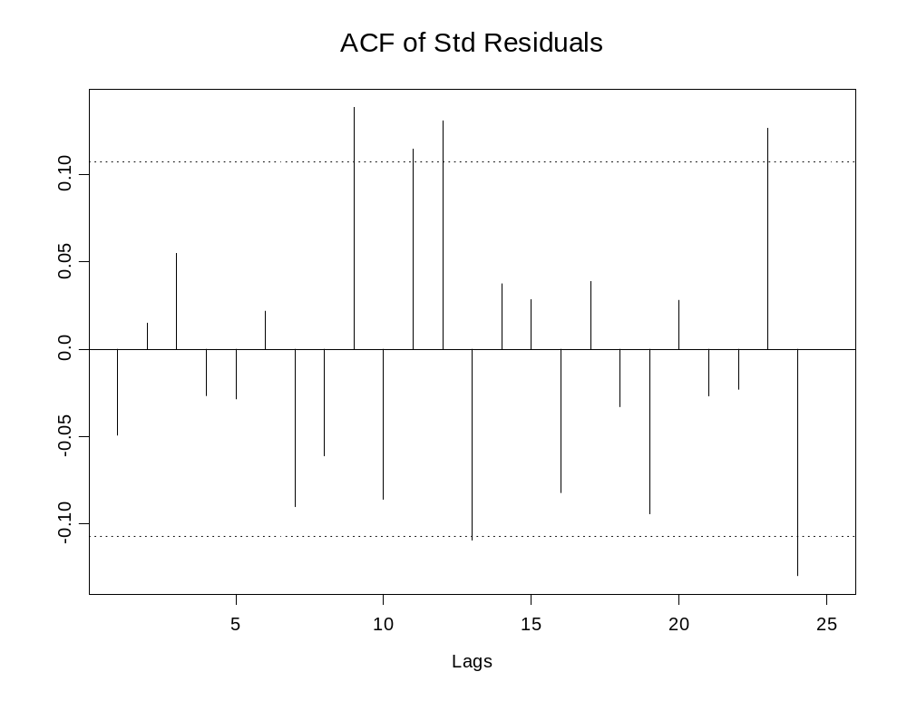
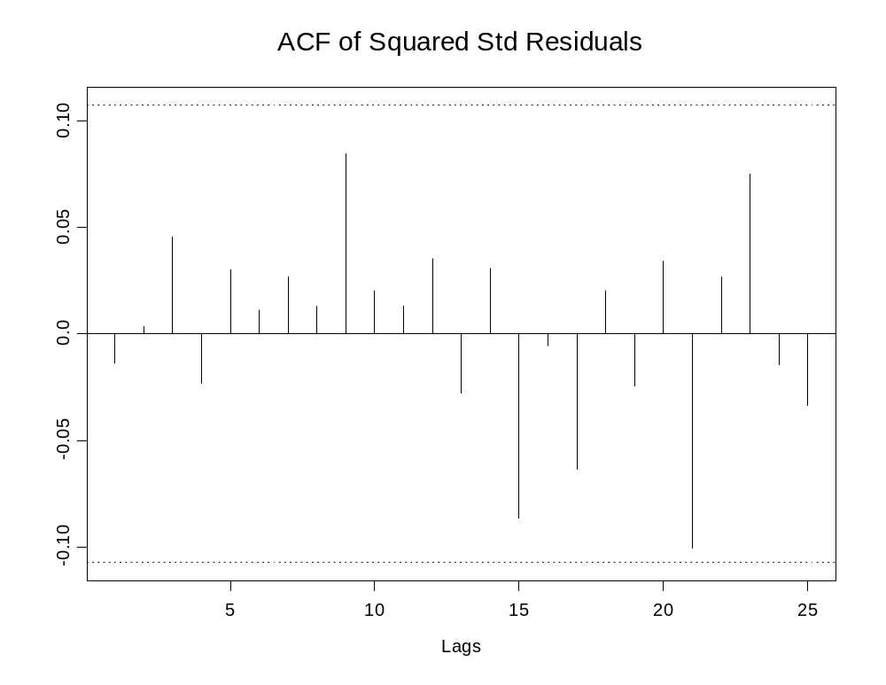

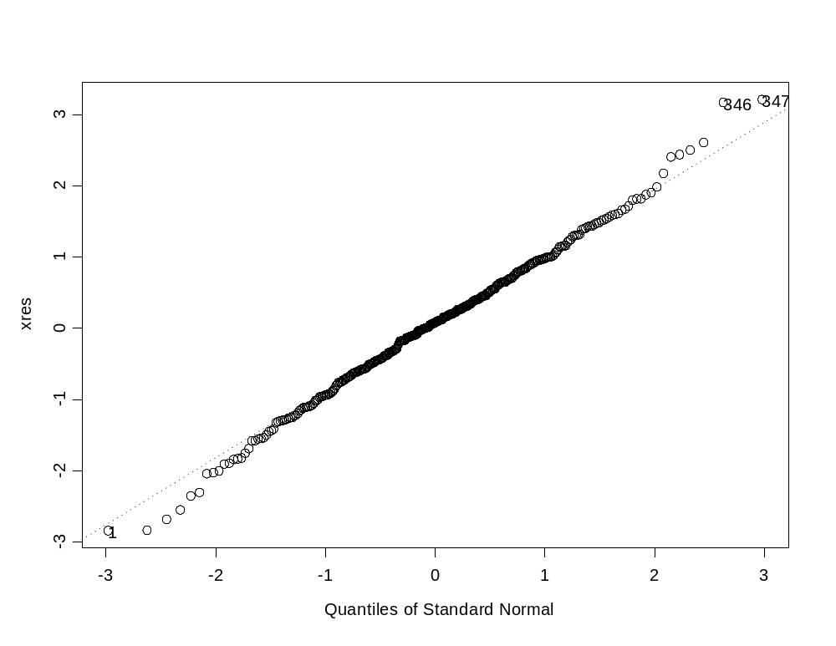

 | Coefficient Estimate |  |  | Standard Errors
Parameter | ARIMA | GARCH |  | ARIMA | GARCH
θ₁ | 0.865 | -0.856 |  | 0.028 | 0.028
Θ₁ | 0.710 | -0.716 |  | 0.042 | 0.033
β | 0.704 | 0.690 |  | 0.077 | 0.063
ω₁ | 0.454 | 0.375 |  | 0.048 | 0.026
υ₁ | 0.439 | 0.528 |  | 0.079 | 0.164
υ₁₁ | 1.816 | 1.870 |  | 0.081 | 0.109
δ₁ | 0.306 | 0.310 * |  | 0.162 | -
γ |  | 0.001 |  |  | 0.0003
a₁ |  | 0.188 |  |  | 0.058
b₁ |  | 0.661 |  |  | 0.085

