Alabama

ARIMA (0,1,1) (0,1,1)

Parameter | Estimate | Std. Error | t-statistic | p-value
θ₁ | -0.845 | 0.029 | -29.10 | <.001
Θ₁ | -0.732 | 0.041 | -18.04 | <.001
β | 0.450 | 0.132 | 3.40 | 0.001
ω₁ | 0.510 | 0.072 | 7.06 | <.001
ω₂ | 0.379 | 0.075 | 5.03 | <.001
υ₂ | 0.704 | 0.132 | 5.32 | <.001

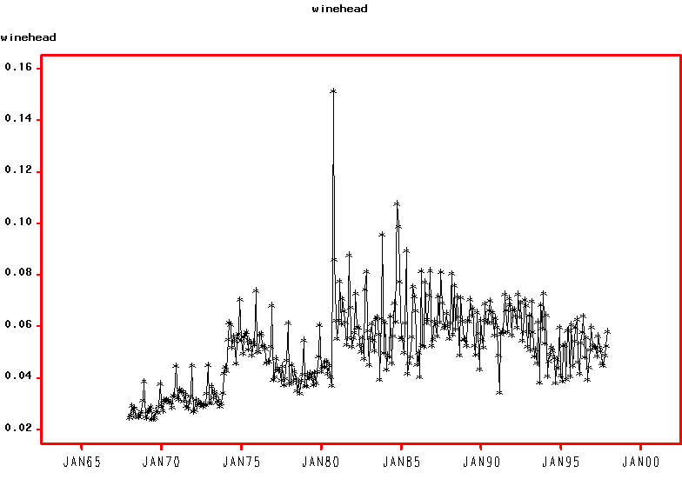

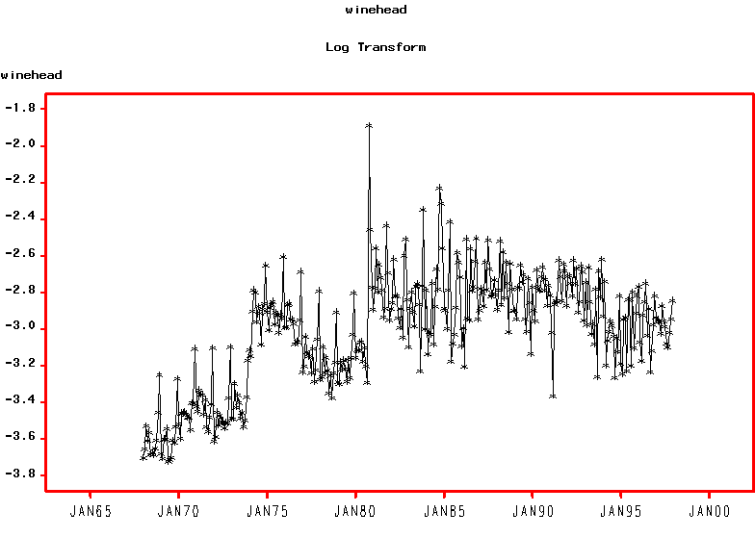
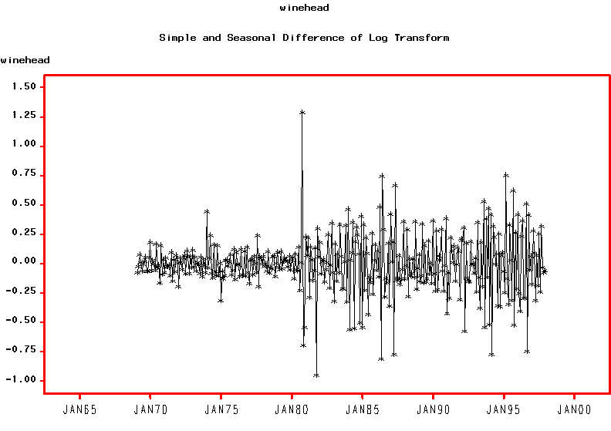
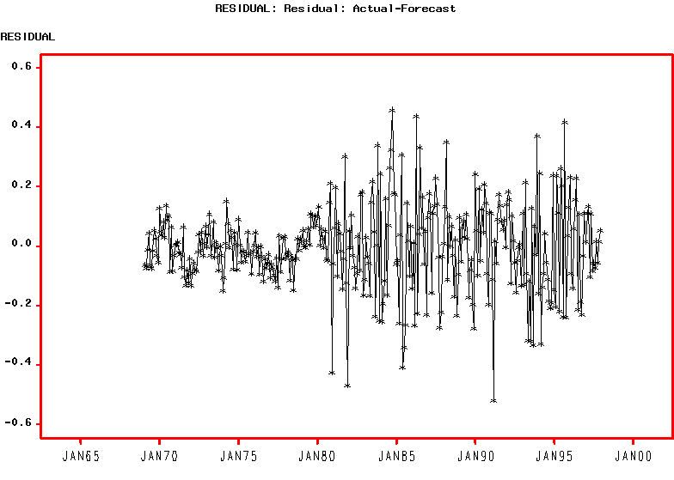
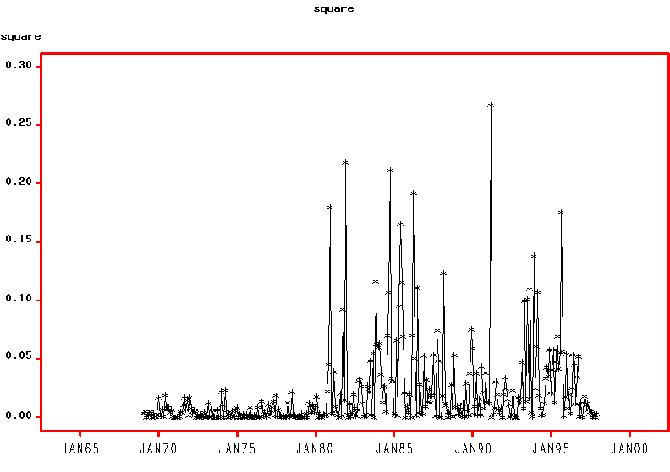

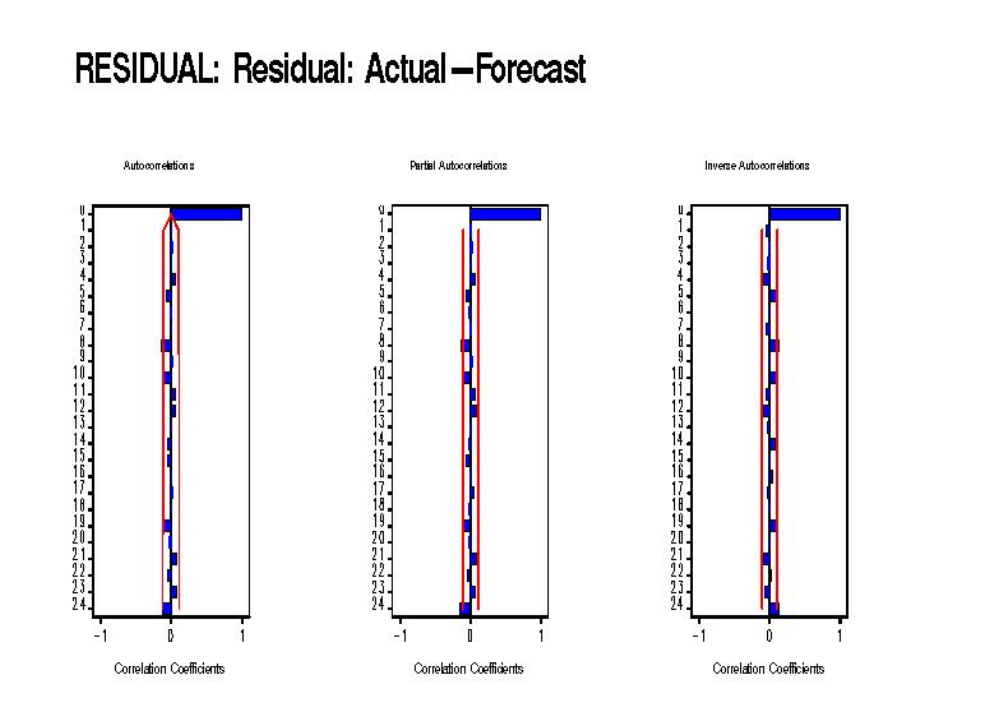

ARCH (2)

Parameter | Estimate | Std. Error | t-statistic | p-value
θ₁ | -0.686 | 0.043 | -15.84 | <.001
Θ₁ | -0.792 | 0.036 | -22.03 | <.001
β | 0.455 | 0.076 | 5.96 | <.001
ω₁ | 0.427 | 0.040 | 10.73 | <.001
ω₂ | 0.298 | 0.038 | 7.92 | <.001
υ₂ | 0.762 | 0.035 | 21.53 | <.001
γ | 0.003 | 0.001 | 4.50 | <.001
a₁ | 0.299 | 0.087 | 3.45 | 0.001
a₂ | 0.237 | 0.077 | 3.08 | 0.002
λ₁ | 0.015 | 0.003 | 4.31 | <.001

Fit Statistics | Value
AIC | -457.5615
BIC | -376.7257
Test Statistics | Value | p-value
W test for normality | 0.992 | 0.976
Q_{LB} test for standardised residuals | 19.47 | 0.078
Q_{ML} test for squared std. residuals | 17.79 | 0.122
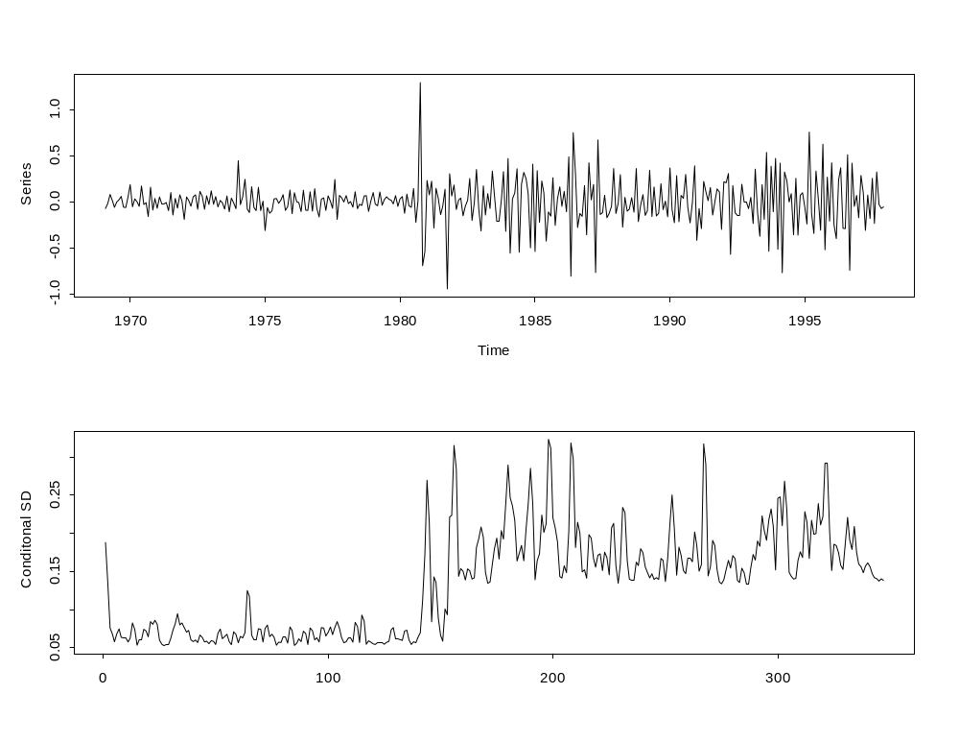
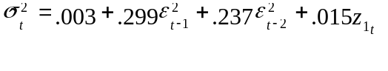

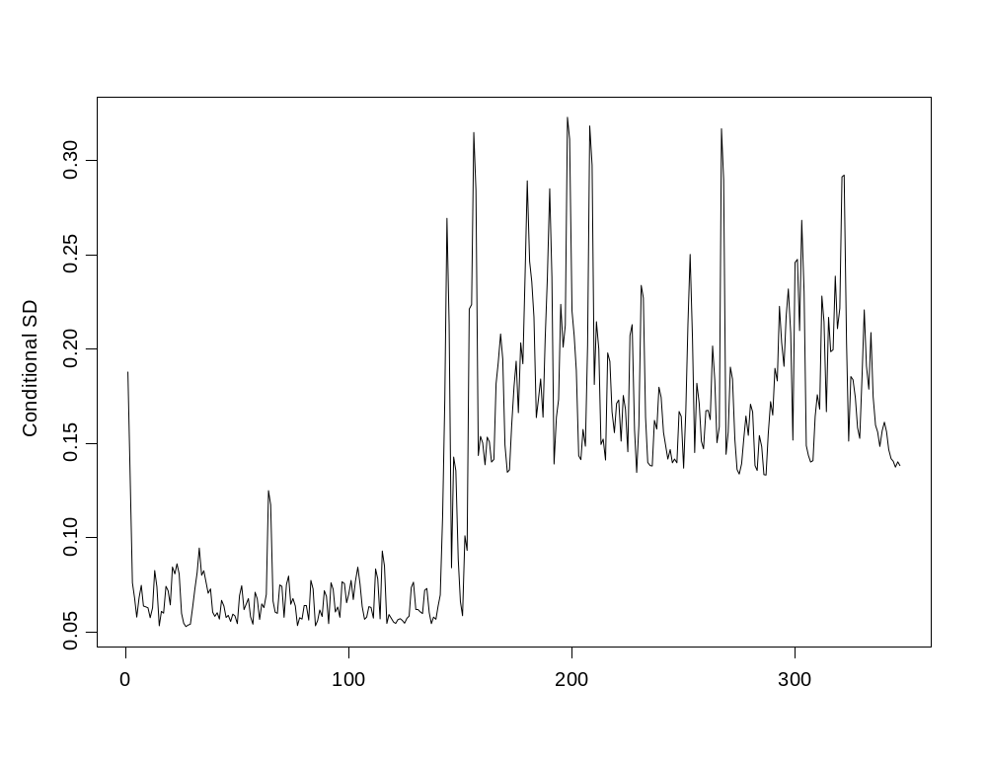
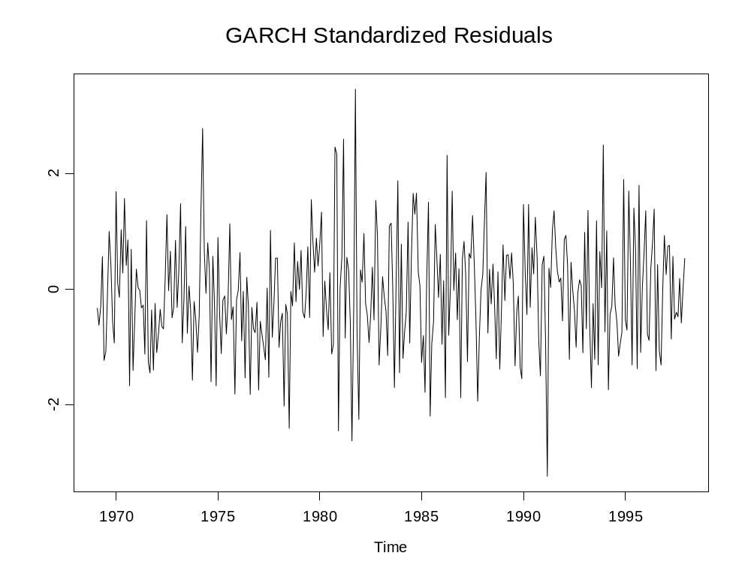
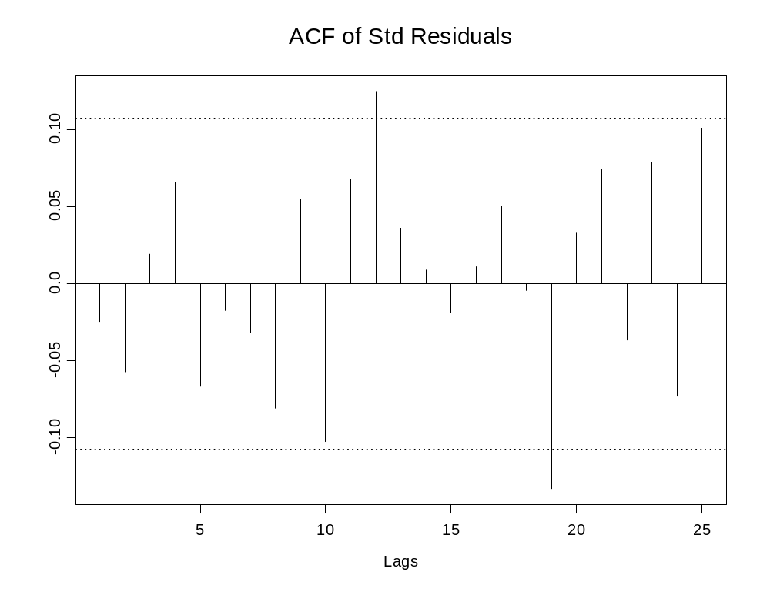
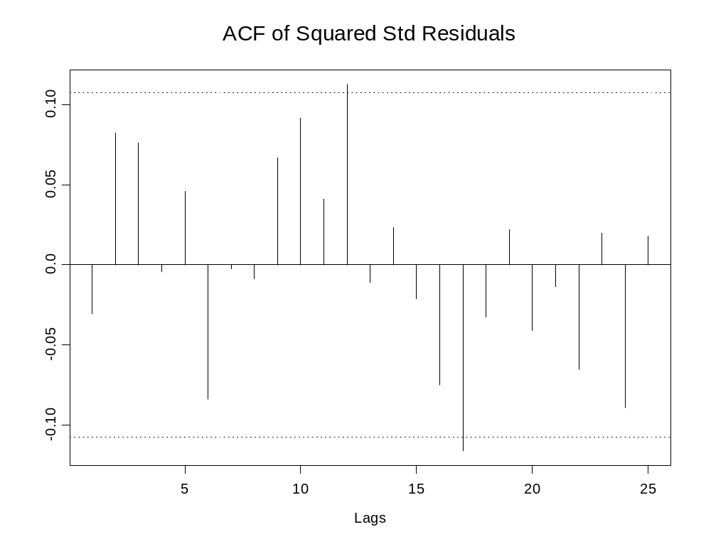
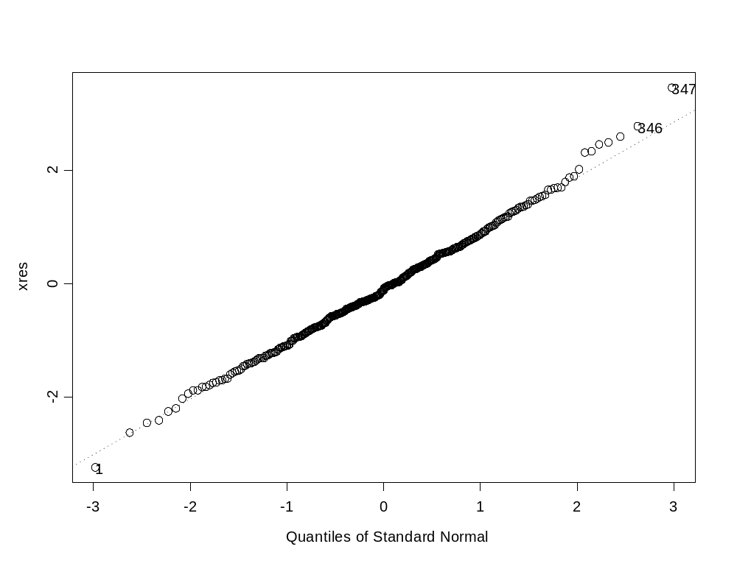

 | Coefficient Estimate |  |  | Standard Errors
Parameter | ARIMA | GARCH |  | ARIMA | GARCH
θ₁ | -0.845 | -0.686 |  | 0.029 | 0.043
Θ₁ | -0.732 | -0.792 |  | 0.041 | 0.036
β | 0.450 | 0.455 |  | 0.132 | 0.076
ω₁ | 0.510 | 0.427 |  | 0.072 | 0.04
ω₂ | 0.379 | 0.298 |  | 0.075 | 0.038
υ₂ | 0.704 | 0.762 |  | 0.132 | 0.035
γ |  | 0.003 |  |  | 0.001
a₁ |  | 0.299 |  |  | 0.087
a₂ |  | 0.237 |  |  | 0.077
λ₁ |  | 0.015 |  |  | 0.003

