Maine
ARIMA (0,0,0) (0,1,1)
Parameter | Estimate | Std. Error | t-statistic | p-value
Θ₁ | -0.623 | 0.045 | -13.96 | <.0001
β | 0.797 | 0.116 | 6.87 | <.0001
ω₁ | 0.837 | 0.048 | 17.54 | <.0001
υ₁ | 1.726 | 0.148 | 11.68 | <.0001
δ₁ | 0.623 | 0.046 | 13.58 | <.0001

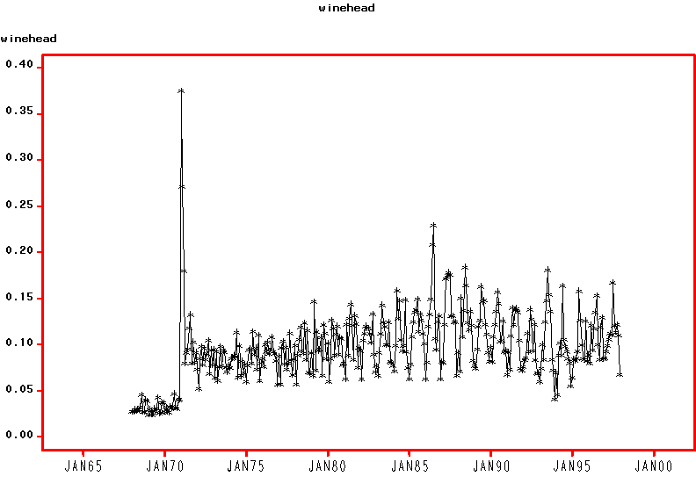

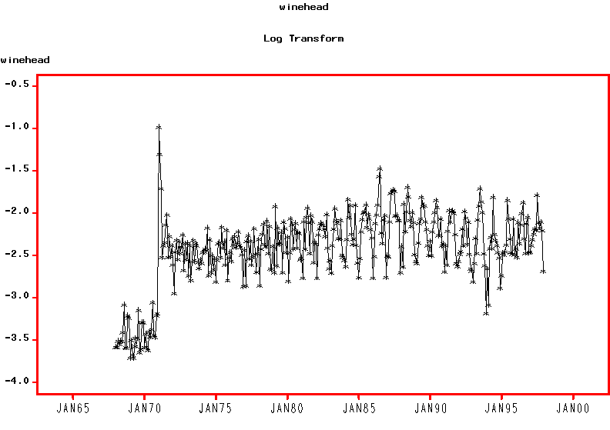
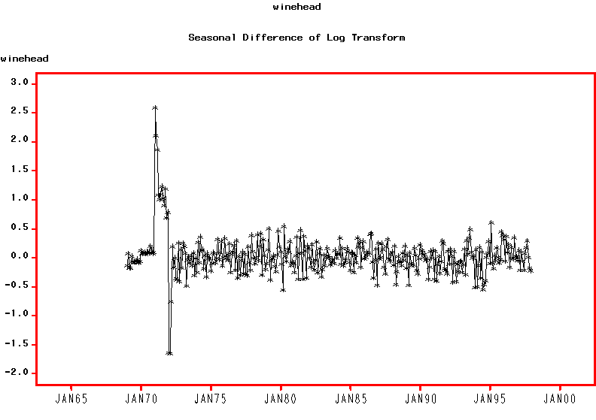
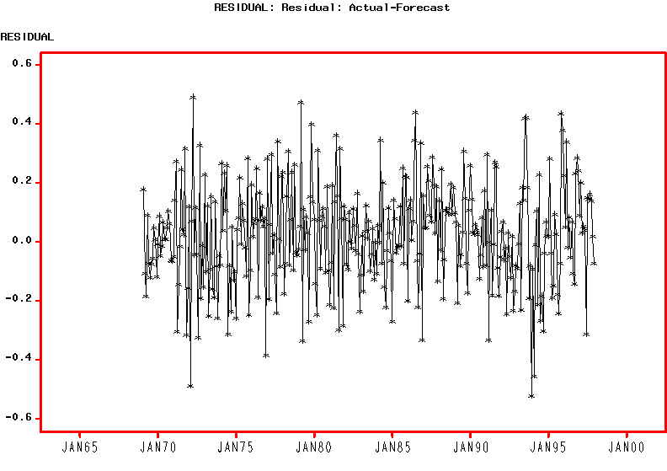
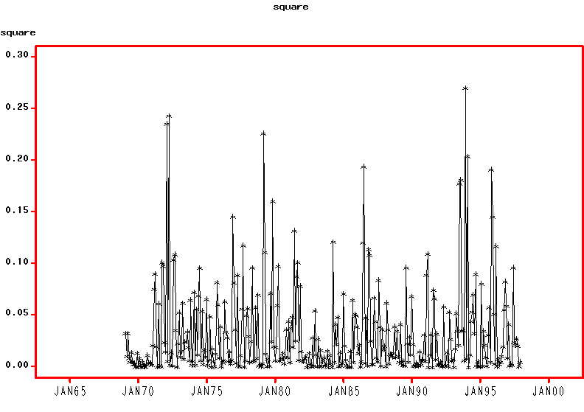

GARCH (1,1)
Parameter | Estimate | Std. Error | t-statistic | p-value
Θ₁ | -0.619 | 0.048 | -13.01 | <.001
β | 0.807 | 0.115 | 15.16 | <.001
ω₁ | 0.839 | 0.037 | 22.61 | <.001
υ₁ | 1.736 | 0.115 | 15.16 | <.001
δ₁ | 0.620 * | - | - | -
γ | 0.008 | 0.005 | 1.50 | 0.134
a₁ | 0.119 | 0.067 | 1.78 | 0.076
b₁ | 0.629 | 0.200 | 3.15 | 0.001

Fit Statistics | Value
AIC | -188.91
BIC | -119.57
Test Statistics | Value | p-value
W test for normality | 0.986 | 0.662
Q_{LB} test for standardised residuals | 6.79 | 0.871
Q_{ML} test for squared std. residuals | 10.36 | 0.584

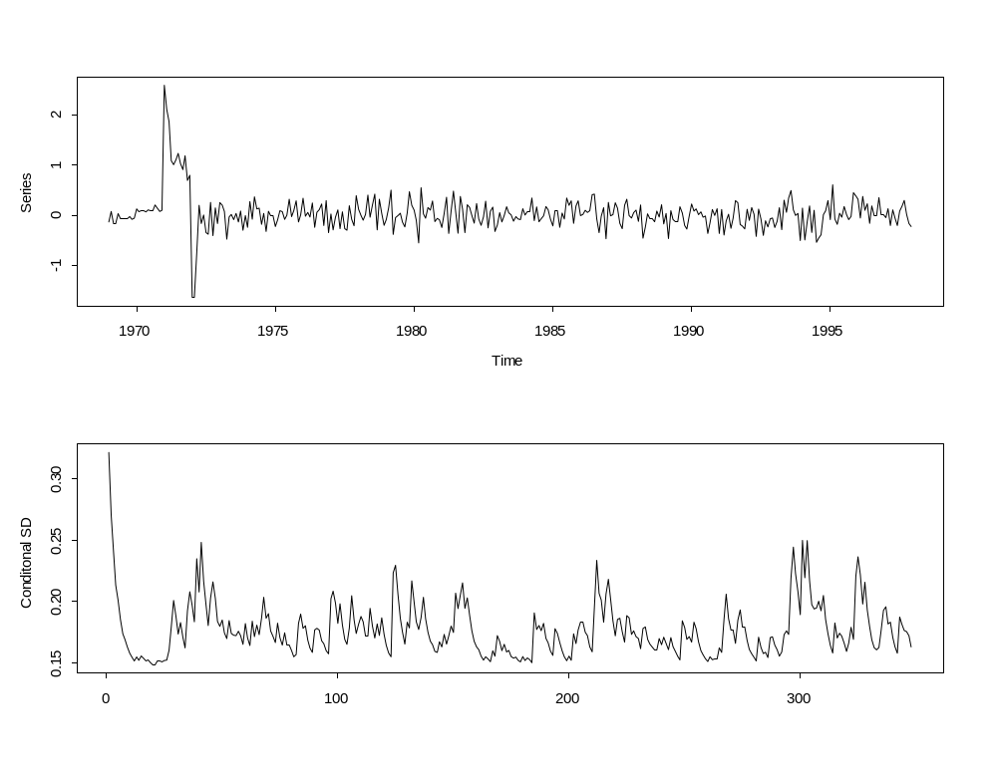
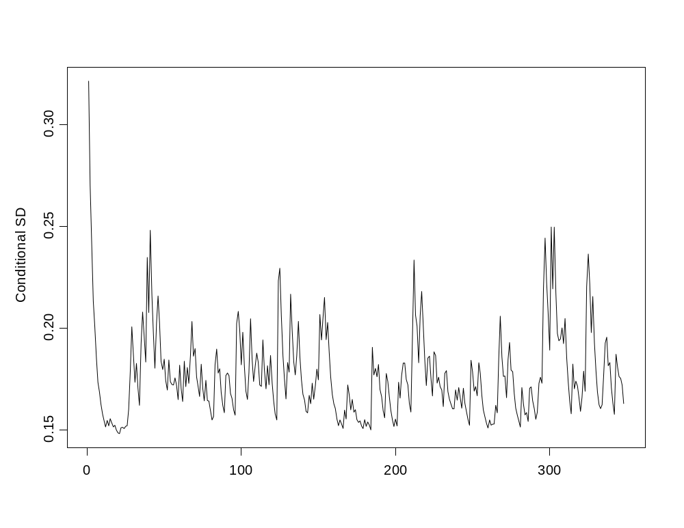
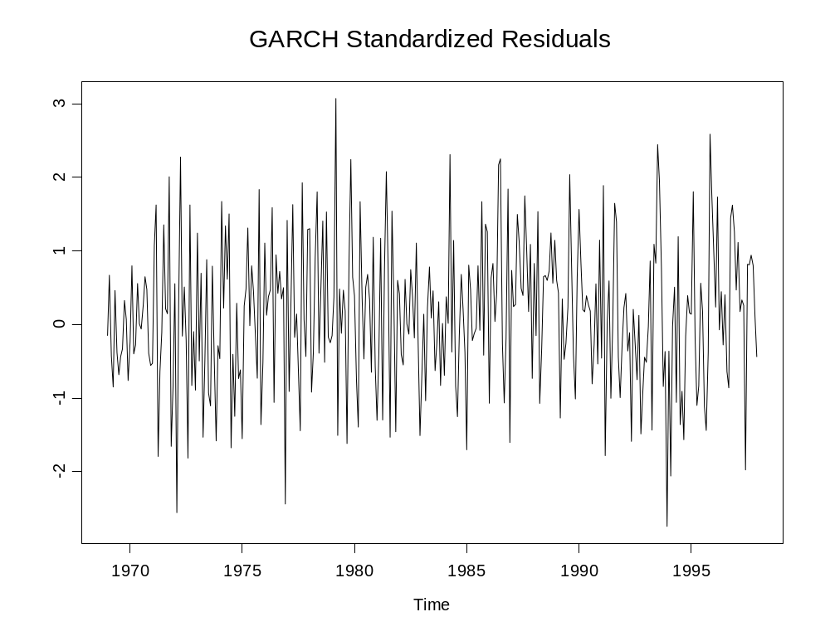
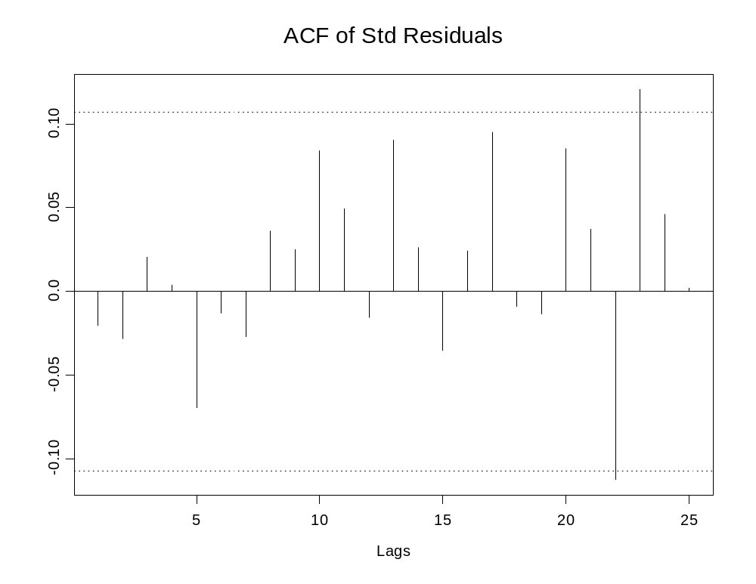
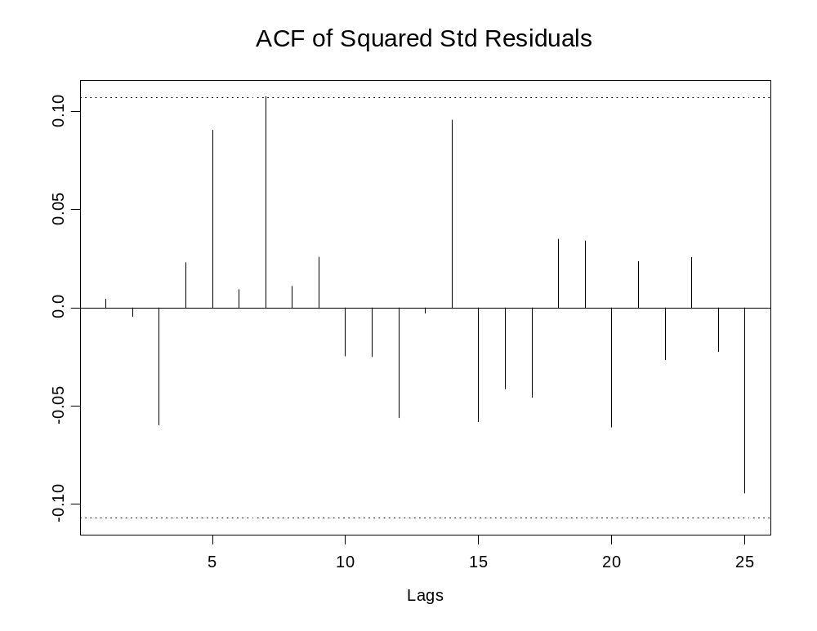
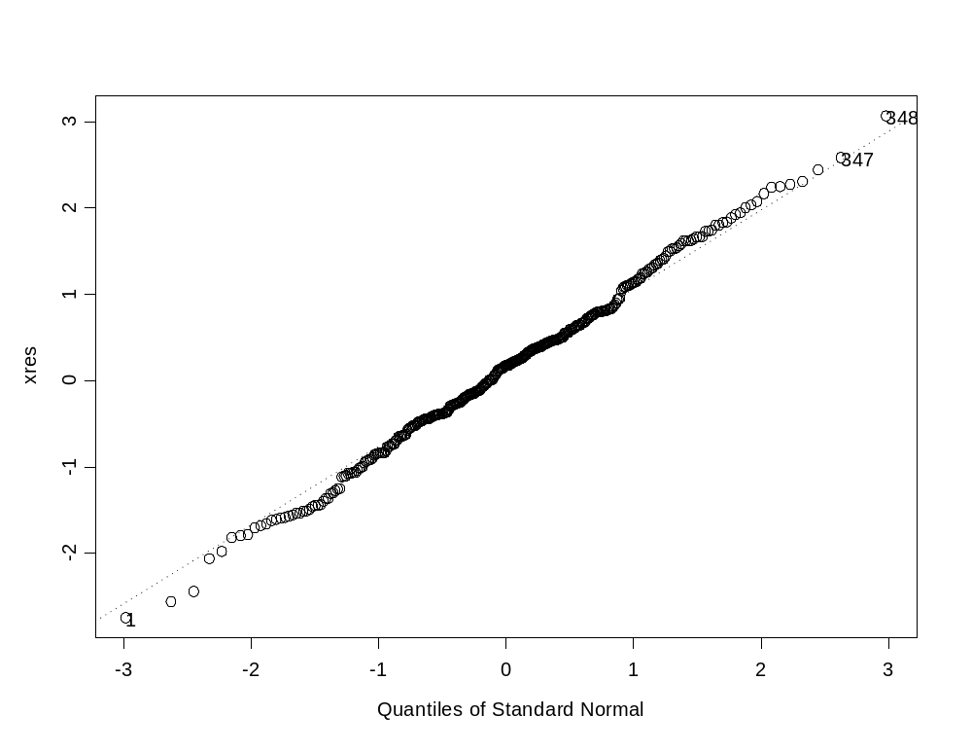

 | Coefficient Estimate |  |  | Standard Errors
Parameter | ARIMA | GARCH |  | ARIMA | GARCH
Θ₁ | -0.623 | -0.619 |  | 0.045 | 0.048
β | 0.797 | 0.807 |  | 0.116 | 0.115
ω₁ | 0.837 | 0.839 |  | 0.048 | 0.037
υ₁ | 1.726 | 1.736 |  | 0.148 | 0.115
δ₁ | 0.623 | 0.620 * |  | 0.046 | -
γ |  | 0.008 |  |  | 0.005
a₁ |  | 0.119 |  |  | 0.067
b₁ |  | 0.629 |  |  | 0.200

