Globular Clusters

Practical Astronomy

Rob Glassey - August 2014

Giant Star Clusters
Globular Clusters are huge balls of often hundreds of thousands stars. They are so big they are able to remain bound together by gravity for many billions of years, while smaller clusters eventually drift apart. Globular clusters orbit the galaxy in the faint outer halo, often ten's of thousands of light years from the centre. From our perspective, some 25,000 light years from the centre, some clusters are as close as 7500 light years, while others are very distant.

Southern Skies
Since globular clusters orbit the centre of the galaxy, most globular clusters can be seen in that direction, towards the constellations of Sagittarius, Scorpius, and Ophiuchus. This part of the Milky Way is low or even below the horizon in the Northern Hemisphere, so only a few bright globular clusters are easily visible from there, and the best ones often cannot be seen at all. Here in the southern hemisphere, the galactic centre is high in the winter sky, and we have a good view of all but 2 of about 150 globular clusters in the Milky way. About half of them are visible in small telescopes.

Speckled Hazy Balls
In the telescope, a globular cluster look like small hazy ball, something like an elliptical galaxy, but because globular clusters are 1000's of times closer than galaxies, individual stars can often be seen. On a good night, small scopes will show a few stars in the bigger, brighter clusters, while 4-6" telescopes will partly resolve many bright globular clusters, and 8" telescopes show a lot of stars in many clusters.

Ancient Stars
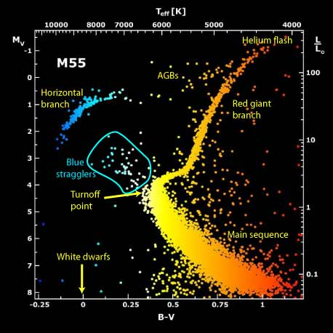
Modern astronomy dates most globular clusters as very, very old, almost as old as the universe itself. This is due to their lack of short-lived massive blue or white stars, and because of the evolution of long-lived yellow stars into red giants. Since all the stars that are becoming red giants now are much the same brightness and colour, they have probably been burning hydrogen for much the same length of time, indicating that these stars all formed about same time. Most of the remaining long-lived stars have a similar brightness and colour to our sun or smaller dwarf stars, and they are yet to evolve into red giants.
Colour Magnitude diagram of Globular Cluster M55.
Colour (B-V) of each star is plotted against it's absolute magnitude (Brightness)
Red Giants
As a sun-like star nears the end of it's life and becomes a red giant, it brightens dramatically, becoming hundreds of times brighter than is once was. It is mostly these red giant stars that we can see as individual stars in globular clusters. Of the hundreds of thousands of stars in a globular cluster, there may be only a few thousand visible as red giants.

The "Horizontal Branch"
There are also some bright blue stars in globular clusters, identified as the "Horizontal Branch". These are stars that have passed the red giant phase, lost much of their outer shell, and are now small, hot, blue stars, fusing helium. They are considerably dimmer than the brightest red giants, but they can still be visible in photographs or with large telescopes.

Blue Stragglers
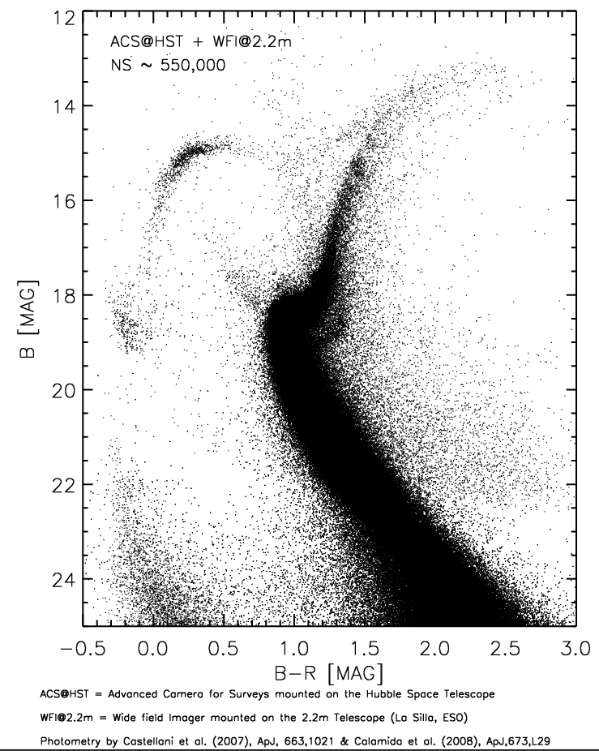
Dimmer yet, but still brighter than the sun-like yellow stars, are the "Blue Stragglers". These are large "main sequence" stars that use up their fuel fast and would be long gone had they formed like this at the same time as the other stars in the cluster. These are believed to be the result of old smaller stars getting a "top up", either from a collision with another star, or from gas being sucked off a companion red giant star. If the pair was close enough, the red giant star would have swelled up enough to come within reach of the smaller star, transferring material. Since then the red giant has faded away to become white dwarf. Spectroscopic studies of Blue Stragglers show that most of them have a companion white dwarf star in a binary system. Studies of eclipsing binaries show that there are also many "contact binaries" in globular clusters, where a red giant is transferring material to a smaller star. "Blue" Stragglers are actually more "white" in colour, and are too dim to be seen in amateur telescopes.

Colour Magnitude diagram of Omega Centauri
Showing actual magnitude (brightness) as seem from earth.
The Dim Haze
At the distance of globular clusters, a star like our sun would be magnitude 18-20, far to dim to see in anything but a large professional telescope. But globular clusters often contain hundreds of thousands of these Yellow Dwarf stars, and their combined light is barely visible as a smooth background glow in the cluster, often brightening towards the centre.

Grains of sparkling sand
Some of the extremely bright red giant stars are just within the reach of a small telescope (mag 10-11), and many are visible in telescopes 8" and above (mag 12-13). Even the red giants that are not visible as individual stars are still visible when seen together, creating a grainy effect in the haze of light. A larger telescope will often be able to resolve this graininess into individual stars. Even a smaller telescope will sometimes briefly show a few stars in the graininess if the conditions are good, especially with averted vision. A grainy glob can sometimes appear to briefly sparkle with very dim pinpoints of light. Keep watching!

The Bright Core
Many globular clusters have a core that is much brighter than the outlying halo. The core of even fairly dim globular clusters is often visible in small scopes if it is sufficiently concentrated. Conversely some poorly concentrated clusters can be hard to see even if they have a high total brightness, as only a board halo is visible. Globular clusters are classified into Classes depending on concentration. From Class I for extremely concentrated to Class XII for very broadly concentrated. There are some good examples below.
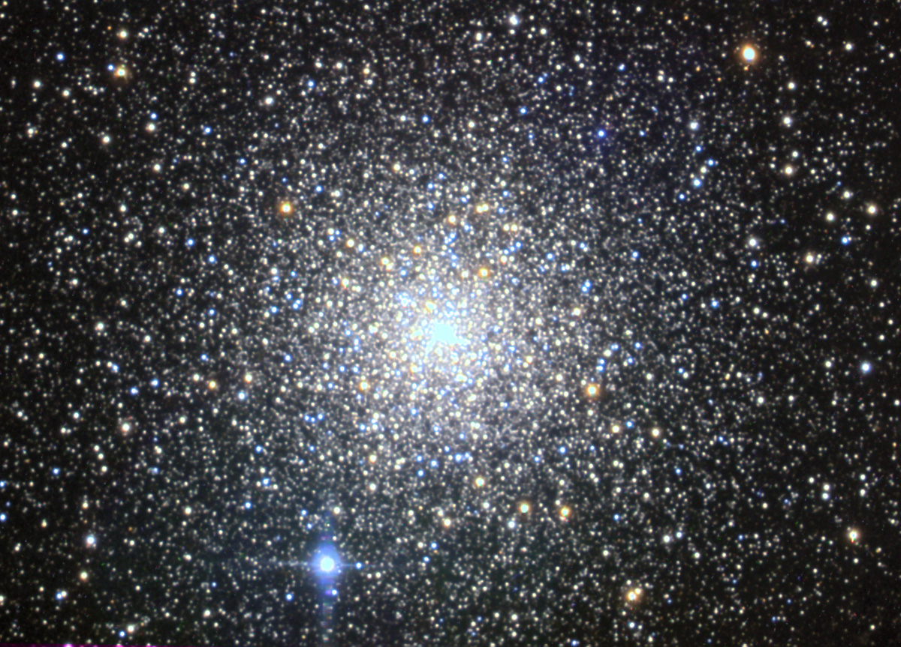

Pavo Globular Cluster NGC6752

Small Scope Highlights

Omega Centauri, NGC 5139. (17,000ly away). The Biggest and Brightest of them all! Easily visible to the naked eye, even under moderate urban skies. Millions of Stars! Big in binoculars, fills a good part of the eyepiece in a telescope! Fairly broad concentration, grainy in a small scope, uncountable stars in anything bigger. Omega Centauri is also slightly elongated, about a 5:6 ratio.

47 Tuc, NGC 104. (15,000ly away). Often described as THE best glob in the sky! Easily visible to the naked eye, right beside the Small Magellanic Cloud. Sharply concentrated in the centre. A 4" scope will start to resolve it, and in a 6" scope or bigger, on a good night, it will resolve into a spectacular cluster of stars stretching far from the bright core. This is another big one. Unfortunately 47 Tuc does not easily resolve into stars with smaller scopes. The Pavo glob and M22 are a bit easier.

NGC 362 is near 47 tuc, at the Achernar end of the SMC, on the 47 Tuc side. It's half the size, twice the distance and 2 magnitudes dimmer than 47 Tuc, but it is still one of the 15 brightest in the sky. Worth a good look while you're in the neighbourhood! Both 47 Tuc and NGC362 are visible all year round but are best late in the year.

Pavo Glob, NGC 6752. (13,000ly away). One of the best globs in the sky, especially for small scopes. Bright, nice concentration, lots of bright stars sprinkled across it in 4" scope or bigger. Even small scopes will show stars on a reasonable night with averted vision. By far the best and easiest to resolve with a small scope. A bit harder to find, but worth it! My personal favourite!

M22 This was the first globular cluster to be discovered (1665). It was discovered while observing Saturn, when Saturn was less than 2 degrees away. Easy to spot in Binoculars, bright, nicely concentrated. Some stars will resolve in a small 60mm scope on a good night with averted vision. This one sparkles nicely! Nearby is the smaller globular cluster M28 - a nice contrast.

M4. Very obvious in Binoculars. First glob to be resolved into stars. (Charles Messier). One of the closest globs at 7500ly. Only broadly concentrated, but bright. A few stars resolve on a good night even with 60mm. It is not as round and regular as other globs. In medium side scopes it can appear to have a brighter "bar" across the centre, perhaps an illusion created by a few brighter stars on opposite sides of the core or by a slighter darker regions on one side of the "bar". M4 sits far behind a window on the edge of the Rho Ophiuchi molecular cloud system. Maybe dust from this cloud is giving it it's irregular appearance? Behind M4 are the dark dust clouds that lie between us and the centre of the Milky Way. M80 is another bright but small glob nearby.

Ara Glob NGC 6397. Closest (7200ly), bright (5.7), but low concentration, Class IX in bright star field. Contrast against background is not as strong as M4, but it's a nice backdrop. Some stars are just resolvable in small scope, and a number of stars are scattered around the edges which can be hard to tell apart from the background stars. Interesting to compare with M4, which is the same brightness, size, distance and class, but stands out more against the dark dust clouds behind it.

Delta Musca Glob, NGC 4833. Near bright star Delta Musca. Clearly visible on a good night, not far from the bright star Delta Musca. Mildly concentrated (class VIII). Starts to resolve with 6". Interesting to contrast with nearby Gamma Musca glob. Nice glob in a dob.

Gamma Musca Glob, NGC 4372. Near bright star Gamma Musca. It's easy to find where it should be, but a real challenge to actually see it in a small scope. It is only a little dimmer than Delta Musca, NGC 4833, but it is Class XII, so it's very broad, with no visible central concentration and low surface brightness. It is has a magnitude 6.6 field star right on the edge of the cluster which makes it even harder to see. It almost looks like a faint tail of a comet with the bright star as the head. I got quite a buzz from finally spotting this one in my 60mm refractor! A nice subtle one, right beside a big blazing star. even in a dob it's subtle, with widely scattered tiny stars over a subtle haze. Easier to spot now you know what to look for!

M Cen glob, NGC 5286 (mag 7.4, Class V) Near mag 4.6 star M Centauri. Some resolution in 6-8". Nice contrast with bright star M Centauri, near Omega Cen. Compare with Gamma Musca glob, NGC 4372. Both have a similar total brightness, and both have a bright star very close, but 5286 is class V and 4372 is class XII, making NGC 5286 is much easier to see!

G Scorpii glob, NGC 6441, (mag 7.2 Class III) Not resolvable even in mid size scopes, but it's in a rich field and contrasts nicely with the bright star G Scorpii. NGC6441 is another big glob with over a million stars, but it's 38,000 ly away. G Scorpii is only 126ly away, and only 4 arc minutes from NGC 6441.

M5 Easy to see in binoculars, but not near any bright stars, so it's harder to find. It's fairly big and bright (5.9) and moderately concentrated. At least 4" and a steady night is needed to resolve any stars. The second best glob visible from the Northern hemisphere, and it's still a good one here! Often overlooked as it does not get higher than 40 degrees here, and is only high for a short time. Well work a look, but catch it very early in the evening this time of year.

M13. Easy in Binoculars, but barely gets higher than 10 degrees here. It's bright (mag 5.9), and has a broard, concentration a bit like a small version of Omega Centauri. It's the best glob visible from the Northern Hemisphere, but being so low here, it is only really worth a look for the challenge and to get some idea of how much better it must look further north. But it still can't compare with Omega Cen, 47 Tuc, M22, Pavo, or Ara globs - all of which are bigger, brighter, and closer. Even M5 is the same brightness and distance, but M13 claims first prize because it is bigger and higher in the Northern Hemisphere sky.

M54 (mag 7.6 class III) One of the farthest globs you can see with a small scope (86,000ly). It looks quite small and dim, but well concentrated so it's not so hard to see. M54 is second only to Omega Centauri in both luminosity and mass, one reason why such a distance glob is still visible in small scopes. It has been identified as belonging to the Sagittarius Dwarf Galaxy, a small satellite galaxy of the Milky Way currently being absorbed into the Milky Way after a "recent" close interaction with the Milky Way core.

M55 is loose, broad, moderately bright, grainy, and starts to resolve in a 4" scope. (mag 6.3 class XI). In a small scope M55 is a nice example of a disperse, grainy glob. Nice contrast between M54 and M55, both being similar surface brightness, but M55 is much bigger and easier to resolve, while M54 is a tiny concentrated fuzzy spot. M55 can be hard to find as it is a long way from bright stars. Use binoculars to become familiar with the nearby star patterns and real star brightness. (Charts and screens don't represent brightness well and this can have a big effect on the patterns you see).

Carina Glob, NGC 2808 - Class I, 31,000 ly, mag 6.2. great in a big scope, but in a small scope it is notable for its very strongly concentrated centre. This is as strongly concentrated as they get! It's in a nice rich field, and is one of the big ones, containing over a million stars. Resolves with 8". Best at 7:30pm. Gets quite low later.

Vela Glob, NGC3201 - Class X, 16,000 ly, mag 6.8. Nice disperse glob, resolvable in medium size scope. Dimmer than similar globs M55 or M12, but near the Class 1 NGC 2801 for a comparison. Best at 7:30pm. Gets quite low later.

M10 & M12 in Ophiuchus are about the same distance and brightness (6.6), but M12 is Class IX, broadly concentrated with a lower surface brightness than M10. M10 is Class VII, intermediate concentration, with a higher surface brightness. These can be seen as a very wide pair in binoculars, and are nice moderately disperse globs to compare side by side.

M11 in Scutum is not a Glob, but it is a very big open cluster, with around 3000 stars. It looks like a loose globular cluster that resolves easier. Once considered an intermediate cluster between open and globular clusters. It has fewer dim stars, and more bright stars, so there is less haze and more grain and more resolved stars. It is also clearly not a symmetrical ball, with one of the groups of "wild ducks" spanning out in a V shape on one side of the cluster.

M30 in Capricorn is not as big or bright as the showpiece globs, but this one has "horns". On a good night 4" scopes or bigger show two bright lines of stars emerging from the core of the cluster, perhaps giving the impression of horns. With an 8" scope, and an even bigger imagination, other stars around the core could look like a tail? I like to call this one the "Devil Glob."

M2 in Aquarius and M15 in Pegasus reach their highest around midnight this time of year. Both are reasonably bright (6.5), both well concentrated and at a similar distance (35,000 ly). Not easily resolved, but good from both North and South hemispheres. M15 contains a planetary nebular, but it's tiny and about mag 14. It is the only planetary visible in a glob with large aperture amateur equipment. It is on the bright edge of the core slightly east of North, almost in line, about 1/4 of the distance to a nearby bright star. Planetary nebula is not visible in small scopes, need at least 12" and UHC filter.

NGC 6723, Sagittarius / Corona Australis (mag 6.8, Class VII, 28,000 ly). A hazy patch with a mild concentration, a few stars may be visible on a good night with a 6" or bigger, but the real reason to look at this one is what it's next to. You will need a very dark sky and your lowest power, but between the glob and the bright stars of Corona Australis lies a dark dust lane, cool when you see it!

NGC 6553 & NGC 6544, Wide pair of globular clusters, small & dim, both magnitude 8.3. Only 1 degree apart, right beside Lagoon Nebula in rich star field. Need a dark night. Interesting pair if can get low enough magnification (30-40x). Faint but visible in 60mm.

NGC 6528 & NGC 6522 another pair of globular clusters between bright stars. Small and dim (8.6/9.5), dimmer than NGC 6553 & 6544, but clearly fuzzy amongst the bright sharp stars with 4" or more on a dark night. 1/4 degree between them, 1 degree field shows nearby bright stars. 8" aperture and 100x shows these up well. The both sit on a line that would run half way between two bright stars.

M7 glob, NGC 6453. Very, dim even in 8" but well concentrated (mag 9.9, class IV). About 2/3 degree from centre of M7. Can be seen in the same low power field if M7 is on the east edge of the field (just coming into view). The small fuzzy glob is a contrast with the sharp stars of M7.

Tarantula Nebula in the LMC, NGC2070. Not a globular cluster - yet? This is the largest star forming region in the local group of galaxies, and at it's centre is over a million new stars, easily enough to hold together as a new globular cluster. But this is not the only new globular cluster in the LMC. NGC 1818 (mag 9.8) is another new globular cluster in the LMC, estimated to be only 25 million years old.
