**Hong Kong Institute of Vocational Education (Tsing Yi)**

**Department of Information Technology**

**HD in Software Engineering**

**ITP4511**

**Enterprise Systems Development**

**Topic:**

**E-Learning Platform System**

**Assignment Report**

|  |  |
| --- | --- |
| **Group No.** | 5 |

|  |  |  |
| --- | --- | --- |
| **Student** | **Contribution to the project (%)**  **(Total 100%)** | **Signature** |
| Fung Kwun Yiu |  |  |
| Liu On Chun Arthur |  |  |
| Chong Ho Man |  |  |

We declare that this is a group project and that no part of this submission has been copied from any other student’s work or from any other source except where due acknowledgement is made explicitly in the text, nor has any part been written for us by another person.

Table of Contents

1. Assumption 3

2. User and System Requirements 4

3. Site Map 6

4. System Structure 7

5. Database Structure 8

6. Brief Description 9

7. Conclusions 10

8. Skill Checklist 11

# **1. Assumption**

* All student and teacher account is created by Admin.
* All user must login by their username and password, their user id only using to identify in the system and database.
* Only teacher can upload, delete the materials to specified module which are teaching by himself.
* Only teacher can allow temporarily restricted student to download the material.

# **2. User and System Requirements**

|  |  |
| --- | --- |
| **Function** | **Description** |
| **All User** | |
| 1. **Login** | Each user allow login the system using their username and password that there are three types: Admin, Teacher and Student. Different account has different functions in the system. |
| 1. **Search Material or Module** | All user can browse materials and module which They are designated and search materials and module by entering any keywords. They can input keywords such as name and id. |
| 1. **Maintain Profile** | Edit own profile with own information. |

|  |  |
| --- | --- |
| **Function** | **Description** |
| **Admin** | |
| 1. **Show Existing User** | Display all the existing users in the system. |
| 1. **Create User** | Create new users such as Student, Teacher account. |
| 1. **Delete User** | Disable the user's account, such as the student drop out of school. |
| 1. **Edit User Detail** | To modify the user's information, such as the user's role. |

|  |  |
| --- | --- |
| **Function** | **Description** |
| **Student** | |
| 1. **Download Learning Materials** | Download the learning materials in the module they have to teach. |
| 1. **Browse Module** | Browse the module which student is studying. |
| 1. **Participate Quiz** | Participate a quiz which be assigned by teacher. |
| 1. **Check Test History and Result** | When a test is completed, the student can inquire about the results and the results of their answer. |
| 1. **Check Assigned Quizzes** | Students can see which of their quiz are assigned by teachers. |

|  |  |
| --- | --- |
| **Function** | **Description** |
| **Teacher** | |
| 1. **Upload Learning Materials** | The teacher can upload the material to the module he teaches. |
| 1. **Download Learning Materials** | Download the learning materials in the module they have to teach. |
| 1. **Temporarily Restricted Student to Download the Material** | Allow temporary restrictions on students to download materials in special circumstances. |
| 1. **Remove Existing Leaning Materials** | Remove the learning materials, such as a learning materials error or out of date. |
| 1. **Manage Quiz** | - Select questions from the pool and assign it to a specific quiz  - Assign quiz to a group of students or a specific student  - Assign the time limit for a quiz  - Allow number of attempts  - Enable a specific period of attempt |
| 1. **Manage Question Pool and Corresponding Answers** | Create and Delete the question. |
| 1. **Show Quiz Report** | - Show the performance in the exercise for a specific student and group of students  - Calculate the average mark, select the lowest & the highest scores students |

# **3.** **Site Map**

# **4. System Structure**

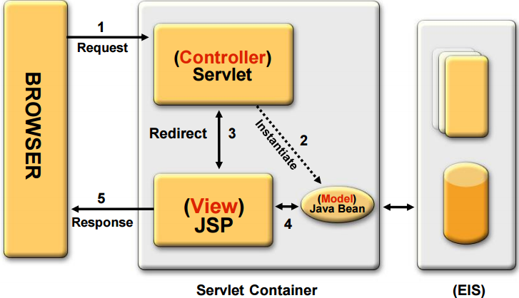

The system uses MVC Design Pattern as the whole system structure. The client or manager will send different operations to the application server. The application server will use Java Servlet as a controller to handle requests from the client, including parameters checking and identifying the nature of the request. After that, Java Servlet will call the business logic and create a Java Bean to handle the data operations. Then, the servlet stores the bean in the session and forward the request to the JSP page and displays the result of the action request from the client or the manager.

Take the system as an example. Students request to browse the module. He or she enters a hyperlink. Servlet will receive the request and get the details of the module. After that, servlet will create a module, Java Bean, to handle the module's data. After the logic is carried out. Servlet redirects to a JSP View based on the logical success. Finally, the students can see the results of the modules and materials after the JSP output response of the application server.

# **5. Database Structure**

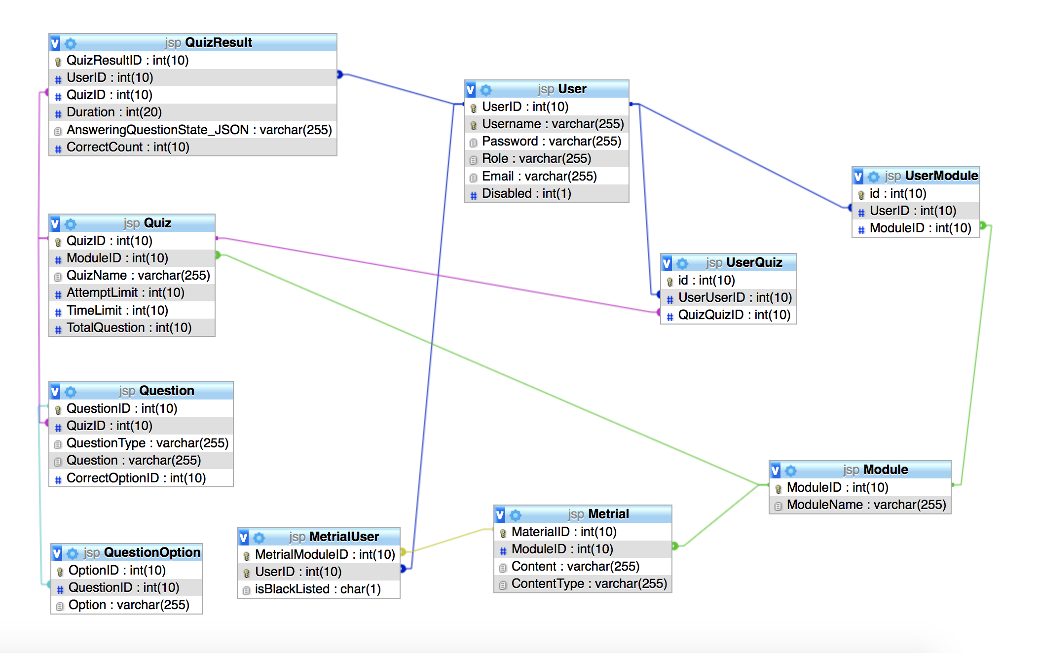

# **6. Brief Description**

The website applies Model-view-controller(MVC) design pattern to design. Servlet as a controller handle all logical operation, JSP page as a view dynamically generate a HTML page and JavaBean as a model store the database record.

When Container receives a request for a Servlet URL. It will pass the request to the correspondent Servlet to handle it. The Servlet will handle the request based on request’s parameter, it might call the database class to get data which it desired. At the same time, the Database class put these data into JavaBean class to store it and return back to servlet. Finally, the Servlet forwards the JavaBean and other data to JSP page, let it dynamically generate a HTML page.

Also, we have used some custom tag to separate other functionality logic. It is useful since the JSP page can reduce logical Java code as a result, page authors can focus on page design, the custom tag developed by programmers. More importantly, some of the actions that need to be repeated can be a custom tag so it makes the application more reusable and maintainable.

# **7. Conclusions**

According to this report, the website can provide different functions after different user accounts. At the same time, it shows how to handle and maintain the web site according to the design of system requirements, system structure, web site and database.

Finally, the MVC design pattern can systematically handle all requests between pages. The data conversion is as follows:

JSP passes data < servlet handle > Data > database class to get some data that is placed in a list of JavaBean classes for storage.

On the basis of the path, each role plays a role to handle their own tasks, which is the advantage of the MVC pattern.

# **8. Skill Checklist**

* Use JSP/servlets to dynamically generate HTML pages
* Use JSP/servlets to accept user inputs from browser
* Use JSP Action
* Use Custom Tag
* Use JavaBean
* Use JDBC for database connection
* Use session checking
* Use login control
* Apply MVC model