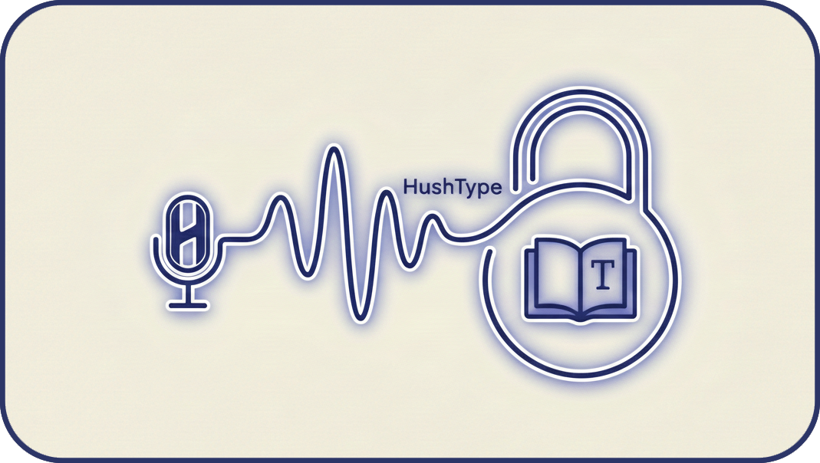
User Guide
On-device speech-to-text for macOS
Version 1.41

What is HushType?
HushType is a macOS menu-bar app that turns your speech into text, entirely on your Mac. Hold a trigger key, speak, and your words are typed into whatever application has focus. There is no cloud service involved — all processing happens locally on your Apple Silicon chip using the Whisper AI model.
Because everything runs on-device, HushType works offline, keeps your audio completely private, and responds quickly without network latency.

Requirements
- macOS 14 (Sonoma) or later
- Apple Silicon Mac — any Mac with an M1, M2, M3, or M4 chip (Intel Macs are not supported)
- A working microphone (built-in or external)

Installing HushType
1. Download the DMG from the HushType releases page on GitHub.
2. Open the DMG. Double-click the downloaded file to mount it.
3. Drag HushType to Applications. In the window that opens, drag the HushType icon onto the Applications folder alias.
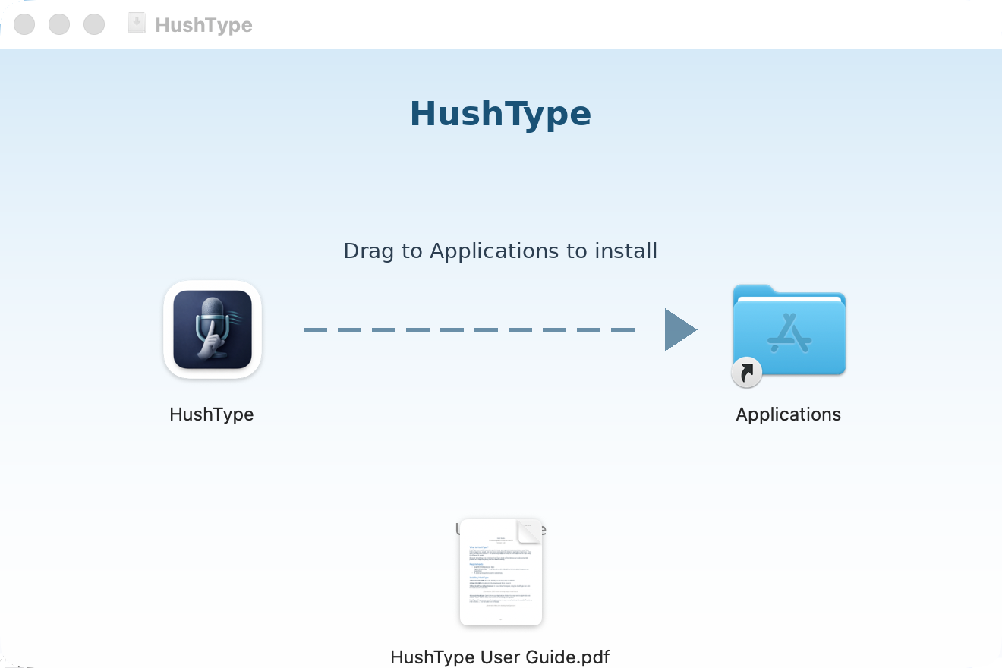
DMG window showing drag-to-install layout
4. Launch HushType. Open it from your Applications folder. You may need to right-click and choose "Open" the first time, then confirm in the dialog that appears.
Once all required permissions are granted, HushType will appear as a small icon in your menu bar (near the clock). The icon is hidden until permissions are set up. There is no main window — the menu bar icon is the app.

Menu bar showing HushType icon

Setting Up Permissions
HushType needs two macOS permissions to work correctly: Microphone and Accessibility. A third permission, App Management, is recommended for automatic updates but not required. On first launch, HushType displays a permissions window that shows the status of each permission at a glance. Each row shows whether the permission is already enabled or still needs to be granted.
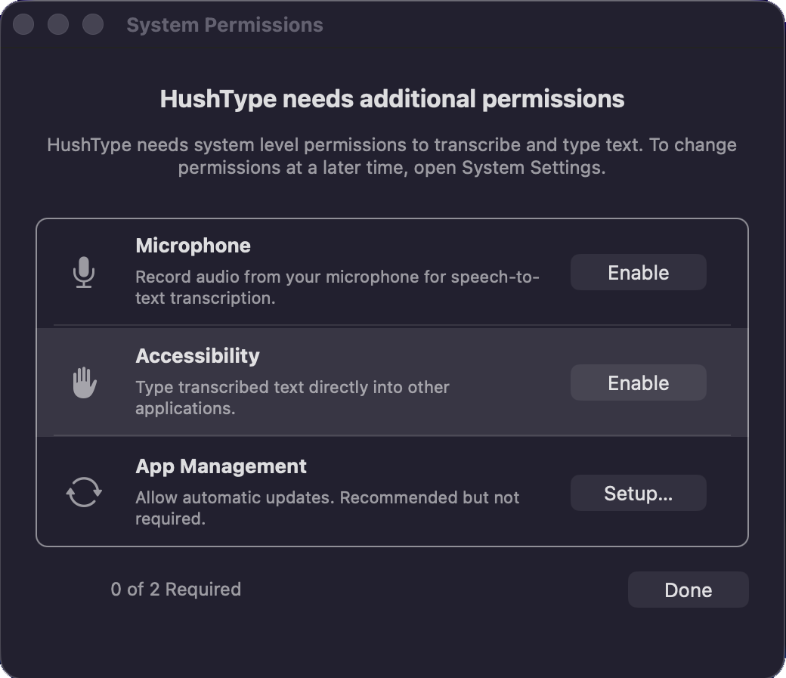
HushType permissions window showing permission status
The permissions window stays in the foreground so it is not lost behind other windows. It updates live — as you grant each required permission, its status changes to a green checkmark. If you close the window before granting both Microphone and Accessibility, HushType will quit, since it cannot function without them. This section explains each permission in detail.
Tip: You can always check or change these permissions later in System Settings → Privacy & Security.

1. Microphone Access
What it does: Allows HushType to hear your voice so it can transcribe your speech.
How to enable: Click the Enable button next to Microphone in the permissions window. macOS will show a system dialog — click Allow.
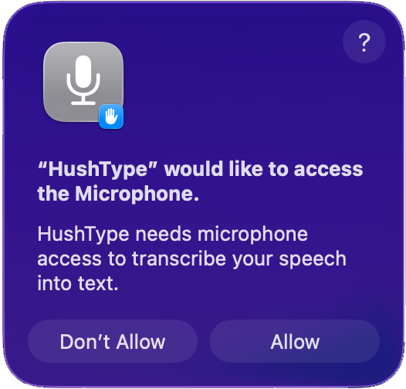
macOS microphone permission dialog
If you accidentally denied it: Open System Settings → Privacy & Security → Microphone, find HushType in the list, and toggle it on.
Without microphone access, HushType cannot hear you at all. This permission is essential.

2. Accessibility Access
What it does: Allows HushType to type the transcribed text into other applications on your behalf. Without this, the app cannot simulate keystrokes or paste text into your active window.
How to enable: Click the Enable button next to Accessibility in the permissions window. This opens System Settings to the correct page. Unlike the microphone dialog, macOS does not grant this permission automatically — you need to add HushType to the list manually. Here are the steps:
1. Open System Settings → Privacy & Security → Accessibility.
2. Click the "+" button at the bottom of the list.
3. Navigate to your Applications folder, select HushType, and click Open.
4. Make sure the toggle next to HushType is switched on.
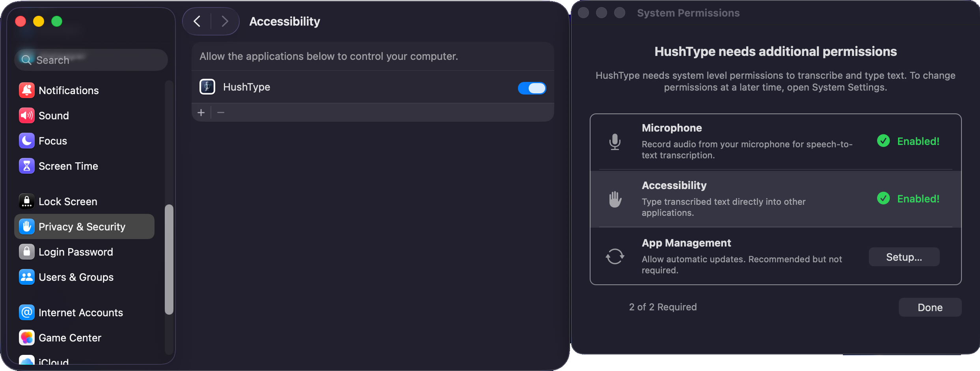
System Settings → Privacy & Security → Accessibility with HushType enabled
Without Accessibility access, HushType will still transcribe your speech, but it can only copy the result to your clipboard. It won’t be able to type the text directly into your applications.

3. App Management (Recommended)
What it does: Allows HushType to install updates automatically via the built-in Sparkle update system. Without it, updates may be blocked by macOS in some configurations.
Why it’s optional: If HushType and its updates are signed by the same developer, macOS normally allows the update without this permission. However, edge cases can arise where macOS blocks an update. Granting App Management avoids this.
How to enable: Click the Setup… button next to App Management in the permissions window. This opens System Settings to Privacy & Security and displays guidance in the permissions window. Follow these steps:
1. In System Settings, select Privacy & Security in the sidebar.
2. Scroll down the right-hand panel to find "App Management".
3. Click App Management and enable the toggle next to HushType.
If HushType is not listed under App Management, it will appear automatically the next time an update is available.
App Management cannot be detected automatically, so the Setup… button always remains visible in the permissions window. The counter only tracks the two required permissions (Microphone and Accessibility).

Re-granting Accessibility after updates
macOS revokes Accessibility permission whenever an app’s code changes — which happens after every update. This is a macOS security measure, not a bug in HushType. After an update, HushType’s permissions window will appear showing Accessibility as needing attention.
If a previous version of HushType is already in the Accessibility list, it must be removed and HushType must be restarted. This is because macOS caches the permission check when the app launches, and a restart is the only way for it to recognise the new entry. The permissions window will display a hint after a few seconds if it detects this situation, along with a Restart HushType button that handles the restart automatically. The steps are:
1. Open System Settings → Privacy & Security → Accessibility.
2. Select the old HushType entry and click the "−" (minus) button to remove it.
3. Click the Restart HushType button in the permissions window.
4. HushType will quit and relaunch. In the new permissions window, click Enable next to Accessibility and re-add HushType.
This only takes a few seconds and is a one-time step after each update. HushType detects when this has happened and will remind you.

Permissions at a glance
Permission | What happens without it | How to grant
Microphone | App cannot function at all | System dialog on first use
Accessibility | Text copied to clipboard instead of typed | Manually add in System Settings
App Management | Updates may be blocked (recommended, not required) | Setup… button → System Settings

Using HushType
Once permissions are set up, HushType is ready to use. The basic workflow is simple:
1. Click into any text field — an email, a document, a chat window, a search bar, anything.
2. Hold the Fn key (or whichever trigger key you’ve configured in Settings).
3. Speak clearly.
4. Release the key. Your words will be transcribed and typed at the cursor position.
A small floating overlay will appear at the top of your screen while recording, showing audio levels so you know your microphone is picking up your voice.

The Menu Bar
Clicking the HushType icon in the menu bar opens a dropdown with the following items:
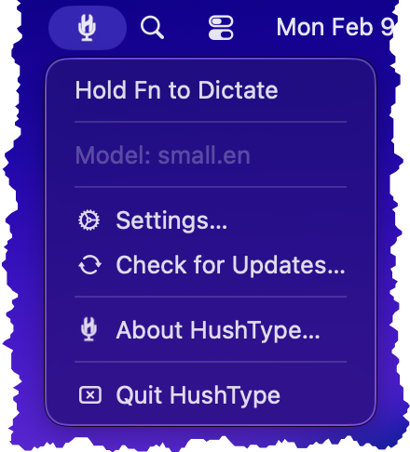
HushType menu bar dropdown
Hold [key] to Dictate — shows the current status. While idle it displays the trigger key to hold. During recording it changes to "Recording…", and during transcription it changes to "Transcribing…". You can also click this item to start or stop recording manually without using the trigger key.
Model: [name] — shows which Whisper model is currently loaded (for example "small.en"). This is a display-only item; to change the model, use the Settings panel.
Settings… — opens the Settings panel where you can configure all of HushType’s options (see below).
Check for Updates… — manually checks for a new version of HushType. The app also checks automatically in the background.
About HushType… — shows the version number, build number, copyright information, and open-source acknowledgements for WhisperKit and OpenAI Whisper.
Quit HushType — exits the application.

Settings
The Settings panel is organised into seven sections. Open it by clicking the HushType menu bar icon and selecting "Settings…".
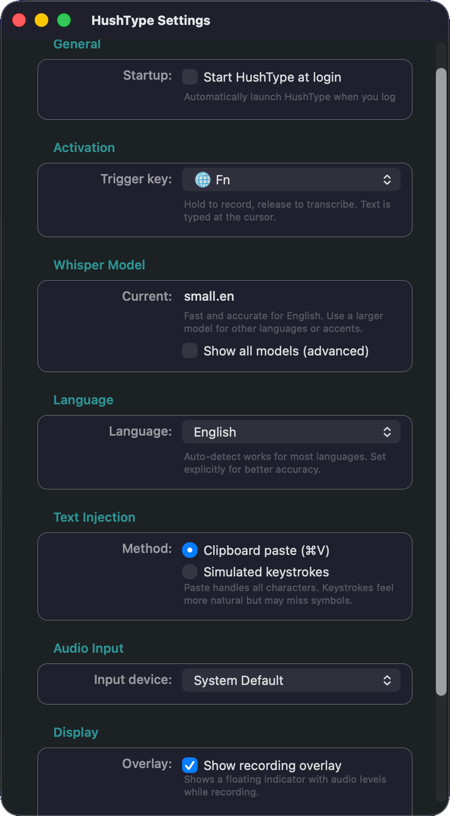
HushType Settings panel

General
Start HushType at login — when enabled, HushType will launch automatically each time you log in to your Mac. This integrates with macOS’s built-in Login Items system (visible in System Settings → General → Login Items), so you can also toggle it from there.

Activation
Trigger key — the modifier key you hold to start recording. Choose from Fn (the default), Control, or Option. The trigger key must be pressed alone; holding other modifier keys at the same time is ignored to prevent false triggers from keyboard shortcuts. Shift and Command are deliberately excluded because they conflict with too many system and application shortcuts.

Whisper Model
Current — displays the name of the Whisper model currently loaded. The default is "small.en", which provides a good balance between speed and accuracy for English.
Show all models (advanced) — tick this checkbox to reveal a dropdown listing every available model, from the fastest (tiny) to the most accurate (large-v3). Smaller models transcribe faster and use less memory; larger models produce better results, especially for non-English languages or difficult audio. If the model you select is not already on your Mac, HushType will download it automatically (a progress window will appear).
Available models, in order from fastest to most accurate: tiny, tiny.en, base, base.en, small, small.en, medium, medium.en, large-v3, and large-v3-turbo. Models ending in “.en” are English-only and slightly more accurate for English speech.

Language
Language — choose the language you will be speaking. The default is "Auto-detect", which lets Whisper identify the language from the audio. Setting an explicit language can improve accuracy. HushType supports 30 languages including English, Spanish, French, German, Chinese, Japanese, Korean, Arabic, and many more.
If you select a non-English language while using an English-only model (e.g. small.en), HushType will automatically switch to the equivalent multilingual model (e.g. small).

Text Injection
This controls how HushType types the transcribed text into your active application. There are two methods:
Clipboard paste (⌘V) — the default and recommended method. HushType temporarily copies the text to your clipboard, simulates a Cmd+V paste, and then restores whatever was on your clipboard before. This handles all Unicode characters, punctuation, and special characters perfectly.
Simulated keystrokes — types each character individually by simulating keyboard events. This can feel more natural in some applications but is limited to the US keyboard layout and may miss certain symbols. Use this if clipboard paste causes issues in a particular application.

Audio Input
Input device — choose which microphone HushType uses. The default is "System Default", which uses whichever microphone macOS has selected. If you have multiple microphones (for example a built-in mic and a USB headset), you can select a specific one here.

Display
Show recording overlay — when enabled, a small floating indicator appears at the top of your screen during recording. It shows audio levels so you can see that your microphone is picking up your voice. The overlay never steals focus from your active application. Disable this if you find it distracting.
Menu bar icon — choose between the custom HushType icon (the default) or a standard system microphone icon (SF Symbol). The HushType icon is designed to be easily distinguishable from Apple’s own microphone icons that may appear in the menu bar.

Automatic Updates
HushType includes a built-in update mechanism powered by Sparkle. The app periodically checks for new versions in the background, and when one is available, it will prompt you to install it. Updates are downloaded and applied automatically — you just need to confirm when asked. You can also check for updates manually at any time by clicking the menu bar icon and selecting “Check for Updates…”.
All updates are cryptographically signed to ensure they are genuine and have not been tampered with. The update files are hosted on GitHub and verified before installation.
For the smoothest update experience, grant the App Management permission as described in the Setting Up Permissions section. This ensures macOS does not block HushType from installing updates.
Remember: after each update, macOS will require you to re-grant Accessibility permission (see the Setting Up Permissions section). HushType will remind you when this is needed.

Troubleshooting

Text goes to clipboard instead of being typed
This means Accessibility permission is missing or was revoked after an update. Follow the Accessibility steps above to re-grant it.

No sound is being captured
Check that Microphone permission is granted in System Settings → Privacy & Security → Microphone. Also check that the correct input device is selected in HushType’s Settings panel.

The app won’t open / shows a security warning
Right-click the app in your Applications folder and choose Open. macOS may show a warning for apps downloaded outside the App Store. Clicking Open from the right-click menu bypasses Gatekeeper for that specific launch. You only need to do this once.

Updates are failing
Make sure you have a working internet connection and try again from the menu bar: click the HushType icon and choose Check for Updates. If macOS is blocking the update, grant App Management permission in System Settings → Privacy & Security → App Management (see the Setting Up Permissions section). If the update still fails, download the latest version manually from the HushType website and replace the app in your Applications folder.

Transcription is inaccurate or repeats phrases
Try switching to a larger Whisper model in Settings (for example, from "small.en" to "medium.en" or "large-v3"). Larger models are significantly more accurate, especially with background noise, accents, or complex vocabulary. If you are speaking a language other than English, make sure the correct language is selected in Settings and that you are using a multilingual model (one without the ".en" suffix).

Created: 9 February 2026
© 2026 Malcolm Taylor. All rights reserved.

