A Characterization of Processing Loops in AI and Biological Systems and its Implications for Understanding Consciousness

Malcolm J. Lett1

1No affiliation

**\* Correspondence:**Malcolm Lett  
malcolm.lett@gmail.com

Keywords: Access Consciousness, Phenomenal Consciousness, Biosemiotic Process, Visceral Loop, Monitoring and Control, Recurrent Process, Non-physical Action, Conscious Content

Abstract

todo

# Introduction

todo

# Meta-Cognition

# Meta-Management

## The need for meta-management in connectionist computational systems

# Regulation

An autonomous embodied agent, depending on its purpose, may need to control either its environment, itself, or both, towards some static or dynamically determined target. That agent can be described as a *regulator* of its target system.

For example, an agent that regulates its environment operates within a system containing environment state *senv* which changes with some ambient dynamics *denv(t)*. The agent must perform an action, *aenv*, against the environment in order to regulate itself towards some target. After an action has been executed the environment state outcome *oenv* is influenced by both *denv(t)* and *a*env. This can be summarized as the following equation:

$$s_{env}+d_{env}\left(t\right)+a_{env}=o_{env}$$

According to the *good regulator theorem*, if the agent is to regulate the environment state it must be a "model of the system" (Conant & Ashby, 1970). Furthermore, we can say that the efficiency of the agent to regulate its environment depends on its accuracy in modeling the system. Errors in the accuracy of the model result in errors in the regulation of the system. In learning agents, those errors are used for subsequent training of the model.

An embodied agent with complex actions may require an additional level of regulation. For example, an animal must not only regulate its external environment, but also regulate its own physical state. This includes both maintaining homeostasis and controlling the efficiency and effectiveness of its actions against the environment. The agent performs action *abody* against its body with the intent to regulate the body towards efficiently achieving environment action *aenv* while satisfying its requirement for body homeostasis. Such an agent thus operates in a system that additionally has body state *sbody* with ambient dynamics *dbody(t)*. The agent performs action *abody* against its body, producing outcome *obody*, summarized as follows:

$$s_{body}+d_{body}\left(t\right)+a_{body}=o_{body}$$

Agents that incorporate multi-step processing have a third kind of action: one that changes its internal data state without affecting its physical state. This system requires regulation for the same reasons as for environment and body, but such *non-physical* actions do not elicit any change to *sbody* or *senv*. Thus the agent must regulate its non-physical state *smind*, having ambient dynamics *dmind(t)*. The target state in this case is dynamically inferred based on its requirement for environment action *aenv*, body action *abody*, and possibly for some form of non-physical homeostasis of *smind*. In order to regulate towards that target it performs action *amind* producing outcome *omind*, summarized as follows:

$$s_{mind}+d_{mind}\left(t\right)+a_{mind}=o_{mind}$$

By way of example of the importance of such mind regulation, consider the case of fluent aphasia caused by damage to the Wernicke's area[1] of the brain. Individuals with fluent aphasia can easily produce speech, but it is typically full of many meaningless words and often unnecessarily long winded. Wernicke's area is associated with language comprehension. In a neurotypical individual, the comprehension of their own vocalizations provides a corrective mechanism. This illustrates the importance of feedback in the regulation of one's own actions, and by way of analogy extends to the regulation of non-physical actions.

# Models

All of the systems described above are of the form $s+d\left(t\right)+a=o$. The production of the optimal action *a* for a given situation can be computed by a function, *f*, such that $a=f\left(s,o,t\right)=o−s−d\left(t\right)$. In this way, function *f* becomes a *model* of the system in exactly the way meant by Conant and Ashbey. There are many different ways of constructing such a function, with implications on how much its inherent model can be introspected for purposes other than merely computing the next action.

Consider the following function. This function is, for example, effective at predicting the action required to regulate towards a target state of 3 by doubling the input signal and comparing to that target state. However, an agent that merely uses this function to calculate actions cannot inspect anything about the function other than the actions it calculates for different inputs.

$$f\left(x\right)=3−2x$$

Alternatively consider Figure 1, which shows an abstract syntax tree[2] (AST) of the function above, of the sort used by computer science to parse an expression within a software compiler. Instead of using the above function, a regulating agent could use this AST to calculate its next action and achieve the same outcome. However the AST is a more explicit model of the dynamics being regulated. The components of the original function are represented individually and thus they can be individually queried. So here the AST can be introspected and much more can be derived from it that may apply either to the system being modeled or to how the AST models that system.

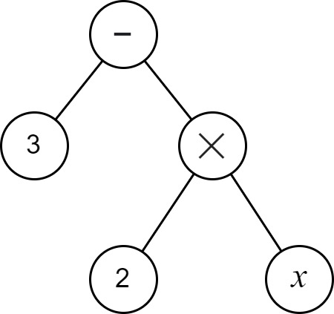  
Figure 1: Abstract syntax tree of 3 - 2x

To examine the introspective opportunities further, consider the task of constructing a set, *F*, that contains all beliefs that may be drawn from the model. In the case of the function, pairs of input and output action values are all that can be drawn from the model, ie: <0,3>, <2,-1>, <-3,9>, <-1,5>, etc. The AST supports the ability to draw those same pairs of input and action values. However the AST also supports that many other beliefs may be drawn from the model and added to *F*. For example that i) the target is 3, ii) input signal *x* is significant to the calculation, while *y* and *z* are not, and iii) the execution of the function depends on the operations of *subtraction* and *multiplication*.

So, it is clear that different architectures enable different levels of *introspection* of the underlying models. What about the case for neural networks? In the modern use of artificial neural networks (ANNs), it is commonplace to refer to ANNs as a *function approximator* (Goodfellow et al., 2016), and indeed many networks fall into the category of a function. For example, in *model-free* deep reinforcement learning (RL) an ANN is used to calculate either the next action or the expected value of all possible actions given the current state (Lazaridis, Fachantidis & Vlahavas, 2020). The architecture of the RL algorithm treats the ANN as a function without any introspective capabilities. See Figure 2(A) for an example. There is also *model-based* RL. One variant of model-based RL, illustrated in Figure 2(C), uses ANNs to predict the expected outcome of executing an action. The introspective ability here is the same as for model-free deep RL - the ANN is treated as a function. For the RL models mentioned so far, the set *F* of beliefs is of similar content: *F* is the set of <state,action> or <state,action,outcome> tuples. There do exist forms of model-based RL that use something more akin to the AST, usually where there is a known physics model that is represented mathematically, and which could potentially be used to introspect for more than just <state,action,outcome> tuples, such as is illustrated in Figure 2(B). However, a significant point to note here is that ANNs, and probably neural networks in general, do not lend themselves to introspection on their own.

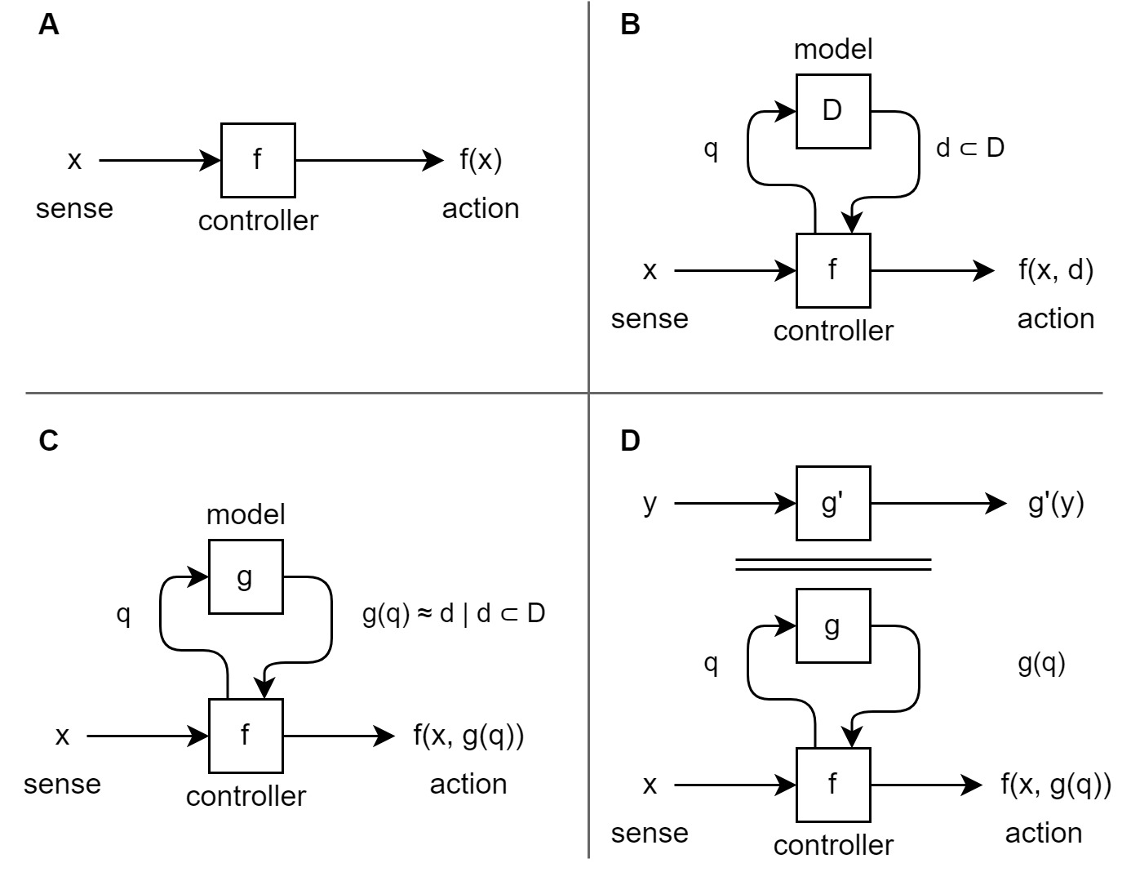  
Figure 2: Different architectures for *modeling regulatory actions against the environment.* In (**A)**, the controller determines the next action by executing function *f* against sense input *x*. The function may, for example, be an ANN that is trained through many iterations of an appropriate learning algorithm. Function *f* merely models the best next action without modeling any other aspects of that environment and thus cannot be used to introspect anything other than the next regulatory action. In (**B)**, set *D* holds an explicit model of the environment which can be arbitrarily queried (*q*) to gain insight about any aspect of the environment that is encapsulated within *D*. Controller function *f* uses that to determine the next action. In (**C**), set *D* is replaced by function *g(q)* which approximates queries against *D*. This architecture is commonly used in AI where the dynamics of the environment are too complex to determine a priori, and *g(q)* is built as a second ANN that is trained through exploration. In (**D**), the secondary system *y = g'(y)* models some aspect of the environment other than the next regulatory action. For example, it may observe and predict long term trends in the environment state. Potentially further additional modeling systems are required for each additional aspect of the environment that needs to be modeled.

For that reason, a third form of modeling system exists, whereby a secondary model predicts the behaviors of the former, such as is illustrated in Figure 2(D). The secondary model may, for example, be a second ANN that captures aspects of the same underlying system but at a more macro level, and it may be more suitable for integration with other data. This macro representation is at the core of the theory of Higher Order Thought Theory (HOTT) (Rosenthal, 1997 & 2006), and of recent theories based on it such as Hierarchical Active Inference (Giovanni et al, 2018) and Integrated World Modeling Theory (IWMT) (Safron, 2020).

# Schemas

The lack of introspective ability of a simple function contrasts with the introspective ability of a human. Psychology has long identified in humans the existence of a model of the individual's body – known as the *body schema*. A good definition is given by Morasso et al (2015):

*"In summary, we view the body schema as a set of fronto-parietal networks that integrate information originating from regions of the body and external space in a way, which is functionally relevant to specific actions performed by different body parts. As such, the body schema is a representation of the body’s spatial properties, including the length of limbs and limb segments, their arrangement, the configuration of the segments in space, and the shape of the body surface".*

So the body schema is a model used in production of action control by integrating information from our main physical senses and the proprioceptive senses (Proske & Gandevia, 2012). That model can also be introspected – for example, we can know where our hands and feet are without seeing them – and those introspections can become the topic of subsequent thought. But there are aspects of the model that cannot be introspected – for example, we have no observability of the arrangement of the sense nerves used to infer the hand and feet positions, or of the effector nerves used to actuate their muscles.

This paper hypothesizes the existence of a second schema, the *mind schema*, that performs an analogous role for the regulation of the mind and non-physical actions. Anecdotally, this seems highly plausible within humans given our introspective ability towards our own mind's capabilities. For example, we can know that we are good at focusing, but struggle with math, that we are more creative when background music is present, and that we need the support of tools to help remember people's names (eg: a notebook). The underlying notion here is that the mind schema helps us to control, monitor, predict, and rationalize about our mental structure and actions in the same way that our body schema does that for our physical structure and actions. It is the regulatory model for our non-physical actions. Additionally, just as for the body schema, there is a distinct delineation between what can be introspected and subsequently thought about, and what cannot.

The suggestion of a mind schema has also been made in the form of *Attention Schema Theory* (Graziano & Kastner, 2011; Webb & Graziano, 2015; Graziano, 2017), although the meaning there is perhaps narrower than what is proposed in this paper.

# Summary

todo

# Author Contributions

The author confirms being the sole contributor of this work and has approved it for publication.

# Funding

No funding was received.

# References

1. https://en.wikipedia.org/wiki/Wernicke%27s_area
2. https://en.wikipedia.org/wiki/Abstract_syntax_tree