Meta-management in AI and Biological Systems and its Implications for Understanding Consciousness

Malcolm J. Lett1

1No affiliation

**\* Correspondence:**Malcolm Lett  
malcolm.lett@gmail.com

Keywords: Theories of consciousness, Meta-cognition, Meta-management, Biosemiotic Process, Recurrent Process

Abstract

*todo ....*

# Introduction

Theories of consciousness (TOCs) attempt to explain the functioning of the cognitive processes of the brain and how those processes give rise to subjective experience – often described as "what it is like" to be conscious (citation, Nagel). Computational theories of consciousness view individual neurons, groups of neurons, and regions of the brain as "processing" received information in order to produce an output. Several computational theories of consciousness today receive a lot of interest, including Global Workspace Theory, Higher-order Thought Theories, and Integrated Information Theory, to name just a few.

One recurring question in research on consciousness in general, and on subjective experience particularly, is what utility it provides over and above other brain processes that are not associated with subjective experience. Many theories, including computational TOCs, make reference to the need for flexibility or adaptation. However these theories tend to provide high-level descriptions. They thus either fail to identify what flexibility or adaptation means, they fail to specify the mechanisms underlying such flexible adaptation, or they fail to sufficiently explain how the theory balances the need for flexibility without collapsing into disorganized chaos.

Behavioral scientists have been asking these very questions in the study of meta-cognition. This area looks at the ability of an individual to monitor and control their own mental processes, and how that relates to flexibility, learning, and other capabilities. The study of meta-cognition tries to incorporate behavioral studies with our growing understanding of brain function from neuroscience. However, many questions remain about which behaviors are truly meta-cognitive, and about how tightly or loosely meta-cognition is tied to subjective experience. The problem, again, is that these theories are too high-level.

At the other end of the spectrum, artificial intelligence (AI) research has taken inspiration from neuroscience to build so called *connectionist* models, for example artificial neural networks (ANNs). More recent improvements have seen a surge in "deep AI", where tens or hundreds of layers can be combined to produce spectacular results on specific niche problems. Deep AI uses well understood low-level mechanisms, and has great practical use. But these connectionist models lack the very flexibility hypothesized by TOCs and studied by meta-cognition.

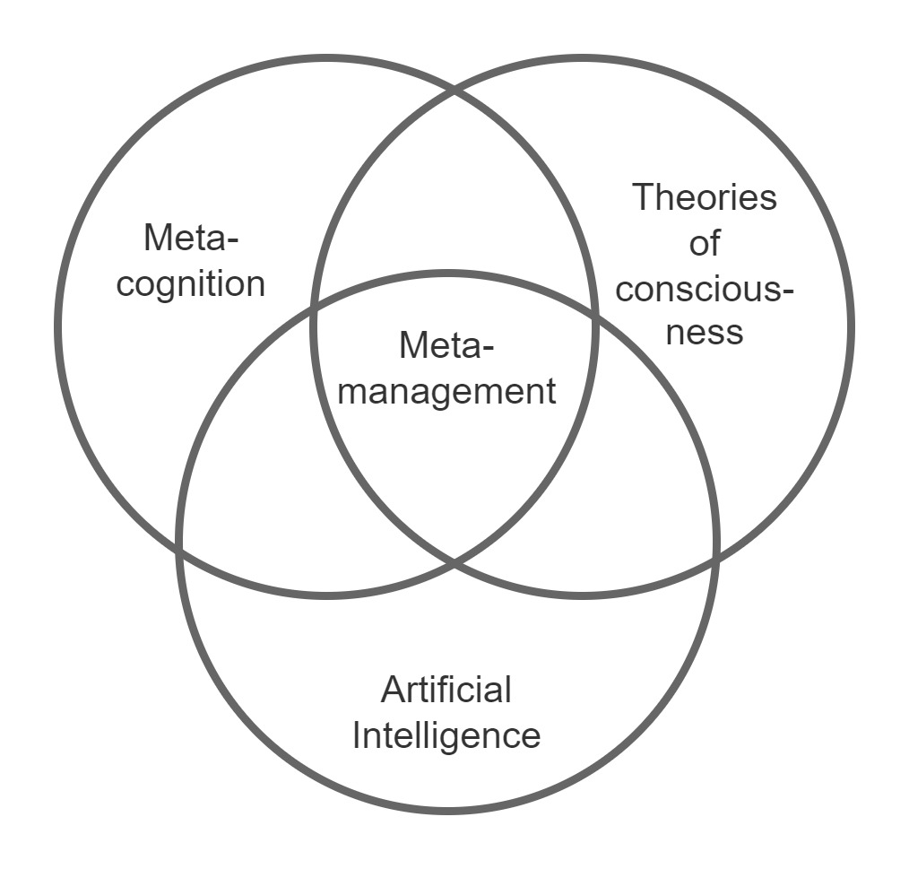Figure 1: Meta-management as key to meta-cognition, theories of consciousness, and AI

All three research areas would benefit from a more detailed, more systematic understanding of what "flexibility" is and the mechanisms underlying it. This is the study of *meta-management*. As illustrated in Figure 1, meta-management sits at the intersection between meta-cognition, TOCs, and AI research, but it has not received the focus that it deserves. The purpose of this paper is to build a systematic grounding for further research into meta-management, by building up from first principles why it is needed and what architectures might support it.

The rest of this paper proceeds as follows. A background is first given to each of meta-cognition, TOCs, and AI. Meta-cognition, in particular, is studied for its inspiration for the kinds of flexibilities that need to be supported by meta-management. Chapters 5 through 10 build up the case for meta-management and define its architectures. This is followed by a speculative description of how those meta-management architectures may underlie human meta-cognition, and a final paper summary.

## Terms used in this paper

Todo - table of terms.

* Experiential awareness. Rather than using the word "consciousness", to be more specific, this paper prefers the term "experiential awareness".......
* meta-cognition
* meta-management
* micro and macro recurrency.
* first-order processes
* state-machine
* state
* computational process

# Meta-cognition

In ..{year}.. it was found that people who had a better understanding of their own learning abilities, learned better. People with more awareness of their learning abilities developed better learning strategies to leverage their strengths, while working around their limitations (eg: using mnemonics to improve memory). Thus the field of *meta-cognition* was born – to study the mechanisms whereby people can monitor their own mental behaviors and use that knowledge for adaptation. .*.....need to list some lab-observed behaviors......*

Meta-cognition is defined as knowledge about one's own knowledge.....

The study of meta-cognition has a particular relevancy to the study of consciousness. Why do we have conscious experiential awareness of our external perceptions? Why do we have conscious experiential awareness of some aspects of our own mind's state (eg: inner thoughts)? Theories attempting to explain the evolutionary advantage of this conscious awareness generally implicate adaptive flexibility. But they fail to explain precisely what kinds of adaptive flexibility need conscious awareness, and why conscious awareness is needed for those adaptive flexibilities. The study of meta-cognition provides insight because it specifically addresses questions around our ability to know aspects of our own mind's state.

But meta-cognition studies are embroiled in debate about which lab-observed behaviors are truly meta-cognitive. Many of the claimed behaviors might be explained by unconscious processes. And lab results are hard to interpret – eg: the difficulty is separating activated brain regions from involvement in the original meta-cognition versus the production of verbal report? Thus, a deeper understanding of the low-level mechanisms underlying meta-cognition would help significantly to untangle the confusion.

*todo - Define: first-order processes.*

Meta-cognition has been variously studied in terms of so called "feelings of knowing" where one thinks they know the answer before recalling the answer itself (Rosenthal, 2012; Shimamura, 2000; Metcalfe & Shimamura, 1994), memory of the source of knowledge or other memories (Dunlosky & Bjork, 2008; Shimamura, 2000; Fernandez-Duque, 2000; Bejamin et al, 1998; Metcalfe & Shimamura, 1994), judgements of certainty and error detection (Carruthers & Williams, 2022; Cleeremens, 2020; Whitmarsh, Oostenveld, Almeida & Lundqvist, 2017; Fernandez Cruz et al, 2016; Paul et al, 2015; Fleming et al "Metacognition..." 2012; Fleming et al "Prefrontal..." 2012; Shimamura, 2000; Fernandez-Duque, 2000), classification of first-order outcomes into knowledge, hope, fear, regret, etc. (Cleeremans et al, 2007), identification of links between separately obtained knowledge (Clark & Karmiloff-Smith, 1993; Karmiloff-Smith, 1992), representing the absence of knowledge (Fleming et al "Metacognition..." 2012), selection of strategies for memory, learning, life-span approaches (Marković et al, 2021; Shimamura, 2000), learning higher-level objectives (Timmermans et al, 2012), trading off between exploration and exploiting existing knowledge (Marković et al, 2021), balancing effort vs benefits of possible behaviors (Carruthers & Williams, 2022; Marković et al, 2021; Peters, 2010; Fernandez-Duque, 2000), planning (Marković et al, 2021; Cleeremens, 2020; Fernandez-Duque, 2000), monitoring and predicting first-order dynamics (Cleeremens, 2020; Fleming et al "Metacognition..." 2012; Timmermans et al, 2012; Cleeremans et al, 2007; Peters, 2010), control of attention (Whitmarsh, Oostenveld, Almeida & Lundqvist, 2017; Shimamura, 2000), control over working-memory (Whitmarsh, Oostenveld, Almeida & Lundqvist, 2017; Shimamura, 2000), internal conflict resolution (Shimamura, 2000; Fernandez-Duque, 2000), maintenance of cognitive homeostatic needs (Peters, 2010; Shimamura, 2000), emotion regulation (Shimamura, 2000), theory of mind (Carruthers & Williams, 2022; Cleeremens, 2020), and in support of social cooperation by enabling a group to identify the individual who is most certain about some decision point (Cleeremens, 2020; Fleming et al "Metacognition..." 2012; Fleming et al "Prefrontal..." 2012; Cleeremans et al, 2007).

*todo - Meta-cognition can be viewed as having a few aspects:*

* *meta-representation ...explain...*
* *meta-control (observation only vs control) ...explain...*
* *first-order vs conscious processes ...explain...*

*todo - Some running questions have cropped up out of those studies:*

* *To what extent does meta-cognition actually need meta-representations? ...examples...*
* *To what extent are meta-cognitive processes truly conscious? Or are they just first-order processes that influence verbal report without direct conscious access? ...examples...*
* *axis:*
  + *with/without meta-representation*
  + *first-order only vs higher-order network architectures*
  + *extent to which different human meta-cognitive behaviours employ meta-management.*
  + *relationship to conscious experience.*
  + *caught up in questions about whether consciousness has any functional purpose (Rosenthal, etc)*

# Computational Theories of Consciousness

*todo - Define: computational.*

Computational theories of consciousness promise to provide the mechanisms underlying consciousness, and this should hopefully cover some of the processes of meta-cognition. For example, Global Workspace Theory (GWT) posits that groups of functionally specialized processes cooperate to boost their collective signal strength and thus gain the right to broadcast to all other processes within the system, via the so-called *global workspace*. Stable collaborations between such processes form contextual *frames*, which influence the behaviors of other processes. Thus, changing external circumstances can be quickly adapted to by changing the set of collaborating processes.

However, GWT is described at a very high level. Furthermore, it fails to develop the mechanisms needed to ensure that the system as a whole is stable, and how an agent built on the theory would learn its objectives and act towards those objectives. GWT, and all other computational theories of consciousness, define a system having internal state. That internal state must be managed somehow as it interacts with perceptions of external state, governs the processes operating within the system, and becomes updated as a result of those perceptions and processes. Many computational theories of consciousness fail to cover this area at all. Others that do focus on the state management processes (eg: bayesian models of consciousness, discussed later) either fail to link back to adaptive flexibility, or do so only in a high level manner.

Thus, the studies of meta-cognition and computational theories of consciousness would both benefit from a more in-depth investigation of the processes and mechanisms for management of the changing internal state that influences perceptions and actions. This is the area of *meta-management* (the more general, non-biological, equivalent of meta-cognition).

The focused study of meta-management will i) identify the problem spaces that require explicit meta-management, ii) elucidate mechanisms of meta-management, iii) help to resolve some of the confusions in meta-cognitive research, and iv) add to the growing body of techniques that are useful in development of artificial intelligence (AI) systems.

This paper attempts to untangle the meta-cognition research confusion by relating biological meta-cognitive needs to the need for meta-management processes within artificial computational models. An argument is presented for the need of specific adaptive abilities within computational models, and for the meta-management processes that can underlie those adaptive abilities.

*GWT*

*HOT*

*Bayesian Models*

*Bayesian models view much of brain operation as a system for predicting latent state, and for predicting actions that move latent state towards a preferred latent state. Thus conscious perception is inferred latent state.*

*This provides a useful backbone to meta-cognition, as inference over brain state.*

*IIT?*

# Artificial Intelligence

*....todo....something brief....*

# State in Embodied Agents

Most computational theories of consciousness indirectly describe the brain as a *state machine*. This is meant here in the sense that the brain has a dynamical state that persists through time, and which influences and is influenced by the cognitive processes. In brains, this includes high-level examples such as knowledge, memories, and life-style choices, down to low-level examples such as messages passed in recurrent loops, levels of arousal, and neuroplasticity.

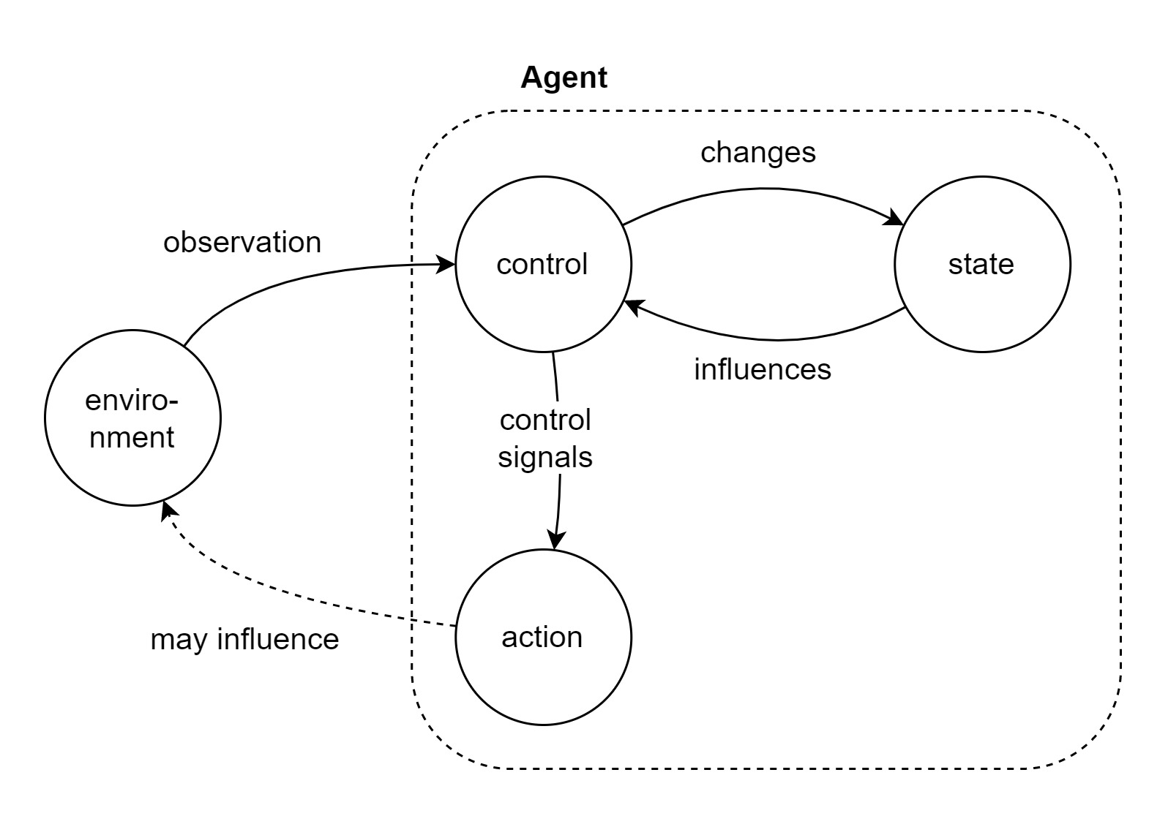

Figure 2: State machine

As highlighted in Figure 1, the point is that every observation of and reaction to the environment results in a change to the agental system; and that this change affects the agent's subsequent reactions. This broad conception of state machine will be re-used throughout the rest of this paper. Additionally, sometime it will be referred to as a single state, other times it will be convenient to refer to the fact that a system's state is made up of many different components (*eg:...todo...*) and thus will be referred to in the plural "states".

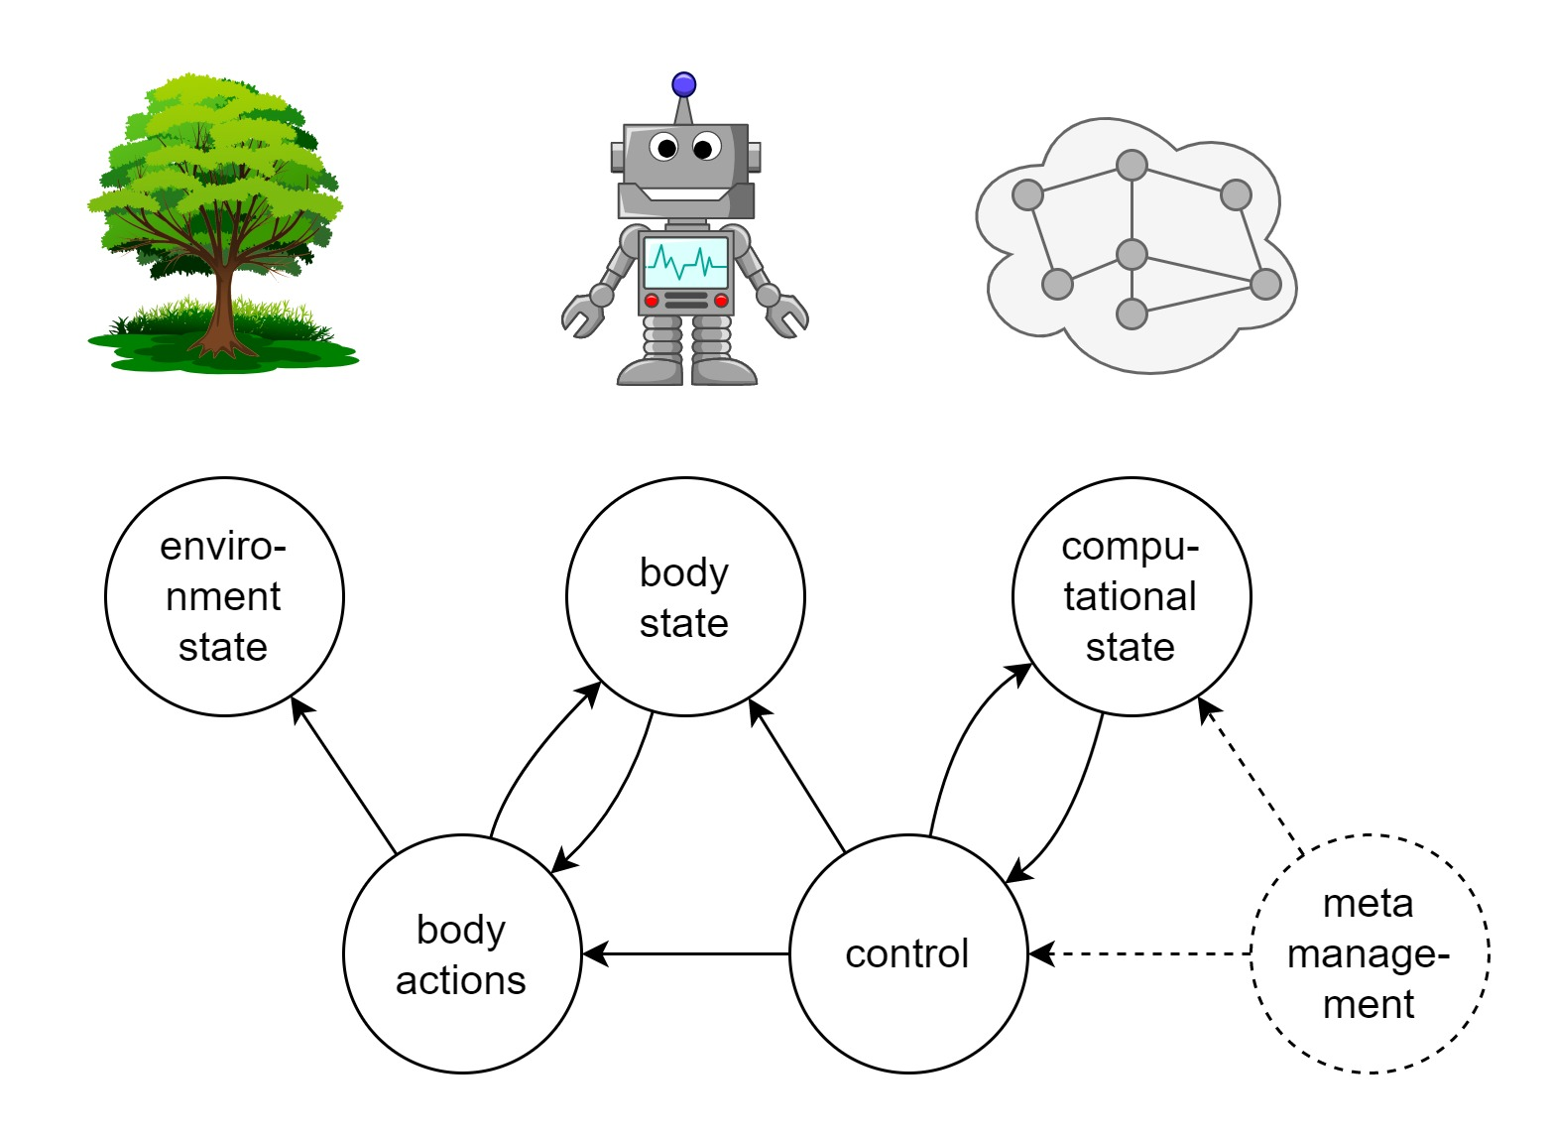Figure 3: Three states of concern to an embodied agent. The agent seeks to control the environment state through its body actions. The agent must monitor and control its body state in order to successfully use its body actions to perform that environment control. The agent's control process is influenced by its computational state. That computational state also needs to be controlled (meta-managed). There is also a constant reciprocal interaction between the body state and body actions, and between the computational state and the first-order control process.

Thus, a computational control process can have state that is independent of the state of its external environment. As illustrated in Figure 3, embodied agents with state machine computational control processes have three distinct states: i) the state of their external environment, ii) the state of their (biological or artificial, physical or virtual) bodies, and iii) their internal computational state.

An agent that exists within an environment must monitor and predict the state of that environment. It may also act with the intent to change the environment (eg: put a plate on the table, or lift the object held by the robotic claw).

These actions are performed by the agent's body, which itself can be said to be in some state at any point in time. A significant component of the computational control processes are required to monitor, predict, and to tune the body's static state (eg: it's current location and energy levels) and dynamic state (eg: speed and acceleration of arm movement, adapting to resistance in movement due to detritus in gears). This is known as the *first-order* control process.

The same can be said for the state of the computational control process itself. It too needs to be managed. It needs a higher-order control process known as *meta-management*. But the case for this needs a little more explanation.

## State Trajectories

The course taken by an agent to get from a past state to its current state is its *state trajectory*. Analogous to the path taken by an agent while walking through a maze, the state trajectory describes the path of the agent through state space. Here the state space can refer to its possible locations in physical space, such as in the maze example, or to more abstract possible states, such as an encapsulation of all measurable aspects of the agent's body parts. This provides a useful abstraction away from the low-level details of individual actions. It is a useful abstraction to us for conceptualizing about the agent's behavior. It is also a useful abstraction for the agent itself, as will be seen later.

Not all state trajectories are good ones. Figure 4 illustrates a number of possible state trajectories from start state S to goal state G, while avoiding obstacle X. Each trajectory successfully reaches the goal, but they vary in other ways that may have significant impact to the agent. They length of the trajectory may indicate energy efficiency, which is important for an agent with limited energy reserves. The length may also indicate the time taken, which impacts whether or not the goal is reached "in time". The smoothness of the trajectory can be important. A jagged trajectory might indicate that the agent's physical body is moved in a chaotic way with abrupt stops and starts, causing damage to delicate moving parts from the stresses of that chaotic movement. A smoother trajectory may be easier for the agent to subsequently learn from and reason about in order to improve its later attempts; whereas a more chaotic path may add so much noise to the observations of the trajectory that the agent is unable to detect the most important patterns for such learning.

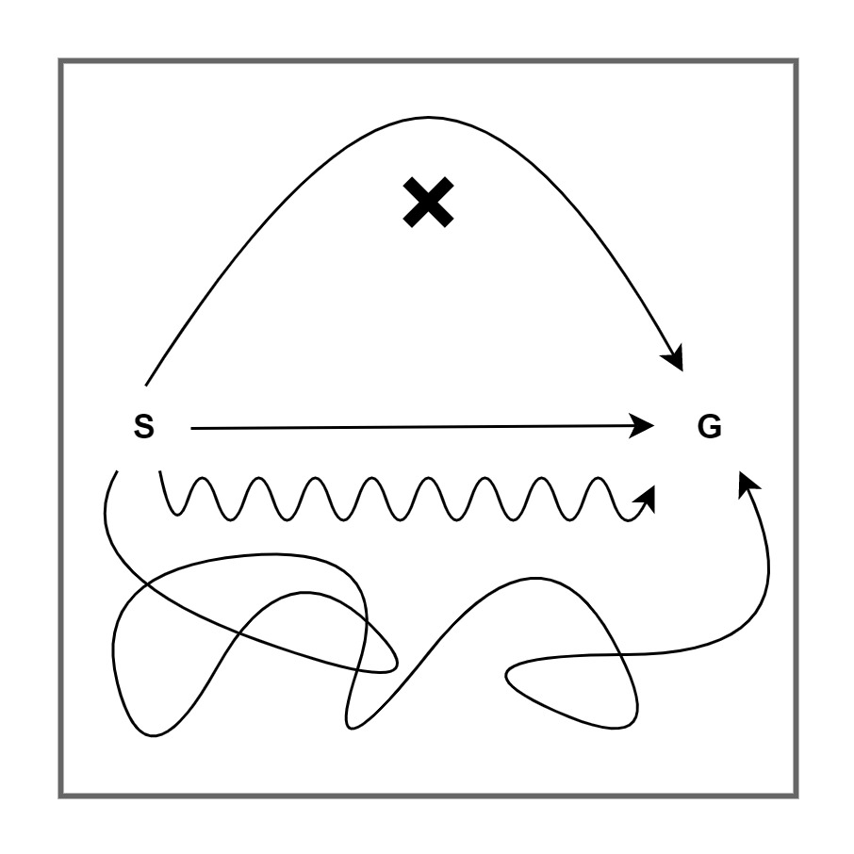Figure 4: Good and bad state trajectories. Examples of some possible state trajectories from start state *S*, to goal state *G*, while avoiding obstacle *X*. The shortest and smoothest trajectory is assumed to be the best: the most energy-efficient, the quickest, the least stresses applied the mechanics of the agent.

Thus, it is not sufficient only for an agent to achieve its goals, it must achieve those goals through "good" state trajectories – to whatever extent "good" means in the context. This is obviously true for the physical state of the body of an embodied agent. In certain circumstances it is also true for the computational state of the control system. A number of examples are presented next.

## Computational State Trajectory during Body Action

Actions by an embodied agent occur over time. During the time it takes for an agent to move its arm through space from the arm's initial position to target position, the agent will make many observations about the environment and body states. The agent's goal and action plan must be relatively persistent during that time. Otherwise the agent's behavior will be chaotic, with rapid goal and action changes.

Thus, while the agent manages (controls) the trajectory of its body state through the use of its computational state (eg: the given goal and action-plan at the time), it must also *meta-manage* the trajectory of that computational state. In this case, the agent's computational state must to some extent resist change influenced by new observations.

## State Trajectory during Multi-step Processing

Not all actions can be decided upon immediately. Any computational system has a limit on its bandwidth: the level of complexity of computation that it can perform in a single pass from input to output. In the field of Artificial Intelligence, deep neural networks use many layers (sometimes hundreds) to improve that bandwidth (citations). Recent work (citation, "loops are the way forward") has found that deep neural networks can be replaced by shallower networks that employ end-to-end recurrency (where top-level output is used as feedback into the bottom-level input layers). These shallower *macro-recurrent* (..definition...) networks provide the same or better performance, but have less free parameters and are faster to train.

Thus, such an agent can execute a trajectory through computational state space, without performing any body actions. And this state space trajectory needs to be managed just the same as above. In order to maintain stability the agent needs to i) observe the state space trajectory, ii) apply some objective measure to decide upon the relative effectiveness of the trajectory, and iii) act to change the trajectory if a better one is available.

A number of examples of potential control problems in such a system with "deliberative" capabilities were given by Beaudoin (1994):

* **Oscillation between decisions**. Wasteful re-assessments of decision points, leading to a meta-stable (oscillating) but stagnant (ultimately achieving nothing useful) state.
* **Insistent goal disruption.** Repeatedly getting distracted by competing goals that have been previously disregarded.
* **High busyness.** Attempting to multi-task between too many goals, leading to poor outcomes.
* **Digressions.** Choosing to deliberate over some sub-goal, and then loosing track of the "big picture" by forgetting to return to the overarching goal.
* **Maundering.** Getting stuck deliberating over the details of a goal without making a decision.

## State Trajectory during Iterative Inference

A third example of the need for control of state trajectories is found in the case of *iterative inference*.

*todo Here ............*

This is similar to the above examples of state trajectories. The computational state needs to be relatively persistent during the execution of the iterative inference process, as part of that computational state reflects the context of the inference. In other respects, the computational state is part of that iterative process, and thus changes with it. The trajectory of the changing computational state needs to be managed.

## Recurrency

*todo - I might not need this section.*

F*eedforward - has no state.*

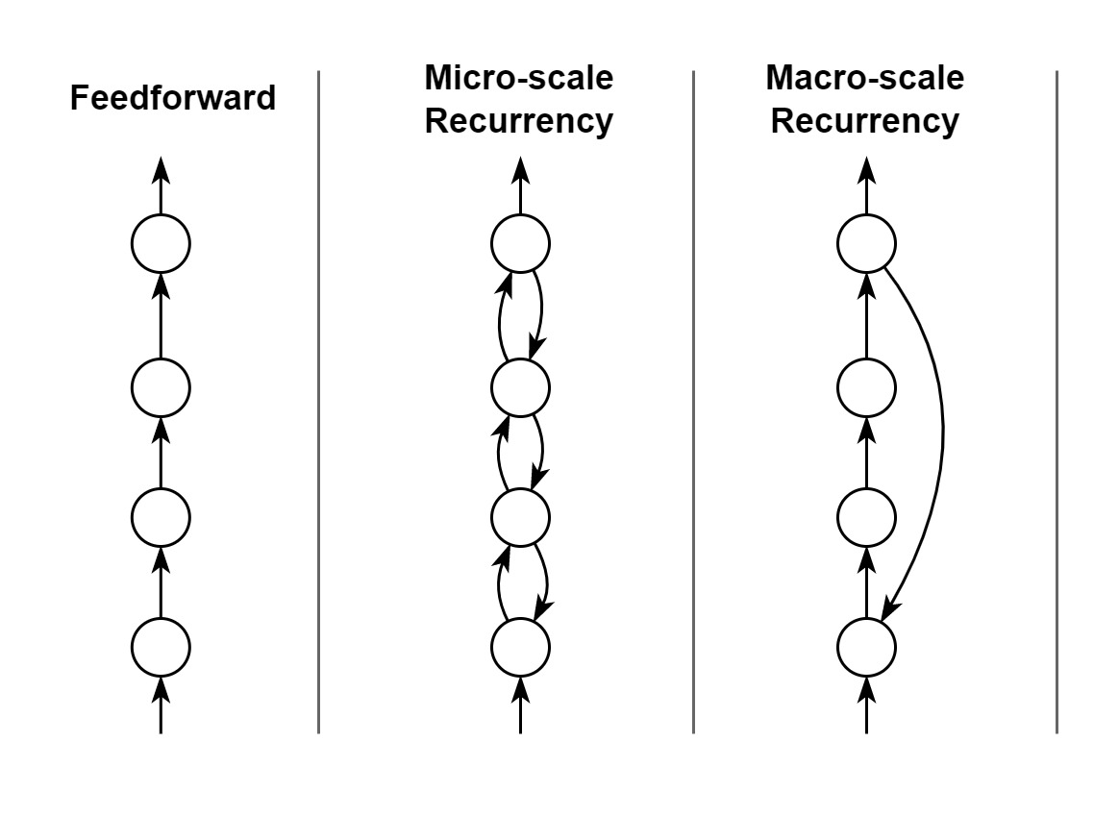Figure 5: Types of recurrency. A feed-forward network as an example of no recurrency. Micro-scale recurrency: hierarchical predictive coding employs recurrency between adjacent layers in order to execute an iterative process; but it still ultimately produces a single output for a given input. Macro-scale recurrency: a loop, where the end result of the output layer is fed back as input into the input layer. This enables multi-step processing, aka processing loops.

*Micro-scale recurrency - eg: iterative predictive networks; hierarchical architectures.*

*Macro-scale recurrency - eg: state machine loops; large-scale recurrency in cortico-thalamic system and others.*

# Meta-management

*todo ... with all that is said, it is now time to formally define meta-management:*

* *Cleeremans defines meta-management as not having causal effect on the outcome of the first-order network. This suggests an observation-only role for meta-management, which limits its usefulness, and elicits ideas of epiphenomenalism.*
* *I suggest that meta-management always also includes active control of the first-order network, and thus is causal, but only in a specific way.*
* *Possibly better: meta-management is a higher-order process that monitors and controls the first-order network in such a way as the first-order network has no observability of the existence of operation of the higher-order meta-management network. => However, even this fails because it conflicts with "integrated meta-management".*
* *Another: meta-management is how a system maintains (the consistency, stability, convergence of) its own internal state, while the system manages its interactions with its external environment.*
* *Thus, meta-management may take many forms - and the purpose of this paper is to elucidate on those forms and the implications thereof.*

*todo - Include references to existing meta-management research and signal detection theory-based characterisations.*

The following four chapters look at meta-management and its options from different perspectives.

# Meta-management Needs

Why might we need to add meta-management processes to connectionist architectures? Deep AI techniques have had many successes of late (citation). However, these networks still lack some of the most basic adaptive capabilities that we see in many biological organisms (citations, eg: sloman).

Here some specific meta-management features are discussed in the context of how they might improve connectionist computational systems such as deep AI architectures. This "design stance" is useful as a means for teasing out the lower level mechanisms that may underlie much higher-order behaviors such as meta-cognition.

## State trajectory control

As discussed in detail in an earlier chapter, there is a strong case for the need to actively manage the trajectory of the agent's computational state. Three contexts have been highlighted for this need:

* during iterative prediction (micro-scale recurrency)
* during looping multi-step execution (macro-scale recurrency)
* while waiting for actions to play out.

Mechanisms underlying state trajectory control can include:

* Observing performance over time
* Predicting future outcomes from current trajectory
* Predicting expected future utility of current trajectory, and comparing against that of other predicted possible trajectories.
* Applying tuning control where current trajectory is sub-optimal.

Meta-management of computational state is not necessary in all computational systems. Many of the most successful deep AI systems today undergo a training phase, where externally controlled learning pressures are applied (eg: supervised learning, re-enforcement learning), followed by a non-learning runtime phase. In these, the state trajectories are effectively pre-configured during the training phase. Some contexts in which active self-management of computational state trajectories include:

* Agents with continuous and/or online learning
* Hierarchical architectures. Agents with a separation between higher- and lower-order goals and control systems, whereby the higher-order control systems apply context or control over the lower-order control systems effectively employ meta-management.

## Objective learning

How does a continuously learning embodied agent know which actions are better than others? This decision is tied to the agent's *objective*: it's ultimate goal that influences all other goals. For example, to eat and stay healthy in order to survive. Or, to produce as many staples as possible in as little time as possible (citation). If the agent is not pre-configured with its objective, then it must learn that objective.

An agent in the human world requires the use of inedible metal tokens (coins), which are used in complex ways for the purpose of life preservation. The involvement of such an inedible metal token as part of some process (eg: doing a job and being payed) does not necessarily immediately result in a life sustaining outcome. Thus, without any other information, it is hard for the agent to learn the relationship between that inedible metal token, the processes that it must be involved in, and the life sustaining result. This is known in the AI community as "sparse feedback", and it poses a particularly difficult problem for continuously learning agents (*citation needed*).

Another problem for a continuously learning agent is known as the "exploration-exploitation dilemma" (*citation needed*). The agent gains knowledge about its world and itself by exploring places, things, and behaviors that it knows little about. When the agent needs to achieve a goal, it may know that it can achieve the goal via its existing knowledge (exploitation), but it may be able to achieve that goal in some better way if it were to explore more first; it also may not. The dilemma concerns how the agent chooses between exploration and exploitation at any given moment.

Sparse feedback and the exploration-exploitation dilemma make objective learning difficult. One solution is for the agent to build simplified models of its environment, itself, the behaviors it can perform, and how those behaviors influence different outcomes. Simplified models have fewer degrees of freedom than found in the raw first-order signals. This means that the models can be built up from fewer examples, and they are easier to change as learning progresses. These models become the agent's "knowledge", and somewhere within that knowledge a continuously learning agent builds a structure that ultimately governs its behaviors and goals – that is, an objective that it infers over time.

Importantly, those models can have different forms, and their forms influence what kinds of inferences the agent can draw from the knowledge, and consequently how they can be used for other management and meta-management purposes. A discussion of different models is presented in a later section.

Objective learning becomes a meta-management concern for two reasons. Firstly, the objective governs all lower level concerns, including meta-management. Secondly, as will be seen later, meta-management necessarily operates at a higher-order representation, and is thus an appropriate framework upon which to build objective learning.

## Mode selection

A number of seemingly distinctly different behavioral outcomes share a single principle, referred to here as *mode selection*. Mode selection involves a decision being made between multiple alternatives, and that decision influencing the way in which a subsequent process or decision is carried out.

Examples of mode selection include:

* **Strategy selection.** Choosing between multiple previously learned strategies (ie: sequences of processing) that may be useful for solving the particular problem at hand. The selected strategy may affects goal selection and/or it may bias the outcomes of certain processes.
* **Goal selection.** Choosing the next target state, for example based on an interpretation of external signals, or from weighed up options in an ambiguous situation. The chosen target state thus becomes the reference point for generation of actions.
* **Context.** Context plays a huge part in the interpretation of sparse signals. A patch of yellow with dark spots, when seen in the Savannah, may indicate a leopard, but the same patch on the beach may simply indicate sea shells. Context is not always available from direct sense of the external environment. Most perceptual interpretation also receives context from short-term and/or long-term term memory. Thus meta-management plays a role in ensuring that the most useful memories are employed in the construction of context.
* **Attention.** As suggested in the chapter on embodied state machines, the bandwidth of any computational system is limited, and the complexity of the environment may exceed the agent's computational bandwidth. One solution is to focus on only the most salient features of the environment, ignoring the rest. What the agent considers salient differs depending on things in the environment, the context in which the agent is operating, and on the agent's knowledge. Obviously attention has a significant impact on the first-order processes – a change in attention changes the input to the first-order processes, and thus to their output.
* **Exploration vs exploitation.** Already introduced in an earlier discussion on objective learning, the choice between exploration and exploitation affects sub-goal selection and the actions taken by the agent. Where an agent chooses its actions based on certainty of expected outcome, an exploration mode may for example bias the agent towards preferring expected outcomes with least certainty.

The examples above share similarities in their plausible underlying mechanisms. One such mechanism will be briefly discussed here, where the mode selection *biases* subsequent processing.

Probabilistic inference methods are increasingly being used in both neurocomputational models of the brain (citations), and in AI research (citations), increasingly paving a stronger link between these two otherwise disparate research programmes. Specific approaches vary, but many are to some degree based on Bayesian modeling of the problem space. The classic Bayes rule is defined as:

A common use case is to infer the most likely *A* as the interpretation of some observed *B*, when given that observed *B* and a range of different possible values for *A*. Bayes rules means that past observations of the *generative process* from *A* to *B* can be used to infer from *B* to *A*. For this use case, only the relative posterior probabilities (the values of *P(A|B)*) are required, and the value of *P(B)* drops out. But the prior expectation of which *A* values are more likely than others, (*P(A)*), strongly influences the final outcome.

The prior, *P(A)*, is not necessarily static nor based only on past observations. It may represent context – leopards are more likely than seashells in the Savannah. It may represent preferred outcomes – when inferring the best action to achieve an outcome, the prior may bias towards certain actions based on a previously chosen strategy or goal. Likewise the choice between exploration and exploitation can act as a bias in Bayesian inference.

Bayes rule also conveys uncertainty. It has been suggested that attention control can be governed by encoding of uncertainty (citation, Friston).

## Mode identification

For mode selection to be possible, the agent must identify the modes that can be selected from, whether they be discrete or a range of continuous values. This requires two important features of the meta-management system: i) that it has sufficient access to observe the things that it needs to control, the outcomes of the control, and the values used in control; and ii) that it can model those observations and later use that model to choose the control mode.

In some cases this may involve modeling the relationships between different components of the first-order system. Timmermans et al (2012) give the example of meta-cognitive processes learning cause-effect relationships between the supplementary motor cortex and the primary motor cortex and using this to infer what signals to send from higher order areas.

## Distributed cooperation

Some theories of brain function describe the brain as having multiple independent processes that are in constant competition. For example the *biased-competition theory of attention* (citations), assumes multiple processors, each interpreting their own local sub-scene out of a larger visual scene. It pits those different sub-scene interpretations against each other, until a single unified scene interpretation wins out. Global Workspace Theory adds the option for groups of otherwise competing processes to cooperate (citation), with the outcome being that they can collectively win the competition for attention whereas they would all loose otherwise.

This seems like an obvious situation in which meta-management has a part to play – in managing the competition and cooperation between those processes. A likely mechanism is the same as discussed in the section above on *Mode selection* – by adjusting priors.

Curiously, as observed by Baars (citation, pp ref), humans don't appear to have experiential awareness of this competition / cooperation process. Rather, we observe only a sort of stabilized outcome. So perhaps this is a first-order concern, at least in humans. But in principle it could also be a meta-management concern.

## Certainty measurement / reaction

*todo: Eg: low level simulations linking certainty encoding to attention. Not sure how used for meta mgtmt, but has a plausible low level mechanism.*

## Deliberative control

Some readers will be surprised not to see a cornucopia of capabilities listed here that invoke such human things as deductive reasoning, lifetime goal setting, balancing of goals, and all variations of deliberative management of goals, desires, needs, fears, memories, and of social relationships. These are excluded from the list here, in short, because we don't understand them enough. We don't know which of these are first-order or meta-management processes. We don't know how to build them. Rather, these concerns are abstracted into a single term: *deliberative control*.

Clearly, deliberative control is much more complex than the other meta-management needs discussed so far, and it operates at a much higher level. Some useful comments can still be made about it:

* **Complex domains.** The more complex the domain, the more complex the control process needs to be. In the case of meta-management, we are already talking about one control process governing another control process. Thus, a complex domain for meta-management is a case where meta-management is required of a complex control process. Human life is rife with such examples, some of which were already listed in the intro to this section: lifetime goals, social interactions, balancing of goals, wants, and fears. Meta-management of these complex domains may itself require multiple iterations of processing; with goals and sub-goals to break up the problem into manageable chunks.
* **Model re-use.** It is reasonable to assume that meta-management of these more complex domains requires that the system models them. One option is for the meta-management processes to create their own models of the domain, based on their own observations. This seems inefficient. In such a complex domain, whatever model construction is useful for meta-management, it is probably useful for first-order processes too, and vice-versa. Additionally, complex domains usually require understanding them from many different perspectives. Sometimes whole concepts needs to be understood as single units, while at other times their component parts need to be disentangled and handled separately (eg: a car versus wheels, steering wheel, chassis, lights, roof, etc). Thus, some mechanism is needed that can re-use, re-shape, build-up and break-down models, and it needs to be shared between first-order and meta-management processes.

# State Representation

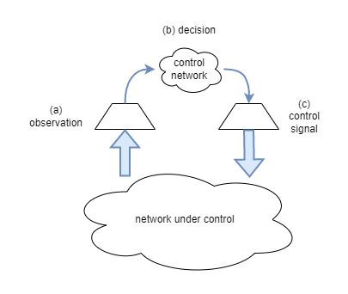

Figure 6: Dimensionality reduction. A large network under control (NUC) can be observed and controlled efficiently by a much smaller network. Dimensionality reduction benefits the process in three ways. (a) a reduced dimensionality observation of the state of the NUC enables the control network to interpret that state without an exponential increase in the total number of neurons in the system. (b) When operating over a reduced dimensionality, the control network can learn with fewer training iterations, and apply more advanced decision rules with less resources. (c) the output of the control network can also be in a dimensionally reduced space, further simplifying its computations, as hierarchical models provide a mechanism for low-dimensionality signals to control higher-dimensionality networks.

**Observation:** A network cannot micro-manage itself. In order to observe the full state of every neuron would require at least just as many neurons again, or probably many times more. Thus, the dimensionality of the observation of system state must be significantly reduced for the practical purpose of avoiding an exponential scaling out in the number of neurons of the total system. Predictive mechanisms are well suited to this. Typically predictive mechanisms are used to infer the hidden *latent* state of a system, based on observations obtained about that system. A side effect is that the inferred latent state is only an estimated representation of the true system latent state, and consequently it usually has significantly less dimensionality than the true latent state. Thus, the predictive mechanism can also be seen as a dimensionality reduction mechanism that produces a self-stabilizing (auto-convergent) simpler representation of the state of the system under observation.

**Decision:** A reduced dimension state space is beneficial for the control logic. Learning good control methods/parameters is more efficient and more stable in a lower dimensional state space. Additionally, the control system can apply more complex rules with less resources than it would otherwise need.

**Control:** Lastly, a reduced dimensionality is also good for the final output of the control system, for all the same reasons as above. However, that reduced dimensionality may need to be subsequently up-scaled if it is to control at the low-level scales. Thankfully there is well-established precedent for that in the form of U-Nets (citation) and in hierarchical predictive models (citations).

Most of the meta-management needs discussed in the earlier section benefit hugely from using higher-order representations because it reduces the dimensionality of state spaces for: monitoring current internal state, monitoring external feedback, learning associations. Additionally, where those higher-order representations are inferences over the latent states, then they unify multiple sources of information (different sensory modalities, information presented over time).

# Model Structure

*todo - ....good regulators need to be a model....complex regulators need to have a model...*

According to the *good regulator theorem*, if the agent is to regulate the environment state it must be a "model of the system" (Conant & Ashby, 1970). Furthermore, we can say that the efficiency of the agent to regulate its environment depends on its accuracy in modeling the system. Errors in the accuracy of the model result in errors in the regulation of the system. In learning agents, those errors are used for subsequent training of the model.

## Kinds of Model Representation

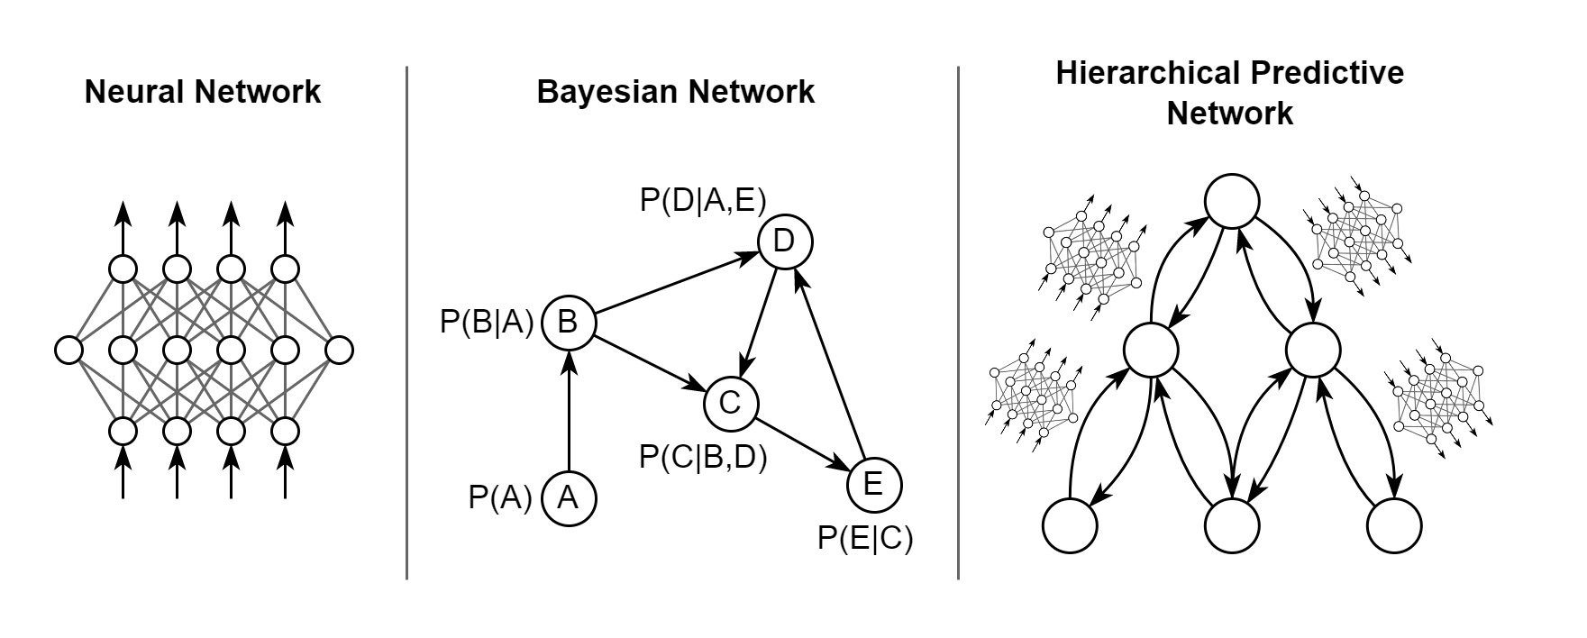Figure 7: Forms of of model

# Meta-management architectures

*(for each section, explain what it is, how it might be implemented, and existing papers)*

Integration styles: what options are available for building a stable system?

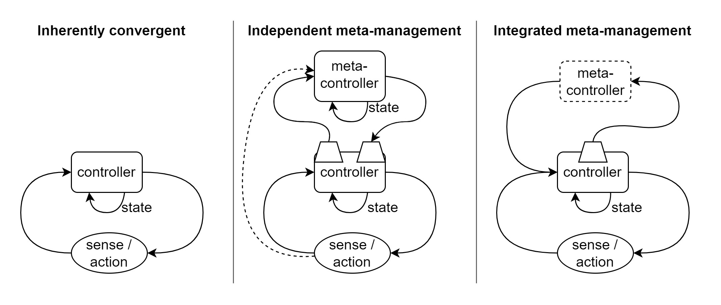Figure 8: Meta-management architectures

## Implicit meta mgmt / Inherent-convergence / first-order (meta-)management

* This is the null-hypothesis architecture - one which doesn't need meta-management because it's inherently stable.
* Examples: engineered solutions, static systems, predictive models.
* Con: presumably less rapid adaptation as it's always running under the same (implicit) objective measure. Presumably, the advantage of explicit meta-mgmt is a higher-order effect: the main systems operate against the first-order objective; the first-order objective is customised by meta-mgmt; the meta-mgmt system operates against a higher-order objective. By working against a simplified representation, and thus a heavily dimensionally reduced state space, it is more efficient to train.
* citations - suggestions that this is suitable:
  + Peter Carruthers, David M. Williams (2022). Model-free metacognition.
  + There was another paper asking whether meta-cognition is needed for consciousness, but I've lost it.

todo: Predictive mechanisms are inherently convergent.

## Independent meta mgmt

* Totally independent. First order network gets no feedback from second order network. But second order network tunes first order. Output of first order never represents anything from 2nd order network.
* Examples: hierachical models could be considered a case of this, though they are perhaps arguably only a simple form?
* citations
  + Most synthetic models assume this architecture.
  + eg: Cleeremans.

## Integrated meta mgmt

* Pro: domain dependent knowledge and processing
  + (search meta-management note for source) "Karmiloff and Clark's re-representation theory is primarily focused on re-representation of knowledge of external environment. This re-representation requires a relatively complex system to perform its functioning. But re-representation can just as easily be useful in development models of one's own mind, and thus this requires access to that same capability."
* Con: less stable, but presumably there are mechanisms. Eg: active inference.
* Specific case: Observation + objective measure only
  + Con with other meta-managements is that they too need to be trained, so what objective do they train against?
  + This architecture has the meta-mgmt loop as just a meta-awareness with no active role. It just mirrors the brain's state back onto itself, along with a judgement about the efficacy of the current trajectory.
  + The brain's unconscious processes can then use that for meta-mgmt, for example under an Active Inference model.
* Specific case: Observation only
  + It's possible that even the judgement too can be done via the main loop's unconscious processors, particularly under an Active Inference (inherently-convergent) model.
  + I find this the most compelling architecture.

*todo - How? inherently convergent (predictive mechanisms).*

# Meta-management in the Human Brain

This paper would not be complete without drawing some speculations about the nature of the meta-management architecture (or architectures) within the human brain, and an attempt to link that back to meta-cognition and human perceptual experience in general.

## A Speculative Human Meta-management Architecture

First, some observations:

* The brain is tremendously complex so it stands to reason that the brain likely employs multiple different meta-management systems, operating at different levels.
* It is well confirmed that we have experiential awareness of only a small fraction of the full state of the brain (*citations*). Thus it seems reasonable to conclude that the conscious part of the brain (the part that has experiential awareness of things) receives only a dimensionally reduced representation of the brain state.
* Unconscious automatized processes can do a lot on their own without conscious involvement (*citation, Baars, Rosenthal*).
* One significant benefit of automatized processes seems to be that it frees up higher-order processes for other things, such as contemplating longer-term issues. Thus the brain is able to operate automatized processes while cogitating on completely unrelated things, all in parallel. We see this is the form of the "default mode" network, and mind-wandering.
* Experiential awareness seems to be very much about observation of perceptions of the external environment combined with perceptions of one's own state. So, presumably, anything that is conscious requires a meta-management feedback loop.

With those observations in mind, a speculative meta-management architecture of the human brain is as follows (illustrated in Figure 9).

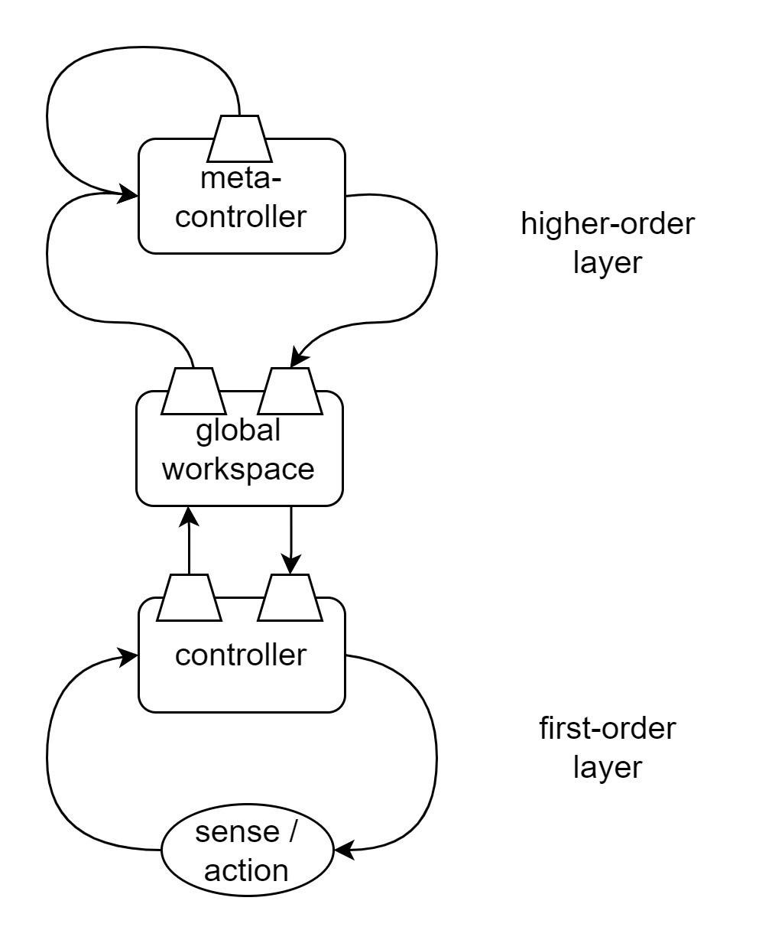Figure 9: Speculative human meta-management architecture

It has (at least) two hierarchical layers: a first-order layer and a meta-management layer. The first-order layer receives, processes, and controls first-order low-level signals. It employs learning mechanisms, such that sufficiently well learned (automatized) processes can be executed without further involvement from the meta-management layer. For a static or well-rehearsed context, an automatized process is effectively inherently convergent, and does not need meta-management. This is especially true where the underlying mechanisms are predictive.

The meta-management layer provides an independent meta-management architecture for the first-order layer. The meta-management layer constantly predicts the expected outcome of the first-order layer, in the same way that our sensorimotor system constantly predicts the expected outcome of our actions (citation). When the first-order layer performs as expected, the meta-management layer does not get involved. It does get involved, however, when its prediction of the outcome from the first-order layer's behavior is either different to what it's currently observing, or because it predicts an undesirable outcome. This may, for example, also occur where context in which the first-order process is operating is unusual. When necessary, the meta-management layer influences the first-order network through changes to priors, attention, etc.

The meta-management layer can also do computational processing for its own purposes, independent of the first-order layer. The reason for this is that it employs a number of complex systems, including modeling and deliberative systems, that are necessary for the control of the first-order layer; however, when the meta-management system is not controlling the first-order layer, those systems are free to be used for other things.

With such a complex and adaptive meta-management system, it too needs meta-management. This is solved by the meta-management layer further employing an integrated meta-management architecture: it meta-manages itself.

The interaction between the two layers is via a global workspace. The content of that global workspace can be influenced by either layer, with different aspects of the state within the global workspace having different influences on the processing happening within the two layers. And this influence changes over time as the global workspace state changes. In this way there is a dynamically changing degree of interaction between first-order and meta-management layers, and the meta-management layers can leverage the domain-specific capabilities of the first-order network where it needs to.

The global workspace holds a dimensionally reduced representation of the state of the first-order network. Thus the meta-management layer needs only build simplified models for the prediction and control of first-order processes.

## Meta-management and Meta-cognition

The above architecture fits with some observations from behavioral studies, and offers some possible resolutions for remaining contentious issues.

*...todo...should be able to link back to the specific "recurring problems" with meta-cognitive research for more examples...*

Most meta-cognitive behaviors could be achieved through first-order means, without the need for meta-cognition. This is consistent with the idea that automatized behaviors are first-order processes that don't need constant meta-management involvement.

Whether consciousness has any utility? Anecdotally, experiential awareness seems to coincide with explicit meta-management processes. This would seem to have something to do with the self-observation component of the integrated meta-management architecture. That self-observation component definitely has utility – without it the entire system would become unstable. Thus, assuming that there is something about the self-observation feedback loop that causes the effect of experiential awareness, and assuming that the self-observation feedback loop and experiential awareness are somehow intimately linked (ie: one cannot exist without the other), then it can be said that consciousness has utility.

# Summary

Three meta-management architectures have been presented. The claim is not that one architecture is better than the others. Each architecture will have its niche. Empirical studies will be needed to determine their respective use cases.

*todo - some examples:*

* *eg: Metcalfe’s CHARM model (Metcalfe, 1993). See reference in note: Meta-management > Shimamura  2000, "Toward a Cognitive Neuroscience of Metacognition"*
* *eg: Kimberg and Farah (1993). See reference in note: Meta-management > Shimamura  2000, "Toward a Cognitive Neuroscience of Metacognition"*

# Summary

todo

# Author Contributions

The author confirms being the sole contributor of this work and has approved it for publication.

# Funding

No funding was received.

# References

*...todo...*

Beaudoin (1994)

Roger C. Conant and W. Ross Ashby. 1970. Every good regulator of a system must be a model of that system. Int. J. Systems Sci., 1970, vol. 1, No. 2, 89-97.

Timmermans et al (2012). Higher order thoughts in action: consciousness as a unconscious re-description process