Deploy Mini Conda via Intune

🧰 Step-by-Step: Package Miniconda for Intune

1. **Download Miniconda Installer**

* Get the latest Windows installer from <https://www.anaconda.com/docs/getting-started/miniconda/install>
* Choose the .exe installer for 64-bit Windows.

2. **Grab my repo with the Silent Install and Uninstall scripts.**

3. **Prepare the App for Intune**

Use the Microsoft Win32 Content Prep Tool to convert the installer folder into a .intunewin file.  
Download from: <https://github.com/Microsoft/Microsoft-Win32-Content-Prep-Tool>

**Run the PS Command**  
  
“.\IntuneWinAppUtil.exe -c "C:\Miniconda" -s "install.ps1" -o "C:\IntuneWinApp\Packages"  
  
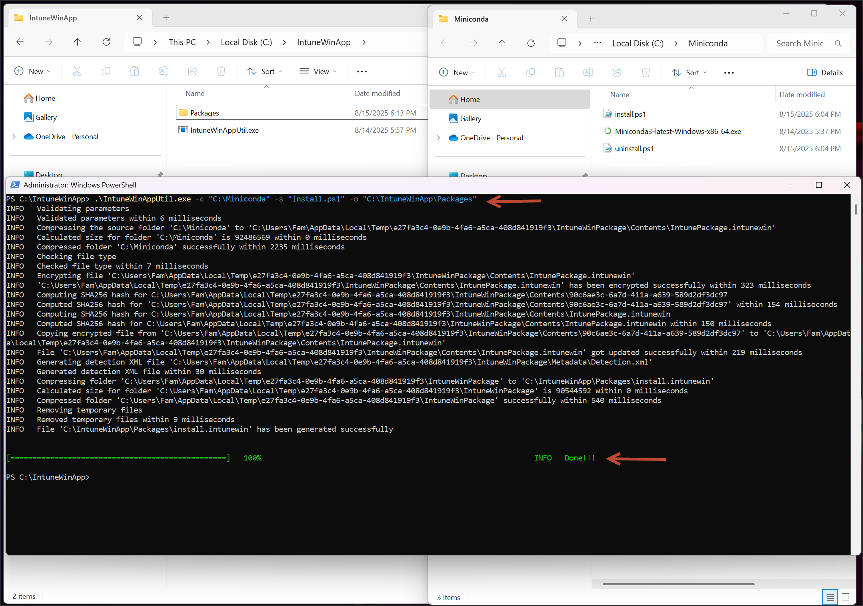

Command Notes:  
  
-c: Source folder containing installer and script  
-s: Setup file (.ps1)  
-o: Output folder for .intunewin

4. Upload to Intune the file Package “install.intunewin”

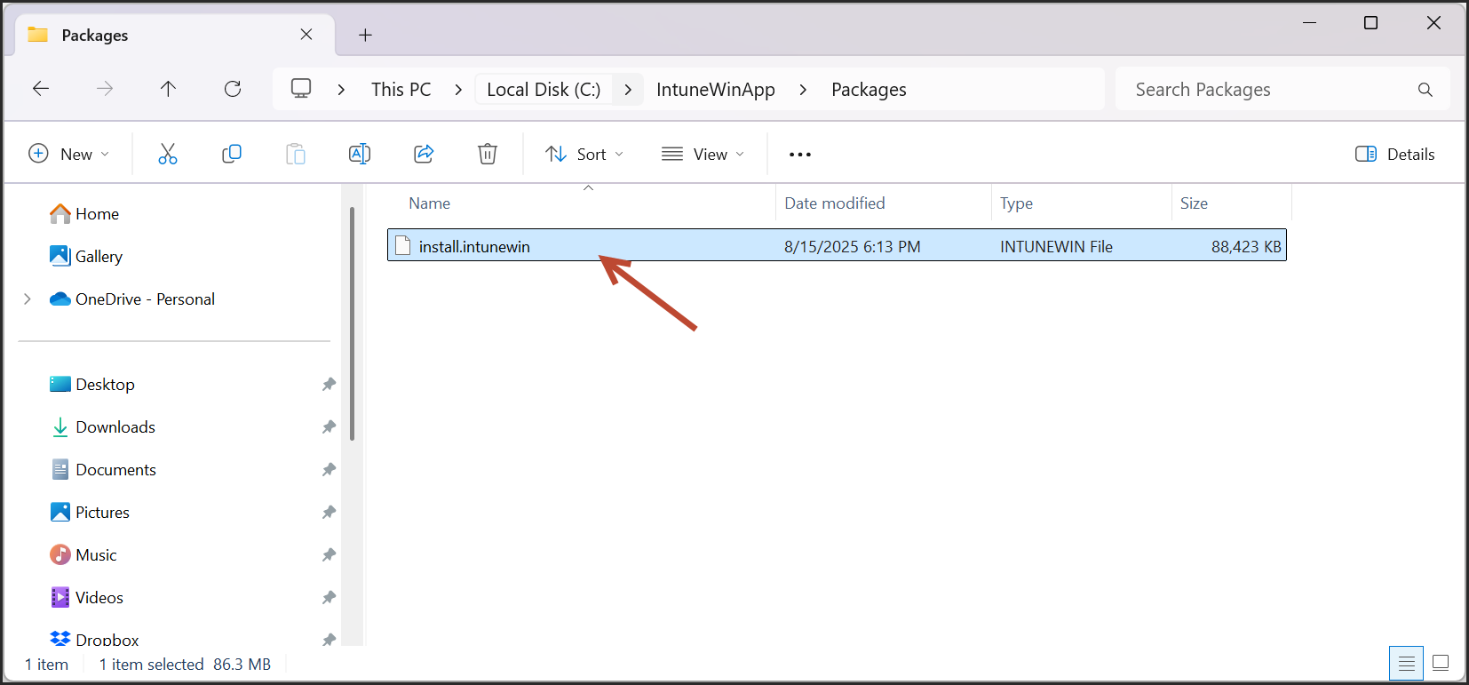

Go to **Intune Admin Center** > **Apps** > **Windows apps** > **Create > Windows app (win32) > Select**

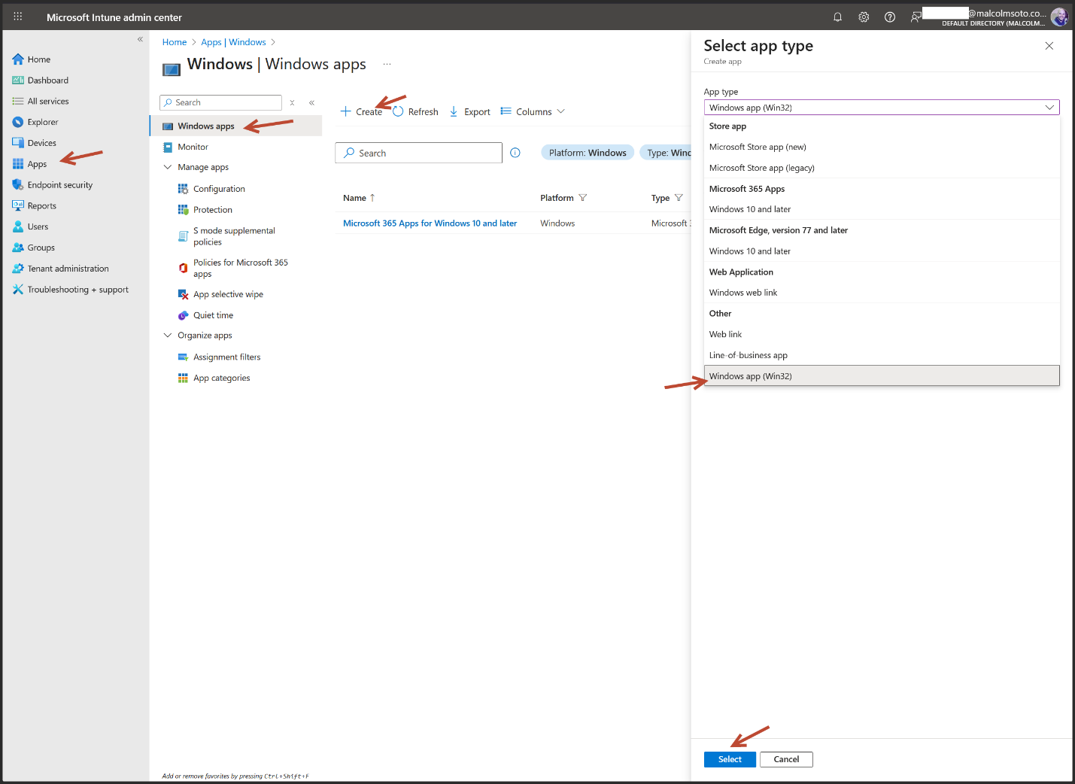

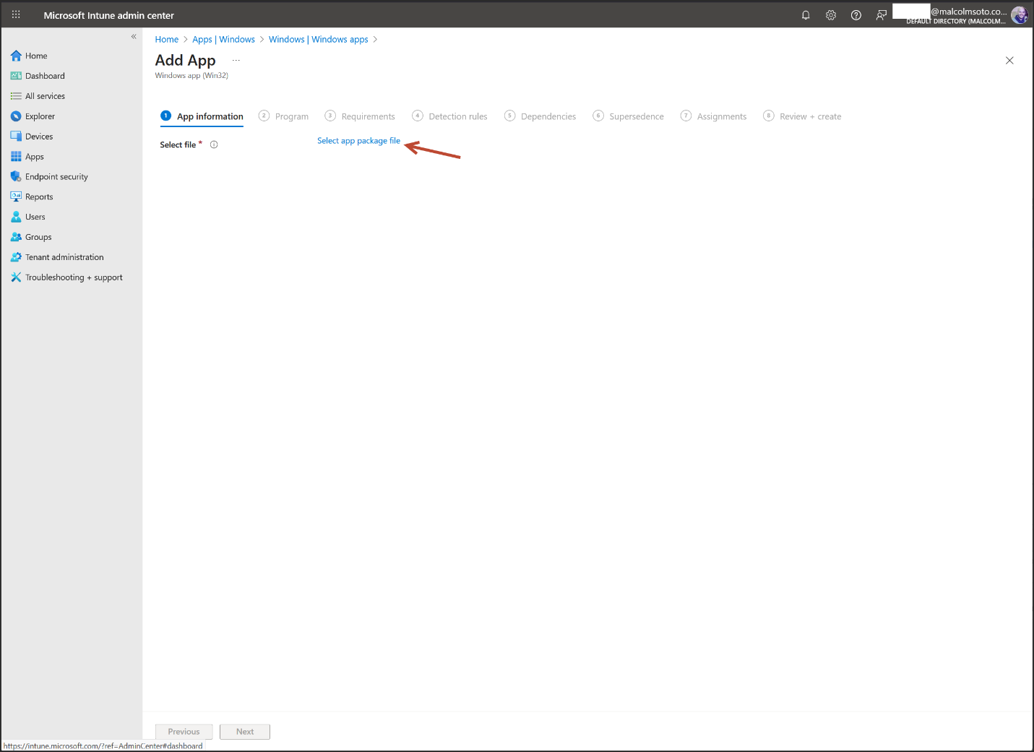

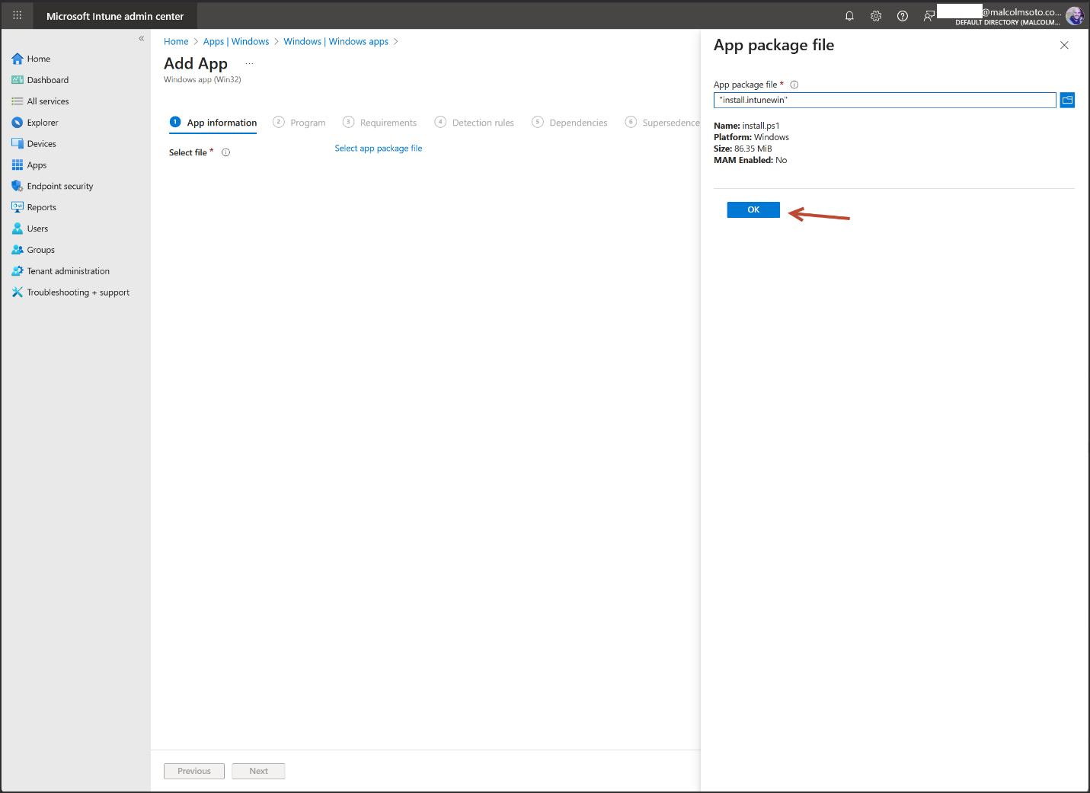

Upload the .intunewin file

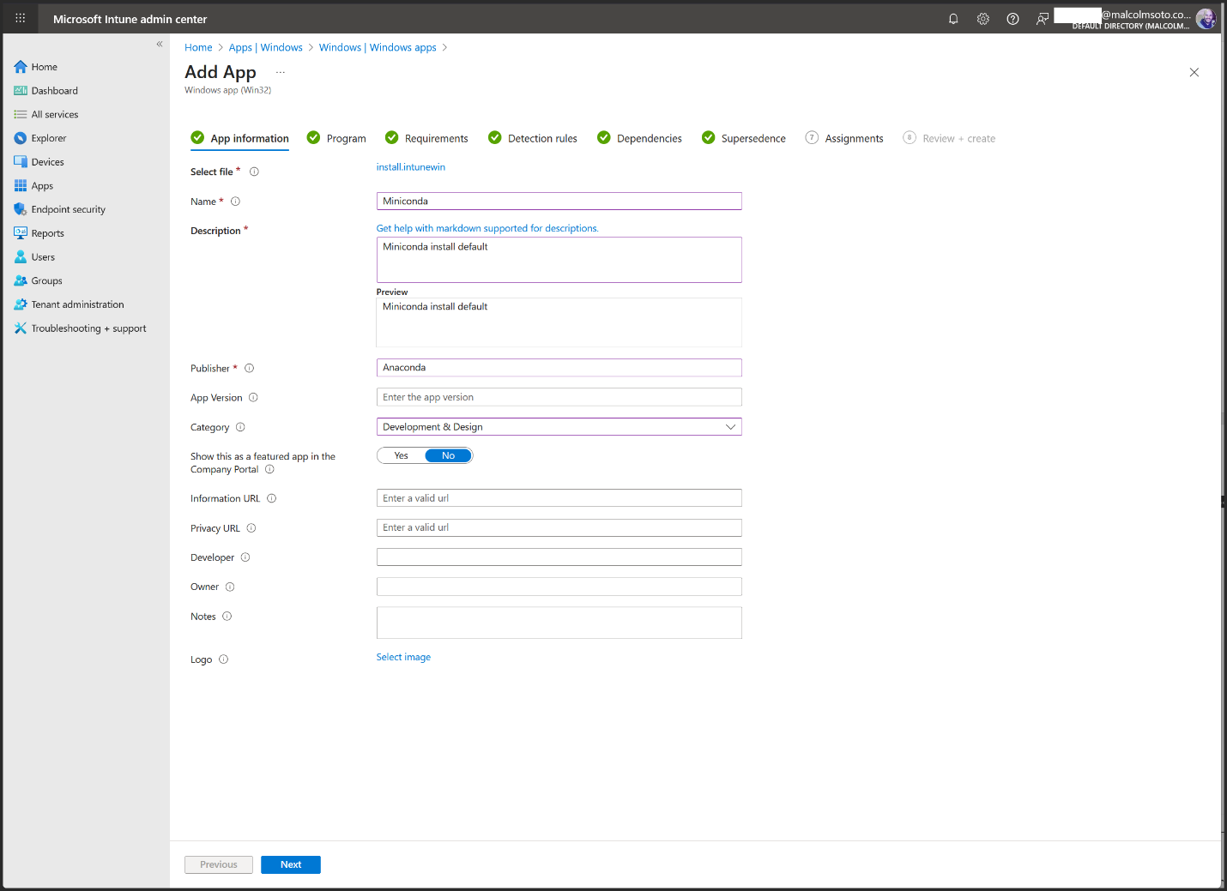

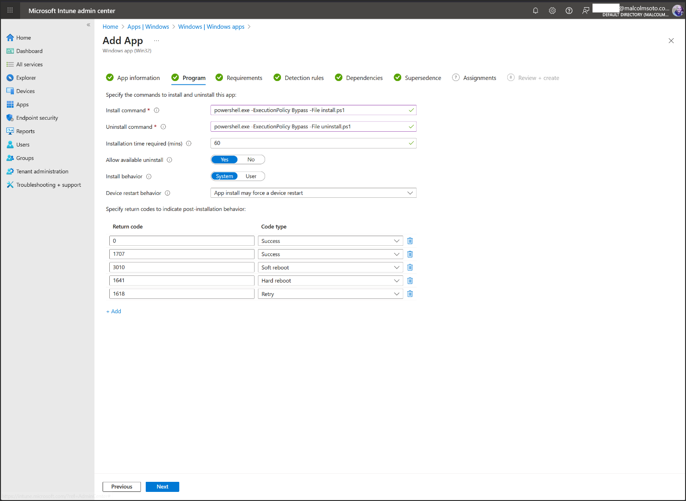

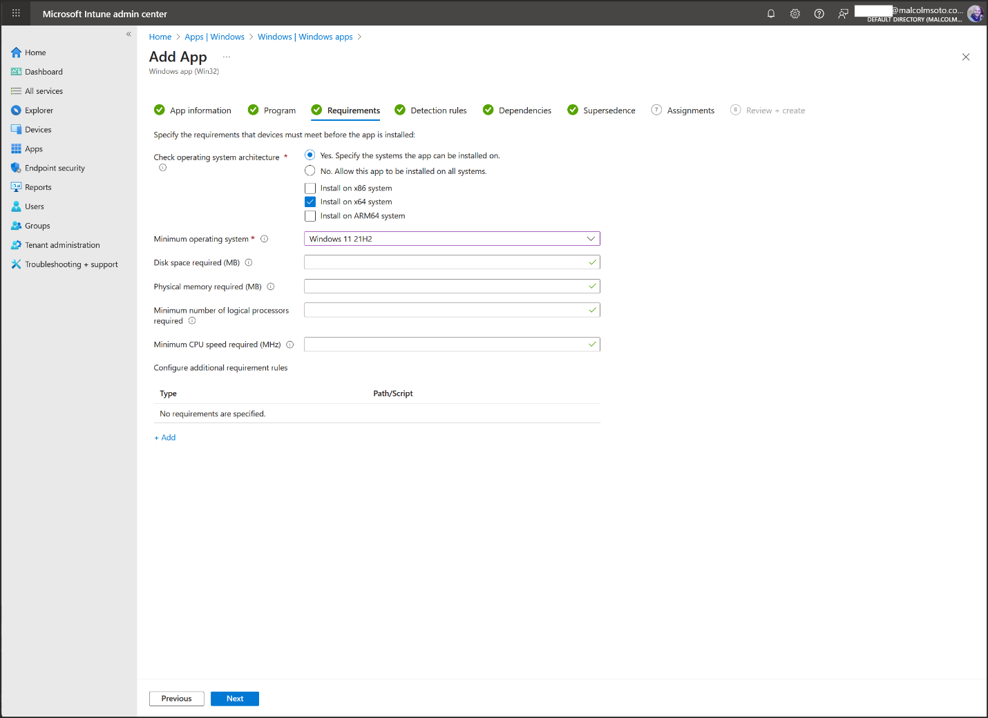

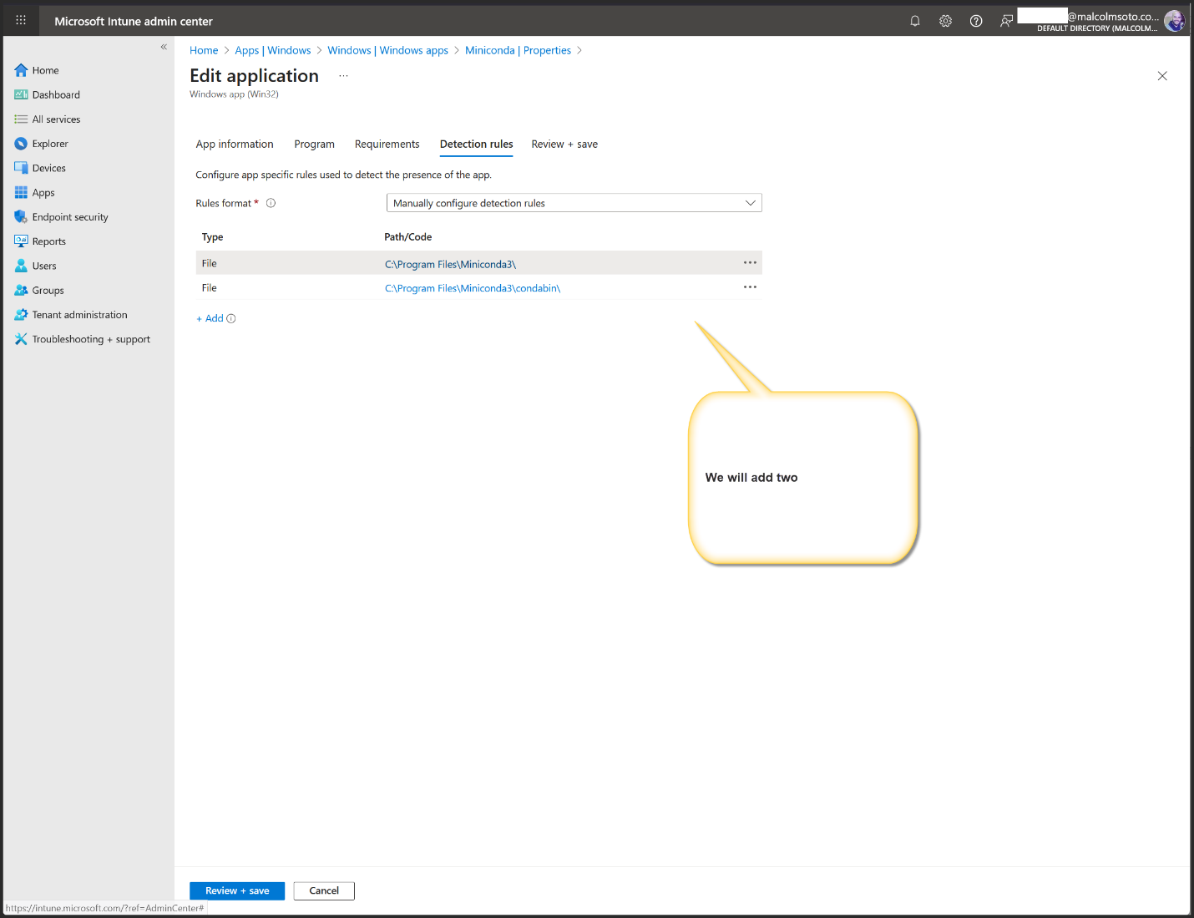

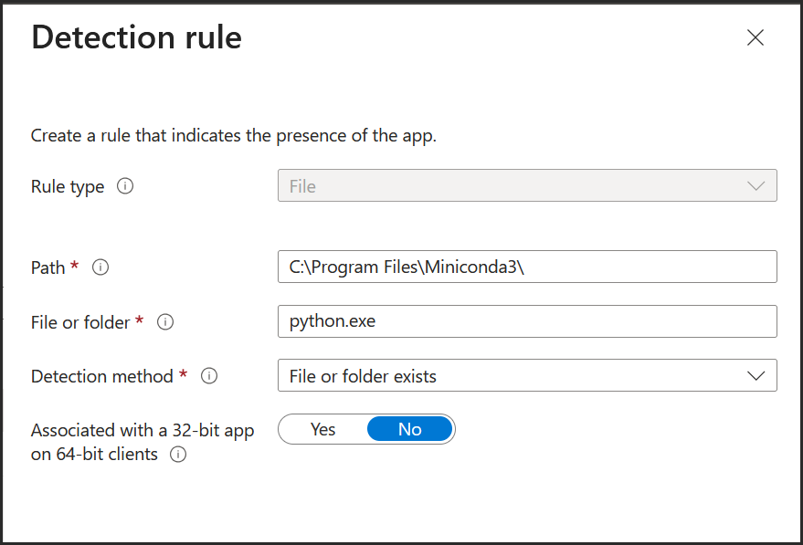

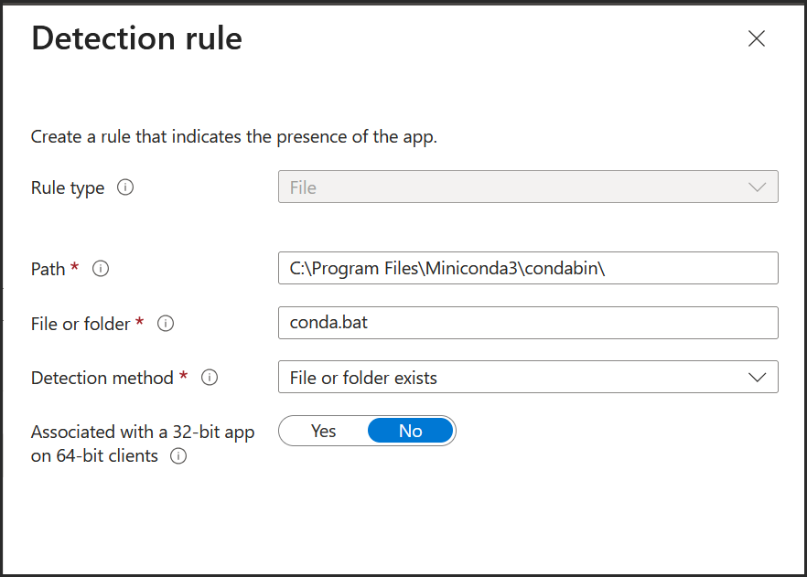

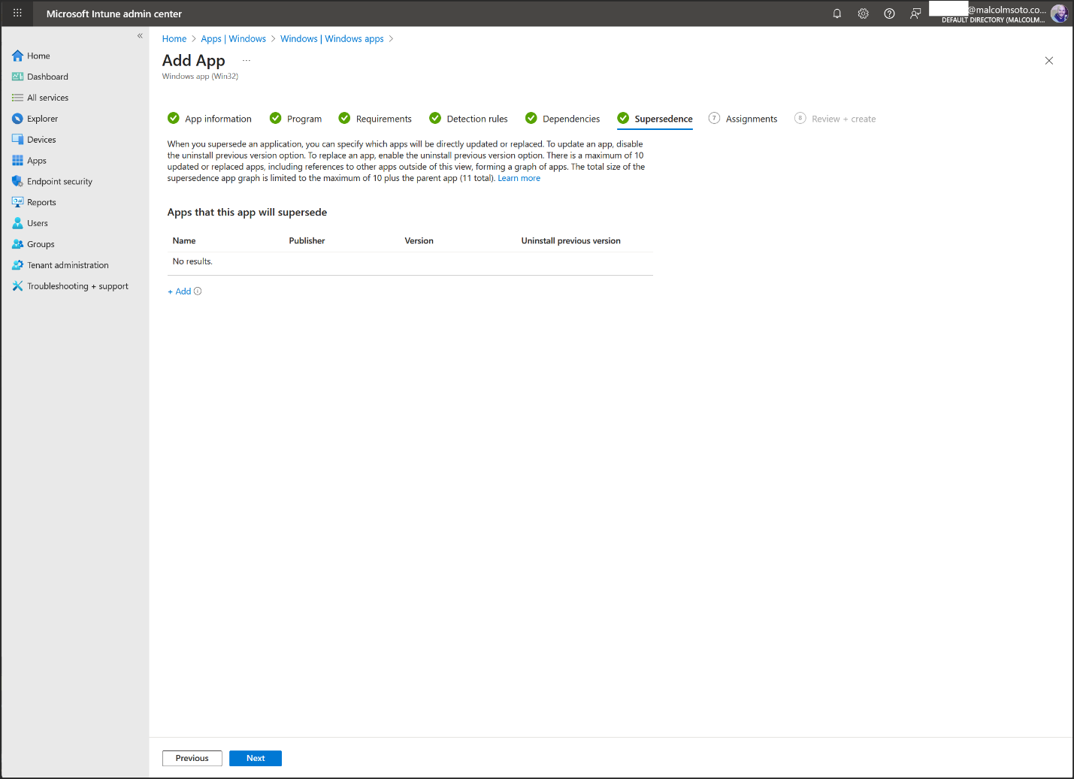

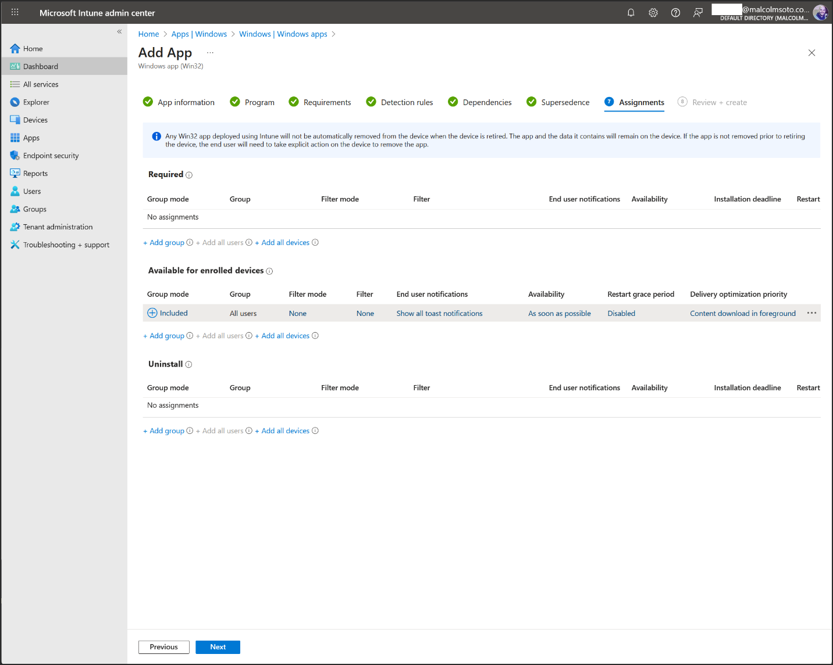

Required - Install automatically

Available for enrolled device – user can install from Company Portal

Uninstall – removes the app from target users

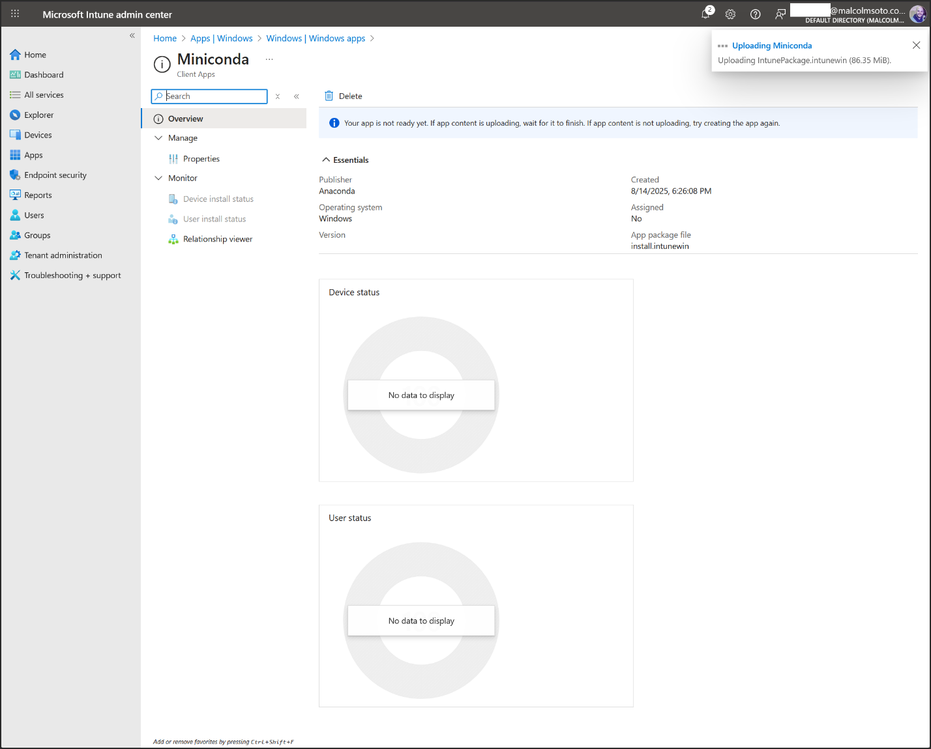

5. Test Deployment

