Use group-based licensing in Entra ID to auto-assign licenses.

**🧑‍🤝‍🧑 Step 1: Create a Security Group**

You’ll need a group to assign the license to.

1. Go to https://entra.microsoft.com
2. Navigate to **Identity > Groups > All groups**.
3. Click **+ New group**.
4. Set **Group type** to **Security**.
5. Name it something like “Lic_365_E5”
6. Click **Create**.  
     
   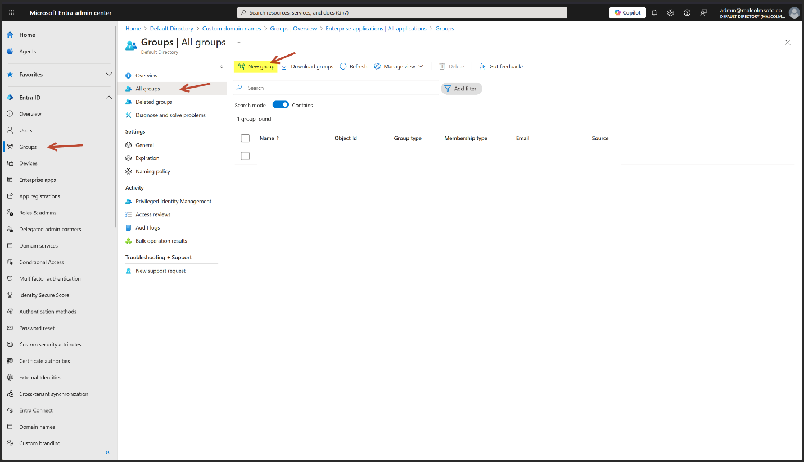

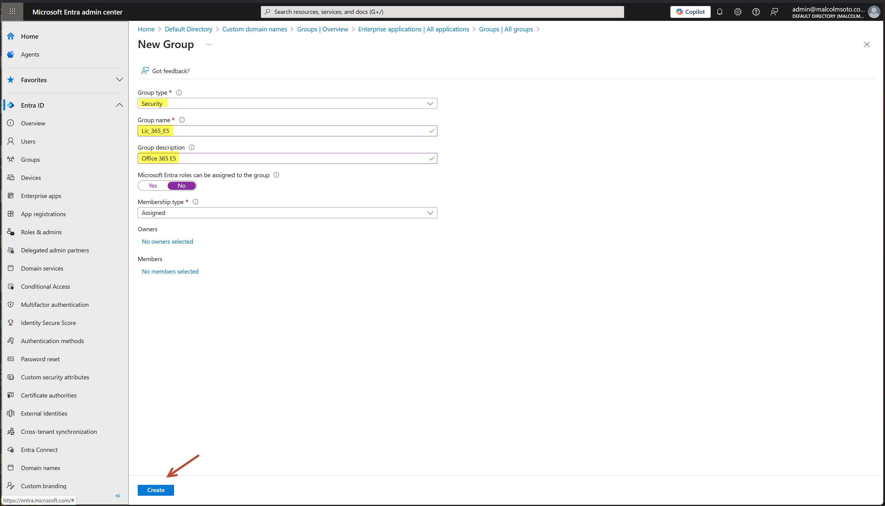

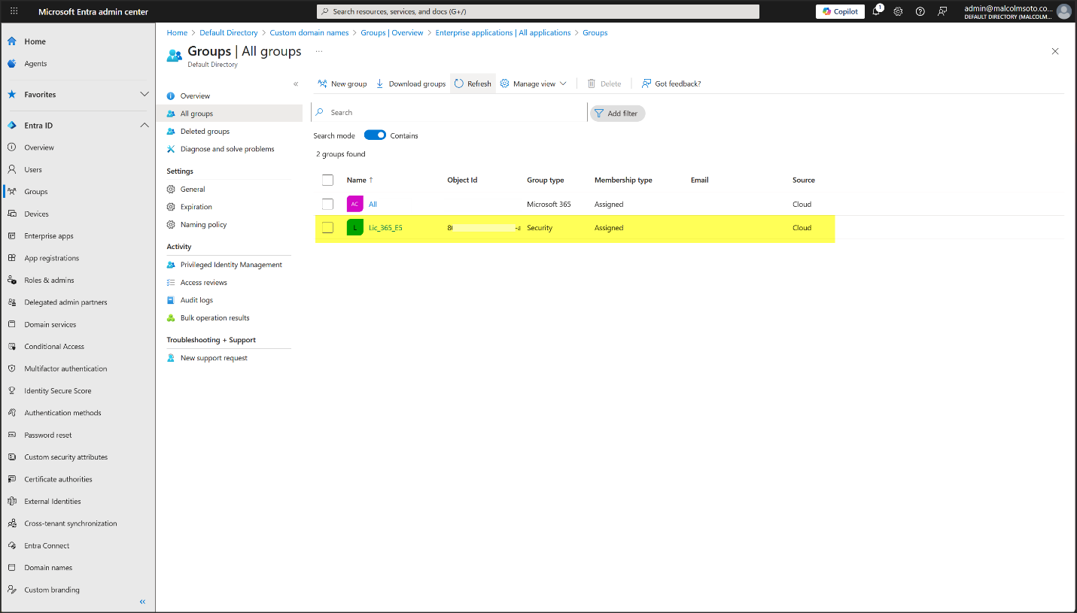

**🪪 Step 2: Assign the E5 License to the Group**

1. In Admin Center <https://admin.microsoft.com> , go to **Billing** > **Licensing**
2. Select **Microsoft 365 E5**.
3. Click **Groups**
4. Click **+ Assign licenses**.
5. Search and choose your new group (Lic_365_E5).
6. Select the services you want (e.g., Windows 11 Enterprise, Defender, Purview).
7. Click **Assign**.

⚠️ Note: As of Sept 2024, license assignment must be done via **Microsoft 365 Admin Center**, not Entra or Azure portals

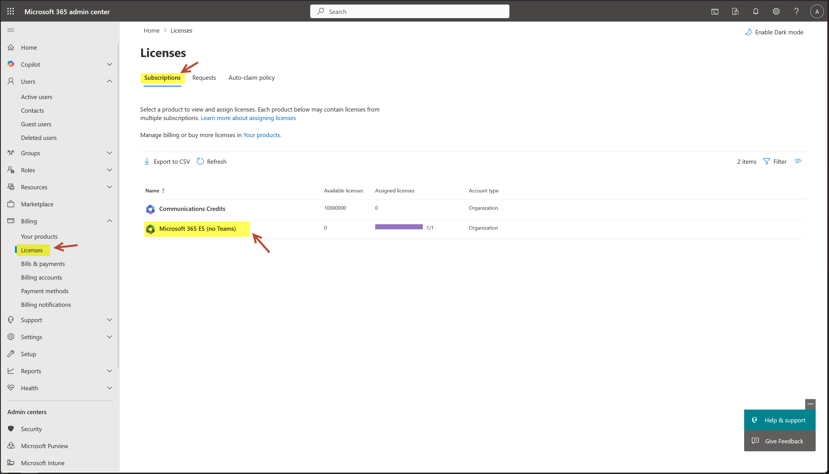

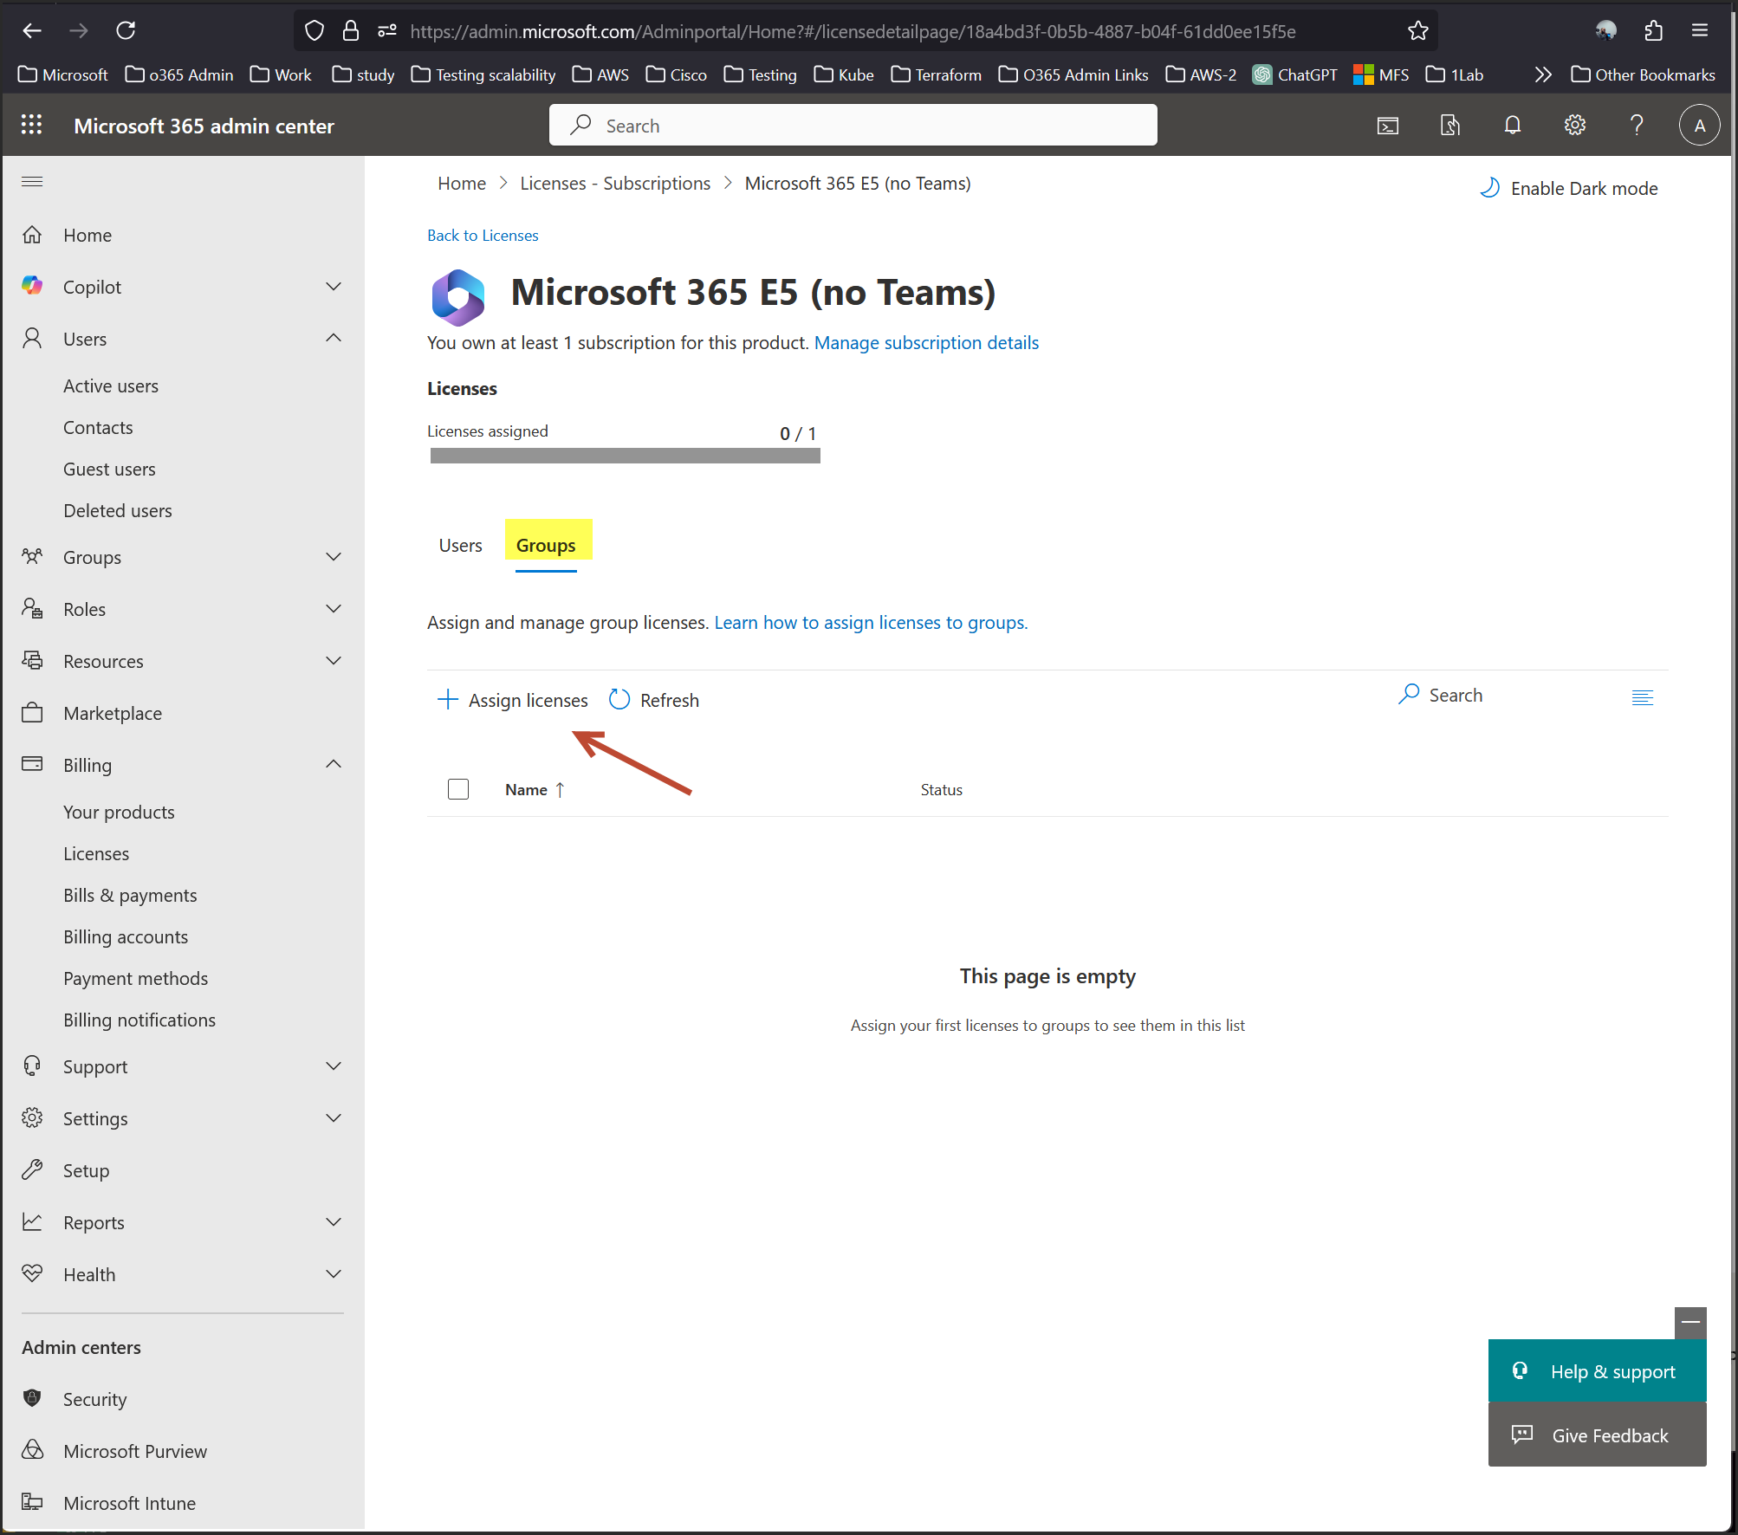

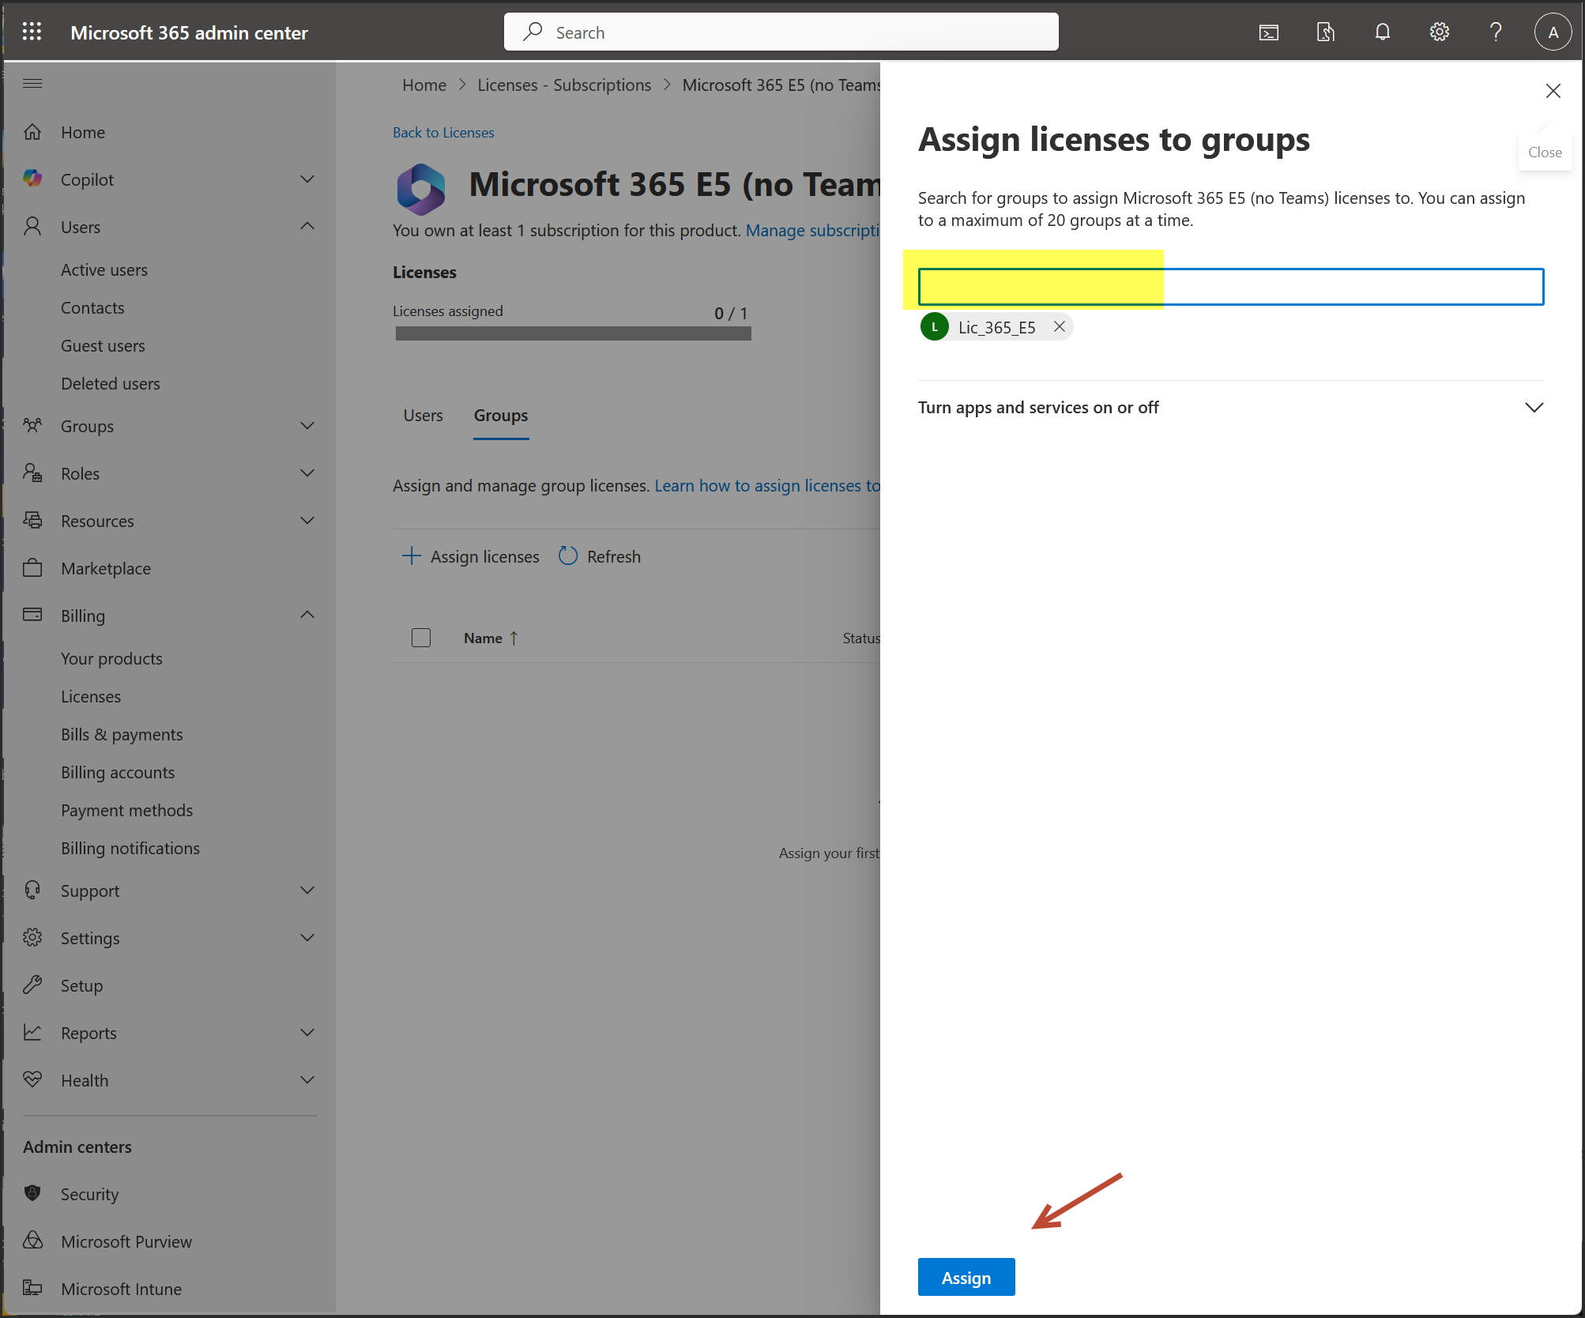

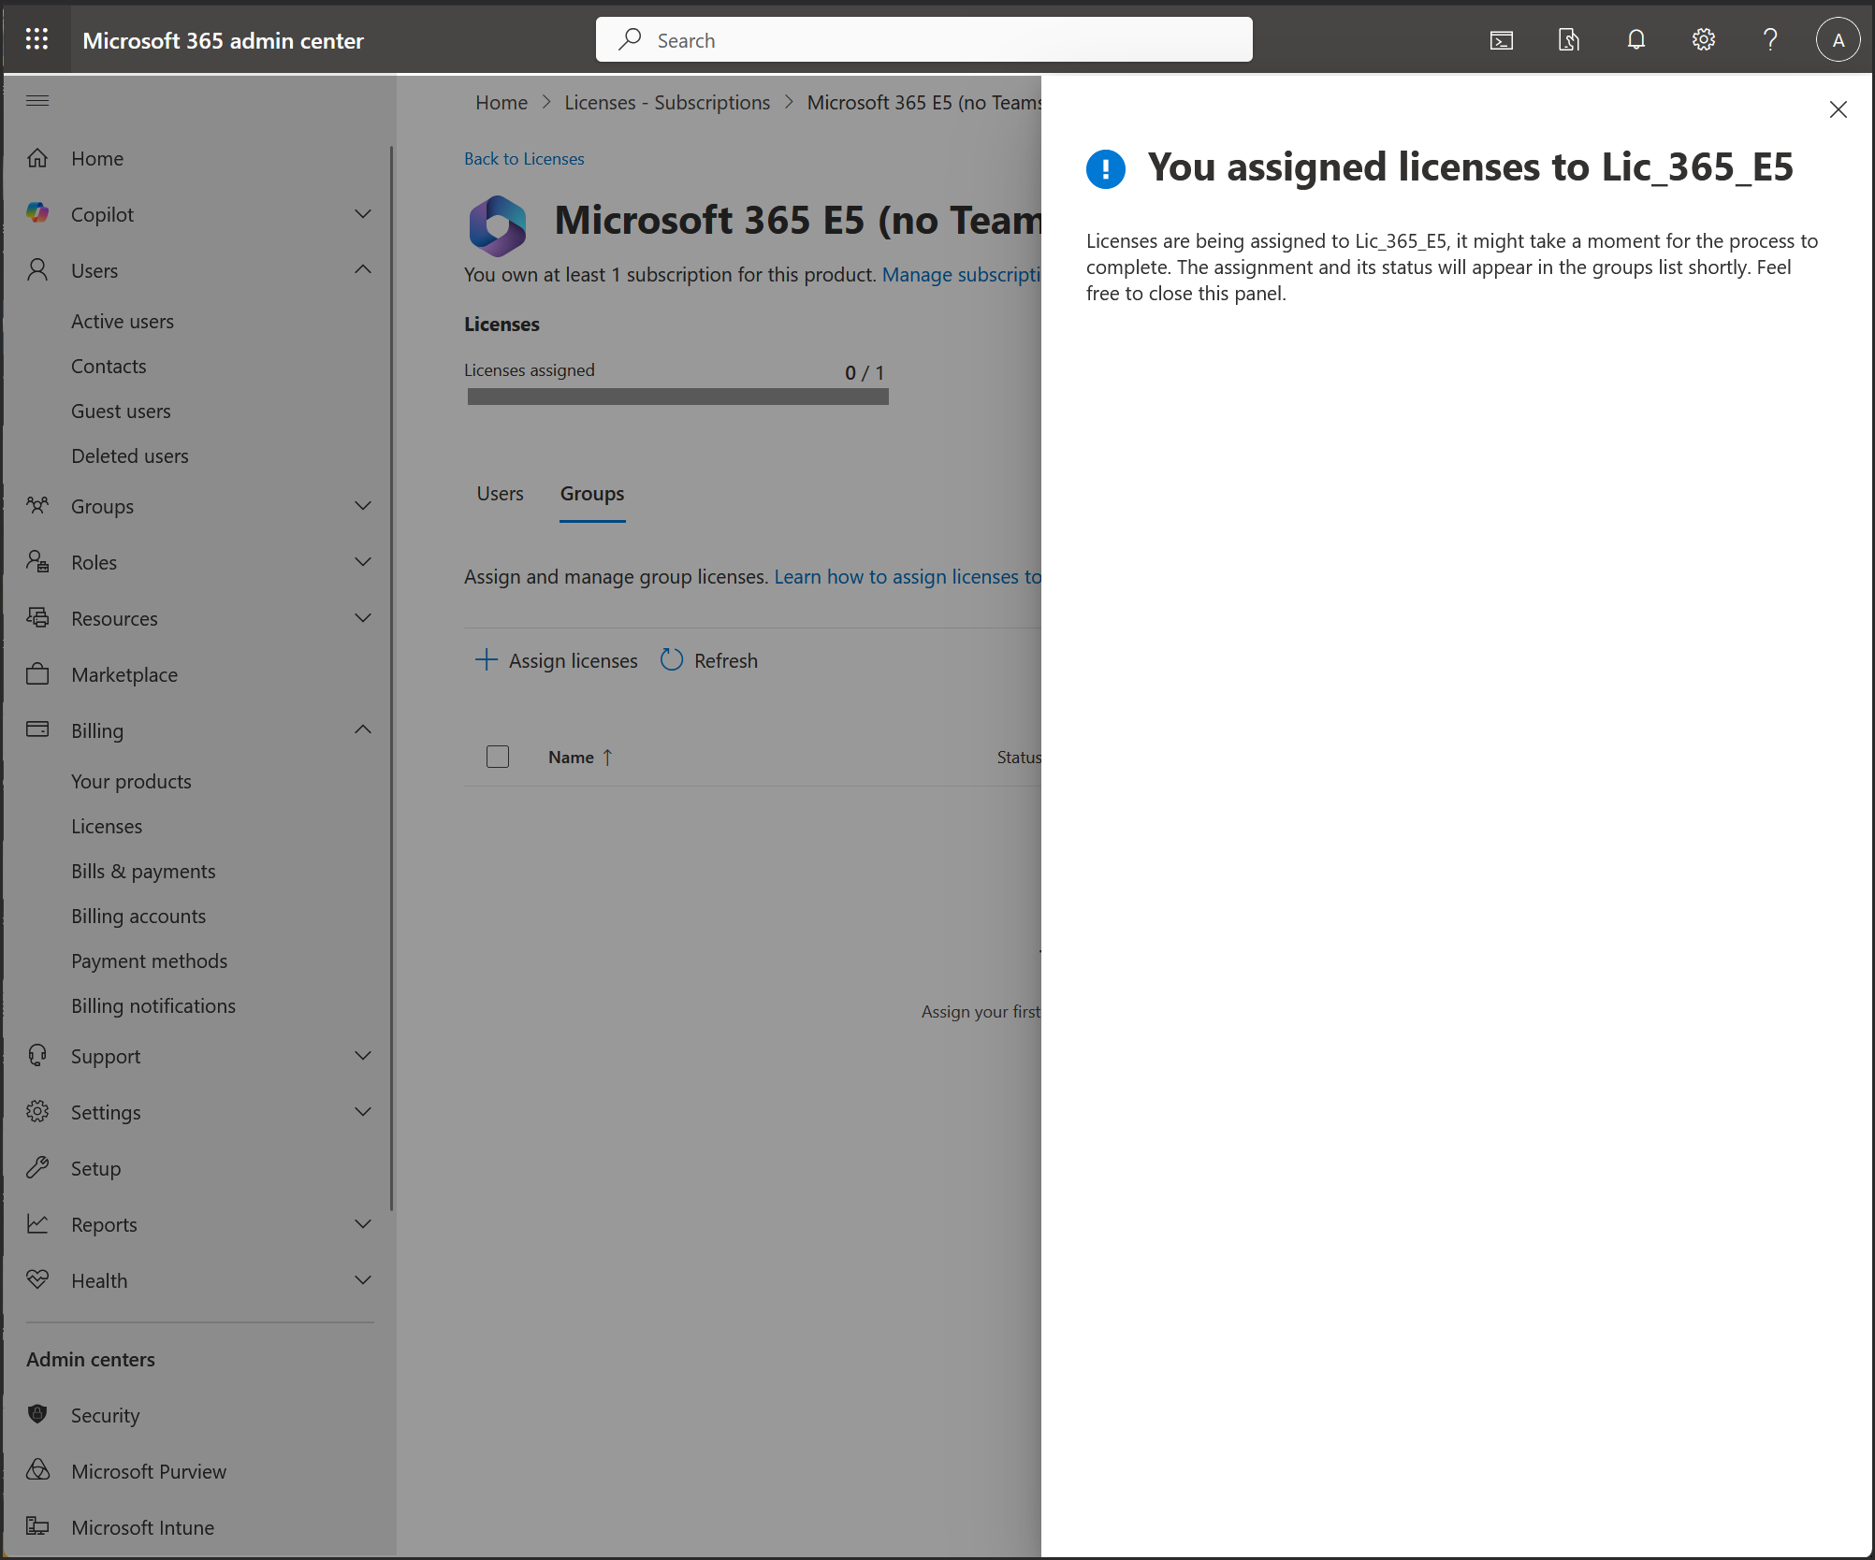

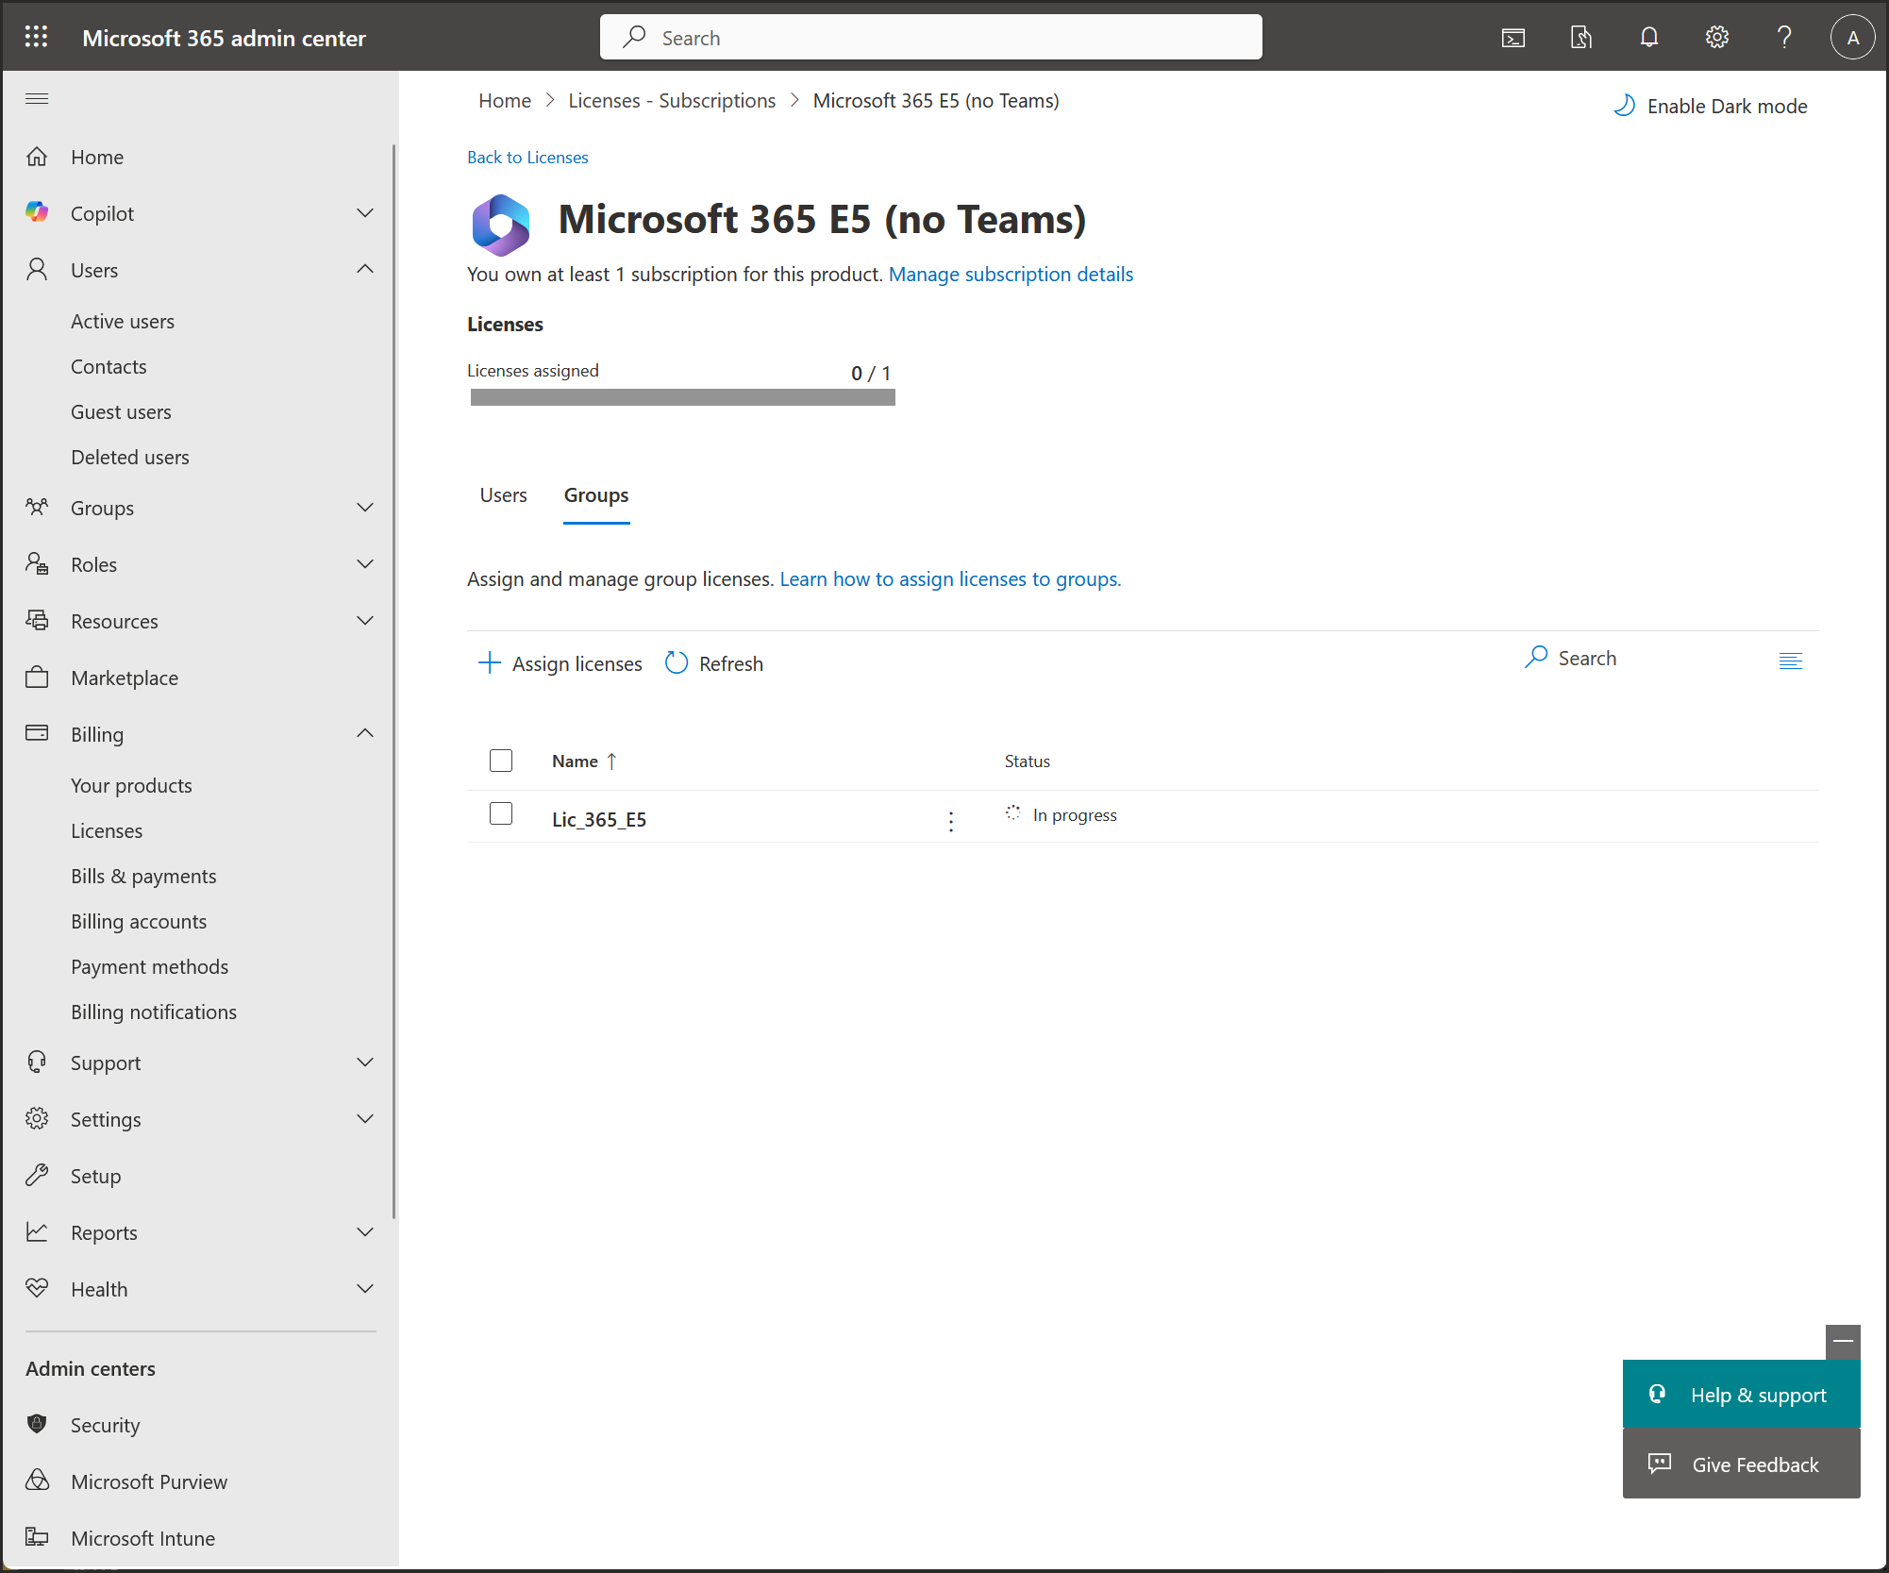

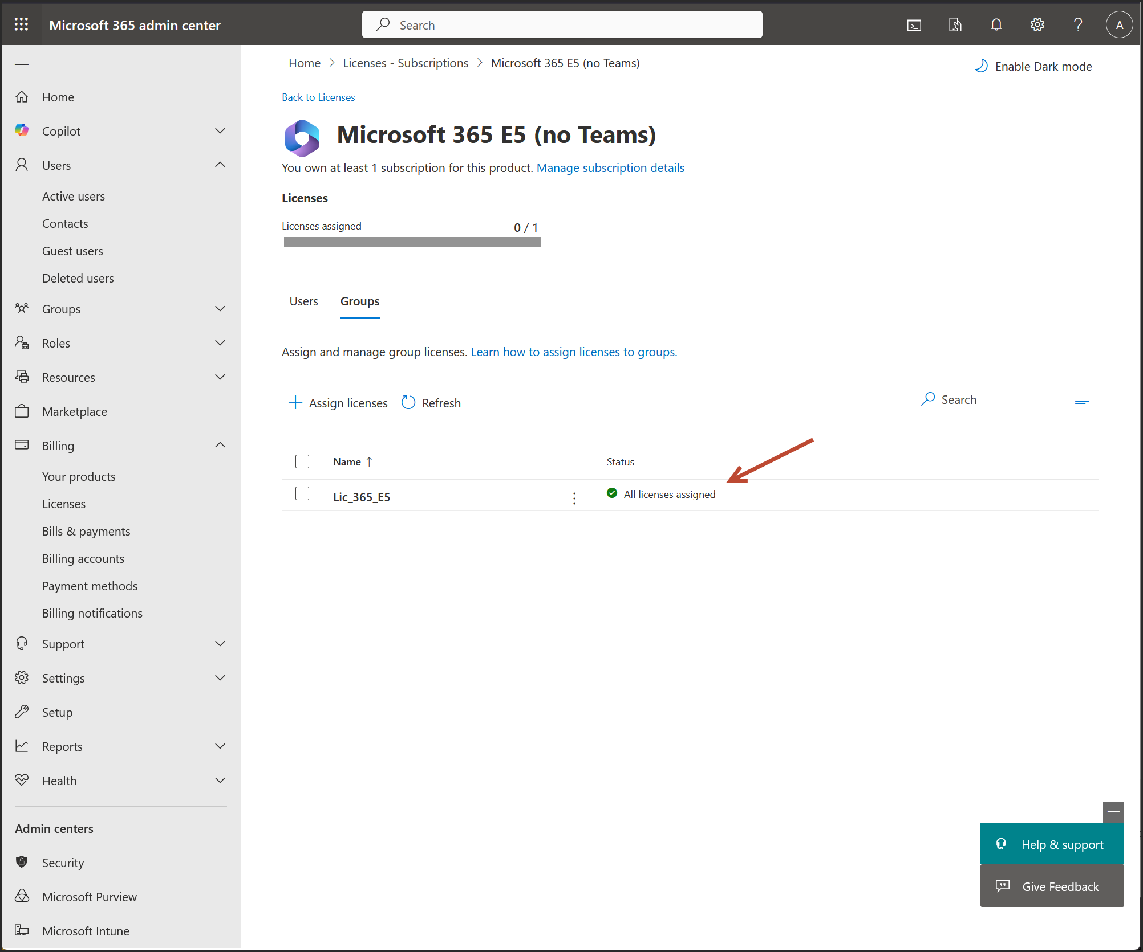

**🔄 Step 3: Add Users to the Group**

* Add users manually or use **dynamic membership rules** (e.g., auto-add users with a specific department or tag).
* Once added, Entra ID will automatically assign the E5 license to each member.