# Malcolm Williams

# CS 255 System Design Document

## UML Diagrams

### UML Use Case Diagram

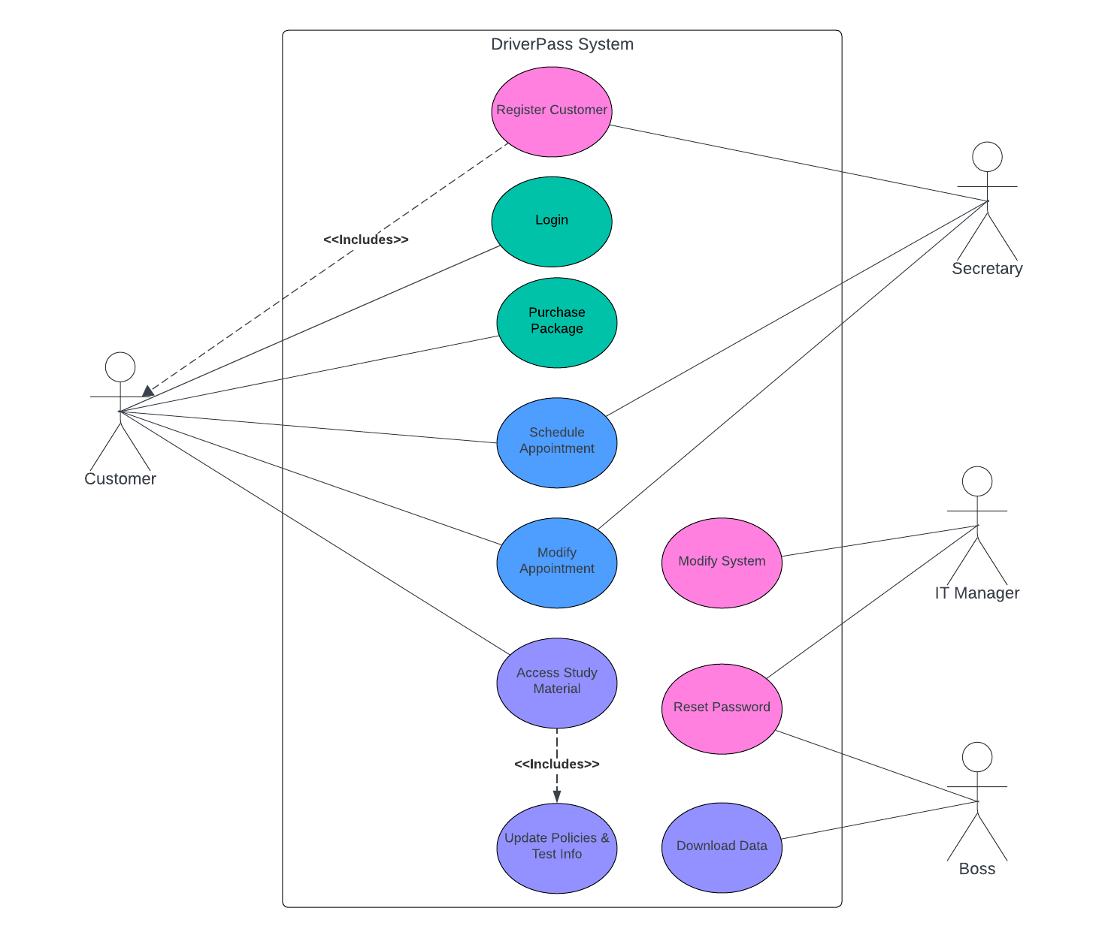

### UML Activity Diagrams

### UML Sequence Diagram

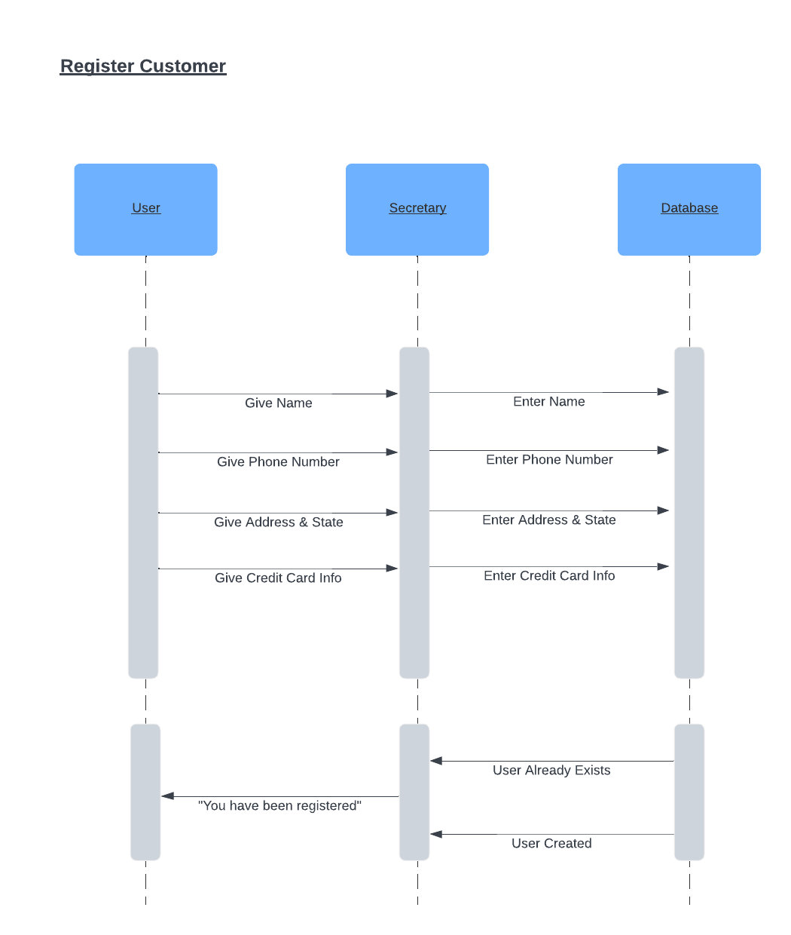

### UML Class Diagram

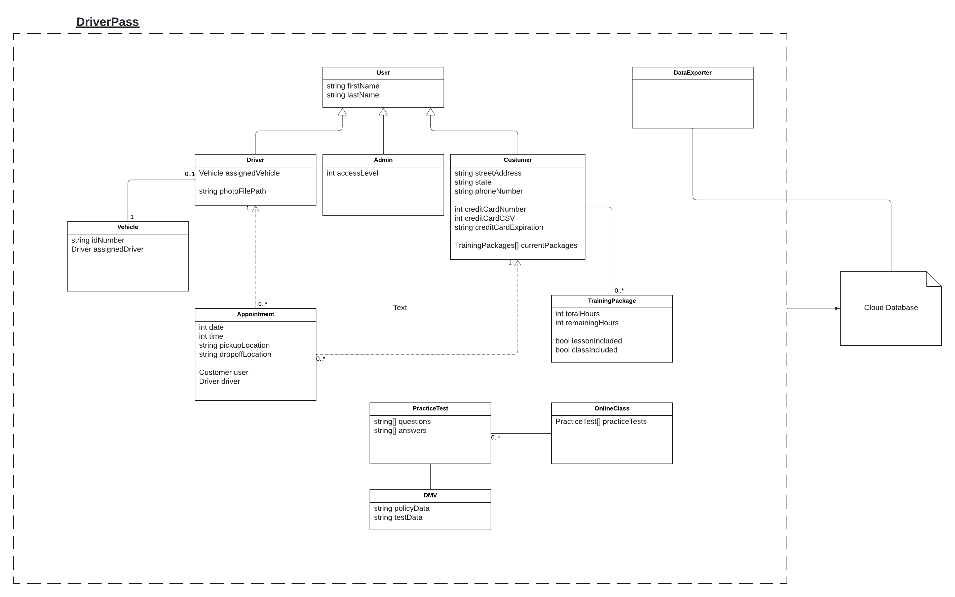

## Technical Requirements

Hardware:

Anyone wishing to use the DriverPass system will need a computer device with either a Windows, MacOS, or Linux operating system installed. The system may also be accessed from a mobile Android and iOS devices.

Software:

To interface with the system, where online classes can be accessed and driving lessons can be scheduled, customers will need a web browser to visit the DriverPass website.

Employees will also need access to a web browser to utilize their backend functions.

Tools:

To efficiently maintain data, the system will need to utilize a relational database to store data regarding users, drivers, vehicles, appointments, courses, sales, and any additional data being tracked such as change logs.

Infrastructure:

The DriverPass system will not be operating on local servers owned by the DriverPass company. This requires the system to utilize a Backend-as-a-service (Baas) cloud provider to host the database and web application.