Project: MIGRATION OF A SAMPLE DATABASE TO AWS

1. Sign up for an AWS account:

This is the starting point, and it's crucial to have an AWS account to access AWS services.

* IAM
* Users
* Add user
* access to console
* IAM user
* custom password, pas de reset
* Attach existing policies
* pas de tags
* retour a liste d'user ou login
* select user
* security credentials
* CLI, I understand
* create acccess key

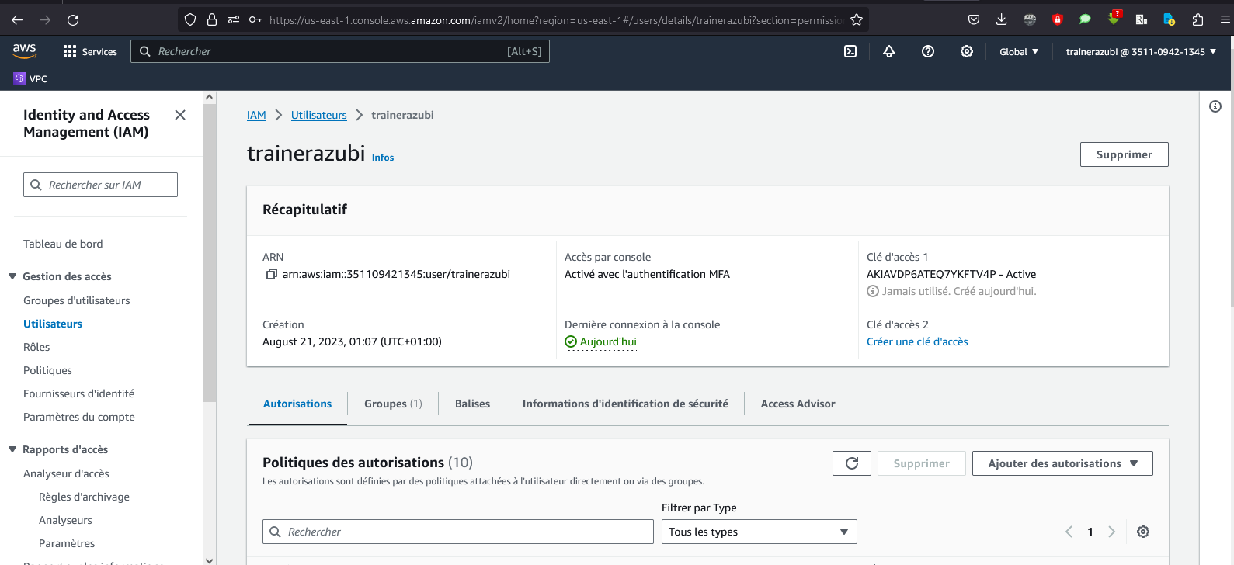

1. Introduction to AWS:

**EC2 (Elastic Compute Cloud)**: For deploying virtual instances.

**S3 (Simple Storage Service)**: For data storage.

**RDS (Relational Database Service)**: For managing relational databases.

**DynamoDB:** For NoSQL databases.

**AWS DMS (Database Migration Service):** The key tool in our project for migration.

Concrete Example:

Here is a concrete example of navigating the AWS console after logging in:

You open your browser and go to aws.amazon.com.

You click on "Sign in to the AWS Console" and enter your authentication information.

Once logged in, you see the AWS Console dashboard with shortcuts to various services.

You use the search bar to find the "RDS" service and access the RDS console for database management.

You explore other services like EC2 and S3 to understand how they work.

1. AWS Well-Architected Framework:

Understand the five pillars of the AWS Well-Architected Framework:

**Operational Excellence:** Optimize operations to deliver a reliable and efficient service.

**Security:** Implement robust security measures to protect sensitive data.

**Reliability:** Ensure the system operates reliably and without interruption.

**Performance Efficiency:** Optimize performance to meet application needs.

**Cost Optimization:** Reduce unnecessary costs while maintaining optimal performance."

1. AWS Infrastructure Overview:
2. Planning and Discovery:
3. Selecting the Target Database on AWS:
4. Designing the Target Database Architecture:
5. Data Migration:
6. Architecture: