HW5Q2.R

# Approximating a compound poisson random variable   
  
numb_sn <- 100000 # M   
lambda <- 100 # Poisson process parameter   
mu = 0.10 # Parameter for X   
sigma = 0.4 # Parameter for X  
  
# Begin approximating Sn   
# Generate random values of N from poisson distribution   
N_vector <- rpois(numb_sn, lambda)  
  
# Compute a sample of Sn   
Sn_sample <- function(N, mean = mu, std = sigma){  
 # Draw N random variables from distribution of X  
 log_X_k <- rnorm(N, mean = mu, sd = sigma)  
 X_k <- exp(log_X_k)  
 Sn <- sum(X_k)  
 return (Sn)  
}  
  
# Pre allocate space   
Sn_MC_samples <- rep(0, numb_sn)  
  
# Compute M copies of Sn   
for (sample in 1:numb_sn){  
 N_i <- N_vector[sample]  
 Sn_MC_samples[sample] <- Sn_sample(N_i, mu, sigma)  
   
}  
  
# Plot the distribution with a normal density overlaid   
makeHist <- function(x, color = "blue", title = "Histogram"){  
 h<-hist(x,breaks = 100 ,main=title)   
 xfit<-seq(min(x),max(x),length=100)   
 yfit<-dnorm(xfit,mean=mean(x),sd=sd(x))   
 yfit <- yfit*diff(h$mids[1:2])*length(x)   
 lines(xfit, yfit, col=color, lwd=2)  
}  
  
makeHist(Sn_MC_samples)

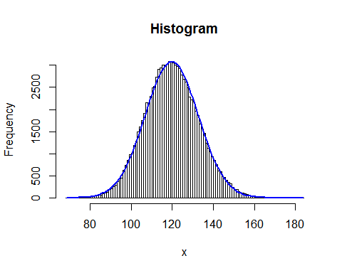

####################### Quantile Stuff #############################  
#################################################################  
  
quantiles <- seq(from = 0.95, to = 0.99999, by = 0.00001)  
  
# Empirical distribution quantiles   
empirical_tail <- quantile(Sn_MC_samples, quantiles)  
emp_tail <-1- empirical_tail   
  
# Normal Approximation quantiles   
Sn_mean <- exp(mu)*lambda  
Sn_sd <- lambda*sigma^2* + exp(mu^2)*lambda  
  
norm_tail_approx2 <- qnorm(quantiles, Sn_mean, Sn_sd)  
norm_tail2 <- 1- norm_tail_approx2   
  
norm_tail_approx <-qnorm(quantiles, mean(Sn_MC_samples), sd(Sn_MC_samples))  
norm_tail <- 1- norm_tail_approx  
# Gamma tail approx ... Equations from the book - pg 477 of pdf   
# Or simplified equations on 497 in appendix  
EX1 <- mean(Sn_MC_samples) # E[X]  
EX2 <- mean(Sn_MC_samples^2) # E[X^2]  
EX3 <- mean(Sn_MC_samples^3) # E[X^3]  
  
alpha_g <- (2*sqrt(lambda*EX2^3)/EX3)^2  
beta_g <- sqrt(alpha_g/ (lambda*EX2))  
k_g <- lambda*EX1 - alpha_g/beta_g  
  
library(FAdist)

## Warning: package 'FAdist' was built under R version 3.1.3

gamma_tail_approx2 <- qgamma3(quantiles,shape = alpha_g, scale = beta_g, thres=k_g )  
gamma_tail2 <-1- gamma_tail_approx2   
  
  
# Find the parameters using MLE in the MASS package  
library(MASS)

## Warning: package 'MASS' was built under R version 3.1.3

gamma_params <- fitdistr(Sn_MC_samples, "gamma")  
gamma_shape <- gamma_params$estimate[1]  
gamma_rate <- gamma_params$estimate[2]  
# Compute the quantiles and find the tail distribution   
gamma_tail_approx <- qgamma(quantiles,shape = gamma_shape, rate = gamma_rate )  
gamma_tail <- 1- gamma_tail_approx   
  
  
  
# Plot on log log scale   
# NOT ON LOG LOG SCALE  
plot(emp_tail, quantiles, type = 'l', col = 'red', lwd = 2)  
lines(quantiles, norm_tail, type = 'l', col = 'blue', lwd = 2)  
lines(quantiles, gamma_tail, type = 'l', col = 'orange', lwd = 2)  
legend("bottomleft", c("Empirical", "Normal", "Gamma"), lwd = 2, col = c("red", "blue", "orange"))

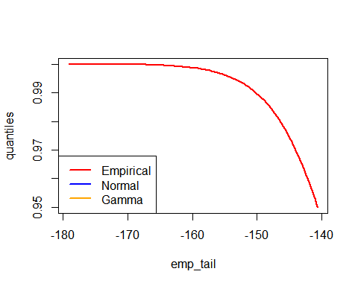

# The approximations should not straddle the empirical distribution   
  
  
# Plotting again to look more like his but same analytical problems   
# Switch x and y axis   
  
plot(emp_tail, quantiles, type = 'l', col = 'red', lwd = 2)  
lines(norm_tail, quantiles, type = 'l', col = 'blue', lwd = 2)  
lines(gamma_tail, quantiles, type = 'l', col = 'orange', lwd = 2)  
legend("bottomleft", c("Empirical", "Normal", "Gamma"), lwd = 2, col = c("red", "blue", "orange"))

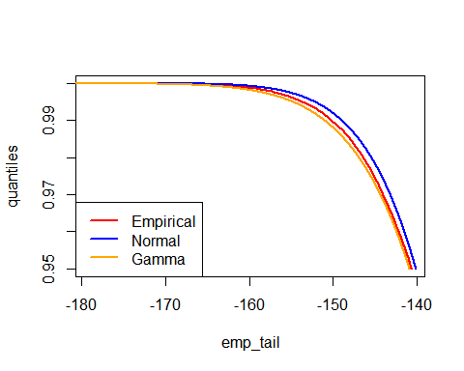

# The gamma approximation seems to work better because it is close to the empirical distribution.