HW5Q4.R

# Homework 5 Part 2   
  
# Read data and look at summary statistics  
data <- read.csv("SP500_Log_Returns_20150101_20160101.csv")  
head(data)

## Date Closing.Price Ln.Price Ln.Return  
## 1 1/2/2015 2058.20 7.629587 -0.000340021  
## 2 1/5/2015 2020.58 7.611140 -0.018447213  
## 3 1/6/2015 2002.61 7.602207 -0.008933255  
## 4 1/7/2015 2025.90 7.613769 0.011562736  
## 5 1/8/2015 2062.14 7.631500 0.017730169  
## 6 1/9/2015 2044.81 7.623060 -0.008439322

Returns <- data[[4]]  
plot(Returns, type = 'l')

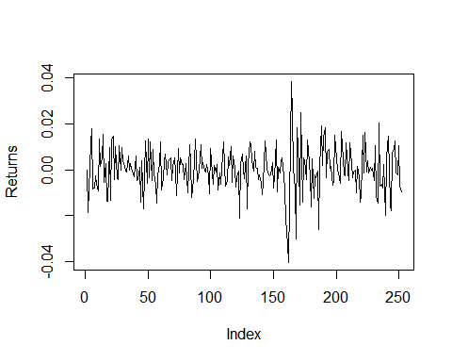

hist(Returns, breaks = 30)

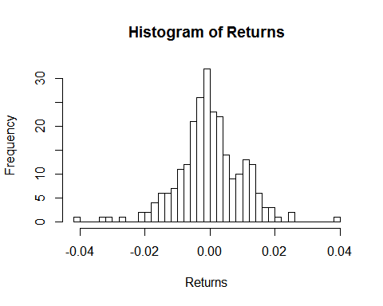

# Initialize parameters  
V <- 1e6 # Portfolio value   
alpha <- 0.95 # Var Confidence   
beta <- 0.025 # Estimate confidence   
numb_sim <- 100000 # M   
n <- length(Returns) # number of observations  
  
  
# Part a   
Return_mean <- mean(Returns)  
Return_var <- var(Returns)  
norm_inverse <- qnorm((1-alpha), mean= 0, sd=1)  
Var_known = V*(1 - exp(Return_mean +sqrt(Return_var)* norm_inverse))  
  
# Use slide 27 equations for upper and lower sigma paramter   
conf_int_quantile_down<- beta/2  
conf_int_quantile_up <- 1-beta/2  
conf_ints <- c(conf_int_quantile_down, conf_int_quantile_up)  
chisq_df <- n-1  
  
sigmas2_known <- ((n-1)*Return_var)/qchisq(p = conf_ints , df = chisq_df) # stores 2 values, conf ints has both betas   
#sigma_down <- ((n-1)*Return_var)/qchisq(p = conf_int_quantile_down, df = chisq_df)   
  
# Watch the signs?  
Var_known_conf_int <- V*(1 - exp(Return_mean +sqrt(sigmas2_known)* norm_inverse)) # Again 2 sigmas (high, low) in sigmas2_known   
# Var_down <- V*(1 - exp(Return_mean +sqrt(sigma_down)* norm_inverse))  
  
  
  
############################################  
############# Part b ########################  
###########################################  
  
  
# Following steps on slide 31   
  
# First simulate sigma   
  
chisq_MC <- rchisq(numb_sim, chisq_df)  
sigma2_MC <- ((n-1)*Return_var)/(chisq_MC)  
sigma_MC <- sqrt(sigma2_MC)  
  
# Preallocate space   
mu_MC <- rep(0, numb_sim)  
  
# Simulate mean of the VaR   
for(sim in 1:numb_sim){  
 mu_MC[sim] <- rnorm(1,mean = Return_mean, sd = (sigma_MC[sim]/sqrt(n)))  
}  
  
# Simulate VaR alpha   
VaR_alpha_MC = V*(1 - exp(mu_MC +sigma_MC* norm_inverse))  
hist(VaR_alpha_MC, breaks = 40)

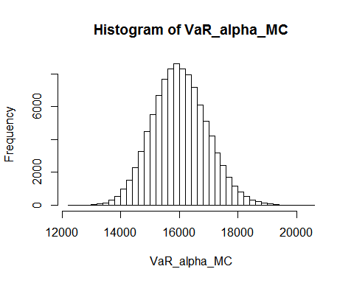

VaR_MC_mean <- mean(VaR_alpha_MC)  
VaR_MC_conf_int <- quantile(VaR_alpha_MC,conf_ints)  
  
# Compare two method of finding VaR  
  
Var_known

## [1] 15970.06

Var_known_conf_int

## [1] 17718.07 14527.45

VaR_MC_mean

## [1] 16019.67

VaR_MC_conf_int

## 1.25% 98.75%   
## 14030.90 18236.33

# The two methods are very similar. The means are slightly different but the confidence intervals overlap for the majority of the time. The MC confidence interval is slightly larger than the analytical formula