Effects of Volunteering Activities on Crime Rate: Identify Correlation

**2. Domain**

The domain for this research will be about community, specifically crime and volunteering activities. This paper will focus on finding the relationship between crime rate and volunteering participation.

**3. Question**

Crime rate has been increasing for the past few years and it has become a major issue in Victoria (Percy, 2016). This report will tackle this issue and try to answer the following question: **“Could increase in volunteering participation reduce offence/ crime rates?”**. The answer might interest government and organisations, such as Department of Justice and Regulation Victoria, Department of Human Services Victoria, and other volunteering organisations (i.e. Go Volunteer and Volunteering Victoria) as it will help resolve connectedness issues that will reduce crime rate. To answer the question, this report will investigate the relationship between variables, specifically volunteering participation and offence rates. If we find a negative correlation between offence and volunteering participation, this information can be used as potential solution for the problem, which benefits volunteer organisations as they get more support from Victorian government as well as the government itself as they find a way to solve crime issues.

**4. Innovative Information the Answer Provides**

The answer can provide innovative information as relationship between volunteering and crime hasn’t been widely explored. Although it hasn’t been widely explored, it can provide valuable analysis such as correlation (see Section 3) and clustering. This data can help government to decide potential causation and determining location that need help at most. In addition, innovative way of volunteering as a solution also provide a new perspective through solving connectedness issues at a smaller scale. For example, when socially disconnected people volunteers, they are given opportunity to make new friends/ connections, do activity that helps them realize that they are useful, as well as feelings of belonging to the society. As their experience increase through numerous volunteer opportunities, they can gain organisation and other skills that help them solve unemployment/ income problem which also a major cause of increasing crime rates.

**5. Datasets**

The first of the chosen dataset was taken from AURIN (named “community_data.csv”) has been filtered and contain data about percentage of people participate in volunteering (volunteer_participation_percentage) based on LGA from Department of Health and Human Services that was released on November 2016.

Link: <https://data.aurin.org.au/dataset/vic-govt-dhhs-vic-govt-dhhs-lga-profiles-2015-lga2011>

The second dataset was also taken from AURIN (named “offence_data.csv”) which contain data about offences in 2012 – 2016 that was divided into section A-F based on LGA from Crime Statistics Agency that was released on 2017.

Link: <https://data.aurin.org.au/dataset/vic-govt-csa-lga-vic-crime-statistics-2012-2016-lga2011>

**6. Adding Values Through Processing, Integration, Analysis, and Visualisation**

Processing, integration, analysis and visualising data add value compared to having raw data. Processing can add value by making sure data is consistent and accurate. In the project, processing begins by stripping irrelevant columns and changing column name, thus making the data more consistent and useful for the research. Next, more processing benefits can be seen when offence_data was normalised to extract true information about the offence rate in a location unbiased from number of population (see Section 7).

Integrating both datasets add values as we can easily use it in visualisation and further analysis to spot correlation between them (getting hint of causation), predict pattern, or classifying the data. For example, combining both datasets allow correlation analysis through scatter plots and Pearson correlations between volunteer participation and offence rate (see Section 7). Analysis and visualisation add values by making it easier for human eyes to spot pattern and interpreting large information. As an example, bar chart can be used to display the increasing rate of crime, find segmentation behaviour for each type of crime, while scatter plot and best fit can be used to visualise correlation (see Section 7) which helps to find possible factor of certain events.

**7. Summary of Initial Wrangling**

*7.1 Pre-processing*

Pre-processing starts by removing unnecessary columns using AURIN filter tools on both datasets. CSV files was read to DataFrame, column names were changed (i.e. lga_code11 -> lga_code) for consistency and smooth integration using inner join. Afterward, offence_data was transformed so that it displays valuable information about offence rate. Note that before this transformation, offence count (a- f_total, offence_total) is not normalised and therefore biased by number of population in an LGA. To solve the issue, every row was iterated and changed so that the number of offence is changed to a normalised version using formula from Crime Statistics Agency to calculate offence rate / 100,000 people (number of populations in each LGA is given as LGA_ERP).

$$offence rate= \frac{number of crimes}{number of populations}*100,000$$

Before integration process, an average of offence rate from 2012 – 2016 was calculated because community_data is taken from 2011 census, which have different time periods. Despite different time periods, government of Victoria – Department of Health and Human Services confirmed the validity of community_data for 2012 – 2016 periods when it was released in 2016.

*7.2 Integration*

Integration was done to merge offence_data and community_data using its index (lga_code). This was done using df.merge() function using inner join mode. Columns after merging is lga_code, a_total, b_total, c_total, d_total, e_total, f_total, offence_total, lga_name, and volunteer_rating_percentage. The process went smoothly due to column editing in pre-processing steps. Duplicated column such as lga_name was deleted and merge data was saved to merged_data.csv file for reusability purposes during later analysis.

*7.3 Visualisation and Analysis (Bar Plots and Scatter Plots)*

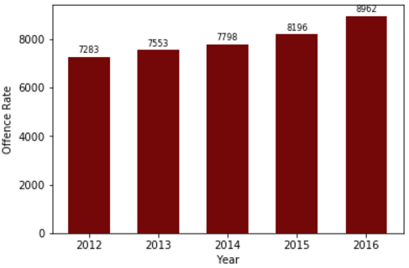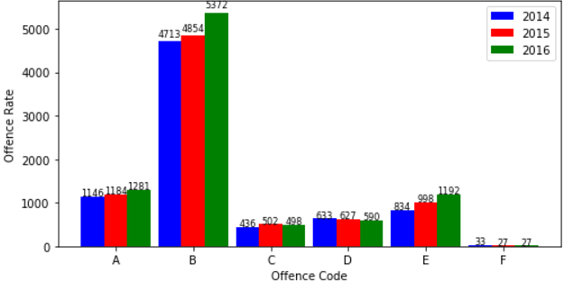Bar plots is used to display the frequency of offence rate per year (Fig 1). Moreover, segmentation analysis (crime type A – crime type F) is also visualised using bar plot which provide in-depth information for specific crime type throughout years (Fig 2).

Figure 1. Figure 2.

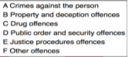

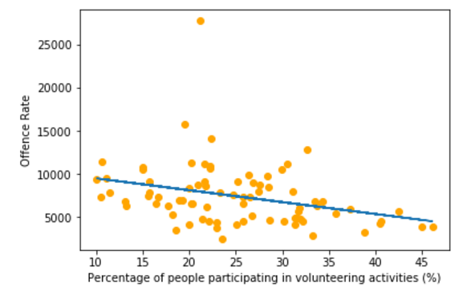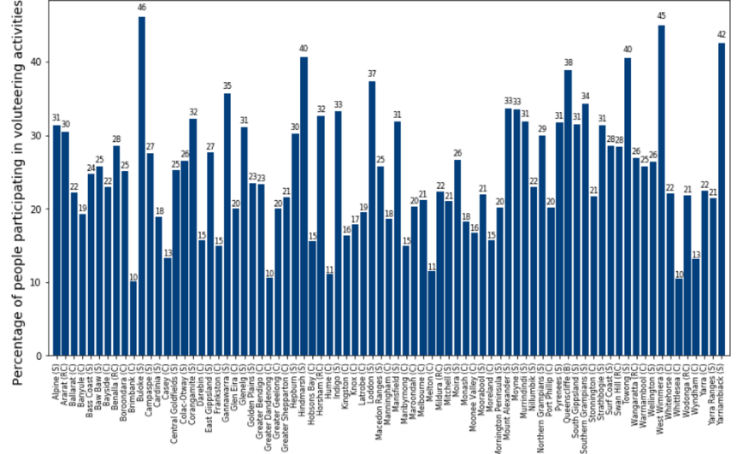Bar plot above clearly communicate that some segments (A, B, E) of offence is increasing while other segments (C, D, F) is decreasing. However, total offence rate (normalised) still consistently increasing throughout the years by about 3-9% every year. This fact shows that overall crime rates has increased for the last 5 years and therefore a major issue that government and society of Victoria need to be aware. Another bar plot is used to visualize the participation in volunteering activities for each LGA. From the bar plot, the participation percentage in every LGA is below 50% with numerous LGA below 20% participation (Fig 3). This information shows that there is room for government and volunteering organisations to encourage participation and increase volunteering events.

Figure 3 Figure 4.

Scatter plot and line of best fit is another visualisation and analytics tools that effectively display correlation between offence rate and volunteer participation. Figure 4 shows that the correlation is negative, but without the strength of correlation. Therefore, Pearson Correlation is implemented using python and used to calculate the correlation. This evaluates to -0.32 which is moderately strong correlation (Bailey, 2017). Consequently, increase number of participation in volunteering activities might reduce offence rate. Even though correlation analysis doesn’t imply causality, however this project can be further investigated to help answer the question with more certainty and thus provide innovative solution to crime problems in Victoria.

**8. Continuation of the Project**

There are 3 factors which makes this project feasible and interesting. First factor regarding the offence rate discussed in investigation. Crime clearly is one of the major issue in Victoria. The number of crime rate for the past 5 years has increased with a total of 23.05%. This rapid increase should have alarmed Victoria Government and push them to think for a solution. Second factor is about the volunteering participation percentage. According to the data, the participation rate is less than 50% in every LGA, which therefore implicitly implies that there haven’t been many volunteering activities. By observing this result, government and volunteer organisations can use this as an opportunity to increase volunteering events that will benefits people in the society. Finally, correlation between offence rate and volunteering event has showed an interesting result. From data wrangling using python, crime rate and participation is inversely related. It correlation is – 0.32, which is moderately strong. This suggest that with increasing participation in volunteering activities, might reduce the number of offence rate. Therefore, volunteering activities might be a possible new solution for resolving the issue of crime. Note that volunteering events is also budget friendly and relatively easy to execute compare to other solutions. In addition, it also helps overcome connectedness issue which is a definite source of crime.