Programming Project Report

Alexander Ahlbrandt

010726372

# Problem Statement:

The goals of this assignment are to make a terrain model and shade it using Gouraud shading. Inputs to the program are: coordinates, colors, and lighting configurations from the user for the model. The output of the program is a graphical image of a surface. No error handling is required.

# Design:

I designed the program to be easy to read - no complex data structures, functions, or random variables. While there is a lot of code, there is also a lot required of the programmer for this project. I used mostly primitive data structures - float arrays for my coordinates, colors, vectors, etc. I did not use any complex algorithms.

# Implementation:

To implement this project, first, I needed to know the problem I was trying to solve. Then I looked at some examples that were provided to me via the professor's website to see if I could bootstrap my work with those. I can trust the professors work, and read his code clearly via comments. I used this code to model my code after, so my code would be clear and concise. I used the split function to split the square and get some random surfaces. Then I used Phong shading to get it all working (inputs and controls), so I could see if everything was working the way it was supposed to, and switched over to Gouraud shading. To keep track of my changes, I used a git repository. The open source code will be available one week after the dead-line (https://github.com/malec/GLTerrain). The development timeline for this project was about a week.

# Testing:

To test the project, I tried putting the camera in weird positions, performing random rotations, and trying to get values out of bounds for OpenGL. Fortunately, there were no errors, and I did not have to write any code to handle any either, and everything worked as expected. Below are some screenshots of my program in action!

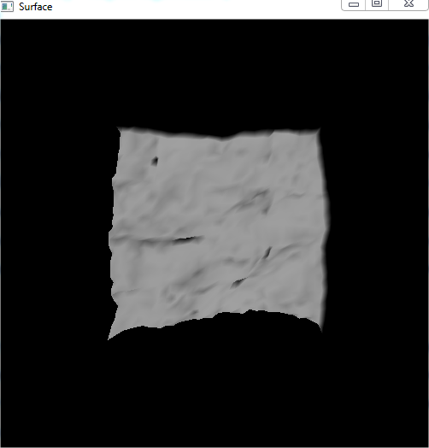

Figure - Initial render of the surface

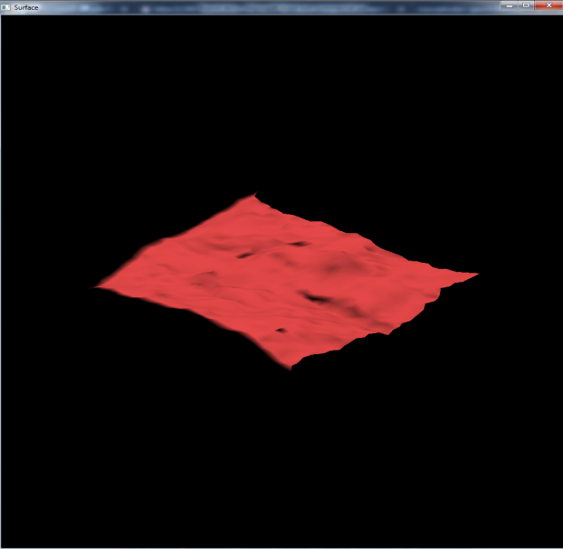

Figure - Red color added, rotated on x and z axis

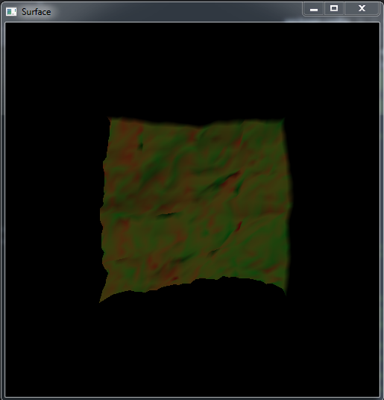

Figure - Red color on the left, green color on the right.

# Conclusion:

Overall, the result of this assignment is a success. I have simulate a terrain model, shaded it, and allowed the user to perform interactions with the model like rotations, and transformations. Next time, I would write some unit tests, maybe make the surface bigger, or put a box around the light source so you could see where it is better. I would have also done this project in two sub steps because this was a hard project. It took me a week to complete.