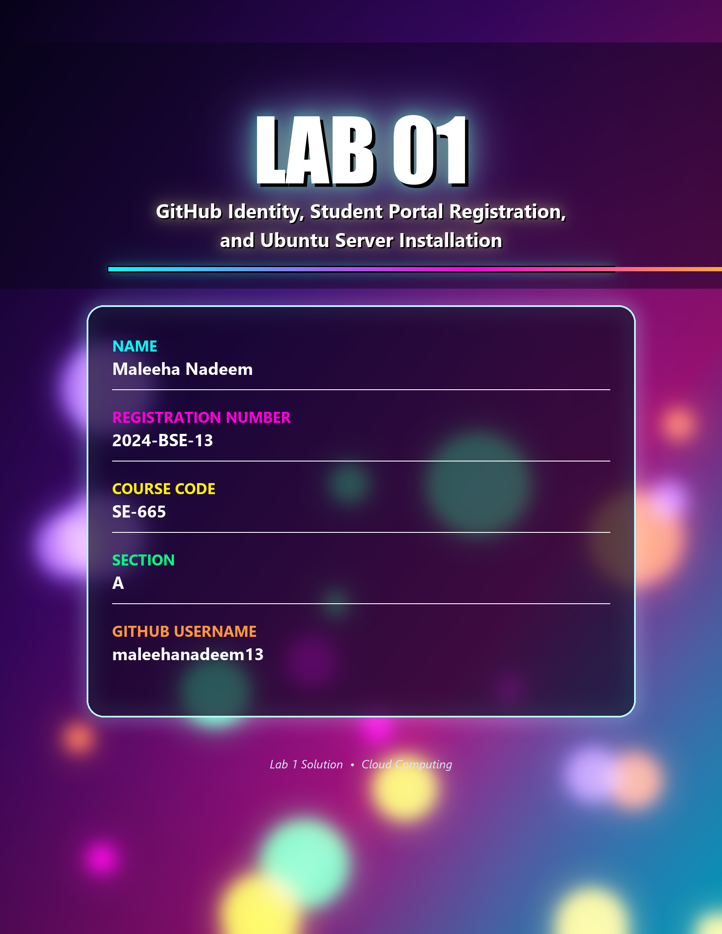

Getting Started

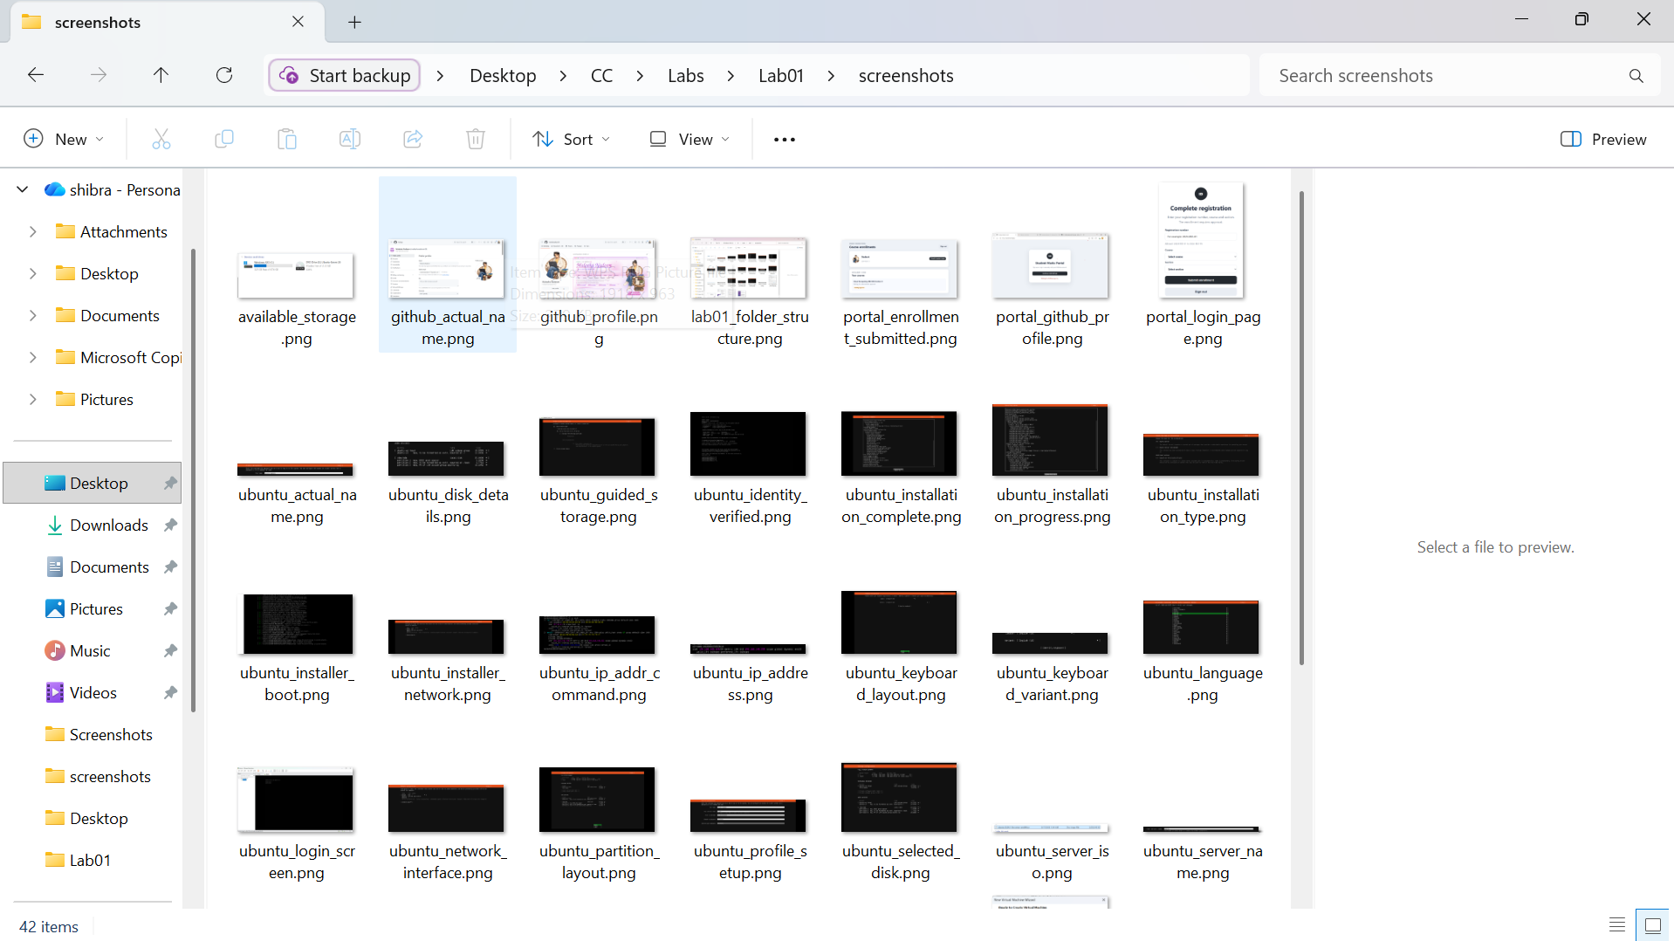
Created directory structure Labs/Lab01/screenshots/ inside the CC repository, ready to store evidence for this lab.

Task 1: Create and Configure Your GitHub Account

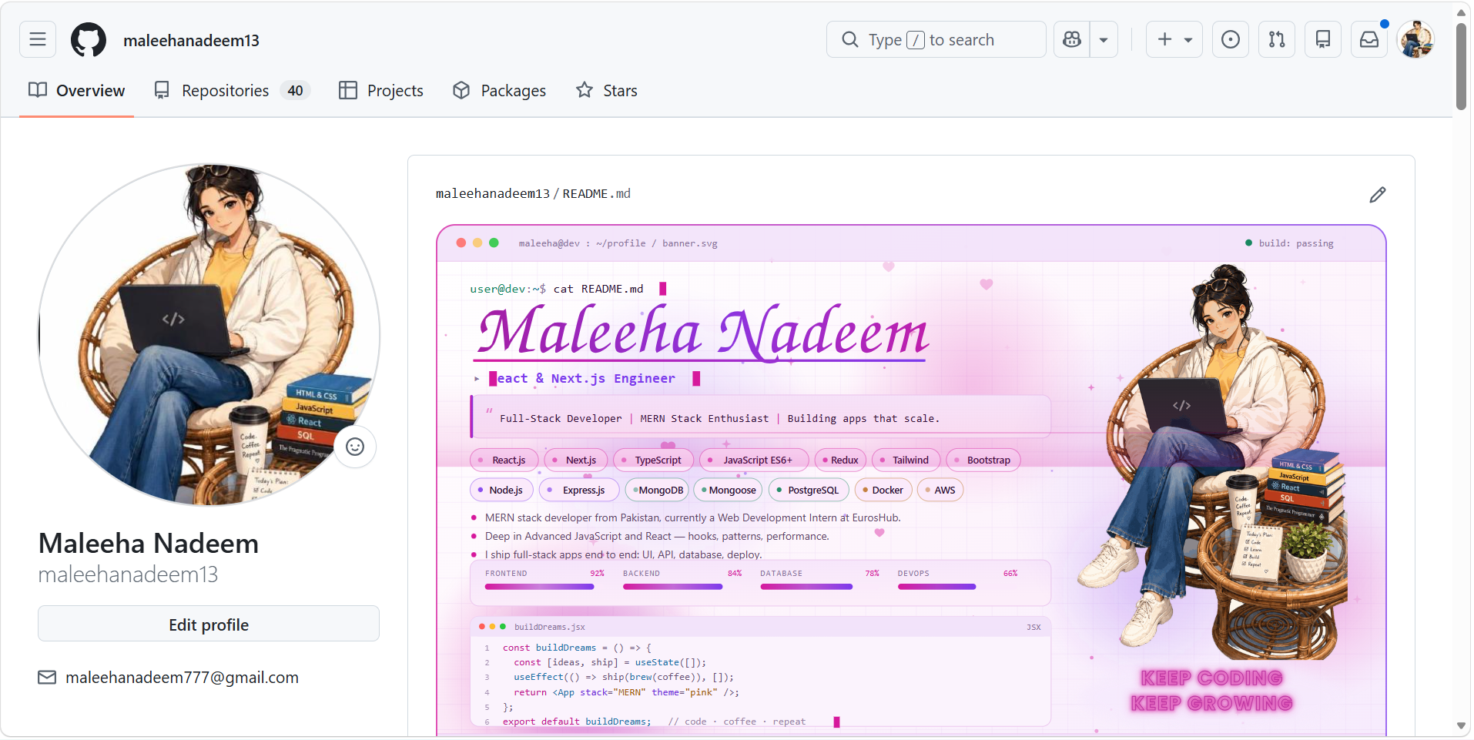
GitHub profile overview page showing the account name 'Maleeha Nadeem' and username 'maleehanadeem13'.

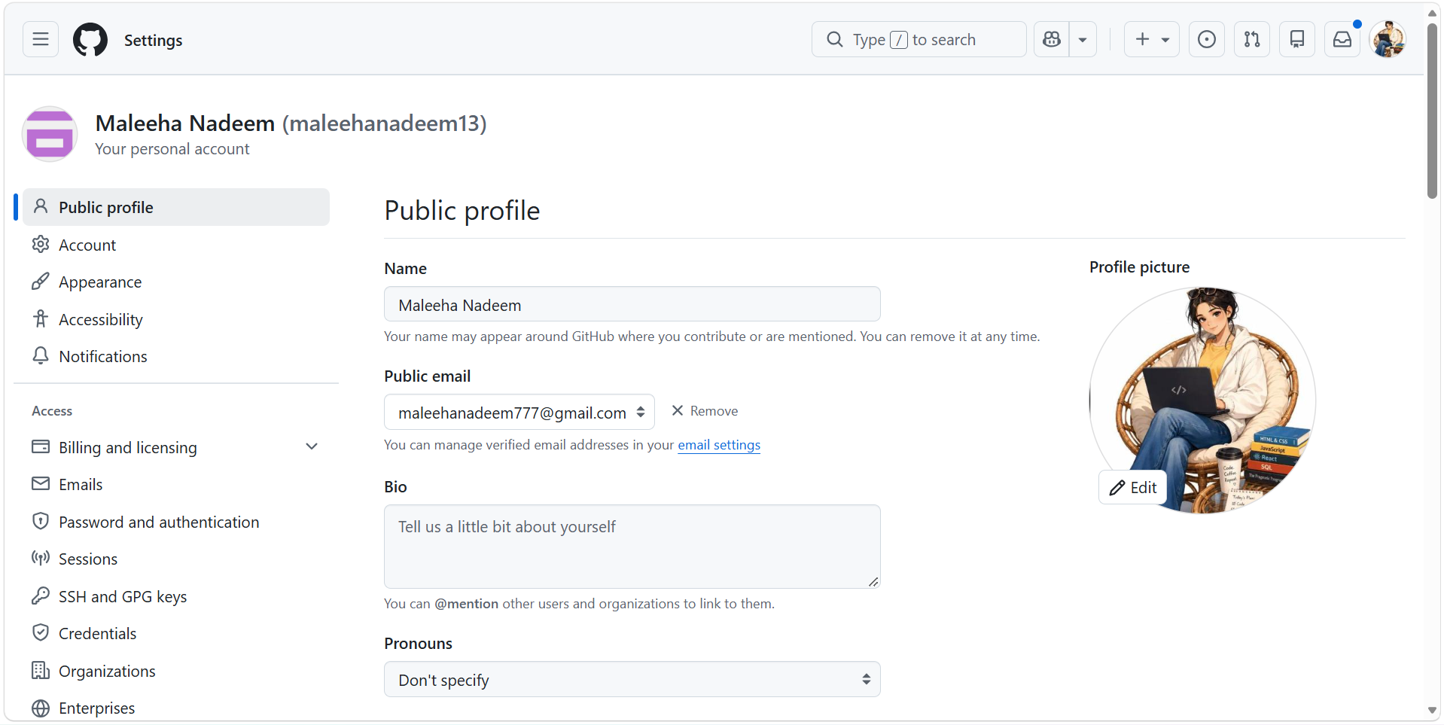
GitHub Settings > Public profile page with the Name field set to 'Maleeha Nadeem', confirming the complete actual name is on the account.

Task 2: Register in the Student Marks Portal

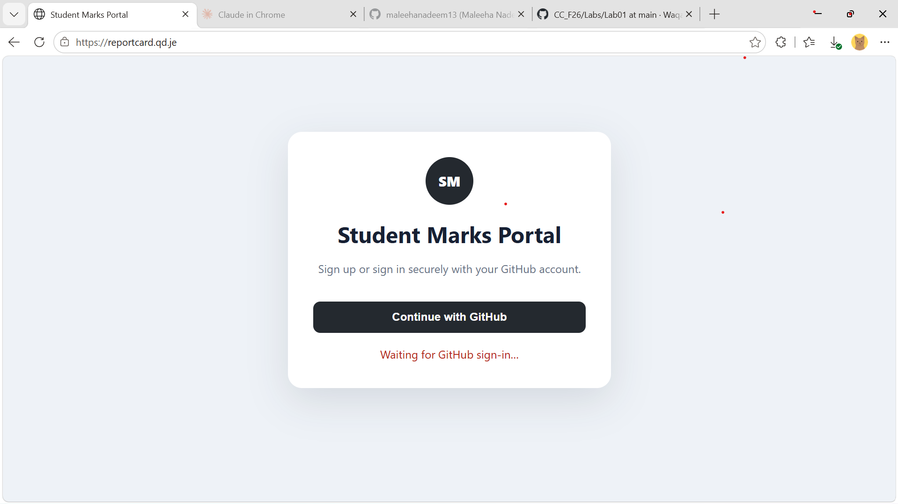
Student Marks Portal login page, prompting sign-in with GitHub.

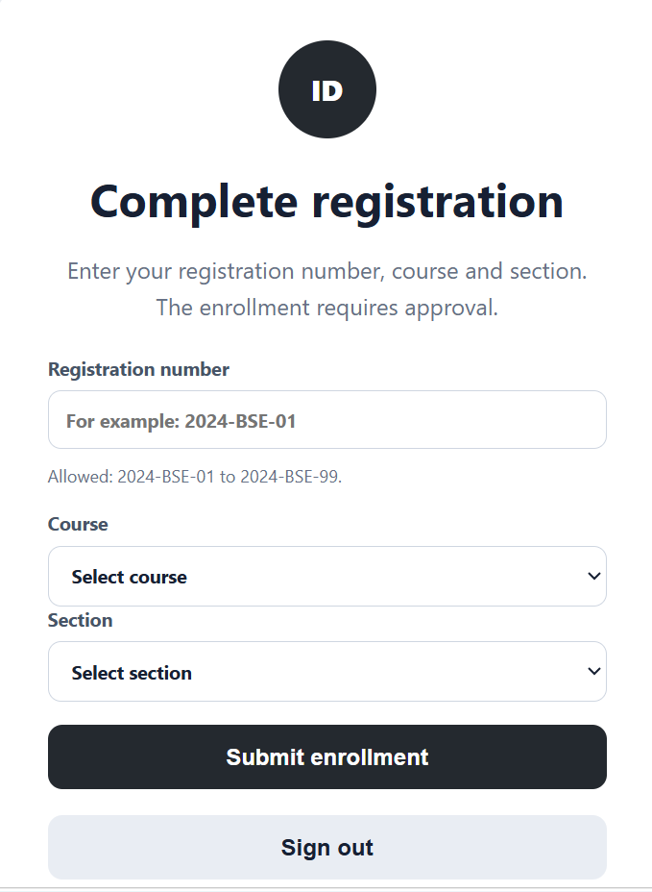
Student Marks Portal registration form for entering the registration number, course, and section after signing in with GitHub.

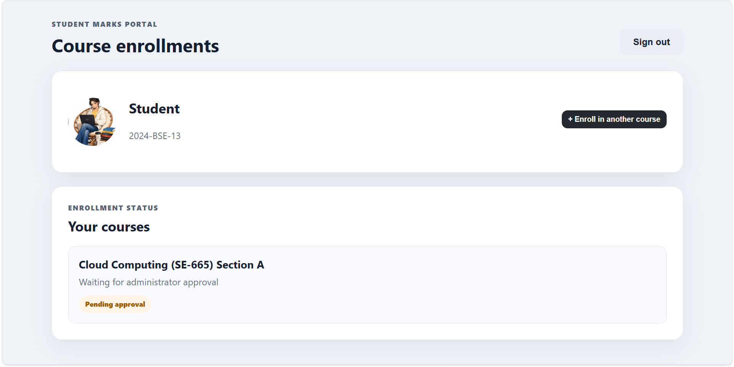
Course enrollment submitted for Cloud Computing (SE-665), Section A, under registration number 2024-BSE-13, showing status 'Pending approval'.

Task 3: Download VMware Workstation Pro and Ubuntu Server

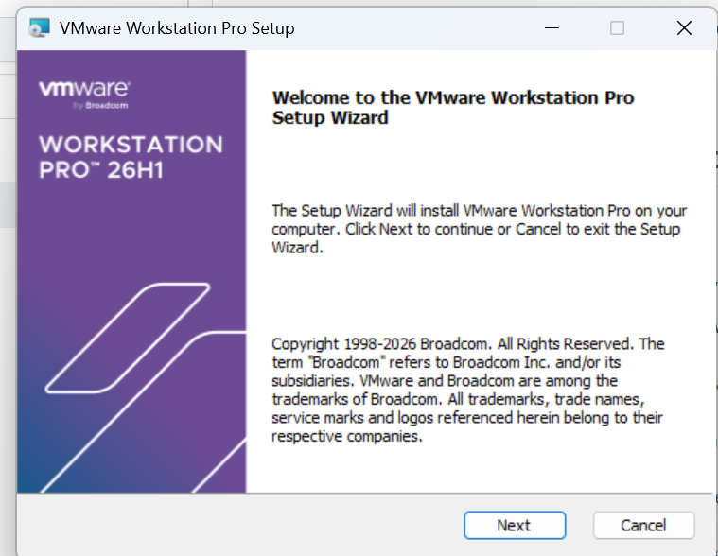
VMware Workstation Pro running on Windows, confirming the hypervisor is installed and functional.

Downloaded Ubuntu Server LTS ISO file, confirming the installation media is ready for use.

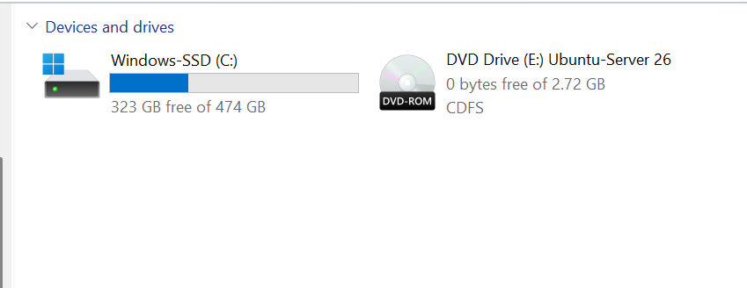
Available disk storage on the host machine, confirming at least 20 GB of free space for the Ubuntu Server virtual machine.

Task 4: Create the Ubuntu Server Virtual Machine

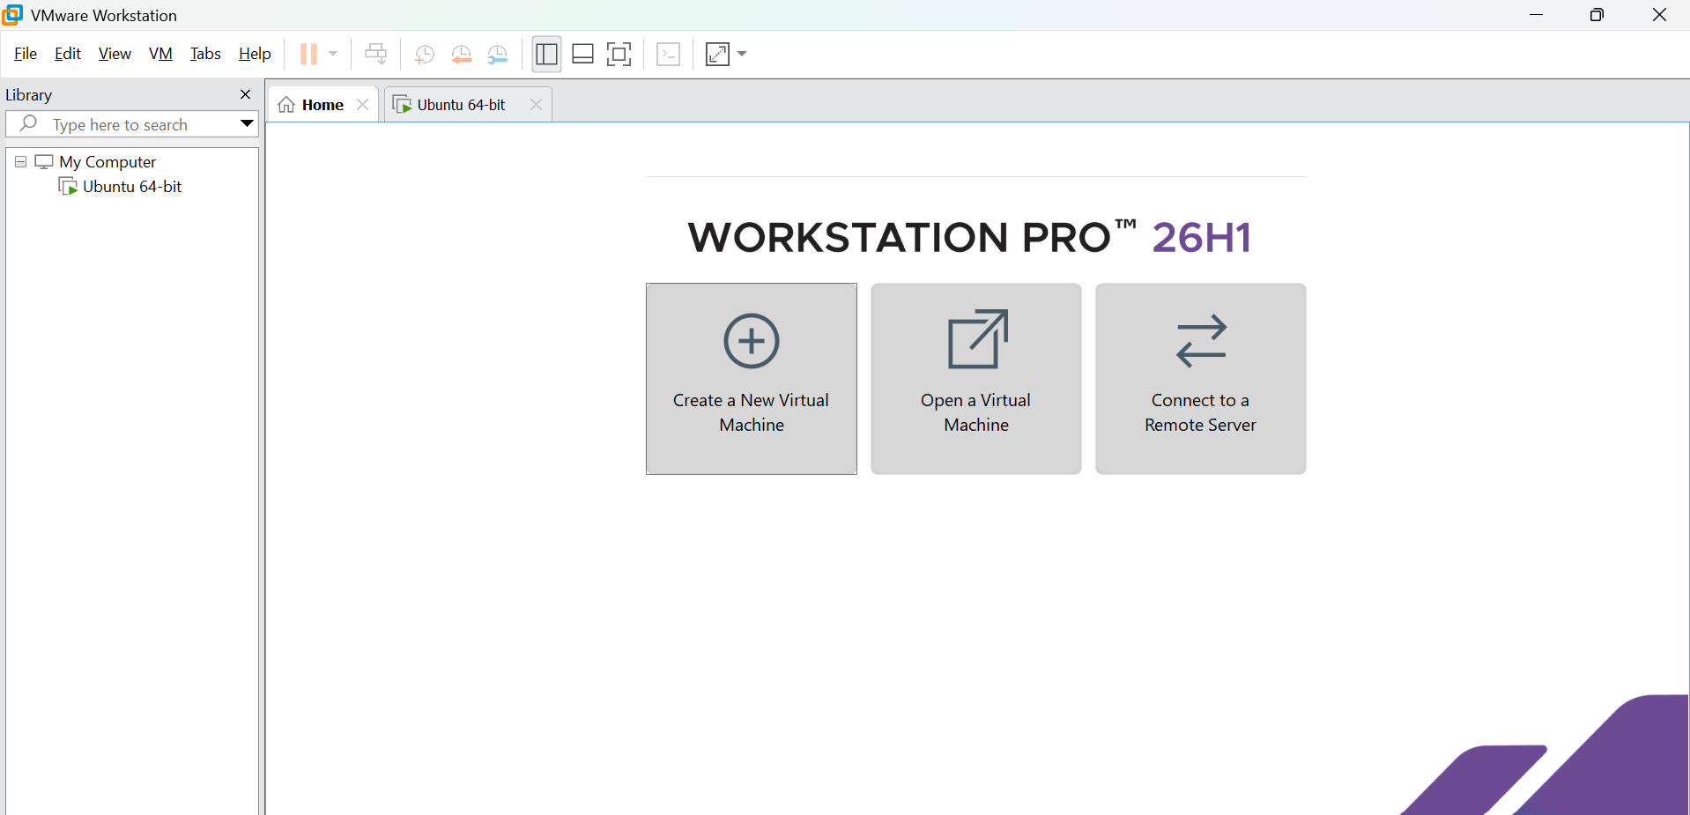
New Virtual Machine Wizard opened in VMware Workstation Pro to begin creating the Ubuntu Server VM.

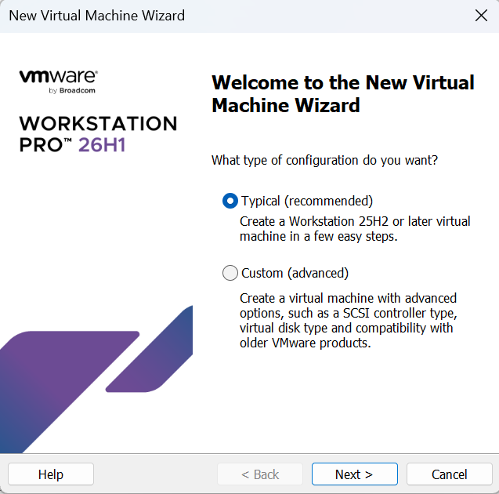
'Typical (recommended)' configuration selected for the new virtual machine.

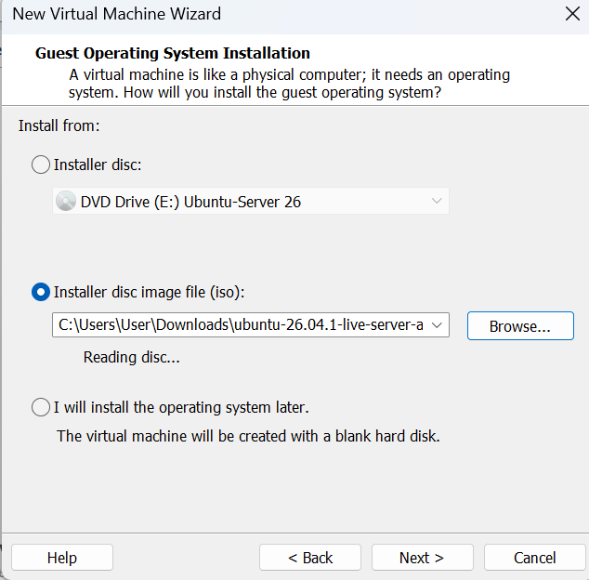
'Installer disc image file (ISO)' option selected with the downloaded Ubuntu Server ISO path chosen.

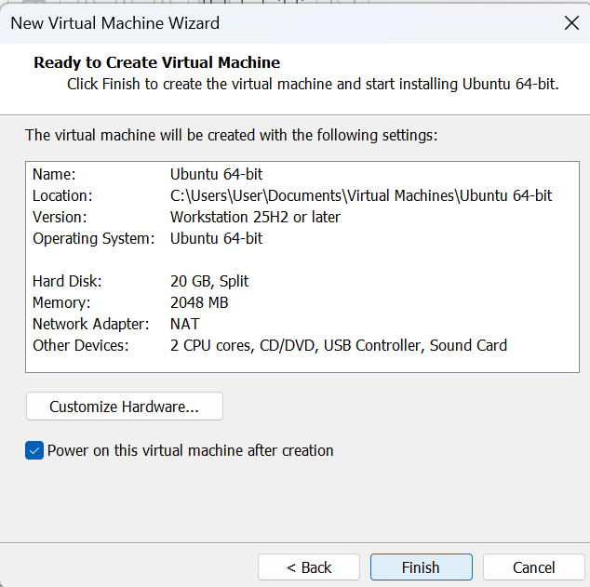
Final virtual machine configuration summary showing the allocated disk space and settings before creation.

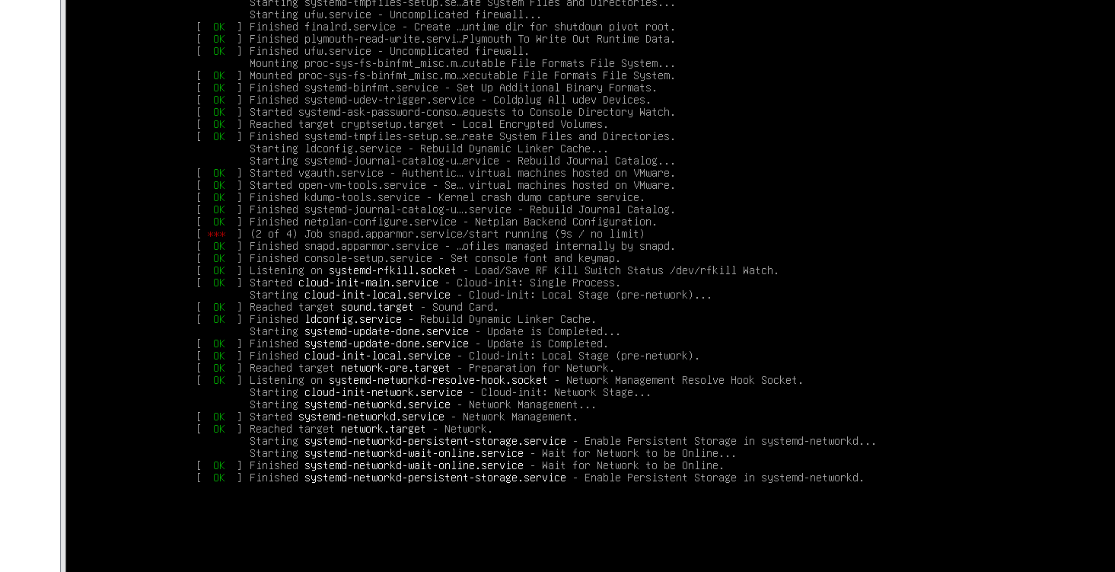
Ubuntu Server boot screen displayed after powering on the newly created virtual machine.

Task 5: Choose the Installation Language

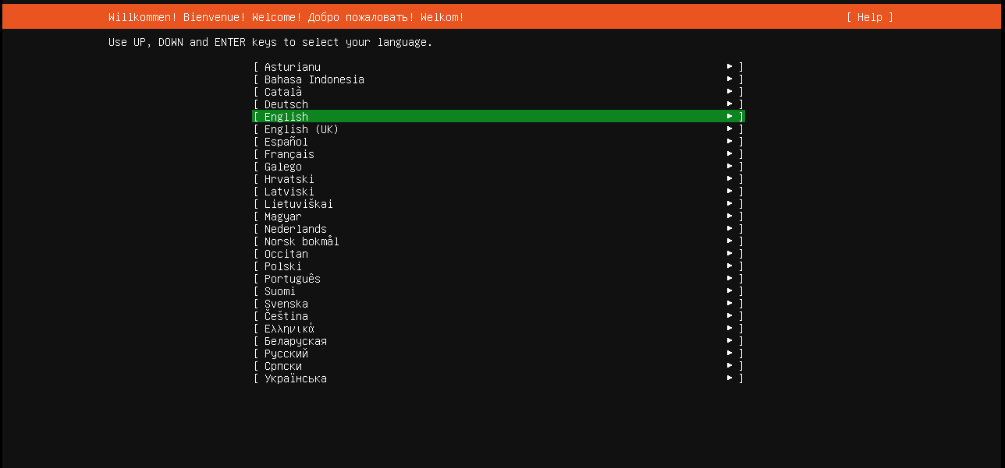
Installer language selection screen with the required installation language highlighted.

Task 6: Configure the Keyboard Layout

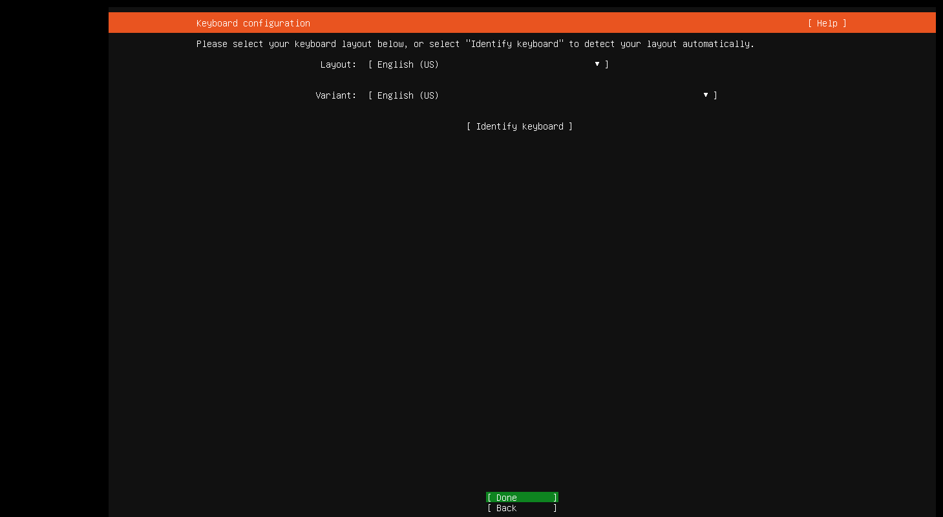
Keyboard layout selection screen showing the layout matching the host keyboard.

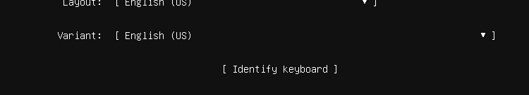
Keyboard variant selection confirming the correct variant for the chosen layout.

Task 7: Choose the Ubuntu Server Installation Type

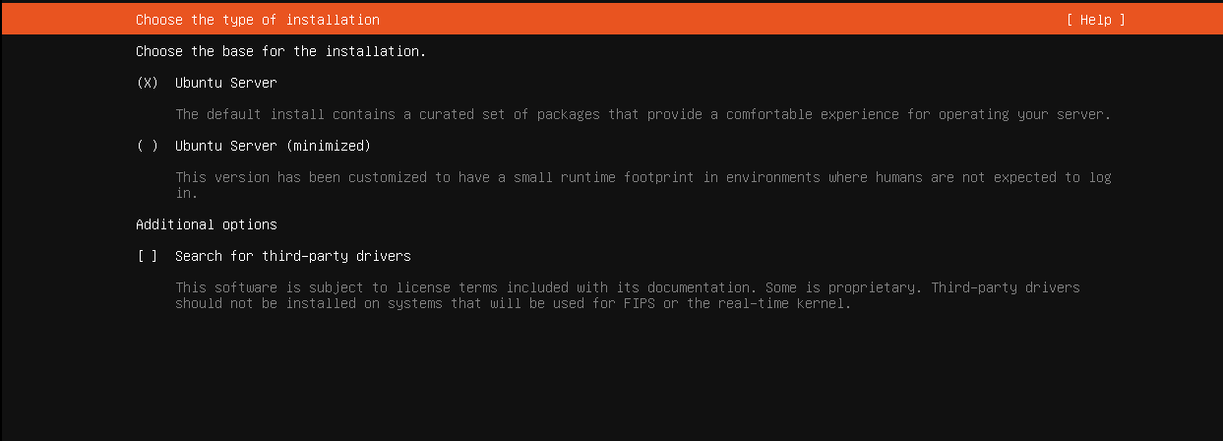
Normal Ubuntu Server installation option selected (not MAAS).

Task 8: Configure the Network

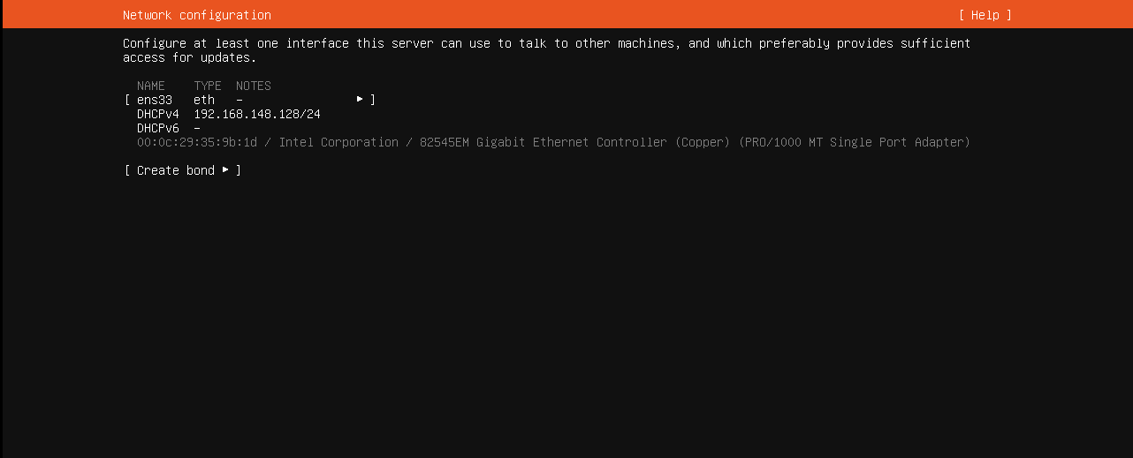
Network interface detected by the Ubuntu Server installer.

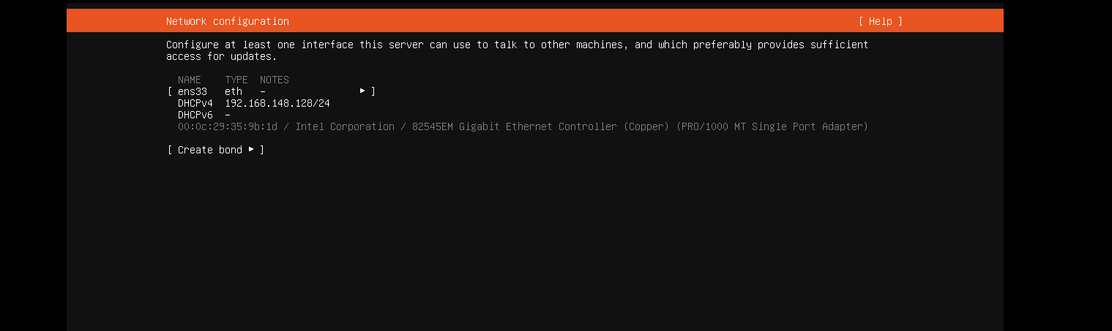
Network interface showing an IP address automatically assigned via DHCP.

Task 9: Configure Storage

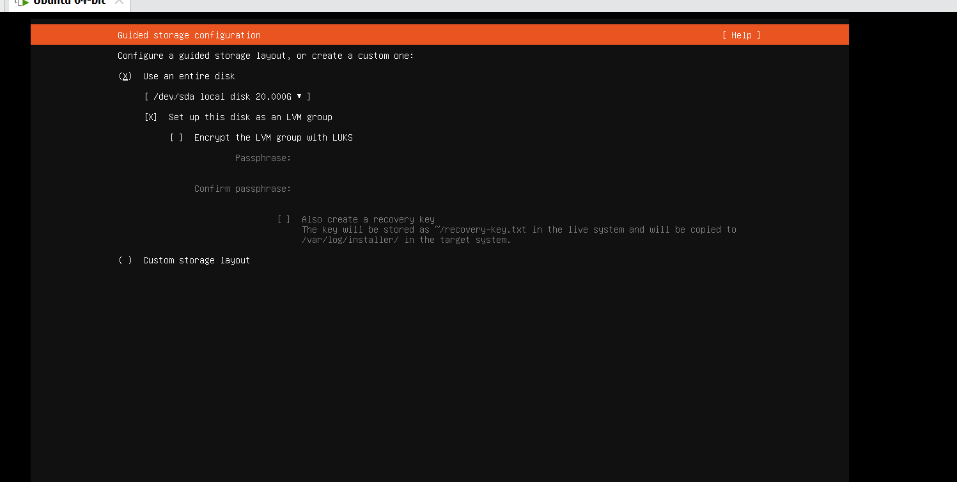
Guided storage configuration option selected to use the VMware virtual disk.

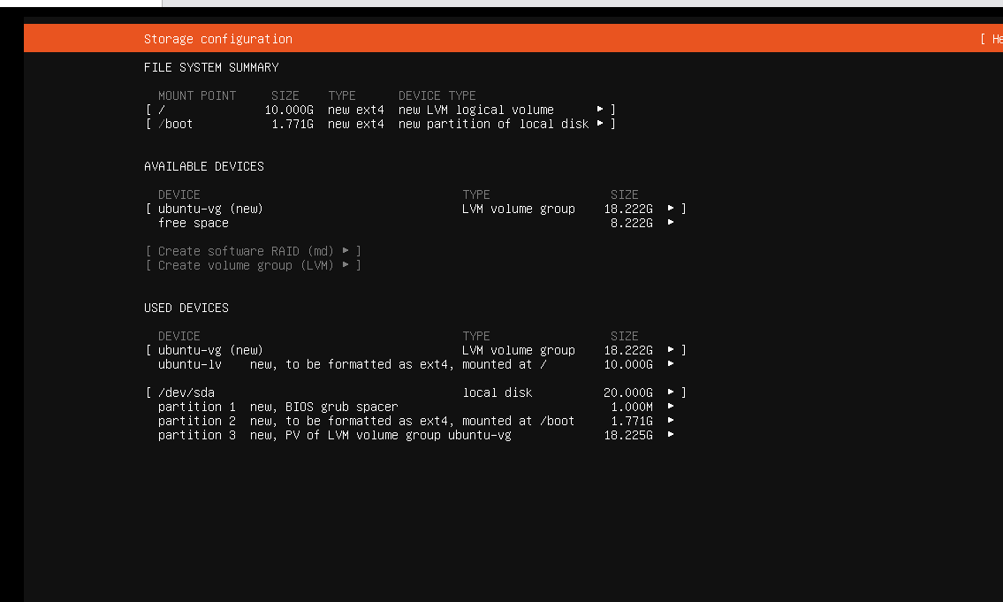
Storage configuration screen reviewed before proceeding with partitioning.

Task 10: Select the Installation Disk

Virtual disk created for the Ubuntu Server VM selected as the installation target.

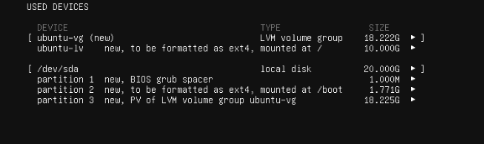
Selected disk's name and size confirmed as the correct VMware virtual disk.

Task 11: Review the Partitions

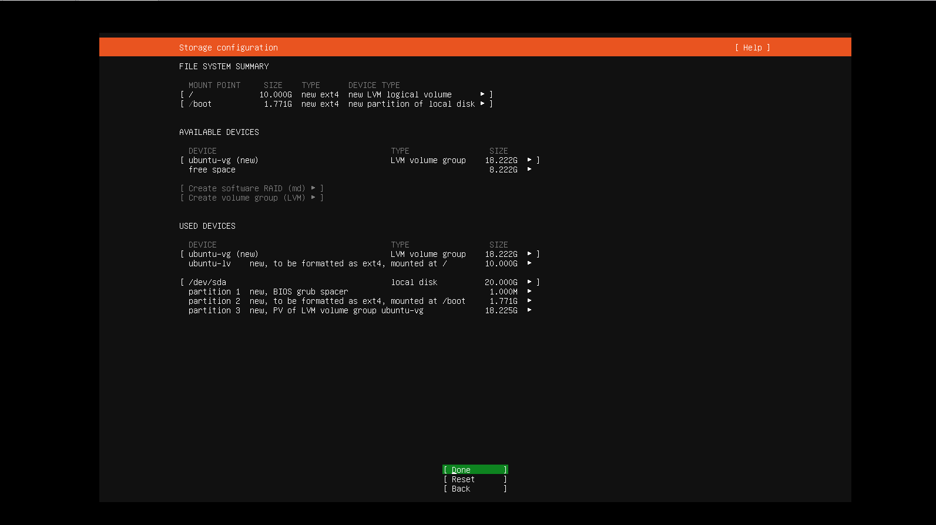
Proposed partition layout on the VMware virtual disk reviewed before continuing.

Task 12: Confirm the Storage Changes

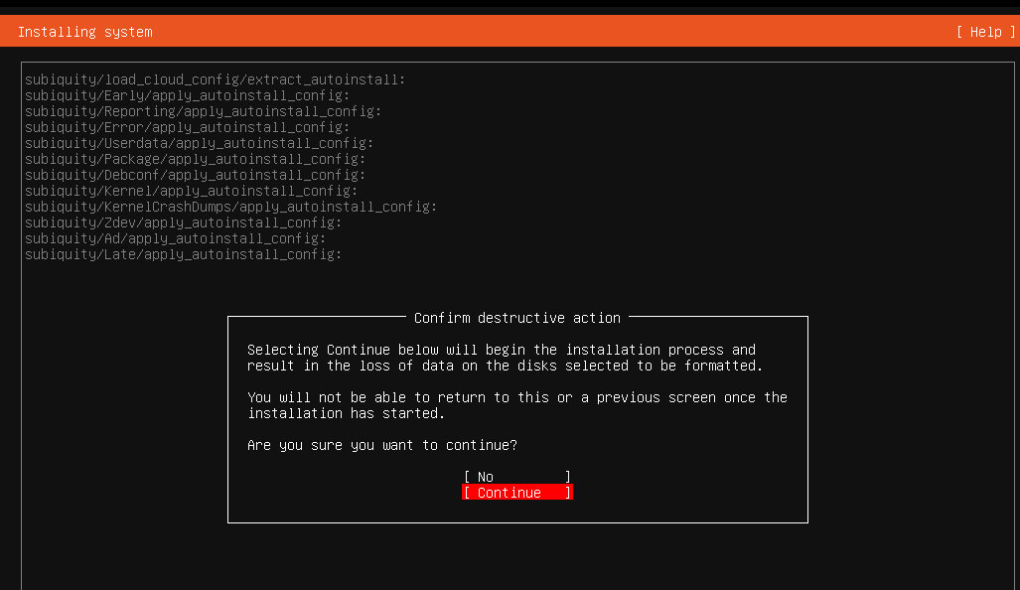
Final destructive-action warning displayed before storage changes are applied.

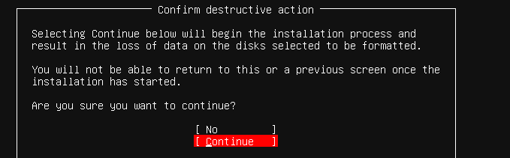
Storage changes confirmed on the correct VMware virtual disk.

Task 13: Configure the Ubuntu Profile

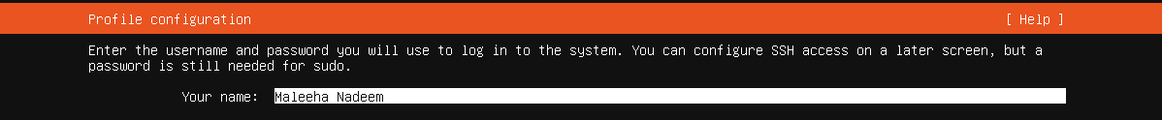
'Your name' field on the profile setup screen filled in with 'Maleeha Nadeem'.

'Your server's name' field set to 'ubuntu' as required.

'Pick a username' field set to 'maleehanadeem13', matching the GitHub username exactly.

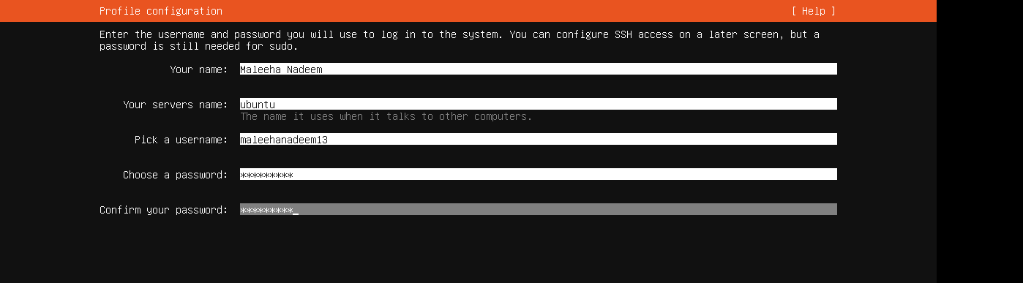
Completed Ubuntu profile setup page reviewed before continuing the installation.

Task 14: Complete the Software Installation

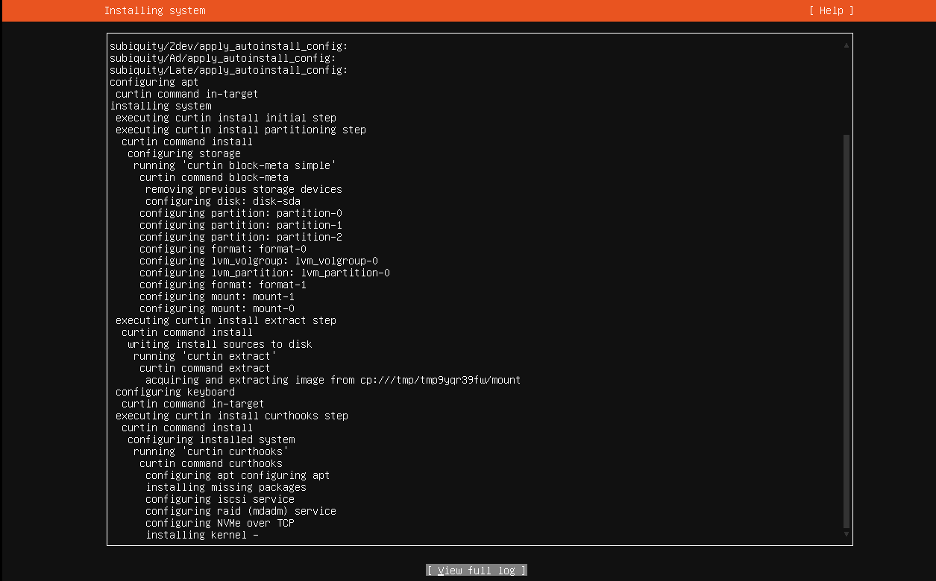
Ubuntu Server installation progress screen while the required software installs.

Task 15: Reboot and Verify the Ubuntu Identity

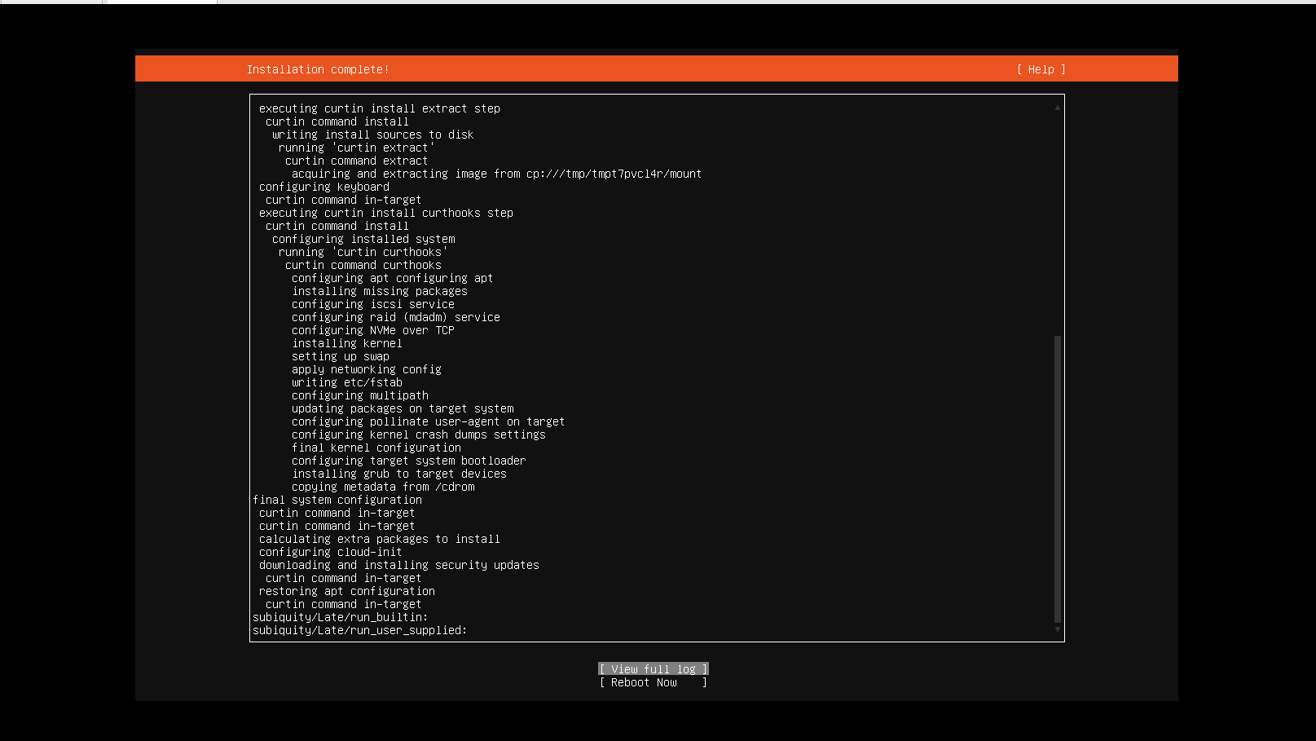
Installation-complete screen with the 'Reboot Now' option.

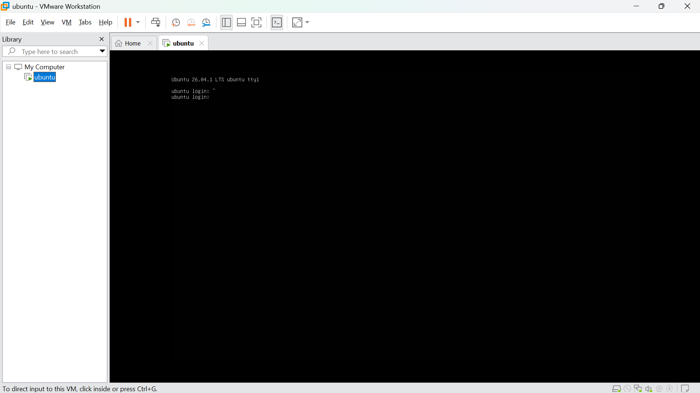
Ubuntu Server login screen shown after the first reboot.

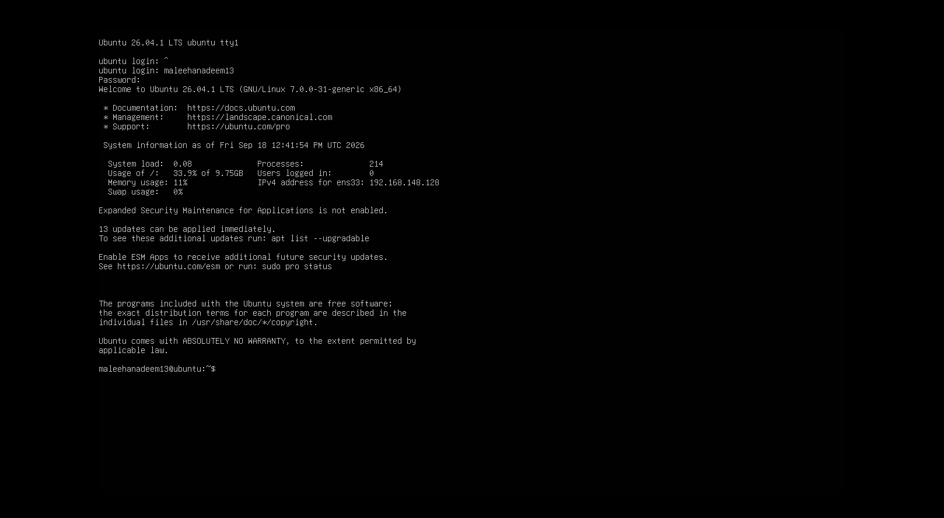
Successful terminal login using the Ubuntu username and password configured in Task 13.

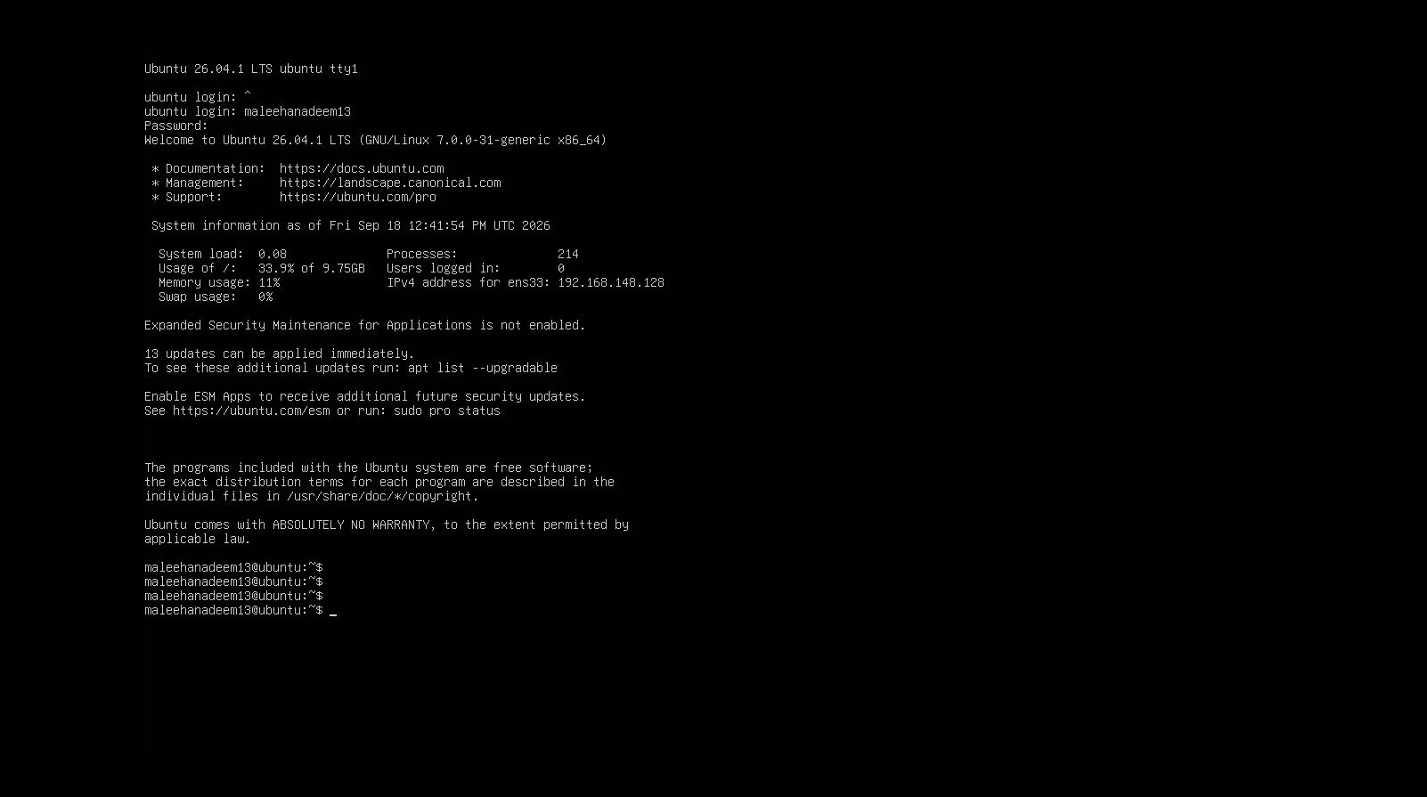
Terminal prompt confirming the identity format maleehanadeem13@ubuntu:~$, matching the required <github-username>@ubuntu pattern.

Task 16: Find the Ubuntu Server IP Address

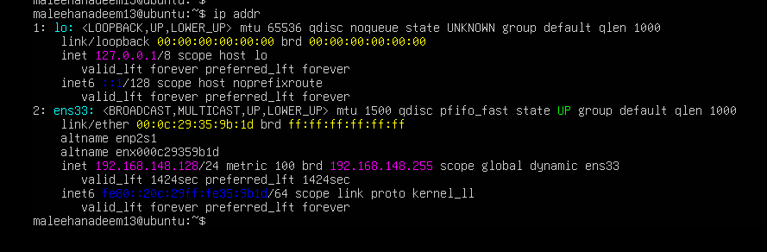
Output of the 'ip addr' command showing the ens33 interface with IPv4 address 192.168.148.128, distinct from the 127.0.0.1 loopback address.

Close-up confirmation of the assigned IPv4 address 192.168.148.128 on interface ens33, distinct from the loopback address.

Task 17: Connect to Ubuntu Server from Windows

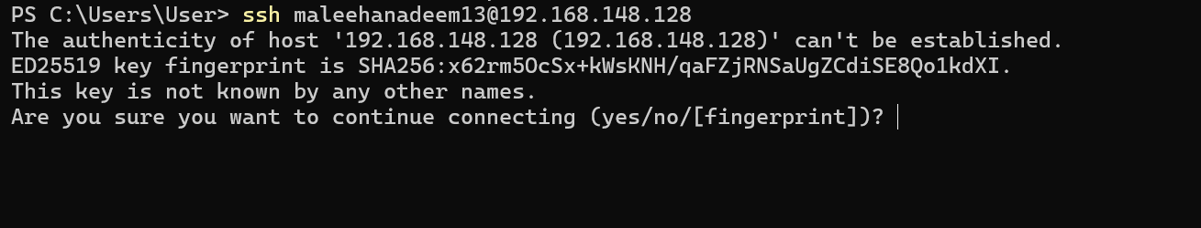
SSH command run from Windows to connect to the Ubuntu Server using its IPv4 address (192.168.148.128).

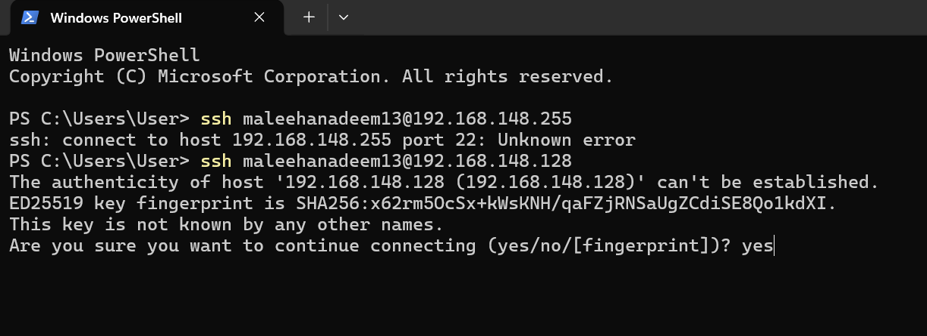
Server fingerprint prompt accepted by typing 'yes' during the first SSH connection.

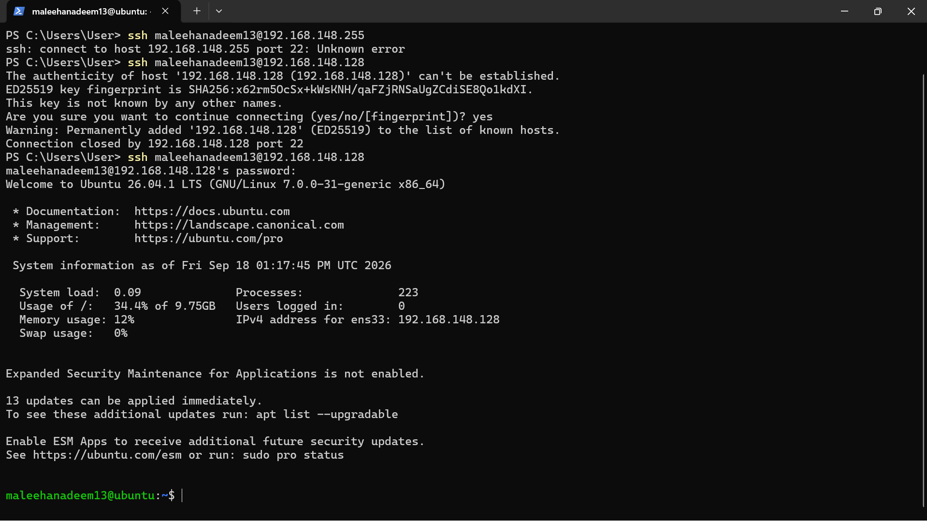
Successful SSH login into the Ubuntu Server from Windows.

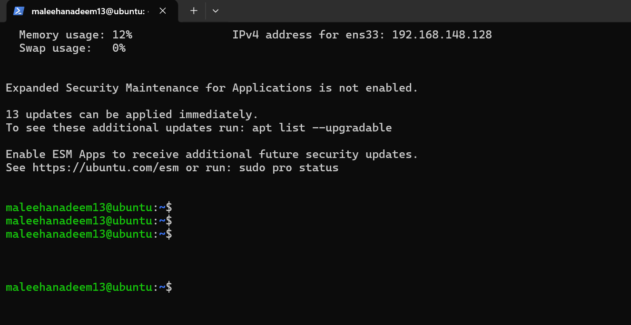
Remote SSH terminal prompt confirming maleehanadeem13@ubuntu:~$, matching the required identity pattern.

