Assignment 01 Solution
Git, Gitea, GitHub, Git LFS, and GitHub Pages
Student: Maleeha Nadeem
Course: Cloud Computing (BSE-410)
Submission date: 10 October 2026
Total marks: 10
This document records the steps performed and the evidence collected for Assignment 01. Each task below states what was done and includes the required screenshot(s) immediately at the point they were captured.

Task 1: Install Gitea and Push a Repository from the Ubuntu Server

Step 1.1: Install and Run Gitea on the Ubuntu Server
Installed Docker Engine and curl, installed the Docker Compose CLI plugin, started the Docker service, and added my Ubuntu user to the docker group. Verified git, docker, and docker compose versions. Cloned the instructor-provided Gitea setup repository and started Gitea and PostgreSQL with docker compose up -d. Confirmed both containers were running and that Gitea responded on port 3000. Completed the Gitea web installation using the required PostgreSQL database settings.
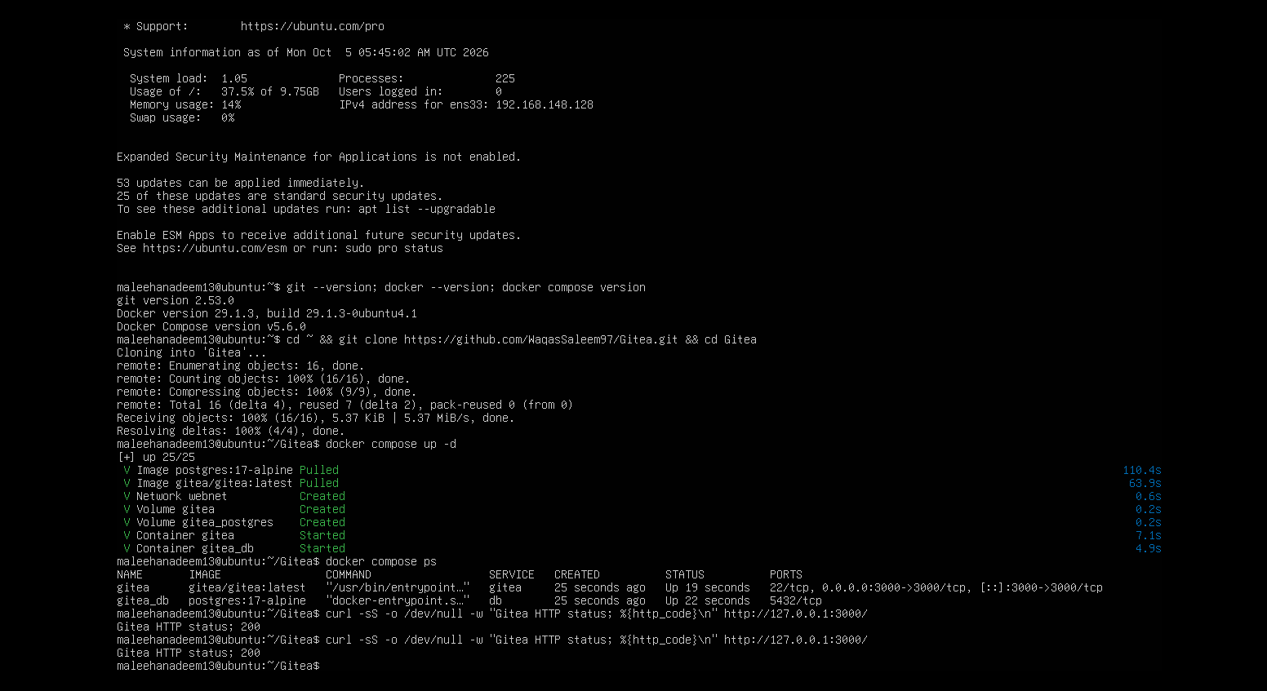

Step 1.2: Create and Push the Initial Repository
Created an empty public repository named Assignment01 in Gitea (no README/.gitignore/license). On the Ubuntu server, created a separate local repository, added a README.md with my full name and registration number, and committed it. Generated a Gitea personal access token (ubuntu-server-token, write:repository scope). Added the gitea remote (username only, no token in the URL) and pushed the initial commit using the token as the password when prompted.
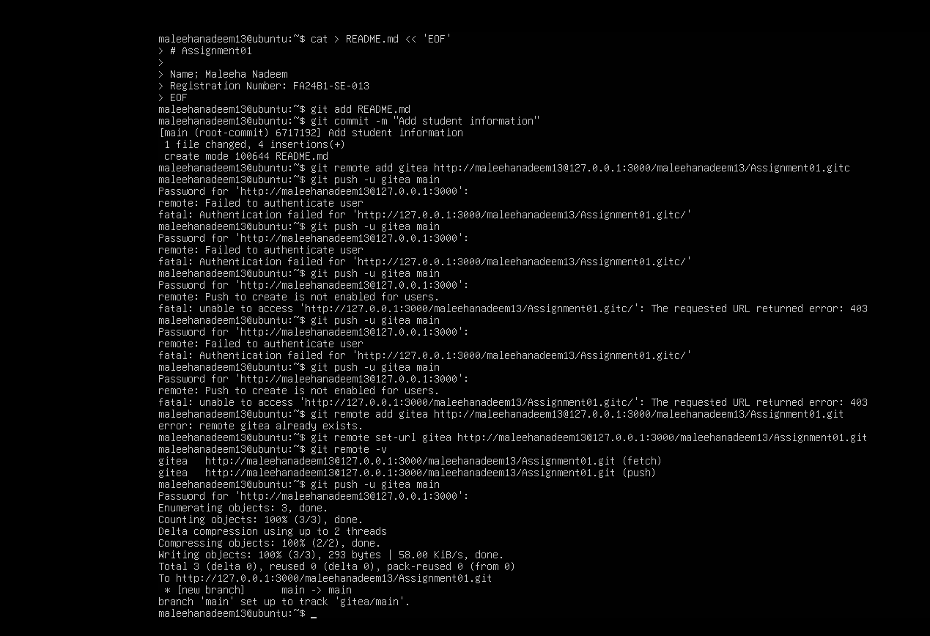

Step 1.3: Verify the Gitea Repository
Opened the Assignment01 repository in Gitea and confirmed the repository owner, repository name, that it is public, and that the rendered README.md shows my full name and registration number.
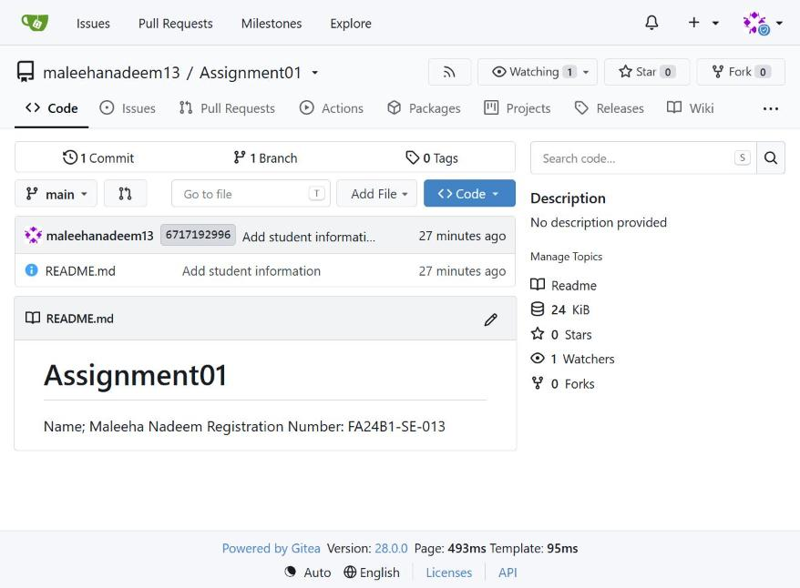

Task 2: Push the Same Repository to GitHub

Step 2.1: Create the GitHub Repository and Verify Both Remotes
Created an empty public GitHub repository named Assignment01 (no README/.gitignore/license). Added GitHub as a second remote (github) on the same local repository used in Task 1 and verified both remotes with git remote -v, confirming no token or password appears in either URL.
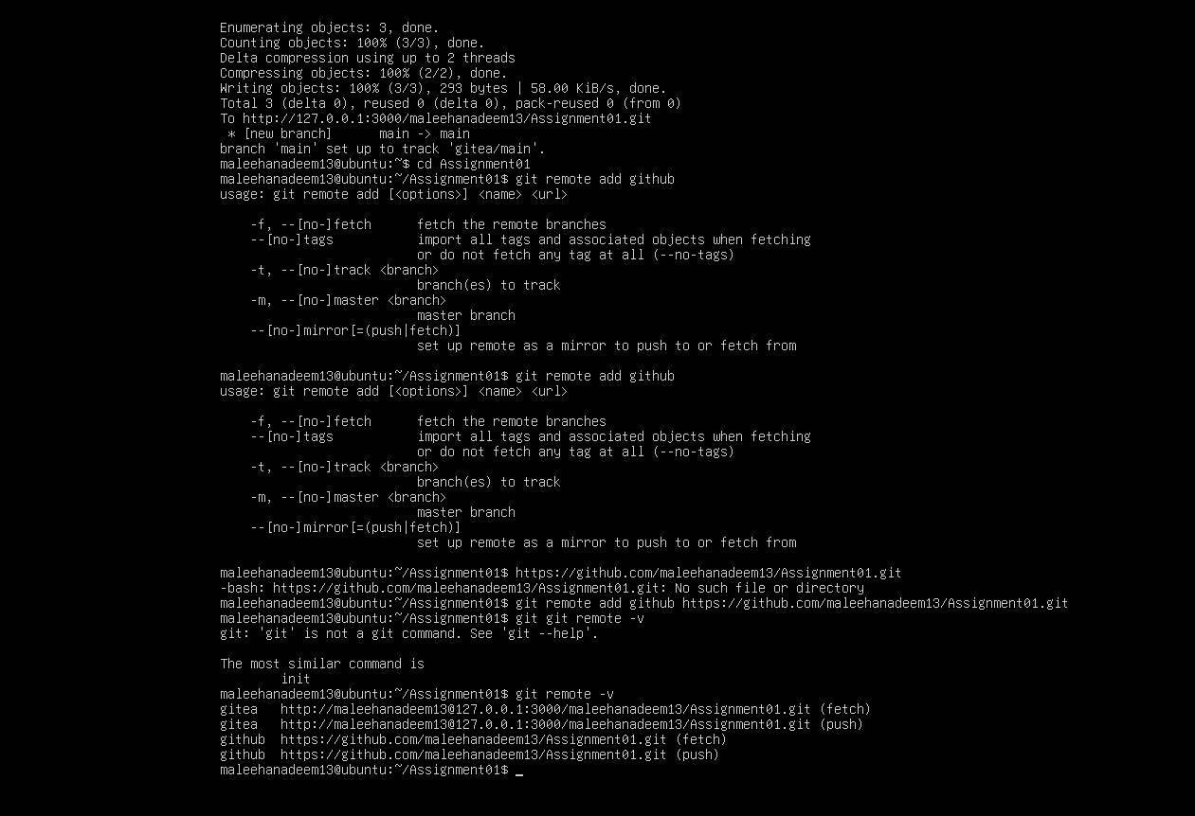

Step 2.2: Push to GitHub
Pushed the main branch to the github remote.
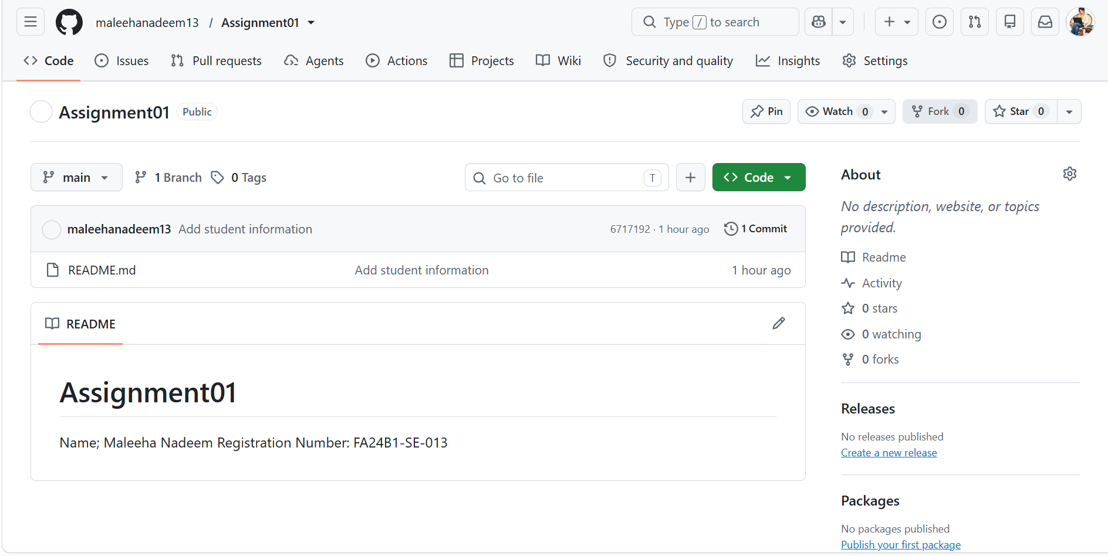

Step 2.3: Verify the GitHub Repository
Opened https://github.com/<my-github-username>/Assignment01 and confirmed the repository owner is my GitHub account, the repository name is Assignment01, the repository is public, and the rendered README shows my full name and registration number.
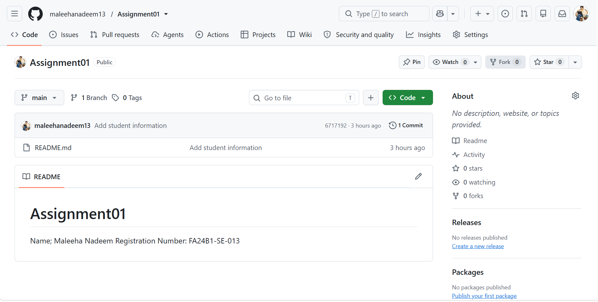

Task 3: Track Three Large Files with Git LFS

Step 3.1: Configure Git LFS
Initialized Git LFS, confirmed its version, and configured tracking for *.bin files. Verified the resulting rule in .gitattributes.
SCREENSHOT PENDING
File: task3_lfs_setup.png
Must show: successful git lfs install, the git lfs version, the git lfs track "*.bin" command, and the *.bin rule in .gitattributes.

Step 3.2: Create and Verify Three LFS Files
Created three files each larger than 100 MiB (large-file-1.bin, large-file-2.bin, large-file-3.bin) using truncate, staged .gitattributes and the three files, and verified they are tracked by Git LFS with their sizes.
SCREENSHOT PENDING
File: task3_lfs_files.png
Must show: output of git lfs ls-files --size listing all three files, each larger than 100 MiB.

Step 3.3: Commit and Push the LFS Files
Committed the three LFS-tracked files and pushed them to the GitHub Assignment01 repository.
SCREENSHOT PENDING
File: task3_lfs_push.png
Must show: the LFS object upload completing successfully (ideally 100% (3/3)) during git push github main.

Task 4: Create a Portfolio or CV with GitHub Pages

Step 4.1: Create and Push the Portfolio Repository
Created a public GitHub repository named <my-github-username>.github.io containing index.html and styles.css, with About Me, Education, Skills, and Projects sections. Committed and pushed the source files to the main branch.
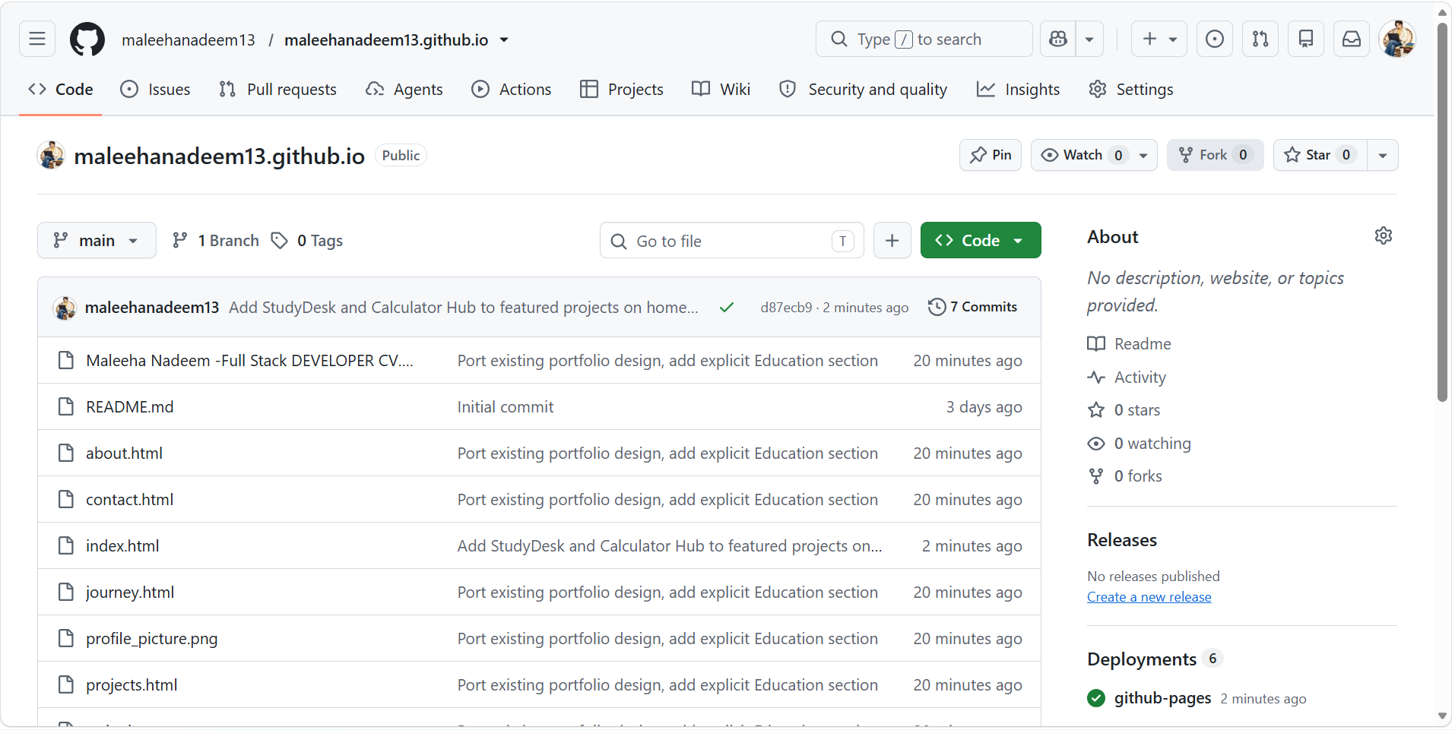

Step 4.2: Publish with GitHub Pages
In repository Settings > Pages, selected Deploy from a branch, chose the main branch and /(root) folder, saved, and waited for GitHub to report the site as published/live.
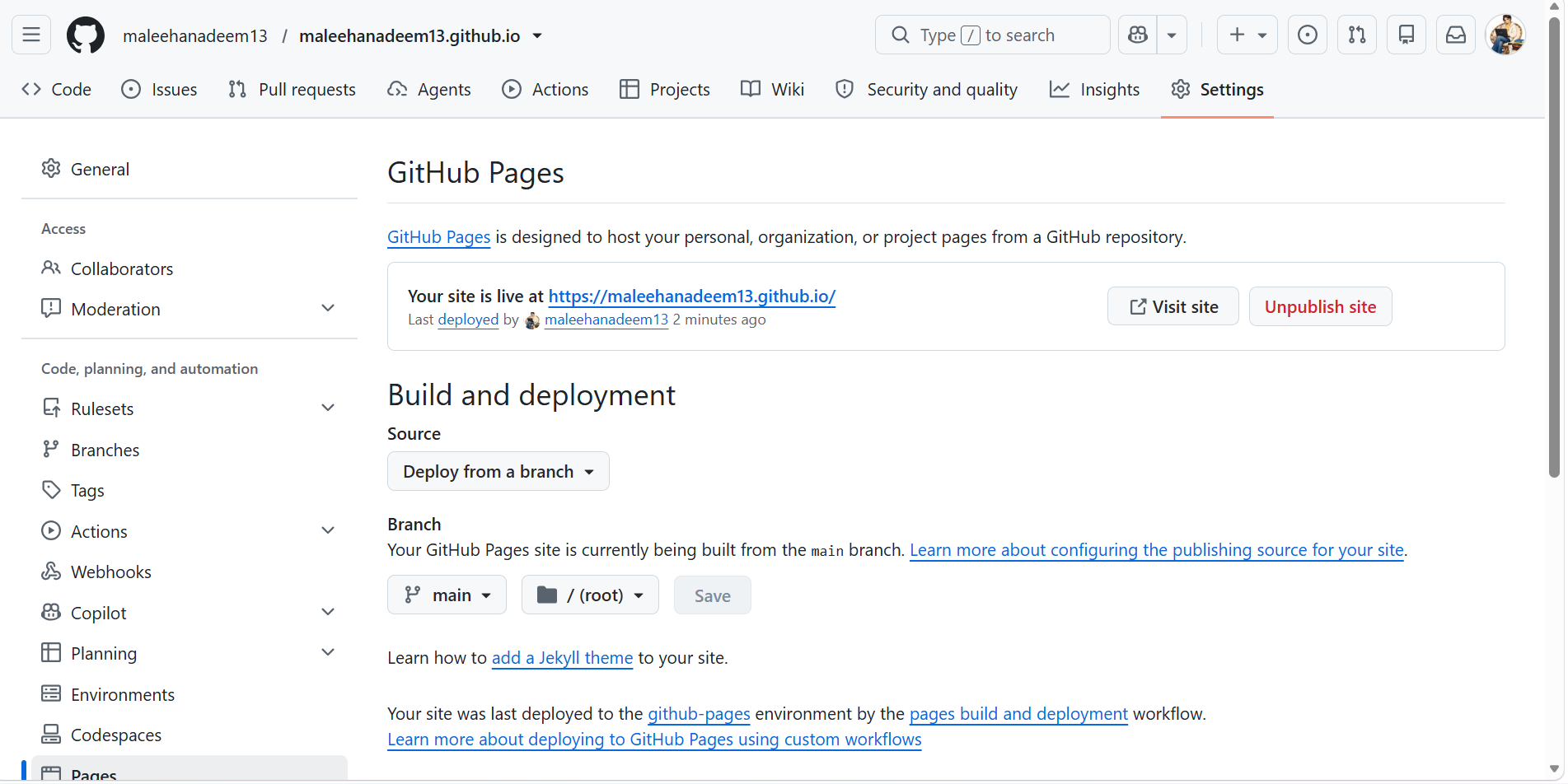

Step 4.3: Verify the Live Portfolio
Opened https://<my-github-username>.github.io/ and confirmed the site loads successfully with the portfolio content visible.
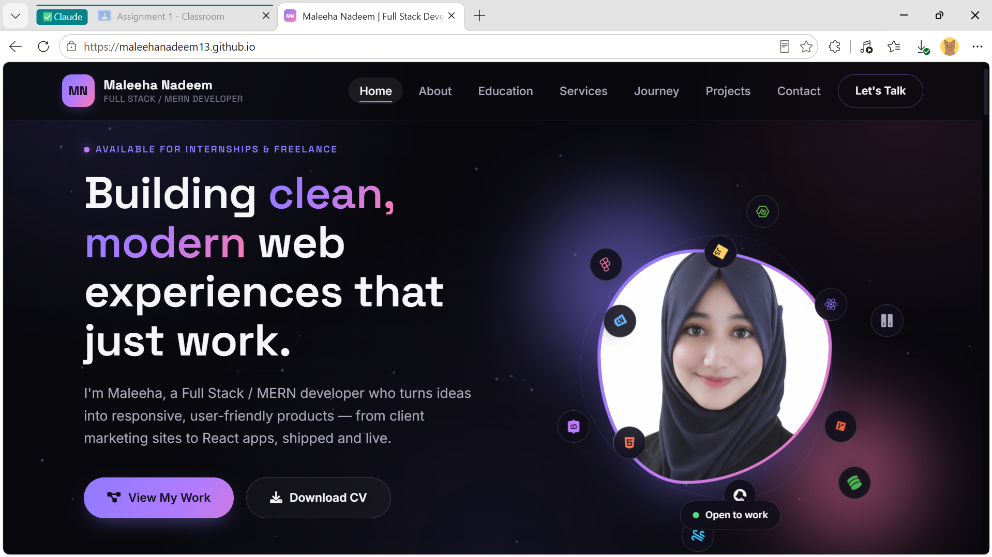

Assignment Summary
- Installed and ran a Gitea service on an Ubuntu server.
- Performed Git work from an Ubuntu server with my GitHub identity visible.
- Pushed the same local repository to Gitea and GitHub using two remotes.
- Configured Git LFS and pushed three large files.
- Created and published a portfolio/CV with GitHub Pages.
- Prepared this Word solution and exported it as a readable PDF.

Links
Gitea repository: http://192.168.148.128:3000/maleehanadeem13/Assignment01
GitHub Assignment01 repository: https://github.com/maleehanadeem13/Assignment01
Portfolio (GitHub Pages): https://maleehanadeem13.github.io/

Final Submission Checklist
- I completed the assignment individually.
- Assignment01.md is inside CC/Assignments/Assignment01/.
- Assignment01_Solution.docx is inside CC/Assignments/Assignment01/ and opens correctly.
- Assignment01_Solution.pdf is inside CC/Assignments/Assignment01/, matches the Word solution, and opens correctly.
- My CC repository contains Assignments/Assignment01/screenshots/.
- All 12 required screenshots are present and readable.
- Every screenshot was captured immediately after the requested step.
- Every screenshot was created from my own work.
- My GitHub username is visible in every Ubuntu server terminal screenshot.
- Every terminal screenshot shows the required command and its relevant result.
- Every browser screenshot shows the required repository, URL, page, or status.
- No screenshot contains a token, password, private key, or other credential.
- My CC, GitHub Assignment01, and <username>.github.io repositories are public.
- My Gitea Assignment01 repository was created and pushed from the Ubuntu server.
- All repositories use the main branch.
- I pushed the complete Assignments/Assignment01 directory before the deadline.
- I uploaded all three required assignment files to Google Classroom.
- I submitted the three required links on Google Classroom.

