JAVA INSTITUTE FOR ADVANCED TECHNOLOGY
Unit HF2J | Assessment Submission
WEB APPLICATION DEVELOPMENT
PROJECT REPORT
Project
SkillHub Academy Training Management Portal
Unit
HF2J – Web Component Development I
Student name | Kothalawala Liyanage Maleesha Pramud
Student ID | 2023/2024/CO/SE/I12/0837
Batch | 2023/2024/CO/SE/Intake12 (ATHENA UNI)
Submission date | 20/10/2026
Institution | Java Institute for Advanced Technology
Technology | Java EE (Servlet 4.0, JSP 2.3, JSTL 1.2) on Apache Tomcat 9

Table of Contents
1. Introduction 3
2. Requirements Analysis 3
3. Application Planning 4
4. Application Architecture 5
5. Web Application Structure 7
6. Servlet Development 7
7. JSP Development 8
8. Web Container Features 10
9. Session Management 11
10. Security Implementation 12
11. Deployment and Testing 13
12. Operational Maintenance and Future Scope 14
13. Conclusion 15
Appendix A: Complete web.xml Deployment Descriptor 16
Appendix B: Core Servlet, Listener and Filter Source Code 20
Appendix C: User Interface Screenshots 25

List of Figures
Figure 1: Layered (MVC) architecture of the SkillHub portal
Figure 2: Request processing cycle
Figures C1 to C23: Screenshots of the running application (Appendix C)

1. Introduction

1.1 Background of SkillHub Training Academy
SkillHub Training Academy is a training centre in Colombo, Sri Lanka. It runs short professional courses in four areas: Technology, Business, Professional Development and Languages. Classes are held on weekdays and weekends at different locations. Every course has one trainer, a fixed number of seats, a schedule and a fee. Three groups of people use the academy: administrators who manage it, trainers who teach, and students who learn.

1.2 Problems with the manual workflow
In the project scenario, the academy handles its work with paper forms and shared spreadsheets. This causes the following problems:
- Slow and error-prone registration. Student details are copied by hand into files, so spelling mistakes and duplicate records are common.
- No live seat count. Staff cannot see quickly whether a course is full, so a course can be over-booked.
- Attendance on paper. Sheets get lost or are filled in late, and it is hard to calculate an attendance percentage for each student.
- Poor visibility for trainers. Trainers must ask the office for class lists and attendance history.
- No access control. Anyone who can open the shared file can read or change any record.
- Slow reporting. Enrolment numbers, course utilisation and expected fees have to be counted by hand.

1.3 Proposed Java EE solution
This project replaces the manual process with a web portal built using Java EE technologies: Servlet 4.0, JSP 2.3 and JSTL 1.2, running on Apache Tomcat 9. The portal follows the Model-View-Controller (MVC) pattern. Servlets and filters are the controllers, JSP pages are the views, and plain Java classes with an in-memory store are the model. As the assessment requires, no database or JDBC is used. All data is kept in thread-safe Java collections that live in the ServletContext.
The high-level deliverables are listed below.
Deliverable | Quantity | Details
Deployable archive | 1 | skillhub.war (about 468 KB, includes the JSTL jar)
Servlets | 14 (+1 abstract) | Login, Logout, Register, Dashboard, Course, Enrolment, Attendance, AttendanceMark, Profile, AdminStudent, AdminTrainer, AdminUser, AdminSettings, AdminReport; AbstractPeopleServlet is the shared base class
JSP pages | 15 + index.jsp | Views under WEB-INF/jsp, plus 5 shared fragments (.jspf)
Filters | 5 | Encoding, SecurityHeaders, Authentication, Authorization, Csrf
Listeners | 3 | AppContextListener, SessionTrackingListener, RequestStatsListener
Model and store | 5 + 1 | User, Role, Course, Enrolment, Attendance and InMemoryStore
Deployment descriptor | 1 | web.xml (Servlet 4.0): servlets, filters, listeners, session, JSP, security, error pages

2. Requirements Analysis

2.1 User personas
Persona | Goals | What the portal gives them
Administrator (demo: Nuwan Perera) | Run the academy: keep people, courses and enrolments correct, record attendance, see how the academy is doing. | Full menu: students, trainers, courses, enrolments, take attendance, reports, user accounts, settings.
Trainer (demo: Dilani Fernando) | Know which courses they teach and how well students attend. | Dashboard with assigned courses and students, attendance records for their own courses only.
Student (demo: Kasun Rajapaksha) | Register, find a suitable course, enrol, and check own attendance. | Self-registration, course catalogue with one-click enrolment, own enrolments and attendance, profile.

2.2 Functional requirements
ID | Requirement | Actor
FR1 | Authenticate with username and password; show a clear message for wrong details. | All
FR2 | Sign out and end the session safely. | All
FR3 | Register a new student account with server-side validation (name, username, email, phone, password rules). | Student
FR4 | View the course catalogue. Trainers see only their own courses; students see active courses and their enrolment state. | All
FR5 | Add, edit, activate and deactivate courses (code, title, category, trainer, weeks, capacity, fee, schedule). | Admin
FR6 | Enrol in a course. The system must reject duplicates and full courses. Admin can enrol any student. | Student, Admin
FR7 | Mark attendance (Present, Late, Absent) for each enrolled student for a course and date. | Admin
FR8 | View attendance records and rates: own records (student), assigned courses (trainer), all courses (admin). | All
FR9 | Manage students (add, edit, activate, delete) and trainers (add, edit, activate). | Admin
FR10 | Manage user accounts (activate or deactivate, reset password) and change application settings. | Admin
FR11 | Update own profile and change own password. | All
FR12 | View reports: course utilisation, attendance, expected fees, activity log, system information, CSV export. | Admin

2.3 Non-functional requirements
Area | Requirement
Concurrency | Many users share the same data. All shared collections must be thread-safe, and rules such as "no over-booking" must hold under parallel requests.
Security | Every page except login and registration needs a signed-in user. Roles are enforced on the server. Passwords are hashed. Forms are protected against CSRF and XSS.
Responsiveness | The interface uses Bootstrap 5 and works on desktop, tablet and phone widths. The sidebar becomes an off-canvas menu on small screens.
Usability | Clear messages after every action, client-side hints on forms, and the same layout on every page.
Maintainability | Clear package structure (filter, listener, model, servlet, store, util) and one place for data access (InMemoryStore).
Portability | A standard WAR that runs on Apache Tomcat 9 (Java EE 8 javax.* namespace), compiled for Java 11.

2.4 Assumptions and constraints
- No DBMS and no JDBC. All data is volatile and stored in memory. It is lost when Tomcat restarts, and demo data is loaded again at start-up.
- Session lifetime is 20 minutes of inactivity (set in web.xml). Sessions are also held in memory on one Tomcat node.
- Only students can register themselves. Trainers and administrators are created by an administrator or by the seed data.
- Browsers can reach the Bootstrap CDN and Google Fonts. The Content-Security-Policy allows only these two external sources.
- The portal targets Tomcat 9. Tomcat 10 and later use the jakarta.* namespace and would need a code migration.

3. Application Planning

3.1 Purpose and scope
Purpose. The portal gives SkillHub Training Academy one secure place to manage students, trainers, courses, enrolments and attendance, so that the manual spreadsheets and paper sheets are no longer needed.
In scope: authentication, role-based dashboards, student registration, course catalogue, enrolment with seat control, attendance marking and reporting, user and settings administration, session tracking, and a security layer. Out of scope: persistent storage, online payment, email or SMS notifications, and enrolment cancellation (listed in Section 12 as future work).

3.2 Specific and measurable objectives
# | Objective | How it is measured
O1 | Protect all non-public URLs with login and role checks. | Only /login, /register, the welcome page and /assets/* are reachable without a session (tests TC15, TC12 to TC14).
O2 | Let a student register and enrol without help from staff. | Registration is one form; enrolment is one click on the course card (TC06, TC08).
O3 | Never over-book a course or enrol a student twice. | enrol() is synchronized and checks duplicates and capacity before saving (TC09).
O4 | Record attendance for a whole class in one submission. | One form saves all students for one course and date (TC10).
O5 | Keep shared data correct under parallel requests. | ConcurrentHashMap collections and synchronized write methods (Section 12).
O6 | Deliver as one small, standard WAR. | skillhub.war is about 468 KB and deploys by copying into webapps (TC24).

3.3 Expected benefits
Type | Benefit for SkillHub Academy
Quantitative (expected) | Enrolment becomes a single click for the student instead of a paper form handled by two staff members. Attendance for a whole class is saved with one submission. Seat usage and attendance percentages are calculated automatically for every course (8 courses and 18 enrolments in the demo data).
Quantitative (measured) | Deployment package of 468 KB; 24 functional tests passed; page-view and request counters are collected by listeners without extra code in each servlet.
Qualitative | Fewer data-entry mistakes, trainers see their own information without calling the office, clear audit trail in the activity log, role-based privacy, and a modern interface that works on phones.

4. Application Architecture

4.1 Multi-tier MVC design
The portal uses a layered Java EE MVC design. Figure 1 shows the three tiers inside the Tomcat web container.
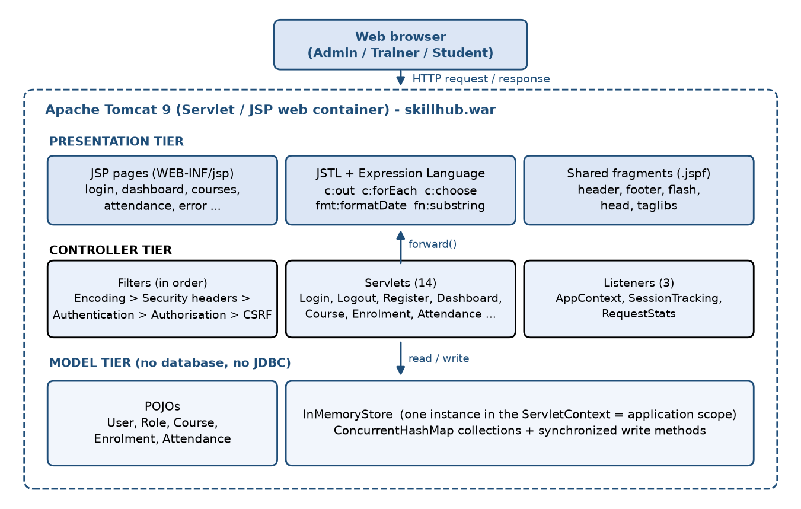
Figure 1: Layered (MVC) architecture of the SkillHub portal
Key principle: controllers never write HTML, JSP pages never contain Java code, and only the store touches application data. Each tier can change without breaking the others.

Presentation tier
JSP pages live in WEB-INF/jsp, so a browser cannot open them directly. They use JSTL (c:out, c:forEach, c:choose, fmt:formatDate, fn:substring) and the Expression Language (for example ${currentUser.fullName} or ${sessionScope.csrfToken}). The deployment descriptor sets scripting-invalid to true, so scriptlets are not allowed. Common parts (header with the sidebar, footer, flash messages) are shared fragments.

Controller tier
Fourteen servlets handle requests. Five filters run before them in a fixed order: encoding, security headers, authentication, authorisation and CSRF. Three listeners watch the application, session and request life cycles.

Model tier
Plain Old Java Objects (User, Role, Course, Enrolment, Attendance) hold the data. InMemoryStore keeps them in ConcurrentHashMap collections. One store object is created at start-up and saved in the ServletContext, so all users share it.

4.2 Request processing cycle and data flow
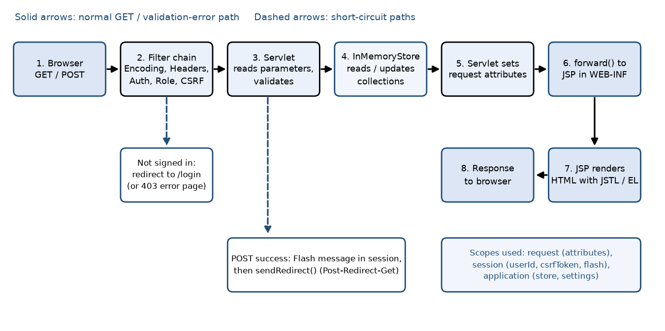
Figure 2: Request processing cycle
Every request follows the same path. As an example, when a student presses Enrol on a course card:
- The browser sends POST /skillhub/enrolments with the course id and the hidden _csrf token.
- The filters run in order. AuthenticationFilter finds the user from the session, AuthorizationFilter checks the role (admin or student), and CsrfFilter compares the token with the one in the session.
- EnrolmentServlet.doPost takes the student id from the session (not from the form), then calls store.enrol().
- InMemoryStore.enrol() checks the student, the course, duplicates and free seats, and then saves the enrolment inside a synchronized method.
- The servlet stores a flash message in the session and answers with sendRedirect("/enrolments") (Post-Redirect-Get).
- The browser makes a new GET /enrolments. The servlet puts the list in request scope and forwards to enrolments.jsp, which shows the message once and removes it.

5. Web Application Structure

5.1 Project directory structure
The project is a Maven web project (packaging = war). Source code is under src/main/java, and web resources are under src/main/webapp.
skillhub-portal/
|-- pom.xml Maven build (war packaging, Java 11, JSTL 1.2)
|-- README.md, PROJECT.md, LICENSE
`-- src/main
|-- java/com/skillhub
| |-- filter/ EncodingFilter, SecurityHeadersFilter, AuthenticationFilter,
| | AuthorizationFilter, CsrfFilter
| |-- listener/ AppContextListener, SessionTrackingListener, RequestStatsListener
| |-- model/ User, Role, Course, Enrolment, Attendance (POJOs)
| |-- servlet/ Login, Logout, Register, Dashboard, Course, Enrolment, Attendance,
| | AttendanceMark, Profile, AbstractPeople, AdminStudent, AdminTrainer,
| | AdminUser, AdminSettings, AdminReport
| |-- store/ InMemoryStore (all data)
| `-- util/ WebUtil, Flash, Validation, PasswordUtil
`-- webapp
|-- index.jsp welcome page (redirects to /dashboard)
|-- assets/css/style.css, assets/js/app.js
`-- WEB-INF
|-- web.xml deployment descriptor
|-- jsp/ login, register, dashboard, courses, course-form, enrolments,
| attendance, attendance-mark, people, person-form, users,
| settings, reports, profile, error (15 views)
`-- jspf/ taglibs, head, header, footer, flash (shared fragments)

5.2 Deployment architecture and runtime environment
Maven builds target/skillhub.war. The WAR contains the compiled classes in WEB-INF/classes, the JSTL library in WEB-INF/lib, the JSP views and the static assets. The Servlet and JSP APIs are marked provided because Tomcat supplies them.
Layer | Technology
Client | Any modern browser (tested with Chrome); Bootstrap 5.3 and Bootstrap Icons from a CDN
Web container | Apache Tomcat 9.0.x, HTTP connector on port 8080, application context /skillhub
Java runtime | JDK 11 or newer (compiled with --release 11)
Application | skillhub.war: servlets, filters, listeners, JSPs, JSTL 1.2
Data | JVM heap only: InMemoryStore inside the ServletContext (no database)

6. Servlet Development
All servlets extend HttpServlet and are declared in web.xml. They share a small helper class, WebUtil, which gets the store, reads the signed-in user, trims and converts parameters, forwards to a view and redirects. The use cases in the brief map to these classes: login to LoginServlet, logout to LogoutServlet, student registration to RegisterServlet, course enrolment to EnrolmentServlet, attendance to AttendanceServlet and AttendanceMarkServlet, and trainer management to AdminTrainerServlet.

6.1 Core servlets
Servlet and URL | Methods | Parameters and validation | Execution flow
LoginServlet /login | doGet, doPost | username, password. Both must be non-blank. The account must not be locked. | GET shows the form (or goes to the dashboard if signed in). POST checks lock-out, calls store.authenticate(), records failures, then changeSessionId(), saves userId and loginTime in the session and redirects to the saved target or /dashboard.
LogoutServlet /logout | doPost (doGet redirects) | Only _csrf token (POST only, so a link cannot sign a user out). | Calls session.invalidate(), creates a new session that carries only the "signed out" message, and redirects to /login.
RegisterServlet /register | doGet, doPost | fullName 3-60 chars; username 4-20 chars (letters, digits, . _ -) and unique; valid email; optional phone; password 8+ chars with a letter and a digit, and matching confirm. | Refuses if registration is closed in settings. Collects all errors in a list. On errors it forwards back to the form with the typed values. On success it hashes the password, saves a STUDENT and redirects to login.
EnrolmentServlet /enrolments | doGet, doPost | courseId; studentId only for admins. A student's id always comes from the session. | GET lists enrolments (all for admin, own for student). POST calls store.enrol(), which returns an error text or null, then flashes the result and redirects.
AttendanceMarkServlet /attendance/mark | doGet, doPost | courseId, date (yyyy-MM-dd; future or invalid dates become today), status_<studentId> = PRESENT, LATE or ABSENT. | GET builds the sheet from active enrolments and existing marks. POST accepts only the three valid statuses for enrolled students and calls store.markAttendance() (replaces any mark for the same student, course and date).
AttendanceServlet /attendance | doGet | Optional courseId, which must be one of the courses this user may view, otherwise 403. | Builds the list of allowed courses by role, collects records, and calculates present, late and absent totals, the attendance rate and a per-student report.
AdminTrainerServlet /admin/trainers (and AdminStudentServlet) | doGet, doPost (in AbstractPeopleServlet) | action = new, edit, toggle or delete; person fields validated like registration. Trainers cannot be deleted; students can. | One abstract class handles list, add, edit, activate and delete. The two subclasses only say which role, which URL and whether delete is allowed.

6.2 Supporting servlets
Servlet and URL | Purpose and main logic
DashboardServlet /dashboard | Builds different data for each role: totals and seat utilisation for admin; assigned courses, student count and recent attendance for trainer; own enrolments and rate for student. Then forwards to dashboard.jsp.
CourseServlet /courses | GET lists courses for the role or shows the add/edit form (admin only). POST validates nine fields (code pattern, unique code, category, trainer, weeks 1-52, capacity 1-500 and not below current enrolments, fee, schedule, description length) and toggles active state.
ProfileServlet /profile | Updates name, email and phone, or changes the password after checking the current one. It also puts session information (id, creation and last access time, timeout) in request scope for display.
AdminUserServlet /admin/users | Activates or deactivates accounts (not the admin's own) and resets a password to a random temporary one that is shown once.
AdminSettingsServlet /admin/settings | Validates and writes academy name, support email, default capacity and the registration switch to application scope.
AdminReportServlet /admin/reports | Calculates utilisation, attendance and expected fees per course, shows the activity log and system information, and exports enrolments as CSV with formula-injection protection.

Common servlet rules used in every class: read parameters with WebUtil.trim / toInt, validate on the server even if the browser already checked, never build HTML in Java, use sendError for 403 and 404, and use Post-Redirect-Get after every successful POST.

7. JSP Development
Every page follows the same pattern: set the page title and active menu item with c:set, include header.jspf (document head, sidebar and flash message), write the page content, then include footer.jspf. A jsp-property-group in web.xml loads taglibs.jspf automatically (so c:, fmt: and fn: are always available), sets UTF-8 and turns scripting off. All screenshots are in Appendix C.

7.1 Page walkthrough
JSP page | UI and form binding | Dynamic content (EL / JSTL) | User feedback
index.jsp | Welcome file. | c:redirect to /dashboard. | Unauthenticated users are sent on to the login page by the filter.
login.jsp | Username and password with a show/hide button. The form posts to /login with the hidden _csrf field. | ${applicationScope.academyName}, c:out on the typed username, c:if for the error and the registration link. | Bootstrap validation hints, error banner (C2), sign-out and sign-in-required messages (C20, C21).
register.jsp | Full name, username, phone, email, password, confirm. Fields keep their values after an error (${formUser.fullName}). | c:forEach over errors; c:out on every value. | A list of problems from the server (C12) and a success banner on the login page (C13).
dashboard.jsp | No form. Admin, trainer and student blocks inside one c:choose. | ${currentUser.admin}, stat cards from request attributes, fmt:formatDate, progress bars from seat counts. | Welcome flash message; empty-state text when a student has no courses (C3, C14, C19).
courses.jsp | Search box (JavaScript filter). Each card has an Enrol form (student) or Edit / Deactivate (admin). | c:forEach over courses; userNames[c.trainerId] map lookup; fmt:formatNumber for the fee; enrolledIds.contains(c.id). | Badges: Enrolled, Course full, Inactive. Confirm dialog before enrol (C4, C15).
attendance-mark.jsp | Course and date selector (GET), then one POST form with radio buttons status_<id> for each student and All present / All absent buttons. | c:forEach over students; existing[s.id] pre-selects saved marks; ${sessionDate}. | Coloured toggle buttons (C8); success message and updated report (C9).
attendance.jsp | Course filter (auto-submit). Read-only report. | Counters from request attributes; tables built with c:forEach. | Present, Late, Absent and rate cards; empty-state text.
error.jsp | No form. isErrorPage="true". | ${requestScope['javax.servlet.error.status_code']} with c:choose for 403, 404, 400/405 and the rest. | Friendly text without technical details (C22, C23).

Other views follow the same pattern: enrolments.jsp (admin enrol form and list), course-form.jsp, people.jsp and person-form.jsp (students and trainers), users.jsp, settings.jsp, reports.jsp and profile.jsp.

7.2 Output safety and user feedback
- Escaping. Every value that comes from a user or from the store is printed with c:out, which converts < and > into entities. Where EL is used inside an attribute (data-confirm), fn:escapeXml is used.
- Flash messages. flash.jspf shows the message stored in session scope and then removes it with c:remove, so it appears only once.
- Client and server validation. Forms use the Bootstrap was-validated pattern for quick hints (app.js), but the servlets always validate again.
- No inline scripts. All behaviour is in app.js, which allows a strict Content-Security-Policy.

8. Web Container Features

8.1 Scopes
The application uses the three required Java EE scopes. Page scope (c:set) is used only for small values such as the page title.
Scope | Container object | What is stored | Lifetime
Application | ServletContext | store (all data), academyName, supportEmail, defaultCapacity, registrationOpen, startedAt, activeSessions, totalRequests | From start-up until the web app stops. Shared by every user.
Session | HttpSession | userId, loginTime, csrfToken, pageViews, lastPage, postLoginTarget, flash message and type | From first visit until logout or 20 minutes of inactivity. One per browser.
Request | HttpServletRequest | currentUser, lists to display (courses, records), lookup maps (userNames, courseMap), errors, formUser | One request, including a forward. Gone after the response.

Design rule: put shared, long-lived data in application scope, identity and one-time messages in session scope, and anything the next page needs to display in request scope.

8.2 RequestDispatcher: forward, include and redirect
Mechanism | Where it is used | Behaviour
RequestDispatcher.forward() | WebUtil.render() after every GET and after validation errors | Server-side hand-over to a JSP in WEB-INF. Same request, so request attributes survive. The URL in the browser does not change.
response.sendRedirect() | WebUtil.redirect() after every successful POST, and in the filters | Browser makes a new request. Request attributes are lost, so a flash message in the session is used. This prevents duplicate form submission on refresh.
Include | <%@ include file="...jspf" %> in every page | Static include at translation time that merges header, footer and flash fragments into each JSP. (The project uses the include directive instead of RequestDispatcher.include().)

public static void render(HttpServletRequest req, HttpServletResponse res, String view)
throws ServletException, IOException {
attachLookups(req); // request-scope helper maps
RequestDispatcher rd = req.getRequestDispatcher("/WEB-INF/jsp/" + view + ".jsp");
rd.forward(req, res); // forward: same request, same URL
}

public static void redirect(HttpServletRequest req, HttpServletResponse res, String path)
throws IOException {
String url = req.getContextPath() + path;
res.sendRedirect(res.encodeRedirectURL(url)); // redirect: a brand new request
}

8.3 Listeners and life-cycle hooks
Listener | Interface | Hook | Role
AppContextListener | ServletContextListener | contextInitialized | Creates InMemoryStore, calls seed() to load 10 users, 8 courses, 18 enrolments and sample attendance; reads the four context-params from web.xml; creates the counters and start time; writes a log line.
 |  | contextDestroyed | Logs that the app stopped and in-memory data is discarded.
SessionTrackingListener | HttpSessionListener, HttpSessionAttributeListener | sessionCreated, sessionDestroyed | Increases and decreases activeSessions inside synchronized (ctx).
 |  | attributeAdded, attributeRemoved | When userId is added or removed, writes "signed in" or "signed out" to the activity log with the user's name and role.
RequestStatsListener | ServletRequestListener | requestInitialized | Counts every HTTP request in totalRequests for the admin report.

8.4 Filter chain and context parameters
Filters are mapped to /* and run in the order of their mappings in web.xml: EncodingFilter (UTF-8 from an init-param), SecurityHeadersFilter (CSP, X-Frame-Options and no-store caching), AuthenticationFilter (login required), AuthorizationFilter (role rules) and CsrfFilter (token check on POST). The four context-param values (academyName, supportEmail, defaultCapacity, registrationOpen) are read once by the listener, and the admin can change them later on the Settings page.

9. Session Management

9.1 Session tracking mechanics
HTTP is stateless, so the container gives every browser an HttpSession and identifies it with a session-id cookie. In web.xml the cookie is renamed to SKILLHUBSESSION and marked HttpOnly, so JavaScript cannot read it. The tracking mode is set to COOKIE only. This disables URL rewriting (;jsessionid=...), so a session id can never leak through the address bar, browser history, server logs or the Referer header. The code still calls encodeRedirectURL() as a safe habit, but with cookie-only tracking it adds nothing. The cookie header seen in testing was:
Set-Cookie: SKILLHUBSESSION=54DAAEC72FD2818237A28BDF451B2581; Path=/skillhub; HttpOnly

9.2 Session life cycle in SkillHub
Stage | What happens | Code
Creation | The first request creates a session, because CsrfFilter calls getSession(true) to store the CSRF token. SessionTrackingListener increases the active-session counter. | CsrfFilter, SessionTrackingListener
Login | After the password is verified, request.changeSessionId() gives a new id (prevents session fixation). The old CSRF token is removed, and userId and loginTime are saved. Only the user id is stored, not the whole User object. | LoginServlet
Access validation | On every request AuthenticationFilter reads userId, loads the user from the store, and rejects the request if the user is missing or deactivated. Because the user is loaded again each time, an admin who deactivates an account takes effect at once. | AuthenticationFilter
Tracking | The same filter updates pageViews and lastPage. The profile page shows the session id (first 8 characters), sign-in time, last activity, pages viewed and timeout. | AuthenticationFilter, ProfileServlet
Timeout | <session-timeout>20</session-timeout> in web.xml. After 20 minutes without a request Tomcat destroys the session, the counter goes down, and the next request is redirected to login. | web.xml
Logout | session.invalidate() removes all data. A new session is created only to carry the "signed out" message. The old session id no longer works. | LogoutServlet

Evidence from testing. The session id before login was 07CB58FD... and after login 54DAAEC7... (test TC18). After logout, sending the old cookie to /dashboard returned a redirect to /login (TC19). The 20-minute value is visible on the profile page (Figure C18).
Store the least possible in the session: an id, not an object. The server stays the single source of truth for who the user is and whether the account is active.

10. Security Implementation

10.1 Authentication
Authentication is done by LoginServlet and InMemoryStore.authenticate(), and enforced on every request by AuthenticationFilter. Only /login, /register, /, /index.jsp and /assets/* are public.
- Password storage. Passwords are hashed with PBKDF2WithHmacSHA256 (65,536 iterations, 256-bit key) and a random 16-byte salt for each user. The stored value is salt:hash, and plain passwords are never kept.
- Safe comparison. MessageDigest.isEqual compares hashes in constant time. For an unknown username a dummy hash is checked, so the response time does not show whether the user exists.
- Generic error. The message is always "Invalid username or password", and deactivated users get the same message.
- Brute-force control. After 5 failed attempts the username is locked for 5 minutes, even if the next password is correct (TC04). Failed attempts are written to the activity log.
- Password rules. At least 8 characters with a letter and a digit, checked on registration, profile change and admin forms.

10.2 Authorisation (role-based access control)
AuthorizationFilter runs after authentication and holds a small rule table. Denied requests receive HTTP 403 and an "ACCESS DENIED" line in the activity log.
URL rule | Allowed roles
/admin/* (students, trainers, users, settings, reports) | ADMIN
/attendance/mark | ADMIN
/enrolments | ADMIN, STUDENT
All other signed-in URLs | Every role (data is then limited inside the servlet)

Defence in depth. Servlets repeat important checks so that one mistake in a filter rule is not enough to break security. CourseServlet.doPost rejects non-admins, AttendanceServlet returns 403 if the course is not one the user may view, and EnrolmentServlet takes the student id from the session so a student cannot enrol someone else by editing the form.

10.3 Input handling, direct URL access and error masking
Threat | Control | Where
Cross-site scripting (XSS) | c:out on all output; Content-Security-Policy default-src 'self' with only the CDN allowed; no inline scripts (TC21). | JSPs, SecurityHeadersFilter
Cross-site request forgery | Random 24-byte token per session, required as _csrf on every POST and compared in constant time (TC17). | CsrfFilter, forms
Session fixation and hijacking | New session id at login; HttpOnly cookie; cookie-only tracking; no-store caching so Back does not show private pages after logout. | LoginServlet, web.xml, SecurityHeadersFilter
Invalid or malicious input | Server-side validation with regular expressions and length limits; numeric parsing with defaults; only three attendance statuses accepted. | Validation, servlets
Direct URL access | Login required for all URLs; JSPs hidden under WEB-INF so a direct request returns 404 (TC16); forms redirect to login with a clear message (TC15). | Filters, WEB-INF
Unwanted HTTP methods | security-constraint with an empty auth-constraint blocks everything except GET, POST and HEAD (TC20). | web.xml
Log and CSV injection | Line breaks are removed from log messages; CSV cells starting with = + - @ are prefixed with a quote. | InMemoryStore.log, AdminReportServlet
Information leakage | error-page entries for 400, 403, 404, 405, 500 and Throwable show a friendly error.jsp without stack traces or server details. | web.xml, error.jsp

Never trust the client. Check identity, role, token and input again on the server for every request.

11. Deployment and Testing

11.1 WAR generation and deployment procedure
- Install JDK 11 or newer and Apache Tomcat 9.0.x (not Tomcat 10 or later). Set JAVA_HOME and CATALINA_HOME.
- Open a terminal in the folder that contains pom.xml and run mvn clean package. Maven compiles the code for Java 11 and creates target/skillhub.war.
- Copy the file into Tomcat: cp target/skillhub.war $CATALINA_HOME/webapps/ (Windows: copy target\skillhub.war %CATALINA_HOME%\webapps\).
- Start Tomcat with bin/startup.sh or bin/startup.bat. Tomcat unpacks the WAR, starts the context, and AppContextListener loads the demo data.
- Open http://localhost:8080/skillhub/ and sign in with a demo account, for example administrator nuwan.
- In IntelliJ IDEA the same result is reached with a Tomcat 9 run configuration and the artifact skillhub-portal:war exploded.

Test environment. Windows 11, JDK 22 running Tomcat (code compiled with --release 11), Apache Tomcat 9.0.122, Google Chrome and curl. Maven was not installed on the test machine, so the same source files were compiled with javac and packaged with the jar tool using the same WAR layout that Maven produces. The 468 KB skillhub.war was copied into the webapps folder of a clean Tomcat instance (TC24). A second run used the unpacked folder for the interactive browser tests. Tests were run on 20/10/2026.

11.2 Functional test matrix
ID | Functionality tested | Input data | Expected outcome | Actual outcome | Result
TC01 | Admin login | nuwan with the correct password | Dashboard with welcome message and admin menu | "Welcome back, Nuwan Perera!" and full admin sidebar (C3) | Pass
TC02 | Login, wrong password | nuwan with a wrong password | Stay on login with a generic error | "Invalid username or password." (C2) | Pass
TC03 | Login, empty fields | Blank username and password (POST) | Message asks for both fields | "Please enter both your username and password." | Pass
TC04 | Account lock-out | 5 wrong passwords, then the right one | 6th attempt blocked | "Too many failed attempts. Please wait 5 minutes..." even with the right password | Pass
TC05 | Registration validation | Username kasun (taken); password abcdefgh | Two errors; typed values kept | "That username is already taken." and "Password must contain at least one letter and one number." (C12) | Pass
TC06 | Student registration | Valid details, username amal.s | Account saved; redirect to login | "Account created. You can now sign in." (C13) | Pass
TC07 | New student login | amal.s with the new password | Student dashboard and student menu only | 0 courses, 8 to explore; menu has Courses, Enrolments, Attendance, Profile (C14) | Pass
TC08 | Student enrols | Enrol button on JEE101 | Enrolment saved; seat count rises | "You are now enrolled in Java EE Web Development." (C16); seats 3/25 became 4/25 (C19) | Pass
TC09 | Duplicate enrolment | Enrol in JEE101 again | Rejected with a message | "Amal Silva is already enrolled in JEE101." (C17) | Pass
TC10 | Admin marks attendance | JEE101, today: Tharindu Absent, Sathyaa Late | Saved; report updated | "Attendance saved for JEE101 on 2026-10-20."; new LATE and ABSENT rows in the report (C9) | Pass
TC11 | Trainer dashboard | Login as dilani | Only own courses | 2 assigned courses; recent attendance shows the new marks (C19) | Pass
TC12 | Role check on URL | Student opens /admin/users | 403 error page | "403 Access denied" page (C23) | Pass
TC13 | Role check, mark page | Student requests /attendance/mark | 403 | HTTP 403 | Pass
TC14 | Role check in servlet | Student POSTs to /courses with a valid token | 403 | HTTP 403 | Pass
TC15 | Direct URL, signed out | Open /dashboard without a session | Redirect to login with message | Login page: "Please sign in to continue." (C21) | Pass
TC16 | Direct JSP access | Request /WEB-INF/jsp/dashboard.jsp | Not served | HTTP 404 "Page not found" (C22) | Pass
TC17 | CSRF protection | POST /enrolments with no token and with a wrong token | 403 | Both requests returned 403 | Pass
TC18 | Session id rotation | Cookie before and after login | New id after login | 07CB58FD... became 54DAAEC7... | Pass
TC19 | Logout | Sign out, then reuse the old cookie | Session invalid; redirect to login | Redirect to /login with "signed out" message (C20); old cookie also redirected | Pass
TC20 | Blocked HTTP methods | PUT, DELETE, OPTIONS, TRACE | Rejected | 403, 403, 403 and 405 | Pass
TC21 | XSS escaping | Username <script>alert(1)</script> | Shown as text, not run | Output encoded as &lt;script&gt;... | Pass
TC22 | Session timeout setting | Open My Profile | Shows 20 minutes | "Auto sign-out after 20 min idle" (C18). The 20-minute wait itself was not run. | Pass (setting)
TC23 | Reports and listeners | Admin opens Reports | Active sessions, request count, activity log | Active sessions 2, requests served 27, and log lines for sign-in, failed login and attendance (C10, C11) | Pass
TC24 | WAR deployment | skillhub.war in a clean Tomcat 9.0.122 webapps | Auto-deploy; listener runs | Log: "SkillHub portal initialised with demo data."; /login returned 200 | Pass

All 24 test cases passed. Reference numbers such as (C3) point to the screenshots in Appendix C.

12. Operational Maintenance and Future Scope

12.1 Concurrency and thread safety
A servlet container handles many requests on different threads, but all of them share one InMemoryStore. The store protects its data in two ways:
- Thread-safe collections. Users, courses, enrolments, attendance and failed-login counters are ConcurrentHashMap objects, so reads and single writes never corrupt the map.
- Synchronized compound operations. Steps that must happen together are in synchronized methods: saveUser, deleteUser, saveCourse, enrol, markAttendance, recordFailure and log. For example, enrol() checks duplicates, counts seats and inserts the record without another thread entering between these steps, so a course cannot be over-booked. The id counters are also incremented inside these methods.
- Shared counters. activeSessions and totalRequests are changed inside synchronized (ctx) blocks in the listeners.
public synchronized String enrol(int studentId, int courseId) {
User s = findUser(studentId);
Course c = findCourse(courseId);
if (s == null || s.getRole() != Role.STUDENT) return "The selected student was not found.";
if (c == null || !c.isActive()) return "The selected course is not available.";
if (isEnrolled(studentId, courseId)) // duplicate check
return s.getFullName() + " is already enrolled in " + c.getCode() + ".";
if (enrolledCount(courseId) >= c.getCapacity()) // seat check
return c.getCode() + " is full. No seats are available.";
Enrolment e = new Enrolment();
e.setId(++enrolSeq); // id counter, safe because synchronized
e.setStudentId(studentId);
e.setCourseId(courseId);
enrolments.put(e.getId(), e); // check + insert happen as one step
return null; // null means success
}

Known limits. The activity log is a plain ArrayList guarded by synchronized methods and limited to 100 lines. Entity objects such as User are mutable and shared, and simple edits (for example activating an account) are not locked. This is acceptable at this size but would need care at scale.

12.2 RAM usage and operation under in-memory persistence
All data lives on the JVM heap. The demo data (10 users, 8 courses, 18 enrolments and 45 attendance records) needs well under one megabyte. Attendance grows fastest. A rough estimate of 100 to 150 bytes per record (object and map entry) means that 1,000 students in 3 courses with 40 sessions each (120,000 records) would use about 12 to 18 MB, which is easy for a default Tomcat heap. Operations staff should remember:
- Restart means data loss. Every restart resets the portal to the seed data. This is by design for this assessment.
- Monitoring. The Reports page shows active sessions, requests served, uptime, Tomcat and Java versions, and the last 25 activity events. Set a safe heap limit with -Xmx if attendance history grows.

12.3 Scalability constraints
- One JVM only: data and sessions are not shared between servers, so a load balancer would need sticky sessions and still lose data on failure.
- Many store methods scan all values of a map (for example enrolledCount and markAttendance), which is O(n) and acceptable for hundreds of records but slow for very large data.
- No transactions across several collections, no history, no backup and no search index.

12.4 Migration path to an enterprise database
Step | Change | Why it is easy
1 | Extract an interface (DAO or repository) from the public methods of InMemoryStore. | Servlets already call only these methods through WebUtil.store().
2 | Map the POJOs to JPA entities (@Entity) and use PostgreSQL or MySQL with a connection pool (HikariCP or a Tomcat JNDI DataSource). | The model classes are plain POJOs with getters and setters.
3 | Replace synchronized blocks with database transactions and unique constraints (username, course code, student and course pair). | The same rules (duplicate, capacity) already exist as methods.
4 | Keep sessions in Redis or Tomcat's persistent session manager; add a distributed cache for the course catalogue. | The session holds only the user id.
5 | Move to Jakarta EE 10 (jakarta.*) and Tomcat 10+, add email notifications, enrolment cancellation, trainer-side attendance, and JUnit and Selenium tests. | Listed in the project roadmap.

13. Conclusion
The SkillHub Academy Training Management Portal meets the aims of the assessment and the objectives in Section 3. It is a complete Java EE web application with 14 servlets, 15 JSP views, 5 filters and 3 listeners, packaged as one 468 KB WAR that deploys on Apache Tomcat 9 by copying a file.
Objective | Outcome
O1 Protect non-public URLs | Achieved. Authentication and authorisation filters, servlet-level checks and hidden JSPs were all tested (TC12 to TC16).
O2 Self-service registration and enrolment | Achieved. A new student registered, signed in and enrolled in one course (TC06 to TC08).
O3 No over-booking or duplicates | Achieved. A duplicate enrolment was refused (TC09), and capacity is checked inside a synchronized method.
O4 One-submission attendance | Achieved. A class sheet was saved and the report updated at once (TC10).
O5 Thread-safe shared data | Achieved by design with ConcurrentHashMap and synchronized methods. No load test was run.
O6 Small standard WAR | Achieved. About 468 KB, deployed to a clean Tomcat (TC24).

Technical outcomes. The project uses the three scopes, RequestDispatcher forward with redirect (Post-Redirect-Get), three listeners, a filter chain, a full deployment descriptor, cookie-based session tracking and layered security (hashing, lock-out, session-id rotation, role-based access control, CSRF tokens, escaping, security headers and error masking). Business outcomes. The academy gets one secure place for its data, live seat counts, quick attendance recording and instant reports.
Limitations and lessons learned. Data is only in memory, so it disappears when the server restarts, and the design cannot scale across several servers. I learned why a separate store class matters: servlets never touch the collections directly, so moving to a real database later is a contained change. I also learned that security needs several layers, and that testing with a browser and curl finds details that reading code does not.

Appendix A: Complete web.xml Deployment Descriptor
The file below is src/main/webapp/WEB-INF/web.xml, copied exactly from the project.
<?xml version="1.0" encoding="UTF-8"?>
<web-app xmlns="http://xmlns.jcp.org/xml/ns/javaee"
xmlns:xsi="http://www.w3.org/2001/XMLSchema-instance"
xsi:schemaLocation="http://xmlns.jcp.org/xml/ns/javaee http://xmlns.jcp.org/xml/ns/javaee/web-app_4_0.xsd"
version="4.0">

<display-name>SkillHub Training Academy Portal</display-name>
<description>Training management portal: students, trainers, courses, enrolments and attendance.</description>

<!-- ===================== Application-wide settings (ServletContext init-params) ===================== -->
<context-param>
<param-name>academyName</param-name>
<param-value>SkillHub Training Academy</param-value>
</context-param>
<context-param>
<param-name>supportEmail</param-name>
<param-value>support@skillhub.lk</param-value>
</context-param>
<context-param>
<param-name>defaultCapacity</param-name>
<param-value>30</param-value>
</context-param>
<context-param>
<param-name>registrationOpen</param-name>
<param-value>true</param-value>
</context-param>

<!-- ===================== Listeners ===================== -->
<listener>
<listener-class>com.skillhub.listener.AppContextListener</listener-class>
</listener>
<listener>
<listener-class>com.skillhub.listener.SessionTrackingListener</listener-class>
</listener>
<listener>
<listener-class>com.skillhub.listener.RequestStatsListener</listener-class>
</listener>

<!-- ===================== Filters (execution order = order of the mappings) ===================== -->
<filter>
<filter-name>EncodingFilter</filter-name>
<filter-class>com.skillhub.filter.EncodingFilter</filter-class>
<init-param>
<param-name>encoding</param-name>
<param-value>UTF-8</param-value>
</init-param>
</filter>
<filter>
<filter-name>SecurityHeadersFilter</filter-name>
<filter-class>com.skillhub.filter.SecurityHeadersFilter</filter-class>
</filter>
<filter>
<filter-name>AuthenticationFilter</filter-name>
<filter-class>com.skillhub.filter.AuthenticationFilter</filter-class>
</filter>
<filter>
<filter-name>AuthorizationFilter</filter-name>
<filter-class>com.skillhub.filter.AuthorizationFilter</filter-class>
</filter>
<filter>
<filter-name>CsrfFilter</filter-name>
<filter-class>com.skillhub.filter.CsrfFilter</filter-class>
</filter>

<filter-mapping>
<filter-name>EncodingFilter</filter-name>
<url-pattern>/*</url-pattern>
</filter-mapping>
<filter-mapping>
<filter-name>SecurityHeadersFilter</filter-name>
<url-pattern>/*</url-pattern>
</filter-mapping>
<filter-mapping>
<filter-name>AuthenticationFilter</filter-name>
<url-pattern>/*</url-pattern>
</filter-mapping>
<filter-mapping>
<filter-name>AuthorizationFilter</filter-name>
<url-pattern>/*</url-pattern>
</filter-mapping>
<filter-mapping>
<filter-name>CsrfFilter</filter-name>
<url-pattern>/*</url-pattern>
</filter-mapping>

<!-- ===================== Servlets ===================== -->
<servlet>
<servlet-name>LoginServlet</servlet-name>
<servlet-class>com.skillhub.servlet.LoginServlet</servlet-class>
</servlet>
<servlet>
<servlet-name>LogoutServlet</servlet-name>
<servlet-class>com.skillhub.servlet.LogoutServlet</servlet-class>
</servlet>
<servlet>
<servlet-name>RegisterServlet</servlet-name>
<servlet-class>com.skillhub.servlet.RegisterServlet</servlet-class>
</servlet>
<servlet>
<servlet-name>DashboardServlet</servlet-name>
<servlet-class>com.skillhub.servlet.DashboardServlet</servlet-class>
</servlet>
<servlet>
<servlet-name>CourseServlet</servlet-name>
<servlet-class>com.skillhub.servlet.CourseServlet</servlet-class>
</servlet>
<servlet>
<servlet-name>EnrolmentServlet</servlet-name>
<servlet-class>com.skillhub.servlet.EnrolmentServlet</servlet-class>
</servlet>
<servlet>
<servlet-name>AttendanceServlet</servlet-name>
<servlet-class>com.skillhub.servlet.AttendanceServlet</servlet-class>
</servlet>
<servlet>
<servlet-name>AttendanceMarkServlet</servlet-name>
<servlet-class>com.skillhub.servlet.AttendanceMarkServlet</servlet-class>
</servlet>
<servlet>
<servlet-name>ProfileServlet</servlet-name>
<servlet-class>com.skillhub.servlet.ProfileServlet</servlet-class>
</servlet>
<servlet>
<servlet-name>AdminStudentServlet</servlet-name>
<servlet-class>com.skillhub.servlet.AdminStudentServlet</servlet-class>
</servlet>
<servlet>
<servlet-name>AdminTrainerServlet</servlet-name>
<servlet-class>com.skillhub.servlet.AdminTrainerServlet</servlet-class>
</servlet>
<servlet>
<servlet-name>AdminUserServlet</servlet-name>
<servlet-class>com.skillhub.servlet.AdminUserServlet</servlet-class>
</servlet>
<servlet>
<servlet-name>AdminSettingsServlet</servlet-name>
<servlet-class>com.skillhub.servlet.AdminSettingsServlet</servlet-class>
</servlet>
<servlet>
<servlet-name>AdminReportServlet</servlet-name>
<servlet-class>com.skillhub.servlet.AdminReportServlet</servlet-class>
</servlet>

<servlet-mapping>
<servlet-name>LoginServlet</servlet-name>
<url-pattern>/login</url-pattern>
</servlet-mapping>
<servlet-mapping>
<servlet-name>LogoutServlet</servlet-name>
<url-pattern>/logout</url-pattern>
</servlet-mapping>
<servlet-mapping>
<servlet-name>RegisterServlet</servlet-name>
<url-pattern>/register</url-pattern>
</servlet-mapping>
<servlet-mapping>
<servlet-name>DashboardServlet</servlet-name>
<url-pattern>/dashboard</url-pattern>
</servlet-mapping>
<servlet-mapping>
<servlet-name>CourseServlet</servlet-name>
<url-pattern>/courses</url-pattern>
</servlet-mapping>
<servlet-mapping>
<servlet-name>EnrolmentServlet</servlet-name>
<url-pattern>/enrolments</url-pattern>
</servlet-mapping>
<servlet-mapping>
<servlet-name>AttendanceServlet</servlet-name>
<url-pattern>/attendance</url-pattern>
</servlet-mapping>
<servlet-mapping>
<servlet-name>AttendanceMarkServlet</servlet-name>
<url-pattern>/attendance/mark</url-pattern>
</servlet-mapping>
<servlet-mapping>
<servlet-name>ProfileServlet</servlet-name>
<url-pattern>/profile</url-pattern>
</servlet-mapping>
<servlet-mapping>
<servlet-name>AdminStudentServlet</servlet-name>
<url-pattern>/admin/students</url-pattern>
</servlet-mapping>
<servlet-mapping>
<servlet-name>AdminTrainerServlet</servlet-name>
<url-pattern>/admin/trainers</url-pattern>
</servlet-mapping>
<servlet-mapping>
<servlet-name>AdminUserServlet</servlet-name>
<url-pattern>/admin/users</url-pattern>
</servlet-mapping>
<servlet-mapping>
<servlet-name>AdminSettingsServlet</servlet-name>
<url-pattern>/admin/settings</url-pattern>
</servlet-mapping>
<servlet-mapping>
<servlet-name>AdminReportServlet</servlet-name>
<url-pattern>/admin/reports</url-pattern>
</servlet-mapping>

<!-- ===================== Session management ===================== -->
<session-config>
<session-timeout>20</session-timeout>
<cookie-config>
<name>SKILLHUBSESSION</name>
<http-only>true</http-only>
<!-- Set <secure>true</secure> when the site is served over HTTPS -->
</cookie-config>
<tracking-mode>COOKIE</tracking-mode>
</session-config>

<!-- ===================== JSP configuration ===================== -->
<jsp-config>
<jsp-property-group>
<description>All JSP pages: UTF-8, JSTL tag libraries pre-loaded, no stray whitespace</description>
<url-pattern>*.jsp</url-pattern>
<page-encoding>UTF-8</page-encoding>
<scripting-invalid>true</scripting-invalid>
<trim-directive-whitespaces>true</trim-directive-whitespaces>
<include-prelude>/WEB-INF/jspf/taglibs.jspf</include-prelude>
</jsp-property-group>
<jsp-property-group>
<description>Shared JSP fragments (header, footer, flash messages)</description>
<url-pattern>*.jspf</url-pattern>
<page-encoding>UTF-8</page-encoding>
<scripting-invalid>true</scripting-invalid>
</jsp-property-group>
</jsp-config>

<!-- ===================== Security ===================== -->
<!-- Declarative security: block HTTP methods the application never uses (TRACE, PUT, DELETE, OPTIONS...). -->
<security-constraint>
<display-name>Block unused HTTP methods</display-name>
<web-resource-collection>
<web-resource-name>Unsupported methods</web-resource-name>
<url-pattern>/*</url-pattern>
<http-method-omission>GET</http-method-omission>
<http-method-omission>POST</http-method-omission>
<http-method-omission>HEAD</http-method-omission>
</web-resource-collection>
<auth-constraint/>
</security-constraint>

<!-- Authentication (login filter + session) and authorisation (role filter) are implemented in
AuthenticationFilter and AuthorizationFilter; see the report, section 10. -->

<!-- ===================== Error pages ===================== -->
<error-page>
<error-code>400</error-code>
<location>/WEB-INF/jsp/error.jsp</location>
</error-page>
<error-page>
<error-code>403</error-code>
<location>/WEB-INF/jsp/error.jsp</location>
</error-page>
<error-page>
<error-code>404</error-code>
<location>/WEB-INF/jsp/error.jsp</location>
</error-page>
<error-page>
<error-code>405</error-code>
<location>/WEB-INF/jsp/error.jsp</location>
</error-page>
<error-page>
<error-code>500</error-code>
<location>/WEB-INF/jsp/error.jsp</location>
</error-page>
<error-page>
<exception-type>java.lang.Throwable</exception-type>
<location>/WEB-INF/jsp/error.jsp</location>
</error-page>

<welcome-file-list>
<welcome-file>index.jsp</welcome-file>
</welcome-file-list>
</web-app>

Appendix B: Core Servlet, Listener and Filter Source Code

B.1 LoginServlet (authentication and session creation)
package com.skillhub.servlet;

import com.skillhub.model.User;
import com.skillhub.store.InMemoryStore;
import com.skillhub.util.Flash;
import com.skillhub.util.Validation;
import com.skillhub.util.WebUtil;
import java.io.IOException;
import java.util.Date;
import javax.servlet.ServletException;
import javax.servlet.http.HttpServlet;
import javax.servlet.http.HttpServletRequest;
import javax.servlet.http.HttpServletResponse;
import javax.servlet.http.HttpSession;

/** Use case: Login (Student, Trainer, Admin). */
public class LoginServlet extends HttpServlet {

@Override
protected void doGet(HttpServletRequest req, HttpServletResponse res) throws ServletException, IOException {
HttpSession session = req.getSession(false);
if (session != null && session.getAttribute("userId") instanceof Integer
&& WebUtil.store(req).findUser((Integer) session.getAttribute("userId")) != null) {
WebUtil.redirect(req, res, "/dashboard");
return;
}
WebUtil.render(req, res, "login");
}

@Override
protected void doPost(HttpServletRequest req, HttpServletResponse res) throws ServletException, IOException {
InMemoryStore store = WebUtil.store(req);
String username = WebUtil.trim(req.getParameter("username"));
String password = req.getParameter("password");

if (Validation.isBlank(username) || Validation.isBlank(password)) {
fail(req, res, username, "Please enter both your username and password.");
return;
}
if (store.isLocked(username)) {
fail(req, res, username, "Too many failed attempts. Please wait 5 minutes and try again.");
return;
}
User user = store.authenticate(username, password);
if (user == null) {
store.recordFailure(username);
store.log("Failed login attempt for '" + username + "'");
fail(req, res, username, "Invalid username or password.");
return;
}

store.clearFailures(username);
req.changeSessionId(); // prevents session fixation
HttpSession session = req.getSession();
session.removeAttribute("csrfToken"); // issue a fresh token for the authenticated session
session.setAttribute("loginTime", new Date());
session.setAttribute("userId", user.getId());
Flash.success(req, "Welcome back, " + user.getFullName() + "!");

String target = (String) session.getAttribute("postLoginTarget");
session.removeAttribute("postLoginTarget");
WebUtil.redirect(req, res, target == null || !target.startsWith("/") ? "/dashboard" : target);
}

private void fail(HttpServletRequest req, HttpServletResponse res, String username, String message)
throws ServletException, IOException {
req.setAttribute("error", message);
req.setAttribute("username", username);
WebUtil.render(req, res, "login");
}
}

B.2 LogoutServlet (session invalidation)
package com.skillhub.servlet;

import com.skillhub.util.Flash;
import com.skillhub.util.WebUtil;
import java.io.IOException;
import javax.servlet.http.HttpServlet;
import javax.servlet.http.HttpServletRequest;
import javax.servlet.http.HttpServletResponse;
import javax.servlet.http.HttpSession;

/** Use case: Logout. Includes "Invalidate Session" and "Redirect to Login". */
public class LogoutServlet extends HttpServlet {

@Override
protected void doPost(HttpServletRequest req, HttpServletResponse res) throws IOException {
HttpSession session = req.getSession(false);
if (session != null) {
session.invalidate(); // Invalidate Session
}
Flash.success(req, "You have been signed out successfully."); // new session only carries this message
WebUtil.redirect(req, res, "/login"); // Redirect to Login
}

@Override
protected void doGet(HttpServletRequest req, HttpServletResponse res) throws IOException {
WebUtil.redirect(req, res, "/dashboard"); // logout is POST-only (protected by the CSRF token)
}
}

B.3 AppContextListener (ServletContextListener)
package com.skillhub.listener;

import com.skillhub.store.InMemoryStore;
import java.util.Date;
import javax.servlet.ServletContext;
import javax.servlet.ServletContextEvent;
import javax.servlet.ServletContextListener;

/**
* Runs once when the web application starts. Creates the in-memory store, loads the demo data
* and publishes application-wide settings in the ServletContext (application scope).
*/
public class AppContextListener implements ServletContextListener {

@Override
public void contextInitialized(ServletContextEvent sce) {
ServletContext ctx = sce.getServletContext();

InMemoryStore store = new InMemoryStore();
store.seed();

ctx.setAttribute("store", store);
ctx.setAttribute("academyName", valueOr(ctx.getInitParameter("academyName"), "SkillHub Training Academy"));
ctx.setAttribute("supportEmail", valueOr(ctx.getInitParameter("supportEmail"), "support@skillhub.lk"));
ctx.setAttribute("defaultCapacity", Integer.parseInt(valueOr(ctx.getInitParameter("defaultCapacity"), "30")));
ctx.setAttribute("registrationOpen", Boolean.parseBoolean(valueOr(ctx.getInitParameter("registrationOpen"), "true")));
ctx.setAttribute("startedAt", new Date());
ctx.setAttribute("activeSessions", 0);
ctx.setAttribute("totalRequests", 0L);

ctx.log("SkillHub portal initialised with demo data.");
}

@Override
public void contextDestroyed(ServletContextEvent sce) {
sce.getServletContext().log("SkillHub portal stopped. In-memory data discarded.");
}

private static String valueOr(String v, String def) {
return v == null || v.isBlank() ? def : v;
}
}

B.4 SessionTrackingListener (session life cycle)
package com.skillhub.listener;

import com.skillhub.model.User;
import com.skillhub.store.InMemoryStore;
import com.skillhub.util.WebUtil;
import javax.servlet.ServletContext;
import javax.servlet.http.HttpSessionAttributeListener;
import javax.servlet.http.HttpSessionBindingEvent;
import javax.servlet.http.HttpSessionEvent;
import javax.servlet.http.HttpSessionListener;

/**
* Session tracking. Counts live sessions and writes sign-in / sign-out events to the activity log.
* A session counts as a sign-in when the "userId" attribute is added to it.
*/
public class SessionTrackingListener implements HttpSessionListener, HttpSessionAttributeListener {

@Override
public void sessionCreated(HttpSessionEvent se) {
ServletContext ctx = se.getSession().getServletContext();
synchronized (ctx) {
ctx.setAttribute("activeSessions", (Integer) ctx.getAttribute("activeSessions") + 1);
}
}

@Override
public void sessionDestroyed(HttpSessionEvent se) {
ServletContext ctx = se.getSession().getServletContext();
synchronized (ctx) {
int count = (Integer) ctx.getAttribute("activeSessions");
if (count > 0) {
ctx.setAttribute("activeSessions", count - 1);
}
}
}

@Override
public void attributeAdded(HttpSessionBindingEvent event) {
if ("userId".equals(event.getName())) {
describe(event, "signed in");
}
}

@Override
public void attributeRemoved(HttpSessionBindingEvent event) {
if ("userId".equals(event.getName())) {
describe(event, "signed out");
}
}

@Override
public void attributeReplaced(HttpSessionBindingEvent event) {
// not needed
}

private void describe(HttpSessionBindingEvent event, String action) {
ServletContext ctx = event.getSession().getServletContext();
InMemoryStore store = WebUtil.store(ctx);
if (store == null || !(event.getValue() instanceof Integer)) return;
User u = store.findUser((Integer) event.getValue());
if (u != null) {
store.log(u.getFullName() + " (" + u.getRole().getLabel() + ") " + action);
}
}
}

B.5 AuthenticationFilter
package com.skillhub.filter;

import com.skillhub.model.User;
import com.skillhub.store.InMemoryStore;
import com.skillhub.util.Flash;
import com.skillhub.util.WebUtil;
import java.io.IOException;
import java.util.Set;
import javax.servlet.Filter;
import javax.servlet.FilterChain;
import javax.servlet.ServletException;
import javax.servlet.ServletRequest;
import javax.servlet.ServletResponse;
import javax.servlet.http.HttpServletRequest;
import javax.servlet.http.HttpServletResponse;
import javax.servlet.http.HttpSession;

/**
* Authentication: only the login page, registration page and static assets are public.
* Every other URL needs a session that holds a valid "userId". The signed-in user is
* published as the request attribute "currentUser". Also performs simple session tracking
* (page view counter and last page visited).
*/
public class AuthenticationFilter implements Filter {
private static final Set<String> PUBLIC_PATHS = Set.of("/login", "/register", "/index.jsp", "/");

@Override
public void doFilter(ServletRequest request, ServletResponse response, FilterChain chain)
throws IOException, ServletException {
HttpServletRequest req = (HttpServletRequest) request;
HttpServletResponse res = (HttpServletResponse) response;
String path = req.getServletPath();

if (path.startsWith("/assets/") || PUBLIC_PATHS.contains(path)) {
chain.doFilter(request, response);
return;
}

HttpSession session = req.getSession(false);
User user = null;
if (session != null) {
Object id = session.getAttribute("userId");
if (id instanceof Integer) {
InMemoryStore store = WebUtil.store(req);
user = store.findUser((Integer) id);
if (user != null && !user.isActive()) {
session.removeAttribute("userId");
user = null;
}
}
}

if (user == null) {
HttpSession s = req.getSession(true);
if ("GET".equals(req.getMethod())) {
String target = path + (req.getQueryString() == null ? "" : "?" + req.getQueryString());
s.setAttribute("postLoginTarget", target);
}
Flash.info(req, "Please sign in to continue.");
res.sendRedirect(res.encodeRedirectURL(req.getContextPath() + "/login"));
return;
}

// Session tracking
Integer views = (Integer) session.getAttribute("pageViews");
session.setAttribute("pageViews", views == null ? 1 : views + 1);
session.setAttribute("lastPage", path);

req.setAttribute("currentUser", user);
chain.doFilter(request, response);
}
}

B.6 AuthorizationFilter
package com.skillhub.filter;

import com.skillhub.model.Role;
import com.skillhub.model.User;
import com.skillhub.store.InMemoryStore;
import com.skillhub.util.WebUtil;
import java.io.IOException;
import java.util.EnumSet;
import java.util.LinkedHashMap;
import java.util.Map;
import java.util.Set;
import javax.servlet.Filter;
import javax.servlet.FilterChain;
import javax.servlet.ServletException;
import javax.servlet.ServletRequest;
import javax.servlet.ServletResponse;
import javax.servlet.http.HttpServletRequest;
import javax.servlet.http.HttpServletResponse;

/**
* Authorisation (role based access control). Runs after AuthenticationFilter.
* URLs not listed here are open to every signed-in user.
*/
public class AuthorizationFilter implements Filter {
private final Map<String, Set<Role>> rules = new LinkedHashMap<>();

@Override
public void init(javax.servlet.FilterConfig config) {
rules.put("/admin/", EnumSet.of(Role.ADMIN));
rules.put("/attendance/mark", EnumSet.of(Role.ADMIN));
rules.put("/enrolments", EnumSet.of(Role.ADMIN, Role.STUDENT));
}

@Override
public void doFilter(ServletRequest request, ServletResponse response, FilterChain chain)
throws IOException, ServletException {
HttpServletRequest req = (HttpServletRequest) request;
HttpServletResponse res = (HttpServletResponse) response;
User user = WebUtil.currentUser(req);

if (user != null) { // null means a public URL
String path = req.getServletPath();
for (Map.Entry<String, Set<Role>> rule : rules.entrySet()) {
boolean match = rule.getKey().endsWith("/") ? path.startsWith(rule.getKey()) : path.equals(rule.getKey());
if (match && !rule.getValue().contains(user.getRole())) {
InMemoryStore store = WebUtil.store(req);
store.log("ACCESS DENIED: " + user.getUsername() + " tried " + path);
res.sendError(HttpServletResponse.SC_FORBIDDEN);
return;
}
}
}
chain.doFilter(request, response);
}
}

B.7 EnrolmentServlet (course enrolment)
package com.skillhub.servlet;

import com.skillhub.model.Course;
import com.skillhub.model.Enrolment;
import com.skillhub.model.Role;
import com.skillhub.model.User;
import com.skillhub.store.InMemoryStore;
import com.skillhub.util.Flash;
import com.skillhub.util.WebUtil;
import java.io.IOException;
import java.util.ArrayList;
import java.util.List;
import javax.servlet.ServletException;
import javax.servlet.http.HttpServlet;
import javax.servlet.http.HttpServletRequest;
import javax.servlet.http.HttpServletResponse;

/**
* Use cases: Enrol in Course (Student), Enrol Student and View Enrolment List (Admin).
* Access is limited to ADMIN and STUDENT by AuthorizationFilter.
*/
public class EnrolmentServlet extends HttpServlet {

@Override
protected void doGet(HttpServletRequest req, HttpServletResponse res) throws ServletException, IOException {
InMemoryStore store = WebUtil.store(req);
User user = WebUtil.currentUser(req);
List<Enrolment> list = user.isAdmin() ? store.findEnrolments() : store.enrolmentsByStudent(user.getId());
req.setAttribute("enrolments", list);
if (user.isAdmin()) {
List<Course> active = new ArrayList<>();
for (Course c : store.findCourses()) {
if (c.isActive()) active.add(c);
}
req.setAttribute("students", store.findUsers(Role.STUDENT));
req.setAttribute("activeCourses", active);
}
WebUtil.render(req, res, "enrolments");
}

@Override
protected void doPost(HttpServletRequest req, HttpServletResponse res) throws ServletException, IOException {
InMemoryStore store = WebUtil.store(req);
User user = WebUtil.currentUser(req);
int courseId = WebUtil.toInt(req.getParameter("courseId"), -1);
// A student can only enrol themselves; only an admin may choose the student.
int studentId = user.isAdmin() ? WebUtil.toInt(req.getParameter("studentId"), -1) : user.getId();

String error = store.enrol(studentId, courseId);
if (error == null) {
Course c = store.findCourse(courseId);
Flash.success(req, user.isAdmin() ? "Student enrolled successfully." : "You are now enrolled in " + c.getTitle() + ".");
} else {
Flash.error(req, error);
}
WebUtil.redirect(req, res, "/enrolments");
}
}

Appendix C: User Interface Screenshots
The screenshots were taken from the running application (Apache Tomcat 9.0.122, Google Chrome) on 20/10/2026. Demo data and test accounts were used.
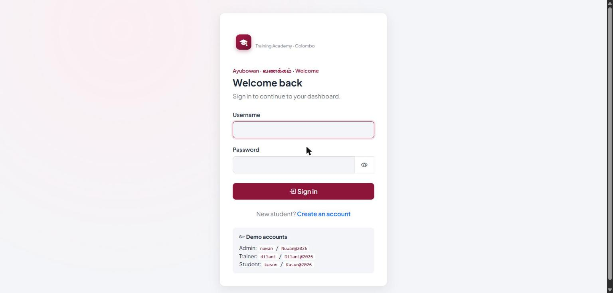
Figure C1: Login page (login.jsp) with demo account hints
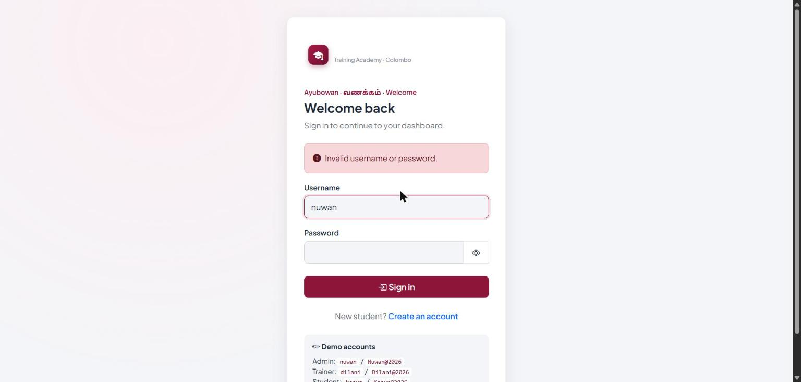
Figure C2: Login page after a wrong password (generic error, request scope)
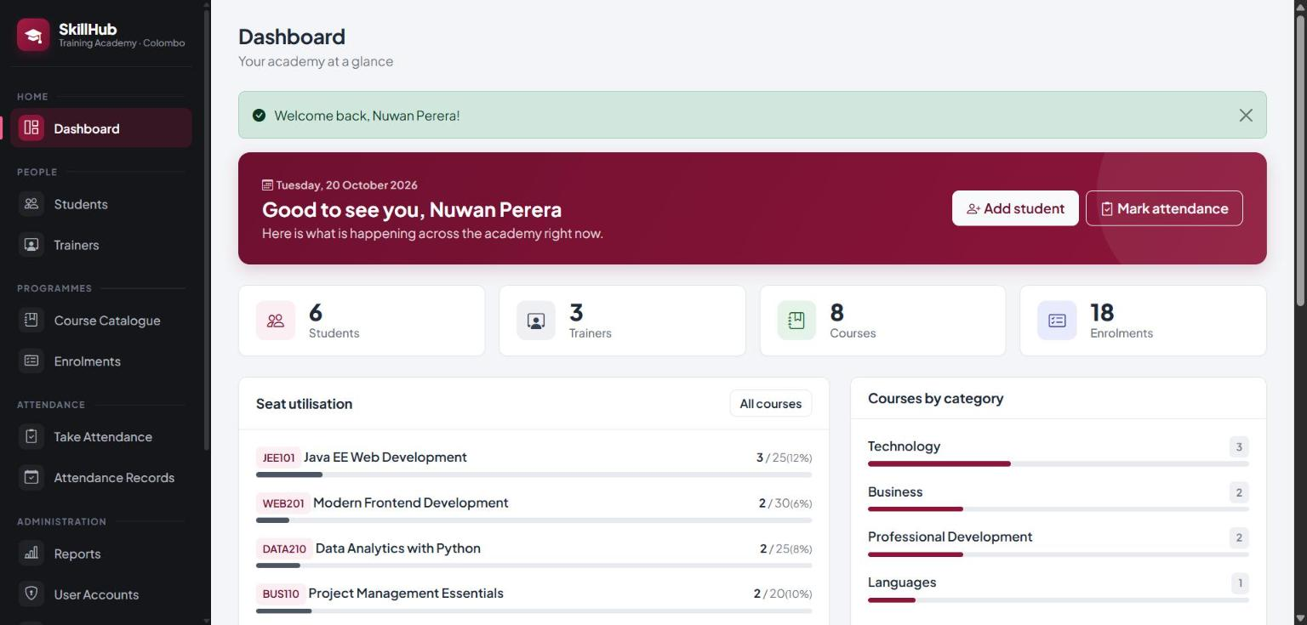
Figure C3: Administrator dashboard with statistics and seat utilisation (dashboard.jsp)
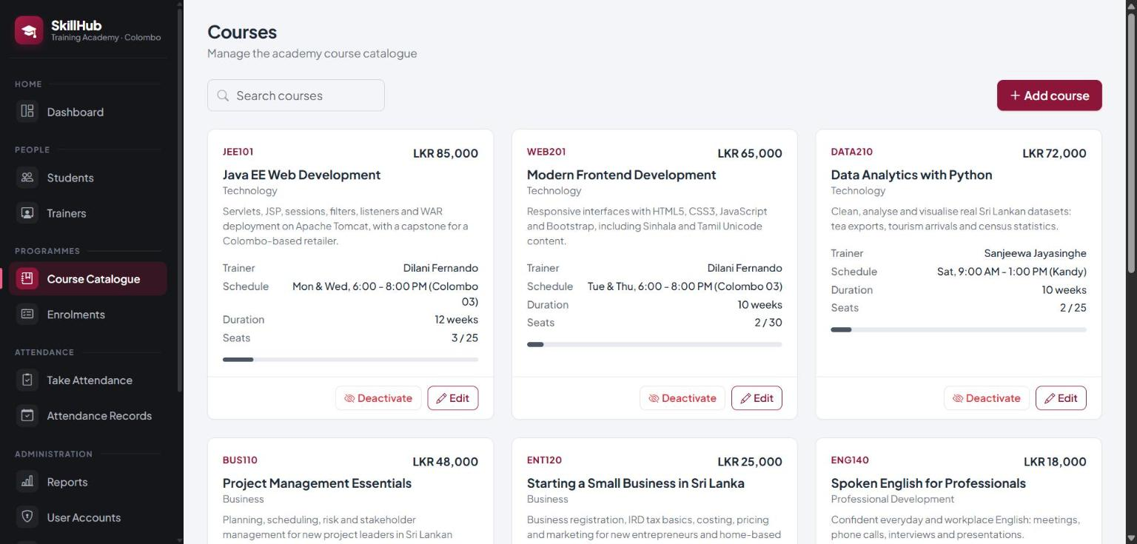
Figure C4: Course catalogue for the administrator, with Add, Edit and Deactivate (courses.jsp)
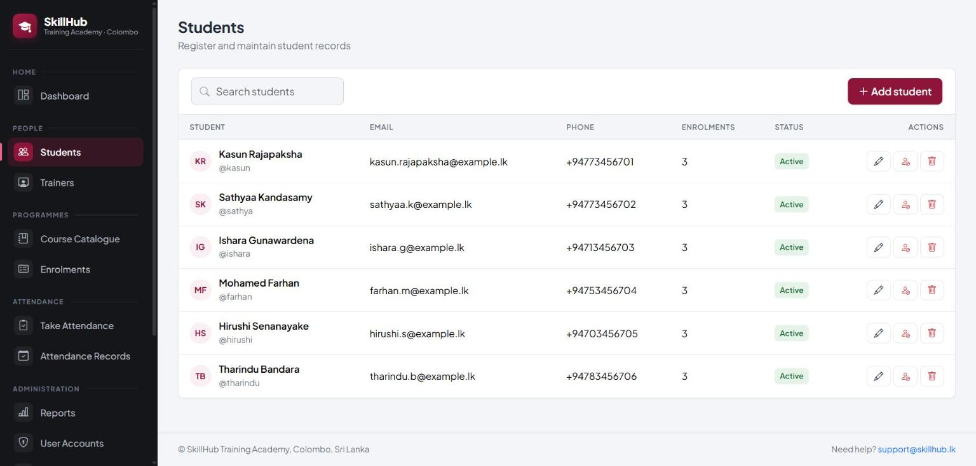
Figure C5: Manage Students list (people.jsp via AdminStudentServlet)
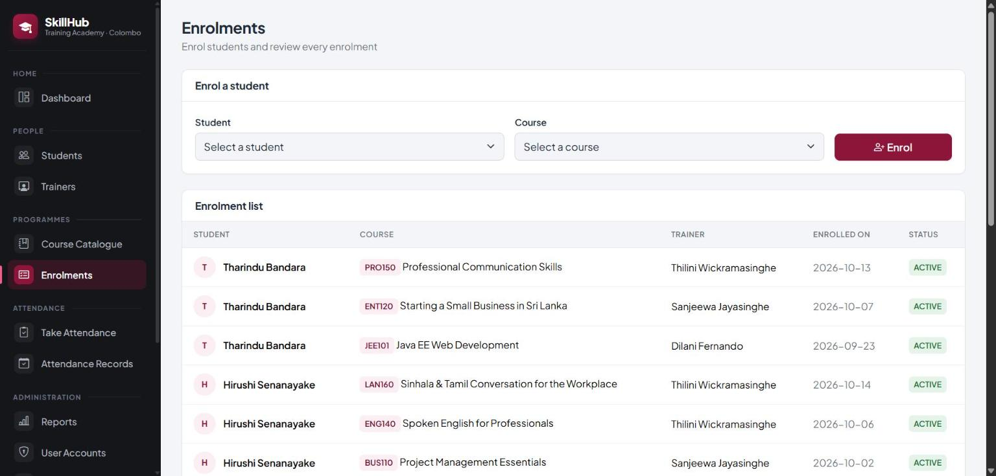
Figure C6: Administrator enrolment form and enrolment list (enrolments.jsp)
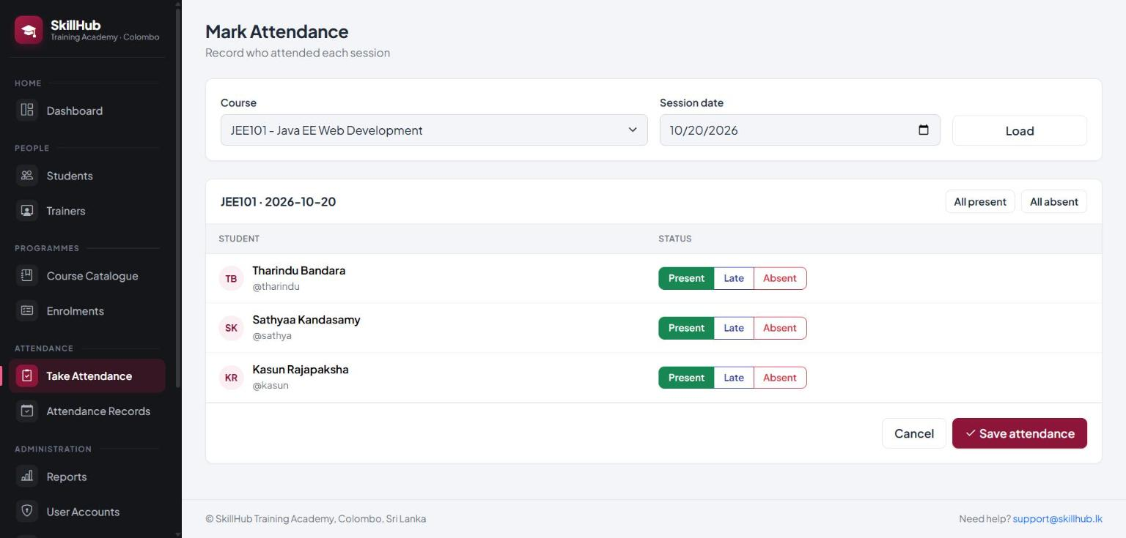
Figure C7: Mark Attendance sheet for JEE101 (attendance-mark.jsp)
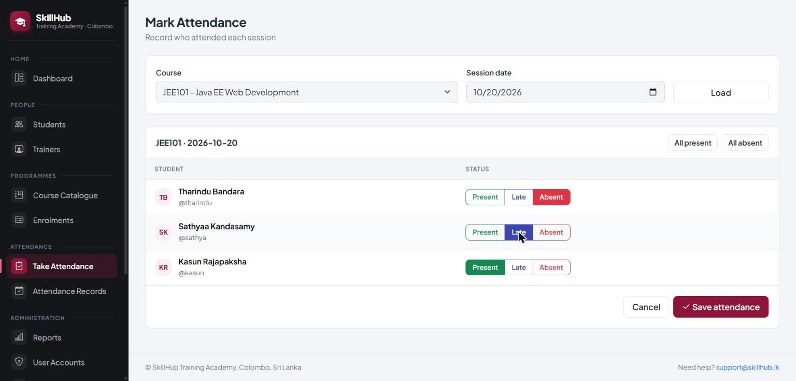
Figure C8: Attendance sheet with Absent and Late selected before saving
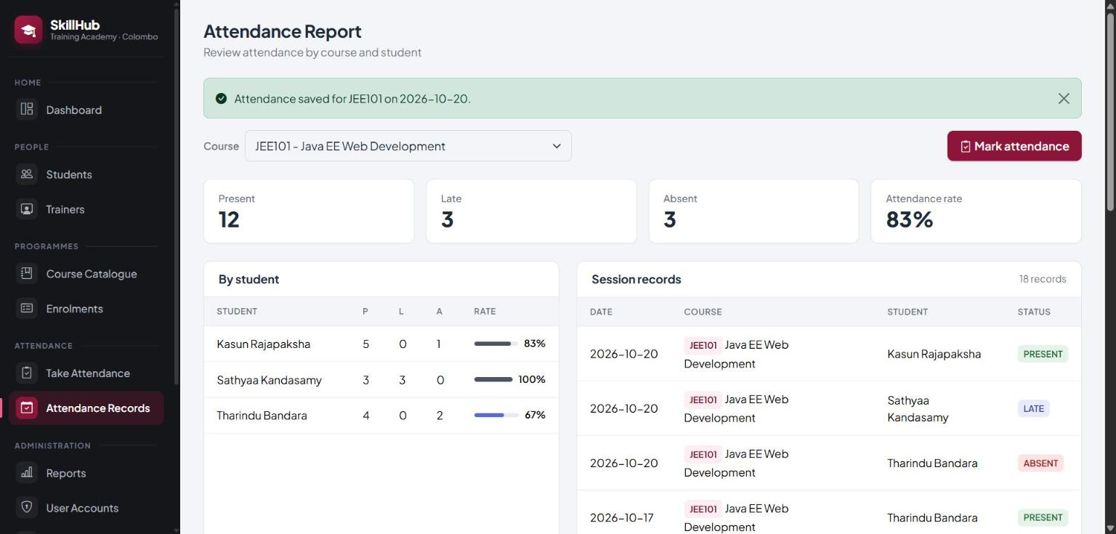
Figure C9: Attendance report after saving, with success message (attendance.jsp)
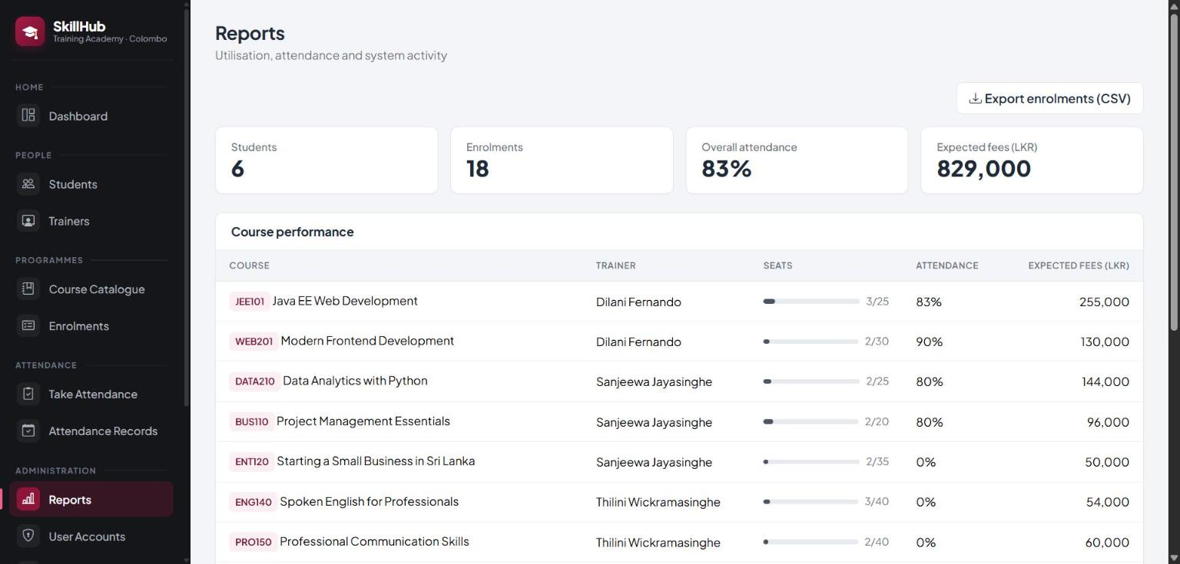
Figure C10: Reports page: summary cards and course performance (reports.jsp)
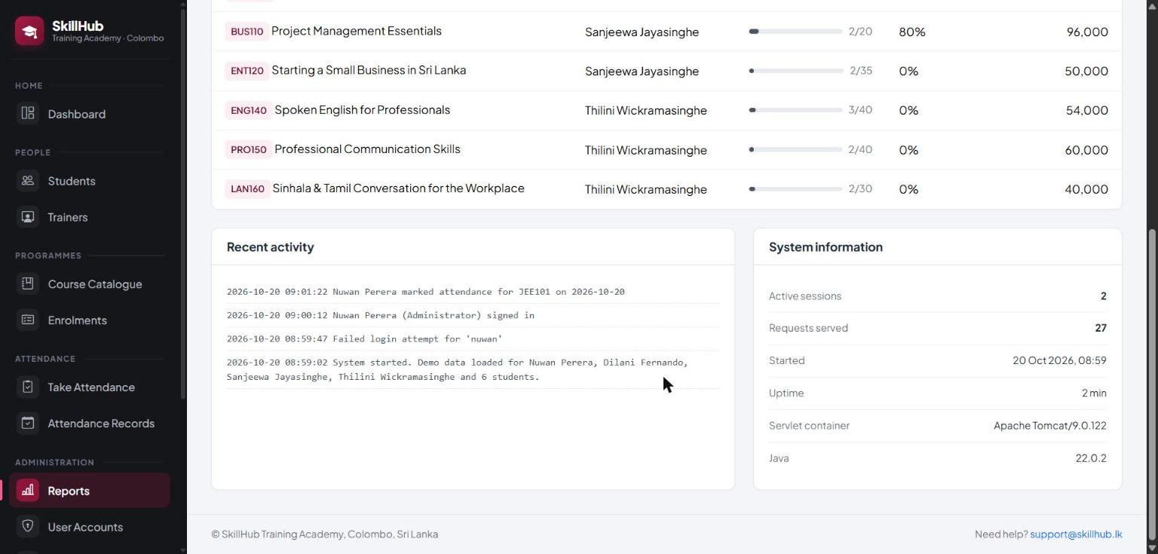
Figure C11: Reports page: recent activity log and system information (listeners at work)
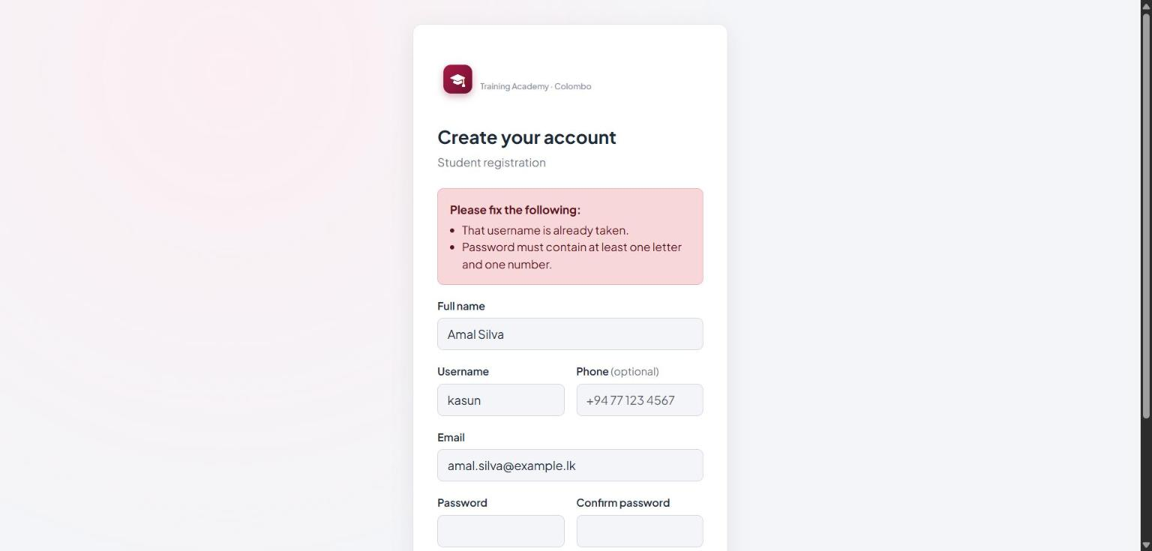
Figure C12: Registration form with server-side validation errors (register.jsp)
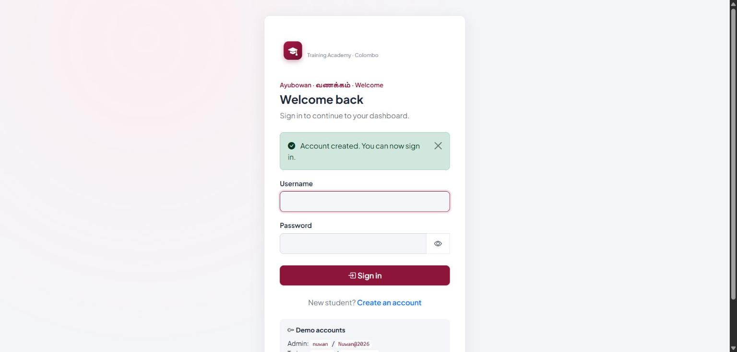
Figure C13: Login page after successful registration (flash message from session scope)
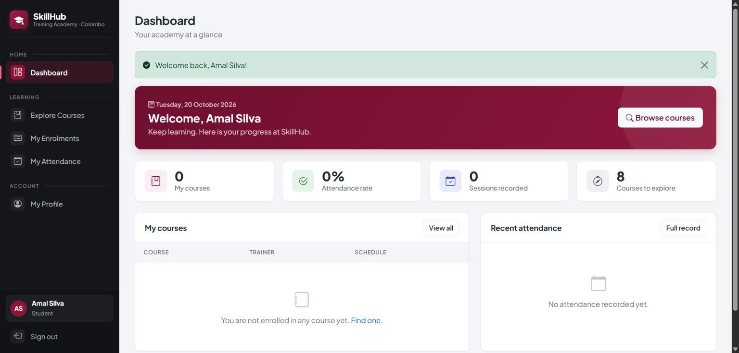
Figure C14: Student dashboard and student-only menu
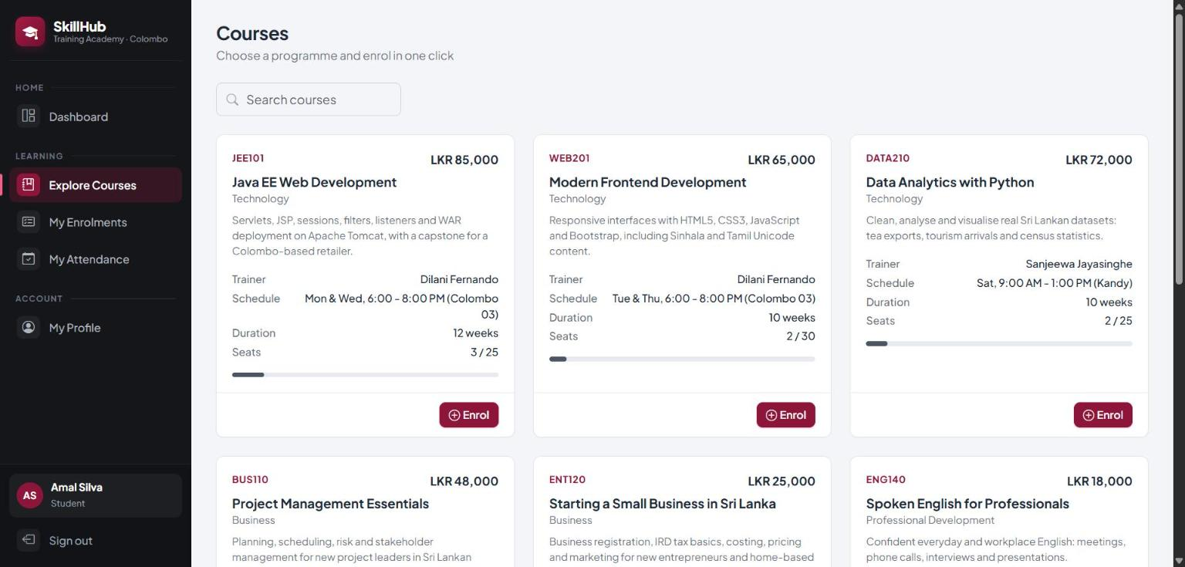
Figure C15: Course catalogue for a student, with one-click Enrol buttons
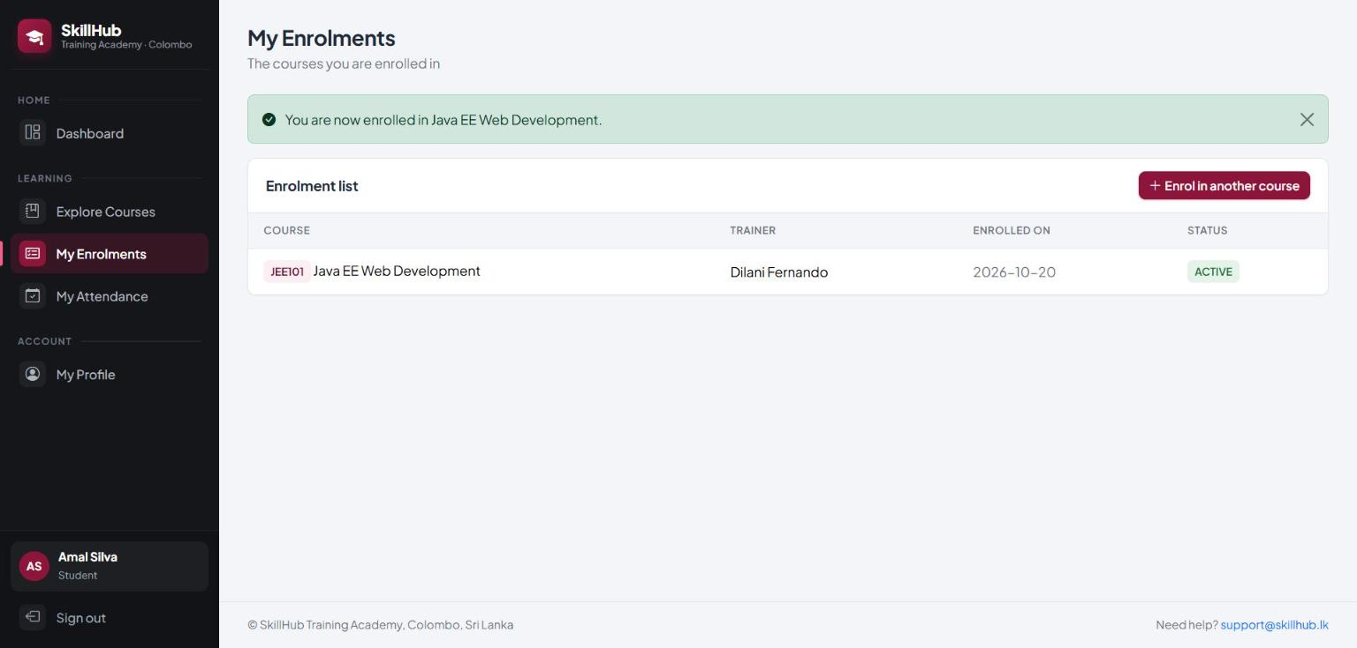
Figure C16: My Enrolments after a successful enrolment
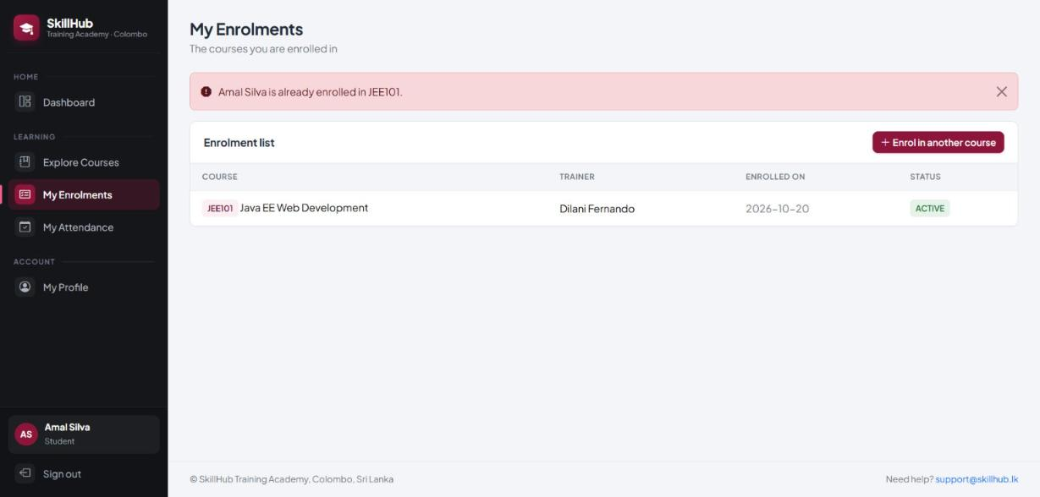
Figure C17: Duplicate enrolment rejected with an error message
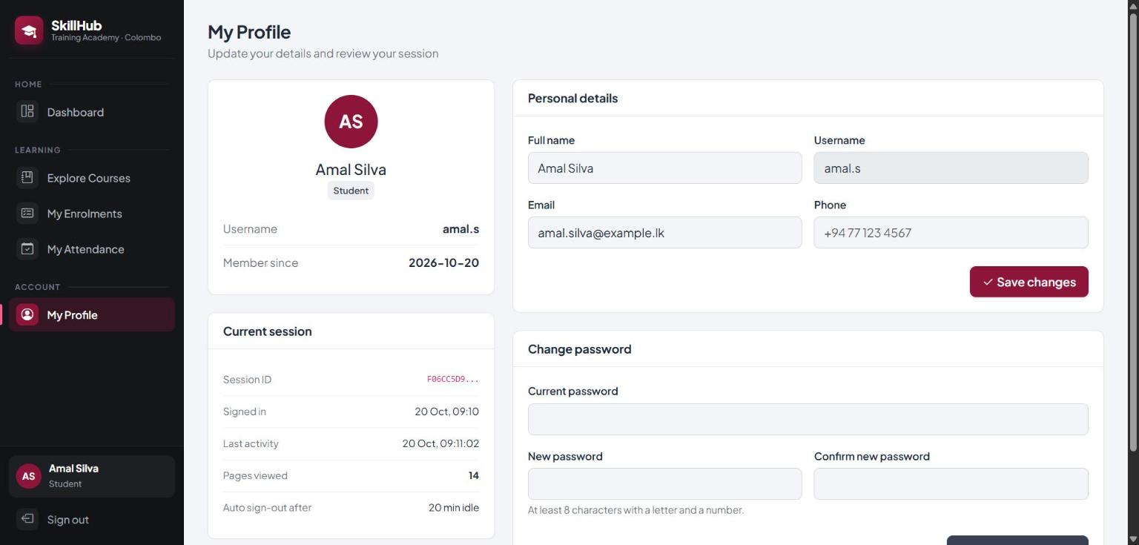
Figure C18: My Profile with session tracking details (session id, activity, pages viewed, timeout)
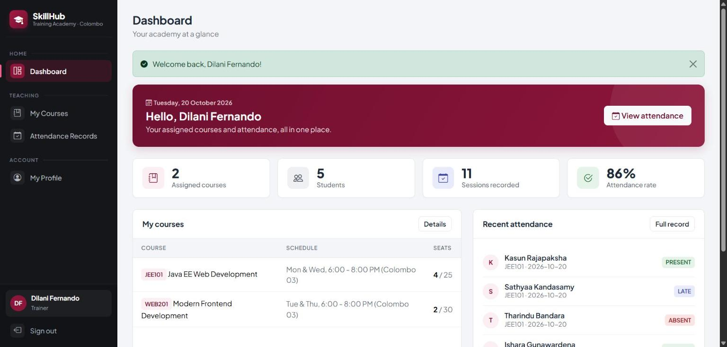
Figure C19: Trainer dashboard showing assigned courses and recent attendance
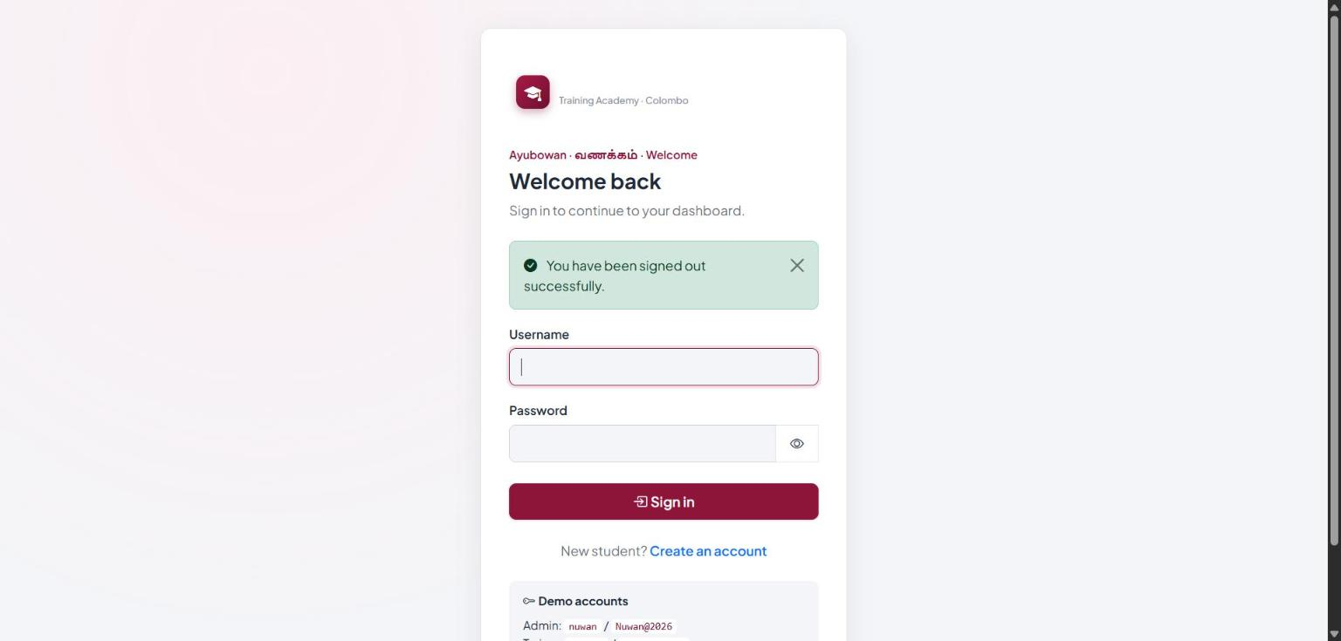
Figure C20: Login page after logout (session invalidated)
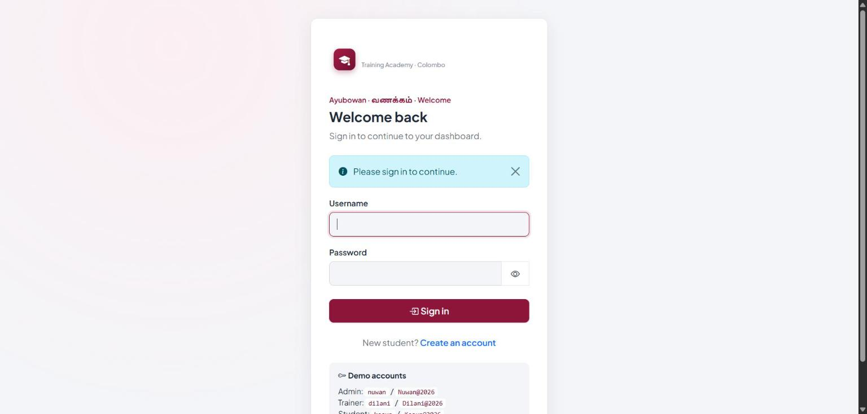
Figure C21: Unauthenticated request to /dashboard redirected to login
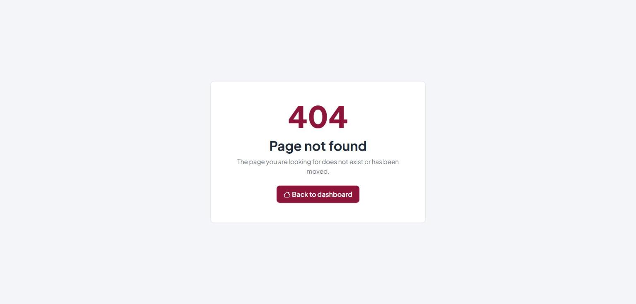
Figure C22: Direct request for a JSP under WEB-INF returns 404 (error.jsp)
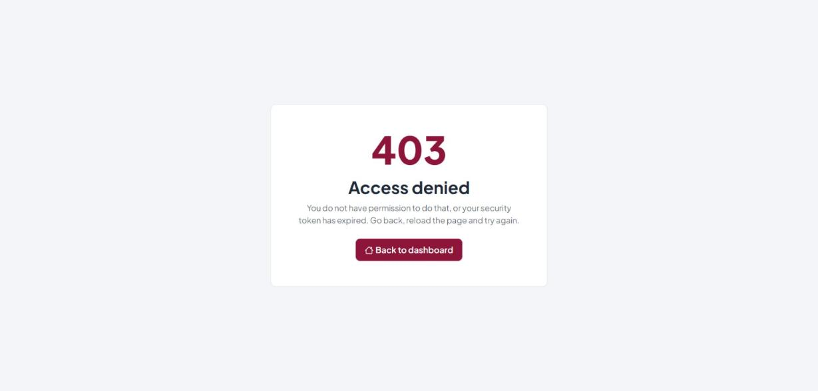
Figure C23: Student opening an administrator URL receives 403 Access denied

