Deploy Link: <https://slice-clone.vercel.app>

Content:

WEBPAGE SNAP…………………………………………………………………………………………………………..2

HTML CODE……………………………………………………………………………………………………………………4

CSS CODE……………………………………………………………………………………………………………………..11

WebPage SnapShots

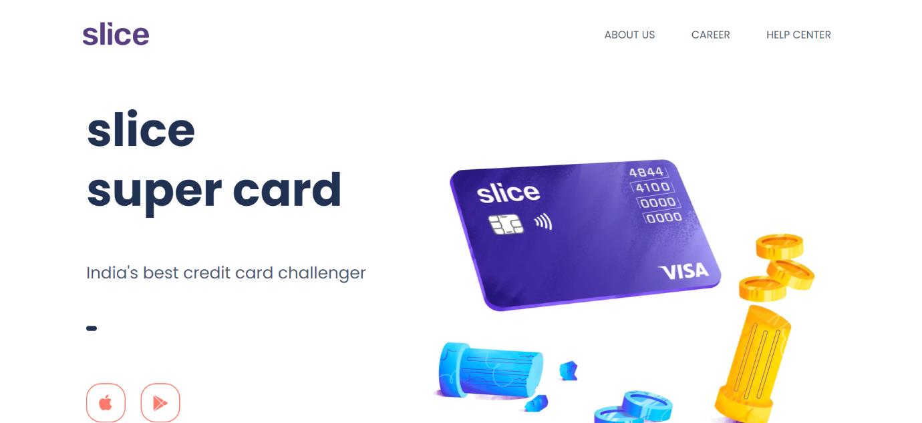



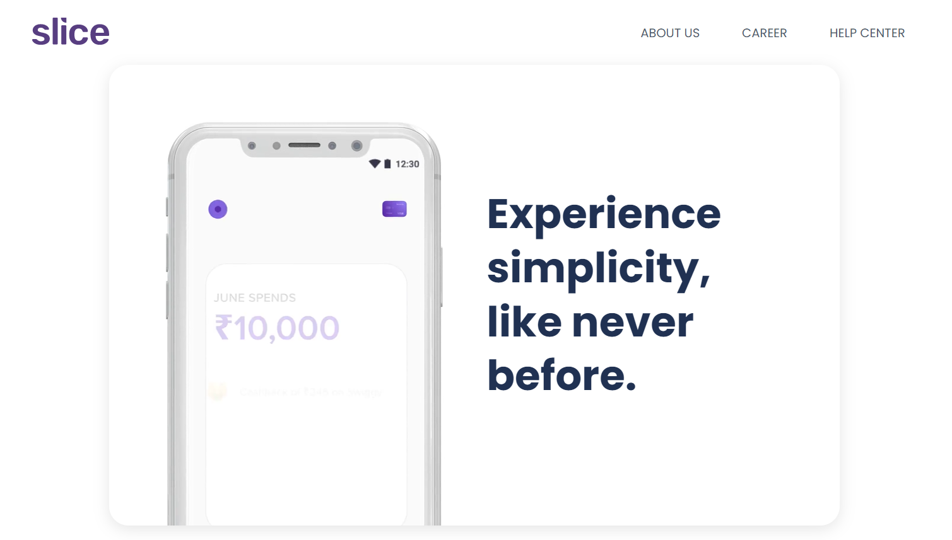



HTML CODE

<!DOCTYPE html>

<html lang="en">

<head>

    <meta charset="UTF-8" />

    <meta http-equiv="X-UA-Compatible" content="ie=edge" />

    <meta name="viewport" content="width=device-width,initial-scale=1" />

    <link rel="preconnect" href="https://fonts.googleapis.com">

    <link rel="preconnect" href="https://fonts.gstatic.com" crossorigin>

    <link href="https://fonts.googleapis.com/css2?family=Poppins:wght@100;200;300;400;500;600;700;800;900&display=swap" rel="stylesheet">

    <link href="style.css" rel="stylesheet">

    <title>India's best credit card challenger | slice super card</title>

</head>

<body>

    <div class="root">

        <header>

            <div class="navbar">

                <div>

                <a href="#" class="logo"><img src="media/logo.svg" alt=""></a>

                </div>

                <div>

                    <ul class="navbar-links">

                        <li><a href="#">ABOUT US</a></li>

                        <li><a href="#">CAREER</a></li>

                        <li><a href="#">HELP CENTER</a></li>

                    </ul>

                </div>

            </div>

        </header>

        <div >

            <section class="section margin">

                <div class="text-block text-block1">

                    <h1>slice</h1>

                    <h1>super card</h1>

                    <p>India's best credit card challenger</p>

                    <div id="horizonalrule"></div>

                    <div class="store" >

                        <a href="#">

                        <img src="media/appstore.svg" alt="">

                        </a>

                        <a href="#">

                        <img src="media/playstore.svg" alt="">

                        </a>

                    </div>

                    <div class="million">Trusted by <span>5 million+</span> Indians</div>

                </div>

                <div class="video-block">

                    <div>

                        <video src="media/cardVideo.mp4" autoplay loop muted></video>

                      </div>

                </div>

            </section>

            <section class="section section2">

                <div class="video-block video-block2">

                    <video src="media/2nd_section.mp4" autoplay loop muted></video>

                </div>

                <div class="text-block text-block2">

                    <h1>Get used to instant rewards.</h1>

                    <p>

                        Enjoy upto 2% cashback on every transaction.

                    </p>

                </div>

            </section>

            <section class="section">

                <div class="text-block text-block3">

                    <h1>slice your bill in 3, for free.</h1>

                    <p>Shop anywhere and slice all your bills over 3 months without any extra charges.</p>

                </div>

                <div class="video-block video-block3">

                        <video src="media/Staircases.mp4" autoplay loop muted></video>

                </div>

            </section>

<!-- ================= FEATURE SECTION ================= -->

            <section class="feature glow">

                <div class="videocard">

                    <video src="media/simplicity.mp4" autoplay loop muted></video>

                </div>

                <div class="textcard">

                    <h1>Experience simplicity, like never before.</h1>

                </div>

            </section>

            <section class="feature4">

                <div class="card">

                  <p>NO annual fees.</p>

                  <p>NO joining fees.</p>

                  <p>NO hidden charges.</p>

                </div>

                <div class="whitecard">

                  <p>Credit Limits that touch skies: from ₹2k - ₹10L.</p>

                  <img src="media/rocket.svg" alt="">

                </div>

              </section>

            <section class="feature glow glow2">

                <div class="videocard videocard2">

                    <video src="media/spark_offers.mp4" autoplay loop muted></video>

                </div>

                <div class="textcard textcard2">

                    <h1>Get new deals every week with slice spark.</h1>

                </div>

            </section>

            <section class="feature glow2 blackcard">

                    <div class="white-text">

                        <h1>Accepted at 99.95% merchants across the country that accept Visa.</h1>

                    </div>

            </section>

            <section class="feature4">

                <div class="card orange-card">

                  <p>When we say 'No Credit Score required', we mean it.</p>

                  <div>

                    <p>Anyone 18+ can apply.</p>

                    </div>

                </div>

                <div class="whitecard nopadding">

                  <p>Split bills with friends by taking notes, or adding tags.</p>

                  <img src="media/splitBills.svg" alt="">

                </div>

              </section>

            <section class="feature glow">

                <div class="videocard  passbook">

                    <video src="media/passbook.mp4" autoplay loop muted></video>

                </div>

                <div class="textcard passtext">

                    <h1>Managing expenses just got more beautiful with Passbook.</h1>

                </div>

            </section>

            <section class="feature4">

                <div class="card">

                  <p>We believe the present moment is the only real thing in life.</p>

                  <p>We obsess over valuing your time.</p>

                </div>

                <div class="whitecard card-p">

                  <p>We're all ears for you, always</p>

                  <video src="media/slice_ears.mp4" autoplay loop muted></video>

                </div>

              </section>

              <section class="midtext">

                  <div>

                  <p>Your love inspires us,</p> <p>every minute</p>

                    </div>

              </section>

              <section class="feature glow sliceepic">

                <div class="videocard sliceepicimg">

                    <img src="media/sliceEpic.svg">

                </div>

                <div class="epic">

                <div class="textcard sliceepictext">

                    <h1>slice</h1>

                    <h1>super card</h1>

                    <p>make now epic!</p>

                </div>

                <div class="store" >

                    <a href="#">

                    <img src="media/apple_icon_epic.svg" alt="">

                    </a>

                    <a href="#">

                    <img src="media/play_store_epic.svg" alt="">

                    </a>

                </div>

                </div>

            </section>

        </div>

    </div>

    <footer>

        <div>

            <h1>SLICE CLONE -BY RaHaT SaYYeD</h1>

        </div>

        <div>

            <a href="https://github.com/maleficscorpio" target="_blank"> <i class="demo-icon icon-github-squared">&#xf300;</i></a>

            <a href="https://www.linkedin.com/in/youreachedrahat/" target="_blank"> <i class="demo-icon icon-linkedin-squared">&#xf30c;</i> </a>

        </div>

    </footer>

</body>

</html>

CSS CODE

@import url('https://fonts.googleapis.com/css2?family=Poppins:wght@100;200;300;400;500;600;700;800;900&display=swap');

*{

*font-size*: 10px;

}

.root{

*max-width*: 1150px;

*box-sizing*: border-box;

*margin*: 0 auto;

*font-family*: Poppins, sans-serif;

*font-size*: 10px;

}

/* TYPOGRAPHY */

.text-block h1{

*font-size*: 7rem;

*color*: #203152;

*font-weight*: bolder;

}

.text-block p{

*font-size*: 2.5rem;

*color*: #4b5871;

*line-height*: 2.5em;

}

.text-block3 p{

*max-width*: 90%;

*font-size*: 3rem;

*color*: #4b5871;

*line-height*: 1.5em;

    }

/* LAYOUT */

header {

*display*: block;

*height*: 80px;

*background*: #fff;

*z-index*: 1000;

*margin*: 0 auto;

*position*: sticky;

*top*: 0;

*left*: 0;

*width*: 1150px;

*padding*: 0 auto;

}

 .navbar{

*display*: flex;

*justify-content*: space-between;

*align-items*: flex-end;

 }

 .logo{

*position*: relative;

*width*: 20%;

 }

 .logo img{

*width*: 10em;

 }

 .navbar a{

*text-decoration*: none;

*color*: #4c576b;

*font-size*: 1.6rem;

*font-weight*: 400;

 }

 .navbar ul{

*list-style*: none;

*display*: grid;

*grid-auto-flow*: column;

*grid-gap*: 4.5em;

*padding*: 0 1em;

 }

.navbar li{

*margin-top*: 3em;

*padding*: 0.1em 0.5em;

}

.section img:hover{

*background-color*: rgba(0, 0, 0, 0.04);

*border*: hidden;

*box-shadow*: 0px 3px 1px -2px rgba(0, 0, 0, 0.2),

          0px 4px 4px 0px rgba(0, 0, 0, 0.14),

          0px 2px 10px 0px rgba(0, 0, 0, 0.12);

}

.section{

*display*: flex;

*justify-content*: space-between;

*align-items*: center;

*padding*: 1em 0.5em;

*margin*: 3.5em 0;

}

.margin{

*padding-top*: 10em;

}

.text-block{

*max-width*: 38%;

}

.video-block{

*max-width*: 55%;

}

.section video{

*max-width*: 100%;

}

.text-block h1{

*padding*: 0;

*margin*: 0;

*line-height*: 1.3em;

}

.text-block1 p{

*padding*: 1em 0;

}

#horizonalrule{

*color*: #203152;

*background*: #203152;

*border*: 0.2em solid;

*width*: 1.2em;

*height*: 0.3em;

*border-radius*: 1em;

}

.store{

*padding*: 8em 0;

}

.section a{

*text-decoration*: none;

*padding*: 1em 0;

*padding-right*: 2em;

  }

.section a img{

*transition*: 0.5s;

*border-radius*: 30%;

*height*: auto;

*cursor*: pointer;

*max-width*: 6em;

}

.million{

*font-size*: 2.5rem;

*color*: #203152;

*margin*: -1.4em 0;

}

.million span{

*font-weight*: 600;

*font-size*: 2.5rem;

}

.section2{

*padding*: 10em 0;

}

.text-block2{

*max-width*: 45%;

}

.text-block2 p{

*line-height*: 1em;

*max-width*: 70%;

}

.video-block2{

*max-width*: 45%;

}

.text-block3{

*max-width*: 45%;

}

.video-block3{

*max-width*: 50%;

}

.feature{

*margin*: 5em 10em;

*display*: flex;

*align-items*: center;

*justify-content*: space-evenly;

*overflow*: hidden;

}

.glow{

*border-radius*: 2.5em;

*color*: #fff;

*box-shadow*: 0 5px 20px rgb(0 0 0 / 10%);

}

 .textcard{

*width*: 45%;

*z-index*: 4;

 }

.textcard h1{

*font-size*: 5.4em;

*color*: #203152;

*line-height*: 1.3em;

*font-weight*: bolder;

*max-width*: 80%;

}

.textcard2{

*margin-left*: 20em;

*padding*: 10em 0;

}

.passtext{

*width*: 50%;

}

.passtext h1{

*border*: solid 1 px magenta;

*max-width*: 100%;

}

.videocard{

*position*: relative;

*width*: 45%;

*height*: 100%;

*margin-bottom*: -2em;

}

.passbook{

*margin-bottom*: 0em;

}

.videocard video{

*position*: relative;

*top*: 3em;

*left*: 3em;

*width*: 90%;

*height*: 100%;

*object-fit*: cover;

}

.passbook video{

*width*: 80%;

*height*: 100%;

}

.glow2{

*justify-content*: space-between;

*height*: 58em;

*overflow*: hidden;

*padding-left*: 0;

}

.videocard2{

*width*: 40%;

*height*: 100%;

*margin-bottom*: 0em;

}

.videocard2 video{

*position*: relative;

*top*: 0em;

*left*: 0em;

*width*: 130%;

*height*: 110%;

*object-fit*: cover;

}

.blackcard{

*display*: block;

*box-shadow*: 5px 5px 20px rgb(0 0 0 / 10%);

*border-radius*: 20px;

*background*: #000;

*display*: flex;

*align-items*: center;

}

.white-text{

*width*: 80%;

*padding-left*: 5em;

*margin*: 10em 0;

}

.white-text h1{

*font-size*: 5.8em;

*color*: #fff;

*font-weight*: 700;

*line-height*: 1.5em;

}

.feature4{

*padding*: 60px 110px;

    /* display: grid;

    grid-template-columns: 1fr  1fr;

    grid-template-areas: "card whitecard";

    grid-gap: 2.5em; */

*display*: flex;

*justify-content*: space-between;

}

.card{

*max-width*: 48%;

    /* grid-area: card;

    grid-column: 1/2; */

*border-radius*: 25px;

*background*: #6d3afe;

*color*: #fff;

*box-shadow*: 0 5px 20px rgb(0 0 0 / 10%);

*height*: 100%;

*display*: flex;

*flex-direction*: column;

*justify-content*: center;

*align-items*: center;

*padding*: 7.8em 0;

}

.card p{

*font-size*: 5.4em;

*color*: #fff;

*line-height*: 1.3em;

*font-weight*: bolder;

*padding-left*: 1em;

*margin*: 5px;

}

.whitecard{

    /* grid-column: 2/3;

    grid-area: whitecard; */

*max-width*: 48%;

*border-radius*: 25px;

*background*: #fff;

*box-shadow*: 0 5px 20px rgb(0 0 0 / 10%);

*height*: 100%;

*display*: flex;

*flex-direction*: column;

*justify-content*: center;

*align-items*: center;

*padding*: 5em 0 4em 0;

*overflow*: hidden;

}

.whitecard p{

*font-size*: 3.4rem;

*color*: #633dea;

*line-height*: 1.3em;

*font-weight*: 700;

*width*: 80%;

*height*: 80%;

}

.card-p p{

*font-size*: 5.4rem;

}

.whitecard img{

*display*: relative;

*margin-left*: 8em;

*object-fit*: cover;

*object-position*: -1% 0;

*width*: 35em;

}

.whitecard video{

*padding-top*: 4em;

*display*: relative;

*margin-left*: 8em;

*object-fit*: cover;

*object-position*: -1% 0;

*width*: 35em;

}

.orange-card{

*background*:#ff7a6c;

}

.orange-card p{

*max-width*: 80%;

*padding-left*: 0;

*margin*: 0;

}

.orange-card div{

*position*: relative;

*right*: 7em;

*top*: 5em;

*padding-bottom*: 1em;

}

.orange-card div p{

*max-width*: 100%;

*font-size*: 2rem;

*font-weight*: 400;

*line-height*: 2.5em;

}

.nopadding{

*padding-top*: 2em;

}

.nopadding p{

*max-width*: 100%;

}

.midtext div{

*max-width*: 80%;

*margin*: 1em auto;

}

.midtext p{

*color*: #203152;

*font-size*: 6.4rem;

*line-height*: 0.3em;

*font-weight*: 700;

*text-align*: center;

*white-space*: pre;

}

.sliceepic{

*background*:#15cf74;

*padding*: 0;

*justify-content*: space-between;

*padding-left*: 3em;

}

.sliceepicimg img{

*width*: 50em;

}

.epic{

    /* display: flex;

    flex-direction: column; */

*width*: 42%;

*padding*: 5em 0 0 0;

}

.sliceepictext{

*width*: 100%;

*padding*: 0;

*margin*: 0;

}

.sliceepictext p{

*font-size*: 2em;

}

.sliceepictext h1{

*color*: #fff;

*line-height*: 0.4em;

}

.epic a{

*text-decoration*: none;

*padding*: 0 1em;

}

.epic img:hover{

*border-radius*: 1em;

*background-color*: rgba(0, 0, 0, 0.04);

}

footer{

*background*: #4a3083;

*margin*: 0;

*padding*: 0;

*height*: auto;

*text-align*: center;

}

footer h1{

*color*: #fff;

*font-size*: 3rem;

*font-family*: Poppins, sans-serif;

*font-weight*: 500;

*letter-spacing*: 0.5em;

}

footer a{

*text-decoration*: none;

*filter*: invert(1);

*filter*: brightness(4000%);

}

footer i:hover{

*transform*: scale(0.6) translate(0px);

}

footer i{

*filter*: grayscale(1);

*transform*: scale(1);

*transition*: 0.5s;

}

@font-face {

*font-family*: 'fontello';

*src*: url('./media/font/fontello.eot?73955942');

*src*: url('./media/font/fontello.eot?73955942#iefix') format('embedded-opentype'),

         url('./media/font/fontello.woff?73955942') format('woff'),

         url('./media/font/fontello.ttf?73955942') format('truetype'),

         url('./media/font/fontello.svg?73955942#fontello') format('svg');

*font-weight*: normal;

*font-style*: normal;

  }

  .demo-icon {

*font-family*: "fontello";

*font-style*: normal;

*font-weight*: normal;

*font-size*: 4em;

*display*: inline-block;

*text-decoration*: inherit;

*width*: 1em;

*margin-right*: .2em;

*text-align*: center;

*font-variant*: normal;

*text-transform*: none;

*line-height*: 1em;

*margin*:0 1em 2em 1em;

*-webkit-font-smoothing*: antialiased;

*-moz-osx-font-smoothing*: grayscale;

  }