Comparaison
- https://www.ncbi.nlm.nih.gov/pmc/articles/PMC7567393/

Weekly dengue forecasts in Iquitos, Peru; San Juan, Puerto Rico; and Singapore

Result - ML models had 21% and 33% less error than regression and time series models respectively. using weather data only, ML models did not demonstrate a practical advantage.

Models- ML models (i.e., Random Forest [RF] and Random Forest-Univaraite Flagging Algorith [RF-UFA]) forecast dengue, relative to commonly used prediction models (i.e., Poisson regression, Logistic regression and autoregressive integrated moving average [ARIMA] models)
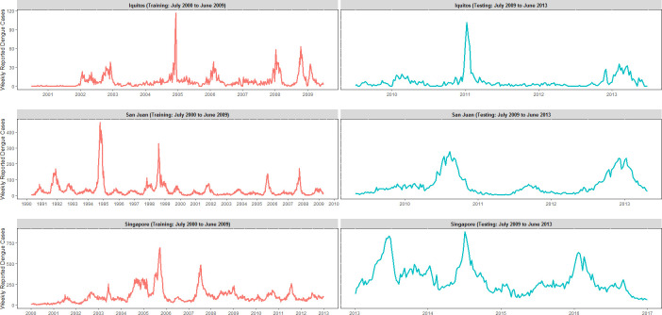
https://www.ncbi.nlm.nih.gov/core/lw/2.0/html/tileshop_pmc/tileshop_pmc_inline.html?title=Click%20on%20image%20to%20zoom&p=PMC3&id=7567393_pntd.0008710.g002.jpg

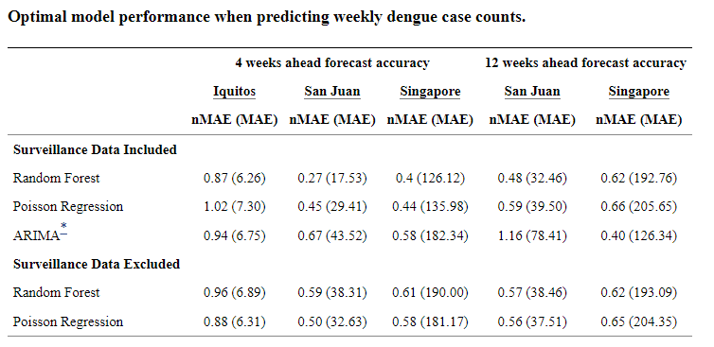
https://www.ncbi.nlm.nih.gov/pmc/articles/PMC7567393/table/pntd.0008710.t002/?report=objectonly

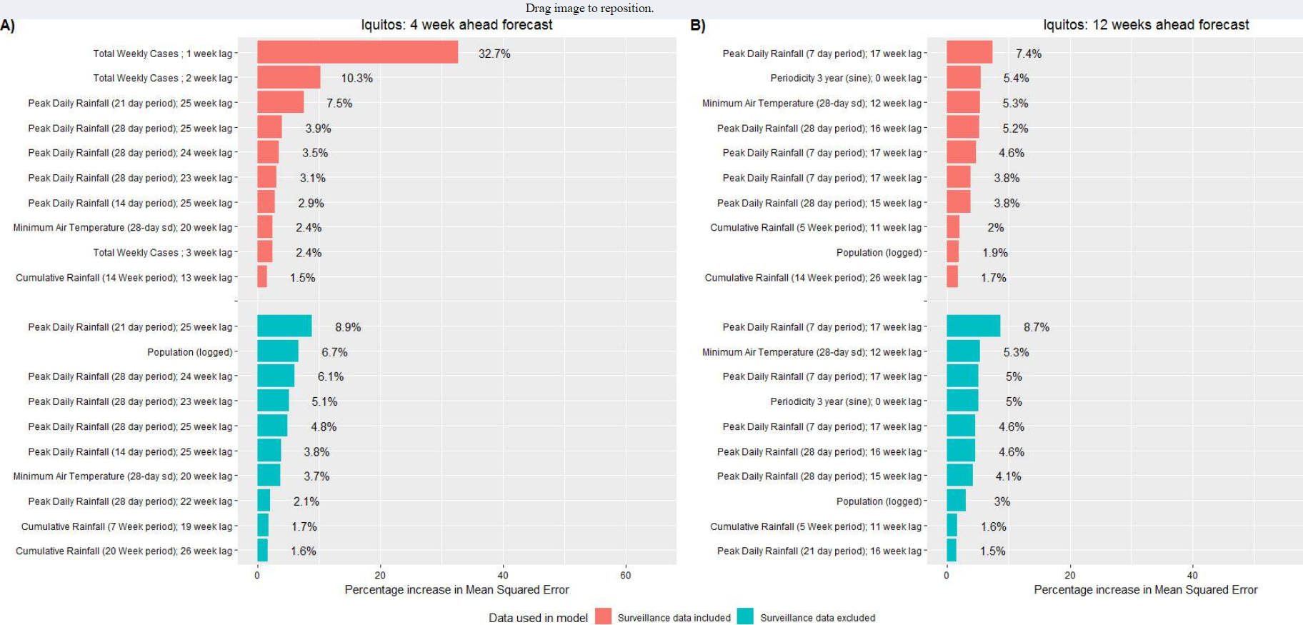
https://www.ncbi.nlm.nih.gov/core/lw/2.0/html/tileshop_pmc/tileshop_pmc_inline.html?title=Click%20on%20image%20to%20zoom&p=PMC3&id=7567393_pntd.0008710.g006.jpg

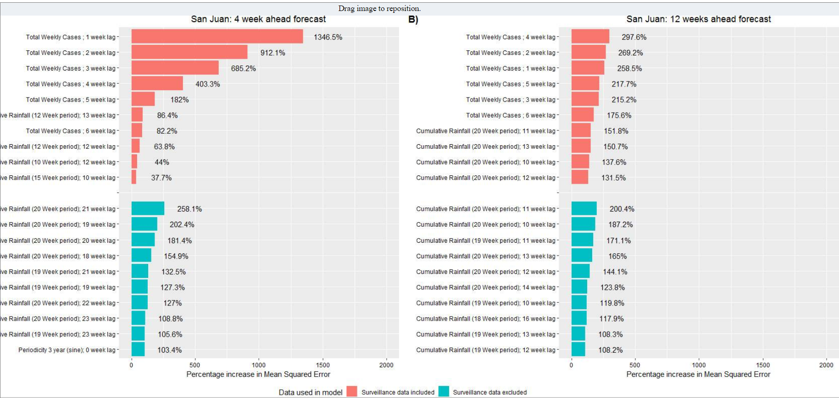
https://www.ncbi.nlm.nih.gov/core/lw/2.0/html/tileshop_pmc/tileshop_pmc_inline.html?title=Click%20on%20image%20to%20zoom&p=PMC3&id=7567393_pntd.0008710.g007.jpg

