The Analysis of Temperature Impact on Ice Cream Sales at B. Laban
Submitted by: Yousef Hatem 24-101444
Mohamed Yasser 24-101326
Malek Medhat 24-101474
Kareem Hany 24-101316
May 4, 2026

Introduction
B. Laban has grown into one of Egypt's most popular dessert chains. Managing inventory for a massive food business is a hard challenge. A common assumption in the food and beverage industry is that dessert sale (specifically ice cream) are heavily dependent on the weather. Understanding exactly how temperature drives customer purchasing behavior is crucial. By analyzing B. Laban's transaction data, this report aims to uncover whether temperature truly dictates ice cream cravings. The insights derived from this analysis can help businesses optimize their supply chains, reduce food waste, and better allocate staffing during specific weather conditions.

Research Question
Does the ambient temperature significantly affect the average daily sales of ice cream at B. Laban branches?

Hypothesis
- Null Hypothesis (H0): There is no significant difference in the average daily sales of ice cream across different temperature ranges.
- Alternative Hypothesis (H1): There is a significant difference in the average daily sales of ice cream across different temperature ranges.

Population of Interest:
The population of interest consists of all retail and delivery customer transactions at B. Laban branches across various regions in Egypt

Sampling Method:
This dataset utilizes sampling through automated digital data collection. The data consists of 7,000 continuous system-generated logs captured by B. Laban’s point-of-sale (POS) software and delivery integrations (such as Talabat and ElMenus). Because it relies on unedited financial and operational system records rather than self-reported human surveys, this method eliminates human error and ensures high reliability of the financial figures.

Bias Identification:
In utilizing this dataset, we have identified and accounted for a few critical sources of bias:
- Delivery Bias: Because B. Laban relies heavily on delivery services, harsh weather might deter walk-in customers but simultaneously increase delivery orders, masking the true effect of temperature on the desire for ice cream.

Survey Questions/Collected Data/Dataset:
For this project, we filtered the data specifically for the 'Ice Cream' category. Key variables used include:
- Date_Time: The exact timestamp of the transaction, which was used to group data into distinct operational days.
- Category & Product_Name: The classification of the item sold, utilized to isolate ice cream sales from other B. Laban desserts.
- Temperature_Celsius: The continuous numerical recording of the weather at the time of sale, which we categorized into 5-degree intervals (bins) for categorical comparison.
- Total_Sales: The continuous numerical value representing the final financial total of the transaction in EGP.
- Branch & Region: The geographic location of the store fulfilling the order.
- Customer Demographics: Variables such as Customer_Age, Order_Source, and Payment_Method provide background context on consumer behavior.
Number of samples used: 7,000 total transactions (Filtered down to 850 transactions specifically for the Ice Cream analysis).

Analysis:
To analyze the data collected from this system, we grouped the continuous temperature data into 5-degree categorical bins. We then calculated basic descriptive statistics, summing the raw sales and calculating the average daily sales per bin to account for the varying frequency of certain weather conditions. We created visual representations of the data using charts to help identify trends.
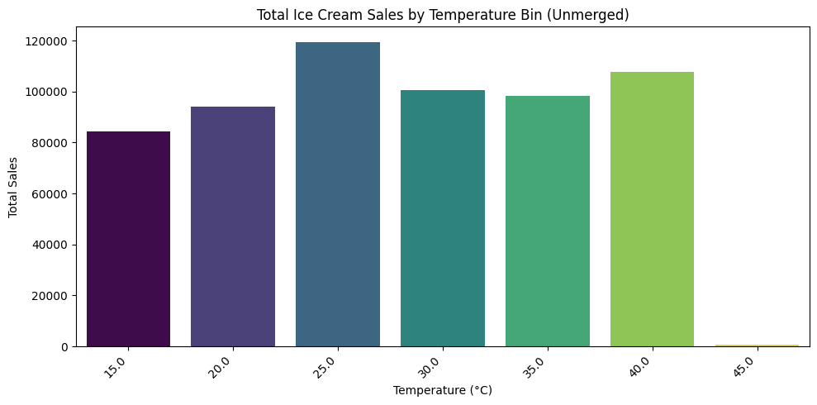Description: This bar chart displays the absolute total sales of ice cream grouped into 5-degree temperature bins. It reveals the raw distribution of our data, highlighting that the vast majority of our total sales volume occurred in the 20°C to 30°C range.
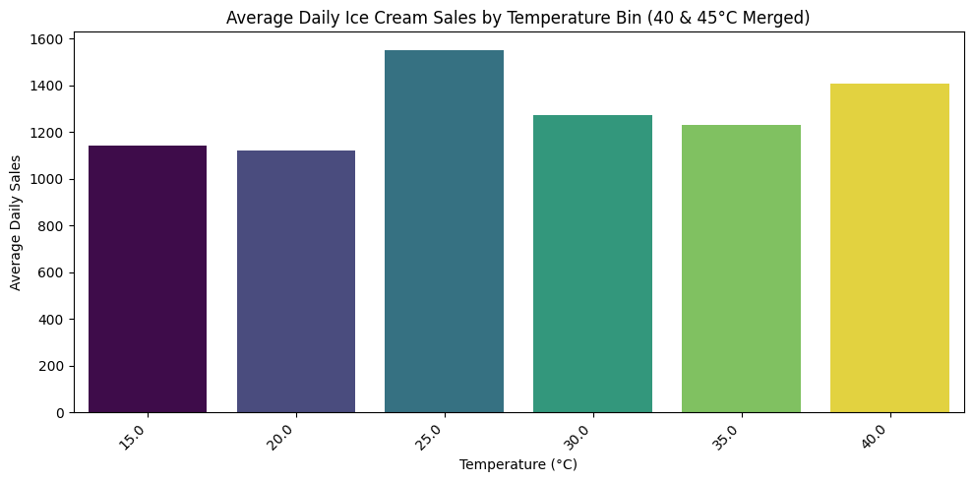
We merged the highly sparse 45°C data into the 40°C bin to prevent statistical outliers. This chart reveals a surprisingly stable distribution; when normalized by the number of days, the average daily sales remain relatively flat across all temperature ranges, contradicting the assumption that higher heat automatically equals higher average sales.

Hypothesis Testing Steps
- Step 1: Define the hypotheses. H0: The mean daily sales are equal across all temperature bins. H1: At least one temperature bin has a different mean.
- Step 2: Select the appropriate statistical test and significance level. Because we are comparing the means of more than two independent groups against a single continuous variable, we use a One-Way ANOVA. We set our significance level (α) at 0.05.
- Step 3: Compute the test statistic and p-value. Grouping the sales values by their respective temperature bins and running the ANOVA test yielded an F-statistic of 1.70 and a precise P-value of 0.12.
- Step 4: State the decision. Since the calculated p-value of 0.12 is strictly greater than our significance level of 0.05, we fail to reject the null hypothesis.

Conclusion
Based on the ANOVA test, the data does not provide sufficient evidence to conclude that temperature has a statistically significant effect on B. Laban's ice cream sales at the 95% confidence level. The results imply that customer purchasing decisions for these specific desserts may be driven more by brand loyalty, marketing, or general consumer habits rather than being heavily dictated by how hot or cold it is outside.

Any potential issues
During the data cleaning and analysis process, several issues were discovered in the dataset:
- Missing Data Attributes: While the core operational data was 100% complete, there were significant gaps in customer demographic data. Topping_Type, Customer_Age, Customer_Gender, and Store_Rating contained hundreds of null values.
- Sparsity at Extremes: There was virtually no data for temperatures at 45°C. To maintain the integrity of the ANOVA test and avoid breaking the visualizations, this sparse bin had to be manually merged into the 40°C bin.

