**Senior Project:**

* Implementation of how to put glasses on an image of a person’s face:
  + <https://www.glassesusa.com/virtual-try-on-glasses>

* + [https://www.makeuseof.com/tag/framefinder-glasses-photo-buying-online/](https://nam04.safelinks.protection.outlook.com/?url=https%3A%2F%2Fwww.makeuseof.com%2Ftag%2Fframefinder-glasses-photo-buying-online%2F&data=05%7C01%7Cazim%40usf.edu%7C45a29e2a7998439434f308da8b6f43c4%7C741bf7dee2e546df8d6782607df9deaa%7C0%7C0%7C637975607243530245%7CUnknown%7CTWFpbGZsb3d8eyJWIjoiMC4wLjAwMDAiLCJQIjoiV2luMzIiLCJBTiI6Ik1haWwiLCJXVCI6Mn0%3D%7C3000%7C%7C%7C&sdata=wjNJ5BT7%2FKIa0vTmHd%2Fo5OlAt6Yi4IDSivgaCZUc0p0%3D&reserved=0)

* + <https://pixelied.com/features/add-glasses-to-photo>

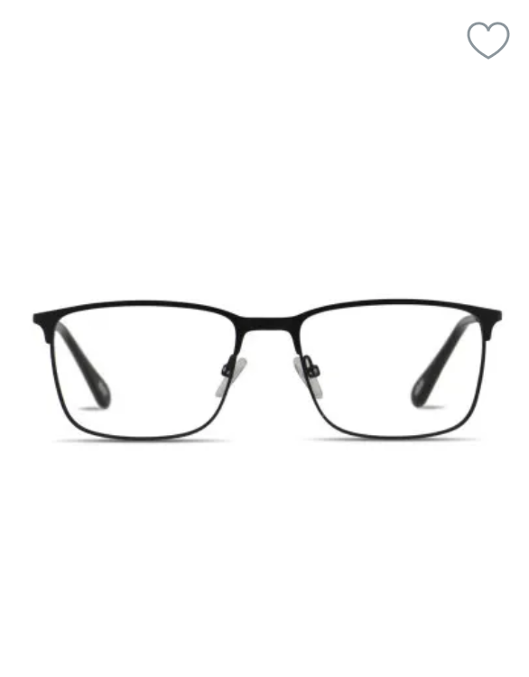

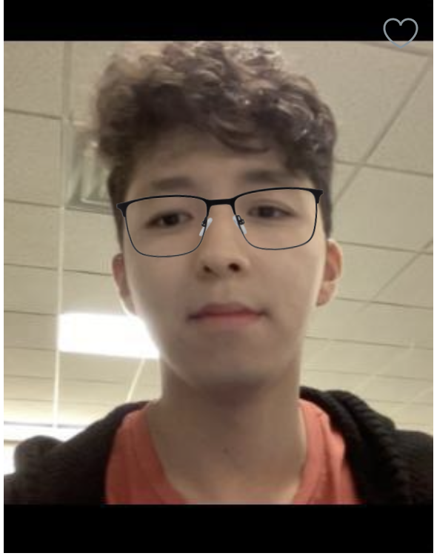

* Database for people faces:   <https://thispersondoesnotexist.com>
* Finding the right glasses:   <https://www.businessinsider.com/how-to-buy-glasses-that-fit-your-face-2016-11>
* Determine size of the face in proportion to the eyes.
  + Small/Narrow Face: 125mm – 129mm
  + Medium Face: 130mm – 134mm
  + Large Face: 135mm – 139mm
  + Wide Face: 140mm – 145mm
* Eyeballs should be in the center of the lens.
* The eye should only cover the top half of the lens
* Important to consider shape of the face - in modern research works most researchers use ML learning to determine the shape of the face
  + Types of faces:
    - Round - rectangular or cat-eye frames
    - Oval - rectangular, square and aviator frames
    - Square - round or oval frames
    - Heart - Rectangular, Tortoiseshell Frames
    - Diamond - cat-eye or oval or rectangle frames.
    - Rectangle - Oval, aviator frames
    - Triangle - cat-eye, rectangle
    - Inverted Triangle - rimless or wireframe, and choose ones in a light color
    - Source: <https://fabbon.com/articles/makeup/types-of-face-shapes> and <https://www.allure.com/gallery/best-glasses-frames-for-your-face-shape> and <https://www.rosineyecare.com/face-shapes/>
* Skin Tone:
  + Warm skin tones:  light tortoise, browns shades, gold or honey, beige, and olive green.
  + Cool skin tones: silver, black, dark tortoise, pink, purple, blue, mauve and gray
* Lifestyle or personality

Holiday

Project statement:  Is it possible to build a ML model that is able to determine the best looking glasses on a person’s face with accuracy over 85%.    Definition of accuracy: There will be a test group of more than 10 people and they will grade the results of the model on a scale from 0 to 10. The percentage that the ML model gets within 1 point of the test group’s average scores would be the accuracy.