Platform Maintenance
Regular maintenance of the Application Platform is done with the help of CIF Self Management, External Access Manager (EAM), Basic Services (TBS), Database Services (TDS) and Telecom Security Services (TSS). These services functions are:
- a user interface for authority control (and administration of the Authority Database) (TSS)
- log administration support for administration of the log tables generated by the applications and the platform (TDS)
- support for symbol customizing (GNIP) (In a Master - PM Server system, do this only on the Master Server)
- external access interface (EAM) (In a Master - PM Server system, do this only on the Master Server)
- all types of backups (Netbackup/DMR)
- archiving, dumping, and deleting of logs (TBS)
- checking the status of the processes (CIF Self Management)
- reading mail (sybase, nmsadm, root mail)
- descriptions of alarms, the documentation about the alarms and how to administer them

3.3 Maintenance Intervals

Daily Tasks
- Check the system error log in CIF Management Console. See Reference [22].
- Check the Sybase error log /var/opt/sybase/sybase/log. See Section 3.4.3 .
- Check the UNIX error log /var/adm/messages and /var/log/syslog .
- Check the FMA alarm and operator logs. See Section 3.4.3 .
- Check web server logs in the /var/opt/redhat/stronghold/logs directory.
- Read mail (sybase, nmsadm, root mail).
- Check the remaining space for the Sybase databases and their transaction logs by using db_check.sh.
- Check the remaining disk space for the sybase database dumps in /export/dbdumps/<SQLSERVER> and /var/opt/sybase/sybase/transdump file system. Make sure there is enough disk space left for the automatic database dumps (threshold dumping of transaction logs, dumping of transaction logs once every 12 hours and weekly dumping of sybase databases) (see Section 3.4.6 ). If there is not enough disk space left, move the dump files to tape and save the tape until the next database dump has been made.
- Check all administrator's messages in the /var/adm/messages and the /var/log/syslog directory, using UNIX commands.
- Check the disk status with the command vxprint | egrep -i "iofail|recover" . No output if the disk status is okay.
- Using the CIF Management Console, check that all needed processes are running.
- Check the remaining disk space for the versant database dumps in /export/dbdumps/versant/db. Make sure there is enough disk space left for the automatic database dumps.

3.3.2 Weekly Tasks
- Total backup of the system. Dump the databases, ( and make a total on-line backup of the UNIX file system and the Admin server, (see Section 3.4.1 ). Store the total system backup that was performed most recently for at least two years.
- Delete and store the FMA alarm and operator log, EAC command and responses, and information log. Use Log Administration (see Section 3.4.4 ). The EAC logs and FMA logs are deleted and stored by a cronjob , so no manual action is necessary. (In a Master - PM Server system, do this only on the Master Server)
- Delete all old ( message.<n> and syslog.<n> ) administrators' messages in the /var/adm directory and the /var/log directory, using UNIX commands. Do not delete the active files.
- Delete old PMS log files. The log files are found in the following directory: /var/opt/ericsson/nms_cif_tmos_tbs/log .
Note:
Make sure the error information in the log file is no longer needed before deleting the log file.

- Read and delete old system logs found in /var/opt/ericsson/log . Use ordinary UNIX commands.
- Find all core files. Use normal UNIX commands, for example find. Analyze the files to see if they indicate any major problems. Use for example the Unix command what . Delete them when they are not needed.
- Scan the UNIX file system for large files. To check for files larger than 10 MB, use the command find / -type f -size +10000000c -ls . Delete them if they are not needed.
- Check and clean EAC database. See Reference [11]. (In a Master - PM Server system, do this only on the Master Server)
- Check the UAS session log. See Section 4.11.2.
- Clean the Solaris BSM Auditing log. See Section 5.19.3.

3.3.3 Monthly Tasks
- Administer UNIX and Sybase error logs (see Section 3.4.3 ).
- Remove the CNA printouts, which are stored in the directory /var/opt/ericsson/cna/log/printouts . Check that all adjustments and update jobs are completed before removing the printouts. (In a Master - PM Server system, do this only on the Master Server).
- Delete dump transaction logs in the /var/opt/sybase/sybase/transdump directory if they are not needed.
- Check the directory /var/opt/ericsson/nms_rnr_pmr/data/axefiles and /var/opt/ericsson/nms_rnr_pmr/data/tempfiles for files that do not belong to ongoing recordings. Recording files are temporarily stored in this directory during recording and unpacking but are normally removed afterwards. In case of a serious failure, for example a database failure, recording files can be left in this directory and thus must be deleted manually. Check that they are not needed by any user and in that case delete them. (In a Master - PM Server system, do this only on the Master Server)
- Check and remove the error logs for GNIP located in each operator's home directory, /home/<username>/_gnip/GnipErr.log . See Reference [10] . (In a Master - PM Server system, do this only on the Master Server)
- The files created during archiving of logs can be transferred to tape to reduce the disk space used.
Change directory to /var/opt/ericsson/nms_cif_tmos_tds/log/logfiles .
Transfer the files to tape by using, for instance, tar.
When the files have been transferred to tape, they can be deleted from the directory.
- To remove the old and unused MO information from the BSM database the script bsmdb_cleanup.sql should be run. This script removes the old information and recreates the BPMIT table indexes. By doing this the size of the BSM database is decreased.
The syntax of running the script in a terminal window:
# isql -S<servername> -U<username> -P<password> -i/opt/ericsson/bsmcm/info/bsmdb_cleanup.sql

3.4 Maintenance Tasks
This section contains the description of the major maintenance tasks that are to be performed according to Table 2 .

3.4.1 Backup and Restore of the UNIX File System and the AdminServer
Note:
The main tool for performing system dumps is Veritas Netbackup. See Reference [19]. However, in special cases it is also possible to use the Disk Mirror & Recovery Tool (DMR) which is part of the System Configuration Kit.
DMR can, for example, be used to reduce system downtime when performing a tape restore on an inactive disk mirror or when a dump from one hardware configuration should be restored on another hardware configuration (for example on other type of disks or when a disk has been replaced due to a disk crash). See Reference [18] for further information on features in DMR.

3.4.2 Model Administration
In a Master - PM Server system, do the following only on the Master Server.
The OSS RC Network Resource Model (ONRM) contains the network topology. This information is maintained by the following management applications:
- Add Remove Network Elements function in OSS Network Explorer (ONE) maintains the Network Elements
- Cellular Network Administration (CNA) maintains the MSC <-> BSC relation
- BTS Configuration Manager (BCM) maintains GSM radio sites
The Geographical and Logical Network Information Presentation, GNIP, is a common geographical and logical presentation tool which is utilized by several applications. It shows network information such as alarm status and cell configuration, recording results from several applications in one user interface simultaneously. See Reference [10] on how to administer GNIP.

3.4.3 Handling of Internal Alarms
Application generated alarms classified as critical are forwarded to FM via the SNMP Manager. The figure below shows a logical overview.
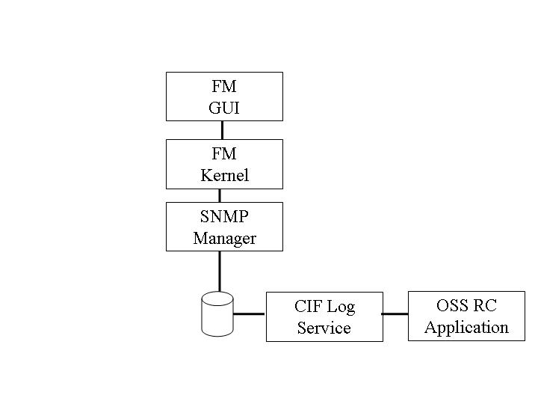
Figure 4 Internal Alarms Forwarded to FM

3.4.3.1 Logging of Errors
Sybase errors are logged in the files <sqlservername>.ERRORLOG and <sqlservername>_ BACKUP.ERRORLOG in the directory /var/opt/sybase/sybase/log .
See more about the sybase error logging in the Sybase System Administration Manual.
Administrators' messages ( message.<n> and syslog.<n> ) are logged in the directories /var/adm and /var/log .
Errors in the different applications are reported to the Process Management Service (PMS) in TBS. The reports contain a unique error number for each error. Error reports can be subscribed to from PMS for further processing and for presentation of the error reports with Fault Management Application (FMA). All PMS errors are also logged in the Openfusion Log Service.
Each error report is described in an Error Printout Description (EPOD) file, presented in FMA.
For more information on how to administer the Fault Management application, please refer to Reference [2] .
Errors in the Fault Management Alarm Viewer are logged in the operator's home directory, /home/<username>/fm. See Reference [9] .
Errors in the Geographical and Logical Network Information Presentation (GNIP) are logged in the operator's home directory, /home/<username>/_gnip. See Reference [10] .
System errors and events are logged via Openfusion Log Service in a circular log. The logs are viewed with the Log Viewer in CIF Self Management.

3.4.3.2 Checking the Error/Event Logs
The contents of the active error/event log are checked with the Log Viewer in CIF Self Management. Information about the contents of the error/event log is found in Reference [1] (PMS errors) and Reference [22] (system errors/events).
Normally the error reports are subscribed to by the FMA, and the contents in the error log are errors that have no subscriber.
The Sybase error log is not accessible through the Log Viewer. Read the Sybase error log with the help of UNIX commands.
UNIX error logs are found in the directory /var/adm . For information about checking and administration, see the UNIX manuals.
The Fault Management Alarm Viewer log is found in the operator's home directory, /home/<username>/fm. See Reference [9] .
The Geographical and Logical Network Information Presentation (GNIP) log is found in the operator's home directory, /home/<username>/_gnip. See Reference [10] .

3.4.3.3 Administering the Error Logs
The Sybase error log is to be read. Error log entries older than 14 days are to be deleted. Archiving of the error log is done in the weekly total backup.
The PMS error log is archived in the weekly total backup and the old PMS error logs are to be deleted weekly.
System errors/events are written in a circular log, no administration is needed.
More about Fault Management is found in Reference [2] .

3.4.4 Database Log Administration
Various activities, such as alarms and MML commands, are logged in OSS. The system will handle the archiving and deleting of these logs. To check and administer the deleting and archiving of the logs (stored in Sybase), Log Administration is used. See Reference [3] .

3.4.5 Parameter Database Settings
Site and customer specific parameters are described in Reference [4] . Application parameters that can be changed during runtime are found in the System Administrator Guide for each application.

3.4.6 Dump/Restore Databases
For dump and restore of Sybase databases, see Reference [20].
For dump and restore of Versant databases, see Reference [21].

