202

3

**Load/Performance Testing using K6 Tool:**



**Purpose:**

The purpose of this comprehensive guide is to provide a thorough and practical resource for individuals and teams interested in load generation using the k6 tool. It aims to empower readers with the knowledge and skills required to plan, execute, and analyse load tests effectively. Whether you are a performance engineer, a developer, a DevOps professional, or a student, this guide is designed to help you understand the principles and best practices of load testing with k6.

**Scope:**

This document covers a wide range of topics related to load generation with k6, including but not limited to:

* Installation and setup of k6 on various platforms.
* Writing and structuring load testing scripts in k6.
* Configuration options for load tests, including test duration, virtual users, and thresholds.
* Execution of load tests both locally and in a distributed manner using k6 Cloud.
* In-depth analysis of test results, including interpreting k6 output and advanced reporting with Grafana.
* Best practices for script optimization, test data management, and scalability testing.
* Advanced topics such as parameterization, handling cookies and sessions, and WebSocket testing.
* Troubleshooting common issues and debugging techniques.
* Security considerations when conducting load tests with k6.
* Utilizing external tools and integrations, such as InfluxDB, for enhanced reporting and data storage.
* Access to additional resources, recommended reading, and community support.

This document is intended to serve as a comprehensive reference and learning guide, equipping readers with the knowledge and practical skills required to plan, execute, and analyse load tests efficiently. It provides both foundational concepts and advanced techniques, making it suitable for users with varying levels of experience in load testing and performance engineering.

Top of Form

**Target Audience:**

This comprehensive guide on load generation with k6 is designed to cater to a diverse audience, including but not limited to:

1. **Performance Engineers:** This guide provides valuable insights and best practices for performance engineers responsible for conducting load tests, analysing results, and optimizing web applications for performance.
2. **Developers:** Developers interested in understanding how to write and run performance tests using k6 will find this guide beneficial. It explains how to create and integrate performance tests into development workflows.
3. **DevOps Professionals:** DevOps engineers and professionals seeking to incorporate performance testing into their continuous integration/continuous deployment (CI/CD) pipelines will discover practical guidance for automating load tests with k6.
4. **Students and Learners:** Students studying software engineering, computer science, or related fields can use this guide as a learning resource to gain hands-on experience with load testing and performance analysis using k6.
5. **Quality Assurance (QA) Teams:** QA teams and testers looking to expand their skill set to include performance testing will find step-by-step instructions and best practices for using k6 in their testing efforts.
6. **Technical Enthusiasts:** Individuals with a technical background and a general interest in web performance, load testing, and k6 will benefit from the comprehensive explanations and examples provided in this guide.
7. **System Administrators:** System administrators responsible for maintaining and optimizing server infrastructure may find insights into how load testing can help identify and address performance bottlenecks.
8. **Anyone Interested in Performance Testing:** Whether you're a seasoned professional or a beginner in the field of performance testing, this guide aims to be an accessible resource for all who want to learn about load generation and k6.

Please note that while this guide aims to accommodate a broad range of audiences, it may be necessary to adapt the content or provide additional context based on the specific knowledge and expertise of your readers. The level of detail and complexity varies throughout the document to cater to different skill levels and interests.

**Document Overview:**

Welcome to the "Comprehensive Guide to Load Generation with k6." This document serves as a comprehensive and practical resource for individuals and teams interested in load testing web applications using the k6 tool. Whether you're new to load testing or an experienced performance engineer, this guide has something to offer.

**Key Highlights:**

1. **Getting Started:** The guide begins with instructions on installing k6 and running your first load test. Even if you're new to k6, you'll quickly get up to speed.
2. **Writing Load Testing Scripts:** Learn the fundamentals of creating effective load testing scripts with k6. We cover everything from structuring scripts to handling HTTP requests and adding assertions.
3. **Configuring Load Tests:** Dive into the world of configuring load tests with k6. Understand how to set test durations, control virtual users, and create advanced test scenarios.
4. **Executing Load Tests:** Discover various methods for executing load tests, including local and distributed test execution. We also explore how to integrate k6 into your CI/CD pipelines.
5. **Analyzing Test Results:** Once you've run your tests, it's essential to understand the results. Learn how to interpret k6 output and leverage advanced reporting with Grafana and InfluxDB.
6. **Best Practices:** Gain insights into best practices for optimizing your scripts, managing test data, and conducting scalability testing.
7. **Advanced Topics:** Explore advanced topics such as parameterization, handling cookies and sessions, and WebSocket testing with k6.
8. **Troubleshooting and Debugging:** Find solutions to common issues and learn debugging techniques to streamline your load testing process.
9. **Security Considerations:** Understand how to conduct secure load tests while protecting sensitive data and ensuring secure connections.
10. **Resources:** Access a wealth of additional resources, including links to relevant documentation, recommended reading, and community support.

**Who Should Read This Guide:**

* Performance engineers looking to enhance their load testing skills.
* Developers interested in integrating performance testing into their development workflows.
* DevOps professionals seeking to automate load tests in CI/CD pipelines.
* Students and learners looking to gain hands-on experience with load testing.
* Quality assurance (QA) teams expanding their testing expertise.
* Technical enthusiasts interested in web performance and load testing.
* System administrators aiming to optimize server infrastructure.

Whether you're a beginner or an expert, this guide provides step-by-step instructions, best practices, and advanced techniques to help you master the art of load generation using k6. So, let's get started on your journey to becoming a proficient load tester.

This "Document Overview" section serves as a roadmap for readers, giving them a clear sense of what they can expect to learn from your comprehensive guide on load generation with k6. It sets the stage for a productive and informative reading experience.

**Chapter 1: Getting Started**

* 1. **Installation of k6**

**System Requirements**

Before you begin the installation process for k6, it's essential to ensure that your system meets the following requirements: Minimum System Requirements

* **Operating System**: k6 is compatible with major operating systems, including Windows, macOS, and Linux.
* **CPU**: A multi-core processor is recommended for running load tests with multiple virtual users (VUs).
* **Memory (RAM)**: A minimum of 2GB of RAM is required, but more is recommended for larger tests.
* **Disk Space**: At least 50MB of free disk space for the k6 binary and related files.
* **Internet Connectivity**: Required for downloading k6 and its dependencies.

Optional Requirements

* **Docker**: If you prefer to use Docker, make sure you have Docker installed on your system.

**Installation Methods**

k6 can be installed using different methods, depending on your preference and operating system. Here, we'll cover two common installation methods: Command Line Interface (CLI) and Docker.

**Installation via CLI**

1. **Download the Binary**:
   * Visit the k6 downloads page: <https://k6.io/download>
   * Select the appropriate version for your operating system (e.g., Windows, macOS, or Linux).
   * Download the k6 binary to your computer.
2. **Install k6**:
   * Windows: Place the downloaded binary in a directory that's part of your system's PATH environment variable.
   * macOS/Linux: Open a terminal and navigate to the directory containing the downloaded binary. Run the following command to make it executable:

chmod +x k6

Move the binary to a directory in your PATH, such as **/usr/local/bin** or **~/bin**.

**Verify the Installation**:

* Open a terminal and run the following command to verify that k6 is installed correctly:

k6 version

You should see the k6 version information printed in the terminal.

**Installation via Docker**

If you prefer using Docker, follow these steps:

1. **Pull the k6 Docker Image**:
   * Open a terminal and run the following command to pull the official k6 Docker image from Docker Hub:

bashCopy code

docker pull loadimpact/k6

1. **Run k6 Tests with Docker**:
   * You can now execute k6 tests using the Docker image. Replace **your_script.js** with the path to your k6 test script:

bashCopy code

docker run -v /path/to/your/script:/script.js loadimpact/k6 run /script.js

* + This command mounts your test script into the Docker container and runs it with k6.

That's it! You've successfully installed k6 on your system using either the CLI or Docker.

**1.2 Basic k6 Commands**

Once k6 is installed, you can start using it to run load tests. Here are some basic k6 commands to get you started:

**Running a Simple Test**

To run a simple test with k6, you need a test script (usually written in JavaScript). Here's an example of a minimal test script that sends an HTTP GET request:

JavaScript Copy code

import http from 'k6/http'; export default function () { http.get('https://example.com'); }

To execute this test script, open a terminal and navigate to the directory containing the script. Then, run the following command:

bashCopy code

k6 run your_script.js

Replace **your_script.js** with the actual name of your test script.

**Understanding Output**

When you run a test with k6, it provides output to the terminal that includes various metrics and information about the test. Understanding this output is crucial for analyzing test results. Here's an example of what the output might look like:

yamlCopy code

█ Test completed █ Checks.....................: 100.00% ✓ 1000 ✗ 0 █ Request rate..............: 10/s ✓ 100/minute █ Request duration..........: avg=100ms min=50ms med=90ms max=200ms p(90)=110ms p(95)=120ms █ Bytes In..................: 18416 B/s ✓ 184160 B/minute █ Bytes Out.................: 3104 B/s ✓ 31040 B/minute █ █ ✓ Logged in successfully █ ✗ Passwords match

This output provides information about the test results, including check pass rates, request rates, request durations, and more. Understanding these metrics will help you evaluate the performance of your application under load.

This chapter provides readers with instructions on installing k6, system requirements, and basic k6 commands to run their first load test. It serves as the foundation for readers who are new to k6 and want to get started with load testing.

**Installation on Windows**

1. **Download the MSI Installer**:
   * Visit the k6 downloads page: <https://k6.io/download>
   * Click on the link to download the k6 MSI installer for Windows.
2. **Run the Installer**:
3. **User Account Control (UAC) Prompt**:
4. **Welcome Screen**:
   * The installer will open a welcome screen. Click the "Next" button to proceed.
5. **End-User License Agreement (EULA)**:
   * Read and accept the End-User License Agreement. To proceed, click the "I accept the terms in the License Agreement" radio button and then click "Next."

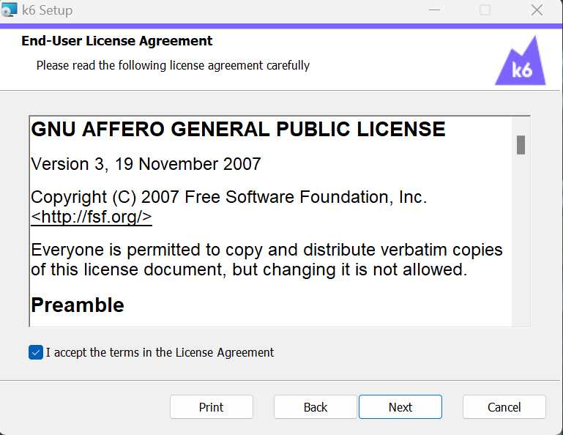

1. **Installation Location**:
   * Choose the installation location for k6. The default location is typically **C:\Program Files\k6**. You can either accept the default or specify a different folder by clicking the "Browse" button. After making your selection, click "Next."
2. **Select Components**:
3. **Ready to Install**:

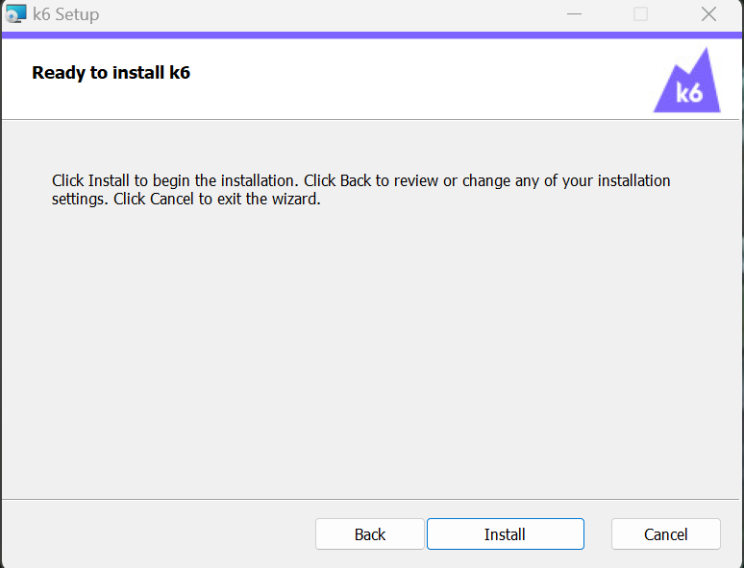

1. **Installation Complete**:
   * Once the installation is finished, you'll see a "Installation Complete" screen. Click the "Finish" button to exit the installer.

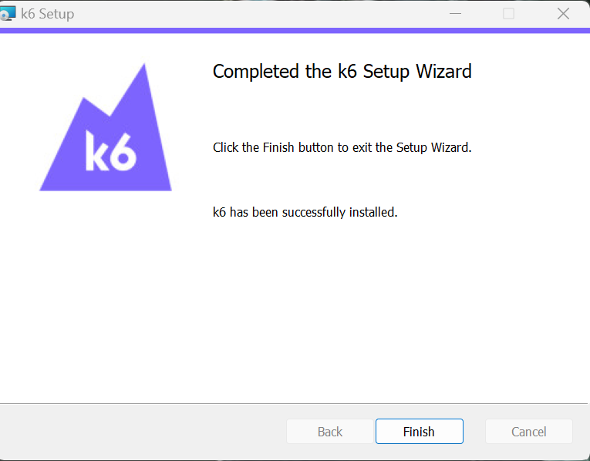

1. **Verify the Installation**:Top of Form

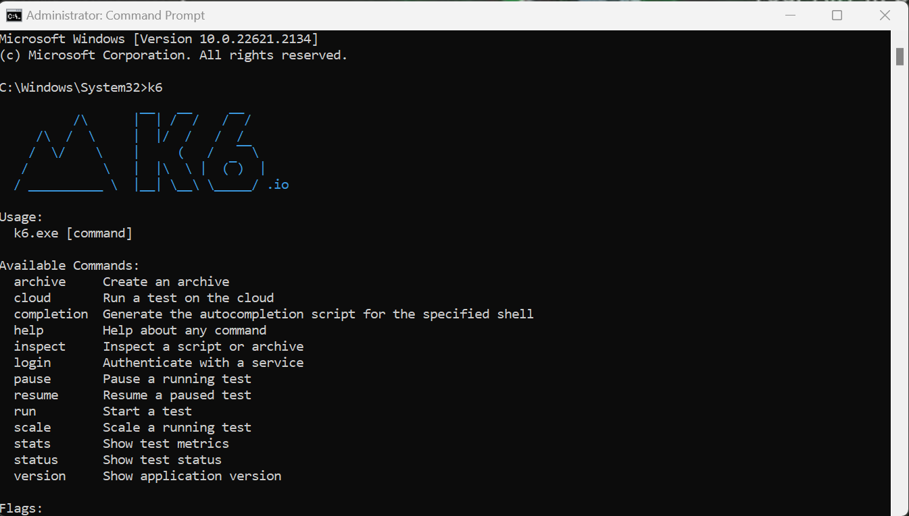Top of Form

Top of Form



It looks like you're outlining the contents of a chapter on writing load testing scripts using the k6 tool. This tool is often used for performance testing and load testing of web applications. Let me provide you with a brief overview of each section you've mentioned:

**2.1 Writing a Simple k6 Script**

In this section, you can introduce readers to the basics of writing a simple k6 script. You can start by explaining what k6 is, its purpose in load testing, and how to set up a basic script to get started with load testing.

**2.2 Anatomy of a k6 Test Script**

Here, you can delve into the structure of a k6 test script. Explain the main components of a k6 script, such as the **import**, **export**, and **default** statements, and the role they play in organizing the script.

**2.3 Importing Libraries and Modules**

This section can cover the process of importing external libraries and modules into a k6 script. Explain how to use the **import** statement to include pre-built functionality or custom modules.

**2.4 Defining Test Scenarios**

Discuss how to define test scenarios in a k6 script. Explain the concept of scenarios and how they allow you to structure and organize your load tests based on different user behaviors or use cases.

**2.5 Handling HTTP Requests**

2.5.1 GET Requests

Explain how to make GET requests using k6. Provide examples of how to specify the URL, headers, and other parameters for GET requests.

2.5.2 POST Requests

Similarly, describe how to make POST requests using k6. Cover topics like specifying request bodies, headers, and handling response data from POST requests.

**2.6 Adding Assertions**

Discuss the importance of assertions in load testing scripts. Explain how to add assertions to verify that the application is behaving correctly under load. Provide examples of common assertions.

**2.7 Custom Functions and Modules**

Explore the creation of custom functions and modules in k6. Show how readers can encapsulate reusable code into functions and modules for better script organization and maintenance.

You may want to include code examples, best practices, and tips throughout each section to help readers understand and apply the concepts effectively. Additionally, consider providing a complete example at the end of the chapter to demonstrate how all the components come together in a real-world load testing script.

Top of Form

Chapter 3, titled "Configuring Load Tests," seems like a valuable resource for readers interested in fine-tuning their load testing configurations. Here's an outline of what you can cover in each section:

**3.1 Test Duration and Iterations**

Explain how to configure the duration and iterations of load tests in k6. Discuss the trade-offs between running tests for a specific duration versus a fixed number of iterations. Provide guidance on choosing the appropriate settings based on testing objectives.

**3.2 Virtual Users (VUs) and Scenarios**

Delve into the concept of virtual users (VUs) in k6 and how they relate to test scenarios. Explain how to define and allocate VUs to different scenarios to simulate various user behaviors concurrently. Offer insights into balancing VUs to mimic real-world traffic.

**3.3 Test Stages (e.g., Ramp-up)**

Describe the importance of test stages in load testing. Discuss the concept of ramp-up, where you gradually increase the load on the system over time. Provide examples of how to implement ramp-up stages in k6 scripts to simulate realistic traffic patterns.

**3.4 Setting Thresholds**

Explain the significance of setting performance thresholds in load testing. Describe how to define performance thresholds for different metrics, such as response times, error rates, and resource utilization. Emphasize the importance of monitoring these thresholds during tests to identify performance issues.

Throughout each section, consider including practical examples and best practices for configuring load tests effectively. Highlight the role of k6-specific configuration options in achieving the desired test outcomes. Additionally, provide insights into common challenges and pitfalls that readers may encounter when configuring load tests and how to address them.

Chapter 4, titled "Executing Load Tests," can provide readers with practical guidance on how to run and manage their load tests using k6. Here's a detailed outline of the content for each section:

**4.1 Running Tests Locally**

Explain the process of running load tests locally with k6:

* Describe the setup required for running tests on a local machine.
* Provide step-by-step instructions on how to execute a k6 test script locally.
* Explain how to interpret and analyze the results generated from local tests.
* Include tips for optimizing local test runs and addressing common issues.

**4.2 Running Distributed Tests (k6 Cloud)**

Discuss the advantages and methods of running distributed load tests using k6 Cloud:

* Explain the benefits of distributing load tests.
* Provide instructions on how to set up and run distributed tests using k6 Cloud.
* Discuss scalability options and how to allocate VUs across multiple load generators.
* Highlight the importance of cloud-based testing for simulating real-world traffic.

**4.3 Running Tests with Environment Variables**

Explain how to parameterize load tests using environment variables:

* Discuss the importance of using environment variables for flexibility in load testing.
* Provide examples of how to define and use environment variables in k6 scripts.
* Explain how to manage and set environment variables for different test scenarios.
* Show how environment variables can be used for configuring test parameters, such as target URLs or authentication tokens.

**4.4 Continuous Integration (CI) Integration**

Discuss the integration of k6 load tests into continuous integration pipelines:

* Explain why integrating load tests into CI pipelines is essential for continuous performance testing.
* Provide guidance on configuring CI tools (e.g., Jenkins, Travis CI) to run k6 tests automatically.
* Discuss the use of test thresholds and pass/fail criteria in CI pipelines.
* Offer tips for generating and storing test reports within CI environments.

Throughout each section, include practical examples, best practices, and troubleshooting tips to help readers effectively execute their load tests. Emphasize the importance of integrating load testing into the development and deployment processes to catch performance issues early in the development lifecycle.

Top of Form

It looks like you've listed the chapter titles for a guide or document related to performance testing, specifically focusing on analyzing test results and utilizing tools like k6, Grafana, and InfluxDB for reporting and analysis. These chapters likely cover various aspects of interpreting, generating, and exporting performance test data. Here's a brief overview of what you might expect to find in each chapter:

**Chapter 5: Analyzing Test Results**

**5.1 Interpreting k6 Output:** This section likely delves into how to interpret the output and results generated by the k6 load testing tool. It might cover metrics, graphs, and other data points that k6 provides to evaluate the performance of your application.

**5.2 Generating and Viewing Load Test Reports:** This section is likely about generating reports from your load testing tool, which can help you summarize and visualize the test results more effectively. These reports can be essential for communicating findings to stakeholders.

**5.3 Advanced Reporting with Grafana:** Grafana is a popular monitoring and visualization tool. This section is probably about integrating Grafana with your load testing setup to create more advanced and customizable reports and dashboards for performance analysis.

**5.4 Exporting Data to InfluxDB for Analysis:** InfluxDB is a time-series database often used for storing performance data. This section might guide you on how to export your performance test data to InfluxDB, enabling you to conduct more in-depth and long-term analysis of performance trends.

These chapters appear to be part of a comprehensive guide or manual for professionals involved in performance testing and analysis, helping them make informed decisions based on the results of load tests. The specific content and details within each chapter would provide step-by-step instructions and best practices for each topic.

Top of Form

Chapter 6 appears to focus on load testing best practices, offering guidance on how to optimize your load tests, manage test data, plan for scalability, and integrate the k6 load testing tool into your DevOps pipelines. Here's a brief overview of what each section may cover:

**Chapter 6: Load Testing Best Practices**

**6.1 Script Optimization Techniques:** In this section, you'll likely find tips and techniques for optimizing your load testing scripts. This could involve improving script performance, reducing resource usage, and ensuring your scripts accurately reflect real-world scenarios.

**6.2 Managing Test Data and Scenarios:** Effective load testing often requires careful management of test data and scenarios. This section may discuss strategies for generating and maintaining test data, as well as creating realistic test scenarios that mimic user behavior.

**6.3 Scalability Testing Strategies:** Scalability testing is crucial for ensuring your application can handle increased load as your user base grows. This section might cover various scalability testing strategies, including how to design and execute tests that evaluate your application's ability to scale horizontally and vertically.

**6.4 Incorporating k6 into DevOps Pipelines:** Integrating load testing into your DevOps pipelines is essential for continuously monitoring performance throughout the software development lifecycle. This section may provide guidance on how to automate load tests using k6 within your CI/CD (Continuous Integration/Continuous Deployment) pipelines. This could involve setting up triggers, generating reports, and analyzing results as part of your DevOps process.

Overall, Chapter 6 aims to equip readers with best practices for conducting effective load testing, ensuring that your applications are performant, scalable, and reliable under various load conditions. Each section is likely to provide practical advice and actionable recommendations for load testing professionals and DevOps teams.

Top of Form

Chapter 7 appears to delve into advanced topics related to load testing and performance testing, covering areas like script parameterization, dealing with cookies, sessions, and authentication, WebSocket testing using k6, and integrating with InfluxDB for long-term data storage and analysis. Here's a brief overview of what each section may include:

**Chapter 7: Advanced Topics**

**7.1 Parameterization of Scripts:** This section likely explores techniques for parameterizing load testing scripts. Parameterization allows you to vary inputs and scenarios dynamically, making your tests more flexible and adaptable to different situations. It may also cover strategies for data-driven testing.

**7.2 Handling Cookies, Sessions, and Authentication:** In this section, you may find information on how to handle cookies, manage user sessions, and deal with authentication mechanisms during load testing. These aspects are critical for accurately simulating real user interactions with your application.

**7.3 WebSocket Testing with k6:** WebSocket is a protocol for real-time communication, commonly used in modern web applications. This section may guide you on how to perform load testing on WebSocket-based applications using the k6 tool, including establishing WebSocket connections, sending messages, and monitoring performance.

**7.4 Integrating with InfluxDB for Long-term Storage:** Building on the previous chapter, this section may provide more advanced insights into integrating k6 with InfluxDB for long-term storage of performance data. You might learn how to set up a robust data pipeline, configure retention policies, and leverage InfluxDB's capabilities for historical performance analysis.

Chapter 7 seems to be geared towards experienced load testing professionals who are looking to tackle more complex and specialized aspects of performance testing. It aims to equip readers with the knowledge and skills necessary to handle advanced scenarios and integrate tools effectively for in-depth analysis and monitoring.

Troubleshooting and debugging are crucial aspects of load testing and performance testing. In this section, you would likely find information on common issues encountered during load testing and the debugging techniques to resolve them. Here's what you might expect to find:

**Troubleshooting and Debugging**

**Common Issues and Solutions:** This section would likely provide a list of common problems that load testing professionals often encounter during performance tests. It may cover issues related to script errors, server errors, data inconsistencies, and more. For each issue, it should offer possible solutions or debugging steps to identify and rectify the problem.

**Debugging Techniques:** This part is likely to delve into debugging strategies and techniques specific to load testing. It may include guidance on how to:

* **Script Debugging:** Tips for identifying and fixing errors in your load testing scripts, including syntax errors, logic issues, or incorrect configurations.
* **Performance Bottleneck Identification:** Strategies for pinpointing performance bottlenecks in your application or infrastructure. This may involve analyzing performance metrics, logs, and profiling tools.
* **Load Generator Issues:** Troubleshooting problems related to load generators, such as resource constraints, network issues, or hardware failures.
* **Data and Test Environment Issues:** Techniques for diagnosing problems related to test data, database configurations, or issues within the testing environment.
* **Script Optimization for Debugging:** How to modify your load testing scripts to facilitate debugging, including the use of debugging statements, logging, and error handling.
* **Integration Issues:** Debugging challenges that can arise when integrating load testing tools with other software components, such as databases, APIs, or third-party services.
* **Error Analysis and Reporting:** Strategies for collecting, analyzing, and reporting errors and issues encountered during load tests.

The goal of this section is to help load testing professionals effectively diagnose and resolve issues that may arise during load testing scenarios. It equips readers with the knowledge and tools necessary to ensure accurate and reliable performance testing results.

**Here we are using Grafana for monitoring:**

**What is Grafana.**

Grafana is a popular open-source monitoring and visualization platform that is commonly used in conjunction with other tools, such as k6, for several reasons:

1. **Data Visualization:** Grafana provides a powerful and flexible interface for visualizing data. It supports various types of charts, graphs, and dashboards, making it easy to display complex data in a clear and comprehensible manner. This is crucial when analyzing load test results, as it allows you to spot trends, anomalies, and performance issues quickly.
2. **Integration with Data Sources:** Grafana can connect to various data sources, including time-series databases like InfluxDB, Elasticsearch, and Prometheus, among others. This means you can store load test results and other monitoring data in these databases and use Grafana to visualize and analyze the data.
3. **Real-Time Monitoring:** Grafana supports real-time data updates, enabling you to monitor your systems and applications in real-time. This is especially useful during load tests, as it allows you to see how your application responds to increasing levels of load and make adjustments as needed.
4. **Alerting:** Grafana includes a robust alerting system that can notify you when certain conditions are met. For example, you can set up alerts to notify you when response times exceed a certain threshold or when error rates spike during a load test.
5. **Custom Dashboards:** Grafana allows you to create custom dashboards tailored to your specific monitoring needs. You can arrange panels, charts, and metrics in a way that makes the most sense for your application and load testing requirements.
6. **Community and Ecosystem:** Grafana has a large and active community of users and developers. This means there are many pre-built dashboards and plugins available for a wide range of data sources and use cases. You can leverage these resources to expedite the setup of your monitoring and visualization environment.
7. **Scalability:** Grafana is designed to be highly scalable, making it suitable for monitoring small applications and large-scale, distributed systems alike. It can handle the visualization and analysis of data from multiple sources and across multiple environments.
8. **Historical Data Analysis:** Grafana allows you to retain and analyze historical data. This is valuable for comparing current load test results with past tests and identifying long-term trends and performance improvements or regressions.
9. **User-Friendly Interface:** Grafana's user-friendly and intuitive interface makes it accessible to both technical and non-technical team members. This facilitates collaboration and knowledge sharing within your team or organization.

In the context of load testing with k6, Grafana can be used to create informative and dynamic dashboards that display performance metrics, response times, error rates, and other key data points during and after load tests. These visualizations help teams identify bottlenecks, assess the impact of load on their applications, and make data-driven decisions to optimize performance.

Top of Form

Before load generate on webserver.

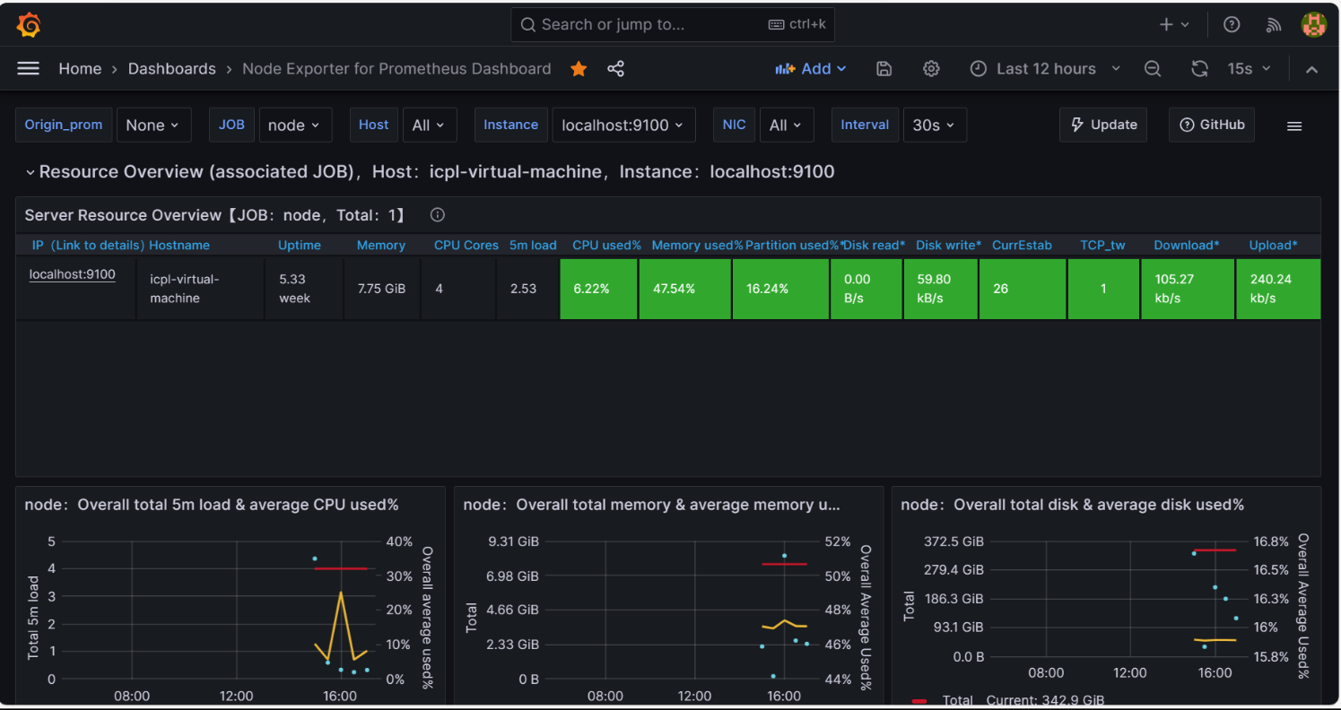

Website page is working properly.



After Load generate on Webserver.

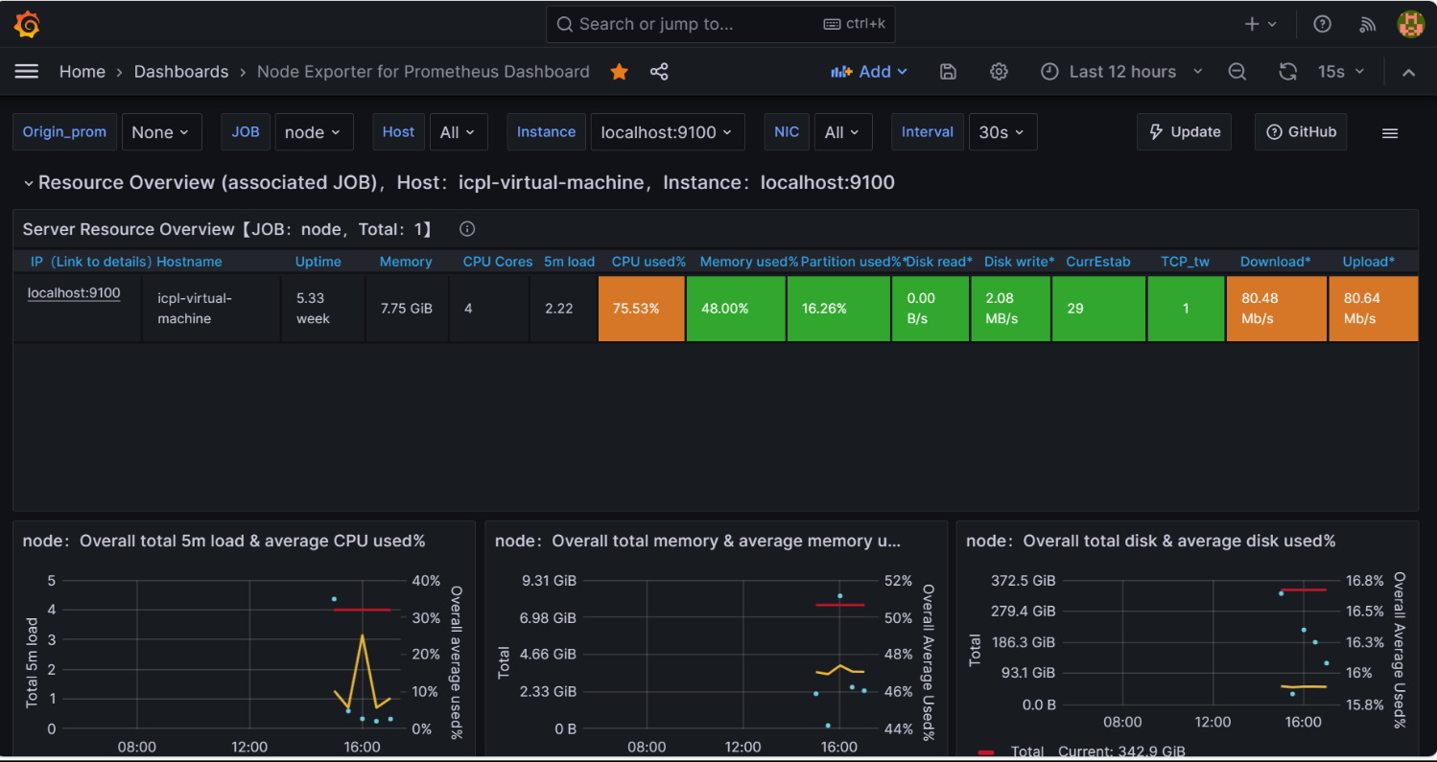

After load generate website page. 