Evaluating Shifts in Market Trends: January vs. November Effect

Malena Goldman Malka and Darcely Peña

Introduction to Time Series Analysis

May 9, 2025

Introduction

The January Effect refers to the observed pattern in financial markets where stock returns, particularly for small-cap firms, tend to be higher in January compared to other months. This phenomenon has intrigued investors for decades, as it challenges the Efficient Market Hypothesis (EMH), which claims that stock prices should fully reflect all available information. While past studies have consistently documented the January Effect, more recent research suggests that these seasonal trends may be fading, with some arguing that November may now be experiencing stronger returns.

This study evaluates the January Effect by analyzing monthly log returns of the S&P 500 index from 1985 to 2025. The primary objective is to assess whether the January Effect persists in recent decades or if other months, such as November, have become more prominent. To achieve this, we employed time series models such as ARIMA, SARIMA, and seasonal regression using monthly dummy variables. The analysis was initially conducted across all decades then divided into individual decades for a more detailed examination. Darcely focused on the 1980s and 1990s, while Malena analyzed the 2000s, 2010s, and 2020s. This division allowed us to capture short-term seasonal trends and gain a better understanding of how the January Effect may have evolved over time.

Our results show that while there is some historical evidence for the January Effect in the 1980s and 1990s, this effect has weakened significantly in recent decades. From 2000 onward, no consistent January anomaly was observed. In contrast, November showed stronger returns in the 2010s, though the 2020s have yet to demonstrate significant seasonal patterns. These findings suggest that the January Effect is no longer a dominant feature in the S&P 500.

Literature Review

The January Effect is one of the most well-known calendar-based anomalies in finance. As previously mentioned, it refers to the tendency for stock prices, particularly those of small-cap firms, to exhibit higher-than-average returns in January. One of the most widely accepted explanations for the January Effect is tax-loss selling. At the end of the year, individual investors often sell losing stocks to offset capital gains for tax purposes, leading to temporary price declines in December. In January, reinvestment or repurchasing causes prices to rebound, particularly among small-cap stocks that are more likely to be held by individual investors (He & He, 2011; Patel, 2016).

Early research by Haug and Hirschey (2006) reaffirmed the presence of the January Effect, especially among small-cap stocks in the U.S. market. Their analysis showed that the anomaly remained significant even after the implementation of the 1986 Tax Reform Act. This finding contradicted claims that the January Effect had been eliminated by regulatory changes or investor arbitrage. According to their results, small firm returns in January continued to exceed those in other months, suggesting that behavioral biases and structural market features still influenced investor behavior.

In contrast, He and He (2011) offered a structural explanation for the apparent decline of the January Effect and the rise of what they identified as a November Effect. They argued that the 1986 Tax Reform Act, which changed the fiscal year-end for mutual funds to October 31, created incentives for tax-loss selling in October. This shift caused stock prices to rebound in November rather than January. Analyzing data from the S&P 500 and Russell 2000 between 1960 and 2007, they found that the January Effect was significant during the pre-TRA period but became weaker or disappeared entirely in the years following the reform. Meanwhile, November returns grew in significance, especially in large-cap stocks, and these returns were independent of firm size. Their findings point to the influence of institutional investors and tax policy in shaping seasonal patterns in stock performance.

Expanding the scope of analysis, Patel (2016) examined monthly return data from 1997 to 2014 across a broad set of global indices, including the Russell 3000, developed markets, and emerging markets. His results showed no statistically significant January Effect in any of the indices. In most cases, January returns were lower than or similar to those of other months. This pattern held even during periods of financial instability, such as the 2008 crisis. Patel also noted that while the January Effect may have once been driven by tax behavior and market inefficiencies, improvements in market efficiency and the rise of institutional investing have likely contributed to its disappearance. His findings suggest that the January Effect has largely vanished from global financial markets and that any previous seasonal anomalies may no longer offer reliable investment strategies.

These three studies collectively trace the changing nature of the January Effect. While Haug and Hirschey (2006) supported its continued existence in certain contexts, He and He (2011) presented strong evidence for a shift in seasonal patterns driven by institutional and regulatory changes. Patel (2016) reinforced the conclusion that the January Effect no longer plays a significant role in modern markets. Together, these studies illustrate the need to account for changes in investor behavior, policy, and global market structures when evaluating calendar-based anomalies. This paper builds on that foundation by reexamining the January Effect with recent data and updated methods.

Model

To analyze the persistence of the January Effect, we will apply a range of time series techniques. First, we will compute the monthly log returns of the S&P 500 data to standardize the data. We will then test the stationarity of the log returns using visual inspection and the Augmented Dickey-Fuller (ADF) test. To identify and isolate any seasonal patterns, including the January Effect, we will employ seasonal decomposition techniques such as STL (Seasonal-Trend decomposition using Loess).

To formally test for seasonal anomalies, we will run a regression model with monthly dummy variables. This will allow us to assess whether returns in January and November are significantly different from those in other months, helping us evaluate the persistence of the January Effect and detect any shifts in seasonal trends.

Furthermore, we fit ARIMA and SARIMA models to the log return series to account for autocorrelation and seasonality. These models allow us to assess whether incorporating seasonal components, such as those associated with the January Effect, offers any explanatory value in modeling monthly returns.

Data

This analysis uses monthly stock price data for companies listed on the S&P 500, spanning from 1985 to the present. The key variables in the dataset include the date, closing price, high price, low price, opening price, and trading volume for each company. We had 474 records in our dataset encompassing all decades.

Empirical Analysis

The analysis of monthly stock returns from 1990 to 2024 provides limited support for the persistence of the January Effect. The Augmented Dickey-Fuller test confirmed that the log return series is stationary (ADF = -20.44, *p* < 0.001) supporting the use of time series models. An ARIMA(1,0,1) model revealed only the constant term was statistically significant (*p* = 0.004) indicating an average monthly return of 0.69% over the period. To better capture seasonality, we applied a SARIMA(1,0,1)(1,0,1) model. However, it showed that while the error variance was significant, the autoregressive or moving average terms were not. Similarly, a seasonal regression framework found no months had significantly lower returns than January. These findings did not support the existence of the January Effect, which may have been masked by the extended time frame analyzed. As a result, breaking the data down by decade may offer better insight into short-term seasonal trends.

The analysis of monthly stock returns from 1985 to 1989 provides some insight into seasonal patterns, including a potential January Effect. The Augmented Dickey-Fuller test confirms the log return series is stationary (ADF = -6.845, *p* ≈ 0.000). The ARIMA(1,0,1) model shows a significant AR(1) coefficient of -0.8194, indicating strong mean-reversion in returns. The SARIMA(1,0,1)(1,0,1)[12] model also identifies a significant negative correlation between consecutive returns (AR(1): z = -5.921, *p* = 0.000), but seasonal terms are not significant. Despite this, the seasonal regression analysis reveals that October and November returns are significantly lower than January (October: t = -0.0887, *p* = 0.016; November: t = -0.0820, *p* = 0.026), suggesting some seasonal weaknesses in the fall months. This is illustrated in Figure 1, where January shows the highest average returns of all months, although only October and November have significantly lower returns. Our results do not strongly support the January Effect when compared to all the months, but it does indicate weaker returns in the fall.

Figure 1: Average Monthly Log Returns (Seasonality Check) in 1980s

The analysis of monthly stock returns in the 1990s provides evidence of a seasonal component consistent with the January Effect. The series was confirmed to be stationary (ADF = -11.9331, p < 0.001), validating time series modeling. An ARIMA(1,0,1) model revealed a significant positive constant (0.0125, p < 0.001), suggesting average monthly returns increased steadily over time. The low error variance (σ² = 0.0014, p < 0.001) further indicated that the model effectively captured variation in the data. When accounting for seasonality using a SARIMA(1,0,1)(1,0,1)[12] model, we found significant seasonal autoregression (Coefficient = 0.7848, p = 0.004), pointing to a strong correlation in returns at a 12-month lag. This suggests a recurring annual pattern. Additionally, the low and consistent volatility of the residuals (σ² = 0.0015, p < 0.001) reinforces model reliability. A seasonal regression analysis showed that January returns were significantly positive (Constant = 0.0250, p = 0.049), and August had notably lower returns (Coefficient = -0.0488, p = 0.006) which is visualized in Figure 2. These results offer modest support for the January Effect during this period, especially when contrasted with weaker August performance.

Figure 2: Average Monthly Log Returns (Seasonality Check) in 1990s

From 2000 to 2009, our analysis did not uncover any statistically significant evidence of a January or November effect in the S&P 500. The Augmented Dickey-Fuller test confirmed that the log return time series was stationary (p < 0.01), which meant that differencing was not required for further modeling. To examine whether certain months exhibited consistently higher or lower returns, we calculated and plotted the average log return for each calendar month during the decade. This is shown in Figure 3, which was used as a preliminary check for potential seasonal trends in monthly performance.

Figure 3: Average Monthly Log Returns (Seasonality Check) in 2000s

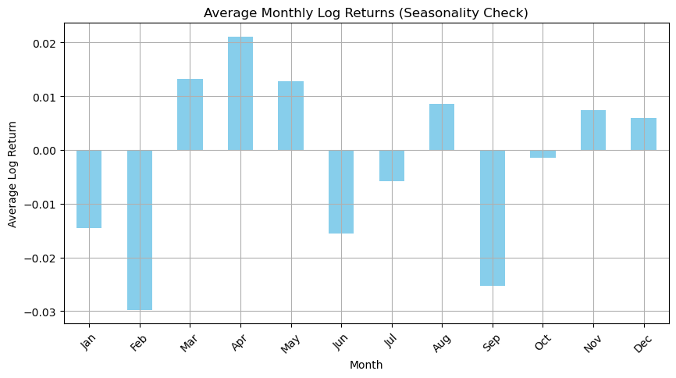

Figure 3 illustrates the average monthly log returns during this decade. Although some months, such as April and March, showed higher average returns, the differences were not statistically meaningful. The seasonal decomposition using STL revealed only a minimal seasonal component, and the seasonal terms in the SARIMA model were not statistically significant. Both the ARIMA(1,0,1) and SARIMA(1,0,1)(1,0,1,12) models fit the data reasonably well, showing no strong signs of residual autocorrelation or heteroskedasticity. However, ARIMA was slightly favored because it had a lower AIC value (−387.49 compared to −385.44) and a simpler structure. The regression analysis using monthly dummy variables found no significant effects for any individual month, and the overall model was not statistically significant based on the F-statistic (p = 0.298). When comparing forecasting performance, SARIMA had marginally lower error values, but both models produced similar results. Overall, the findings for this decade do not support the existence of seasonal anomalies related to either January or November.

During the 2010s, our analysis identified limited signs of seasonal return patterns in the S&P 500. Using the Augmented Dickey-Fuller test, we confirmed that the log return series was stationary (statistic = -5.782, p = 0.000001), which meant we could model the data without differencing. To explore potential monthly effects, we generated a boxplot illustrating the distribution of returns across the calendar year. This visualization, shown in Figure 4, allowed us to examine how return patterns varied month to month and whether any outliers or irregularities appeared.

Figure 4: Distribution of Average Monthly Log Returns (Seasonality Check) in 2010s

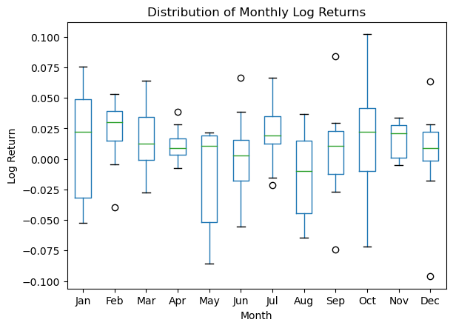

As shown in Figure 4, there is no clear or consistent indication that either January or November consistently outperformed other months. While January showed wider variability, it did not stand out as an anomaly. These visual observations are supported by model-based analysis. The ARIMA(1,0,1) model indicated statistically significant short-term dynamics, with the MA(1) term (0.5120, p = 0.007) showing that past errors meaningfully influenced current returns. The residual variance (σ² = 0.0018, p = 0.000) was small and significant, suggesting the model explained substantial variation in returns.

The SARIMA(1,0,1)(1,0,1,12) model also captured significant short-term error dynamics (MA(1) = 0.5218, p = 0.005), but none of its seasonal parameters were statistically significant. The seasonal AR(12) coefficient was 0.1502 with a p-value of 0.674, indicating no strong correlation at the yearly lag. The residual variance remained low and consistent, mirroring the ARIMA model’s stability.

Regression analysis using monthly dummy variables provided a more nuanced result. While the intercept for January was only marginally significant (0.0185, p = 0.061), the November dummy was statistically significant (0.0350, p = 0.010), suggesting that November returns were meaningfully higher than those in January. This indicates some degree of positive seasonality for November, though it was not supported by the SARIMA model's seasonal structure. Overall, the results from 2010 to 2019 do not point to a robust January effect, but they do suggest that November returns may have outperformed on average during this period. This finding stands out relative to the previous decade, where no individual month showed significant performance differences.

The analysis for the 2020s is based on a shorter time span, covering only the first half of the decade. As a result, this period includes fewer data points, which may limit the statistical power of our findings. Nonetheless, we applied the same methodology used in previous decades to ensure consistency. The Augmented Dickey-Fuller test confirmed that the log return series remained stationary (test statistic = -8.9415, p < 0.000001), meaning that further differencing was not required. However, the ARIMA(1,0,1) model did not reveal any statistically significant short-term dynamics or meaningful drift. Both the moving average term (p = 0.535) and the constant (p = 0.151) were insignificant, though the model's residual variance was still reliable (p = 0.000).

Conclusion

Our results show that the January Effect, once considered a reliable seasonal pattern in financial markets, does not appear to persist in recent decades. While the effect was somewhat visible in the 1980s and showed modest support in the 1990s, our analysis of the 2000s, 2010s, and early 2020s found no consistent or statistically significant evidence of unusually high returns in January. These findings are in line with existing research. Patel (2016) observed that the January Effect has weakened in recent years, likely due to increasing market efficiency and the rise of institutional trading. He and He (2011) also argued that tax policy reforms, such as the 1986 Tax Reform Act, may have shifted seasonal return patterns away from January and toward other months like November. Our findings support this shift, as the only notable seasonal result appeared in the 2010s when November returns were significantly higher than January’s.

Through this project, we learned to apply a variety of time series techniques, including ARIMA, SARIMA, and seasonal regression models, to study patterns in financial data. These tools allowed us to test for stationarity, model return behavior, and evaluate whether monthly patterns had predictive value. A major takeaway was understanding how to compare models not just based on fit statistics, but also on the reliability and interpretability of their components. One challenge we faced was the limited data in the 2020s, which made it harder to draw firm conclusions about recent seasonal trends. We also hoped the models would reveal clearer patterns, especially around January, but the results often lacked statistical strength. Despite these limitations, the project gave us a stronger grasp of both time series analysis and how seasonal behavior in markets can change over time.