Bent-pipe RTT and Rain
Analysis of the WetLinks traceroute data, Osnabrück site
Data: WetLinks dataset (Laniewski et al., arXiv:2402.16448), Sep 14 2023 – Mar 12 2024

1. Objective
The WetLinks paper shows that rain reduces the Starlink download throughput. This study asks a related question about latency:
Is there a relation between rain at the dish and the bent-pipe RTT?
The bent-pipe RTT is the round-trip time over the part of the path that uses radio: dish → satellite → ground station → Starlink gateway. This is the part of the path where rain can weaken the signal. It is measured with the traceroute data (net_traceroute.csv) of the Osnabrück site.
Rain is not the only factor that changes the RTT. The RTT also changes over the day and over the months. These factors must be neutralised first; only then can the remaining RTT be compared with rain.

2. What net_traceroute is
net_traceroute.csv contains the results of MTR (Matt's traceroute, version 0.94). MTR finds every router on the path from the measurement client to the measurement server in Osnabrück (131.173.23.81) and measures the round-trip time to each of them.
- How often: one traceroute run about every 6 minutes (the paper: every 6 minutes; in the Osnabrück data the median time between two runs is 5.9 minutes).
- Packets per hop: MTR runs 15 report cycles, i.e. it sends 15 probe packets to every hop (column packets_send = 15). The RTT columns are statistics over these 15 probes.
- One row per hop: every run writes one row for every router on the path. At Osnabrück the path has 13 hops, so each run generates 13 rows.

2.1 The path at Osnabrück
The dish, the satellite and the ground station do not appear as hops, because they forward the signal without routing it. The first router after the radio part is the Starlink gateway 100.64.0.1, which is hop 1 at Osnabrück. Its RTT therefore contains the whole radio part of the path: the bent-pipe RTT.
Hop | Address (hop_id) | Owner (asn) | Part of the path
– | (not visible) | – | Dish → satellite → ground station (radio, Ku-/Ka-band)
1 | 100.64.0.1 | Starlink | Starlink gateway, end of the bent-pipe (used in this study)
2 | 172.16.250.x | Starlink | Starlink internal network
3–4 | 206.224.65.x | AS14593 (Starlink) | Starlink point of presence (PoP), Frankfurt
5–9 | *.twelve99.net | AS1299 (Arelion) | Internet backbone Frankfurt → Hamburg
10–12 | *.x-win.dfn.de, uni router | AS680 (DFN) | German research network → Osnabrück University
13 | vm952.rz.uni-osnabrueck.de | AS680 | Measurement server (target)

2.2 Columns of net_traceroute.csv
Column | Meaning
site_name | measurement site (uos-rz = Osnabrück)
timestamp_start | start of the traceroute run (UTC); identical for all hops of one run
timestamp_end | end of the run (about 20–25 s after the start)
hop | position of the router on the path (1 = first router)
target | destination of the traceroute (the measurement server)
ip_protocol | IP version (v4)
hop_id | host name and/or IP address of the router; ??? if the router did not answer
asn | autonomous system (network operator) of the router; AS??? if unknown/private
packet_loss | % of the 15 probes to this hop without a reply
packets_send | number of probes sent to this hop (15)
ping_avg | mean RTT of the probes to this hop [ms]
ping_worst | slowest probe [ms]
ping_best | fastest probe [ms]
ping_stddev | standard deviation of the probe RTTs [ms]
hops | total number of hops of this run (13 for a normal Osnabrück run)

2.3 Example: the first 26 rows of the Osnabrück file
This is how net_traceroute.csv of Osnabrück looks. The first 26 rows are two traceroute runs (15:13:03 and 15:18:53, 5 min 50 s apart), each with 13 rows, one per hop. Columns that are constant (site_name = uos-rz, target = 131.173.23.81, ip_protocol = v4) and timestamp_end are left out. Only the highlighted hop-1 rows (100.64.0.1) are used in this study.
Run | Start (UTC) | hop | hop_id | asn | loss % | sent | avg | best | worst | std | hops
1 | 15:13:03 | 1 | 100.64.0.1 | AS??? | 0.0 | 15 | 29.35 | 18.65 | 49.82 | 8.06 | 13.0
1 | 15:13:03 | 2 | 172.16.250.140 | AS??? | 0.0 | 15 | 29.82 | 23.23 | 44.19 | 5.73 | 13.0
1 | 15:13:03 | 3 | undefined.hostname.localhost (206.224.65.194) | AS14593 | 0.0 | 15 | 26.19 | 19.62 | 34.51 | 4.66 | 13.0
1 | 15:13:03 | 4 | undefined.hostname.localhost (206.224.65.178) | AS14593 | 0.0 | 15 | 28.36 | 18.75 | 35.27 | 4.88 | 13.0
1 | 15:13:03 | 5 | ffm-b11-link.ip.twelve99.net (62.115.37.20) | AS1299 | 0.0 | 15 | 28.61 | 19.61 | 38.33 | 4.95 | 13.0
1 | 15:13:03 | 6 | ??? | AS??? | 100.0 | 15 | 0.0 | 0.0 | 0.0 | 0.0 | 13.0
1 | 15:13:03 | 7 | hbg-bb2-link.ip.twelve99.net (62.115.127.90) | AS1299 | 26.67 | 15 | 38.88 | 29.08 | 53.47 | 7.74 | 13.0
1 | 15:13:03 | 8 | hbg-b2-link.ip.twelve99.net (62.115.132.109) | AS1299 | 0.0 | 15 | 38.74 | 25.39 | 51.86 | 8.77 | 13.0
1 | 15:13:03 | 9 | dfn-ic-373396.ip.twelve99-cust.net (213.248.100.167) | AS1299 | 0.0 | 15 | 44.08 | 35.05 | 68.46 | 8.68 | 13.0
1 | 15:13:03 | 10 | cr-ham1-be8.x-win.dfn.de (188.1.144.57) | AS680 | 0.0 | 15 | 51.33 | 40.91 | 67.27 | 7.64 | 13.0
1 | 15:13:03 | 11 | kr-uniosn11.x-win.dfn.de (188.1.231.90) | AS680 | 0.0 | 15 | 61.4 | 49.05 | 85.04 | 10.65 | 13.0
1 | 15:13:03 | 12 | r0001g94rB05-xe0-0-7-u91.net.uni-osnabrueck.de (131.173.252.202) | AS680 | 0.0 | 15 | 55.72 | 47.01 | 67.82 | 6.29 | 13.0
1 | 15:13:03 | 13 | vm952.rz.uni-osnabrueck.de (131.173.23.81) | AS680 | 0.0 | 15 | 57.09 | 45.41 | 70.85 | 8.34 | 13.0
2 | 15:18:53 | 1 | 100.64.0.1 | AS??? | 0.0 | 15 | 31.88 | 19.88 | 41.64 | 5.59 | 13.0
2 | 15:18:53 | 2 | 172.16.250.140 | AS??? | 0.0 | 15 | 30.55 | 19.5 | 40.56 | 5.35 | 13.0
2 | 15:18:53 | 3 | undefined.hostname.localhost (206.224.65.194) | AS14593 | 0.0 | 15 | 31.69 | 23.62 | 43.49 | 5.59 | 13.0
2 | 15:18:53 | 4 | undefined.hostname.localhost (206.224.65.178) | AS14593 | 0.0 | 15 | 31.28 | 18.71 | 37.93 | 5.37 | 13.0
2 | 15:18:53 | 5 | ffm-b11-link.ip.twelve99.net (62.115.37.20) | AS1299 | 0.0 | 15 | 34.51 | 23.77 | 42.72 | 5.78 | 13.0
2 | 15:18:53 | 6 | ffm-bb2-link.ip.twelve99.net (62.115.124.118) | AS1299 | 66.67 | 15 | 36.74 | 31.36 | 42.71 | 4.09 | 13.0
2 | 15:18:53 | 7 | hbg-bb2-link.ip.twelve99.net (62.115.127.90) | AS1299 | 13.33 | 15 | 36.7 | 30.52 | 46.5 | 5.01 | 13.0
2 | 15:18:53 | 8 | hbg-b2-link.ip.twelve99.net (62.115.132.109) | AS1299 | 0.0 | 15 | 36.56 | 30.53 | 43.75 | 4.04 | 13.0
2 | 15:18:53 | 9 | dfn-ic-373396.ip.twelve99-cust.net (213.248.100.167) | AS1299 | 0.0 | 15 | 48.82 | 38.18 | 64.6 | 6.52 | 13.0
2 | 15:18:53 | 10 | cr-ham1-be8.x-win.dfn.de (188.1.144.57) | AS680 | 0.0 | 15 | 52.26 | 42.37 | 61.55 | 5.44 | 13.0
2 | 15:18:53 | 11 | kr-uniosn11.x-win.dfn.de (188.1.231.90) | AS680 | 0.0 | 15 | 59.14 | 51.39 | 68.33 | 4.89 | 13.0
2 | 15:18:53 | 12 | r0001g94rB05-xe0-0-7-u91.net.uni-osnabrueck.de (131.173.252.202) | AS680 | 0.0 | 15 | 61.77 | 47.78 | 91.44 | 10.13 | 13.0
2 | 15:18:53 | 13 | vm952.rz.uni-osnabrueck.de (131.173.23.81) | AS680 | 0.0 | 15 | 59.59 | 54.69 | 72.88 | 4.73 | 13.0

2.4 Why a later hop can show a lower RTT than an earlier hop
In the example above, the RTT does not always grow from one hop to the next. In run 1, hop 3 (26.19 ms) is lower than hop 1 (29.35 ms) and hop 2 (29.82 ms), and hop 12 (55.72 ms) is lower than hop 11 (61.40 ms). Hop 6 did not answer at all (???, 100% loss), while the hops behind it did.
Note: the WetLinks paper does not discuss this effect; it only reports the bent-pipe and end-to-end RTT. The reasons below are the standard explanations for traceroute measurements:
- Replies are generated by the router's control processor. A traceroute reply (ICMP "time exceeded") is created by the router's CPU, not by its fast forwarding hardware. Routers treat this as low priority and rate-limit it. The reply delay of a hop therefore includes a variable processing time, which can be larger than the delay to reach a router further away.
- Every hop is measured with different packets at different moments. The 15 probes to hop 1 and the 15 probes to hop 3 are sent at different times. Over Starlink the delay changes from moment to moment (satellite scheduling, reconfiguration every 15 s), so two hops measured a few seconds apart can see different conditions.
- The reply can take a different return path. The reply from a router comes back over whatever route that router uses, which is not necessarily the forward path.
- Routers may ignore traceroute probes. Some routers never answer or drop most probes (hop 6), while still forwarding the traffic to the next hops.
For this study this means that the RTT of an intermediate hop is noisy. The analysis therefore uses medians over many runs, not single values.

3. How the paper neutralised the time of day (download throughput)
Before relating rain to download throughput, the paper removes the influence of the time of day (Section V-E-1 and Table III of the paper):
- Outliers were removed with the interquartile-range rule (factor 1.5).
- All non-rainy samples of both sites were combined. The overall median download throughput of these samples was calculated.
- The non-rainy samples were grouped into 24 hourly buckets, and the median of each hour was calculated (Fig. 10 of the paper; over 60 Mbit/s between the lowest and the highest hour).
- For every hour, the correction factor c_dt = overall median − hourly median (Table III).
- c_dt was added to every sample of that hour, rainy or not. Afterwards all hours lie on the same level, and the samples were grouped into rain buckets.

Hour | 0 | 2 | 5 | 8 | 12 | 15 | 17 | 19 | 20 | 23
c_dt [Mbit/s] | −10.35 | −13.73 | −29.64 | −5.37 | +0.08 | +4.35 | +20.46 | +30.70 | +31.72 | −1.13
Excerpt of Table III of the paper. Negative = the hour is faster than the overall median, so throughput is lowered; positive = slower hour, throughput is raised.
Example: a sample measured at 19h gets +30.70 Mbit/s added, because 19h is the hour with the lowest throughput. The paper notes as a limitation that this does not account for variation between days (e.g. weekday/weekend). The correction factors are also constant over the six months.

4. This study: bent-pipe RTT vs. rain at Osnabrück

4.1 Plan
- Extract the bent-pipe RTT: from every traceroute run, keep only the hop-1 row (100.64.0.1).
- Attach the weather: rain rate (mm/h) and other weather values from the weather station next to the dish, at the time of each run.
- Neutralise the other factors: remove the influence of the time of day and of the slow change over the months (Section 5).
- Relate the remaining RTT to rain: compare rainy and dry runs and test the correlation.

4.2 The extracted data
The preprocessing script preprocessing/bentpipe_merger.py reads net_traceroute.csv and keeps one row per traceroute run. This gives one bent-pipe RTT value about every 6 minutes:
 | Runs
All traceroute runs, Sep 14 2023 – Mar 12 2024 | 38,703
Removed: outages (no reply from 100.64.0.1) | 7
Removed: no weather data at that time | 962
Removed: rare routes (see 4.3) | 155
Runs used in the analysis | 37,579 (about 37k)

For each run the file stores the bent-pipe RTT (bp_rtt_avg, plus best/worst/std), the route label, the rain rate at the time of the run (rain_now, mm/h), the rain in the 15 and 60 minutes before, other weather values, and the hour and date.

4.3 Why the hops after 100.64.0.1 are also recorded
Only the RTT of hop 1 is analysed. The addresses of the next three hops are nevertheless stored for every run as a route label (path_sig), for the following reason:
- 100.64.0.1 is the same address for every Starlink customer. It does not identify a particular machine. If Starlink moves the traffic to another gateway or ground station, hop 1 still shows 100.64.0.1.
- The hops after it (Starlink internal router and PoP routers) do change. They show which Starlink equipment handled the traffic.
- A different gateway or ground station can mean a different distance on the ground, especially between the ground station and the gateway (100.64.0.1 is most likely located near the PoP in Frankfurt, while the ground station is probably in Aerzen, roughly 250 km away). This fibre section is inside the bent-pipe RTT, so a route change can change the bent-pipe RTT without any change in the weather.
Three routes were found at Osnabrück:
Route | Hops 2–4 after 100.64.0.1 | Period | Runs | Median bent-pipe RTT
R1 | 172.16.250.140 > 206.224.65.194 > 206.224.65.178 | Sep 14 – Dec 7 | 18,711 | 32.3 ms
R2 | 172.16.250.140 > 206.224.65.206 > 206.224.65.184 | Dec 5 – Dec 7 | 477 | 31.9 ms
R3 | 172.16.250.34 > 206.224.65.198 > 206.224.65.182 | Dec 19 – Mar 12 | 18,391 | 28.5 ms

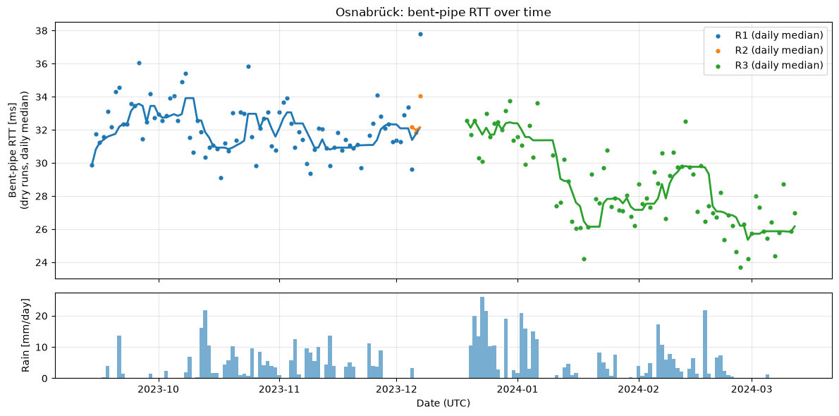
Figure 1 (notebook Step 2a): daily median bent-pipe RTT of the dry runs, coloured by route, with a 7-day rolling median; daily rainfall below.
Observation: the bent-pipe RTT is clearly lower in the later months (about 32 ms in autumn, about 26 ms in March). This could be an effect of the route or an effect of the month; the cause is still an open question:
- R3 starts in late December at about 32.5 ms, the same level as R1. The large drop happens later, in steps (mid-January, late February), while the route label stays R3.
- So the route label alone does not explain the drop. Starlink may have changed something that the traceroute does not show (e.g. ground-station assignment), or the change is related to the season.
For the analysis, the important consequence is: whatever the cause, the RTT level changes over time, and the correction must follow it (Section 5).

5. Preprocessing: neutralising the other factors

5.1 Intuition
Only dry runs are used to learn what the RTT normally is (dry = no rain at the time of the run and none in the 60 minutes before). From them we build an estimation function:
dry_run_function(day, hour) → estimated RTT at that day and hour if there is no rain

Example. Day 23, hour 3: the function estimates that a dry run at that time would measure 31 ms. The run measured at that time actually had 34 ms. The difference is called the excess RTT:
excess_rtt = measured RTT − dry_run_function(day, hour)
= 34 ms − 31 ms = 3 ms

The excess RTT is calculated for every run, dry and rainy. Because the estimate already contains the effects of the day and the hour, these effects are removed from excess_rtt. For dry runs excess_rtt is about 0 on average. The question then becomes: is there a correlation between excess_rtt and rain? If rain slows down the bent-pipe, rainy runs should have a larger excess_rtt than dry runs.

5.2 How the estimation function is built
The paper's correction (Section 3) uses one correction per hour for the whole six months. For the bent-pipe RTT this is not enough, because the RTT level drops over the months (Figure 1). The estimation function therefore has two parts:
dry_run_function(day, hour) = level(day) + hour_correction(period, hour)

Part | Removes | Calculation (dry runs only)
level(day) | the change over the months | median RTT of all dry runs from 3 days before to 3 days after the day (7-day window, at least 200 runs)
hour_correction(period, hour) | the change over the day (night about +2 ms, morning about −1.5 ms) | median of (RTT − level) of the dry runs at that hour; calculated separately before and after the December data gap, because the day/night swing was larger in autumn (4.4 ms) than in winter (2.8 ms)

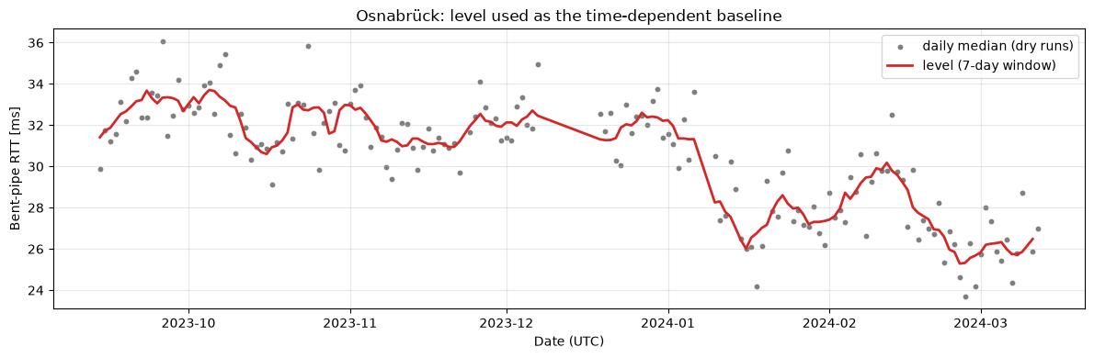
Figure 2 (notebook Step 4a): daily medians of the dry runs (grey) and level(day) (red), which follows the change over the months.
Real example (run on 2023-10-11 at 15:53, before the gap):
level(2023-10-11) = 32.19 ms (dry runs Oct 8 – Oct 14)
hour_correction(period 1, 15h) = −0.67 ms (15h is 0.67 ms below the level)
dry_run_function = 32.19 − 0.67 = 31.52 ms
measured bent-pipe RTT = 41.77 ms
excess_rtt = 41.77 − 31.52 = +10.25 ms

Check of the correction: for the daily medians of the dry runs, the standard deviation drops from 2.71 ms (before) to 1.15 ms (after); the autumn-to-March drop is removed. What remains is random variation of about ±1–2 ms between single days.

5.3 Next step
With excess_rtt available for all 37,491 runs (88 runs next to the December gap have no level), the next step compares the median excess_rtt of rainy runs (by rain rate) with that of dry runs, and tests the correlation between excess_rtt and the rain rate.

