Summary

Sensor coverage, d: there is a sensor node within distance d from every point in the region of deployment.

n – number of nodes
A – area of the region
Radiation power loss model: cr^{m} to transmit up to distance r.

To satisfy coverage d:
Arrangement | Required n | Energy, e_{m} | Energy, m = 2 | Energy, m = 3
Triangular | 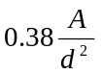 | 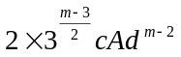 | 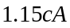 | 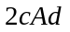
Square | 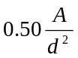 | 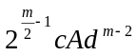 |  | 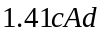
Hexagonal | 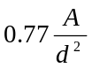 | 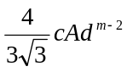 | 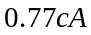 | 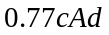

Keeping n constant:
Arrangement | Coverage, d | Energy, e_{m} | Energy, m = 2 | Energy, m = 3
Triangular | 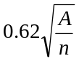 | 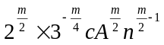 |  | 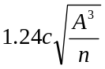
Square | 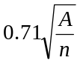 | 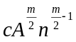 |  | 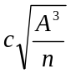
Hexagonal | 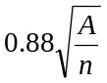 | 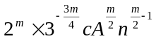 |  | 