/*+++++++++++++++++++++++++++++++++++++++++++++++++++++++++++++++++++++
#+
#+ Glade / Gtk Programming
#+
#+ Copyright (C) 2019 by Kevin C. O'Kane
#+
#+ Kevin C. O'Kane
#+ kc.okane@gmail.com
#+ https://www.cs.uni.edu/~okane
#+ http://threadsafebooks.com/
#+
#+ This program is free software; you can redistribute it and/or modify
#+ it under the terms of the GNU General Public License as published by
#+ the Free Software Foundation; either version 2 of the License, or
#+ (at your option) any later version.
#+
#+ This program is distributed in the hope that it will be useful,
#+ but WITHOUT ANY WARRANTY; without even the implied warranty of
#+ MERCHANTABILITY or FITNESS FOR A PARTICULAR PURPOSE. See the
#+ GNU General Public License for more details.
#+
#+ You should have received a copy of the GNU General Public License
#+ along with this program; if not, write to the Free Software
#+ Foundation, Inc., 59 Temple Place, Suite 330, Boston, MA 02111-1307 USA
#+
#++++++++++++++++++++++++++++++++++++++++++++++++++++++++++++++++++++*/

August 22, 2021

Possible Error Conditions

If you have more than one microphone one your system, be sure the correct mic is designated as the default mic (see Pulse sound preferences panel app or pavucontrol). This must be done prior to starting this application.

If Pulse becomes confused, as to settings, delete the directory ~/.config/pulse and re-boot. That is, if the app meters register no sound and/or the Pulse Volume Meter (pavumeter) resgisters no sound. When you reboot, the pulse directory will be re-built.

Installation

A binary named vumeter-bin is provided. This may or may not work with your system.

To compile from source code, you will need to first install any software not on your system. To do this, please run GeneralInstall.script as root. This will install (via apt install) any standard system packages you may be missing.

The code has been developed using 'out-of-the-box' default desktop themes on Mint Mate 20.2 with the Mint-X theme.

If you are using another Gnome desktop theme than the Mint X theme, it is possible that some objects may not be correctly sized.

To compile the source code, after installing any needed packages, type:

make

To execute the binary, type

vumeter-bin

Command Line Options

The command line options for vumeter-bin are:

-a show arcs
-b show bars only
-c centered spectrum
-g spectrum graph only - no meters
-l lines only
-m meters only - go spectrum graph
-B bars and lines
-v traditional vumeter style
-w wide spectrum
-s val sample rate [50]
-h help
-? help

Examples
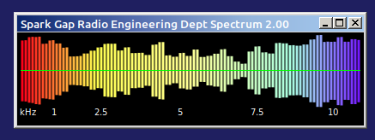

vumeter-bin -g -c -b

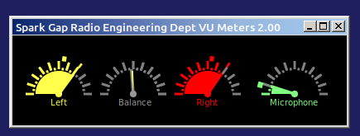

vumeter-bin -m -a

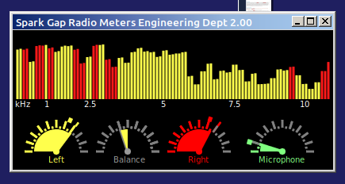

vumeter-bin -a -b

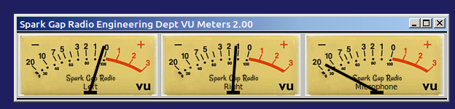

vumeter-bin -v

Kevin O'Kane
kc.okane@gmail.com
https://www.cs.uni.edu/~okane

