**Human Resource Management System**

* **Introduction:**

In the modern corporate landscape, the efficient management of human resources has become a critical aspect of organizational success. Human Resource Management Systems (HRMS) have emerged as indispensable tools that streamline and enhance various HR functions, leading to increased productivity, improved employee satisfaction, and better strategic decision-making. This project aims to develop and implement a comprehensive HRMS solution that will revolutionize the way organizations manage their workforce

The HRMS project seeks to address the challenges faced by HR departments in managing diverse aspects of human resources, such as employee information, payroll, attendance, performance evaluation, training, recruitment, and more. By integrating these functions into a unified digital platform, the project aims to eliminate manual and time-consuming processes, reduce errors, enhance data accuracy, and provide real-time insights to support informed decision-making.

This HRMS project will focus on creating an intuitive user interface that caters to HR professionals and employees, ensuring easy navigation and user-friendly interactions. By providing self-service capabilities to employees, they can access and update their personal information, request leaves, track attendance, and participate in training programs, thereby promoting transparency and empowerment within the organization.

Furthermore, the project will emphasize data security and compliance, ensuring that sensitive employee information is safeguarded through advanced encryption and access controls. This will instill trust among employees regarding the confidentiality and integrity of their personal data within the system.

* **MODULE DISCRIPTION**

The list of modules incorporated with “Human Resource Management System” is...

* + - Login Page for Admin.
    - Admin Dashboard to see Employees overall information.
    - See all Employees.
    - Employees Management.
    - Department Management.
    - About HRMS System.

This module deals with the management of the employee information such as the personal details-his/her name, qualification, skill, experience, login id, password, etc. Importance of modules in any software development side is we can easily understand what the system we are developing and what its main uses are. At the time of project, we may create many modules and finally we combine them to form a system.

* **ER Diagram:**

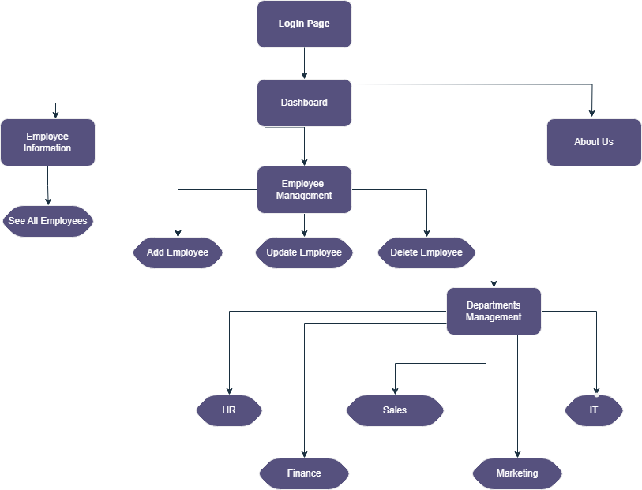

1. **Login Page for Admin Module:**

The HRMS Admin Login Page module serves as the gateway to the Human Resource Management System, providing authorized administrators with secure access to the system's comprehensive features and functionalities. As a critical component of the HRMS project, this module is designed to ensure efficient and controlled access for administrators, allowing them to manage and oversee various aspects of human resource management within the organization.

1. Secure Authentication: The module incorporates strong authentication methods to ensure that only authorized personnel can access the HRMS. This safeguards confidential employee information and prevents unauthorized individuals from tampering with the system.
2. User-Friendly Interface: The login page is designed to be intuitive and user-friendly, ensuring that administrators can easily navigate the login process. Clear instructions and error messages are provided to guide users in case of any issues during login attempts.
3. **Admin Dashboard Overall Information Module:**

In today's dynamic business environment, HR departments require swift access to accurate and up-to-date information about their employees. This module serves as a central hub where HR managers can swiftly retrieve a holistic overview of the workforce's status, performance, attendance, and other pertinent metrics. By presenting this information in an intuitive and visually engaging dashboard, decision-makers can derive actionable insights that inform strategic HR decisions.

1. Real-time Metrics: The dashboard provides real-time updates on employee data, including headcount, on-duty employees, leave requests, and other relevant figures, ensuring that decisions are based on the most current information available.
2. Data Visualization: Visual representations such as charts, graphs, and heat maps make it easier to comprehend complex data trends at a glance.
3. **See All Employees Module:**

The "See all Employees" module is a pivotal component of the Human Resource Management System (HRMS), designed to provide HR professionals and authorized stakeholders with a comprehensive view of the entire workforce within the organization. This module serves as a centralized repository of employee information, facilitating efficient management, data analysis, and decision-making processes.

1. Comprehensive Employee Profiles: This module provides a detailed profile for each employee, containing essential information such as personal details, contact information, job role, department, reporting structure, and employment history. Having a centralized database simplifies the retrieval of employee data and eliminates the need for searching through multiple sources.
2. **Employee Management Module:**

The heart of any organization lies in its workforce, and managing employees efficiently is a cornerstone of successful human resource management. The Employee Management module within the HRMS (Human Resource Management System) serves as the nucleus of the entire system, facilitating the comprehensive management of employee-related information, activities, and interactions. This module plays a pivotal role in optimizing HR operations, enhancing employee engagement, and contributing to the overall success of the organization.

1. Add Employee:The "Add Employee" module serves as a digital gateway that enables HR professionals to input and store comprehensive details about new hires in a centralized database. This information includes personal data, contact details, Department Details, and any other pertinent information required for official records and organizational compliance.
2. Update Employee: The "Update Employee" module within the HRMS project has been designed to provide HR administrators with a powerful tool to effortlessly manage and maintain the latest employee details, thereby contributing to data accuracy, compliance, and informed decision-making.
3. Delete Employee:The "Delete Employee" module is a crucial component within the Human Resource Management System (HRMS) that addresses the process of removing employee records from the system. This module serves as a vital tool for HR professionals to manage workforce changes effectively, ensuring accurate and up-to-date employee information while adhering to company policies and legal requirements.
4. **Department Management Module:**

The "Department Management" module is a fundamental component of the Human Resource Management System (HRMS) project, designed to revolutionize the way organizations structure and manage their departments. In today's dynamic business environment, effective department management is essential for optimizing workflows, fostering collaboration, and achieving organizational goals. This module aims to provide a robust and user-friendly platform that empowers HR administrators and department heads to efficiently manage the organization's structural framework.

1. Department Wise Employee View: Admin can see the employees by selected Department.
2. **About Us Module:**

The "About Us" module within the Human Resource Management System (HRMS) provides a valuable platform for organizations to present a comprehensive overview of their identity, values, culture, and mission. This module serves as a virtual window into the heart of the organization, allowing employees to better understand the company's history, objectives, and core beliefs. The "About Us" module goes beyond a mere introduction, fostering a sense of belonging, unity, and alignment among employees while reinforcing the organization's unique identity.

* **Software Requirements:**
* Windows 10 or higher
* MongoDbCompass
* React Technology
* Node js
* Visual Studio Code
* **Technology:**
* **Front-End**
* React.js
* Bootstrap 5
* Free-Frontend
* **Back-End**
* MongoDBCompass
* Node.js
* Express.js
* **Hardware Components:**
* Processor –intel CORE i3
* Hard Disk – 512 SSD
* Memory – 8GB RAM
* **Advantages of the Proposed Project:**
* Process Efficiency
* Data Accuracy
* Real-time Analytics
* Employee Self-Service
* Compliance Assurance
* Scalability

• Strategic HR Focus

* **Application:**
* This application can be used by the small or large organization.
* This application can be also used in different types of device also

Like: - Desktop, Tablet, Mobile etc.

* **Reference Link:**
* <https://getbootstrap.com/>
* <https://unsplash.com/>
* <https://www.freepik.com/popular-photos>
* <https://www.w3schools.com/>
* <https://nodejs.org/en/docs>
* <https://expressjs.com/>
* <https://storyset.com/>
* <https://fontawesome.com/v4/icons/>
* <https://freefrontend.com/>
* **Inputs :**
* **Login Page:**

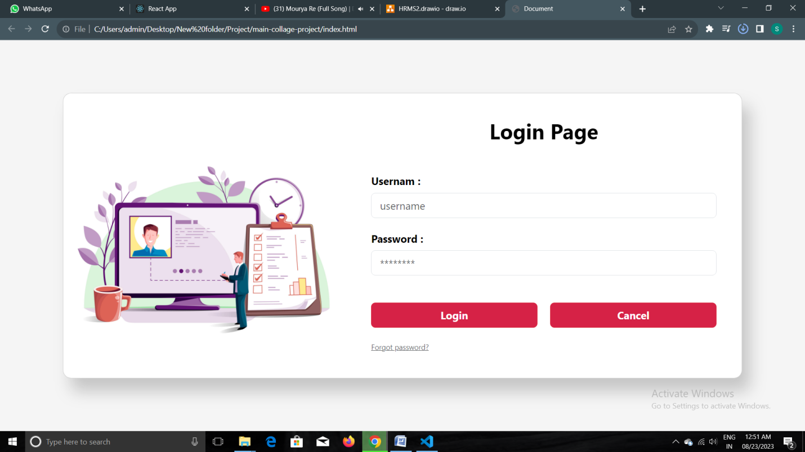

* **Employee Information Page:**

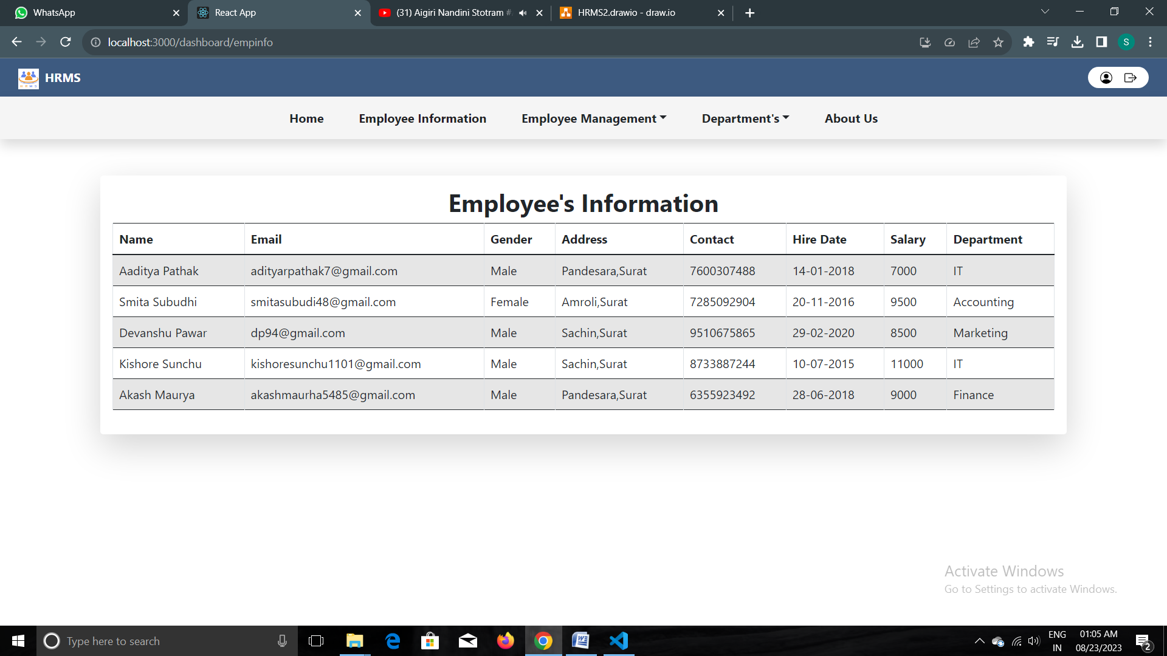

* **Employee Management:**

1. **Add Employee:**

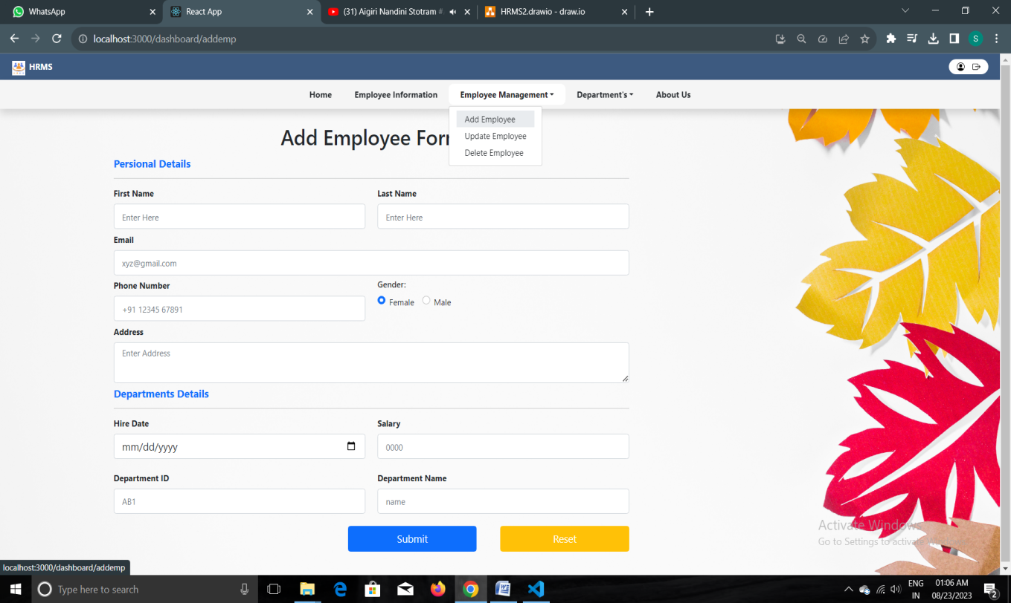

1. **Update Employee:**

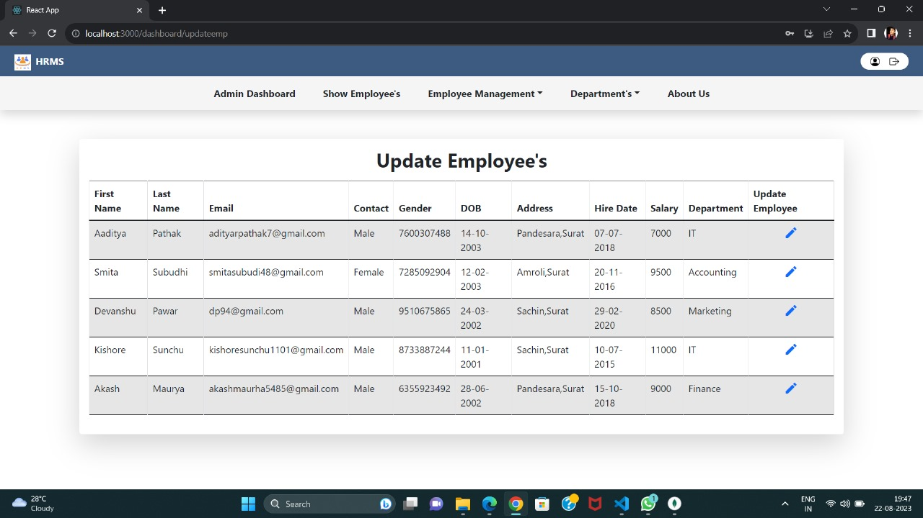

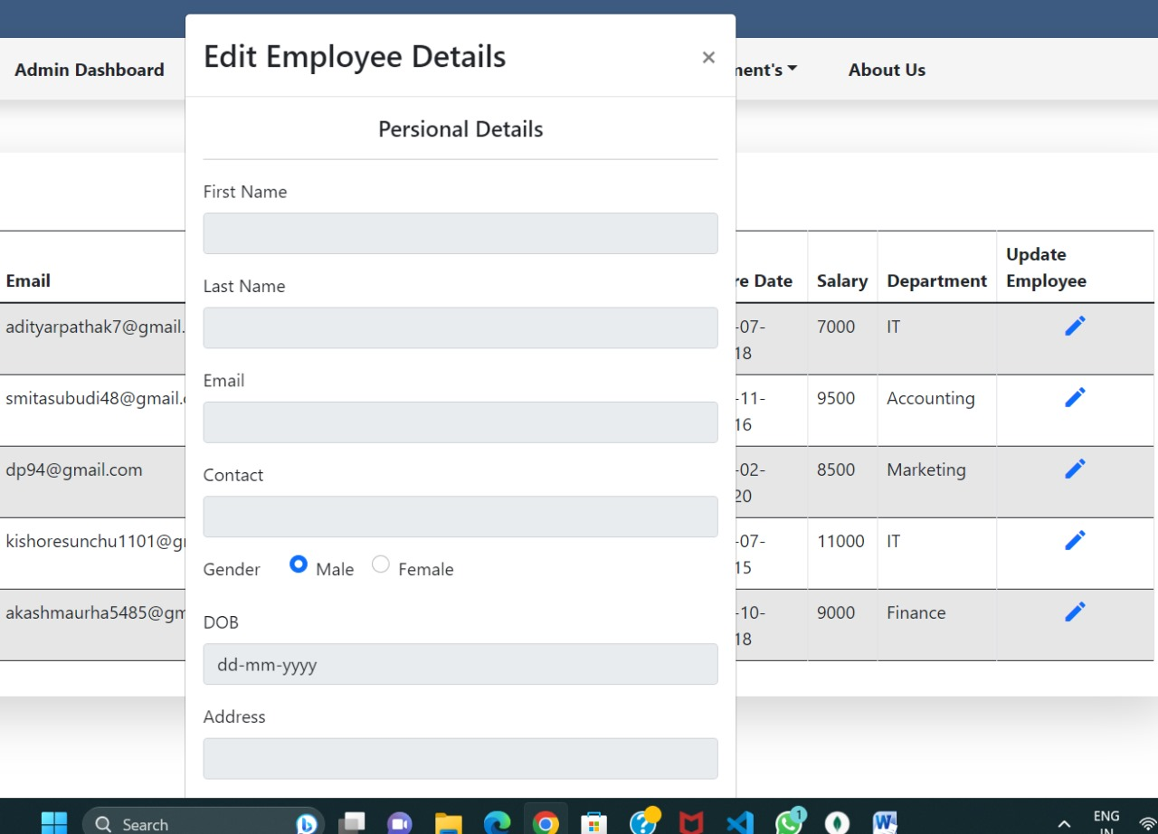

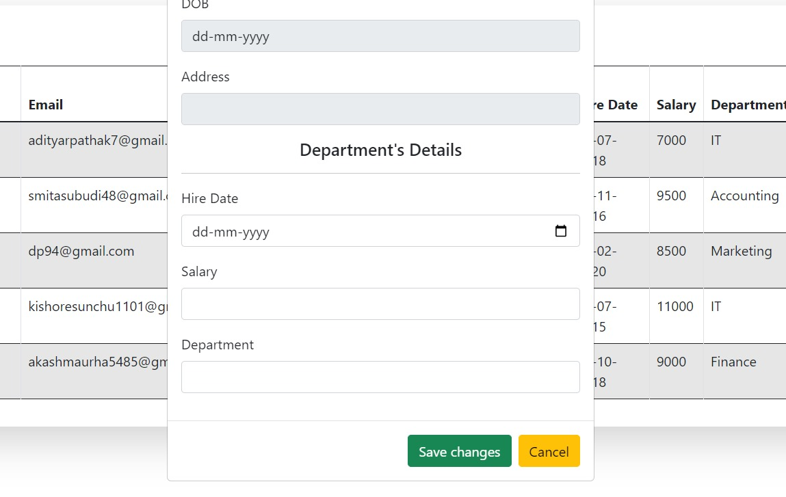

1. **Delete Employee:**

