Discussion:

Part 2:

From the average comparison versus load ratio graph it is clearing that chaining is the best and most efficient method for collision resolution. Chaining was followed by quadratic then linear single hashing in terms of performance. Linear double hashing was the worst resolution and increases exponentially. These results are shown in figure 1.

Part 3:

The findings for part 3 were very similar to that of part 2. Chaining was still the best method for collision resolution. However; linear single hashing performed worse than in part 2 despite having a smaller bucket size. Figure 2 shows the described results. Figures 3 and 4 show the comparison in performance between part 2 and 3.

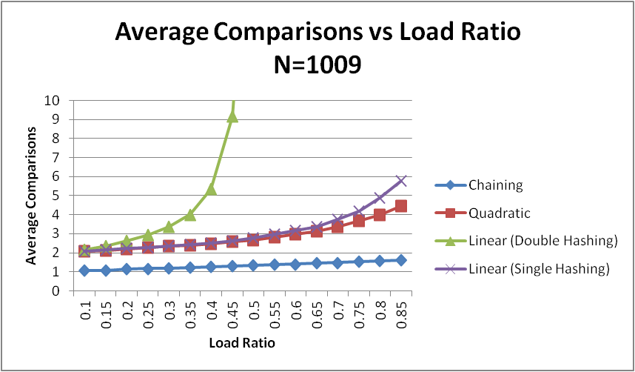

Figure 1

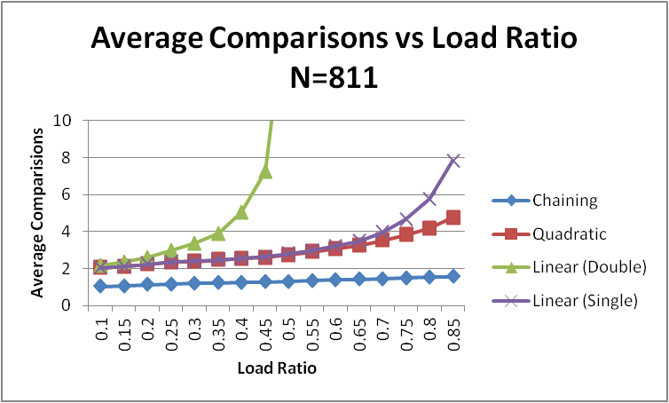

Figure 2

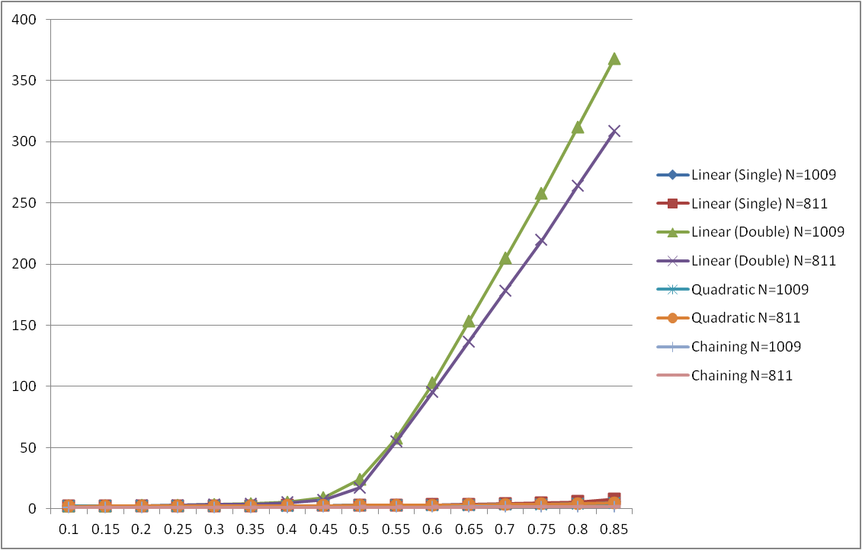

Figure 3

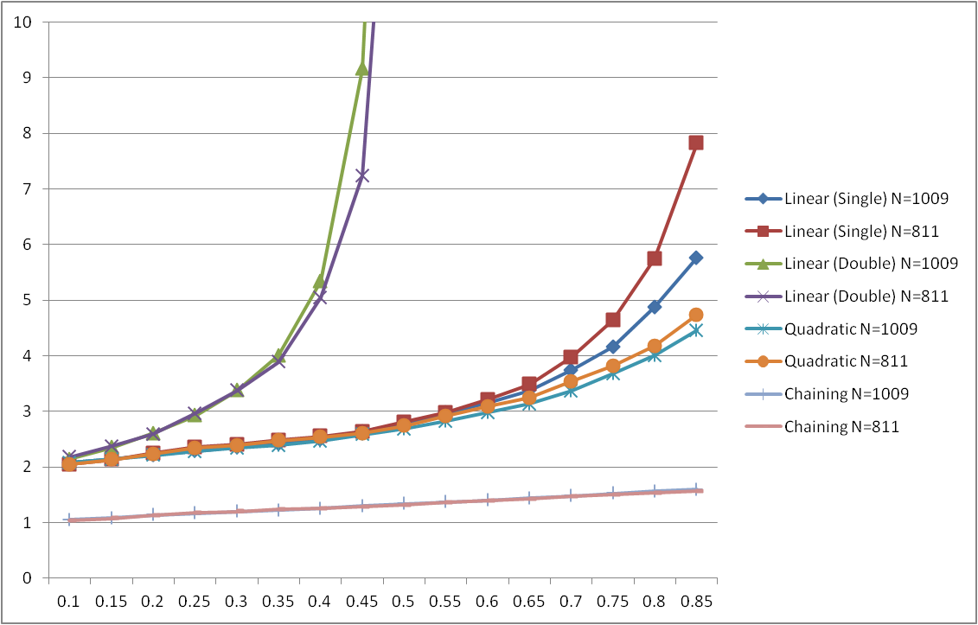

Figure 4