**Social media feed**

Target: As a result of completing the H/W, I created a social network news feed in accordance with the requirements.

Repository: <https://github.com/maleykovichdim/social_net_rss_redis>

Deployment: <https://social-net-rss-redis.herokuapp.com/>

I used Redis as a cache.

1st Stage:

I added 2 tables in a mysql DB:

create table if not exists posts

(

  `id` int(11) NOT NULL AUTO_INCREMENT,

  `author_id` int(11) NOT NULL,

  `content` TEXT NOT NULL,

  `created_at` timestamp DEFAULT CURRENT_TIMESTAMP,

  PRIMARY KEY (`id`)

) ENGINE=InnoDB DEFAULT CHARSET=utf8mb4 COLLATE=utf8mb4_0900_ai_ci;

CREATE TABLE IF NOT EXISTS follows (

    follower_id int(11) NOT NULL REFERENCES users ON DELETE CASCADE,

    followee_id int(11) NOT NULL REFERENCES users ON DELETE CASCADE,

    UNIQUE (follower_id, followee_id)

);

I added a button (**Follow**) to the page to set up subscribers:

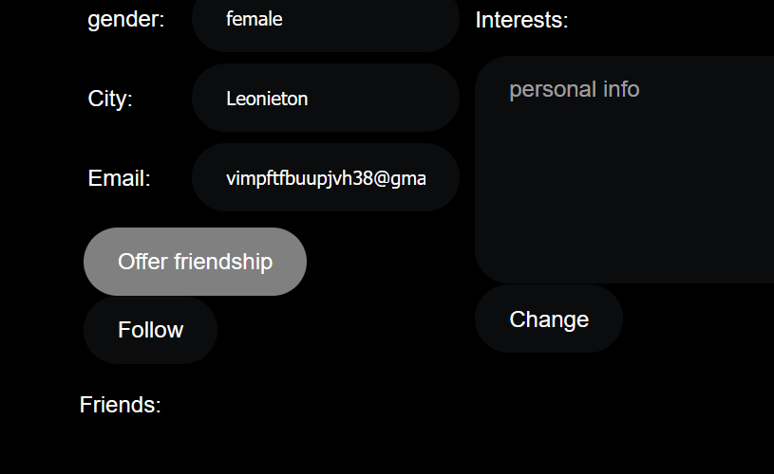

* You can also add **subcribers**, **posts**, get/create **rss feed** by using Java application from “client” folder.

I created several http requests:

    //posts+follower+rss for http requests from html pages

    1. api.HandleFunc("POST", "/auth_user/post", h.userPost) //add post

    2. api.HandleFunc("POST", "/auth_user/follow", h.follow)

    3. api.HandleFunc("GET", "/auth_user/rss_feed", h.rss)

    4. api.HandleFunc("GET", "/auth_user/is_followee", h.isFollowee)

    //only for test purposes without authorization for Java App

api.HandleFunc("POST", "/user/postTest", h.userPostTest)

api.HandleFunc("POST", "/user/followTest", h.followTest)

    api.HandleFunc("GET", "/user/rss_feed", h.rssTest)

2. this request sets “followee” for current user in the mysql db and generates record in Redis:

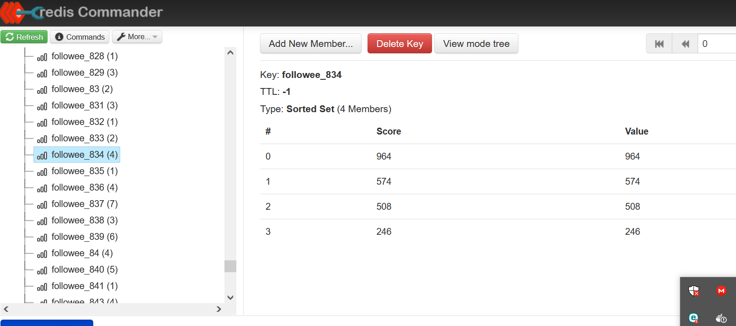

These records are inverted. The key is generated using the user Id for which there were subscriptions.

**Description** of numbered requests:

1. This request checks: are your following the user whose personal information you are viewing…
2. This request gets a new feed data from Redis if it has an appropriate record

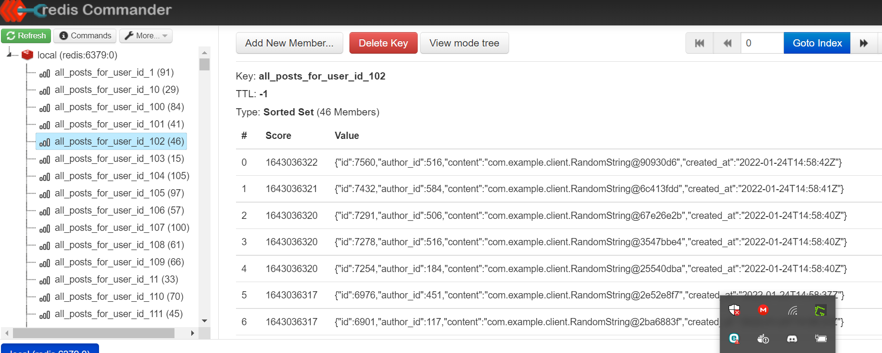

or generate it from the mysql db and put into Redis.

1. This request put a post in the mysql db and after looking up the followee keys in Redis, add the post to the corresponding news feeds in Redis.

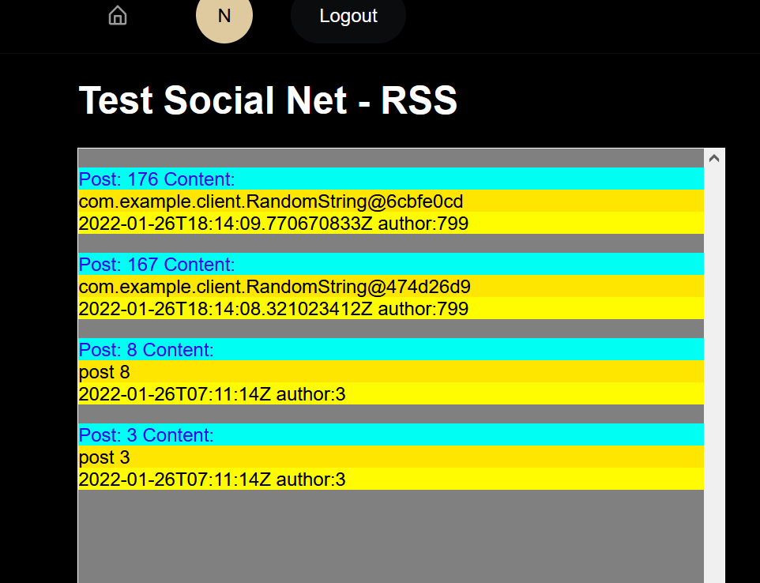

For the page above use the following button:

