|  |  |
| --- | --- |
| **DOKUMENTASI EKSTERNAL**  External Documentation |  |
| **PROYEK**  ***Project*** |
| **MATAKULIAH BA02 – Web Programming** |
| SEMESTER GENAP 2018/2019 ***Odd Semester Year 2018/2019*** |

## Judul Proyek

* **Pintester**

**Abstrak**

* Pintester is a website that used by user to sell their art to others user. User can show their art to the other people before buy the product. Pintester is a place for user to express their desire in creating art. Others user that see the product can appreciate the product by buying the product from the user. All the credit will be given to the creator of the art.

**Pendahuluan**

* Pintester can be used by every people around the globe. People can see and sell their art to other people to have a profitable income. To sell their product, people need to register them self as a member of Pintester. If people is not a member of Pintester, they can only see the product.

**Dokumentasi**

**Login page**

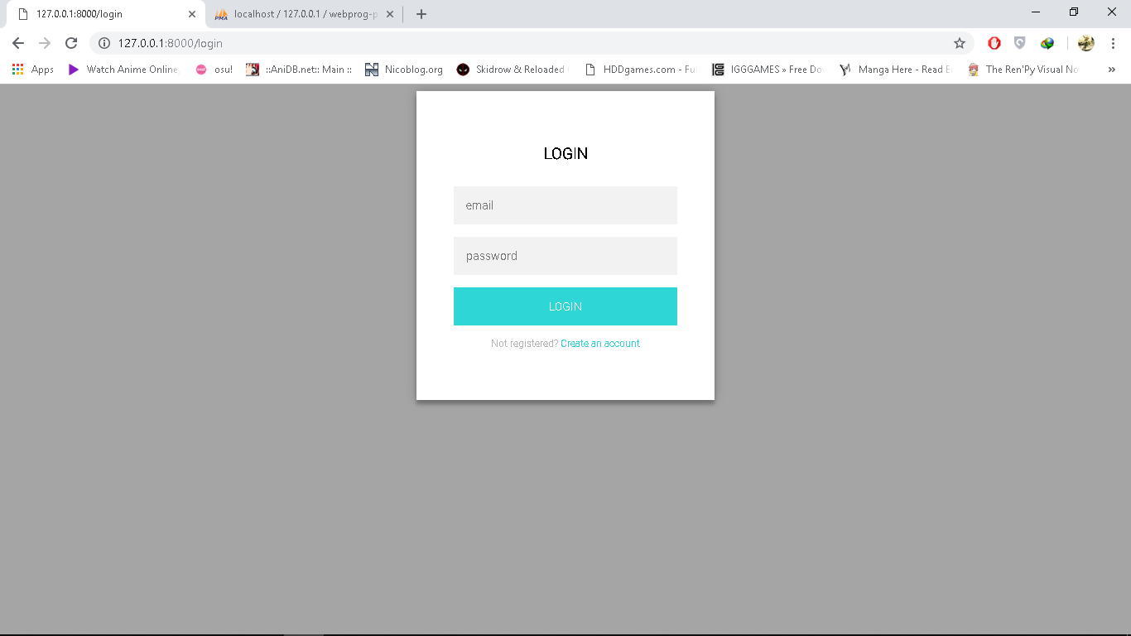

**Register page**

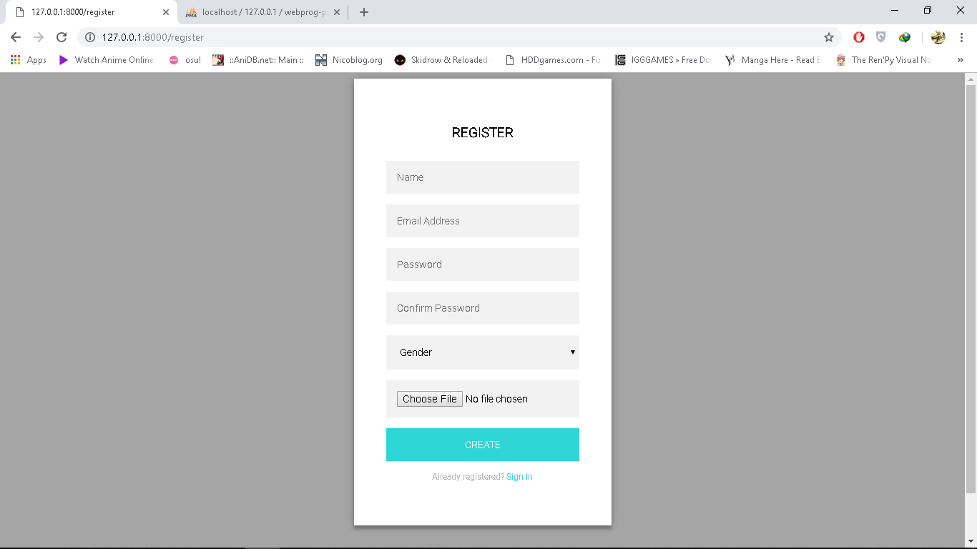

**Home page for Guest**

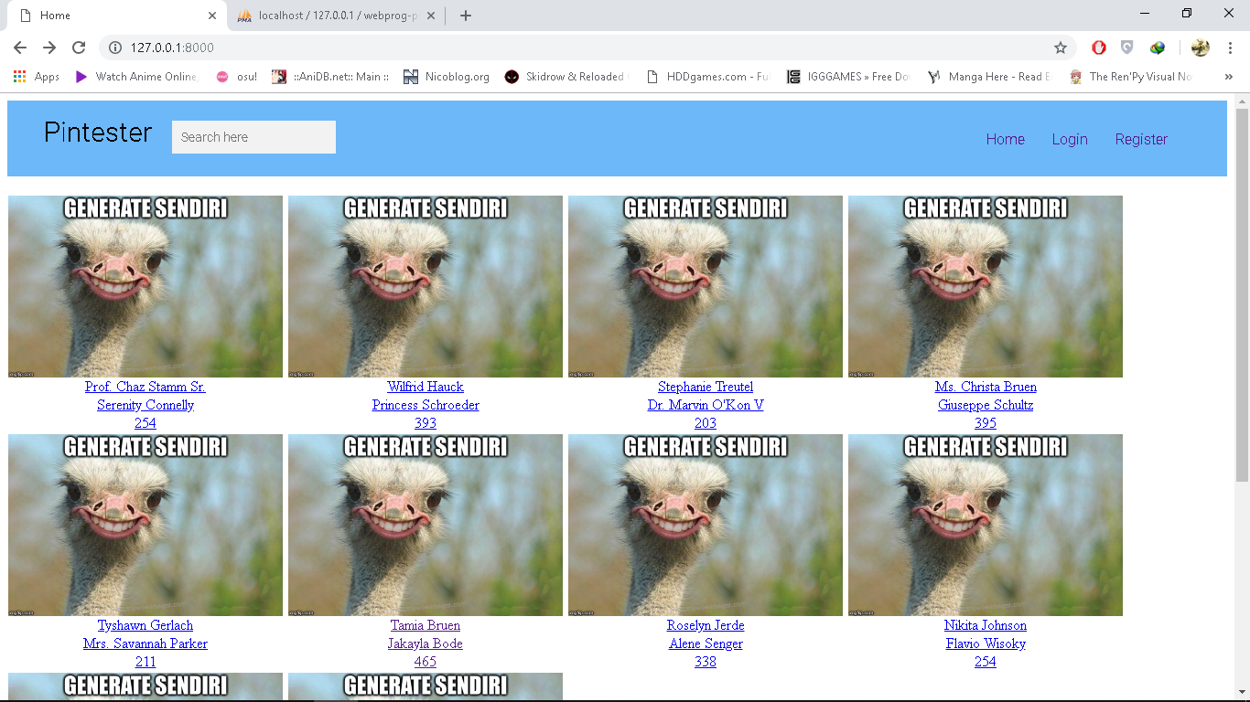

**Home page for Admin**

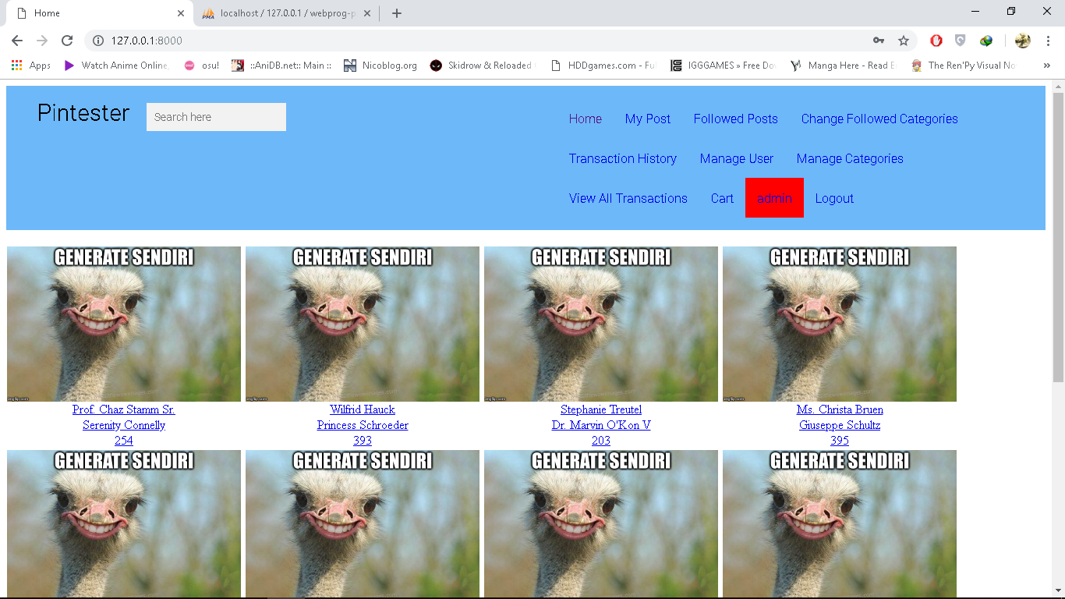

**Home page for Member**

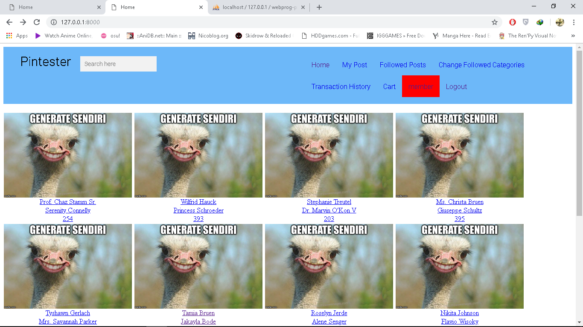

**My post page for Member**

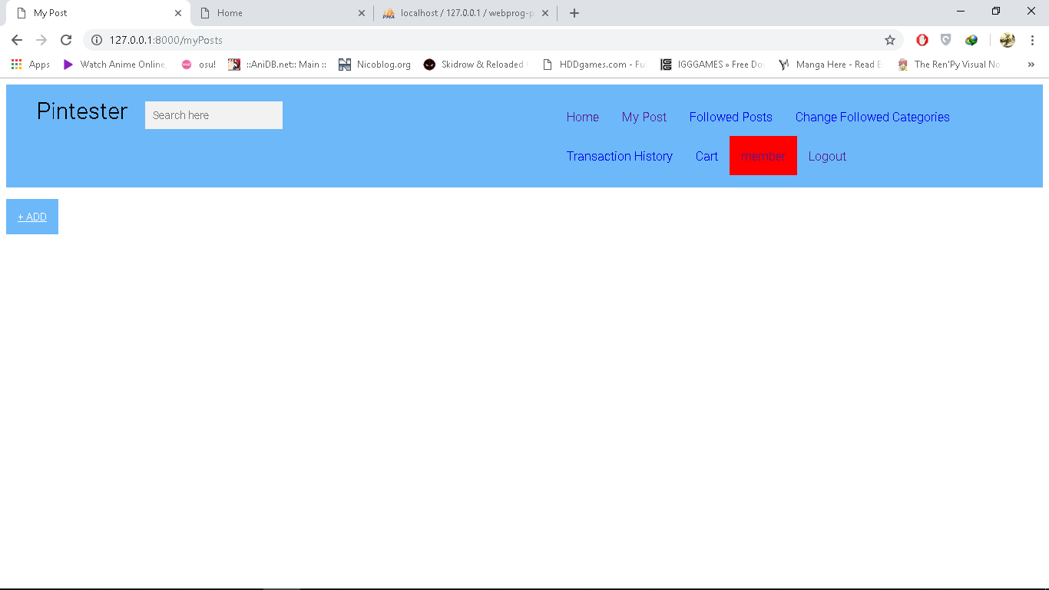

**Followed post page for Member**

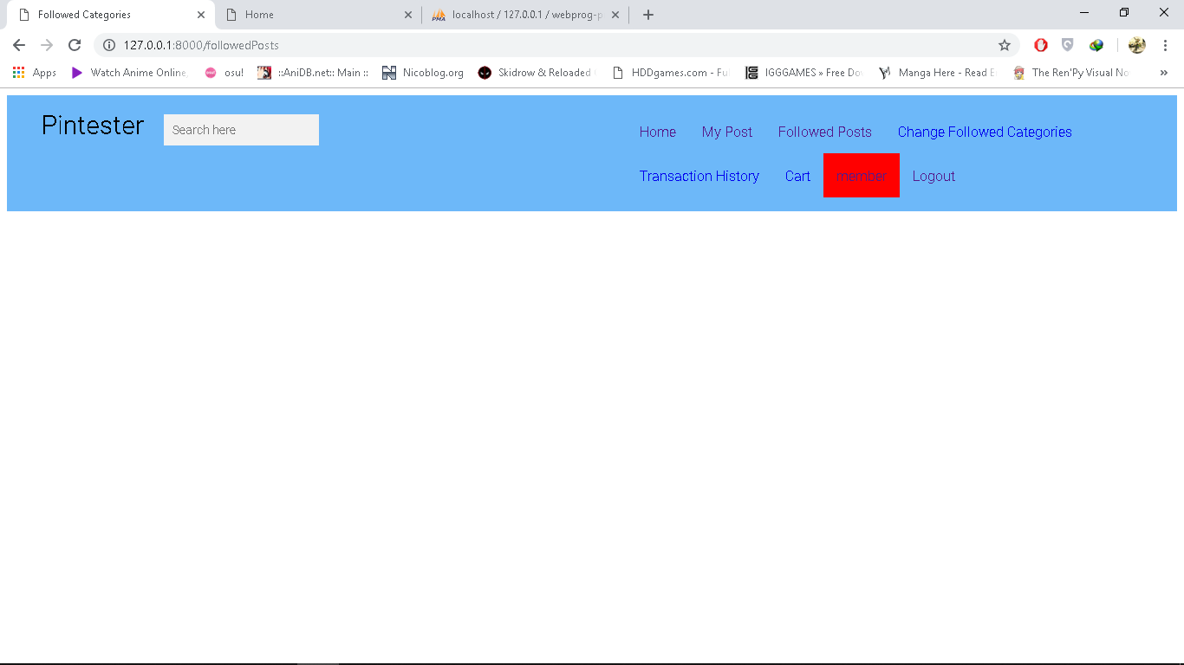

**Changed Followed Categories page for Member**

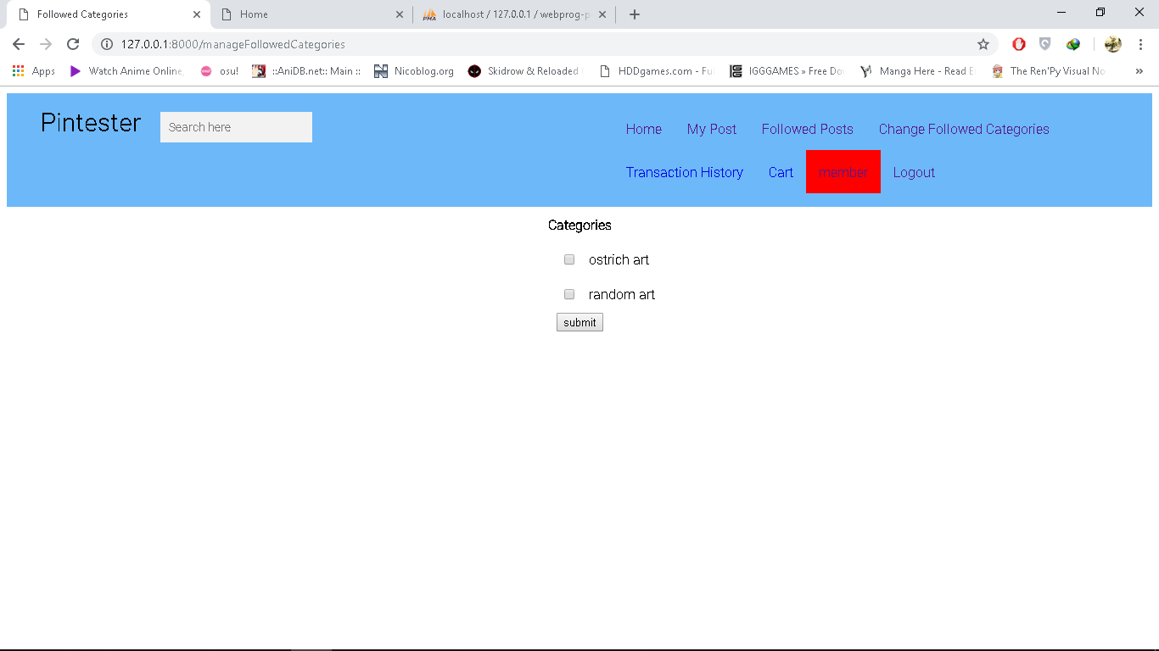

**Transaction History page for Member**

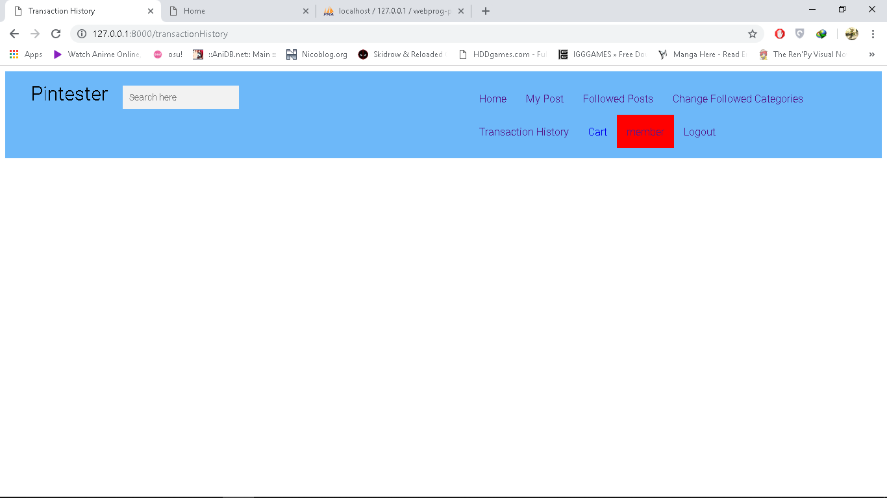

**Cart page for Member**



**Member page for Member**

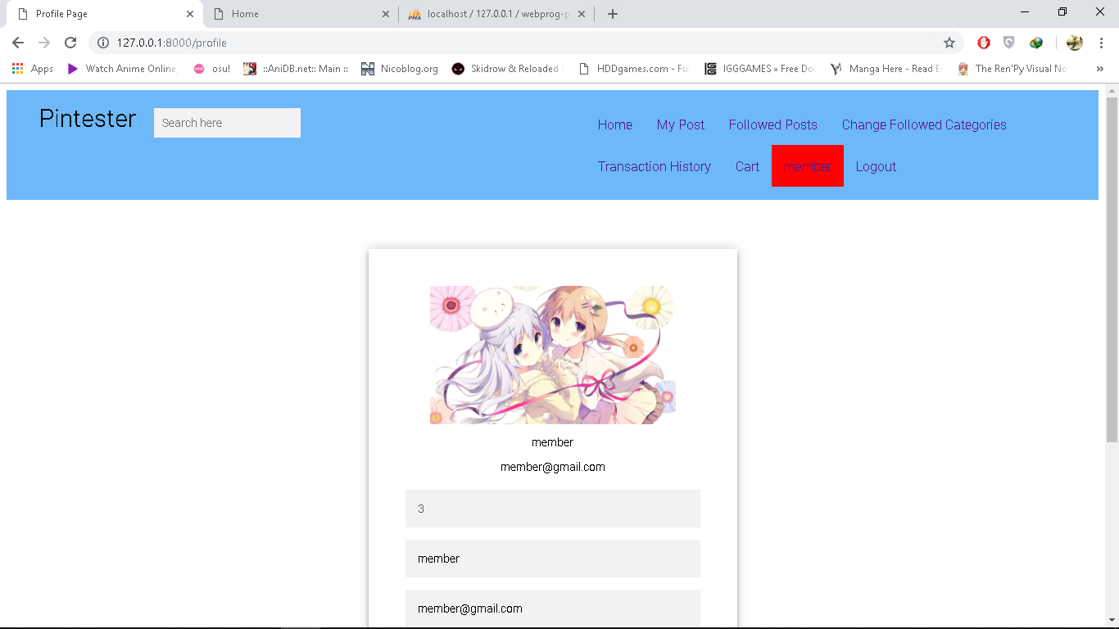

**My post Page for Admin**

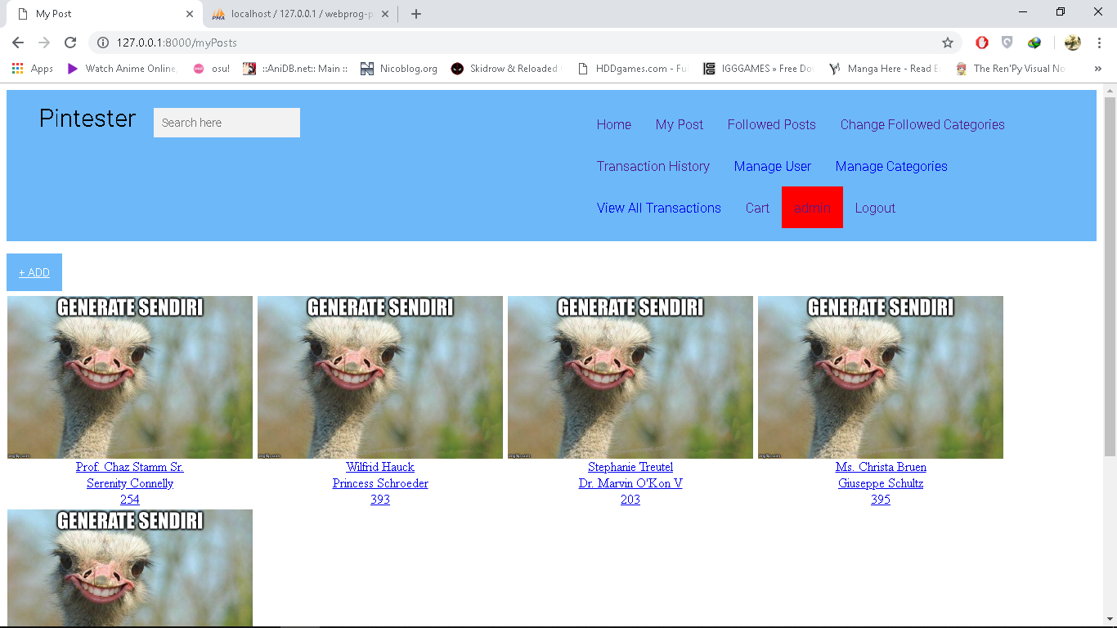

**Followed page for Admin**

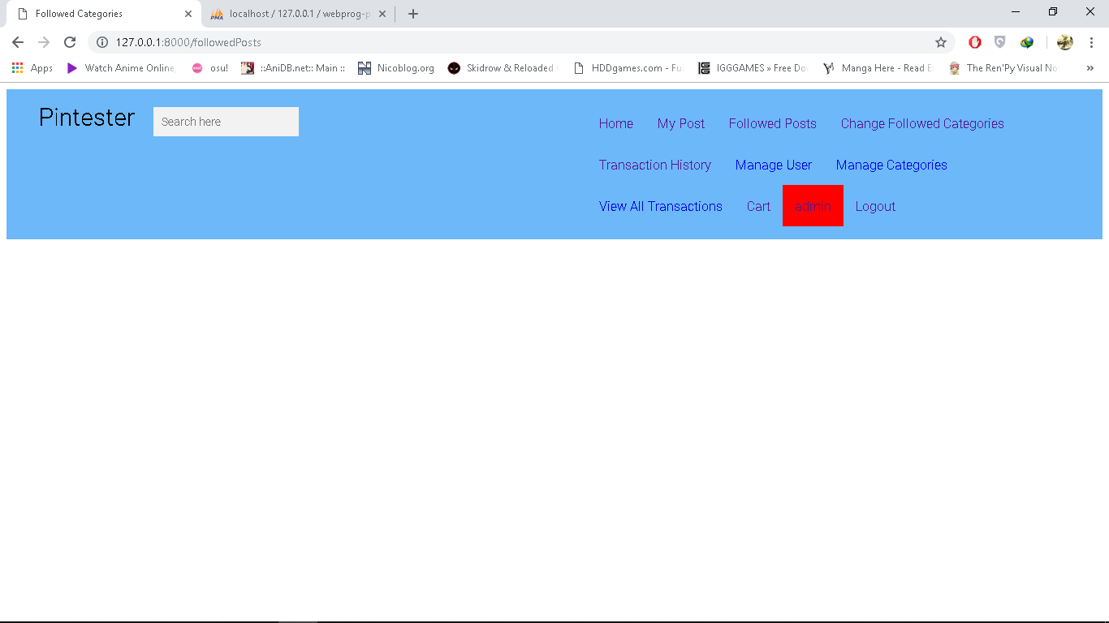

**Changed Followed Categories page for Admin**

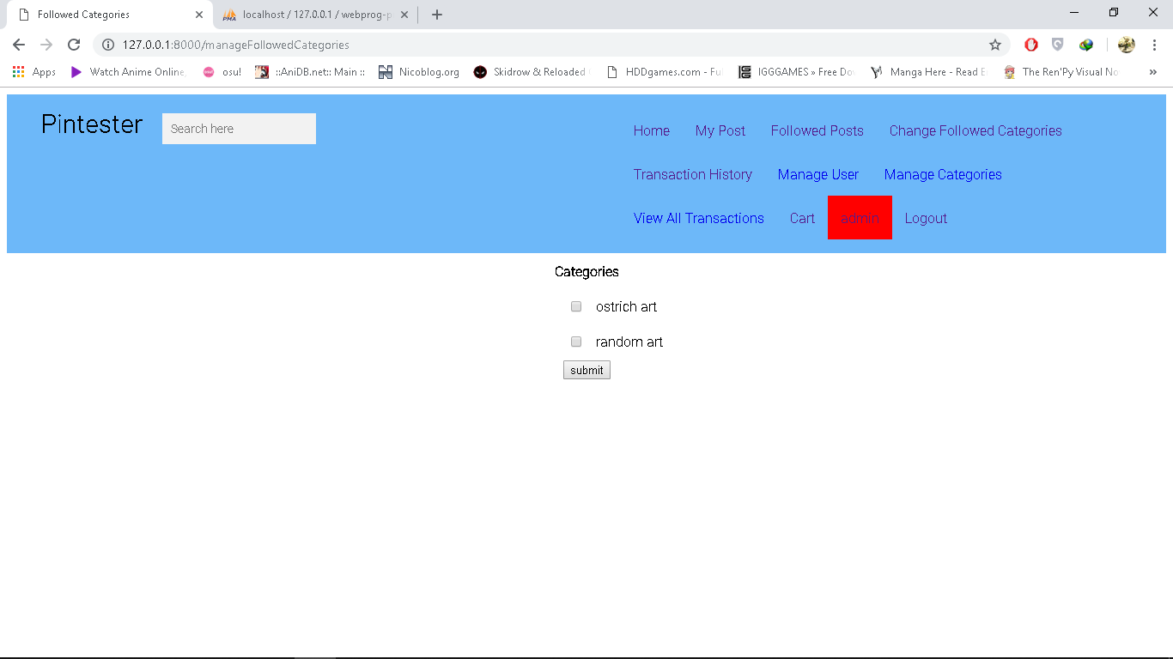

**Transaction History page for Admin**



**Member User page for Admin**

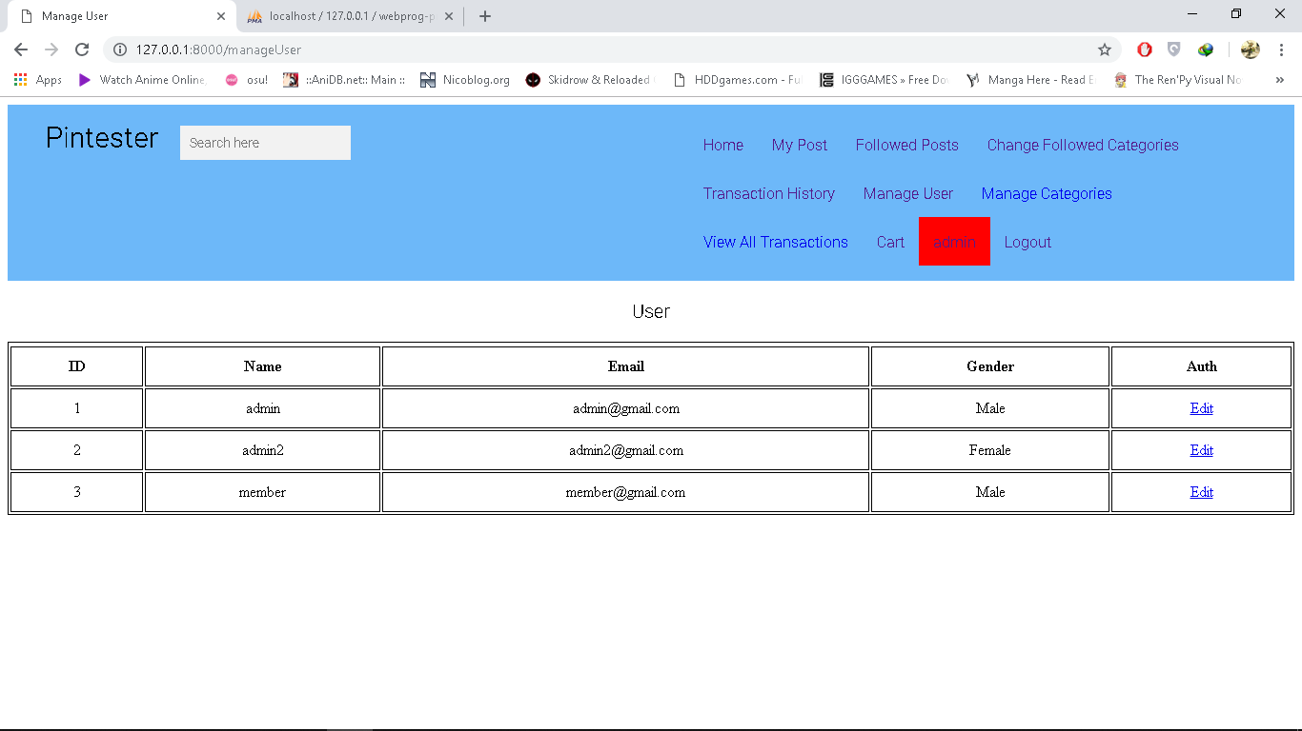

**Manage Categories page for Admin**

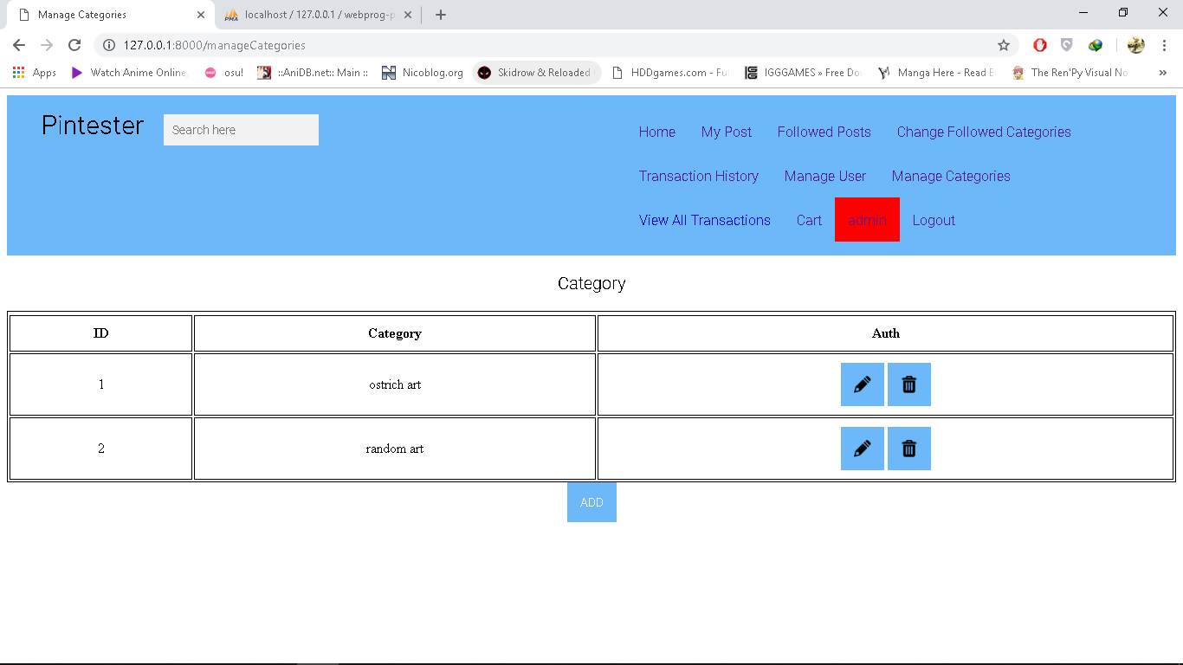

**View All Transaction page for Admin**

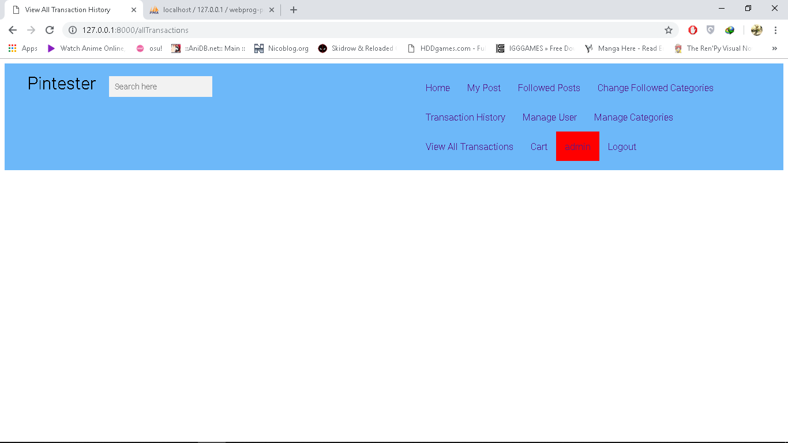

**Cart page for Admin**

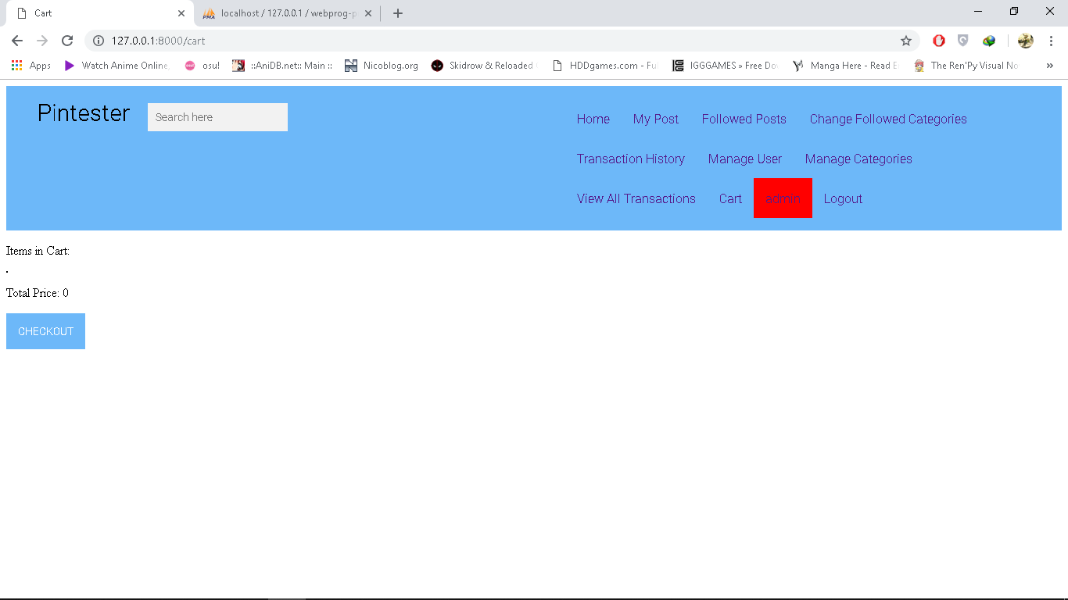

**Admin page for Admin**

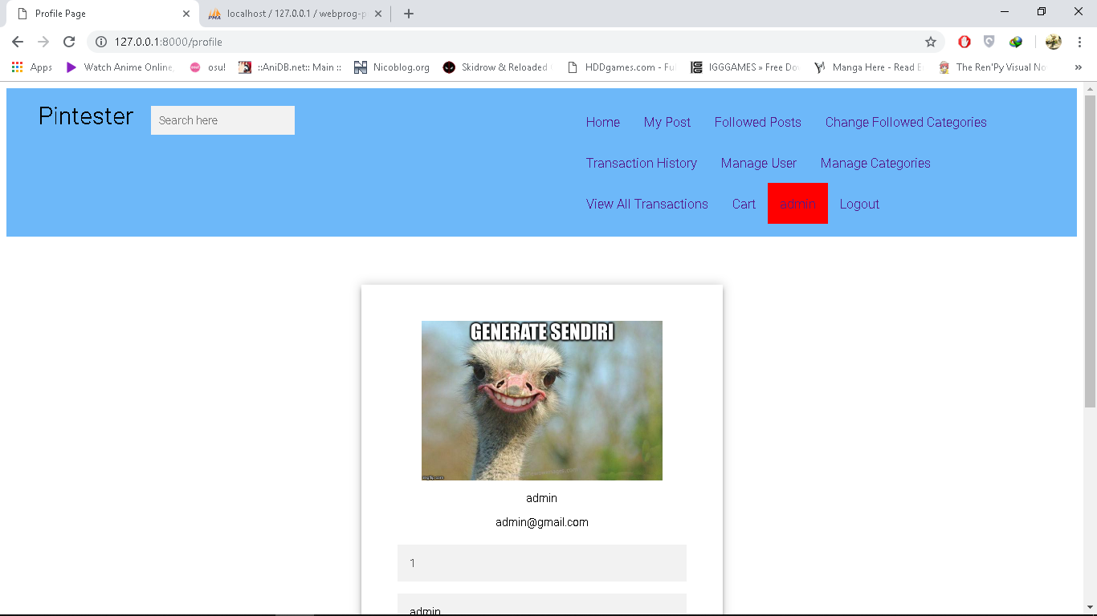

**Post Detail page**

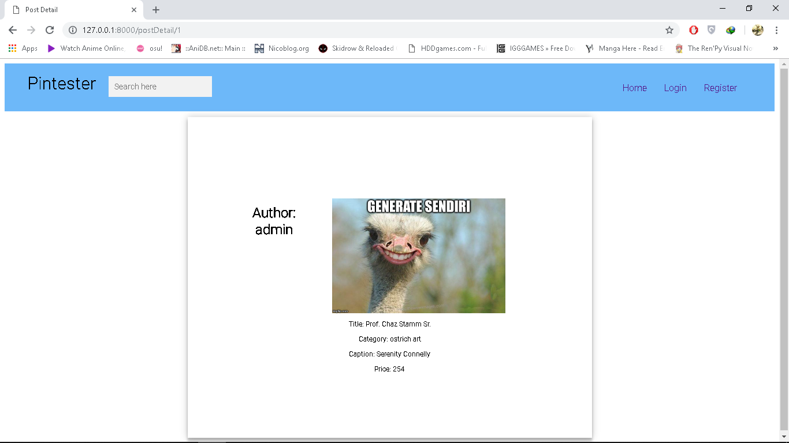

**Insert Post page**

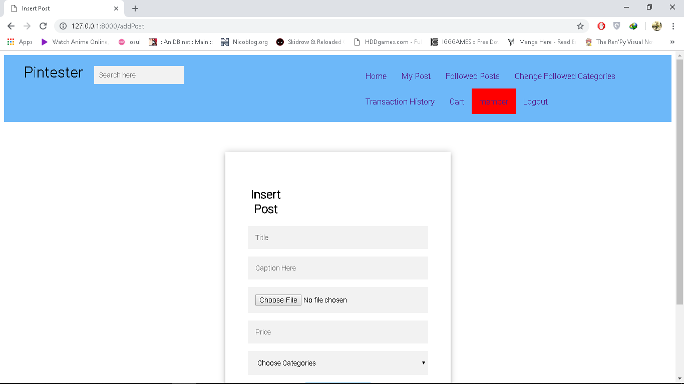

**Edit User Page**

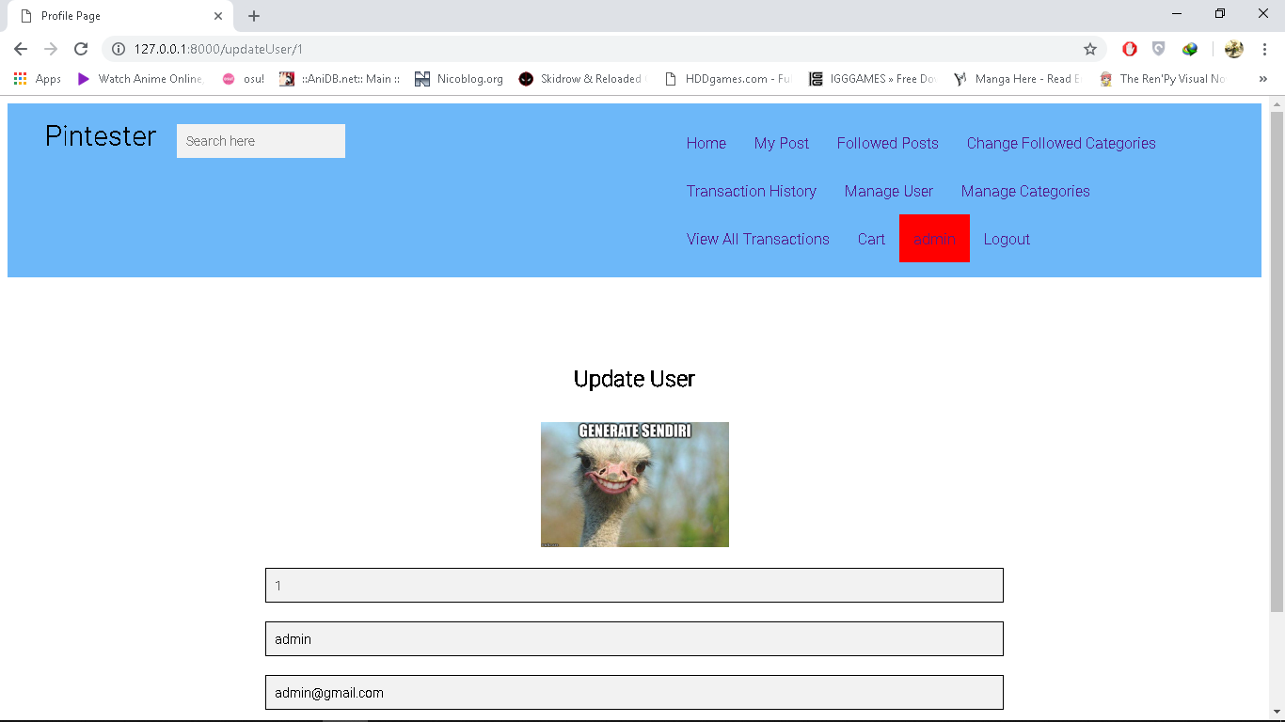

**Insert Categories page**

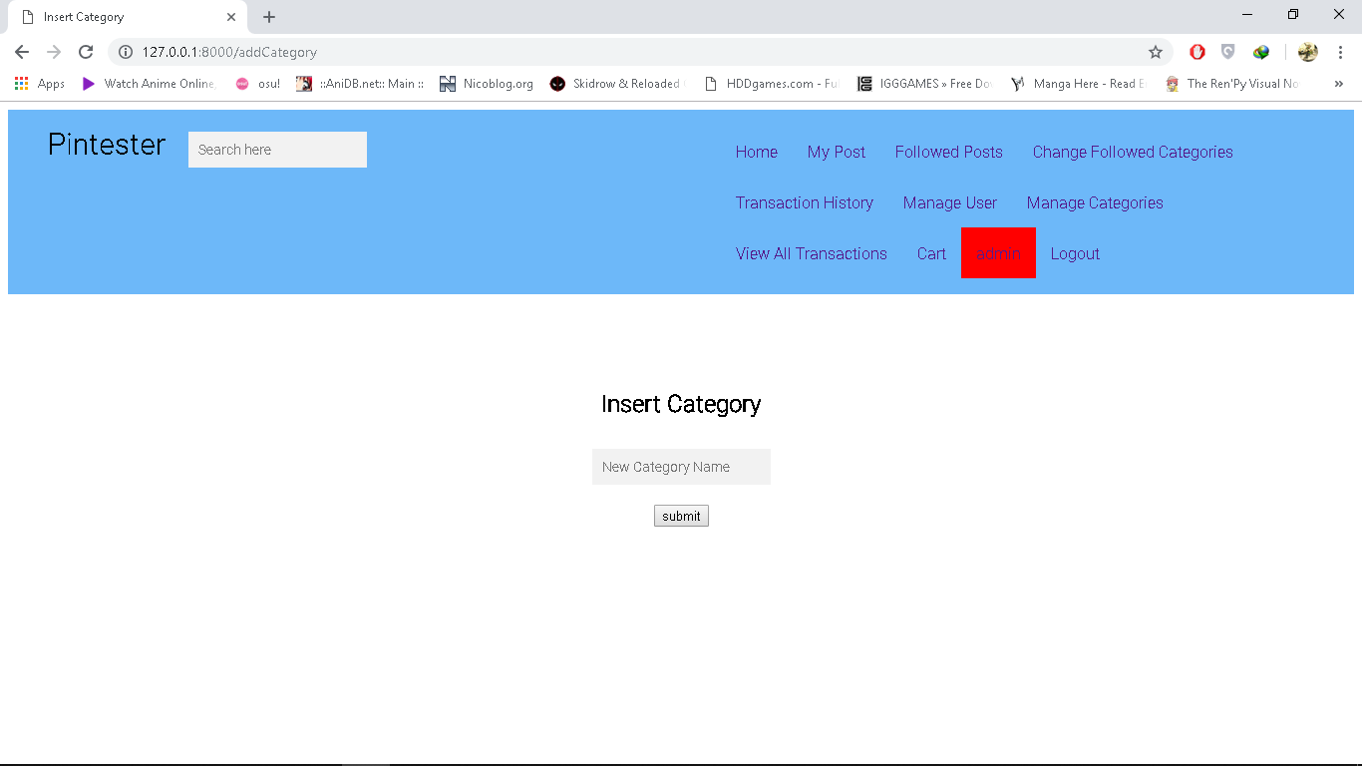

**Update Categories page**

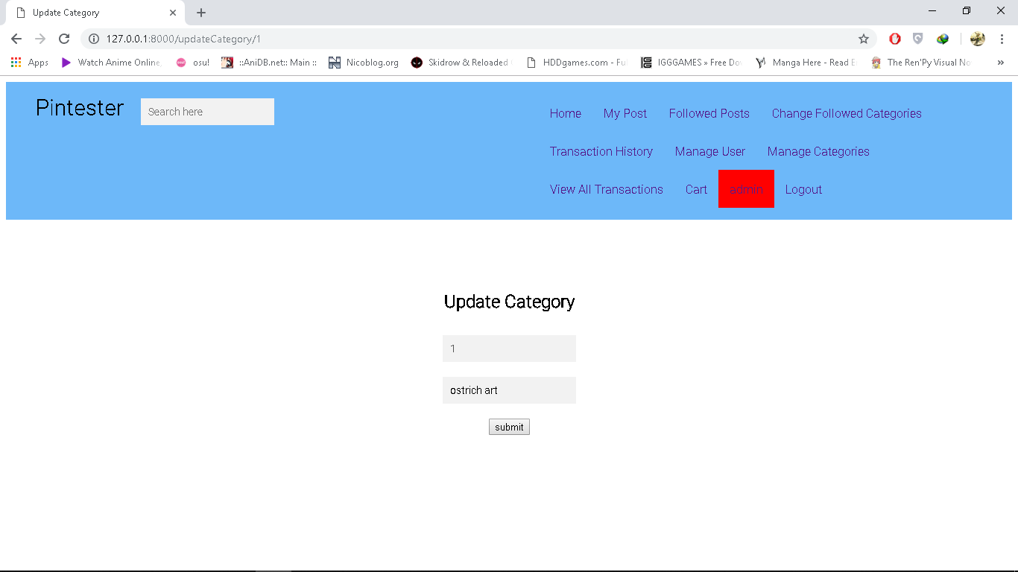

**For Delete category page, after you press the delete symbol, the category will be deleted.**

ERD Table

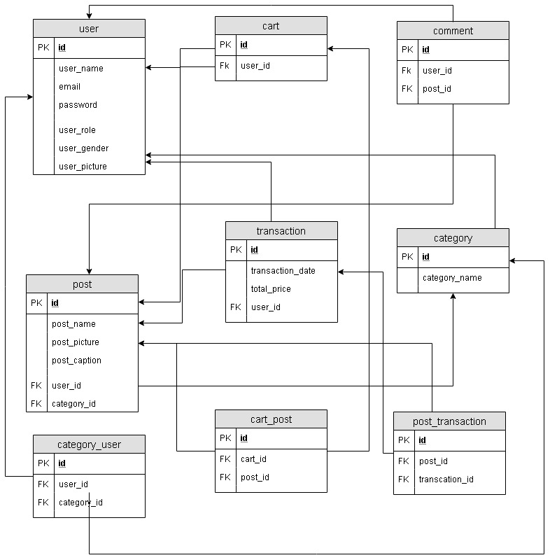

**References:**

* **beautiful-blooming-blossom-1440476**

**https://www.pexels.com/photo/close-up-photography-of-cherry-blossom-tree-1440476/**

* **asia-autumn-beautiful-248195**

**https://www.pexels.com/photo/mt-fuji-248195/**

* **kanna1.jpg**

**https://i.pximg.net/img-master/img/2018/11/19/15/17/49/71727612_p0_master1200.jpg**

* **victorique1.jpg**

**https://i.pximg.net/img-master/img/2018/05/30/17/05/28/68993564_p0_master1200.jpg**

* **Illya.jpg**

**https://i.pximg.net/img-master/img/2013/07/14/16/29/43/37054147_p0_master1200.jpg**

* **pencilLogo.png**

**https://img.icons8.com/metro/1600/pencil.png**

* **deleteLogo.png**

**https://img.icons8.com/metro/1600/trash.png**

* **ahegao.jpg**

**https://i.pximg.net/img-master/img/2018/11/26/02/05/45/71837781_p0_master1200.jpg**

* **0touYsi.jpg**

**Osu.ppy.sh**

Disiapkan Oleh,

* **2001598640 - Evan Fabian Rahardja**
* **2001546025 - Christopher Samuel**
* **2001536812 - Naufal Rayfi Hafizh**