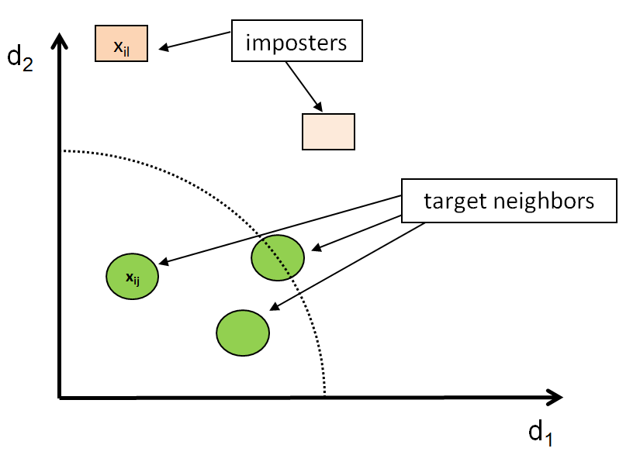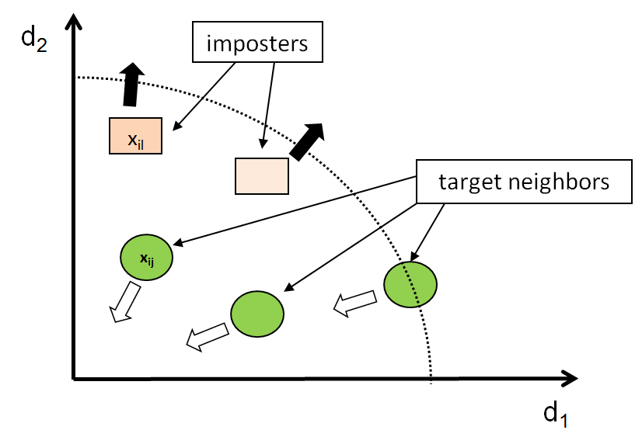

Same class

Different class

Push

Pull

Class 1

local neighborhood

imposters

imposters

target neighbors

target neighbors

Class 3

Class 2

**AFTER LEARNING**

**BEFORE LEARNING**

xl

xl

local neighborhood

local neighborhood